## Joint Information

|  |  |  |  |
| --- | --- | --- | --- |
| JointIndex | JointName | jointLowerLimit | jointUpperLimit |
| 1 | b'FR_hip_joint' | -0.802851455917 | 0.802851455917 |
| 2 | b'FR_hip_fixed' | 0.0 | -1.0 |
| 3 | b'FR_upper_joint' | -1.0471975512 | 4.18879020479 |
| 4 | b'FR_lower_joint' | -2.69653369433 | -0.916297857297 |
| 5 | b'FR_toe_fixed' | 0.0 | -1.0 |
| 6 | b'FL_hip_joint' | -0.802851455917 | 0.802851455917 |
| 7 | b'FL_hip_fixed' | 0.0 | -1.0 |
| 8 | b'FL_upper_joint' | -1.0471975512 | 4.18879020479 |
| 9 | b'FL_lower_joint' | -2.69653369433 | -0.916297857297 |
| 10 | b'FL_toe_fixed' | 0.0 | -1.0 |
| 11 | b'RR_hip_joint' | -0.802851455917 | 0.802851455917 |
| 12 | b'RR_hip_fixed' | 0.0 | -1.0 |
| 13 | b'RR_upper_joint' | -1.0471975512 | 4.18879020479 |
| 14 | b'RR_lower_joint' | -2.69653369433 | -0.916297857297 |
| 15 | b'RR_toe_fixed' | 0.0 | -1.0 |
| 16 | b'RL_hip_joint' | -0.802851455917 | 0.802851455917 |
| 17 | b'RL_hip_fixed' | 0.0 | -1.0 |
| 18 | b'RL_upper_joint' | -1.0471975512 | 4.18879020479 |
| 19 | b'RL_lower_joint' | -2.69653369433 | -0.916297857297 |
| 20 | b'RL_toe_fixed' | 0.0 | -1.0 |

BLUE represents the hip abd/add joints

YELLOW represents the hip fle/ext joints

GREEN represents the knee joints

## Matrix of Yaw Angle

The metrics are shown in the form of LaTeX

* 1. Matrix for front right leg

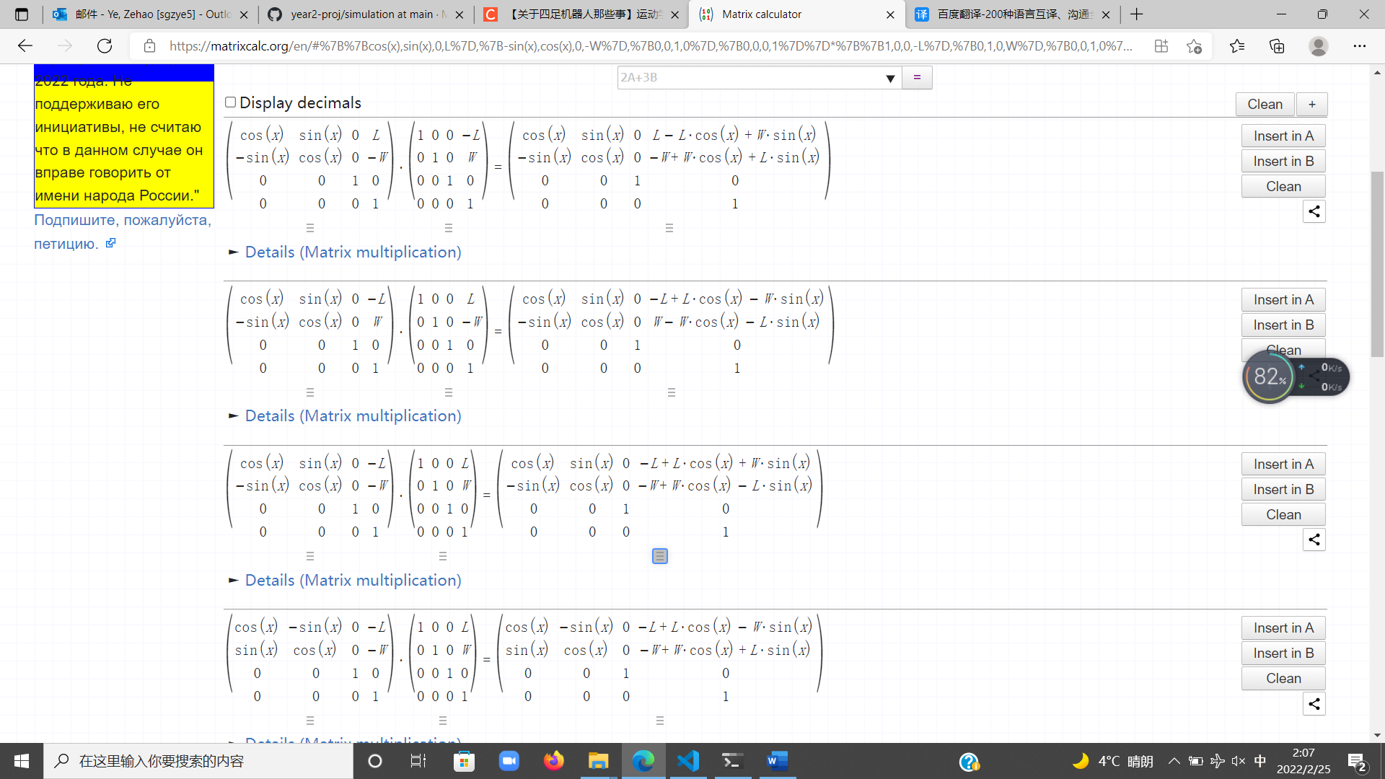

\left(\begin{matrix}

\cos\left(x\right) & \sin\left(x\right) & 0 & -L+L*\cos\left(x\right)+W*\sin\left(x\right) \\

-\sin\left(x\right) & \cos\left(x\right) & 0 & -W+W*\cos\left(x\right)-L*\sin\left(x\right) \\

0 & 0 & 1 & 0 \\

0 & 0 & 0 & 1

\end{matrix}\right)

* 1. Matrix for front left leg



\left(\begin{matrix}

\cos\left(x\right) & \sin\left(x\right) & 0 & -L+L*\cos\left(x\right)-W*\sin\left(x\right) \\

-\sin\left(x\right) & \cos\left(x\right) & 0 & W-W*\cos\left(x\right)-L*\sin\left(x\right) \\

0 & 0 & 1 & 0 \\

0 & 0 & 0 & 1

\end{matrix}\right)

* 1. Matrix for hind right leg



\left(\begin{matrix}

\cos\left(x\right) & \sin\left(x\right) & 0 & L-L*\cos\left(x\right)+W*\sin\left(x\right) \\

-\sin\left(x\right) & \cos\left(x\right) & 0 & -W+W*\cos\left(x\right)+L*\sin\left(x\right) \\

0 & 0 & 1 & 0 \\

0 & 0 & 0 & 1

\end{matrix}\right)

* 1. Matrix for hind left leg

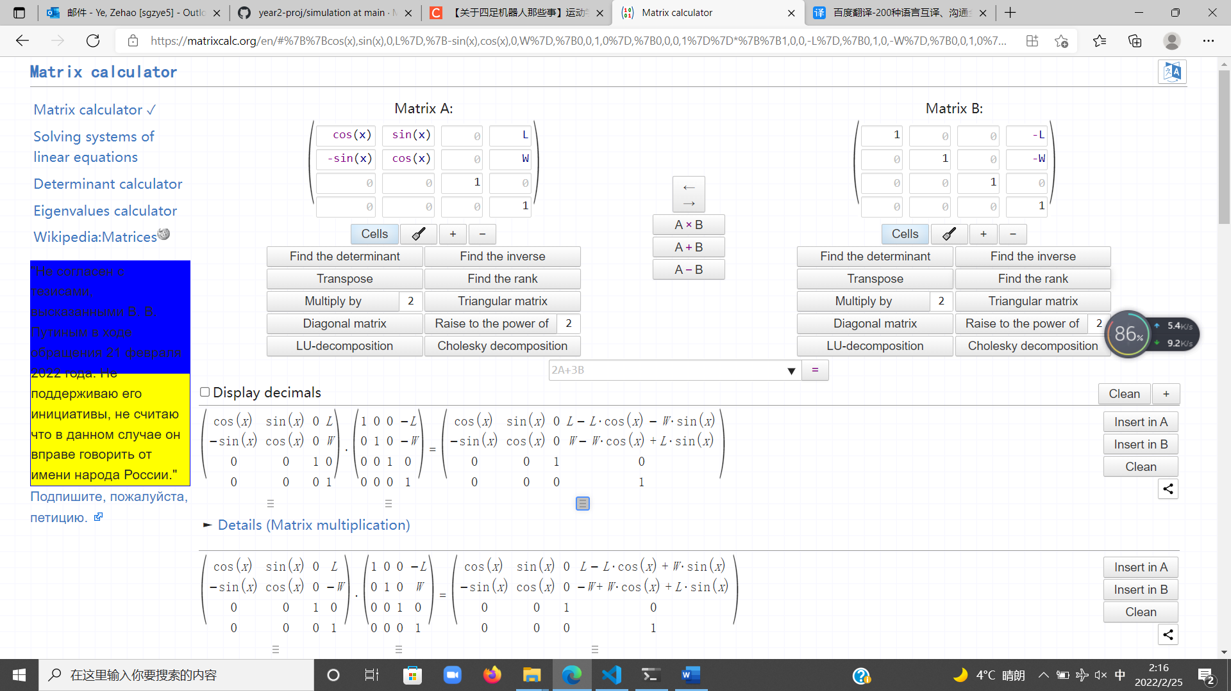

\left(\begin{matrix}

\cos\left(x\right) & \sin\left(x\right) & 0 & L-L*\cos\left(x\right)-W*\sin\left(x\right) \\

-\sin\left(x\right) & \cos\left(x\right) & 0 & W-W*\cos\left(x\right)+L*\sin\left(x\right) \\

0 & 0 & 1 & 0 \\

0 & 0 & 0 & 1

\end{matrix}\right)