Readme:

If you run the function in your terminate, just put the program in the file that contains the image you have mentioned, simply because you mentioned that you will run this program with different images with the same filenames, so I have make the input filename with default value’fig.tif’. Therefore, when you input

python csit5410_assign1.py

you will get the result.

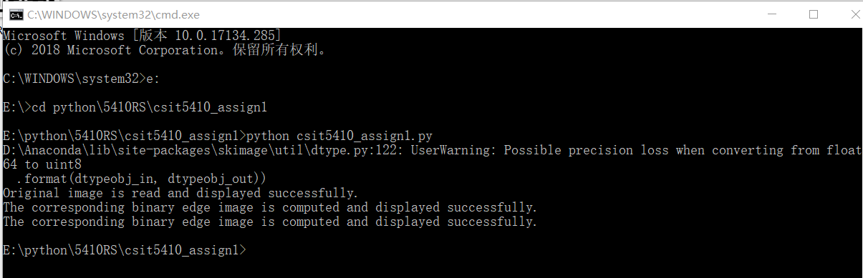

Task1:

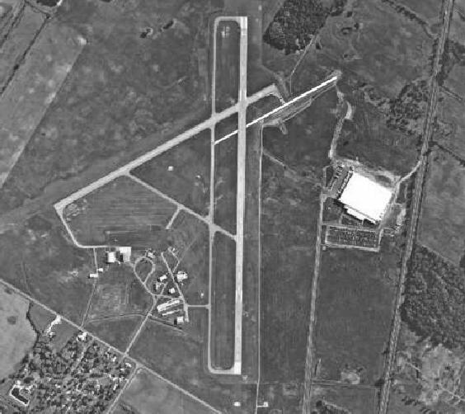

Task2:

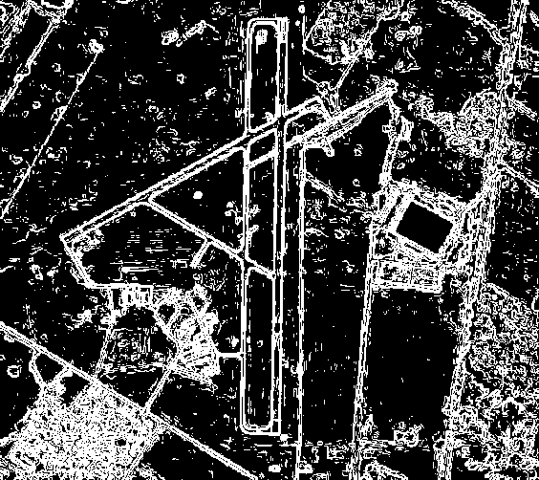

Task3:

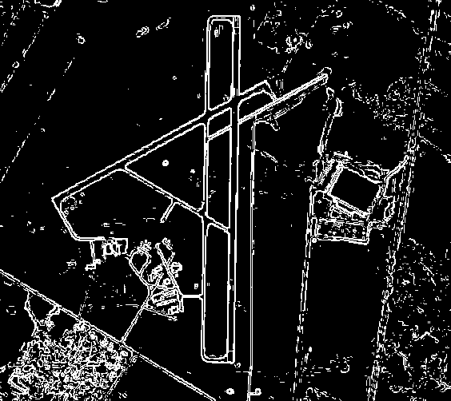

Task4: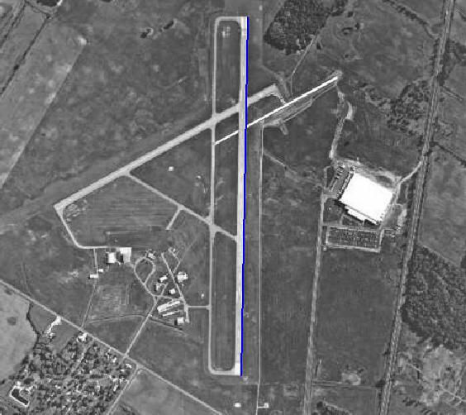

Task5: