Java 一次編寫，到處執行

<http://www.oracle.com/technetwork/java/index.html>

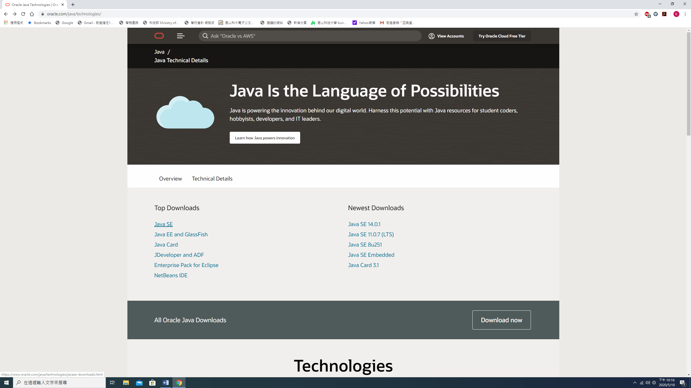

選擇 Java SE (Java Standard Edition)

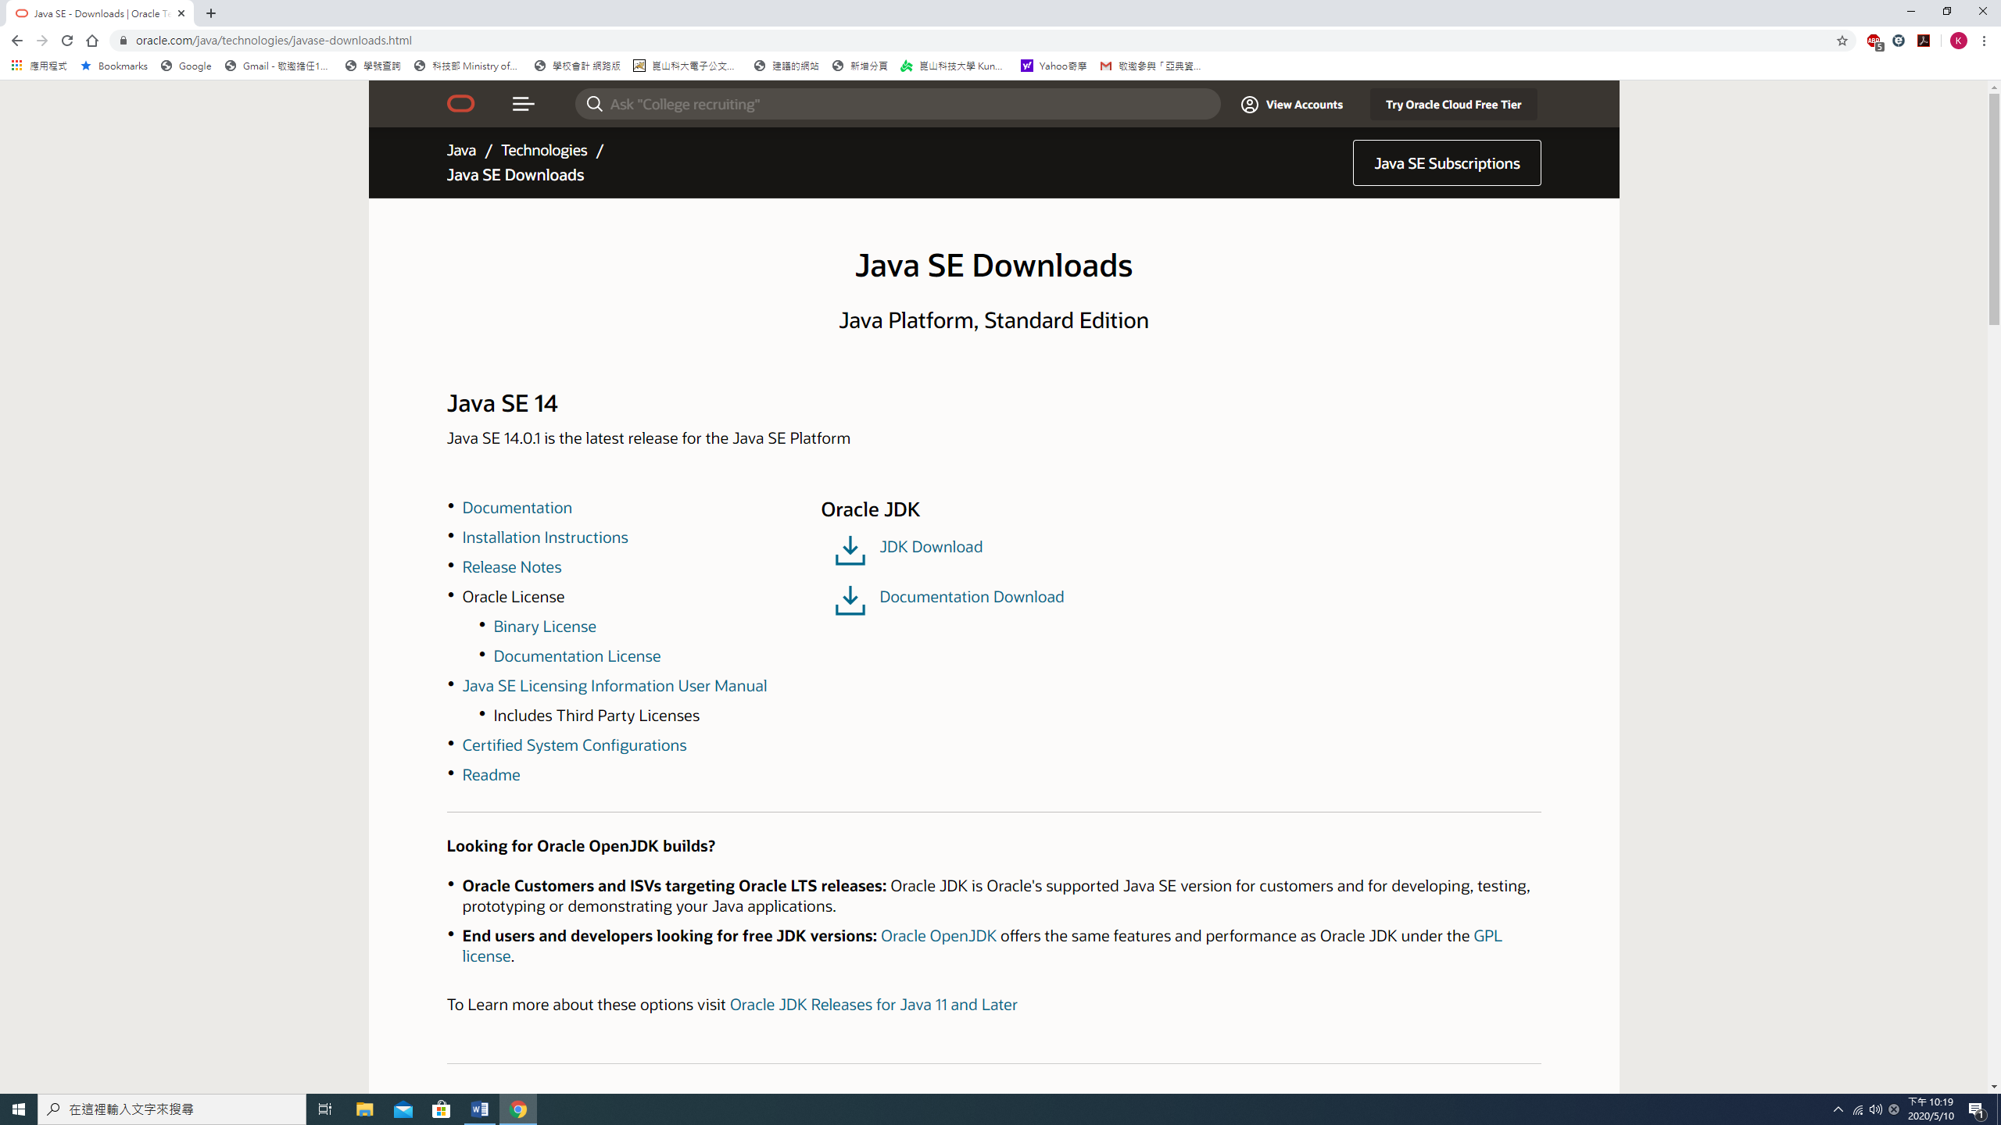

選擇 JDK Download (Java Development Kit), JDK 包含Java執行階段環境、Java 編譯器和Java API。

public class FirstJava{

public static void main(String [] argv){

**byte a=20; //1byte**

**short b=30; //2byte**

**int c=40; //4byte**

**long d=50; //8byte**

**char e='x'; //2byte**

**float f=1.14f; //4byte 數值後加f,否則會被視為double**

**double g=2.17828; //8byte**

**double h=3; //8byte**

**String s1="Hello";**

**String s2="Good\tMorning"; //'\t'為定位字元**

**final double PI=3.141592; //final 具名常數, 無法更改**

**boolean TURN=true;**

System.out.println("a and b = " + a + " and " + b);

System.out.println(a + b);

System.out.println("c and d = " + c + " and " + d);

System.out.println("e and f = " + e + " and " + f);

System.out.println("g and PI= " + g + " and " + PI);

System.out.println("a times b = " + a * b);

System.out.println("a/b = " + a/b);

System.out.println("a/h = " + a/h);

System.out.println("a%b = " + a%b);

System.out.println("a%h = " + a%h);

System.out.println(s1 + '\n' + s2);

System.out.println("The length of s1 is " + s1.length());

System.out.println("The length of s2 is " + s2.length());

System.out.println("TURN = " + TURN + " !TURN= " + !TURN);

System.out.println("a = b : " + (a==b));

System.out.println("a != b : " + (a!=b));

System.out.println("a >= b : " + (a>=b));

System.out.println("a < b : " + (a<b));

}

}

a and b = 20 and 30

50

c and d = 40 and 50

e and f = x and 1.14

g and PI= 2.17828 and 3.141592

a times b = 600

a/b = 0

a/h = 6.666666666666667

a%b = 20

a%h = 2.0

Hello

Good Morning

The length of s1 is 5

The length of s2 is 12

TURN = true !TURN= false

a = b : false

a != b : true

a >= b : false

a < b : true

public class LO{ //Logical Operator

public static void main(String [] argv){

int a=4, b=5;

boolean c=true, d=false;

System.out.println("a = b : " + (a==b));

System.out.println("a != b : " + (a!=b));

System.out.println("a > b : " + (a>b));

System.out.println("a < b : " + (a<b));

System.out.println("c = " + c + "d = " + d);

System.out.println("c & d" + (c & d)); // &: AND

System.out.println("c && d" + (c && d)); // &&: AND

System.out.println("c | d" + (c | d)); // |: AND

System.out.println("c || d" + (c || d)); // ||: AND

System.out.println("(a++ = 4) & (b++ = 5): " + ((a++ == 4) & (b++ == 5)));

System.out.println("a = " + a);

System.out.println("b = " + b);

System.out.println("(a++ = 4) && (b++ = 5)" + ((a++ == 4) && (b++ == 5)));

System.out.println("a = " + a);

System.out.println("b = " + b);

System.out.println("(a++ = 6) | (b++ = 6)" + ((a++ == 6) | (b++ == 6)));

System.out.println("a = " + a);

System.out.println("b = " + b);

System.out.println("(a++ = 7) || (b++ = 7)" + ((a++ == 7) || (b++ == 7)));

System.out.println("a = " + a);

System.out.println("b = " + b);

System.out.println(c? "c: TRUE" : "c: FALSE");

System.out.println(d? "d: TRUE" : "d: FALSE");

a = (b%2 == 1)? a++:b++;

System.out.println("a = " + a);

System.out.println("b = " + b);

b = (a%2 == 0)? a++:b++;

System.out.println("a = " + a);

System.out.println("b = " + b);

}

}

a = b : false

a != b : true

a > b : false

a < b : true

c = trued = false

c & dfalse

c && dfalse

c | dtrue

c || dtrue

(a++ = 4) & (b++ = 5): true

a = 5

b = 6

(a++ = 4) && (b++ = 5)false

a = 6

b = 6

(a++ = 6) | (b++ = 6)true

a = 7

b = 7

(a++ = 7) || (b++ = 7)true

a = 8

b = 7

c: TRUE

d: FALSE

a = 8

b = 7

a = 9

b = 8

import java.util.*;

public class Input{ //Get Input

public static void main(String [] argv){

Scanner sc = new Scanner(System.in);

int a;

Boolean b;

String c;

Float d;

System.out.println("Please input a integer value:");

a = sc.nextInt();

System.out.println("input a integer value is:" + a);

System.out.println("Please input a boolean value:");

b = sc.nextBoolean();

System.out.println("input a boolean value is:" + b);

System.out.println("Please input a String:");

c = sc.next(); //不可輸入空白

System.out.println("input a string is:" + c);

System.out.println("Please input a float value:");

d = sc.nextFloat();

System.out.println("input a float vale is:" + d);

}

}

Please input a integer value:

21

input a integer value is:21

Please input a boolean value:

true

input a boolean value is:true

Please input a String:

Hello

input a string is:Hello

Please input a float value:

32.1234

input a float vale is:32.1234

import java.util.*;

import java.io.*;

public class InputM{ //Get Input many string

public static void main(String [] argv) throws IOException{

BufferedReader br = new BufferedReader(new InputStreamReader(System.in));

System.out.print("Please input a stream:");

String text = br.readLine();

System.out.println("You input a stream is:" + text);

}

}

Please input a stream:Hello I am Leekr

You input a stream is:Hello I am Leekr

import java.util.*;

public class Cif{

public static void main(String [] argv){

Scanner sc = new Scanner(System.in);

int a,b;

System.out.println("Please select ticket type:");

System.out.println("1. Normal(300)");

System.out.println("2. Student(240)");

System.out.println("3. Child(200)");

a = sc.nextInt();

System.out.println("Please input the amount of tickets:");

b = sc.nextInt();

if(a==1)

System.out.println("the ticket price is:" + 300*b);

else if(a==2)

System.out.println("the ticket price is:" + 240*b);

else if(a==3)

System.out.println("the ticket price is:" + 200*b);

else

System.out.println("Input Error");

}

}

Please select ticket type:

1. Normal(300)

2. Student(240)

3. Child(200)

2

Please input the amount of tickets:

4

the ticket price is:960

import java.util.*;

public class Cswitch{

public static void main(String [] argv){

Scanner sc = new Scanner(System.in);

int a,b;

System.out.println("請選擇購票種類:");

System.out.println("1. 全票 300 元");

System.out.println("2. 學生票 240 元");

System.out.println("3. 兒童票 200 元");

a = sc.nextInt();

System.out.println("請輸入購票張數:");

b = sc.nextInt();

switch(a){

case 1:

System.out.println("票價:" + 300*b + "元");

break;

case 2:

System.out.println("票價:" + 240*b + "元");

break;

case 3:

System.out.println("票價:" + 200*b + "元");

break;

default:

System.out.println("購票種類選擇錯誤");

break;

}

}

}

請選擇購票種類:

1. 全票 300 元

2. 學生票 240 元

3. 兒童票 200 元

1

請輸入購票張數:

3

票價:900元

public class Cfor{

public static void main(String [] argv){

for (int x=1; x<=9; x++){

for(int y=1; y<=9; y++){

System.out.print(x + "*" + y + "=" + x*y + "\t");

}

System.out.println();

}

}

}

1*1=1 1*2=2 1*3=3 1*4=4 1*5=5 1*6=6 1*7=7 1*8=8 1*9=9

2*1=2 2*2=4 2*3=6 2*4=8 2*5=10 2*6=12 2*7=14 2*8=16 2*9=18

3*1=3 3*2=6 3*3=9 3*4=12 3*5=15 3*6=18 3*7=21 3*8=24 3*9=27

4*1=4 4*2=8 4*3=12 4*4=16 4*5=20 4*6=24 4*7=28 4*8=32 4*9=36

5*1=5 5*2=10 5*3=15 5*4=20 5*5=25 5*6=30 5*7=35 5*8=40 5*9=45

6*1=6 6*2=12 6*3=18 6*4=24 6*5=30 6*6=36 6*7=42 6*8=48 6*9=54

7*1=7 7*2=14 7*3=21 7*4=28 7*5=35 7*6=42 7*7=49 7*8=56 7*9=63

8*1=8 8*2=16 8*3=24 8*4=32 8*5=40 8*6=48 8*7=56 8*8=64 8*9=72

9*1=9 9*2=18 9*3=27 9*4=36 9*5=45 9*6=54 9*7=63 9*8=72 9*9=81

import java.util.*;

public class Cwhile{

public static void main(String [] argv){

int i=1, n, s=1;

Scanner sc = new Scanner(System.in);

System.out.println("輸入一個正整數:");

n = sc.nextInt();

while (i<=n){

s = s*(i++);

}

System.out.println(n + "!" + "=" + s);

}

}

import java.util.*;

public class Cwhile{

public static void main(String [] argv){

int i=1, n, s=1;

Scanner sc = new Scanner(System.in);

System.out.println("輸入一個正整數:");

n = sc.nextInt();

while (true){

s = s*(i++);

if(i>n) break;

}

System.out.println(n + "!" + "=" + s);

}

}

輸入一個正整數:

5

5!=120

import java.util.*;

public class Carray{

public static void main(String [] argv){

int [] records = new int[5];

Scanner sc = new Scanner(System.in);

for(int i=0; i<5; i++){

System.out.println("輸入第" + (i+1) + "個學生成績:");

records[i] = sc.nextInt();

}

int j=0;

while (j<5){

System.out.println("第" + (j+1) + "個學生的成績:" + records[j]);

j++;

}

}

}

輸入第1個學生成績:

23

輸入第2個學生成績:

45

輸入第3個學生成績:

67

輸入第4個學生成績:

89

輸入第5個學生成績:

90

第1個學生的成績:23

第2個學生的成績:45

第3個學生的成績:67

第4個學生的成績:89

第5個學生的成績:90

import java.util.*;

public class Carray{

public static void main(String [] argv){

int [] records = new int[5];

Scanner sc = new Scanner(System.in);

for(int i=0; i<5; i++){

System.out.println("輸入第" + (i+1) + "個學生成績:");

records[i] = sc.nextInt();

}

int j=0;

for (int s:records){

System.out.println("第" + (j+1) + "個學生的成績:" + s);

j++;

}

}

}

輸入第1個學生成績:

34

輸入第2個學生成績:

56

輸入第3個學生成績:

87

輸入第4個學生成績:

45

輸入第5個學生成績:

89

第1個學生的成績:34

第2個學生的成績:56

第3個學生的成績:87

第4個學生的成績:45

第5個學生的成績:89

import java.util.*;

public class Cargv{

public static void main(String [] argv){

System.out.println(argv[0]);

System.out.println(argv[1]);

}

}

C:\Users\DON\Desktop\Java 教材>java Cargv Hello 你好

Hello

你好

import java.util.*;

public class Jclass{

public static void main(String [] argv){

Scanner sc = new Scanner(System.in);

IcCard mycard = new IcCard();

mycard.id = 1234567;

mycard.money = 1000;

mycard.showInfo();

System.out.println("是否加值:(Y/N)");

String a = sc.next();

if(a.equals("y")){

System.out.println("輸入加值金額:");

int v = sc.nextInt();

mycard.add(v);

}

}

}

class IcCard{

long id;

int money;

void showInfo(){

System.out.println("卡號:"+id+", 餘額:"+money);

}

void add(int value){

money += value;

System.out.println("卡號:"+id+", 加值:"+value+", 餘額:"+money);

}

}

卡號:1234567, 餘額:1000

是否加值:(Y/N)

y

輸入加值金額:

1000

卡號:1234567, 加值:1000, 餘額:2000

import java.util.*;

public class JMclass{

public static void main(String [] argv){

Scanner sc = new Scanner(System.in);

IcCard[] cards = new IcCard[5];

int cardNo = -1;

for(int i =0; i<cards.length; i++){

cards[i] = new IcCard();

cards[i].inputInfor(i);

}

for(int i =0; i<cards.length; i++){

cards[i].showInfo();

}

System.out.println("是否加值:(Y/N)");

String a = sc.next();

if(a.equals("y")){

System.out.println("輸入卡號:");

long no = sc.nextLong();

for(int j =0; j<cards.length; j++){

if (cards[j].id == no){

cardNo = j;

break;

}

}

if (cardNo == -1)

System.out.println("輸入卡號錯誤!!");

else{

System.out.println("輸入加值金額:");

int v = sc.nextInt();

cards[cardNo].add(v);

}

}

}

}

class IcCard{

long id;

int money;

Scanner sc = new Scanner(System.in);

void inputInfor(int index){

System.out.print("輸入第"+(index+1)+"張卡卡號:");

id = sc.nextLong();

System.out.print("輸入第"+(index+1)+"張卡金額:");

money = sc.nextInt();

}

void showInfo(){

System.out.println("卡號:"+id+", 餘額:"+money);

}

void add(int value){

money += value;

System.out.println("卡號:"+id+", 加值:"+value+", 餘額:"+money);

}

}

輸入第1張卡卡號:1

輸入第1張卡金額:100

輸入第2張卡卡號:2

輸入第2張卡金額:200

輸入第3張卡卡號:3

輸入第3張卡金額:300

輸入第4張卡卡號:4

輸入第4張卡金額:400

輸入第5張卡卡號:5

輸入第5張卡金額:500

卡號:1, 餘額:100

卡號:2, 餘額:200

卡號:3, 餘額:300

卡號:4, 餘額:400

卡號:5, 餘額:500

是否加值:(Y/N)

y

輸入卡號:

3

輸入加值金額:

1000

卡號:3, 加值:1000, 餘額:1300

import java.util.*;

public class QuickSort{

public static void main(String [] argv){ //輸入要排序的數到 argv 陣列

Scanner sc = new Scanner(System.in);

int[] data = new int[argv.length];

for (int i = 0; i < argv.length; i++){ //把 argv[] 轉成整數放入 data[]

data[i] = java.lang.Integer.parseInt(argv[i]);

}

Sorter s = new Sorter();

s.sort(data);

}

}

class Sorter{

int[] data;

void quickSort(int start, int end){

if(start >= end){

return;

}

int mid = data[(start + end)/2];

int left = start;

int right = end;

while(left < right){

while((left < end) && (data[left] < mid)){

left++;

}

while((right > start) && (data[right] > mid)){

right--;

}

if(left <= right){

int temp = data[left];

data[left] = data[right];

data[right] = temp;

left++;

right--;

show();

}

}

quickSort(start, right);

quickSort(left, end);

}

void sort(int[] data){

this.data = data;

show();

quickSort(0, data.length-1);

}

void show(){

for(int i: data){

System.out.print(i+" ");

}

System.out.println(" ");

}

}

C:\Users\DON\Desktop\Java 教材>java QuickSort.java 12 4 7 11 15 2 8

12 4 7 11 15 2 8

8 4 7 11 15 2 12

8 4 7 2 15 11 12

2 4 7 8 15 11 12

2 4 7 8 15 11 12

2 4 7 8 15 11 12

2 4 7 8 15 11 12

2 4 7 8 11 15 12

2 4 7 8 11 12 15

import java.io.*;

public class HanoiTower{

public static void main(String [] argv) throws IOException{

HTMove Htm = new HTMove();

BufferedReader br = new BufferedReader(new InputStreamReader(System.in));

System.out.print("請輸入碟子的數量:");

int discs = java.lang.Integer.parseInt(br.readLine());

Htm.go(discs);

}

}

class HTMove{

void go(int discs){

hTower('A', 'C', 'B', discs);

}

void hTower(char a, char c, char b, int discs){

if(discs == 1){

moveDisc(a,c,discs);

return;

}

hTower(a,b,c,discs-1);

moveDisc(a,c,discs);

hTower(b,c,a,discs-1);

}

void moveDisc(char source, char target, int disc){

System.out.println("把"+disc+"號碟子從柱子"+source+"搬到"+target);

}

}

請輸入碟子的數量:4

把1號碟子從柱子A搬到B

把2號碟子從柱子A搬到C

把1號碟子從柱子B搬到C

把3號碟子從柱子A搬到B

把1號碟子從柱子C搬到A

把2號碟子從柱子C搬到B

把1號碟子從柱子A搬到B

把4號碟子從柱子A搬到C

把1號碟子從柱子B搬到C

把2號碟子從柱子B搬到A

把1號碟子從柱子C搬到A

把3號碟子從柱子B搬到C

把1號碟子從柱子A搬到B

把2號碟子從柱子A搬到C

把1號碟子從柱子B搬到C

import java.util.*;

public class Inheritance{

public static void main(String [] argv){

Cylinder cr = new Cylinder(3,5,10);

cr.showInfor();

}

}

class Circle{

private double x,y,r;

public void setCenter(double x, double y){

this.x = x;

this.y = y;

}

public void setRadius(double r){

this.r = r;

}

public void showInfor(){

System.out.println("圓心: "+x+", "+y+". 半徑:"+r);

}

Circle(double x, double y, double r){

System.out.println("建構 Circle");

this.x = x;

this.y = y;

this.r = r;

}

}

class Cylinder extends Circle{

Cylinder(double x, double y, double r){

super(x,y,r);

System.out.println("建構 Cylinder");

}

}

建構 Circle

建構 Cylinder

圓心: 3.0, 5.0. 半徑:10.0

import java.util.*;

public class Lands{

public static void main(String [] argv){

Circle c = new Circle(5);

Square s = new Square(10);

System.out.println("c的價格: "+ Calculator.calPrice(3000, c));

System.out.println("s的價格: "+ Calculator.calPrice(3000, s));

System.out.println("c與s的總價格: "+ Calculator.calPrice(3000, c,s));

}

}

abstract class Land{

double area(){

return 0;

}

}

class Circle extends Land{

int r;

Circle(int r){

this.r = r;

}

double area(){

return 3.14*r*r;

}

}

class Square extends Land{

int side;

Square(int side){

this.side = side;

}

double area(){

return side*side;

}

}

class Calculator{

static double calPrice(double price, Object... objs){

double total = 0;

for(Object o:objs){

if(o instanceof Land){

total += ((Land)o).area()*price;

}

}

return total;

}

}

c的價格: 235500.0

s的價格: 300000.0

c與s的總價格: 535500.0

import java.util.*;

public class ShapArea{

public static void main(String [] argv){

Circle c = new Circle(5,8,7);

System.out.println(c.toString());

System.out.println(c.PI);

System.out.println(Surfacing.PI);

}

}

interface ShowString{

String toString();

}

interface Surfacing extends ShowString{

double area();

double PI = 3.14159;

}

class Shape{

protected double x,y;

public Shape(double x, double y){

this.x = x;

this.y = y;

}

public String toString(){

return "圖形原點:("+x+","+y+")";

}

}

class Circle extends Shape implements Surfacing{

private double r;

public Circle(double x, double y, double r){

super(x,y);

this.r = r;

}

public double area(){

return PI*r*r;

}

public String toString(){

return "圓心:("+x+","+y+"), 半徑: "+r+", 面積: "+area();

}

}

圓心:(5.0,8.0), 半徑: 7.0, 面積: 153.93791

3.14159

3.14159

import java.util.*;

public class InnerClass{

public static void main(String [] argv){

Outter out = new Outter();

out.callInner();

Outter.Inner inn = out.new Inner();

inn.print();

Outter.SInner sinn = new Outter.SInner();

sinn.print();

}

}

class Outter{

private int a = 1, b=2, c=3;

static int k=4;

class Inner{

int a=5, e=6;

void print(){

System.out.print(a);

System.out.print(Outter.this.a);

System.out.print(Outter.k);

System.out.print(c);

}

}

static class SInner{

void print(){

System.out.println("Hello!");

}

}

void callInner(){

Inner in = new Inner();

in.print();

}

}

51435143Hello!

import java.util.*;

public class AnonymousClass{

public static void main(String [] argv){

final int a=10;

(new Object(){

int b=100;

public void show(){

System.out.println("匿名類別.b = "+b);

System.out.println("a = "+a);

}

}).show();

}

}

匿名類別.b = 100

a = 10

-----------------------------------------------------------------------------------------------------------------------

import java.util.*;

public class AnonymousInterface{

public static void main(String [] argv){

new Face(){

public void smile(){

System.out.println("笑臉");

}

}.smile();

}

}

interface Face{

void smile();

}

笑臉

import java.util.*;

public class LambdaInterface{

public static void main(String [] argv){

Face f = () -> System.out.println("笑臉");

f.smile();

}

}

interface Face{

void smile();

}

笑臉