z5135897

Mingkai Ma

1.

(a)

For example, the array is: 10, 10, 10, 11, 8, 2.

If we always pick the largest item with the constraint, we will pick: 11, 10, 2, the result is 23, however there is a better solution if we pick 10, 10, 8, whose result is 28.

(b)

For example: 1, 12, 3, -13, 5,

If we only select odd numbered elements,

We will get 12, -13, the result is obviously not optimal.

If we only select even numbered elements,

We will get 1, 3, 5 the result is also not optimal.

For both above example, we need to select a combination of odd and even

numbered elements. For this example, we need to select 12, 5, 12 is the

second number, 5 is the fifth number.

(c)

Dynamic Programming, implement in C++:

int MaxTotalSum(vector<int>& A)

{

vector<int> res(A.size() + 1);

res[A.size()] = 0;

res[A.size() - 1] = A.back();

for(int i = A.size() – 2; i >= 0; i--)

{

res[i] = max(A[i] + res[i + 2], res[i + 1]);

}

return res[0];

}

2.

We represent each employee with a node in the tree. The root node is CEO.

For each node x, let cost(x) denote the cost of inviting this employee. For each

node x in the tree

we compute the values of Y(x) and N(x), which represent the minimum total

cost of hosting the retreat where x is invited or not invited respectively.

For example:

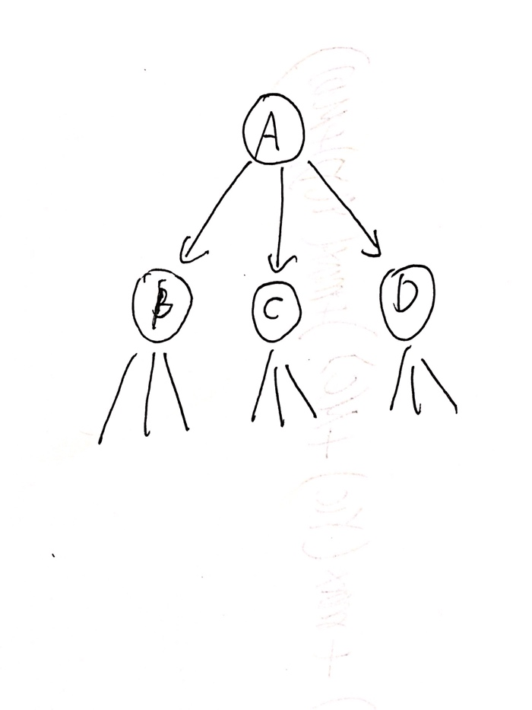

If A is invited to attend the final optimal retreat with minimum total cost, then

B, C, D could be either invited or not. Therefore

Y(A) = cost(A) + min{Y(B), N(B) + min{Y(C), N(C)} + min{Y(D), N(D)}.

If A is not invited to attend the final optimal retreat with minimum total cost, then B, C, D must be invited to attend the final optimal retreat. Therefore

N(A) = Y(B) + Y(C) + Y(D)

We get sub problems, we can compute the sub-problems recursively, or we can use Dynamic Programming to store the computed sub-problems, and whenever we need the results of some sub problems, we will look up it in a data structure.

Pseudo code:

Retreat(u):

Y(u) = cost(u)

N(u) = 0

For all children v of u:

Retreat(v)

Y(u) = Y(u) + min{Y(v), N(v)}

N(u) = N(u) + Y(v)

Once we have computed Y(x) and N(x) for all node x in the tree, we will get the minimum total cost by compare Y(root) and N(root)

If Y(root) > N(root), the minimum total cost is N(root)

Otherwise, the minimum total cost is Y(root).

3.

Dynamic programming.

We use a 2-D matrix to store subproblems results, therefore we don’t need to recursively compute same sub problems.

C++ code:

**int** count(string B, string A)  
{  
 **int** m = A.size();  
 **int** n = B.size();  
  
 **if**(m > n)  
 **return** 0;  
  
 *// here we use the 2D matrix to store sub problem results* **int** matrix[m + 1][n + 1];  
  
 *// If string B's length is 0, there is no subsequence, we set 0* **for**(**int** i = 1; i <= m; i++)  
 matrix[i][0] = 0;  
  
 *// An empty subsequence is subsequence of all sequence, we set 1* **for**(**int** j = 0; j <= n; j++)  
 matrix[0][j] = 1;  
  
  
 *// In buttom up to fill the matrix* **for**(**int** i = 1; i < m + 1; i++)  
 {  
 **for**(**int** j = 1; j < n + 1; j++)  
 {  
 *// If current B[j - 1] does not match with A[i - 1],  
 // then the value of matrix[i][j] is same as the value matrix[i][j - 1]  
 // which means without the B[j - 1] character* **if**(A[i - 1] != B[j - 1])  
 matrix[i][j] = matrix[i][j - 1];  
  
  
 *// If current B[j - 1] does match with A[i - 1]  
 // The value of matrix[i][j] composes of two parts  
 // 1) value of matrix[i - 1][j - 1]  
 // 2) value of matrix[i][j - 1]* **else** matrix[i][j] = matrix[i][j - 1] + matrix[i - 1][j - 1];  
 }  
 }  
  
 *// return the number of different occurrences* **return** matrix[m][n];  
}

4.

(a)

Dynamic Programming

The grid in the below coe in the two-dimensional array A

C++ code:

**int** maxPathSum(vector<vector<**int**>>& grid)  
{  
 **int** row = grid.size();  
 **int** col = grid[0].size();  
  
 **for**(**int** i = 0; i < row; i++)  
 {  
 **for**(**int** j = 0; j < col; j++)  
 {  
 *// start position* **if**(i == 0 && j == 0)  
 ;  
  
 *// no choice, get this position only from left* **else if**(i == 0)  
 grid[i][j] += grid[i][j - 1];  
  
 *// no chiose, get this position only from top* **else if**(j == 0)  
 grid[i][j] += grid[i - 1][j];  
  
 *// choose the max value between top and left direction* **else** grid[i][j] += max(grid[i - 1][j], grid[i][j - 1]);  
 }  
 }

**return** grid[row - 1][col -1];  
}

(b)

Use the matrix to get the path information.

Start from bottom right position, find the path using matrix to top left position,

Using a stack to store the path information

*// 0: down  
// 1: right*stack<**int**> path;  
**while**(i >= 0 && j >= 0)  
{  
  
 **if**(i == 0 && j == 0)  
 **break**;  
  
 **if**(j == 0)  
 {  
 path.push(0);  
 i--;  
 **continue**;  
 }  
  
 **if**(i == 0)  
 {  
 path.push(1);  
 j--;  
 **continue**;  
 }  
  
 **if**(grid[i - 1][j] >= grid[i][j - 1])  
 {  
 path.push(0);  
 i--;  
 }  
  
 **else** {  
 path.push(1);  
 j--;  
 }  
  
  
  
}  
  
  
**while**(!path.empty())  
{  
 **if**(path.top() == 0)  
 cout << **"D"**;  
 **else** cout << **"R"**;  
  
 path.pop();  
}

(c).

Since the input array A is read only,

We need a vector whose size is n to finish the task.

C++ code:

**int** maxPathSum(vector<vector<**int**>>& grid)  
{  
 **int** row = grid.size();  
 **int** col = grid[0].size();  
  
 *// here is the extra space we use* vector<**int**> v(row, grid[0][0]);  
  
 **for**(**int** i = 1; i < row; i++)  
 v[i] = v[i - 1] + grid[i][0];  
  
 **for**(**auto**& i: v)  
 cout << i << **", "**;  
 cout << endl;  
 **for**(**int** j = 1; j < col ; j++)  
 {  
 v[0] += grid[0][j];  
 **for**(**int** i = 1; i < row; i++)  
 v[i] = max(v[i - 1], v[i]) + grid[i][j];  
  
 }  
  
 **return** v[row - 1];  
  
}

To find the maximum score, we only use O(n) space, and according to the input array and the final vector, v, we can rebuild the path information.

For example

The input array is:

grid = {{5,6,2,3},  
 {6,10,-2,5},  
 {10,3,1,15},  
 {4,6,1,2}};

the final vector is: v = {16, 24, 40, 42} and we know the maximum score is 42. Let’s start from the end point, it’s score is 42, and in the input array, the value is 2, since 42 – 2 = 40, so we know we need to get 42 from 40 + 2. In order to get 42 from 40 + 2, we need DOWN. Then we look v[2] = 40, its score is 40, the value in input array is 15, since 40 -25 = 15 != 24, we need to create the new vector which is the previous one. See the diagram:

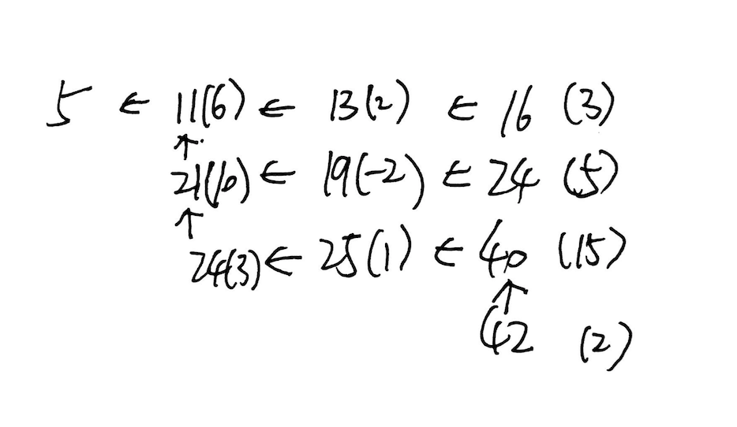

The number in parenthesis is the corresponding value in input array.

Following this procedure, we use no more than O(n sqrt(n)) space complexity. The total time complexity is still O(n2)

5.

We can represent the problem as flow network with multiple sources and sinks. There are two sources in