1.

(a)

T = 60 mins = 3600 s

C = 1267

X = C / T = 1267 / 3600 for the system

CPU:

U(CPU) = B(CPU) / T = 2929 seconds / 3600 s

So:

D(CPU) = U(CPU) / X(system) = B(CPU) / C = 2929 / 1267 = 2.312

Disk:

U(Disk) = B(Disk) / T

D(Disk = U(Disk) / X(system) = B(Disk) / C = 2765 / 1267 = 2.182

(b)

According to X(0) = U(j) / D(j) and U(j) <= 1, we can get

X(0) <= 1 / D(j), should hold for all devices in the system.

So X(0) <= 1 / max(D(j))

Here max(D(j)) = D(CPU)

So X(0) <= 1 / D(CPU) = 1 / 2.312 = 0.432

There is another bound for X(0), as described in slide, we get this bound from Little’s Law,

X(0) <= N / (think time + D(CPU) + D(Disk))

Set slop = 1 / (think time + D(CPU) + D(Disk)) = 1 / (14 + 2.312 + 2.182) = 1 / 18.494

Therefore when X(0) == 1 / D(CPU), N = (14 + 2.312 + 2.182) \* 1 / D(CPU) = 7.999 = 8

So we can get the plot:

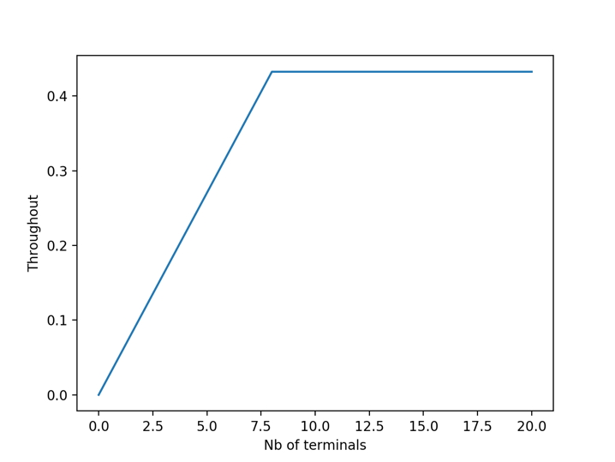

Question 2

(a)

This is M/M/4/n+4 model.

The exponential inter-arrivals is λ = 15 queries/ hour, the exponential service time is μ = 3 queries / hour.

State 0 = there is zero query in the system.

State 1 = there is 1 query in the system.

State 2 = there is 2 query in the system.

State 3 = there is 3 query in the system.

State 4 = there is 4 query in the system.

.

.

State n = there is 4 query in the system(4 at server, n – 4 at queue)

..

State n + 4 = there is n + 4 query in the system(4 at server, n at queue)

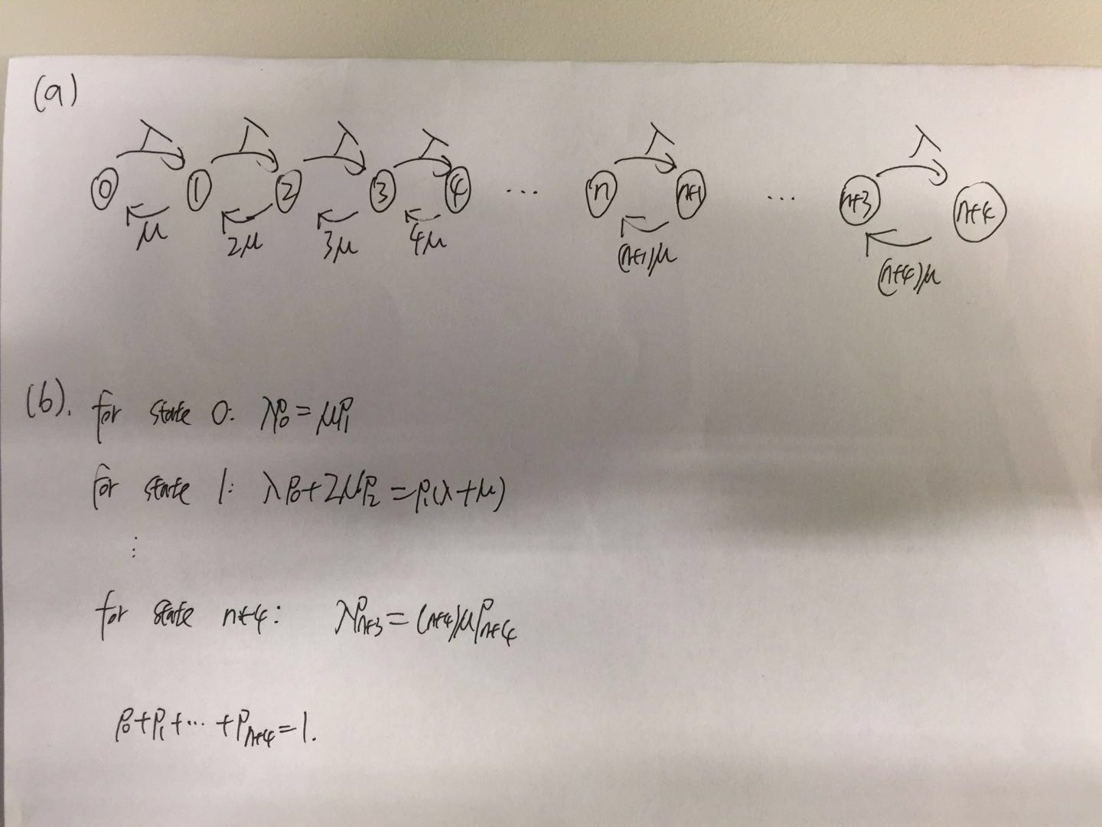

(c)

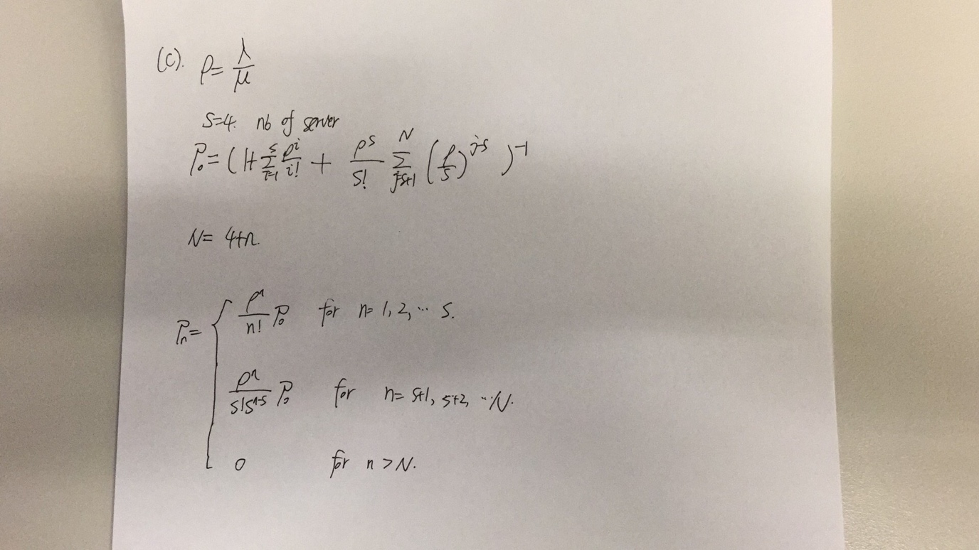

(d)

N = 4 + 2 = 6

The probability that an arriving query is rejected is the same as the probability that there are 6 queries in the system.

(i)

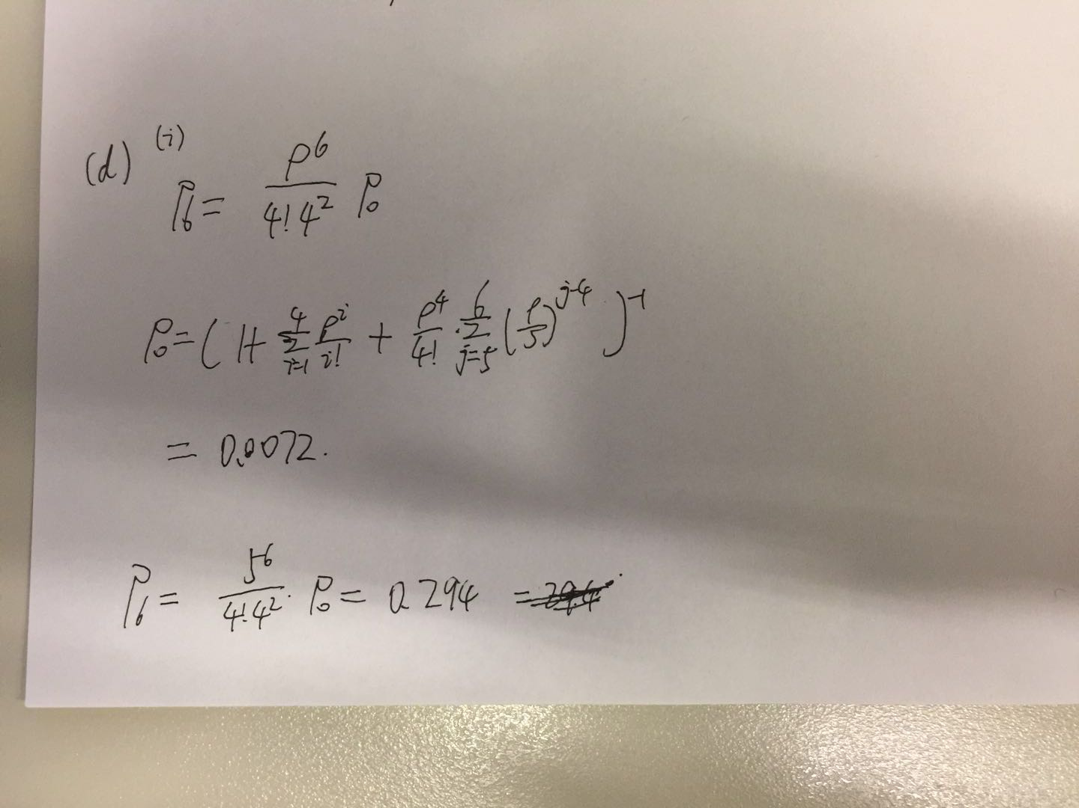

(ii) mean waiting time = mean response time – mean service time

mean service time = 1 / μ

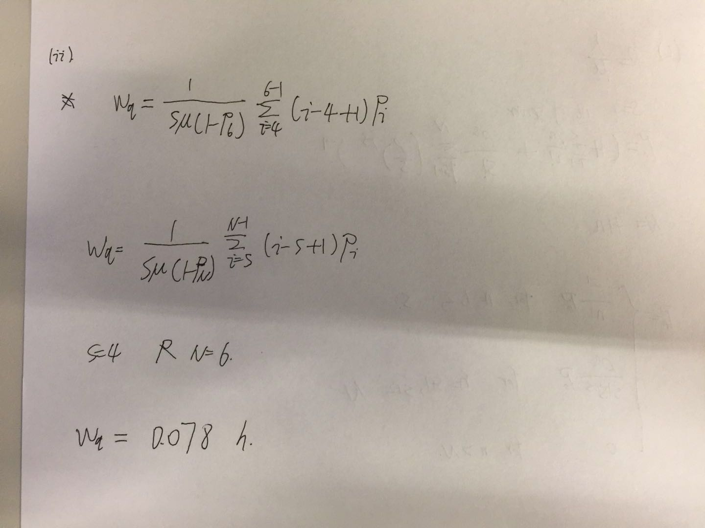

(e)  
add 5:

0.22331931368078703

add 10:

0.20708581427429248

add 15:

0.20226785993865187

add 20:

0.2007375098367033

(f)

Because after adding 10 waiting slots, the value of P0 decreased as almost the same speed of the value of ρn increased, so there is little drop in the total value of Pn, which is the blocking probability.