Contents

1. Introduction

2. Installation

3. To Get Start (configuration)

3.1 Configuration

3.2 start new project / analysis

3.3 load existing project / analysis

3.4 input/output structure

3.5 GUI structure

3.6 Releases

4. HiCeekR workflow

4.1 Filtering

4.2 Binning

4.3 Normalization

4.3.1 ICE normalization

4.3.2 WavSis Normalization

4.4 Downstream Analysis

4.4.1 PCA

4.4.2 Hidden Markov Model

4.4.3 Epigenomic count

4.5 Summary, Project & Analysis Re-loading

5. Results and Data showing

5.1 Chromosome Conformation & TADs (heatmaps)

5.2 Pathway Analysis & gene exspression (networks)

6. Developer notes

6.1 HiCeekR standard outs description

6.2 new module integration

6.3 Export/import Functions

7. faqs

(copertina , current release, versione manuale )

**4.1 Filtering**

The initial processing step for Hi-C data typically consists of trimming of reads (if necessary), mapping the reads to the corresponding reference genome with assay-specific pre- and post-processing to improve the percent of mapped reads, and filtering of the mapped reads and read pairs at several different levels. In the filtering module the strand orientation for a read pair refers to the combination of strands for the two alignments are stored.

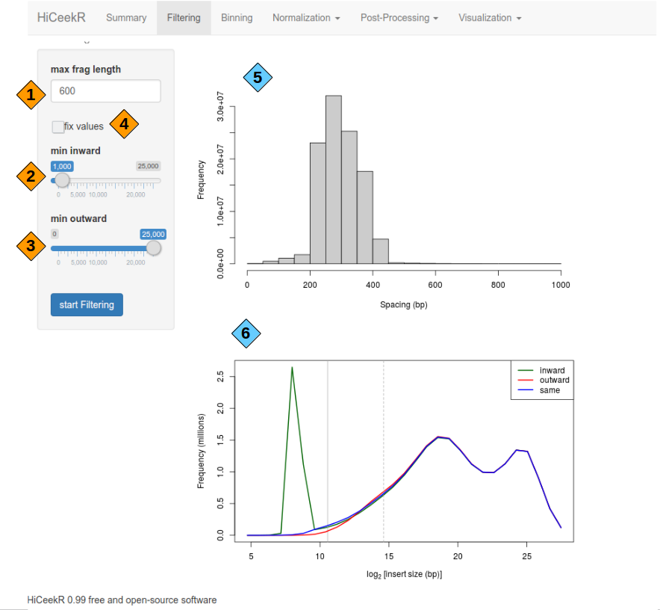



1) The max.frag argument removes read pairs where the inferred length of the sequencing fragment (i.e., the ligation product) is greater than a specified value.

2 & 3) Min distance thresholds of inward and outward reads should be chosen with min.inward min.outward parameters

4) specify numeric value for min.inward and min.outward value



5) Fragments lenght distribution

6) Lower insert sizes distribution, spikes are observed in the ouward- and inward-facing distributions due to self-circularization and dangling ends, respectively.

(pacchetti utilizzati e link)