World reminds for saving

9.及时保存，设置自动保存，还有一有空就ctrl s。

10.多做备份，不但Word不可靠，windows也不可靠， 每天的工作都要有备份才好。注意分清版本，不要搞混了。Word提供了版本管理的功能，将一个文档的各个版本保存到一个文件里，并提供比较合并等功能 。不过保存几个版本后文件就大得不得了，而且一个文件损坏后所有的版本都没了，个人感觉不实用。还是多处备份吧

11.插入的图片、和公式最好单独保存到文件里另做备份。否则，哪天打文档时发现自己辛辛苦苦的编辑的图片和公式都变成了大红叉，哭都来不及了。

其他建议：

12. 使用大纲视图写文章的提纲，调整章节顺序比较方便

13. 使用文档结构图让你方便的定位章节

14. 使用文档保护，方便文章的审阅和修改

Comments from Bai-Zhang:

Abstract: wheat, PHS, white more susceptible than red, TaPHS1 was cloned from white wheat Rio. Rio is ancesster of our comment sued resistant parent Danby, the marker does not work in 2012 breeding lines, so we hyphophasis there is different gene or allele of PHS intergrated into it during breeding from Rio blanco. We use a DH to map QTL.

General row:

No over lap between results and discussion or introduction

Introduction part:

PHS

QTL Mapping summary

Gene cloning

haplotype analysis explanining

Result:

Minor QTL report and compare with other research

PYN AYN separated analysis

No box plots, but tables or histographs to show multiple compare

Sequence analysis process

Which Allele is wild type?

Compare SNP1587 and SNP1607

Delete second set DH part.

Discussion

Put two paper together to introduce your result.

Differnces from other reports is key points to discuss

Screening more landeraces in China and world

Hap as single marker to analysis and compare each other

**Outline of content**

**Abstract**

**Introduction**

**Materials and methods**

**Plant materials**

**Field and greenhouse experiment**

**Pre-harvest sprouting and germination index evaluation**

**Genotyping by sequencing based SNP identification**

**Genetic linkage map construction and QTL screening**

**Results**

**Phenotype evaluation of Pre-harvest sprouting**

**Genetic linkage map construction**

**QTL analyses**

**Major QTL validation by the second set of DH lines derived from the same cross**

**Co-localization of Qphs-3AS and the reported PHS resistant gene *TaPHS1***

**New allelic variation in gene *MFT-3A/TaPHS1* and association comparing with reported casual variations**

**Haplotype analyses in an association analysis panel with three reported casual SNPs**

**Phenotypic effect validation and haplotype comparing in practical wheat breeding programs**

**Discussion**

**Phenotype evaluation of Pre-harvest sprouting and germination index**

**Genetic linkage map construction**

**QTL analyses and validation**

**Co-localization of Qphs-3AS and PHS resistant gene *TaPHS1***

**Casual allelic variation identification and validation by association analyses**

**Haplotype analyses in the same association analysis panel**

**Association and haplotype analysis in practical wheat breeding programs**

**References**

**Dissertation of pre-harvest sprouting resistance QTL in a white wheat cultivar Danby and Haplotype analyses with different casual mutations of gene *MFT-3A/TaPHS1***

**Abstract**

Pre-harvest sprouting (PHS) in wheat results in significant economic losses due to the reduced yield and grain quality. White wheat cultivars have been recognized more susceptible to pre-harvest sprouting than red wheat. Identification of casual QTLs or gene related to PHS is one of the most important steps to increase PHS resistance in white wheat by molecular assisted selection. The basic objective of this study was to map PHS resistance QTL in a white-grained wheat cultivar Danby with a double haploid (DH) population derived from Danby cross Tiger, another white wheat cultivar. In this study, a major QTL controlling pre-harvest sprouting was identified on the short arm of wheat chromosome 3A. This major QTL coincided with gene *MFT-3A/TaPHS1* and explained over 40% of the phenotypic variation in the mapping population. Gene sequence comparison and association analysis revealed a single nucleotide polymorphism at position -222 of the promoter was the casual mutation responsible for the PHS susceptibility in Tiger. To compare the phenotypic effect on PHS of this mutation with the other reported casual mutations in the same gene, haplotype analysis was carried out with a collection of 318 breeding lines from Kansas white breeding programs. Haplotype analysis indicated that the SNP in the promoter was more critical than the gene coding region casual variations and the functional promoter is necessary to express PHS resistance. The PHS resistance comparing among different haplotypes are more valuable than single marker based association analysis for germplasm screening and evaluating to improve PHS resistance. This study provides not only a reliable functional validation for casual variations in gene TaPHS1, but also gives novel information for a comprehensive understanding of the combinational effect of different casual mutations in gene TaPHS1 on wheat pre-harvest sprouting tolerance.

**Keywords:**

Wheat, Pre-harvest sprouting, Seed dormancy, Quantitative trait loci, Haplotype, Chromosome 3AS

**Introduction**

Pre-harvest sprouting (PHS) is known as seed germination in spikes before harvest when physiologically maturated spikes experience humid and wet weather conditions in the field (Li *et al.* 2004; Cabral *et al.* 2014; Mares and Mrva 2014). PHS could cause significant losses of grain yield and end-use quality to wheat farmers and processing industries because of the degradation of starch and protein in germinated grains (Flintham 2000; Shorinola *et al.* 2016). The economic losses of PHS have been widely recognized from all the major wheat producing regions throughout the world. Direct annual losses caused by PHS worldwide can reach up to the US $1 billion (Black *et al.* 2006). For example, the average annual losses due to PHS are approximately $100 million in the major wheat production region of western Canada (DePauw *et al.* 2012).

Seed dormancy, which is referred to the temporary failure of a viable seed to germinate under favorable environmental conditions, is the major factor contributing to PHS (Li *et al.* 2004). PHS is not only controlled by various genetic factors associated to seed dormancy, but also strongly influenced by many other factors like physical structure of wheat spike, grain color and growing temperature during grain filling and ripening stage (Mares and Mrva 2014). For this complicated trait, there is no more economic method available to reduce the losses of PHS than molecular marker assisted breeding by introducing PHS resistance gene into elite cultivars (Gao and Ayele 2014; Barrero *et al.* 2015).

Identifying and validate the phenotypic effect of PHS associated QTL or genes is the most important step to understand its genetic mechanisms and develop applicable molecular markers for PHS resistance improvement (Kulwal *et al.* 2012; Gao *et al.* 2013; Mares and Mrva 2014). Many PHS related QTLs have been identified on almost all of the wheat chromosomes using various mapping populations or germplasms (Anderson *et al.* 1993; Roy *et al.* 1999; Zanetti *et al.* 2000; Kato *et al.* 2001; Mares and Mrva 2001; Flintham *et al.* 2002; Groos *et al.* 2002; Li *et al.* 2004).

Among all those PHS associated QTL across the whole genomes, QTL on chromosomes 3AS and 4AL were investigated more intensively than the other chromosomes and have been taken as good candidate for gene cloning (Miura *et al.* 2002; Mori *et al.* 2005; Liu *et al.* 2008; Rasul *et al.* 2009; Liu *et al.* 2011; Xiao *et al.* 2012; Lei *et al.* 2013; Lohwasser *et al.* 2013; Miao *et al.* 2013; Bi *et al.* 2014; Albrecht *et al.* 2015; Lin *et al.* 2015; Cao *et al.* 2016; Fakthongphan *et al.* 2016). Before two different genes, *PM19* and *MKK3*, were cloned from PHS resistant QTL on wheat chromosome 4AL by two different research groups (Barrero *et al.* 2015; Torada *et al.* 2016), the major PHS-resistant QTL consistently detected on 3AS chromosome were already successfully cloned by two different research groups (Nakamura *et al.* 2011; Liu *et al.* 2013). Both of the cloned genes were proved to be the wheat homolog of MOTHER OF FT AND TFL1 (*MFT*). However they identified different causal variations with significantly effect in PHS resistance in this identical gene. The association between a promoter variation in TaMFT and reduced seed germination was observed by Nakamura et al. Instead of promoter mutation, Liu et al. reported two extremely linked coding region SNP mutations are casual mutations for PHS variation. And the phenotypic effect was validated by RNA interference-mediated knockdown of this gene and association analysis. The identical promoter mutation at the 222 bp upstream of *TaMFT* was also detected in the susceptible lines used in this study but not significantly associated with PHS variation in their association analysis panel.

The confronting conclusions on the phenotypic effect of the same promoter SNP variation in gene TaMFT drown by two different studies cannot be clarified without further functional validation and comparing of the phenotypic effects for those three different casual mutations. Meanwhile, comparing phenotypic effects among different haplotypes composed from those three casual mutations could supply more information than individual casual mutation based association analysis(Galan *et al.* 2007; Huang and Brule-Babel 2012). Haplotype analysis is more useful and reliable for two reasons. First, haplotype may be in closer LD with a causal variantion than any single SNP, and therefore may increase the explained phenotypic variation over single SNP analysis (Barendse 2011). Second, despite each casual variation only having a small effect on phenotype, a specific combination of several causative variations may result in a haplotype with large potential effects(Bickel *et al.* 2011). The Qphs.pseru-3AS resistant QTL validating and phenotypic effect comparing among different casual variants and their haplotypes is more informational, efficient and reliable to improve PHS resistance by molecular marker assisted breeding.

In this study, the preliminary objective was to map PHS resistance QTL in Danby with a double haploid population derived from Danby cross Tiger. After mapping a major QTL in the same location with the cloned gene *TaPHS1* on the short arm of chromosome 3A, we turned our focus into comparing the phenotypic effect among different reported casual mutations and their combinational effect on PHS resistance by association and haplotype analysis.

**Materials and methods**

**Plant materials**

A double haploid (DH) mapping population consists 453 DH lines derived from the cross between Danby (PI#) and Tiger (Martin *et al.* 2013), two white winter wheat cultivars (Kansas State University, Research Center_Hays). A subset of 211 DH lines from this population were used for QTL mapping (mapping population) and the rest of DH lines were used for validation (validation population). A association analysis population was composed of 172 American cultivars and landraces. A set of 318 F5 and F6 breeding lines developed by Kansas white breeding programs from 1999 to 2013 in Hays of KS were used to validate the association between the casual SNP and the PHS resistance.

**Field and greenhouse experiment**

The mapping population was grown in greenhouse of Kansas State University, Manhattan, KS in 2014 and 2015 seasons and in field of Kansas State University, Research Center_Hays in 2015 and 2016 seasons. The association analysis population was grown in greenhouse (2012 and 2013), in field (2013 and 2014) of Kansas State University, Manhattan, KS and in field (2013 and 2014) of Kansas State University, Research Center_Hays. For the greenhouse experiments, five seedlings per line were transplanted into a 13-cm x 13 cm plastic pot and arranged into randomized complete block design with two replicates for all the DH lines in the mapping population. The greenhouse was kept at 22°C day/15°C night with 16 h light. For the field experiments, all the lines were planted in six feet length row with two replications by random complete design with normal field management.

**Pre-harvest sprouting and germination index evaluation**

For the Pre-harvest sprouting evaluation, five spikes were harvested from each line at their physiological maturity when the stem color between the flag leaf ear and spike changed from green to yellow.

Harvested spikes were naturally dried for 5 days in the greenhouse at 25+5°C and then stored in a freezer at -20°C to maintain dormancy until all the lines in the population were harvest and dried. All the spikes will be taken out from freezer and air dried again in room temperature for 6 days to break dormancy partially before sprouting test. All of the five spikes per line were evaluated for PHS in a misting chamber, as described by Liu et al. (2008). The percentage of the visible sprouted kernels in the five spikes was used to screen QTL.

For the second set of DH lines, germination index was evaluated with seeds harvest from 2015 field experiment in the Agricultural Research Center-Hays, Kansas State University to evaluate seeds dormancy which is the major factor of pre-harvest sprouting resistance (Walker-Simmons 1988). Five spikes per lines were harvested at physiological maturity stage and manually threshed after naturally dried in room temperature.

Fifty to sixty seed were placed on two layers of wet tow stroll paper in Petri dish and add 10 ml of clean water every three days to supply enough moisture for seeds germination. All the Petri dishes were kept in a controlled chamber at 20+2 °C. Germinated seeds were counted daily from the 1st day to the 8th day and removed from the Petri dishes after each counting germination index (GI) was calculated with the maxi- mum weight given to the grains that germinated first and less weight to those that germinated later.

GI=[(8×n1 +7×n2 +6×n3 +5×n4 +4×n5 +3×n6 + 2 × n7 + 1 × n8)/(8 × total grains)] × 100 where n1, n2, ... n8 is the number of grains germinated on the first, second, and subsequent days until the eighth day, respectively (Modified from Walker-Simmons 1987).

**Genotyping-by-sequencing based SNP identification**

Genome DNA was isolated from seedling leaf tissue with the standard CTAB protocol (Saghaimaroof *et al.* 1984). Extracted DNA was quantified in 96 well plates using PicoGreen and was normalized to 20ng/ul for each sample. GBS library was constructed following the reported GBS methods designed for barley and wheat (Poland *et al.* 2012b). After digestion by enzymes *Pst*I and *Msp*I, DNA fragments from different DH lines and parents were ligated with a forward and a reverse adapter on two ends to reduce the genome complexity and enrich the genome fragments flanked by two different restriction sites. Each library consists of 96 samples distinguished by unique barcode added to the end of each fragment after ligation with adapters. The procedures of library construction were described previously (Poland *et al.* 2012b). Before sequencing, PCR amplified GBS library were amplified again using a special program with a short extension time (<30s) to enrich shorter fragments suitable for bridge-amplification in the Illumina flow-cell of Illumina HiSeq2000 to get better sequencing results. The raw sequences were assigned back to different DH lines through barcode and then were trimmed to 64 bps in length before SNP calling. The GBS reads were aligned and compared to identify one or two base pairs difference to call SNPs. In order to improve the accuracy of linkage map, only SNP markers with less than 20% missing data were used to construct linkage map.

**Genetic linkage map construction and QTL mapping**

A genetic linkage map was constructed using JoinMap 4.1 (Van Ooijen, 2006). A minimum logarithm of odds (LOD) score of 5 was used to grouping all the markers, and a maximum recombination frequency of 0.35 was set to make the linkage group. Kosambi mapping function (Kosambi, 1944) was used to convert the recombination frequency into centiMorgan (cM) as genetic distance. Chromosome names were assigned by blasting the GBS reads of mapped SNP markers from each linkage group to the flow-sorted Chinese Spring survey sequences (Mayer *et al.* 2014) and the PopSeq sequences data (Chapman *et al.* 2015) with a website based blasting tool (<http://129.130.90.211/wpdb/gbsloc>) developed by Akhunov, et al. (2016). WinQTLCart 2.5 was used for composite interval mapping (CIM) with all the mapped markers and the sprouting rate or GI averaged from two replications for each DH line (Silva Lda *et al.* 2012).

**Results**

**Pre-harvest sprouting evaluation**

The PHS rate of the resistant parent Danby ranged from 15% to 25% and the susceptible parent Tiger showed 55% to 75% in different experiments. Transgression segregation was observed for all the three experiments. The frequency distribution of PHS rate in the DH population shows two peaks in 2014 greenhouse experiment and skewed toward the resistant parent in 2015 field and 2015 greenhouse experiments (Fig. 1). **Genetic linkage map construction**

Linkage map was constructed with 1811 GBS based SNP markers and 13 SSR markers. The map had 34 linkage groups with a genetic distance of 1476 cM and an average interval of 1.2 cM per marker. The distribution of the molecular markers is uneven on different genomes of wheat. Among these markers, 721 markers (40%) are mapped on A genome, 648 markers (35%) on B genome and 455 markers (25%) on D genome (Fig. 2). The density of markers varies among A, B and D genome significantly with 1.5 markers/cM, 1.2 markers/cM and 0.8 markers/cM respectively. D genome has the least number of markers comparing with the other genomes. There are only two markers on 4D chromosome, which is the shortest one in genetic distance based on this mapping population.

**QTL analyses**

A major QTL for PHS resistance was mapped on chromosome 3AS in all of the three environments with phenotypic variance explained (PVE) from 20% to 44% (Fig. 3). Other than the major QTL detected on 3AS chromosome (Qphs-3AS), several minor QTL were also detected on chromosomes 2AS, 3B, 4AL, 5A and 6DS with PVE from 3% to 13% in different environments (Table 1). The QTL on 3B and 5A chromosomes were repeatedly detected in at least two different environments.

**Co-localization of Qphs-3AS and the reported PHS resistant gene *TaPHS1***

In order to conform the co-location of the major QTL mapped in this research and the reported PHS casual gene *TaPHS1*, three KASP markers were designed based on the reported causal SNPs of gene *MFT-3A/TaPHS1* (Nakamura et al. 2011 and Liu et al. 2013). Only the KASP marker (KASP_MFT) designed based on the reported causal SNP-222 in the promoter region showed polymorphisms between the two parents, and no polymorphism was detected in the other two SNP sites (SNP+1587 and SNP+1607) in the coding region of the same gene. This polymorphic gene specific SNP marker KASP_MFT was mapped under the peak of the Qphs-3AS on chromosome 3AS and explained the greatest phenotypic variation among all the markers within the Qphs-3AS QTL region (Figure 1a). The co-localization of the major QTL and the reported casual SNP mutation in the promoter of gene *MFT-3A* confirmed that our major QTL is the gene *MFT-3A/TaPHS1*.

**New allelic variation in gene *MFT-3A/TaPHS1* and association comparison with reported causal variations**

The gene sequences of *MFT-3A/TaPHS1* from Danby and Tiger were investigated and compared after sequencing. Danby has the identical sequence with Zen and Rioblanco, the resistant parents used in gene cloning of *MFT-3A/TaPHS1* (Nakamura et al. 2011 and Liu et al. 2013). Besides the reported promoter region mutation SNP-222, eight more SNPs and one deletion, were observed between Danby and Tiger. After function prediction, two new SNPs in the promoter region were selected and converted into KASP markers. These two SNP markers were used in screening the association analysis panel that was phenotyped on PHS in five different environments including greenhouse and fields tests. For these two new SNPs, SNP-701 is significantly associated with PHS and co-segregated with SNP-222 for all the lines except two in the association panel (Table 4). The other one, SNP-314 was not significantly associated with PHS phenotype variation in this panel (Table 3).

**Haplotype analyses in an association analysis panel with three reported causal SNPs**

After validating the effective function of the promoter mutation discovered in the susceptible parent Tiger, the genetic effect of this mutation and the other two coding region mutations was investigated by association and haplotype analysis. All of the three SNP markers were screened in an association panel with 172 wheat landraces and cultivars that were evaluated for PHS resistance both in field and in greenhouse for multiple seasons.

In the association analysis, all three SNPs are significantly associated with PHS phenotypic segregation (Table 3, 4 and Figure 5). Although promoter mutation can increase PHS susceptibility independently, the coding region SNP mutations have significant accumulating effect on the PHS susceptibility based on haplotype analysis (Table 4 and Figure 5). However there was no significant PHS difference between SSS and SRS haplotypes. That may implies the mutation of SNP+1587 is not as important as other two mutations.

**Phenotypic effect validation and haplotype comparing among the three causal mutations in practical wheat breeding programs**

There were only four haplotypes available in the association analysis panel. In order to investigate the mutation effect on more haplotypes, 318 elite breeding lines, which were already evaluated on pre-harvest sprouting rate and germination index for PHS resistance selection before advancing or releasing, were genotyped with three SNP markers responsible for three different casual mutations in gene *TaMFT1*. Significant association was observed for all of these three casual SNP mutations (p<0.05). SNP-222 in promoter region had higher correlation coefficient on sprouting rate (SPR) and germination index (GI) than coding region mutations (Table 5).

Base on the haplotype analyses and multiple comparing among haplotypes, the promoter SNP-222 mutation increased PHS and GI significantly and independently from coding region mutations based on the phenotype of haplotype SRR, SRS and SSS which are higher than the haplotype RRR (Table 6 and Figures 6, 7). The coding region mutations, cannot affect the PHS or GI significantly showing by haplotype RRS and RSS, however they can enhance the phenotypic effect of the promoter mutation SNP-222 demonstrated by haplotype SRS and SSS which shew higher PHS rate and GI than SRR haplotype (Table 6 and Figures 6, 7).

**Discussion**

**Genetic linkage map construction**

Genotyping by sequencing is an efficient and effective method to genotype the mapping population and construct a putative linkage map for QTL mapping (Poland *et al.* 2012a; Poland *et al.* 2012b; Chen *et al.* 2013; Spindel *et al.* 2013; Rife *et al.* 2015). In this study, all of the 21 wheat chromosomes were covered by GBS markers at 1.25 cM genetic distance per marker. Only one quarter of the markers were mapped on D genome which has the least genome size comparing to A and B genomes of common wheat (Figure 2). Especially for 4D chromosome, there were only two markers mapped in this group. A previous study (Mayer *et al.* 2014) also found that 4D chromosome was relatively smaller than others. Less markers on D genome might also be due to sampling bias during GBS genotyping and only part of D genome might have been digested(ref?).

**QTL analyses**

The major PHS resistance QTL was located in the same region on 3AS chromosome as reported by many other scientists. This major QTL was consistently detected in three different environments, two seasons in greenhouse and one season in rainfed land of western Kansas where is the most important white winter wheat producing area in United States. The stability of this QTL indicates its value in marker assisted selection to improve PHS resistance in wheat.

Meanwhile several minor QTLs were also detected on chromosomes 2AS (Qphs-2AS), 3B (Qphs-3B), 4AL (Qphs-4AL), 5A (Qphs-5A) and 6DS (Qphs-6DS) in different environments in this study (Table 1), suggesting that PHS is a quantitative trait controlled by many genes. And PHS is also highly influenced by many environmental factors like temperature during grain filling and drying, harvest time, grain storage environment (Thomas *et al.* 1996; Gubler *et al.* 2005; Finch-Savage and Leubner-Metzger 2006; Benech-Arnold 2009; Sato *et al.* 2009; Linkies *et al.* 2010; Humphreys *et al.* 2012; Nyachiro 2012; Gao *et al.* 2013; Gao and Ayele 2014; Mares and Mrva 2014; Nonogaki 2014; Willis *et al.* 2014). Qphs-5A and Qphs-3B were detected in two different environments. Meanwhile Qphs-2AS, Qphs-4AL and Qphs-6DS were detected only in one environment.

=====read paper to check which QTL is new

**Co-localization of Qphs-3AS and gene *TaPHS1* andcausal variation identification**

The major PHS resistant QTL was mapped in the distal region of chromosome 3AS where many scientists reported PHS resistance QTL and a casual gene, TaPHS1, was cloned by two different groups independently (Nakamura *et al.* 2011; Liu *et al.* 2013). During gene TaPHS1 gene cloning, different sequence variations were reported responsible for the phenotypic variance of seed germination and PHS. Nakamura *et al.* (2011) reported the SNP in promoter is the casusal variant of seeds germination difference, however Liu *et al.* (2013) proposed that in stead of promoter mutation two SNP mutations in coding region are the casusal varients. We designed three KASP markers based on those three reported casusal SNP variations. Only the marker of promoter variation was polymorphic between our two parets and mapped under the peak of the major PHS resistant QTL on chromosome 3AS. This marker explained 20% to 40% phenotypic variance in different mapping environments. There is no polymorphism detected in two coding region casual variations, SNP646 and SNP666, between Danby and Tiger. Besides those three reported casusal SNP markers, we also designed three more SNP markers based on the promoter sequence differences between Danby and Tiger, but no one shown more significant association with PHS variation than SNP-222 (Table ===). The co-localization of the gene specific marker KASP222 and the major QTL implied that the promoter SNP variation in gene TaPHS is the casual variant of PHS difference in our mapping population.

Danby has the identical allele types with Zen (The resistant parental line used to clone gene TaMFT) and Rioblanco (The resistant parental line used for TaPHS1 cloning). The susceptible parent Tiger only has the SNP222 mutation allele type which is the identical allele type with Chinese spring (The susceptible parental line used to clone gene TaMFT) in these three SNP site. That means the promoter mutation can cause significant PHS phenotypic difference independently from the other two coding region casual mutations. This conclusion is slightly different from what Liu et al reported that promoter variation at 222 base pair position only quantitatively regulated PHS or seeds germination between highly resistant and moderately resistant genotypes especially when spikes maturing at low temperature used by Nakamura *et al.* (2011) for TaMFT gene cloning. However in this study the susceptable parental line is intemediate susceptable and all the spikers evaluated were growing and maturing at normal field temperature. To conclude, the promoter SNP variation in gene TaPHS1 at site -222 is also a critical mutation resulting in PHS sucepbility and has significant effect under normal wheat growing temperature in field and greenhouse.

**Causal variation validation by association analyses**

Promoter mutation at -222 base pair was detected significantly associated with PHS variation in an association analysis panel (Table 3). It is a good validation of the promoter variation effect on PHS besides QTL mapping in bi-parental population. The association between suppressed TaMFT gene expression due to a promoter variation and reduced seed germination was also observed by Nakamura et al. (2011) with seeds developed under 13°C which is much lower than normal wheat grain developing and filling temperature in wheat production (Nakamura *et al.* 2011).

Liu et al. (2013) cloned and characterized PHS casual gene *TaPHS1,* a homolog of *TaMFT,* with two extremely linked casual SNP mutations in gene coding region (Liu *et al.* 2013). The phenotypic effect of these two coding region casual mutations was validated by RNA interference-mediated knockdown of this gene and association analysis with a panel of American landraces and cultivars. The identical promoter mutation at the 222 bp upstream of *TaMFT* coding region was also detected by Liu et al. (2013) in the susceptible lines used in their study for gene cloning but it was not significantly associated with PHS variation in an association analysis panel composed of 82 cultivars. In the present study, a larger association population composed with 172 cultivars and landraces was used to validate and compare the phenotypic effect for these three casual mutations in gene TaPHS1. Enhanced power in a larger association population allowed us to detect the under-evaluated allele effect of the promoter casual mutation on PHS.

Beside our detection of the significant the promoter mutation effect on PHS, Chono *et al.* (2015) also validated the significant effect of promoter mutation SNP-222 on seed dormancy with 324 Japanese wheat varieties collected from the major wheat production areas of Japan in three different seasons (Chono *et al.* 2015). On average, the varieties carrying the resistant allele in promoter showed stronger grain dormancy than the varieties carrying the susceptible allele in their report.

**Haplotype analyses in association analysis panel**

Based on association analysis, all the three reported casual mutations were significantly associated with pre-harvest sprouting variance. To further investigate the effect of different combinations of these mutations, haplotype analyses were carried out to compare the phenotypic effect among different haplotypes. Comparing with the haplotypes detected by Liu *et al.* (2013), there were new haplotypes detected between SNP646 and SNP666 in this association analysis panel. That means there were more allelic variations reserved during artificial and natural selection process in gene TaPHS1. And also it gives us opportunity to compare the phenotypic effects between SNP646 and SNP666.

By haplotype comparing, the promoter region mutation alone can increase the PHS rate from 23.5% (RRR) to 28.9% (SRR). The combination of promoter mutation and coding region mutations could increase the PHS susceptibility from 28.9% (SRR) to 43.4% (SSS) and 44.9% (SRS) (Figure 5 and Table 4). The moderate difference of the phenotypic effect between RRR and SRR haplotypes derived from promoter mutation implies that the promoter mutation has quantitative effect on regulating PHS possibly by reducing gene expressing amount. However the coding region mutations will result in weak or non-functional gene expressing products like a mis-spliced and truncated nonfunctional transcript according to Liu et al. (2013). That is why the coding region mutations shown greater effect on PHS phenotype than promoter mutation.

To identify the effect difference between two coding region mutations, PHS phenotype was compared for different haplotypes of SNP+1587 and SNP+1607. The mutation at SNP+1587 changed the PHS rate from 44.9% (SRS) to 43.4% (SSS), which didn’t reach the significant level (P<0.05). However the mutation at SNP+1607 increased the PHS from 28.9% (SRR) to 44.9% (SRS) significantly. That means the SNP+1607 mutation might be more critical than SNP+1587 mutation for PHS variation. The difference was also detected by single marker association analysis (Table 2). SNP666 has much smaller p-value (2.48E4) than SNP646 (2.33E6). It is reasonable because the truncated protein from SNP+1607 mutation might have more effect than the mis-splicing mutation in SNP+1587 on gene function. This difference needs further validation with more genotypes with SRS haplotype because there were only four cultivars in this haplotype group.

**Association and haplotype analysis of the three causal SNP mutations in practical wheat breeding programs**

All of the three casual mutations were proved having significant effect on pre-harvest sprouting and germination index (Table 3 and 5). In the association analyses using breeding lines, the highest correlation coefficient was detected in the promoter mutation SNP-222 and explained more phenotypic variance than the other two coding region mutations. The significant phenotypic effect of SNP-222 on sprouting rate and germination index is a valuable complementation and validation to the importance of the promoter for the normal gene function on PHS resistance. Especially, the promoter mutation effect on PHS and germination index was evaluated with grains ripening at normal field temperature other than the grains ripening at extremely lower temperature (13°C) used by Nakamura et al. when cloning the *MFT-3A* gene (Nakamura *et al.* 2011).

For the haplotype analyses, there were two more informational haplotypes, RRS and RSS, detected in these breeding lines than the first association panel. Instead of all the eight combinations from three SNP mutations, there were still two haplotypes, SSR and RSR, not observed in this set of breeding lines. Missing of these two haplotypes might be due to the limitation of our population size or the rare allele frequency because the natural and artificial selection will reduce the allele frequency sharply when the trait is not favorable for crop viability itself or human preferences.

Based on haplotype comparing results, promoter mutation can increase PHS and GI significantly and independently. And promoter mutation shown more effect than coding region mutations on SPR and GI. Although the coding region mutations are not as influential as promoter mutation, their effect will be enhanced the mutation effect of promoter SNP-222. Meanwhile, the mutation effect of the coding region SNP+1587 and SNP+1607 varied with the allele type of the promoter SNP-222 site. The coding region mutation effect is larger under resistant allele of promoter SNP-222 than susceptible promoter allele (Table 6; Fig. 6 and 7). With normal promoter allele, the coding region mutation increased sprouting rate by 30% in haplotype RRS and RSS comparing to haplotype RRR. However, under mutated promoter allele SRS and SSS are only 8%-16% higher than SRR haplotype on sprouting rate. One possible way to explain the dependence of the coding region mutation effect on promoter allele types is that the promoter mutation might have epistasis effect on the coding region mutations. Without normal promoter, the gene transcription might be reduced to a very low level or zero so neither the alternative splicing site mutation nor the stop codon mutation cannot display additional phenotypic effect on the lines with mutated promoter.

**Conclusion:**

The evaluation, validation and comparing of the different effects for different casual mutations and their various haplotypes within the same gene is very valuable and useful for germplasm discovery and improvement. Meanwhile the functional validation of the promoter mutation SNP-222 with more landraces, cultivars and breeding lines is a good complementation to the gene region casual mutations. Both of the promoter variation and coding region variation are valuable to understand the genetic mechanisms PHS susceptibility and molecular assisted breeding. Validated diagnostic molecular markers in this study could provide a useful tool for PHS resistance enhancement breeding. Haplotype effects comparing based on three reported casual variations within the same casual gene *TaPHS1* is more reliable and useful than single marker based selection for molecular breeding. It is also more practical for MAS because the haplotype effects were analyzed with a broad scale of American landraces and cultivars and breeding lines collected from white wheat PHS resistance enhancing breeding programs. The haplotype analysis result is also a valuable reference for other white wheat breeding programs across the whole Great Plains of United States because the germplasms are always broadly and routinely shared among different breeding programs in this area every year.

**Table 1** List of PHS resistance quantitative trait loci (QTLs) detected in 2014 and 2015 greenhouse test (2014GH and 2015 GH) and 2015 field test (2015Field) with the double haploid mapping population

|  |  |  |  |  |
| --- | --- | --- | --- | --- |
| **Environment** | **Chromosome** | **QTL position (cMa)** | **LODb** | **PVEc (%)** |
| 2014GH | 3A | 4.11 | 31.4 | 43.63 |
|  | 5A | 14.35 | 6.85 | 6.18 |
|  | 3B | 3.69 | 3.21 | 2.73 |
| 2015GH | 3A | 4.11 | 15.56 | 20.12 |
|  | 4AL | 47.73 | 3.54 | 13.10 |
|  | 6DS | 4.55 | 3.38 | 5.10 |
|  | 5A | 14.35 | 3.3 | 26.55 |
| 2015Field | 3A | 4.11 | 12.39 | 4.89 |
|  | 2AS | 115.5 | 9.1 | 4.21 |
|  | 3B | 9.11 | 3.56 | 4.11 |

a centiMorgans

b logarithm of odds

c phenotypic variance explained by QTL

**Table 2** QTL detected in the double haploid mapping population with germination index (GI) data collected from the field experiment in Kansas state university, Agricultural Research Center-Hays in 2015

|  |  |  |  |  |
| --- | --- | --- | --- | --- |
| **Trait** | **Chromosome** | **Peak Position (cMa)** | **LODb** | **PVEc (%)** |
| 2015GI | 3AS | 1.20 | 51.52 | 52.43 |
| 2015GI | 5D | 6.35 | 5.07 | 3.21 |
| 2015GI | 7AL | 39.20 | 4.71 | 3.09 |
| 2015GI | 2AS | 140.56 | 4.65 | 2.93 |

a refers centiMorgans

b refers to logarithm of odds

c refers phenotypic variance explained

**Table 3** Association analysis between SNPs and pre-harvest sprouting using a panel of 172 American wheat cultivars, landraces and breeding lines.

|  |  |  |
| --- | --- | --- |
| SNP | Location | P-value |
| SNP-701 | Promoter | 0.008127332 |
| SNP-314 | Promoter | 0.171064569 |
| SNP-222 | Promoter | 0.003205865 |
| SNP+1587 | Coding region | 0.000247798 |
| SNP+1607 | Coding region | 2.32712E-06 |

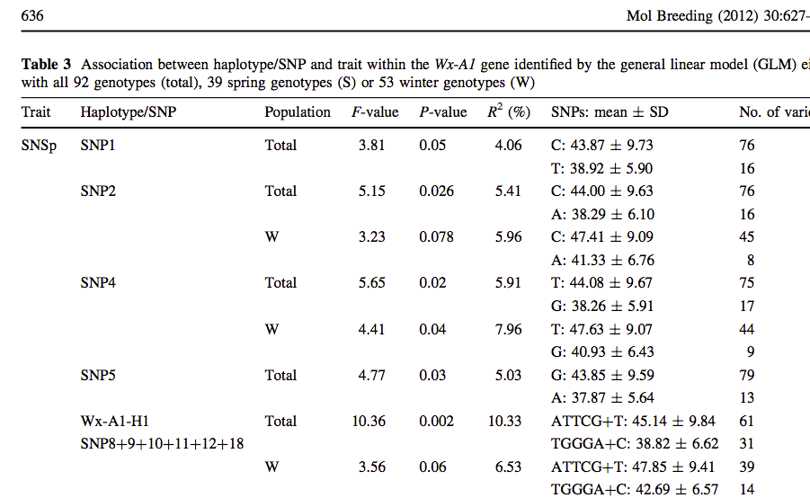**(Huang and Brule-Babel 2012)**

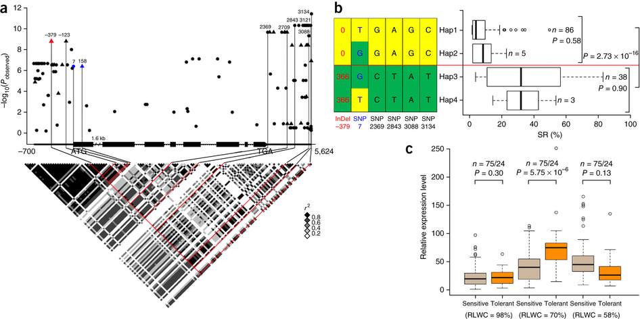

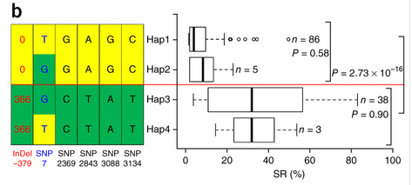

(**b**) Haplotypes of *ZmVPP1* among maize natural variations. *n* denotes the number of genotypes belonging to each haplotype group. When a string of variations are in complete LD, only one is shown. Statistical significance was determined by a two-sided *t*-test. The SR distribution of each haplotype group is displayed by the box plot.

**http://www.nature.com/ng/journal/v48/n10/images/ng.3636-F2.jpg**

**Table 4** Haplotype analysis with three causal SNPs for pre-harvest sprouting in an association analysis panel

|  |  |  |  |
| --- | --- | --- | --- |
| Haplotype | Nc | PHS (%) | SEd |
| SRSb | 4 | 44.9 | 6.1 |
| SSS | 38 | 43.4 | 3.7 |
| SRR | 94 | 28.9 | 1.9 |
| RRR | 36 | 23.5 | 3.3 |

a The first base pair in the haplotype name represents the promoter SNP-222 mutation site; the second is the SNP+1587 mutation in coding region; the third one is the SNP+1607 in coding region

b S means susceptible allele to PHS; R means resistant allele to PHS

c N is the number of genotypes in each haplotype group;

dSE means standard error of the averaged PHS phenotype

**Table 5** Correlation analysis between casual SNPs and pre-harvest sprouting rate (SPR) and germination (GI) of a set of breeding lines

|  |  |  |  |
| --- | --- | --- | --- |
| **SNP** | **Location** | **ra of SPR** | **r of GI** |
| SNP-222 | Promoter | 0.53 | 0.51 |
| SNP+1587 | Coding region | 0.13 | 0.12 |
| SNP+1607 | Coding region | 0.20 | 0.18 |

a r is the correlation coefficient

**Table 6** Mean pre-harvest sprouting rate (SPR) and germination index (GI) of different haplotypes among advanced breeding lines

|  |  |  |  |  |  |
| --- | --- | --- | --- | --- | --- |
| **Haplotypea** | **Nb** | **Mean SPR (%)** | **SEd_SPR** | **Mean GI** | **SE_GI** |
| RRR | 177 | 49.98 | 1.89 | 30.45 | 1.43 |
| RRS | 11 | 65.64 | 10.10 | 39.11 | 7.14 |
| RSS | 5 | 64.20 | 11.01 | 32.28 | 6.62 |
| SRR | 100 | 81.29 | 2.31 | 53.82 | 2.19 |
| SRS | 14 | 87.62 | 3.63 | 59.62 | 3.82 |
| SSS | 11 | 94.76 | 2.40 | 66.43 | 4.18 |

a The first base pair in the haplotype represents the promoter SNP-222 mutation site; the second is the SNP+1587 mutation in coding region; the third one is the SNP+1607 in coding region; R means resistant allele to PHS; S means susceptible allele to PHS

b N is the number of genotypes in each haplotype group

c SE means standard error of the averaged PHS phenotype

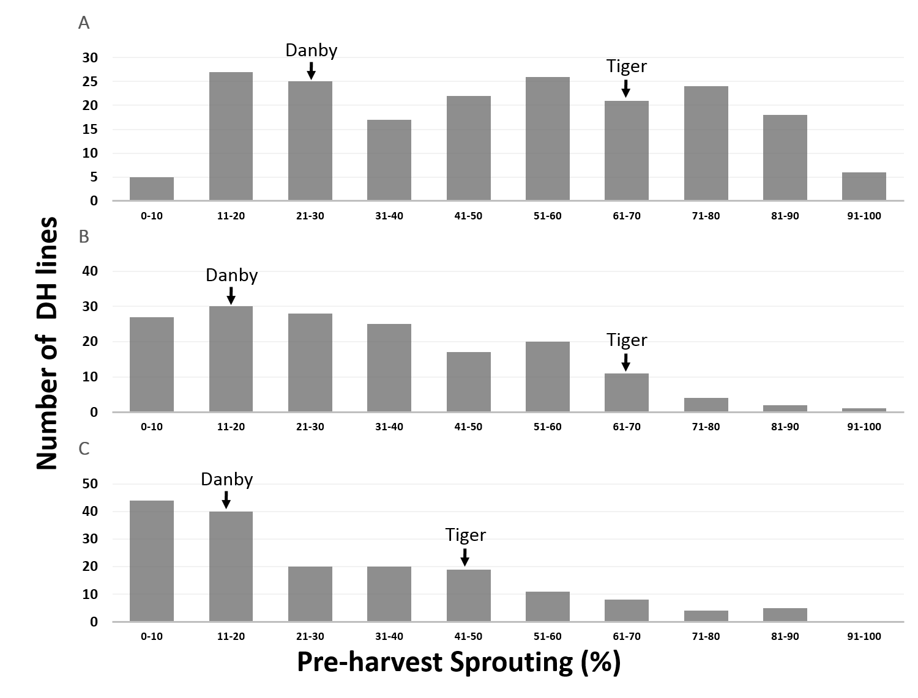

**Fig. 1** Frequency distributions of pre-harvest sprouting (PHS) rate in the DH population. The PHS rate on the bottom of the figure is from 0 to 100% based on proportion of sprouted kernels over total kernels from the 5 spikes after 7 d incubation and averaged from the two replications for each experiment. The black arrows represent PHS rate of the parents. (A) PHS rate from 2014 greenhouse experiment. (B) PHS rate from 2015 greenhouse experiment. (C) PHS rate from 2015 field experiment.

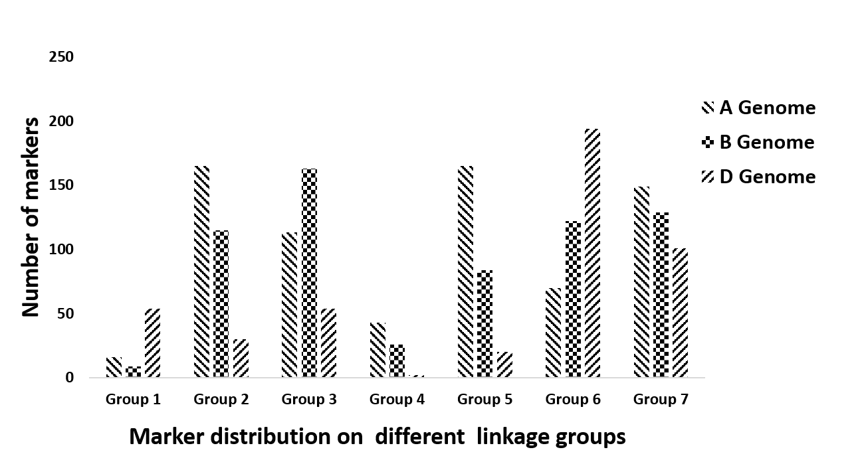

**Fig. 2** Distribution of GBS markers on different wheat linkage groups.

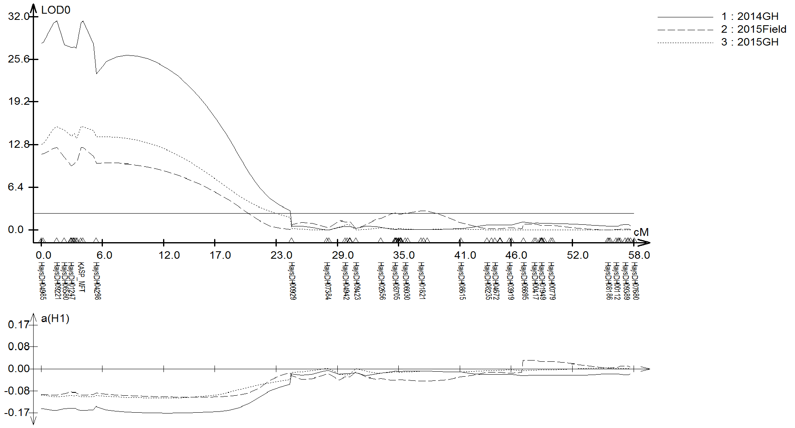

**Fig. 3** Composite interval mapping of a major QTL for pre-harvest sprouting resistance on chromosome 3AS in three different environments. GH represents greenhouse experiment. Field means field experiment.

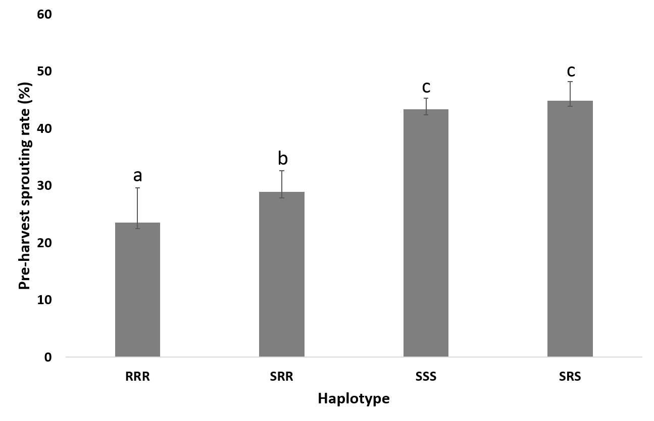

**Fig. 5** Pre-harvest sprouting rate for different haplotype groups in the association panel. 1) S means susceptible allele to PHS; R means resistant allele to PHS. 2) Different letters above the histograms mean the significant difference by multiple comparing (p<0.05).

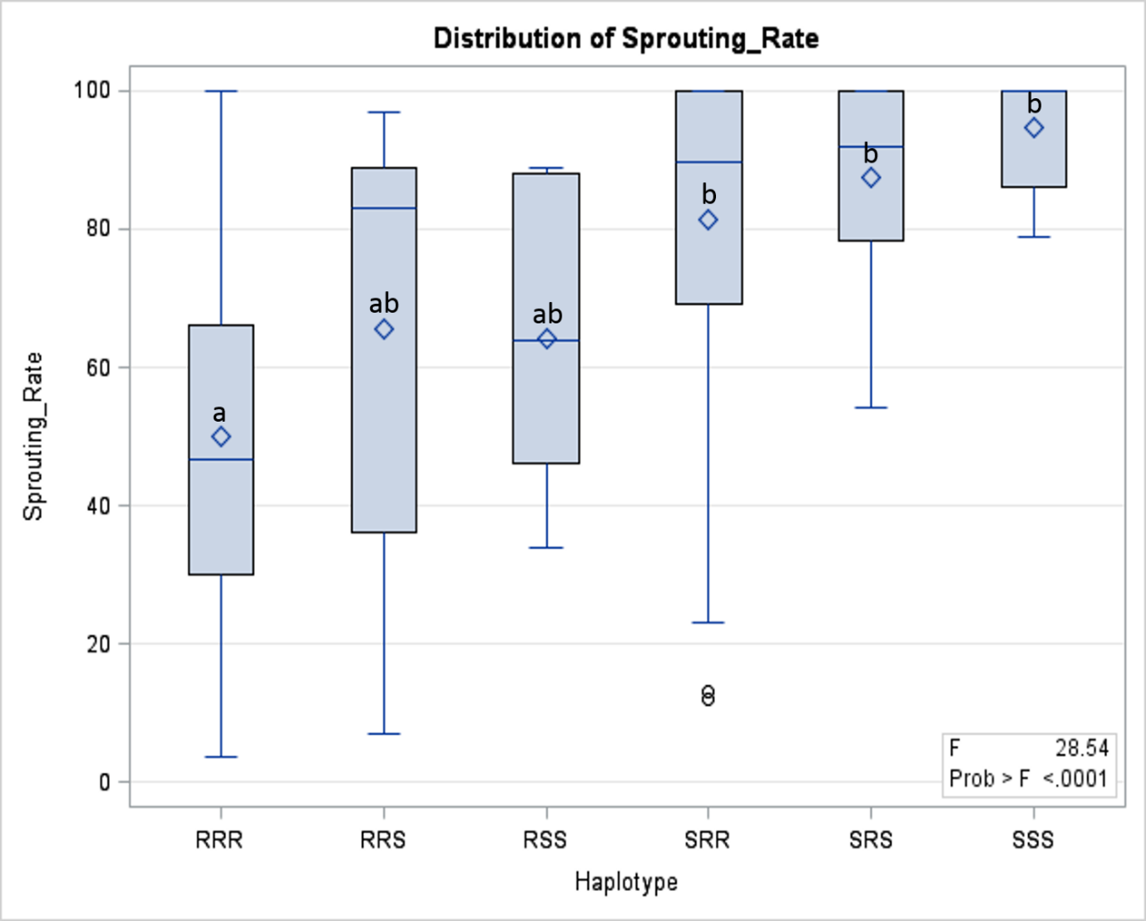

**Fig. 6** Box plot of pre-harvest sprouting rate for different haplotypes (HAP) and Tukey’s multiple comparing among the elite breeding lines

1) S means susceptible allele to pre-harvest sprouting; R means resistant allele to pre-harvest sprouting.

2) Diamond is the mean; horizontal line within box is the median; the bars above and below box are the 90 percentile and 10 percentile respectively.

3) Different letters above the histograms mean the significant difference by multiple comparing (p<0.01).

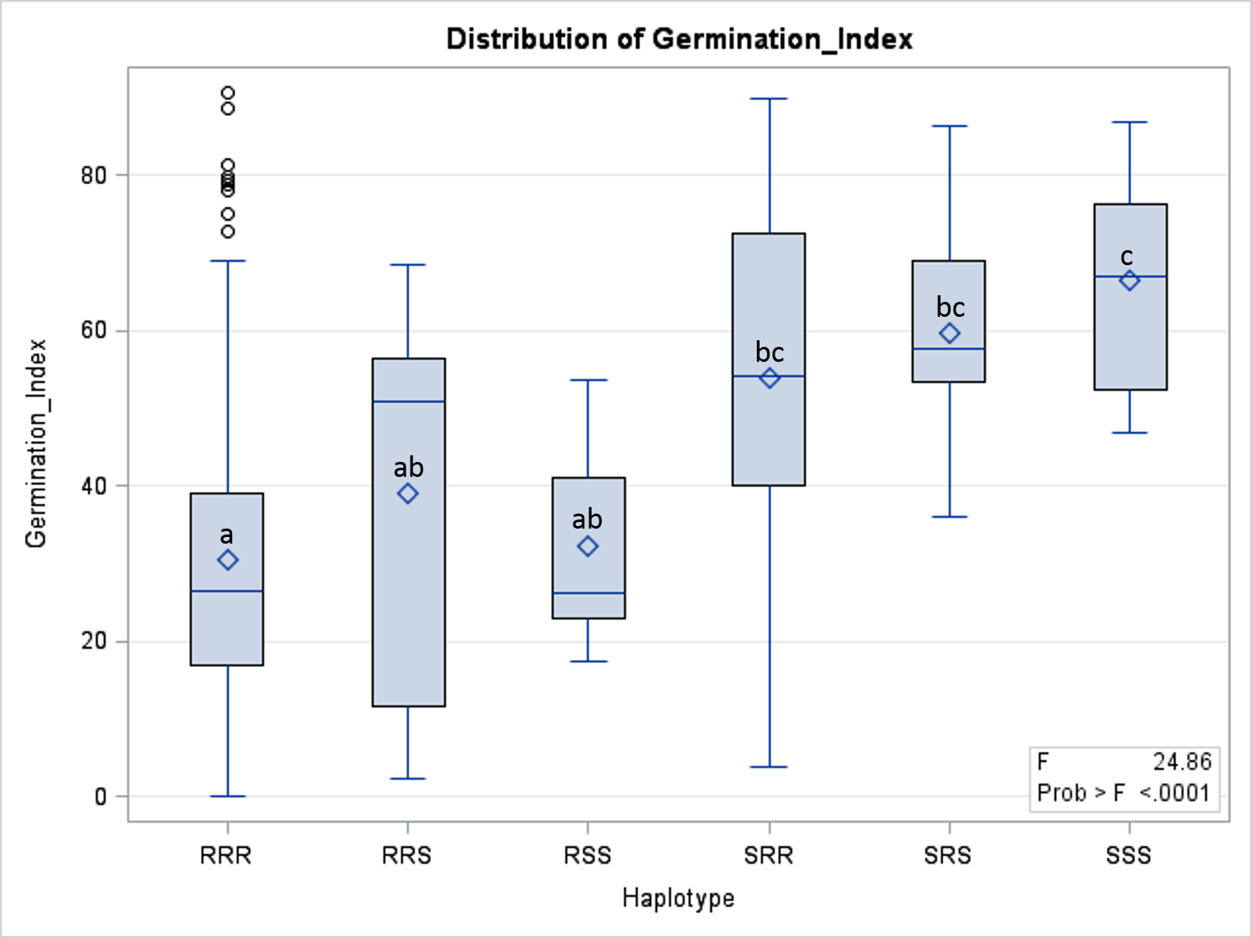

**Fig. 7** Box plot of pre-harvest sprouting rate for different haplotypes (HAP) and Tukey’s multiple comparing among the elite breeding lines

1) S means susceptible allele to pre-harvest sprouting; R means resistant allele to pre-harvest sprouting.

2) Diamond is the mean; horizontal line within box is the median; the bars above and below box are the 90 percentile and 10 percentile respectively.

3) Different letters above the histograms mean the significant difference by multiple comparing (p<0.01).

**References:**

Albrecht, T., M. Oberforster, H. Kempf, L. Ramgraber, J. Schacht *et al.*, 2015 Genome-wide association mapping of preharvest sprouting resistance in a diversity panel of European winter wheats. Journal of Applied Genetics 56**:** 277-285.

Anderson, J. A., M. E. Sorrells and S. D. Tanksley, 1993 Rflp Analysis of Genomic Regions Associated with Resistance to Preharvest Sprouting in Wheat. Crop Science 33**:** 453-459.

Barendse, W., 2011 Haplotype Analysis Improved Evidence for Candidate Genes for Intramuscular Fat Percentage from a Genome Wide Association Study of Cattle. Plos One 6.

Barrero, J. M., C. Cavanagh, K. L. Verbyla, J. F. G. Tibbits, A. P. Verbyla *et al.*, 2015 Transcriptomic analysis of wheat near-isogenic lines identifies PM19-A1 and A2 as candidates for a major dormancy QTL. Genome Biology 16.

Benech-Arnold, R., 2009 Pre-harvest sprouting in cereals. Euphytica 168**:** 289-289.

Bi, H. H., Y. W. Sun, Y. G. Xiao and L. Q. Xia, 2014 Characterization of DFR allelic variations and their associations with pre-harvest sprouting resistance in a set of red-grained Chinese wheat germplasm. Euphytica 195**:** 197-207.

Bickel, R. D., A. Kopp and S. V. Nuzhdin, 2011 Composite Effects of Polymorphisms near Multiple Regulatory Elements Create a Major-Effect QTL. Plos Genetics 7.

Cabral, A. L., M. C. Jordan, C. A. McCartney, F. M. You, D. G. Humphreys *et al.*, 2014 Identification of candidate genes, regions and markers for pre-harvest sprouting resistance in wheat (Triticum aestivum L.). Bmc Plant Biology 14.

Cao, L. Z., K. Hayashi, M. Tokui, M. Mori, H. Miura *et al.*, 2016 Detection of QTLs for traits associated with pre-harvest sprouting resistance in bread wheat (Triticum aestivum L.). Breeding Science 662**:** 260-270.

Chapman, J. A., M. Mascher, A. Buluc, K. Barry, E. Georganas *et al.*, 2015 A whole-genome shotgun approach for assembling and anchoring the hexaploid bread wheat genome. Genome Biology 16.

Chen, C., S. E. Mitchell, R. J. Elshire, E. S. Buckler and Y. A. El-Kassaby, 2013 Mining conifers' mega-genome using rapid and efficient multiplexed high-throughput genotyping-by-sequencing (GBS) SNP discovery platform. Tree Genetics & Genomes 9**:** 1537-1544.

Chen, C. X., S. B. Cai and G. H. Bai, 2008 A major QTL controlling seed dormancy and pre-harvest sprouting resistance on chromosome 4A in a Chinese wheat landrace. Molecular Breeding 21**:** 351-358.

Chono, M., H. Matsunaka, M. Seki, M. Fujita, C. Kiribuchi-Otobe *et al.*, 2015 Molecular and genealogical analysis of grain dormancy in Japanese wheat varieties, with specific focus on MOTHER OF FT AND TFL1 on chromosome 3A. Breeding Science 65**:** 103-109.

DePauw, R. M., R. E. Knox, A. K. Singh, S. L. Fox, D. G. Humphreys *et al.*, 2012 Developing standardized methods for breeding preharvest sprouting resistant wheat, challenges and successes in Canadian wheat. Euphytica 188**:** 7-14.

Fakthongphan, J., G. H. Bai, P. St Amand, R. A. Graybosch and P. S. Baenziger, 2016 Identification of markers linked to genes for sprouting tolerance (independent of grain color) in hard white winter wheat (HWWW). Theoretical and Applied Genetics 129**:** 419-430.

Finch-Savage, W. E., and G. Leubner-Metzger, 2006 Seed dormancy and the control of germination. New Phytologist 171**:** 501-523.

Flintham, J., R. Adlam, M. Bassoi, M. Holdsworth and M. Gale, 2002 Mapping genes for resistance to sprouting damage in wheat. Euphytica 126**:** 39-45.

Flintham, J. E., 2000 Different genetic components control coat-imposed and embryo-imposed dormancy in wheat. Seed Science Research 10**:** 43-50.

Galan, J. J., E. Guarducci, F. Nuti, A. Gonzalez, M. Ruiz *et al.*, 2007 Molecular analysis of estrogen receptor alpha gene AGATA haplotype and SNP12 in European populations: potential protective effect for cryptorchidism and lack of association with male infertility. Human Reproduction 22**:** 444-449.

Gao, F., and B. T. Ayele, 2014 Functional genomics of seed dormancy in wheat: advances and prospects. Front Plant Sci 5**:** 458.

Gao, X., C. H. Hu, H. Z. Li, Y. J. Yao, M. Meng *et al.*, 2013 Factors Affecting Pre-Harvest Sprouting Resistance in Wheat (Triticum Aestivum L.): A Review. Journal of Animal and Plant Sciences 23**:** 556-565.

Groos, C., G. Gay, M. R. Perretant, L. Gervais, M. Bernard *et al.*, 2002 Study of the relationship between pre-harvest sprouting and grain color by quantitative trait loci analysis in a whitexred grain bread-wheat cross. Theoretical and Applied Genetics 104**:** 39-47.

Gubler, F., A. A. Millar and J. V. Jacobsen, 2005 Dormancy release, ABA and pre-harvest sprouting. Curr Opin Plant Biol 8**:** 183-187.

Huang, X. Q., and A. Brule-Babel, 2012 Sequence diversity, haplotype analysis, association mapping and functional marker development in the waxy and starch synthase IIa genes for grain-yield-related traits in hexaploid wheat (Triticum aestivum L.). Molecular Breeding 30**:** 627-645.

Hughes, K. R., C. A. Griffey, D. J. Parrish, W. E. Barbeau, E. Souza *et al.*, 2010 Preharvest Sprouting Tolerance in Current Soft Red Winter Wheat Cultivars. Crop Science 50**:** 1449-1457.

Humphreys, D. G., R. M. DePauw, R. E. Knox, A. K. Singh, R. Cuthbert *et al.*, 2012 Weathering and pre-harvest sprouting resistance. Canadian Journal of Plant Science 92**:** 599-600.

Kato, K., W. Nakamura, T. Tabiki, H. Miura and S. Sawada, 2001 Detection of loci controlling seed dormancy on group 4 chromosomes of wheat and comparative mapping with rice and barley genomes. Theoretical and Applied Genetics 102**:** 980-985.

Knox, R. E., F. R. Clarke, J. M. Clarke, S. L. Fox, R. M. DePauw *et al.*, 2012 Enhancing the identification of genetic loci and transgressive segregants for preharvest sprouting resistance in a durum wheat population. Euphytica 186**:** 193-206.

Kulwal, P., G. Ishikawa, D. Benscher, Z. Y. Feng, L. X. Yu *et al.*, 2012 Association mapping for pre-harvest sprouting resistance in white winter wheat. Theoretical and Applied Genetics 125**:** 793-805.

Lei, L., X. K. Zhu, S. W. Wang, M. R. Zhu, B. F. Carver *et al.*, 2013 TaMFT-A1 Is Associated with Seed Germination Sensitive to Temperature in Winter Wheat. Plos One 8.

Li, C., P. Ni, M. Francki, A. Hunter, Y. Zhang *et al.*, 2004 Genes controlling seed dormancy and pre-harvest sprouting in a rice-wheat-barley comparison. Funct Integr Genomics 4**:** 84-93.

Lin, M., S. B. Cai, S. Wang, S. B. Liu, G. R. Zhang *et al.*, 2015 Genotyping-by-sequencing (GBS) identified SNP tightly linked to QTL for pre-harvest sprouting resistance. Theoretical and Applied Genetics 128**:** 1385-1395.

Linkies, A., K. Graeber, C. Knight and G. Leubner-Metzger, 2010 The evolution of seeds. New Phytologist 186**:** 817-831.

Liu, S. B., G. H. Bai, S. B. Cai and C. X. Chen, 2011 Dissection of genetic components of preharvest sprouting resistance in white wheat. Molecular Breeding 27**:** 511-523.

Liu, S. B., S. B. Cai, R. Graybosch, C. X. Chen and G. H. Bai, 2008 Quantitative trait loci for resistance to pre-harvest sprouting in US hard white winter wheat Rio Blanco. Theoretical and Applied Genetics 117**:** 691-699.

Liu, S. B., S. K. Sehgal, J. R. Li, M. Lin, H. N. Trick *et al.*, 2013 Cloning and Characterization of a Critical Regulator for Preharvest Sprouting in Wheat. Genetics 195**:** 263-+.

Liu, S. B., S. K. Sehgal, M. Lin, J. R. Li, H. N. Trick *et al.*, 2015 Independent mis-splicing mutations in TaPHS1 causing loss of preharvest sprouting (PHS) resistance during wheat domestication. New Phytologist 208**:** 928-935.

Lohwasser, U., M. A. R. Arif and A. Borner, 2013 Discovery of loci determining pre-harvest sprouting and dormancy in wheat and barley applying segregation and association mapping. Biologia Plantarum 57**:** 663-674.

Mares, D. J., and K. Mrva, 2001 Mapping quantitative trait loci associated with variation in grain dormancy in Australian wheat. Australian Journal of Agricultural Research 52**:** 1257-1265.

Mares, D. J., and K. Mrva, 2014 Wheat grain preharvest sprouting and late maturity alpha-amylase. Planta 240**:** 1167-1178.

Martin, T. J., G. R. Zhang, A. K. Fritz, R. Miller and M. S. Chen, 2013 Registration of 'Tiger' Wheat. Journal of Plant Registrations 7**:** 201-204.

Mayer, K. F. X., J. Rogers, J. Dolezel, C. Pozniak, K. Eversole *et al.*, 2014 A chromosome-based draft sequence of the hexaploid bread wheat (Triticum aestivum) genome. Science 345.

Miao, X. L., Y. J. Zhang, X. C. Xia, Z. H. He, Y. Zhang *et al.*, 2013 Mapping quantitative trait loci for pre-harvest sprouting resistance in white-grained winter wheat line CA 0431. Crop & Pasture Science 64**:** 573-579.

Miura, H., N. Sato, K. Kato and Y. Amano, 2002 Detection of chromosomes carrying genes for seed dormancy of wheat using the backcross reciprocal monosomic method. Plant Breeding 121**:** 394-399.

Mori, M., N. Uchino, M. Chono, K. Kato and H. Miura, 2005 Mapping QTLs for grain dormancy on wheat chromosome 3A and the group 4 chromosomes, and their combined effect. Theoretical and Applied Genetics 110**:** 1315-1323.

Nakamura, S., F. Abe, H. Kawahigashi, K. Nakazono, A. Tagiri *et al.*, 2011 A Wheat Homolog of MOTHER OF FT AND TFL1 Acts in the Regulation of Germination. Plant Cell 23**:** 3215-3229.

Nonogaki, H., 2014 Seed dormancy and germination-emerging mechanisms and new hypotheses. Frontiers in Plant Science 5**:** 233.

Nyachiro, J. M., 2012 Pre-harvest sprouting in cereals PREFACE. Euphytica 188**:** 1-3.

Poland, J., J. Endelman, J. Dawson, J. Rutkoski, S. Y. Wu *et al.*, 2012a Genomic Selection in Wheat Breeding using Genotyping-by-Sequencing. Plant Genome 5**:** 103-113.

Poland, J. A., P. J. Brown, M. E. Sorrells and J. L. Jannink, 2012b Development of High-Density Genetic Maps for Barley and Wheat Using a Novel Two-Enzyme Genotyping-by-Sequencing Approach. Plos One 7.

Rasul, G., D. G. Humphreys, A. Brule-Babel, C. A. McCartney, R. E. Knox *et al.*, 2009 Mapping QTLs for pre-harvest sprouting traits in the spring wheat cross 'RL4452/AC Domain'. Euphytica 168**:** 363-378.

Rasul, G., G. D. Humphreys, J. X. Wu, A. Brule-Babel, B. Fofana *et al.*, 2012 Evaluation of preharvest sprouting traits in a collection of spring wheat germplasm using genotype and genotype environment interaction model. Plant Breeding 131**:** 244-251.

Rife, T. W., S. Y. Wu, R. L. Bowden and J. A. Poland, 2015 Spiked GBS: a unified, open platform for single marker genotyping and whole-genome profiling. Bmc Genomics 16.

Roy, J. K., M. Prasad, R. K. Varshney, H. S. Balyan, T. K. Blake *et al.*, 1999 Identification of a microsatellite on chromosomes 6B and a STS on 7D of bread wheat showing an association with preharvest sprouting tolerance. Theoretical and Applied Genetics 99**:** 336-340.

Saghaimaroof, M. A., K. M. Soliman, R. A. Jorgensen and R. W. Allard, 1984 Ribosomal DNA Spacer-Length Polymorphisms in Barley - Mendelian Inheritance, Chromosomal Location, and Population-Dynamics. Proceedings of the National Academy of Sciences of the United States of America-Biological Sciences 81**:** 8014-8018.

Sato, K., T. Matsumoto, N. Ooe and K. Takeda, 2009 Genetic analysis of seed dormancy QTL in barley. Breeding Science 59**:** 645-650.

Shorinola, O., N. Bird, J. Simmonds, S. Berry, T. Henriksson *et al.*, 2016 The wheat Phs-A1 pre-harvest sprouting resistance locus delays the rate of seed dormancy loss and maps 0.3 cM distal to the PM19 genes in UK germplasm. J Exp Bot.

Silva Lda, C., S. Wang and Z. B. Zeng, 2012 Composite interval mapping and multiple interval mapping: procedures and guidelines for using Windows QTL Cartographer. Methods Mol Biol 871**:** 75-119.

Spindel, J., M. Wright, C. Chen, J. Cobb, J. Gage *et al.*, 2013 Bridging the genotyping gap: using genotyping by sequencing (GBS) to add high-density SNP markers and new value to traditional bi-parental mapping and breeding populations. Theoretical and Applied Genetics 126**:** 2699-2716.

Thomas, W. T. B., W. Powell, J. S. Swanston, R. P. Ellis, K. J. Chalmers *et al.*, 1996 Quantitative trait loci for germination and malting quality characters in a spring barley cross. Crop Science 36**:** 265-273.

Torada, A., M. Koike, T. Ogawa, Y. Takenouchi, K. Tadamura *et al.*, 2016 A Causal Gene for Seed Dormancy on Wheat Chromosome 4A Encodes a MAP Kinase Kinase. Current Biology 26**:** 782-787.

Wang, J. R., Y. X. Liu, Y. Wang, Z. H. Chen, S. Dai *et al.*, 2011 Genetic variation of Vp1 in Sichuan wheat accessions and its association with pre-harvest sprouting response. Genes & Genomics 33**:** 139-146.

Willis, C. G., C. C. Baskin, J. M. Baskin, J. R. Auld, D. L. Venable *et al.*, 2014 The evolution of seed dormancy: environmental cues, evolutionary hubs, and diversification of the seed plants. New Phytologist 203**:** 300-309.

Xiao, S. H., H. P. Zhang, G. X. You, X. Y. Zhang, C. S. Yan *et al.*, 2012 Integration of marker-assisted selection for resistance to pre-harvest sprouting with selection for grain-filling rate in breeding of white-kernelled wheat for the Chinese environment. Euphytica 188**:** 85-88.

Zanetti, S., M. Winzeler, M. Keller, B. Keller and M. Messmer, 2000 Genetic analysis of pre-harvest sprouting resistance in a wheat x spelt cross. Crop Science 40**:** 1406-1417.

Kosambi DD (1944) The estimation of map distances from recombination values. Ann Eugen 12:172–175

Van Ooijen JW (2006) JoinMap® 4, Software for the calculation of genetic linkage maps in experimental populations. Kyazma BV, Wageningen

Walker-Simmonds MK (1987) ABA levels and sensitivity in developing embryos of sprouting resistant and susceptible cultivars. Plant Physiol 84:61–66