Problems:

The average of two methods are slightly different for some trials. The reason of this is for example, the trials in 2024-8-13 and 8-14 are missing for one party (where one of the parties (Democratic or Republican) might not have a corresponding entry). A screen shot of a computer

8-13 trial entries are missing Trial 27 for republican because GPT predicts Democratic win all states in that trial. Trial 31 is missing in 8-14 trial entries.

Therefore, **Trial 31** is missing a Republican entry (In this scenario, Democratic wins all states), if calculating the votes percent listed above to get the probability of wining for each trial first and then calculate the mean from these trials, we have:

Votes_BBC=(0.439+0.439)/2=0.439 rather than (0.439+0.439+0)/3=0.293

Method #1 cannot be used due to unbalanced trial entries:

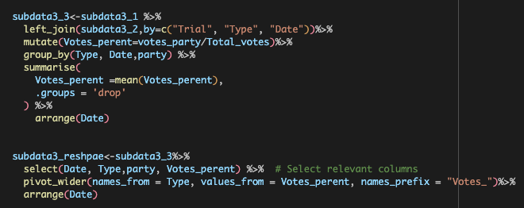

Method #2 should be used (calculate the votes won by each predited winner party and then divided by total votes)：

This method does not calcuate probability of winner for each trial first.

