改：
- 游戏是如何结束的：在20个回合结束之后，系统通过计算你四个值里面的最高值和最低值分别是哪个，然后对应12个结果生成12个结局词条。结局词条包含一个大标题，一段文字介绍，多个代表人物，一张卡通图片。然后加入一个按钮Save，这样图片可以被用户自动保存。（具体查看附录1）
- 在20个回合结束之后，自动显示游戏结束的大弹窗，加入一个按钮View your identity，点进去之后显示results（你的结局词条）
- 加入Local Storage
- 在棋盘界面的左侧加入一个大一些的牌子上面写着你现在在第几回合，还有你的剩余回合。
- 在棋盘右上角加入一个exist game按钮，然后按了之后会有小弹窗说你退出之后将不保留历史记录，请问你确认是否要退出，然后下面有俩按钮，back和exist，按了back会继续回到棋盘界面，按了exit会回到刚进入游戏的初始界面。
- 在进入真正棋盘界面之前，生成一个类似风格的进入游戏页面（初始页面：大大的Start Game按钮，下面是一个稍微小一点按钮Rules，上面是游戏名称Her field，页面上弄一些可爱风格的女运动员图片，图片大小大一些）。
- 点击Start Game按钮可进入游戏界面。
- 点击Rules按钮出现一个大一些的弹窗，风格依旧相似。然后写清楚游戏规则
（具体查看附录2）

附录1:

结局词条：
- SPIRITUAL WEALTH

I am not rich, but I am fulfilled.
（Highest: Satisfaction | Lowest: salary ）
- Athlete Example: Simone Biles (USA, gymnastics)
- Why: At the 2020 Tokyo Olympics, Biles withdrew from multiple finals to protect her mental health — a decision that cost her medals and potential bonuses, but she stood by it for her own well-being.


2. CALM WARRIOR
I accept my limits, but I never surrender.
（Highest: Satisfaction | Lowest: energy ）
- Athlete Example: Li Na (China, tennis)
- Why: After winning two Grand Slams and ranking world No. 2, Li Na retired on her own terms in 2014. She walked away not because she was forced out, but because she was at peace with her body and her legacy.


3. BURNING CANDLE
I gave my body, and I regret nothing.
(Highest: Satisfaction | Lowest: Health )
- Athlete Example: Florence Griffith-Joyner (USA, sprinting)
- Why: "Flo-Jo" set world records in the 100m and 200m that still stand today. She retired at 29 and died suddenly at 38 from an epileptic seizure. Her brilliance burned fast and bright.
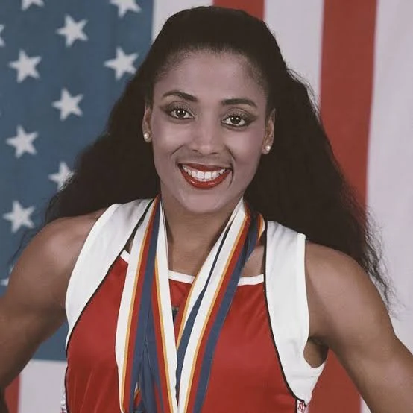

4. ANGRY BULL
I am not happy, but I will never quit.
(Highest: Energy | Lowest: Satisfaction)
- Athlete Example: Martina Navratilova (USA/Czech, tennis)
- Why: She came out as gay in 1981, losing major sponsors and facing relentless media attacks. Despite the hostility, she kept competing and became one of the greatest tennis players of all time — and never stopped speaking out.


5. POOR MARATHONER
I have no money, but I still have fire.
(Highest: Energy | Lowest: Wages )

- Athlete Example: Lauryn Williams (USA, track & bobsled)
- Why: She won Olympic medals in both Summer and Winter Games — yet at 30, she was working a $12/hour internship. "The media coverage was everywhere. The sponsors were nowhere," she said.
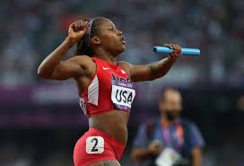

6. SELF-DESTRUCTOR
I broke my body chasing greatness.
(Highest: Energy | Lowest: Health )
- Athlete Example: Caroline Garcia (France, tennis)
- Why: Former world No. 4 played through "unbearable" pain — anti-inflammatories, cortisone injections, plasma treatments just to step on the court. She retired when she realized she was happier when tournaments ended.


7. RICH EMPTY SHELL
I have money. But I am not happy.
(Highest: Wages | Lowest: Satisfaction )
- Athlete Example: Maria Sharapova (Russia, tennis)
- Why: She built a $300 million fortune — but beneath the glamour, she played through chronic shoulder pain for years. "People think I have everything," she once said. "They don't see what it cost."


8. WELL-OILED MACHINE
I am expensive. And I am exhausted.
(Highest: Wages | Lowest: Energy )
- Athlete Example: Naomi Osaka (Japan, tennis)
- Why: She became the highest-paid female athlete in history ($55 million/year). But the price was burnout, anxiety, and stepping away from the sport she loved. She revealed she had suffered from depression since 2018.
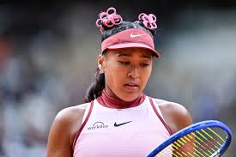

9. GOLDEN CAGE PATIENT
I am rich. But my body is ruined.
(Highest: Wages | Lowest: Health )
- Athlete Example: Monica Seles (USA/Yugoslavia, tennis)
- Why: She was world No. 1, earning millions. Then a fan stabbed her on court in 1993. She survived, but her body — and her career — never fully recovered. The money couldn't fix what was taken.


HEALTH HIGHEST

10. HEALTHY EMPTY SHELL
My body is fine. But my spirit is dead.
(Highest: Health | Lowest: Satisfaction )
- Athlete Example: Kim Min-ji (South Korea, volleyball)
- Why: A promising volleyball player who retired early after relentless online abuse about her body and appearance. Her body could still play. But her heart couldn't take another comment.


11. POWER-SAVE MODE
I am alive. But I have stopped moving.
(Highest: Health | Lowest: Energy )
- Athlete Example: Bridgette Gordon (USA, basketball)
- Why: Olympic gold medalist forced to quit basketball at 31 because a bone condition (osteonecrosis) would otherwise put her in a wheelchair. She walked away healthy enough to coach. But her playing career ended too soon.


12. HEALTHY BUT BROKE
I am healthy. But I have no bread.
(Highest: Health | Lowest: Wages )
- Athlete Example: Katrin Krabbe (Germany, sprinting)
- Why: German sprint champion banned for a doping violation many believe was politically motivated (German reunification tensions). Her health remained. Her career and income were destroyed.


附录2
What Is This Game
You are a professional female athlete. Your goal is to complete 20 moves. Along the way, you will land on different types of tiles that affect four stats:
- Satisfaction — Your happiness, sense of purpose, and emotional well-being
- Energy — Your motivation, focus, and drive to compete
- Salary — Your money from competitions and sponsorships
- Health — Your physical condition and injury status

How to Play
1. Starting the Game
- All four stats begin at 100.
- Each player places their character on the Start tile.
2. Taking a Turn
- Click the Roll Dice button.
- Move your character forward by the number shown.
- Land on a tile and trigger its effect.
3,Winning the Game
The game ends when any player completes one full lap and reaches or passes the Start tile.
At that moment:
- The game stops immediately.
- Look at your highest stat and lowest stat.
- Find your ending on the table below.

