1. Number of nodes: 328

Number of link: 5818

Link density: 0.10848810322965616

Average degree: 35.47560975609756

Degree variance: 185.47501487209996

1. 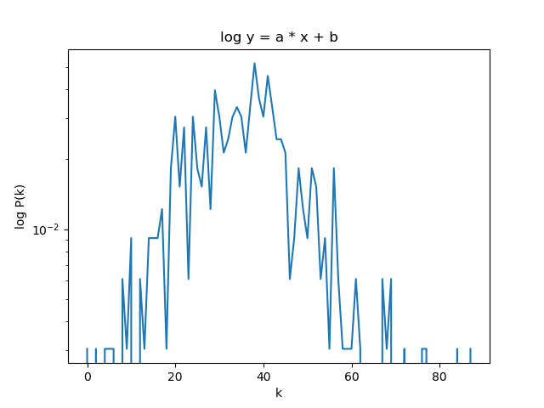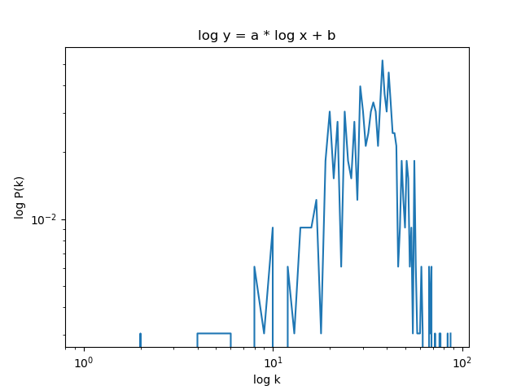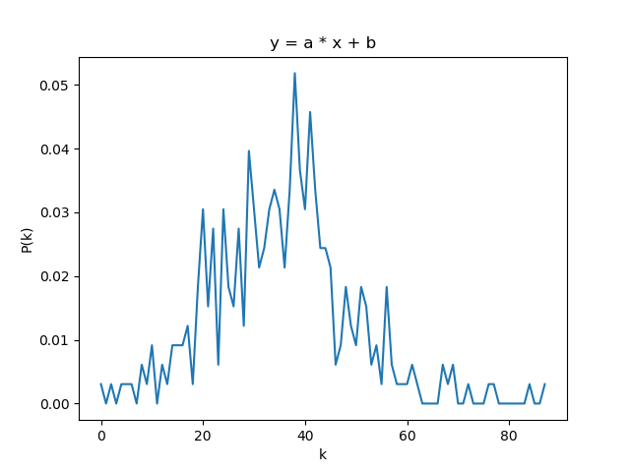

3. 0.03317576993604877

4. 0.44442135612150807

5. 2.1594341569576554

4

7. 41.231605032525906

8. 1.93004886e+00

9. 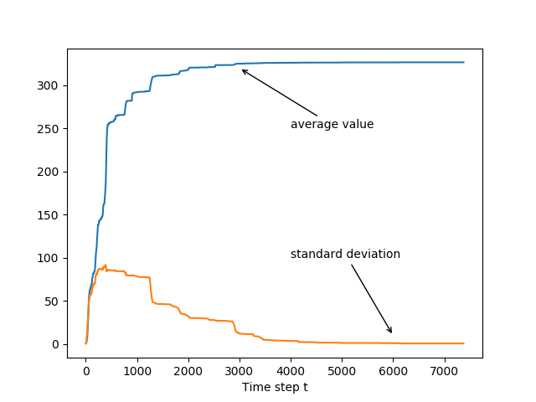

10.

[1, 21, 37, 43, 44, 46, 60, 66, 72, 73, 76, 77, 98, 101, 105, 111, 129, 132, 135, 147, 179, 193, 216, 218, 240, 241, 263, 267, 276, 14, 27, 39, 50, 91, 109, 158, 260, 199, 4, 16, 34, 120, 160, 162, 171, 238, 296, 302, 305, 313, 314, 317, 321, 325, 15, 20, 55, 75, 83, 84, 94, 95, 145, 163, 183, 187, 195, 197, 198, 202, 210, 213, 214, 220, 224, 225, 226, 234, 257, 259, 290, 292, 294, 303, 304, 308, 310, 311, 312, 318, 327, 79, 291, 297, 89, 113, 114, 133, 141, 185, 268, 2, 9, 10, 53, 58, 61, 78, 85, 86, 100, 106, 112, 124, 127, 130, 134, 137, 205, 229, 252, 264, 7, 38, 110, 115, 118, 136, 143, 154, 170, 172, 178, 186, 212, 235, 280, 293, 295, 300, 301, 309, 322, 323, 13, 29, 65, 138, 166, 196, 221, 227, 239, 251, 279, 40, 47, 174, 287, 316, 18, 42, 64, 92, 116, 123, 191, 246, 247, 269, 281, 284, 299, 306, 315, 320, 23, 25, 30, 45, 121, 128, 149, 157, 184, 192, 203, 258, 265, 11, 52, 87, 142, 153, 155, 165, 208, 211, 217, 255, 278, 17, 22, 63, 103, 107, 119, 164, 169, 175, 48, 148, 254, 288, 298, 173, 182, 189, 190, 26, 209, 230, 248, 256, 274, 35, 117, 152, 204, 5, 69, 70, 82, 97, 104, 108, 131, 140, 146, 181, 201, 219, 232, 243, 270, 272, 273, 275, 282, 285, 319, 32, 59, 41, 81, 102, 49, 67, 126, 236, 222, 125, 206, 122, 3, 6, 80, 139, 177, 244, 93, 33, 237, 71, 56, 62, 261, 8, 36, 144, 159, 180, 245, 253, 207, 250, 88, 266, 28, 31, 99, 228, 271, 231, 194, 68, 168, 223, 283, 51, 74, 200, 249, 233, 326, 150, 96, 215, 19, 167, 277, 289, 242, 54, 307, 151, 57, 188, 176, 286, 262, 12, 324, 90, 161, 156, 24]

11.

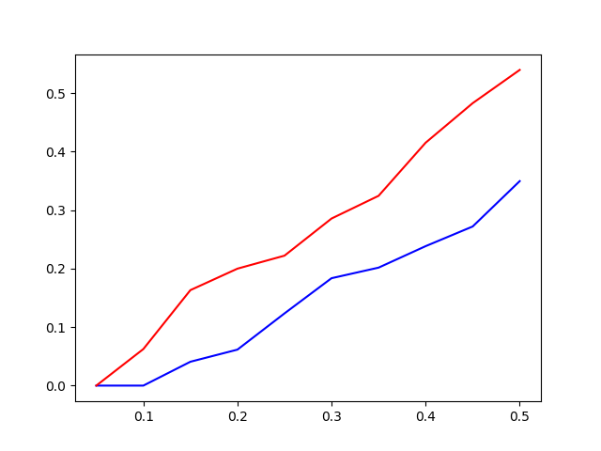

15.

G2

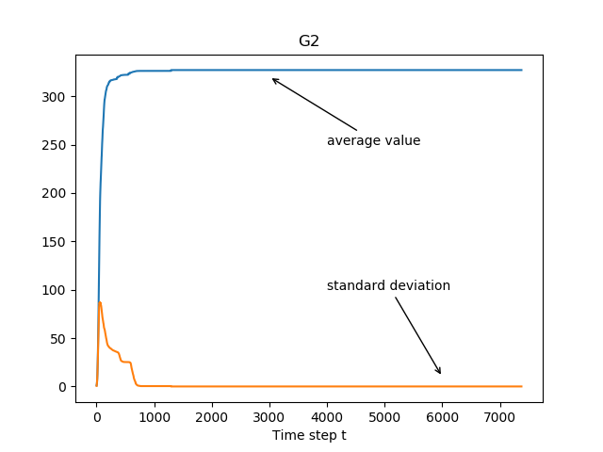

R:(302, 42)

G3

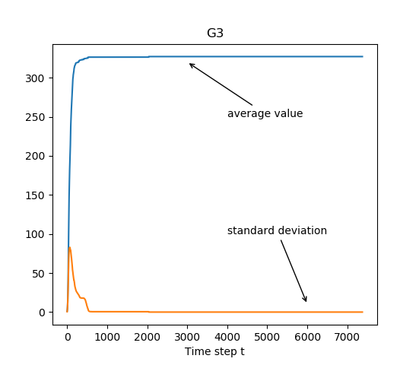

(32, 43)