Installation Guide For Apache 2.4

On Windows 7

Summary: Apache 2.4 is no more available as msi. But you may found it up to version 2.2x in the archive. <http://archive.apache.org/dist/httpd/binaries/win32/>

**Software List:**

1)Apache 2.4 binaries VC1.4

http://www.apachelounge.com/download/

You should download different version of Apache 2.4 based on your Windows version

For example, Windows 7 should download Apache 2.4.17 Win64

2)the latest Visual C++ Redistributable for Visual Studio 2015

Because this version of Apache binaries is built with the Visual Studio C++, so you need to download Visual C++ Redistributable for Visual Studio 2015 for installation.

http://www.microsoft.com/en-us/download/details.aspx?id=48145

You should download different version of latest Visual C++ Redistributable Package based on your Windows version.

For example, Windows 7 should download vc_redist.x64.exe

**Installation Steps**

1)download Apache 2.4 binaries VC1.4 and unzip the files where you want to put

2)download and install the latest Visual C++ Redistributable for Visual Studio 2015

3)run cmd command from StartUp as **Administrator**

change the directory to bin folder under your apache folder

For example , I put Apache fold in the this path : D:\Project\apache\Apache24

So I need to change the directory to the path : D:\Project\apache\Apache24\bin

enter the command -> httpd.exe -k install

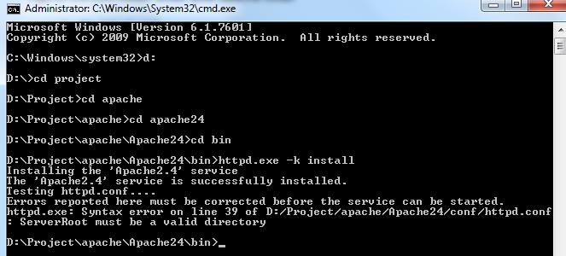

4)go to the conf folder under your apache folder

open the file httpd.conf

go to line 38 ,define your own SRVROOT.

For example, my apache fold path is D:\Project\apache\Apache24

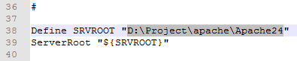

5) go to the fold "D:\Project\apache\Apache24\bin "

run ApacheMonitor.exe , start the service

open your web browser, enter the address http://localhost

If it shows like that following picture, it means you have install Apache sucessfully.

