Installation Guide For PHP 5.6.15

On Windows 7

**Software List:**

1)PHP5.6 VC11 x86 Thread Safe

http://windows.php.net/download#php-5.6--32-bit version

2)Visual C++ Redistributable for Visual Studio 2012 Update 4 --32-bit version

VSU_4\vcredist_x86.exe

**Installation Steps**

1)download PHP5.6 VC11 x86 Thread and unzip the files where you want to put

2) copy the file "php.ini-development" under the folder php , and rename this file as "php.ini"

3)open the file "php.ini" ,search "user_dir" ,see the following screenshot

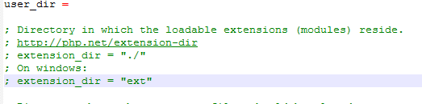

undo the comment "; extension_dir = "ext"" ,see the following screenshot

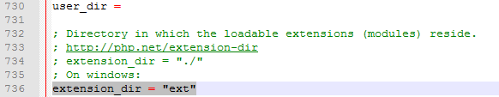

4)open the Properties of Computer

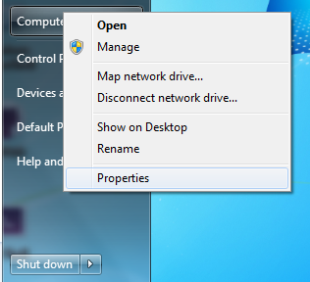

click [Advanced system settings] on the left panel of the page

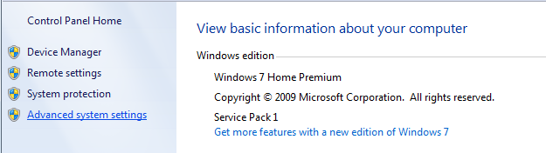

click [Environment Variables] on the tab "Advanced"

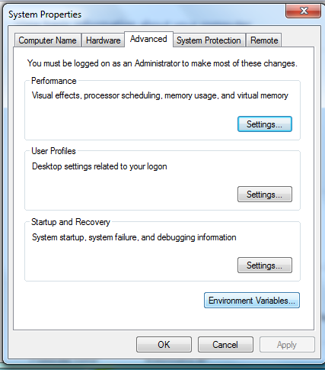

Edit the System Variable [Path]

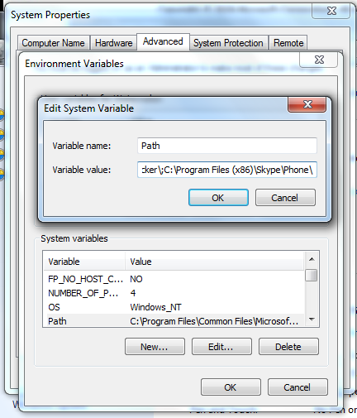

add your php folder path at the end of System Variable [Path]

For example, my php folder is "D:\Project\PHP"

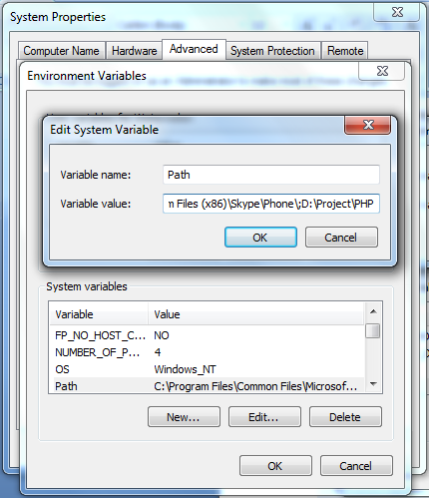

5) open the file install.txt under your php folder, search the keyword [apache module],copy the following content

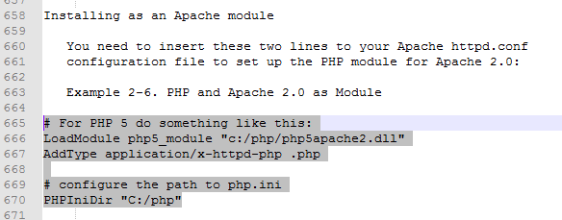

open the file httpd.conf under the folder [Apache24\conf], search the keyword [loadmodule], go to the end of loadmoudle section ,paste the content ,and change the php path to match your php path

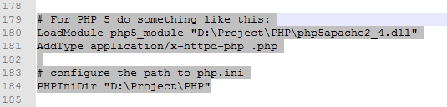

search the keyword [index.html] ,add "index.php"

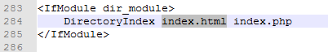

6) restart Apache service

7)add phpinfo.php under the folder[apache24\htdocs]

test the page http://localhost/phpinfo.php