Solomon Benchmark: Six-Instance Results and Discussion
Draft for MSc research report | 100-customer CVRPTW | 60-second computational budget
Data provenance: C101/R101/RC101 from comparison_detailed(6).csv and comparison_summary(6).csv; C102/R102/RC102 from comparison_detailed(4).csv and comparison_summary(4).csv. Best-known solution (BKS) values: SINTEF Solomon 100-customer table. RC101 is listed as “rc101b” on the SINTEF table.

Table 1. Best solutions and BKS comparison
Instance | Method | BKS (V / D) | Best V | Best D | ΔV | ΔD %*
C101 | SA | 10 / 828.94 | 11 | 861.70 | +1 | N/A
C101 | GA | 10 / 828.94 | 10 | 828.94 | +0 | -0.00%
C101 | OR-Tools | 10 / 828.94 | 10 | 828.94 | +0 | -0.00%
C102 | SA | 10 / 828.94 | 10 | 1049.84 | +0 | +26.65%
C102 | GA | 10 / 828.94 | 10 | 886.96 | +0 | +7.00%
C102 | OR-Tools | 10 / 828.94 | 10 | 828.94 | +0 | -0.00%
R101 | SA | 19 / 1650.80 | 21 | 1726.43 | +2 | N/A
R101 | GA | 19 / 1650.80 | 19 | 1713.36 | +0 | +3.79%
R101 | OR-Tools | 19 / 1650.80 | 19 | 1653.53 | +0 | +0.17%
R102 | SA | 17 / 1486.12 | 19 | 1530.55 | +2 | N/A
R102 | GA | 17 / 1486.12 | 18 | 1536.44 | +1 | N/A
R102 | OR-Tools | 17 / 1486.12 | 18 | 1478.63 | +1 | N/A
RC101 | SA | 14 / 1696.95 | 17 | 1747.22 | +3 | N/A
RC101 | GA | 14 / 1696.95 | 16 | 1779.43 | +2 | N/A
RC101 | OR-Tools | 14 / 1696.95 | 16 | 1669.37 | +2 | N/A
RC102 | SA | 12 / 1554.75 | 16 | 1602.27 | +4 | N/A
RC102 | GA | 12 / 1554.75 | 14 | 1579.43 | +2 | N/A
RC102 | OR-Tools | 12 / 1554.75 | 15 | 1509.89 | +3 | N/A
* Distance gap is reported only when the solution uses the same number of vehicles as the BKS. N/A denotes non-comparable vehicle counts. ΔV = Best V − BKS V. All values rounded for display.
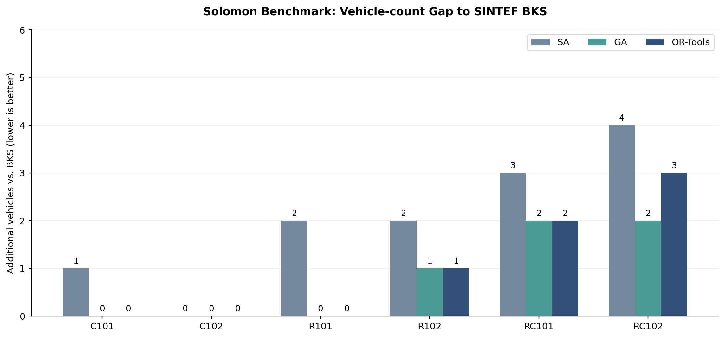
Figure 1. Vehicle-count gap relative to the SINTEF reference (0 indicates matching the BKS vehicle count).
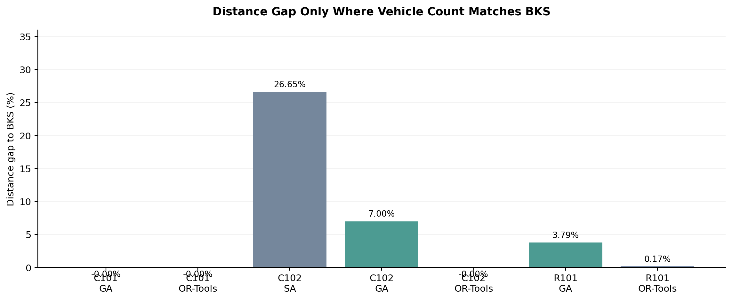
Figure 2. Distance gap (%) only for solutions with the BKS vehicle count.

Results and Discussion (Draft)

1. Experimental setup
Three methods—simulated annealing (SA), a genetic algorithm (GA), and Google OR-Tools Routing Solver—were evaluated on six 100-customer Solomon CVRPTW instances: C101, C102, R101, R102, RC101, and RC102. Each method was executed five times per instance with a nominal 60-second budget, giving 90 runs. SA and GA used seeds 11, 22, 33, 44, and 55; OR-Tools used a fixed search configuration repeated five times rather than five independently varied seeds. Solutions were ranked lexicographically: first by vehicle count, then by total Euclidean distance. The results were compared with SINTEF best-known solutions under the same hierarchical objective.

2. Solution quality
On the clustered C instances, OR-Tools matched the BKS in both vehicle count and reported distance for C101 and C102 (10 vehicles; 828.94). GA also matched the C101 BKS, but on C102 its best distance was 886.96 with 10 vehicles. SA required 11 vehicles on C101 and 10 on C102, with longer distances than OR-Tools. For R101, GA and OR-Tools both used 19 vehicles; OR-Tools achieved 1653.53, only 0.17% above the 1650.80 BKS distance. For R102, GA and OR-Tools both required 18 vehicles, one more than the BKS of 17, while SA required 19. The mixed RC instances remained more challenging relative to the reference fleet size. On RC101, GA and OR-Tools used 16 vehicles against the BKS of 14, whereas SA used 17. On RC102, GA achieved 14 vehicles, outperforming OR-Tools (15) and SA (16) under the vehicle-first objective, although OR-Tools had a shorter distance with its larger fleet.

3. Robustness and feasibility
All 90 recorded runs were marked feasible, and the two sets of 45 saved route files were reported as successfully revalidated by the project’s independent route-checking script (zero reported errors). The CSV files themselves contain route-file paths but not the complete routes; independent reproduction requires retaining the JSON files, instance data, solver settings, and environment details. Across the five repeated runs, OR-Tools produced identical reported results under its fixed configuration. This should not be interpreted as evidence of robustness across random seeds. SA and GA showed instance-dependent variability, with some stable vehicle counts but varying travel distances.

4. Interpretation and limitations
The results support a limited, instance-specific conclusion: OR-Tools was best or tied on five of the six selected instances, while GA achieved the best lexicographic result on RC102. This is not evidence that one method is universally superior. The Solomon C, R, and RC groups differ in spatial structure; the observed variation is consistent with sensitivity to instance characteristics, but the six selected cases are insufficient for broad statistical claims. Distance comparisons against the BKS are meaningful as optimization gaps only when vehicle counts match. A route using more vehicles can have a shorter total distance without improving the hierarchical objective. OR-Tools is a heuristic routing baseline, not an exact optimality certificate. The results also depend on implementation details, computational hardware, integer scaling in OR-Tools, and the selected time limit.

5. Implications for the retail case study
The benchmark establishes that the implementations can produce and independently validate feasible CVRPTW routes under a shared evaluation framework. The Petaling Jaya 7-Eleven case study should next test whether the observed performance differences persist when Euclidean distances are replaced by road-network distance and travel-time matrices, and when replenishment demand and time windows are represented by explicitly documented semi-synthetic assumptions.

Reference and reporting notes
SINTEF (2008), Solomon 100 customers: https://www.sintef.no/projectweb/top/vrptw/100-customers/ . The page identifies the RC101 entry as “rc101b” (14 vehicles; 1696.95). SINTEF reports hierarchical vehicle-first optimization and double-precision Euclidean distance; BKS is a reference solution, not necessarily a mathematical optimality proof.
For the final thesis: record hardware/OS/Python and package versions, solver parameters, and the exact instance file checksums; archive route JSON files and experiment manifests. Avoid pooled mean-distance rankings across different vehicle counts.

