3- tier

User Interface

MainView

AddProductView class;

AddCustomerView class :

AddPurchaseView class :

Add successfully

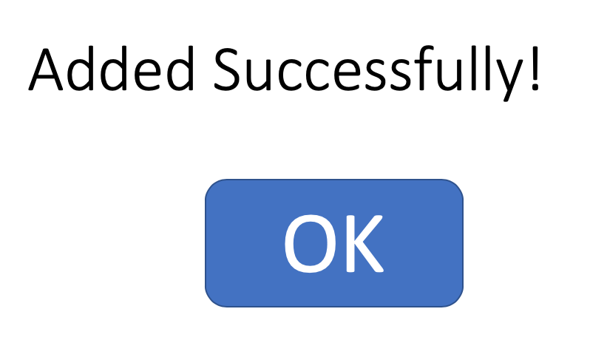

The Ok button:

Business Logic:

ProductModel class: a store information of a product.

AddProductController: process events of AddProductView

CustmerModel class : store information of customer.

PurchaseModel class : store information of purchase

AddCustomerController: process events of AddCustmerView

StoreManager: main application object.

Data Access:

* SQLiteDataAda

User cases:

Addproduct

1st) adds all the elements passed by the user successfully if nothing is missing .

2) shows error message when fields like productid is missing

AddCustomer

1st) adds all the elements passed by the user successfully if nothing is missing .

2) shows error message when fields like customerid is missing

AddPurchase

1st) adds all the elements passed by the user successfully if nothing is missing .

2) shows error message when fields like purchaseid is missing

