Mingyang Li
Tuesday/Thursday Sec 4
MingyangL28

This project develops an interactive Illinois County Economic Intelligence Dashboard that enables users to diagnose, visualize, and simulate unemployment rates across all 102 Illinois counties. The tool employs a dual-model architecture—combining Random Forest for predictive accuracy and Ordinary Least Squares (OLS) regression for econometric interpretability.

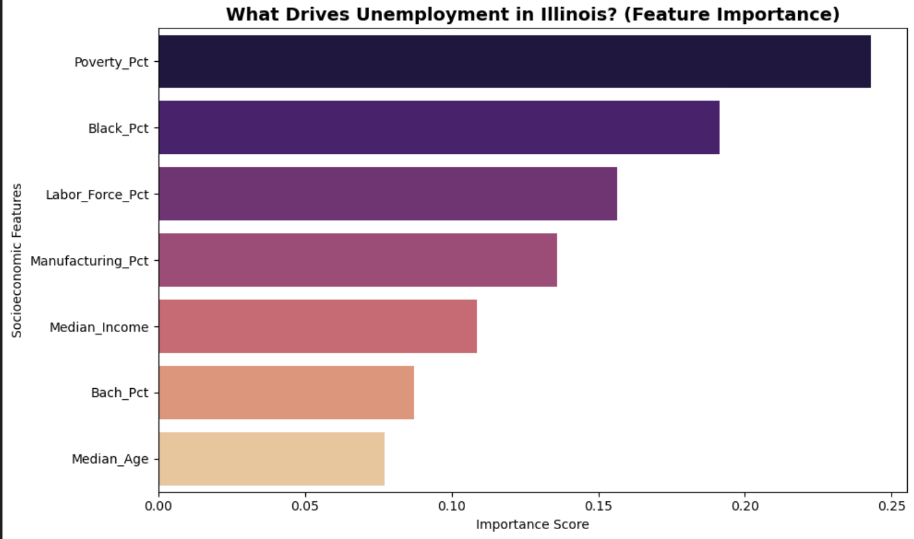
The target variable is the 2023 county-level unemployment rate. Features include Educational Attainment, Poverty Rate, Racial Demographics, Median Household Income, Labor Force Participation Rate, Manufacturing Employment, and Median Age, sourced from the U.S. Census Bureau's ACS 5-Year Estimates (DP03 & DP05) and Decennial Census data. Data cleaning addressed mismatched county naming conventions and inconsistent FIPS codes through standardizing functions that harmonized case, stripped punctuation, and zero-padded codes to the 5-digit format (17XXX). Missing values were imputed using state averages, yielding a clean, unified 102-county dataset.
This horizontal bar chart displays the relative importance of each socioeconomic feature as determined by the Random Forest model. Poverty Rate (Poverty_Pct) ranks as the single strongest predictor of county-level unemployment (importance ≈ 0.24), followed by Black population share (Black_Pct ≈ 0.19) and Labor Force Participation Rate (Labor_Force_Pct ≈ 0.16). Manufacturing employment share, Median Income, Bachelor's degree attainment, and Median Age contribute progressively less explanatory power.

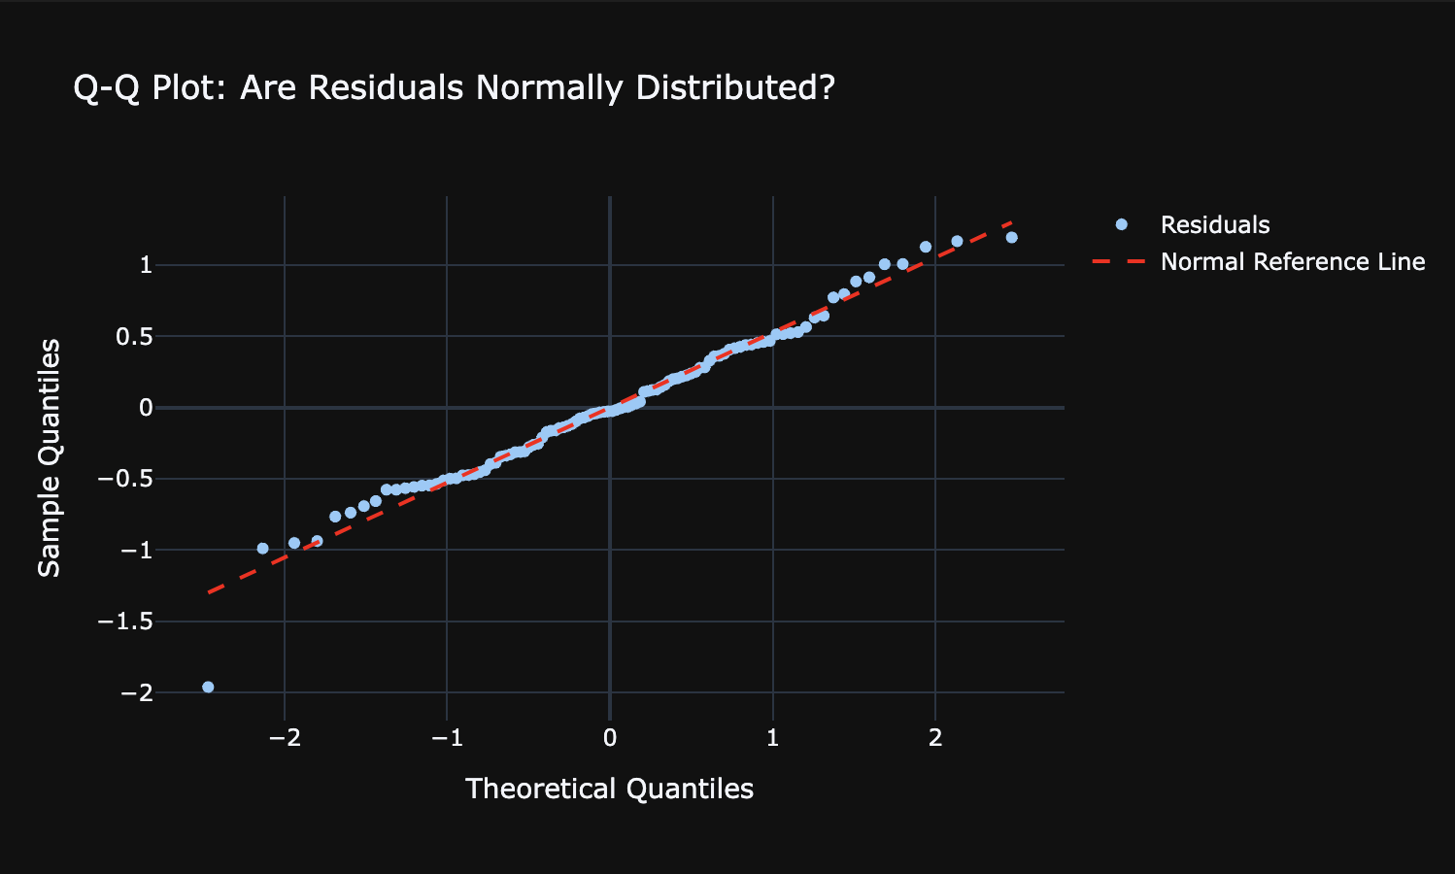
The Q-Q plot tests whether the model's residuals follow a normal distribution — a core assumption of OLS regression. The near-perfect alignment of data points along the reference diagonal confirms that the normality assumption holds for the vast majority of Illinois counties, validating the statistical inference drawn from the regression coefficients and p-values. The single outlier at the lower-left tail corresponds to a county whose unemployment rate is substantially lower than any socioeconomic variable can predict, foreshadowing the overperforming outliers identified in Part 9.

These findings directly address the research question of which demographic and economic factors best explain variation in unemployment across Illinois counties. The dominance of Poverty Rate confirms that economic deprivation is the most structurally embedded driver of joblessness, while the prominence of Black_Pct points to persistent racial disparities in labor market outcomes. The relatively lower importance of education and age suggests that, at the county level, structural poverty and racial composition outweigh human capital factors as predictors — a finding with meaningful implications for targeted policy intervention.

A hybrid modeling strategy balances interpretability and predictive power: OLS regression establishes a statistical baseline with exact coefficients and p-values, while Random Forest captures non-linear feature interactions, powers the scenario simulator, and computes per-county residuals. Built with Streamlit and Plotly, the dashboard is organized into four tabs: a County Profile comparing local metrics against state averages; a Regional Trends & ML Diagnostics panel with color-coded OLS results, feature importance charts, and residual plots; an AI Scenario Simulator where seven policy-lever sliders feed live inputs into the trained model; and a Spatial Intelligence Map supporting multiple choropleth layers with dual statewide and Chicago metro views.

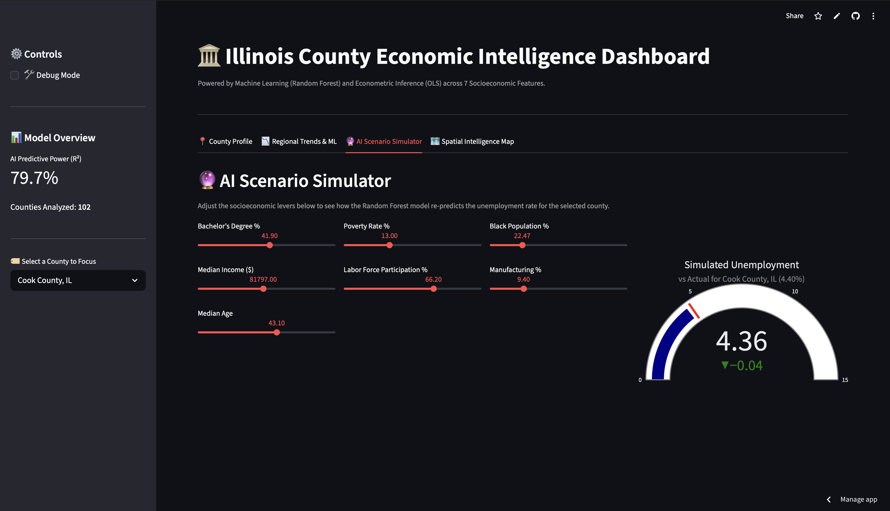
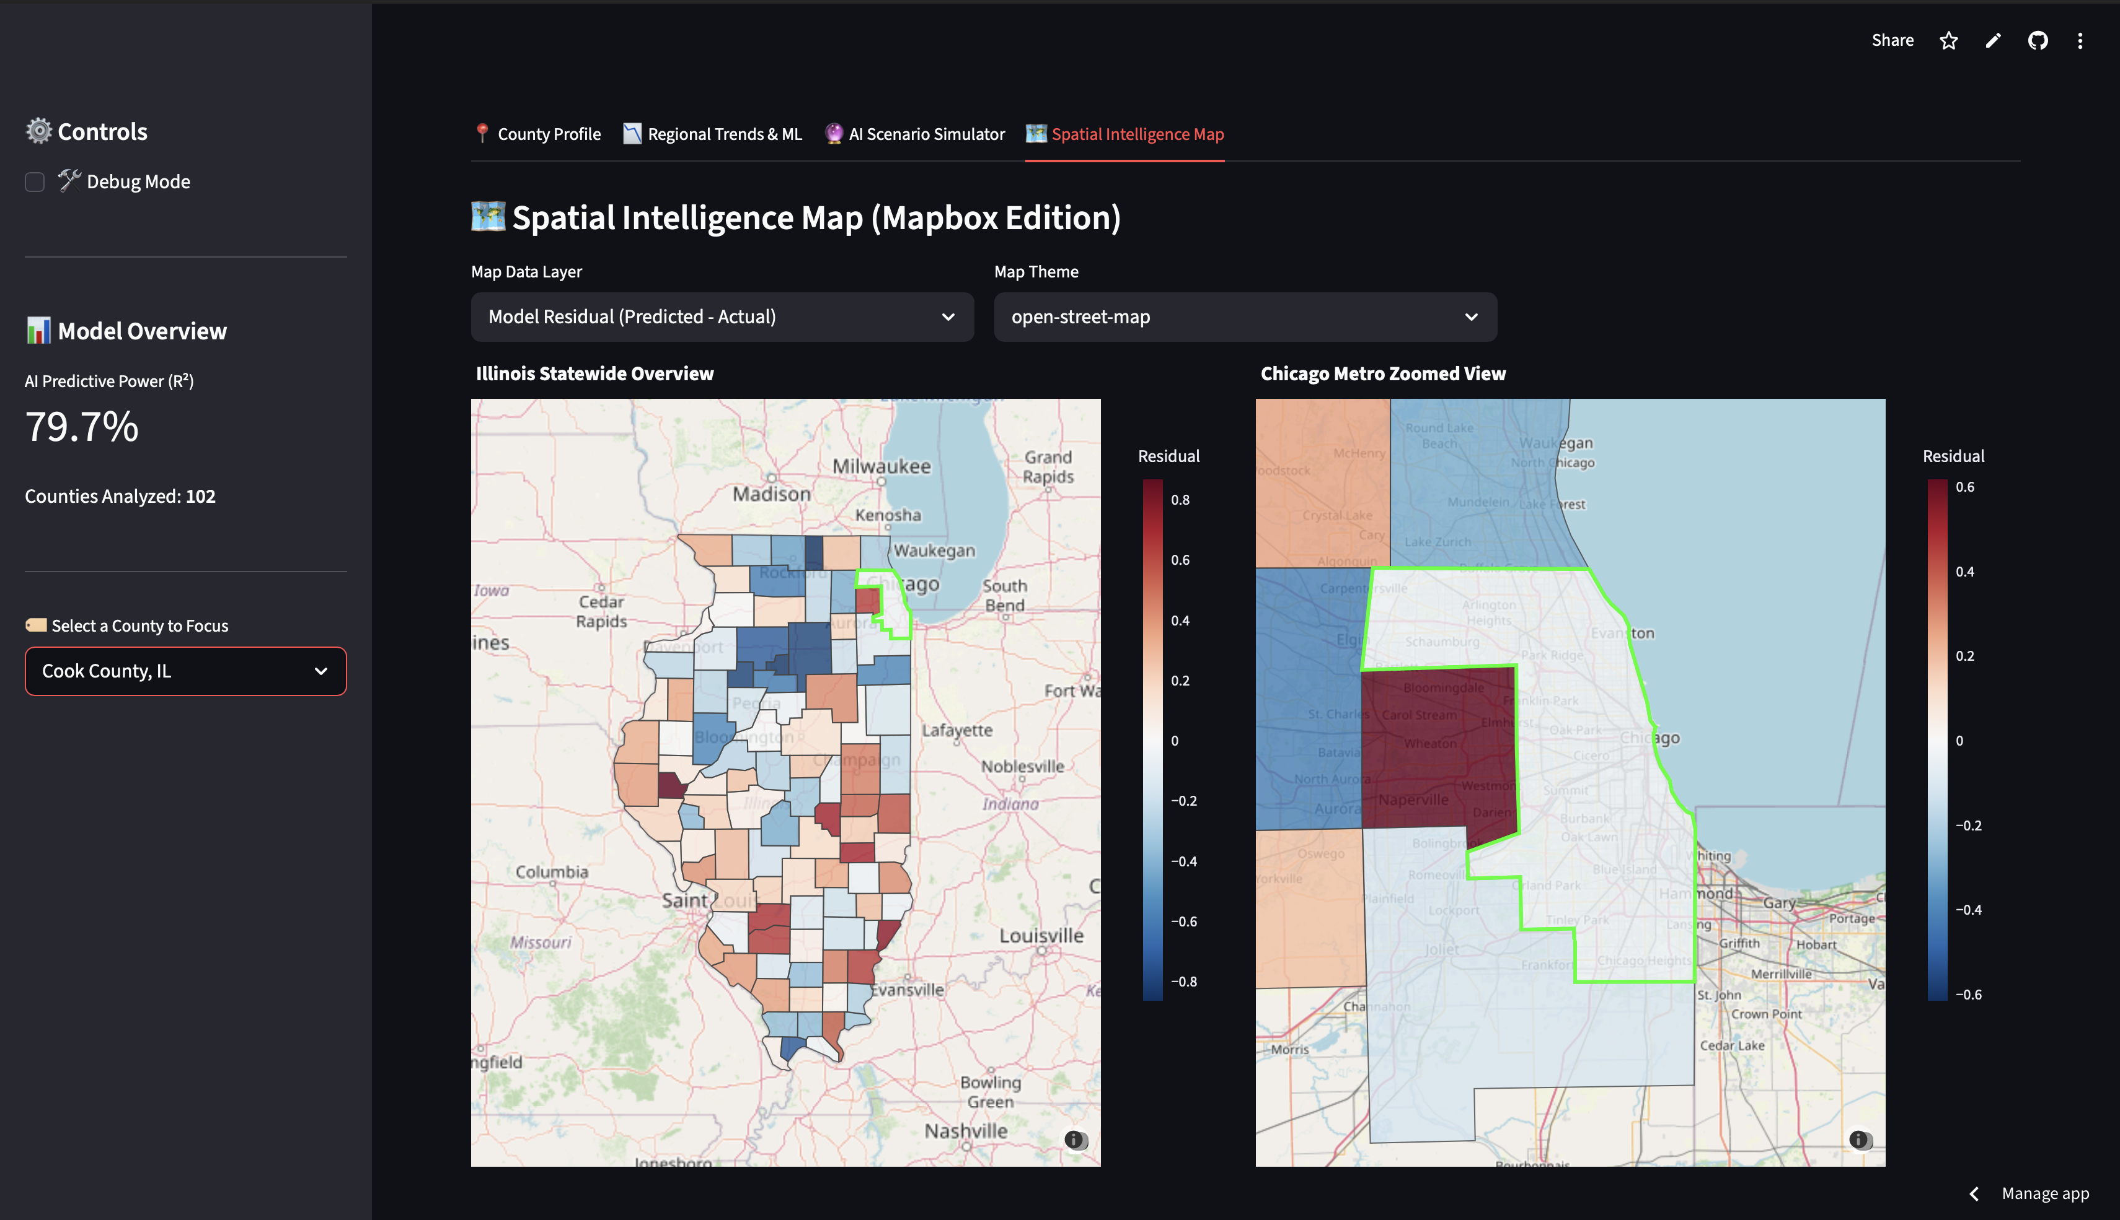
The Random Forest model achieved a strong R², confirming that the seven features explain a substantial share of county-level unemployment variance. Both models consistently identified Poverty Rate and Labor Force Participation as the dominant drivers. Residual mapping revealed that several southern Illinois counties persistently underperform model expectations, suggesting structural factors—such as infrastructure gaps or industry decline—not fully captured by census demographics. Overall, this project transforms fragmented public data into a cohesive, interactive policy tool that integrates econometric rigor with machine learning, demonstrating how modern data visualization can elevate raw statistics into actionable economic intelligence.

