AI Research Report II: Enterprise Data Q&A Agent Architecture（AI 调研报告（二）：企业数据问答 AI 架构全景）
Last updated: 23 October 2026
This report reviews the architecture of enterprise data Q&A agents. It first explains seven core capability modules, then compares end-to-end system shapes and representative technology stacks, and finally recommends an approach for the company’s current stage. Each research table includes a plain-language definition and traceable sources.

0. Report Structure（报告框架与章节关系）

Architecture at a Glance: 3 Online Modules + 3 Cross-cutting Modules + 1 Offline Improvement Loop（行业架构分析框架：3 个在线模块 + 3 个横向支撑模块 + 1 个离线闭环）
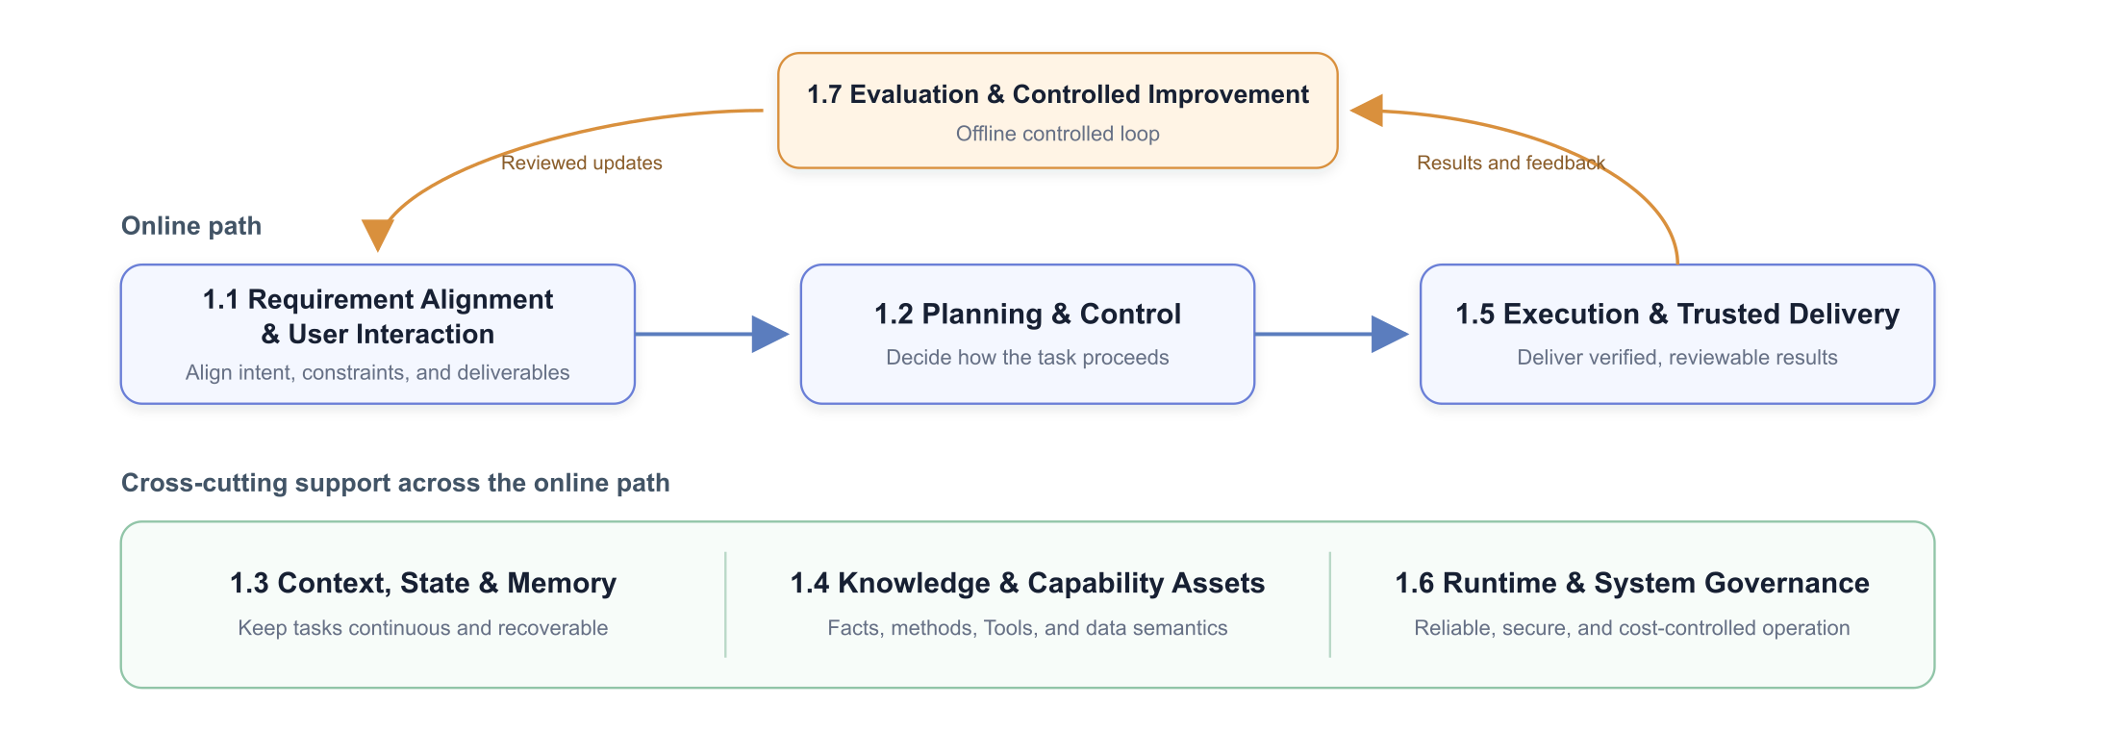
The online path turns a user request into a verifiable result. Three cross-cutting modules provide context, knowledge, tools, runtime reliability, and governance throughout the task. The offline loop improves the other six modules using production evidence. These are capability boundaries—not necessarily seven services or seven sequential steps.
Capability（方案 / 能力） | What is it? | Problem addressed | Strengths | Trade-offs / limits | Architectural role | Representative sources
Requirement Alignment & User Interaction（需求对齐与用户交互） | Converts natural-language requests into confirmed goals, scope, and deliverables. | Ambiguity and missing conditions. | Prevents execution on incorrect assumptions. | Excessive clarification slows users down. | Entry to the online path. | Microsoft: Map agent flows
Task Planning & Control（任务规划与控制） | Decides where a task goes, what happens next, when to replan, and when to stop. | Uncertain multi-step paths. | Balances autonomy, cost, and reliability. | Autonomous loops vary in cost and latency. | Decision center of the online path. | Anthropic: Building Effective Agents
Execution & Trusted Delivery（执行与可信交付） | Safely runs SQL, code, and tools, validates results, and delivers answers, tables, and charts. | Successful execution does not guarantee a correct business result. | Produces reviewable, reproducible outputs. | Requires validation and artifact management. | Output end of the online path. | Google: Data Science Agents
Context, State & Memory（上下文、状态与记忆） | Maintains the current goal, confirmed constraints, SQL history, results, next action, and approved cross-task information. | The model forgets prior decisions or work. | Improves continuity and recoverability. | Requires explicit state and update rules. | Cross-cutting support for task control. | Google ADK: Sessions, State and Memory
Knowledge & Capability Assets（知识与能力资产） | Manages Knowledge, Skills, Tools, data semantics, and dependencies. | Facts, procedures, and actions are mixed in long documents. | Reusable, versionable, and progressively loadable. | Requires ongoing governance. | Supports task control and execution. | Anthropic: Agent Skills · MCP Architecture
Runtime & System Governance（运行与系统治理） | Provides persistence, scheduling, retries, permissions, sandboxing, tracing, and cost controls. | Modules cannot operate reliably or safely together. | Makes the system operable, recoverable, and governable. | A full platform is expensive to build. | Cross-cutting foundation for the online path. | LangGraph: Durable Execution
Evaluation & Controlled Improvement（评测与受控改进） | Converts traces, human feedback, and evaluations into reviewed system changes. | Ad hoc prompt edits do not prevent regressions. | Turns experience into measurable improvement. | Requires datasets, review, and release discipline. | Offline improvement loop. | OpenAI: Agent Improvement Loop

The remainder of the report has four layers: Section 1 reviews industry options within each capability; Section 2 compares end-to-end agent shapes; Section 3 maps frameworks and platforms to these capabilities; Section 4 makes company-specific recommendations.

1. Industry Approaches Across the Seven Capabilities（七项能力的行业方法）
An enterprise data Q&A agent needs all seven capabilities, but each can evolve independently. Clear state, asset, and interface boundaries are more important than forcing every capability into a separate service.

1.1 Requirement Alignment & User Interaction（需求对齐与用户交互）
This module aligns the agent and the user. It does not own planning, SQL execution, or result validation. It covers requirement confirmation before execution and the minimum status, approval, and correction interactions needed during and after execution.
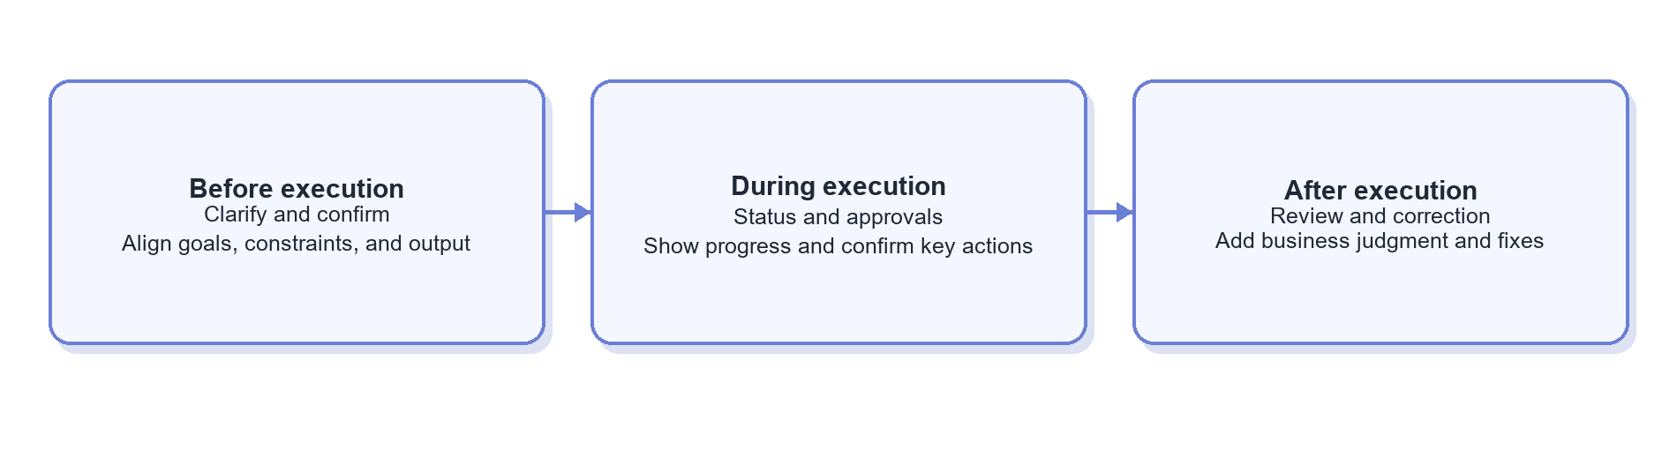

1.1.1 Request Intake: Forming a Task Contract（需求进入：如何形成任务契约）
Approach / capability（方案 / 能力） | What is it? | Problem addressed | Strengths | Trade-offs / limits | Best fit / adoption conditions | Representative sources
Free-form chat（自由聊天） | The model infers constraints from an ongoing conversation. | Lowest-friction Q&A. | Natural and fast to start. | Critical conditions stay implicit and may be lost. | Low-risk exploration. | OpenAI: Session Memory
Proactive clarification（主动澄清） | The agent asks for missing time ranges, metrics, dimensions, scope, or deliverables. | Missing conditions that change the answer. | Prevents work based on unsafe assumptions. | Too many questions degrade experience. | Metric-sensitive tasks; ask only when the answer would change. | Microsoft: Map agent flows
Slot filling（Slot Filling / 参数收集） | Maps a request to predefined fields and fills gaps. | Stable input structure for repeated tasks. | Easy to validate and connect to workflows. | Poor fit for open-ended analysis. | High-volume standardized requests. | Microsoft: Map agent flows
Structured task contract（结构化任务契约） | Stores goal, metric, time, scope, constraints, and output as a JSON/state object. | Later steps interpret the task differently. | Gives every step one shared definition. | Needs update and confirmation rules. | Multi-step analysis; recommended. | Microsoft: Map agent flows
Form-based confirmation（表单化确认） | A UI shows parsed parameters for user review and editing. | The model silently invents key conditions. | Verifiable and auditable. | Adds UI development. | Important metrics or high-risk queries. | Microsoft: Human-in-the-loop

1.1.2 Progress Presentation: What the User Sees（过程呈现：用户能看到什么）
Approach / capability（方案 / 能力） | What is it? | Problem addressed | Strengths | Trade-offs / limits | Best fit / adoption conditions | Representative sources
Final answer only（仅最终答案） | Returns one response when the task ends. | Lowest-cost delivery. | Simple. | Long tasks are opaque. | Simple tasks completed in seconds. | Microsoft: Map agent flows
Token streaming（逐字流式输出） | Streams generated text. | Perceived first-token delay. | Immediate interaction. | Does not express structured task state; total duration is unchanged. | Standard conversational answers. | OpenAI: Agents API Architecture
Step / event streaming（步骤与事件流） | Shows high-level retrieval, tool, SQL, and validation events—not hidden reasoning. | Users cannot tell whether a task is progressing. | Transparent and observable. | Event granularity and redaction require design. | Multi-step analysis; show only meaningful states. | AG-UI
Generative UI / AG-UI（生成式界面与交互协议） | The agent emits tables, charts, forms, approvals, and artifact events for dynamic rendering. | Text alone cannot support an analysis workspace. | Interactive and approval-ready. | More complex UI protocol and permissions. | Productized analytics workbenches. | AG-UI

1.1.3 Human-in-the-loop: Where People Intervene（Human-in-the-loop：人在哪些节点介入）
Approach / capability（方案 / 能力） | What is it? | Problem addressed | Strengths | Trade-offs / limits | Best fit / adoption conditions | Representative sources
Clarification gate（澄清门） | Pauses when a critical condition is missing. | The agent cannot infer safely. | Stops bad inputs from propagating. | Adds an interaction round. | Task intake. | Microsoft: Human-in-the-loop
Plan approval gate（计划审批门） | Shows the plan, expected scope, or cost before execution. | High-risk plans proceed without review. | Corrects direction before cost is incurred. | Too much approval slows work. | Large scans and complex tasks. | Microsoft: Magentic plan review
Action approval gate（动作审批门） | Requires approval only for writes, sensitive data, or over-budget actions. | High-risk tool calls. | Targets human effort precisely. | Requires accurate risk classification. | Exports, write operations, and sensitive fields. | Microsoft: Human-in-the-loop
Result review / correction（结果审核与纠错） | Users review tables, charts, and conclusions; corrections feed the task and offline evaluation. | Results need business judgment. | Improves both current and future performance. | Feedback must be structured. | Formal analytical delivery. | OpenAI: Agent Improvement Loop
Human takeover（人工接管） | Transfers the task with full state and evidence when automation cannot proceed safely. | Long-tail cases exceed safe automation. | Graceful fallback without losing context. | Needs ownership and an operating queue. | Low confidence, conflicting definitions, or access issues. | Microsoft: Human-in-the-loop

1.2 Task Planning & Control（任务规划与控制）
This module decides task direction, execution order, completion criteria, and replanning. Industry practice has moved beyond pure ReAct toward explicit plans, structured ledgers, rolling planning, stall detection, and human review. Process persistence and failure recovery belong to the runtime layer in Section 1.6.
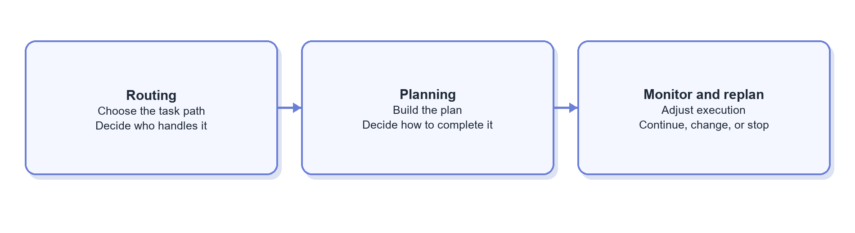

1.2.1 Routing: Choose the Task Path, Not the Exact Skill（Routing：判断任务去向，而不是发现具体 Skill）
Routing identifies task type, handling path, and risk. It has two independent dimensions: decision mechanism and routing depth. Skill/Tool matching belongs to the capability registry in Section 1.4; content loading belongs to context assembly in Section 1.3.
Routing decision mechanisms
Approach / capability（方案 / 能力） | What is it? | Problem addressed | Strengths | Trade-offs / limits | Best fit / adoption conditions | Representative sources
Explicit entry point（显式入口路由） | The user selects “knowledge Q&A,” “data query,” “chart,” etc. | Model-only classification is unstable. | Accurate and model-free. | Adds user effort; categories must stay broad. | Few, clearly bounded task types. | Anthropic: Routing
Rule-based routing（规则路由） | Uses commands, keywords, data types, or risk levels. | Common explicit requests need fast handling. | Fast, cheap, explainable. | Weak on natural-language long tails. | First layer for high-confidence cases. | Anthropic: Routing
Model classification（模型分类路由） | A small or primary model emits task type, risk, and confidence. | Ambiguous language exceeds rules. | Strong semantic coverage. | Adds a call; errors cascade. | Once task categories are reasonably stable. | Anthropic: Routing
Hybrid routing（混合路由） | Rules handle clear cases; a model handles the rest; low confidence falls back to a general agent. | No single method covers accuracy, cost, and long tails. | Combines deterministic and semantic decisions. | Needs priority, confidence, and conflict rules. | Mix of common requests and open-ended language. | Anthropic: Routing

Routing structures
Approach / capability（方案 / 能力） | What is it? | Problem addressed | Strengths | Trade-offs / limits | Best fit / adoption conditions | Representative sources
Flat routing（单层 / 扁平路由） | Classifies once among a small set such as knowledge, data analysis, or other. | Few categories do not need hierarchy. | Simple, fast, easy to evaluate. | Boundaries blur as categories grow. | Small, stable route set. | Anthropic: Routing
Hierarchical routing（分层路由） | Narrows scope in stages—for example task family, then business domain or risk. | One classifier faces too many labels. | Each decision is simpler and separately testable. | Adds latency and error propagation. | Introduce only when domains grow; the final route should still identify a candidate scope, not preload every Skill. | Microsoft: Agentic RAG

Routing output should stay compact: task_type, domain, risk, and candidate capability scope. A registry then finds candidate Skills/Tools, and context assembly loads only what is needed. Routing should not hard-code every execution step.

1.2.2 Planning: How Plans Are Created and Represented（Planning：计划如何生成和表示）
Planning options combine three dimensions: when to plan (upfront or rolling), how to represent the plan (text, structured list, DAG/state graph), and who executes it (the same agent, an executor, or workers).
Approach / capability（方案 / 能力） | What is it? | Problem addressed | Strengths | Trade-offs / limits | Best fit / adoption conditions | Representative sources
Implicit planning / ReAct（隐式规划 / ReAct） | The model chooses the next action after each observation without emitting a full plan. | Short, open-ended tasks. | Flexible and low-overhead. | Goals, dependencies, and completion criteria are easy to lose. | Simple Q&A and short data requests. | Google ADK: PlanReActPlanner
Natural-language checklist（自然语言 Checklist） | Creates a short to-do list and marks progress. | The model forgets remaining work. | Lightweight and readable. | Dependencies and state are hard to validate. | Few-step tasks prone to omission. | Anthropic: Structured note-taking
Structured task plan（结构化任务计划） | Uses JSON/Schema for goals, steps, dependencies, inputs, outputs, state, and completion criteria. | Plans cannot be persisted or validated. | Testable, observable, and updateable. | Overly rigid schemas constrain the model. | Multi-SQL or multi-artifact tasks. | Microsoft: Magentic task ledger
Plan-and-execute（先规划后执行） | A planner creates the plan; an executor follows it. | Complex goals drift during execution. | Separates global intent from local actions. | Initial plans may use incomplete information and add a model call. | Complex analysis with relatively stable dependencies. | Google ADK: Planner
Rolling-horizon / adaptive planning（滚动式与自适应规划） | Plans only near-term steps and revises after new evidence. | Early information is incomplete. | Adapts to data and execution errors. | Needs loop protection. | Exploratory analysis; useful later-stage enhancement. | Microsoft: Adaptive planning
Task-ledger planning（任务账本规划） | Tracks goals, facts, subtasks, progress, stalls, and the next actor. | Long tasks cannot tell whether progress is real. | Supports stall detection, replanning, and audit. | Heavy for simple tasks. | Long or complex tasks. | Microsoft: Magentic orchestration
DAG / graph planning（有向图规划） | Represents tasks as dependency graphs and runs independent nodes in parallel. | Complex dependencies and parallel opportunities. | Makes dependencies explicit. | Graph generation and runtime are more complex. | Stable complex pipelines. | LangGraph
Hierarchical planning（分层规划） | Decomposes goals into subgoals for specialized workers or subagents. | One planning context becomes too large. | Supports focus, specialization, and parallelism. | Handoffs and aggregation are costly. | Only after a clear multi-agent need. | Anthropic: Orchestrator-workers
Human-reviewed planning（人工审核规划） | Presents plans before expensive or sensitive execution. | High-risk plans run unchecked. | Makes risk visible before action. | Adds approval latency. | Large scans, sensitive data, or formal reports. | Microsoft: Magentic plan review

These options combine naturally: short tasks use implicit planning or a checklist; tasks spanning many tables, queries, or deliverables can adopt a structured plan or ledger; uncertain environments favor rolling planning over a fixed upfront plan.

1.2.3 Execution Monitoring, Completion, and Replanning（执行监控、完成判断与 Replan）
Approach / capability（方案 / 能力） | What is it? | Problem addressed | Strengths | Trade-offs / limits | Best fit / adoption conditions | Representative sources
Fixed stop conditions（固定停止条件） | Ends by completed steps, tool calls, time, or token limits. | Infinite loops and runaway cost. | Simple and deterministic. | Tight limits may stop valid work. | Required for every production agent. | Microsoft: Agent design patterns
Result-driven replanning（结果驱动 Replan） | SQL errors, empty results, or incomplete coverage trigger a plan update. | The plan conflicts with real data. | Uses environmental feedback directly. | Needs structured errors and result checks. | Primary replanning mode for data Q&A. | Google: Data Science Agents
Stall / loop detection（停滞与循环检测） | Detects repeated tools, no progress, or repeated errors and resets, reroutes, or stops. | The agent loops on a bad path. | Controls cost and improves explainability. | “No progress” can misclassify legitimate exploration. | Long tasks and agentic SQL. | Microsoft: Magentic progress ledger
Evaluator–optimizer（评估器—优化器） | Rules or a reviewer agent checks whether results meet the goal and requests revisions. | Execution completes but quality is insufficient. | Separates generation from completion judgment. | Evaluators can also be wrong and add cost. | SQL and reports with explicit checks. | Anthropic: Evaluator-optimizer
Human escalation / clarification（人工升级 / Clarification） | Requests a user decision when confidence is low or definitions conflict. | The agent should not guess critical business conditions. | Stops automated error propagation. | Interrupts the experience. | Metric conflicts, access issues, or critical ambiguity. | Microsoft: Human-in-the-loop

1.3 Context, State & Memory（上下文、状态与记忆）
Context assembly decides what the model sees in each turn. Task State stores changing goals, constraints, and execution records for the current task. Memory stores information approved for reuse across sessions. Knowledge holds authoritative organizational facts; Skills hold versioned methods. These objects have different lifecycles, trust levels, and owners.
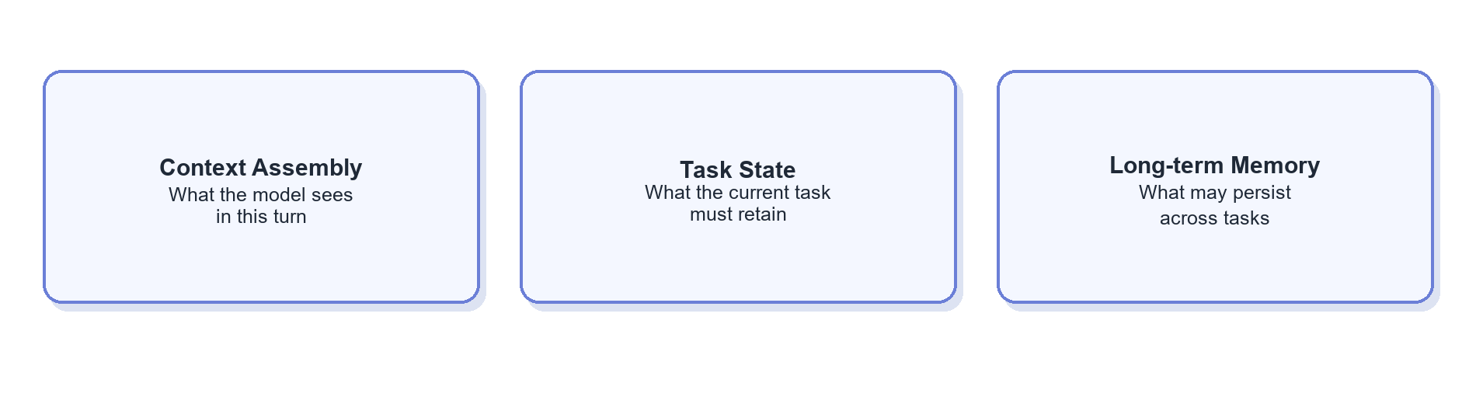

1.3.1 Context Assembly: What the Model Sees Each Turn（Context Assembly：每一轮让模型看到什么）
Context controls are composable. Progressive loading defines when content enters the prompt: first an index or summary, then the matched body, and finally references, schemas, scripts, or raw artifacts only when needed.
Approach / capability（方案 / 能力） | What is it? | Problem addressed | Strengths | Trade-offs / limits | Best fit / adoption conditions | Representative sources
Full context（全量上下文） | Places as much chat, documentation, and tool output as possible in the prompt. | Fear of missing information. | Simple with high recall. | Expensive and highly distracting. | Only very short tasks. | Anthropic: Context Engineering
Sliding window（滑动窗口） | Keeps only the most recent turns. | Unbounded history growth. | Fast and cheap. | Drops early critical constraints. | General chat, not reliable task state. | Anthropic: Context Engineering
Summarization / compaction（摘要 / Compaction） | Compresses earlier history before continuing. | Long tasks exceed context limits. | Preserves continuity at lower token cost. | Irreversibly loses detail. | Medium or long tasks; pair with structured state. | Anthropic: Compaction
Tool-result clearing（工具结果清理） | Keeps conclusions or references while removing older raw outputs. | Tool results crowd the context. | Low-risk token savings. | Details must be re-read later. | Large SQL results, schemas, or logs. | Anthropic: Tool result clearing
On-demand / progressive loading（按需 / 渐进式上下文加载） | Starts with names, summaries, and IDs; loads bodies and deeper resources only when selected. | Too many Knowledge, Skill, and Tool definitions are preloaded. | Keeps context focused while retaining traceability. | Adds retrieval steps; weak descriptions reduce recall. | Large or lengthy capability catalogs. | Anthropic: Just-in-time context · Anthropic: Skill progressive disclosure
Structured Context Builder（结构化 Context Builder） | Assembles fixed sections from state, route, permission, and token budget each turn. | Context selection is entirely improvised by the model. | Observable, testable, and prioritized. | Requires assembly logic and budgets. | Productization stage. | Microsoft Agent Framework: Context providers
Subagent context isolation（子 Agent 上下文隔离） | Gives a subtask a separate context and returns only a compressed result. | Search or analysis noise pollutes the main task. | Isolates noise and enables parallelism. | Summaries lose information and calls cost more. | Independent, noisy, or permission-isolated subtasks. | Anthropic: Sub-agent context

Routing and the capability registry only define a candidate scope. Context Assembly decides what actually enters the prompt. The same Skill may be represented by a summary, a full SKILL.md, or a specific reference—these are loading depths, not different routes.

1.3.2 Task State: Prevent Forgetting and Backtracking（Task State：让任务不遗忘、不倒退）
Approach / capability（方案 / 能力） | What is it? | Problem addressed | Strengths | Trade-offs / limits | Best fit / adoption conditions | Representative sources
Implicit chat state（隐式聊天状态） | Relies only on chat history for goals and progress. | Lowest-cost continuity. | No extra system. | Easy for the model to miss or overwrite. | Simple tasks only. | Google ADK: Sessions
Structured working state（结构化 Working State） | Explicitly stores goal, constraints, plan, knowledge used, SQL, result references, and next action. | Forgotten conditions, SQL, and goal drift. | Verifiable, updateable, recoverable. | Requires fields and write rules. | Multi-step or multi-tool tasks. | Google ADK: State
Task ledger（任务账本） | Adds facts, subtasks, completion criteria, stalls, and plan changes. | Complex tasks cannot prove progress. | Auditable and loop-aware. | Too heavy for simple tasks. | Later-stage complex work. | Microsoft: Magentic task ledger
Artifact references（产物引用） | Stores IDs for SQL, result tables, charts, and files instead of copying full content. | Large results pollute context and versions become unclear. | Lightweight, traceable, and reloadable. | Needs an artifact store and permissions. | Data queries and charting; build alongside state. | OpenAI: Agent Improvement Loop
Checkpoint / durable state（检查点与可恢复状态） | Saves recoverable snapshots at key steps. | Failures, approvals, and waits lose progress. | Supports pause, resume, and fault recovery. | Adds serialization, migration, and runtime cost. | Long or approval-based tasks. | LangGraph: Durable Execution

A minimum Task State should include goal, confirmed_constraints, selected_knowledge, plan, sql_history, result_refs, open_questions, next_action, and completion_status.

1.3.3 Long-term Memory: What Should Persist Across Tasks（Long-term Memory：跨任务应该记住什么）
Approach / capability（方案 / 能力） | What is it? | Problem addressed | Strengths | Trade-offs / limits | Best fit / adoption conditions | Representative sources
Profile / semantic memory（用户画像与语义记忆） | Stores user preferences, stable environment information, and currently valid facts. | Repeatedly restating preferences. | High-signal and cheap to inject. | Can expire; raises privacy and scope questions. | Clear cross-session preferences. | Microsoft: Semantic memory
Episodic memory（情景记忆） | Stores what happened in a past task and its outcome. | Past experience cannot be reused. | Supports history and case retrieval. | Old cases may no longer apply. | Retrieve on demand after enough history exists. | AWS: Agent memory definitions
Procedural memory（程序性记忆） | Stores experience-derived methods not yet promoted to formal Skills. | Similar tasks are repeatedly rediscovered. | Enables learning from experience. | Overlaps Skills; automatic generation is risky. | Keep as candidates; publish as Skills after review. | Microsoft: Procedural memory
Session search（历史会话检索） | Indexes prior sessions for keyword or semantic retrieval. | A single summary misses historical detail. | Preserves original evidence. | May retrieve irrelevant or sensitive content. | Incident review and repeated analysis. | Hermes Agent: Session and memory
Automatic memory extraction（自动 Memory Extraction） | A model selects information to retain after each task. | Manual memory capture is expensive. | Accumulates automatically. | Easily stores errors, trivia, or sensitive data. | Only with strict write policy and review. | OpenAI Agents SDK: Memory
Reviewed writes and forgetting（审批式写入与遗忘） | Candidate memories are reviewed or rule-checked and support TTL, scope, and deletion. | Memory pollution and privacy risk. | Governable and correctable. | Adds operating overhead. | Recommended enterprise pattern. | Microsoft: Memory governance

Authoritative business definitions and table metadata belong in Knowledge, not personal or agent Memory. Stable operating methods belong in reviewed Skills. Memory should retain only cross-task information that is allowed to expire or be deleted.

1.4 Knowledge & Capability Assets（知识与能力资产）
This module separates enterprise facts, task methods, deterministic actions, data-query constraints, and connection standards. Knowledge explains what is true; Skills describe how to perform tasks; Tools execute actions; Data Semantics constrain business concepts to queryable objects; protocols connect these assets across environments.
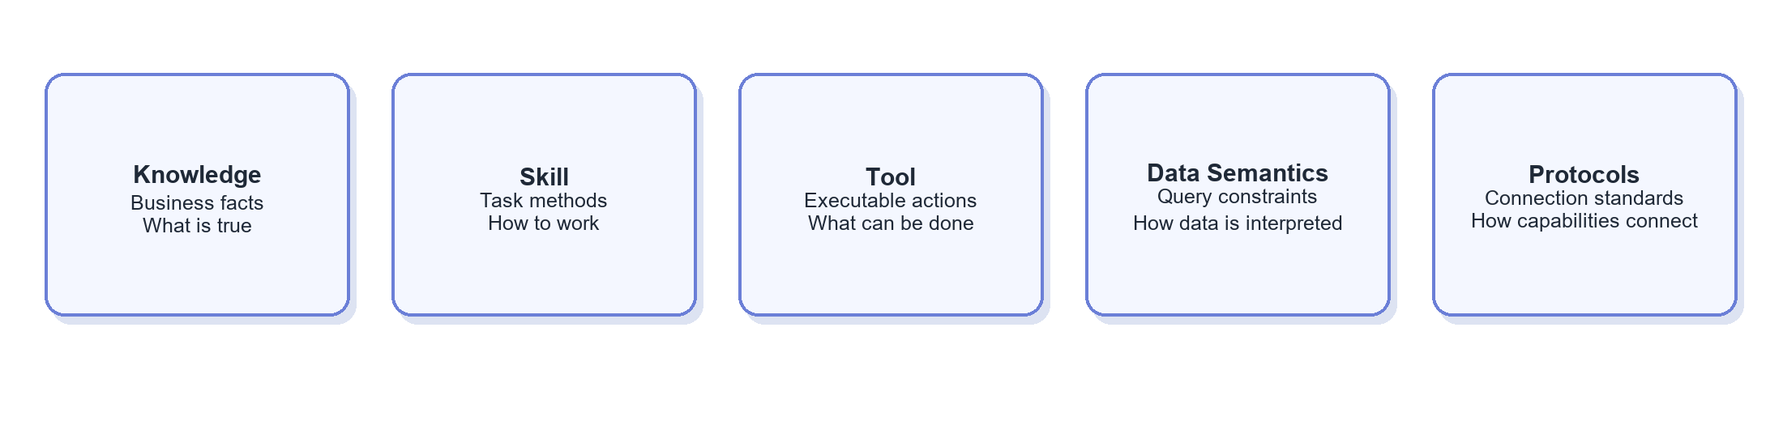

1.4.1 Knowledge: Organizing Enterprise Facts（Knowledge：企业事实如何组织）
Approach / capability（方案 / 能力） | What is it? | Problem addressed | Strengths | Trade-offs / limits | Best fit / adoption conditions | Representative sources
Long-document hub（长文档中心） | One large document contains background, definitions, tables, and SQL for a domain. | Rapidly centralizes knowledge. | Easy to start and human-readable. | Agents get lost; duplication and conflicts are hard to govern. | Legacy pattern; split gradually. | Anthropic: Context Engineering
Templated documents（模板化文档） | Metrics, tables, events, and domains use fixed sections and metadata. | Inconsistent document structure. | Easier search and review with modest migration cost. | Entities remain embedded in documents. | Low-cost improvement to an existing wiki. | Google Dataplex: Business Glossary
Modular atomic knowledge（模块化原子知识） | Metrics, dimensions, tables, fields, events, terms, and cases become reusable units. | The same fact is redefined in many documents. | Single-source maintenance and composability. | More files require naming and navigation standards. | Knowledge is reused across tasks or documents. | Anthropic: Progressive disclosure
Structured business objects（结构化业务对象） | Metrics, terms, synonyms, assets, and relations become objects with stable IDs. | Plain text cannot map concepts reliably. | Validatable, linkable, and tool-queryable. | Requires schemas and maintenance workflows. | Gradually structure core metrics, dimensions, and tables. | Google Dataplex: Glossary
Metadata / context platform（元数据 / Context Platform） | Unifies business and technical metadata, lineage, quality, permissions, and query cases. | Context is fragmented across wiki, code, and platforms. | Provides a unified data context. | High integration and operating cost. | After data governance matures. | Google Agentic Data Cloud
Knowledge graph（知识图谱） | Explicitly models metrics, tables, fields, events, teams, and dependencies. | Multi-hop relationships and impact analysis are difficult. | Intuitive relationship and lineage queries. | Expensive to model and maintain. | Only when relationship queries show recurring value. | Microsoft GraphRAG

1.4.2 Skill: A Better Organization Model（Skill：更好的组织方式是什么）
A mature Skill system combines one clear task entry point, declared dependencies, layered content, a searchable registry, executable resources, versioning, and evaluation. These are complementary design dimensions. Renaming a long document as a Skill does not improve selection or execution.
Approach / capability（方案 / 能力） | What is it? | Problem addressed | Strengths | Trade-offs / limits | Best fit / adoption conditions | Representative sources
Monolithic Skill（单体大 Skill） | One Skill contains all background, definitions, steps, and SQL for a domain. | Fast migration of existing manuals. | Easy to create. | Repeats the long-document problem. | Transitional only. | Anthropic: Skill progressive disclosure
Single-responsibility Skill（单一职责 Skill） | Each Skill has one clear task and deliverable, such as revenue by device model. | Skills overlap or have unclear boundaries. | Easy to select, test, and reuse. | Creates more Skills. | Recommended default granularity. | Anthropic: Agent Skills
Composite / orchestrator Skill（组合 / Orchestrator Skill） | A high-level entry Skill calls reusable sub-Skills or Knowledge. | Complex tasks need several capabilities. | Avoids duplication and supports composition. | Poor orchestration can hide complexity. | A business task has stable reusable sub-capabilities. | Anthropic: Skill composition
Dependency-declared Skill（依赖声明式 Skill） | Metadata lists required/optional Knowledge, Tools, permissions, and prerequisites. | The agent does not know what else to load. | Dependencies become explicit and pre-checkable. | Needs stable IDs, a registry, and resolution logic. | Skills reuse shared knowledge or controlled Tools. | Anthropic: Skills and bundled resources
Layered Skill package（分层 Skill Package） | Separates name/summary, SKILL.md, and deeper references/scripts. | Too many or overly long Skills. | Small entry point with traceable detail. | Requires Context Assembly to realize progressive loading. | Recommended directory standard. | Anthropic: Progressive disclosure
Namespace / registry（命名空间 / Registry） | Maintains stable ID, domain, task type, description, tags, owner, and permissions; returns candidate Skills by route, filters, or similarity. | Dozens or hundreds of Skills are hard to manage. | Enables discovery, access control, ownership, and governance. | Weak metadata causes missed or wrong matches. | As Skill count grows; this is capability discovery, not task routing. | Hermes Agent: Skills · OpenAI: Tool Search
Executable Skill（可执行 Skill） | Bundles validation scripts, templates, or deterministic code. | Text instructions still miss stable checks. | Makes repeatable steps consistent. | Scripts need tests, security, and versioning. | SQL validation, chart templates, result checks. | Anthropic: Agent Skills
Versioned / permissioned Skill（版本化 / 权限化 Skill） | Adds version, owner, review date, allowed tools, permissions, and evaluations. | Changes are untraceable and ownership is unclear. | Supports review, staged rollout, and rollback. | Adds governance overhead. | Production Skills should acquire these controls. | OpenAI: Agent Improvement Loop
Auto-generated / self-improving Skill（自动生成 / 自改进 Skill） | The agent proposes new or modified Skills from experience. | Successful patterns are not captured automatically. | Speeds learning. | Can institutionalize errors. | Candidate generation only; evaluate and review before release. | Hermes Agent: Skills

The relationship is simple: routing narrows task scope; the registry finds candidate Skills within that scope; Context Assembly progressively loads the selected Skill package. Skill discovery is not a routing type, and progressive loading is not a Skill type.
Example layered Skill package:
skills/
revenue/
device_breakdown/
SKILL.md # Scope, goal, suggested process, completion criteria
manifest.yaml # ID, version, owner, triggers, dependencies, permissions, output
references/
exceptions.md # Loaded only for exception cases
sql_patterns.md # Loaded only when SQL examples are needed
scripts/
validate_result.sql # Deterministic validation
evals/
cases.yaml # Representative success and failure cases

knowledge/
metrics/revenue.md
dimensions/device_model.md
datasets/revenue_tables.md
operations/device_model_refresh.md
At minimum, manifest.yaml should include id, summary, when_to_use, when_not_to_use, required_knowledge, optional_knowledge, allowed_tools, required_inputs, outputs, completion_checks, version, owner, and last_reviewed.

1.4.3 Tool: Organizing Executable Actions（Tool：动作能力如何组织）
Approach / capability（方案 / 能力） | What is it? | Problem addressed | Strengths | Trade-offs / limits | Best fit / adoption conditions | Representative sources
Coarse business Tool（粗粒度业务 Tool） | One Tool completes an entire business action. | Too many tool-call rounds. | Few calls and stable flow. | Opaque, less reusable, broad permissions. | Stable, low-risk packaged workflows. | OpenAI: Tools
Fine-grained atomic Tool（细粒度原子 Tool） | Exposes schema lookup, SQL validation, execution, and charting separately. | Need composition, auditability, and least privilege. | Clear, reusable, observable boundaries. | More Tools create selection and latency costs. | Core data-Q&A actions; recommended. | Google: Data Science Agents
Strongly typed Tool schema（强类型 Tool Schema） | Defines required fields, enums, types, and constraints. | Hallucinated parameters and parsing failures. | Validatable, UI-ready, auditable. | Overly narrow schemas reduce flexibility. | Every production Tool. | OpenAI: Function calling
Tool group / capability bundle（工具分组与能力包） | Exposes only Tools relevant to the routed domain. | Always-on Tools cause confusion and token cost. | Shrinks the choice set. | Incorrect grouping hides capabilities. | After Tool count grows. | Microsoft: Agentic RAG
Tool search / deferred loading（Tool Search / 延迟加载） | Searches a Tool catalog before loading full schemas. | Large Tool definitions consume context. | Supports large capability catalogs. | Discovery itself needs evaluation. | Dozens or more Tools. | OpenAI: Tool Search
Policy-wrapped Tool（策略封装工具） | Adds permissions, parameter checks, budgets, audit, and approval around the real Tool. | The model directly reaches high-risk operations. | Separates policy from business logic. | Adds gateway work and latency. | Databases and external write actions. | Microsoft: Agentic RAG Security

1.4.4 Data Semantics & Query Context（数据语义与查询上下文：如何将业务概念转成可执行约束）
This area manages machine-readable constraints for query generation. Knowledge owns authoritative definitions; data semantics convert them into queryable constraints. Wikis, glossaries, and knowledge graphs belong to Knowledge; Golden SQL belongs to retrieved examples or Skill resources; SQL generation and execution belong to Section 1.5.
Approach / capability（方案 / 能力） | What is it? | Problem addressed | Strengths | Trade-offs / limits | Best fit / adoption conditions | Representative sources
Business concept mapping（业务概念映射） | Maps user wording, synonyms, and terms to stable metric, dimension, event, or asset IDs. | “Revenue,” “sales,” and “GMV” do not resolve consistently. | Decouples natural language from physical names. | Mappings expire and may be context-dependent. | Core terms have aliases or ambiguity. | Google Dataplex: Glossary
Physical schema metadata（物理 Schema 元数据） | Provides tables, fields, types, partitions, keys, samples, and descriptions. | The model does not know available fields or filters. | Can be harvested from databases. | Explains structure, not business meaning. | Foundation for every Text-to-SQL system. | Google: Data Science Agents
Metric / semantic layer（指标 / Semantic Layer） | Structures formulas, aggregation, time grain, default filters, and valid dimensions. | The model reinvents metric logic each time. | Consistent and governable frequent metrics. | High modeling cost; long-tail work still needs SQL. | Stable, frequently reused core metrics. | Google Agentic Data Cloud
Relationship / Join model（关系与 Join 模型） | Declares keys, cardinality, temporal validity, recommended paths, and prohibited combinations. | Correct fields still produce duplicate or missing rows. | Constrains generation and enables query validation. | Complex history and many-to-many models are hard to maintain. | Join errors become a major failure source. | dbt: Joins · Google Looker: Working with joins
Runtime data context（运行态数据 Context） | Supplies freshness, quality, lineage, owner, and access state. | A semantically correct query uses stale or unavailable data. | Makes selection and explanation reflect actual data state. | Depends on continuously updated metadata and quality systems. | The data platform already produces reliable signals. | Google Agentic Data Cloud

Join Model Example: Supplemental Context（Join 模型案例（Context 补充））
A Join model can give the agent machine-readable grain, keys, cardinality, and validation rules during multi-table queries:
datasets:
- id: fact_order_revenue
grain: order_id
primary_key: order_id
- id: dim_device_model
grain: device_id
primary_key: device_id

relationships:
- id: revenue_to_device_model
from: fact_order_revenue.device_id
to: dim_device_model.device_id
join_type: left
cardinality: many_to_one
allowed_metrics: [revenue]
checks: [right_key_unique, no_unexpected_fanout, revenue_total_reconciles]
owner: device_analytics
Initially, YAML and Markdown can live in the same Wiki/Git repository and reference each other through stable IDs. They contain metadata and rules—not business data.

1.4.5 Protocols: Connecting Modules（协议：模块之间如何互联）
Protocols define communication interfaces; they do not redefine business responsibilities. For example, AG-UI transports events, while Section 1.1 decides which events users should see.
Approach / capability（方案 / 能力） | What is it? | Problem addressed | Strengths | Trade-offs / limits | Best fit / adoption conditions | Representative sources
Function Calling（函数调用） | The model invokes application functions through JSON Schema. | LLM interaction with deterministic code. | Direct, simple, and validatable. | Coupled to the application. | Tool calls within one application. | OpenAI: Tools
MCP（模型上下文协议） | Open protocol for discovering and calling Tools, Resources, and Prompts. | Internal systems are repeatedly integrated by many clients. | Decoupled and reusable with a broad ecosystem. | Does not replace permissions or business semantics. | Connectors must be reused across agents or clients. | MCP Architecture
A2A / Agent Protocol（智能体间通信协议） | Supports collaboration among independently deployed agents. | Agent-to-agent communication lacks a standard. | Cross-team and cross-system collaboration. | Larger black boxes and more complex identity/audit. | Specialized agents are independently deployed. | A2A Protocol
AG-UI（智能体与界面通信协议） | Event protocol between an agent runtime and UI. | Streaming state, approvals, and generative UI lack consistency. | Decouples front and back ends. | Requires event and permission standards. | Building an analytics workbench. | AG-UI

1.5 Execution & Trusted Delivery（执行与可信交付）
This module turns task-control decisions into data operations and reviewable business artifacts. Industry practice has moved from “can it generate SQL?” to “can it execute within policy and resource limits, validate the result, and preserve evidence?”
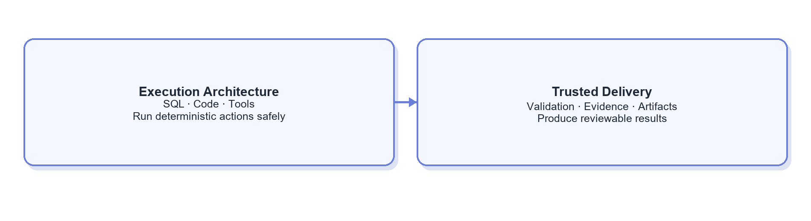

1.5.1 Execution Architecture（执行架构）
Approach / capability（方案 / 能力） | What is it? | Problem addressed | Strengths | Trade-offs / limits | Best fit / adoption conditions | Representative sources
Direct Text-to-SQL（直接 Text-to-SQL） | Generates SQL once from a question and schema. | Simplest natural-language query. | Fast and simple. | Weak on ambiguity, complex metrics, and multi-table work. | Small schemas and low-risk exploration. | Google: Data Science Agents
Retrieval-augmented Text-to-SQL（检索增强 Text-to-SQL） | Retrieves definitions, schema, and historical SQL before generation. | Large schemas and missing business context. | Reduces noise and reuses validated examples. | Stale knowledge or SQL propagates errors. | After knowledge assets improve. | Vanna
Semantic-layer query（语义层驱动查询） | Generates governed metric queries or constrained SQL from metrics, dimensions, and joins. | Inconsistent metric logic. | More stable and governable frequent metrics. | High setup cost; long-tail analysis still needs raw SQL. | Mature core metrics. | Google Dataplex
Agentic SQL（智能体式 SQL） | The agent inspects catalogs/schemas, generates, tests, reads errors, and performs bounded repairs. | Complex exploratory requests. | Covers multi-step and long-tail work. | Slower and costlier; must limit attempts and permissions. | Paths are hard to predefine and bounded trial is acceptable. | Google: Data Science Agents
Controlled query executor（受控查询执行器） | Code checks read-only status, statement type, partitions, scan size, timeout, row count, and output location. | Generated SQL may exceed access or resource limits. | Deterministic, auditable safety independent of model memory. | Must support database dialects and internal policies. | Any agent connected to production or near-production data. | Microsoft: Agentic RAG Security
Code interpreter / sandbox（代码解释器与沙箱） | Runs Python, SQL, and visualization code in isolation. | Complex computation and exploratory visualization. | Flexible for data analysis. | Needs resource, network, and exfiltration controls. | Controlled analytics environments. | Google ADK: Code Execution

1.5.2 Trusted Results & Artifact Delivery（结果可信与产物交付）
Approach / capability（方案 / 能力） | What is it? | Problem addressed | Strengths | Trade-offs / limits | Best fit / adoption conditions | Representative sources
Result validation / reconciliation（结果校验 / Reconciliation） | Checks empty results, scale, time coverage, group totals, anomalies, and key constraints. | SQL succeeds but the business result is wrong. | Deterministic quality assurance. | Critical metrics need explicit checks. | Every formal data delivery. | Google Cortex: Data Product Skills
Sources and evidence chain（来源与证据链） | Records definitions, tables, fields, SQL, runtime, data version, and result references. | Conclusions cannot be explained or reproduced. | Traceable and auditable. | Needs a standard evidence schema. | Every enterprise data answer. | OpenAI: Trace Grading
Artifact-centric delivery（以产物为中心的交付） | Stores tables, charts, reports, SQL, and evidence as versioned artifacts. | Chat messages are not reusable or downloadable. | Supports review, reuse, and retention. | Requires storage, access, and lifecycle governance. | Charts, reports, and formal analysis. | OpenAI: Agent Improvement Loop

Interactive tables, charts, and approvals belong to Section 1.1; synchronous/asynchronous task lifecycle belongs to Section 1.6.1. This module owns the trustworthiness, reviewability, and reusability of delivered content.

1.6 Runtime & System Governance（运行与系统治理）
The runtime keeps agents stable, secure, and economical in production without deciding business goals or task steps. It has four parallel concerns: lifecycle, model access and cost, security, and reliability/observability. Framework products are compared in Section 3.
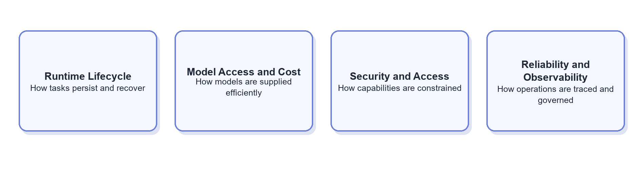

1.6.1 Runtime Lifecycle & Persistence（运行生命周期与持久化）
Approach / capability（方案 / 能力） | What is it? | Problem addressed | Strengths | Trade-offs / limits | Best fit / adoption conditions | Representative sources
Ephemeral in-process run（临时进程内运行） | State exists only in the current process or chat. | Lowest-cost execution for short tasks. | Simple and low-latency. | Hard to recover after interruption. | Tasks completed in seconds without waits or approval. | Google ADK: Sessions
Persistent session / run state（持久化 Session / Run State） | Stores sessions, task state, and execution records externally. | State is lost across turns, restarts, or devices. | Recoverable and auditable. | Needs schemas, concurrency, and expiry rules. | Multi-turn tasks or historical review. | Google ADK: Sessions, State and Memory
Checkpoint / durable execution（检查点与持久化执行） | Saves checkpoints and resumes without repeating side effects. | Long tasks, approvals, and retries duplicate work or lose progress. | Reliable pause, resume, and replay. | Needs idempotency, serialization, and migration. | Long, asynchronous, or approval-based tasks. | LangGraph: Durable Execution
Asynchronous queue and scheduling（异步队列与调度） | Runs long tasks on workers and returns results through IDs, events, or notifications. | Large queries and scheduled work block online requests. | Controls concurrency and supports scheduling. | Adds queues, workers, retries, and lifecycle management. | Highly variable or scheduled task duration. | Temporal

1.6.2 Model Access, Performance & Cost（模型访问、性能与成本）
Approach / capability（方案 / 能力） | What is it? | Problem addressed | Strengths | Trade-offs / limits | Best fit / adoption conditions | Representative sources
Direct model access（直接模型接入） | The application calls one provider directly. | Fast early validation. | Short path and simple debugging. | Multi-model switching, quotas, and cost are fragmented. | Few models and modest scale. | OpenAI: Agents
Model gateway（模型网关） | Centralizes APIs, auth, quotas, fallback, cost, and audit. | Model operations are duplicated across apps. | Central governance and less provider coupling. | Becomes critical infrastructure and a potential bottleneck. | Multiple models, teams, or significant scale. | LiteLLM
Model routing / cascade（模型路由 / Cascade） | Selects models by difficulty, risk, or failure signal and escalates when needed. | Strong models are overused. | Reduces average cost and latency. | Bad downgrades reduce quality; requires evaluation. | Task distribution and quality thresholds are measurable. | Microsoft: Agent Host
Prompt / context cache（提示词与上下文缓存） | Caches stable system prompts, Tool definitions, and shared prefixes. | Repeated input raises cost and first-token latency. | Direct savings with limited behavioral change. | Depends on repetition and stable prefixes. | Long shared context with frequent reuse. | Anthropic: Prompt Caching
Budget and concurrency controls（预算与并发控制） | Caps tokens, tool calls, duration, scan size, and concurrency per task. | Autonomous loops consume uncontrolled resources. | Clear limits by user and task. | Tight limits can stop valid work. | Every production autonomous agent. | Microsoft: Agent design patterns

1.6.3 Security, Permissions & Isolation（安全、权限与隔离）
Approach / capability（方案 / 能力） | What is it? | Problem addressed | Strengths | Trade-offs / limits | Best fit / adoption conditions | Representative sources
Identity propagation and least privilege（身份透传与最小权限） | Maps the real user to Tool, database, row, and column permissions. | The agent uses a shared high-privilege identity. | Security does not rely on model behavior. | Fine-grained identity chains are complex. | As soon as internal data or services are connected. | Microsoft: Agentic RAG Security
Central policy enforcement（集中策略执行点） | Checks permissions, risk, budgets, approvals, and audit rules outside individual Skills/Tools. | Security logic is duplicated and incomplete. | Consistent and easier to update. | Adds a policy layer and latency. | As Tool count and risk types grow. | Microsoft: Agentic RAG Security
Code / data sandbox（代码 / 数据沙箱） | Isolates Python, shell, or visualization code and controls network, files, resources, and data export. | Generated code may damage systems or leak data. | Contains execution risk. | Environment and data exchange are costly. | Any agent allowed to run arbitrary code. | Google ADK: Code Execution
Secret and sensitive-data boundary（密钥与敏感数据边界） | Keeps secrets out of prompts, masks sensitive fields, and scopes trace access and retention. | Credentials or sensitive data leak through prompts and logs. | Covers the full data lifecycle. | Requires classification, masking, and log governance. | Production data or external model services. | Microsoft: Agentic RAG Security

1.6.4 Reliability, Observability & Runtime Governance（可靠性、可观测与运行治理）
Approach / capability（方案 / 能力） | What is it? | Problem addressed | Strengths | Trade-offs / limits | Best fit / adoption conditions | Representative sources
Timeout, bounded retry, and circuit breaker（超时、有界重试与熔断） | Applies error-specific timeouts, finite retries, backoff, and circuit breaking. | Failed dependencies keep consuming resources. | Predictable failure and downstream protection. | Bad thresholds cause false retries or early failure. | Every external dependency. | Microsoft: Agent design patterns
Degradation and human escalation（降级与人工升级） | Returns partial work, asks for clarification, changes path, or transfers full state. | A failed task loses all progress. | Preserves work and makes failure recoverable. | Needs fallback levels and clear ownership. | Low confidence, conflicting definitions, access, or dependency failures. | Microsoft: Human-in-the-loop
Trace / distributed tracing（调用链追踪） | Records route, plan, model, Tool arguments/results, latency, errors, and call relationships. | Failures cannot be localized. | Enables debugging, performance analysis, and evaluation. | Traces may contain sensitive data and cost storage. | From the first multi-step pilot. | OpenAI: Observability · Langfuse
Operational metrics and cost attribution（运行指标与成本归因） | Aggregates success, latency, tokens, query cost, and failure types by user, task, model, Tool, and version. | Individual traces do not show system trends. | Supports capacity, cost, and quality operations. | Requires consistent metrics and tags. | Multi-user or scaled operations. | Microsoft: Agent Host
Runtime version snapshot（运行版本快照） | Records model, prompt, Skill, Tool, code, and data-definition versions for each run. | Historical results cannot be reproduced. | Supports audit, comparison, and release governance. | Needs consistent version IDs and dependency mapping. | Any production agent under continuous change. | OpenAI: Trace Grading

1.7 Evaluation & Controlled Improvement（评测与受控改进）
This module converts production traces, user feedback, and evaluations into verified system changes. RSI—Recursive Self-Improvement—uses system outcomes to propose changes. In enterprise settings, RSI should be controlled: candidates pass evaluation, human or code review, staged release, and rollback gates before production.
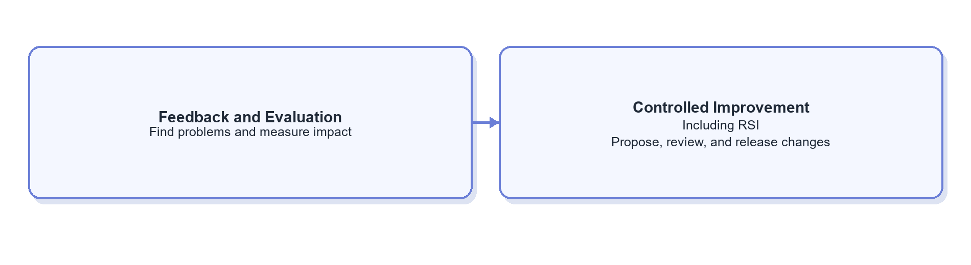
Evaluation here is an offline release gate. Result validation in Section 1.5.2 is an online check within one task. They may share rules, but differ in timing and ownership.

1.7.1 Feedback & Evaluation Signals（反馈与评测信号）
Approach / capability（方案 / 能力） | What is it? | Problem addressed | Strengths | Trade-offs / limits | Best fit / adoption conditions | Representative sources
User feedback（用户反馈） | Captures ratings, written corrections, and expert comments. | Real user dissatisfaction. | Easy and business-relevant. | Sparse and subjective. | Collect from launch. | OpenAI: Evaluating Agents with Langfuse
Human trace review（人工 Trace Review） | Experts inspect knowledge, plan, SQL, result, and answer. | The final answer looks right while the process is risky. | Locates root causes. | Labor-intensive. | Sampling and incident review. | OpenAI: Trace Grading
Deterministic checks（确定性检查） | Code validates SQL syntax, data coverage, constraints, and artifact completeness. | Subjective scoring misses hard failures. | Stable, cheap, explainable. | Covers only formalizable rules. | Build from day one. | Google Cortex: Data Product Skills
Regression evaluation（回归评测） | Freezes representative tasks, expected behavior, and grading rules and reruns them after changes. | A local improvement breaks prior capability. | Repeatable, comparable, release-ready. | Cases need maintenance. | Before and after Prompt, Skill, or Tool changes. | OpenAI: Agent Evals
LLM-as-a-Judge（大模型评审） | Uses a model and rubric to grade answers or full traces. | Human review does not scale. | Scales trend detection. | Biased; should not approve high-risk releases alone. | Combine with rules and human sampling. | OpenAI: Agent Evals

1.7.2 From Feedback to Controlled Release（从反馈到受控发布）
Approach / capability（方案 / 能力） | What is it? | Problem addressed | Strengths | Trade-offs / limits | Best fit / adoption conditions | Representative sources
Manual iteration（人工迭代） | People update Prompt, Knowledge, Skill, or Tool from failures. | Improvements require judgment. | Controlled and suitable early. | Slow and person-dependent. | Early systems with few samples or high change risk. | OpenAI: Agent Improvement Loop
Automated diagnosis and proposals（自动诊断与候选建议） | A model analyzes traces, feedback, and evaluations to suggest root causes and changes. | People cannot read every run. | Speeds diagnosis and design. | Suggestions can be wrong and must not auto-release. | After traces and evaluations accumulate. | OpenAI: Agent Improvement Loop
Controlled RSI（受控 RSI） | Generates candidate Skill, Prompt, Tool, or code changes from failures and evaluations. | Feedback never enters engineering. | Accelerates improvement discovery and implementation. | Candidates may be wrong; release gates are mandatory. | After evaluation and versioning mature. | OpenAI: Agent Improvement Loop · Hermes Agent
Shadow / canary release（影子与金丝雀发布） | Runs new versions in shadow mode or on limited traffic before broad rollout. | Offline evaluation misses real distributions. | Controls deployment risk. | Needs traffic splitting and version observability. | Multi-user production systems. | OpenAI: Model optimization
Rollback / version gate（回滚与版本门禁） | Binds every release to Prompt, Skill, Tool, model, and data versions and supports rollback. | Improvements degrade production. | Auditable and recoverable. | Needs a unified release system. | Every production change. | OpenAI: Agent Improvement Loop
Direct online self-modification（在线直接自修改） | The agent changes production assets with immediate effect. | Pursues fully automatic adaptation. | Fast in theory. | Uncontrolled, hard to audit, and error-amplifying. | Not a default enterprise production pattern. | Hermes Skills and Memory

2. Two Dimensions of End-to-End Agent Design（端到端架构的两类选择维度）
End-to-end design is shaped by two independent choices: whether the execution path is predefined or decided dynamically, and whether one agent or several agents share the work. The seven capability modules define what the system needs; this section defines how those capabilities are assembled.
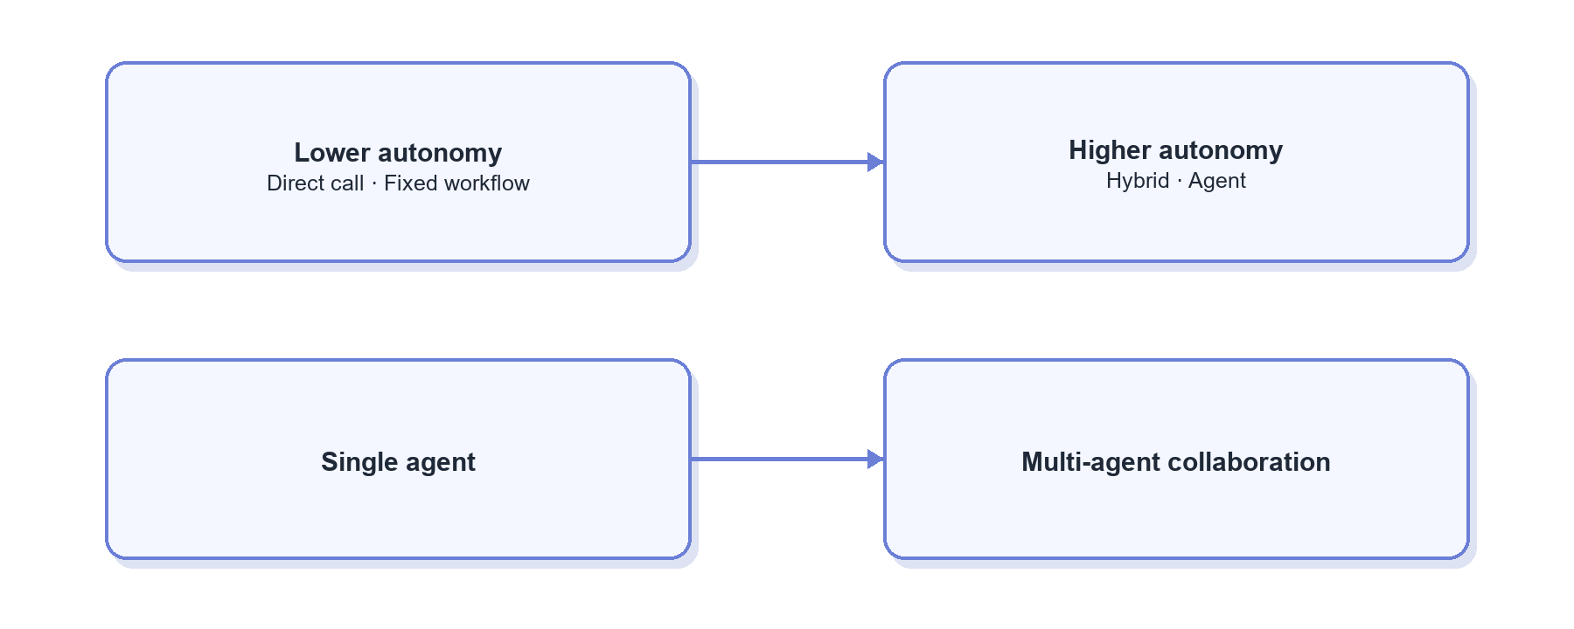

2.1 Degree of Autonomy（自主程度）
More autonomy improves long-tail coverage but raises cost, latency, and behavioral variance. More determinism improves testing and auditability but reduces adaptability.
Approach / capability（方案 / 能力） | What is it? | Problem addressed | Strengths | Trade-offs / limits | Best fit / adoption conditions | Representative sources
Direct model call（直接模型调用） | One prompt or structured-output call returns the result. | Simple extraction, rewriting, or explanation. | Fastest and cheapest. | Cannot retrieve enterprise facts or execute actions. | Single-step tasks with complete context. | OpenAI: Agents
Fixed workflow / RAG（固定 Workflow / RAG） | Code predetermines the path. | Stable, repetitive tasks. | Predictable behavior, cost, and latency. | Inflexible on ambiguity and long tails. | Narrow Q&A or stable processes. | Microsoft: Standard and Agentic RAG
Bounded-autonomy hybrid（有限自主混合架构） | Code fixes outer boundaries while the agent decides within stages. | Need exploration inside reliable guardrails. | Most practical production compromise. | Code/model responsibilities must be explicit. | Data retrieval and analysis. | Anthropic: Building Effective Agents
High-autonomy agent（高自主 Agent） | The agent dynamically chooses plan, tools, and termination. | Complex paths cannot be predefined. | Strong long-tail coverage. | Highest cost, latency, and variance. | High-value exploratory tasks. | Anthropic: Agents

2.2 Agent Organization（Agent 组织方式）
Agent organization determines how context, permissions, and responsibility are divided. A single agent fits most tasks with one decision owner. Multi-agent designs are justified only when context isolation, permission separation, specialization, or parallelism creates measurable value.
Approach / capability（方案 / 能力） | What is it? | Problem addressed | Strengths | Trade-offs / limits | Best fit / adoption conditions | Representative sources
Single agent + Tools（单 Agent + Tools） | One agent retains the goal and context while calling multiple Tools. | Most multi-step work. | Few handoffs and simple structure. | One context may grow large. | One decision owner can complete the task. | Anthropic: Building Effective Agents
Agent-as-Tool（智能体作为工具） | A primary agent invokes specialists but retains final control. | Need expertise with unified output. | Clearer accountability than peer agents. | The primary agent can bottleneck. | Mature local specialist capabilities. | OpenAI: Orchestration
Orchestrator–Workers（协调器—工作者） | A coordinator decomposes work, parallel workers execute, and results are merged. | Subtask count and type are dynamic. | Dynamic specialization and parallelism. | Deduplication, conflict, and merge logic are hard. | Complex research and multidimensional analysis. | Anthropic: Orchestrator-workers
Handoff（任务移交） | One agent transfers conversational control to a specialist. | Roles need separate prompts, permissions, or accountability. | Stronger specialization boundaries. | Handoff context and final ownership are complex. | Clear business or permission boundaries. | OpenAI: Handoffs
Multi-agent deliberation（多 Agent 协商） | Agents collaborate through group chat, debate, or voting. | Multiple perspectives or specialties are required. | Covers complex cross-domain work. | Highest call and debugging cost; not inherently more accurate. | Only after evaluations prove a benefit. | Microsoft AutoGen

3. Agent Technology Stack and Representative Platforms（Agent 技术栈与代表方案）
The technology stack is the engineering vehicle for the seven capabilities, not an eighth business capability. Products often span SDKs, workflows, runtimes, UI, and multi-agent features, so they should be compared by primary role and actual capability coverage.
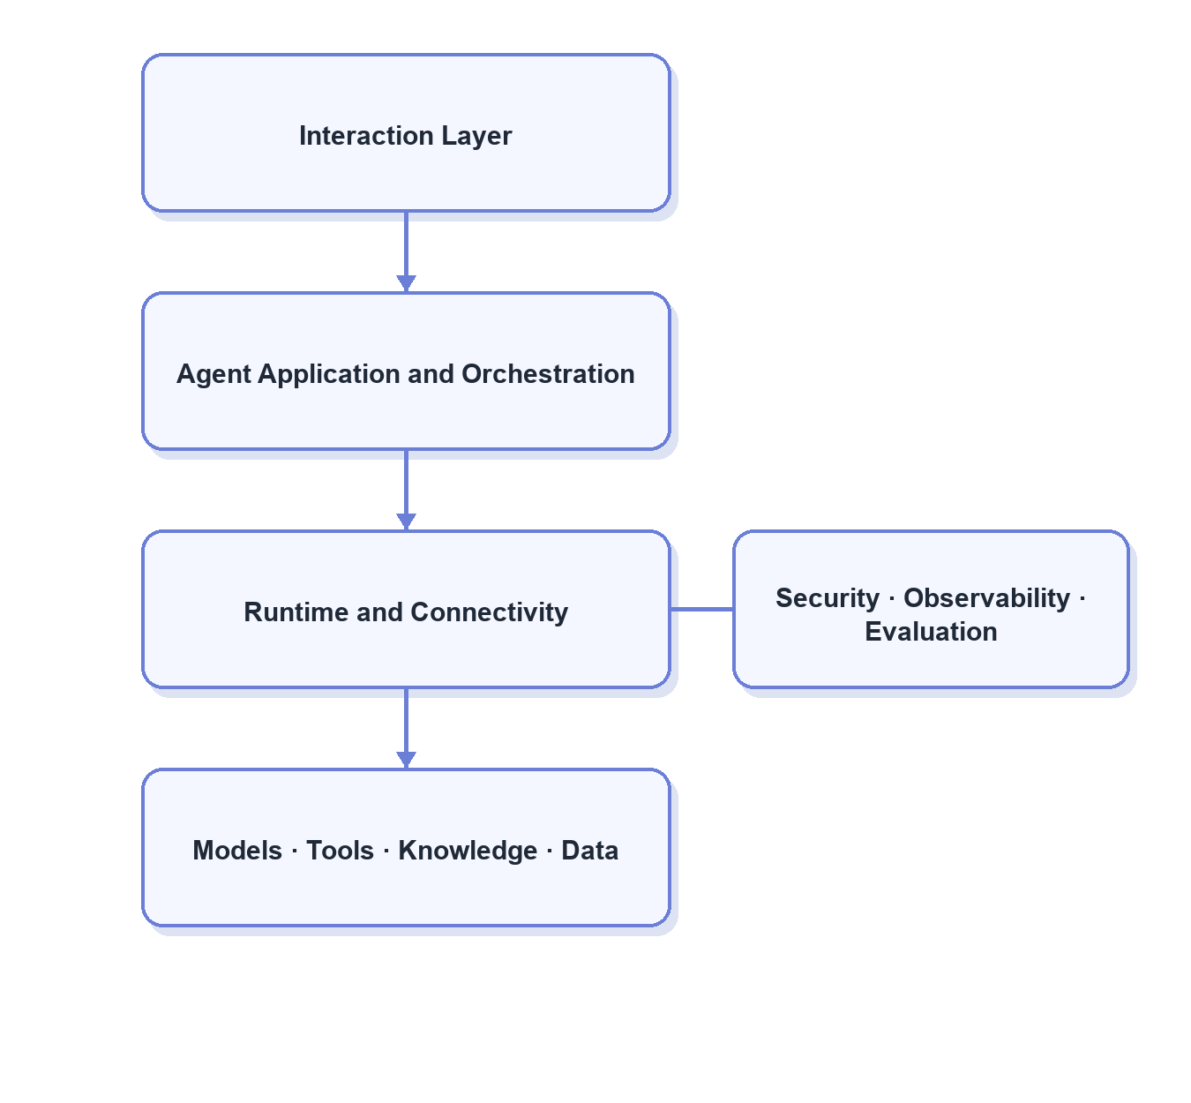

3.1 Technology Categories（技术栈类别）
Approach / capability（方案 / 能力） | What is it? | Problem addressed | Strengths | Trade-offs / limits | Best fit / adoption conditions | Representative sources
Agent SDK（智能体开发套件） | Defines Agents, Tools, guardrails, and outputs in code. | Build custom agents quickly. | Flexible and easy to embed. | State and governance often require separate systems. | Deep customization in existing applications. | OpenAI Agents SDK · Google ADK · PydanticAI
Workflow / durable runtime（工作流与持久化运行时） | Models steps, state, branching, pause, resume, and retry. | Long tasks and reliable execution. | Auditable and recoverable. | Easy to over-engineer workflows. | Long tasks, approvals, or recovery needs. | LangGraph · Microsoft Agent Framework · Temporal
Agent harness（智能体运行套件） | Packages an agent loop, sessions, Tools, Memory, Skills, and entry points. | Continuously running general agents. | Broad capability out of the box. | General design may not fit enterprise data governance. | Rapidly establish a complete autonomous workspace. | Hermes Agent · OpenHands
Multi-agent framework（多智能体框架） | Provides roles, messages, delegation, group chat, and supervisors. | Agent specialization and collaboration. | Intuitive division of work. | Expensive handoffs and debugging. | Clear isolation or parallelism benefits. | AutoGen · CrewAI
Web / generative UI SDK（网页与生成式界面开发套件） | Connects models, Tool Calls, and streaming results to web interfaces. | Agent front ends and interactive artifacts. | Strong streaming and UI experience. | Does not provide a durable back end. | Dedicated analytics workbenches. | Vercel AI SDK · AG-UI
Low-code agent platform（低代码 Agent 平台） | Visually configures models, RAG, workflows, Tools, and channels. | Rapid validation and business participation. | Fast rollout. | Limited deep customization, versioning, and complex debugging. | Prototypes, standard processes, and connector integration. | Dify · Flowise · Langflow
China-focused engineering frameworks（国内工程框架） | Agent frameworks aligned with Java, Go, Python, and domestic model ecosystems. | Fit local technology stacks and deployment constraints. | Stronger local ecosystem integration. | Maturity and governance vary by project. | Domestic models or language-stack constraints. | Spring AI Alibaba · Eino · Qwen-Agent · Youtu-Agent
Managed cloud agent platform（云托管 Agent 平台） | Cloud-hosted models, sessions, Tools, deployment, and observability. | Reduce infrastructure work. | Lower integration and operations burden. | Platform lock-in and cost. | Data and infrastructure already sit in that cloud. | Vertex AI Agent Engine · Azure AI Foundry · Bedrock Agents
Protocol layer（协议层） | Standardizes communication among Tools, resources, agents, and UI. | Clients repeatedly integrate the same capabilities. | Decoupled, interoperable, reusable. | Does not provide business logic or policy. | Capabilities must be reused across systems. | MCP · A2A · AG-UI
Model gateway and observability（模型网关与可观测） | Centralizes model routing, cost, fallback, tracing, prompts, and evaluation. | Multi-model operations and failure diagnosis. | Can evolve independently of the agent framework. | Needs integration and data governance. | Multiple models/apps or meaningful scale. | LiteLLM · Langfuse · Phoenix

3.2 Positioning of Representative Frameworks（代表框架的主要定位）
Platform（方案 / 能力） | What is it? | Problem addressed | Strengths | Trade-offs / limits | Main capabilities covered | Representative sources
Claude Code / Claude Agent SDK（Claude 智能体工具链） | Claude Code is a file-and-terminal agent harness; the SDK embeds a similar loop and Tool model in applications. | Rapid access to an autonomous loop, filesystem work, and Tool execution. | Strong general autonomy for code and file tasks. | Enterprise semantics, permissions, dedicated Task State, and release governance remain custom. | Task control, context, execution, basic runtime. | Claude Agent SDK
LangGraph（状态图智能体框架） | Builds stateful agents with graphs or functional APIs; emphasizes persistence, checkpoints, HITL, and durable execution. | Long tasks, pause/resume, explicit state, and recovery. | Strong state and recovery; can be adopted incrementally. | Premature graph design adds burden; business assets remain custom. | Task control, Task State, runtime, HITL. | LangGraph: Durable Execution
Hermes Agent（通用智能体运行套件） | An integrated persistent harness with Tools, Skills, memory, session search, gateway, cron, and learning loops. | Cross-session operation, channels, and capability accumulation. | Broad out-of-box reference for Skills, Memory, and improvement. | General-purpose; enterprise auto-write and self-improvement need extra gates. | Runtime, Skills, Memory, Tools, improvement. | Hermes Agent · Hermes Skills
OpenAI Agents SDK（OpenAI 智能体开发套件） | Lightweight SDK with Agents, Tools, handoffs, guardrails, sessions, and tracing. | Build custom observable agents in applications. | Simple abstractions and strong Tool/handoff/evaluation integration. | Durable runtime and enterprise data governance require additional systems. | Task control, Tools, multi-agent, tracing. | OpenAI Agents SDK
Google ADK / Agent Engine（Google 智能体开发与运行平台） | SDK plus sessions, Memory, planners, Tools, and managed cloud runtime. | Build, deploy, and operate agents on Google Cloud. | Strong sessions, analytics, and GCP integration. | Greater GCP dependence. | Planning, Memory, Tools, runtime, cloud deployment. | Google ADK
Microsoft Agent Framework（微软智能体框架） | Enterprise framework for Agents and workflows with orchestration, HITL, state, and connectors. | Combine autonomy with enterprise processes and approvals. | Clear workflow, HITL, and enterprise integration boundaries. | Many components increase selection and migration effort. | Interaction, task control, runtime, multi-agent. | Microsoft Agent Framework
Temporal（持久化工作流平台） | General durable-execution platform, not an LLM-specific agent framework. | Very long tasks, reliable retry, scheduling, and failure recovery. | Mature workflow reliability. | Agent, Prompt, Tool, and business-state abstractions are custom. | Runtime lifecycle and reliable execution. | Temporal
AutoGen / CrewAI（多智能体框架） | Multi-agent systems built around roles, messages, collaborative flows, and supervisors. | Specialist division, delegation, and deliberation. | Intuitive multi-agent expression. | High handoff, cost, and debugging overhead. | Multi-agent organization. | AutoGen · CrewAI
Dify / Flowise / Langflow（低代码智能体平台） | Visual configuration for models, RAG, workflows, Tools, and app entry points. | Rapid prototypes with broader participation. | Fast validation and broad connectors. | Deep customization, complex state, and version governance may be constrained. | Low-code apps, workflows, RAG, and Tools. | Dify · FlowiseAI · Langflow
Spring AI Alibaba / Eino / Qwen-Agent / Youtu-Agent（国内智能体工程框架） | Engineering frameworks for Java, Go, Python, and domestic model ecosystems. | Integrate local stacks, models, and deployment environments. | Direct ecosystem fit and language choice. | State, governance, and production maturity vary. | SDKs, workflows, Tools, and domestic models. | Spring AI Alibaba · Eino · Qwen-Agent · Youtu-Agent

3.3 Framework Selection Principles（框架选型原则）
- Identify whether the real gap is business knowledge, Task State, Tool safety, or runtime reliability; a framework cannot replace business governance.
- Change runtime only when the current harness cannot meet persistence, recovery, asynchronous execution, multiple entry points, or unified operations needs.
- Multi-agent is not the natural upgrade path from single-agent. Adopt it only for proven context, permission, specialization, or parallelism benefits.
- “Broadest feature set” is not “best fit.” Compare task success, development complexity, operating cost, observability, and migration cost together.

4. Recommended Direction for the Company（适配当前公司的方案建议）

4.1 Overall Choice（总体选择）
Given the current setup—autonomous Claude Code execution, a Markdown Wiki, grep/glob retrieval, long and sometimes conflicting documents, and repeated loss of confirmed constraints or prior SQL—the best near-term shape is:
Single Agent + lightweight task control + structured Task State + modular Knowledge/Skills + controlled Tools + verifiable delivery.
This does not require an immediate move to LangGraph, Hermes, or a multi-agent system. First improve business reliability and observability. Reconsider the runtime only when long-task recovery, asynchronous execution, multiple entry points, or unified operations become demonstrated bottlenecks.
Timing is grouped into three stages: Now means work can begin directly; Next requires traces, task samples, or governance foundations; Triggered later means build only after the corresponding complexity appears.
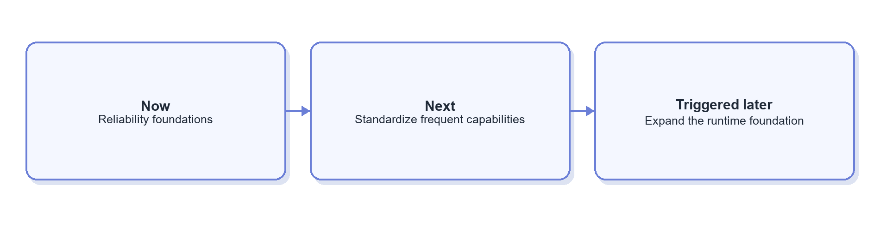

4.2 Module-by-Module Selection Matrix（分模块选型矩阵）
Module（模块） | Submodule（子模块） | Recommended choice(s) | Practical implementation | Why it fits now | Main benefits | Trade-offs / risks | Timing | Representative sources
1.1 Requirement Alignment & User Interaction（需求对齐与用户交互） | 1.1.1 Request intake（需求进入） | Proactive clarification + lightweight structured task contract | Ask only for time, metric, dimension, scope, or deliverable details that change the answer; write confirmations into Task State. | The main issue is forgetting confirmed conditions, not lack of conversation. | Fewer false assumptions and one shared target for SQL and charts. | Too many questions slow users; keep the contract light. | Now | Microsoft: Map agent flows
1.1 Requirement Alignment & User Interaction（需求对齐与用户交互） | 1.1.2 Progress presentation（过程呈现） | Key step/event status + final artifacts | Show high-level states such as finding knowledge, generating SQL, executing, validating, and charting—never hidden reasoning. | Data tasks take time; users need progress and artifact visibility. | Better waiting experience and a future intervention interface. | Events need redaction and careful granularity. | Next | AG-UI
1.1 Requirement Alignment & User Interaction（需求对齐与用户交互） | 1.1.3 Human-in-the-loop（人工介入） | Clarification gate + high-risk action gate + result review | Ask on missing key conditions; approve large scans, sensitive data, or future writes; allow corrections to formal outputs. | Experts still need to resolve definition conflicts. | Stops errors at high-leverage points without workflowing every step. | Broad approval scope reduces efficiency. | Clarification and correction now; risk gates with production access | Microsoft: Human-in-the-loop
1.2 Task Planning & Control（任务规划与控制） | 1.2.1 Routing（任务路由） | Flat hybrid routing + general-agent fallback | Rules handle high-confidence requests; the model classifies only broad groups such as knowledge, analysis, and other; uncertain cases stay with Claude Code. | Categories and Skills are not yet stable enough for fine routing. | Low-cost reduction in obvious misroutes while preserving autonomy. | Premature categories create cascading errors; log confidence. | Now | Anthropic: Routing
1.2 Task Planning & Control（任务规划与控制） | 1.2.2 Planning（任务规划） | Short checklist + structured Working State + result-driven replanning | Track goal, to-do items, completed actions, and next step; revise after SQL errors, empty results, or failed checks. | Directly addresses forgotten goals, conditions, SQL, and remaining work. | Lighter than a complex planner while reducing drift and repetition. | Checklists cannot express complex dependencies. | Now | Anthropic: Context Engineering · Google ADK: State
1.2 Task Planning & Control（任务规划与控制） | 1.2.3 Monitoring and replanning（监控与 Replan） | Fixed budgets + result-driven replanning + loop detection + escalation | Limit calls, time, and scan size; stop, change path, or ask the user after repeated errors or no progress. | The autonomous agent needs exploration room and explicit stop boundaries. | Controls cost and loops; failure paths become clearer. | Tight thresholds can interrupt valid exploration. | Now | Microsoft: Agent design patterns
1.3 Context, State & Memory（上下文、状态与记忆） | 1.3.1 Context Assembly（上下文装配） | Progressive on-demand loading; later add a lightweight Context Builder | Show indexes and summaries first, then load SKILL.md, references, schemas, or scripts as needed. | The common failure is finding the right document but missing the right section. | Less distraction and token use with full traceability. | Weak indexes or summaries reduce recall; adds a retrieval step. | Now | Anthropic: Context Engineering · Anthropic: Agent Skills
1.3 Context, State & Memory（上下文、状态与记忆） | 1.3.2 Task State（任务状态） | Structured Working State + Artifact References | Store goal, confirmed constraints, plan, knowledge references, SQL history, result references, open questions, next action, and completion state. | This is the direct solution to forgotten constraints, SQL, and goals. | Reviewable and recoverable; large results stay outside the prompt. | Must define model-written versus code-written fields. | Now—highest priority | Google ADK: Sessions, State and Memory
1.3 Context, State & Memory（上下文、状态与记忆） | 1.3.3 Long-term Memory（长期记忆） | Defer general memory; keep reviewed preferences and searchable task history only | Put authoritative facts in Knowledge and stable methods in Skills; retrieve history on demand rather than turning it into facts. | Reliable Task State and knowledge governance are more urgent; automatic memory can institutionalize errors. | Avoids contamination and confusion among Memory, Knowledge, and Skills. | Limited personalization at first; later needs privacy and forgetting rules. | Triggered later | Microsoft: Memory
1.4 Knowledge & Capability Assets（知识与能力资产） | 1.4.1 Knowledge（知识） | Templated documents + modular atomic knowledge + stable IDs | Split metrics, tables, fields, events, terms, and cases first; add owner, version, and review date. | Improving structure attacks the current root problem better than jumping to vectors or graphs. | Single-source maintenance, clearer conflicts, greater reuse. | More files require navigation, references, and ownership. | Now—highest priority | Google Dataplex: Glossary · Anthropic: Context Engineering
1.4 Knowledge & Capability Assets（知识与能力资产） | 1.4.2 Skill（技能） | Single responsibility + explicit dependencies + layered package + version/evaluation | One Skill per clear task, such as revenue by device model; reference shared revenue, device, and table knowledge; move detail to references/scripts. | Separates task methods from facts and prevents another long workflow document. | Composable, on-demand Skills; shared definitions are maintained once. | Poor boundaries or triggers cause duplication and misselection. | Now | Anthropic: Agent Skills
1.4 Knowledge & Capability Assets（知识与能力资产） | 1.4.3 Tool（工具） | Fine-grained atomic Tools + strong schemas + policy wrappers | Separate schema lookup, SQL validation, read-only execution, result storage, and charting; apply permissions and budgets by risk. | Deterministic actions should be enforced in code while the model composes them. | Auditable, reusable, least-privilege actions. | More Tools require grouping/search and add calls. | Now | OpenAI: Tools · Google: Data Science Agents
1.4 Knowledge & Capability Assets（知识与能力资产） | 1.4.4 Data semantics（数据语义） | Schema metadata + core term mapping; add metric/Join models gradually | Generate table/field catalogs from databases and code; structure frequent metrics, dimensions, and joins. | The company lacks even a consistent data map; a full semantic layer is premature. | Improves table/field selection first, then stabilizes frequent metrics. | Metadata can stale; a full semantic layer is costly. | Schema now; metric/Join models next | Google: Data Science Agents · Google Agentic Data Cloud
1.4 Knowledge & Capability Assets（知识与能力资产） | 1.4.5 Protocols（协议） | Application-level Function Calling; add MCP only for cross-client reuse | Use strongly typed functions now; wrap as MCP only when multiple agents or IDEs need the same connectors. | No need to refactor around a protocol today. | Simple integration with a future standardization path. | Function Calling is app-coupled; MCP does not supply policy or semantics. | Function Calling now; MCP when triggered | OpenAI: Tools · MCP Architecture
1.5 Execution & Trusted Delivery（执行与可信交付） | 1.5.1 Execution architecture（执行架构） | Retrieval-augmented Agentic SQL + controlled read-only executor; sandbox when needed | Retrieve definitions, schema, and cases; generate and test SQL with bounded repair; enforce statement, scan, partition, and timeout limits. | Long-tail queries need autonomy, but database risk needs deterministic controls. | Preserves Claude Code flexibility inside hard safety boundaries. | Slower than one-shot SQL; stale examples need governance. | Now | Google: Data Science Agents · Vanna
1.5 Execution & Trusted Delivery（执行与可信交付） | 1.5.2 Trusted delivery（可信交付） | Deterministic result checks + evidence chain + artifact-centric delivery | Validate nulls, time coverage, scale, and group totals; save definitions, SQL, runtime, result tables, and charts. | SQL success is not business correctness, and formal results need review. | Traceable, reproducible delivery and future evaluation samples. | Business checks and artifact storage must grow over time. | Now—highest priority | Google Cortex: Data Product Skills · OpenAI: Trace Grading
1.6 Runtime & System Governance（运行与系统治理） | 1.6.1 Runtime lifecycle（运行生命周期） | Keep the current harness; persist Task State first; defer checkpoints/async | Keep Claude Code; persist state and artifact references across turns; evaluate durable runtime only when long tasks or approvals require it. | The current bottleneck is not the lack of a sophisticated runtime. | Low migration cost and faster validation of business-layer changes. | Limited long-task recovery under the current harness. | State now; runtime when triggered | Google ADK: Sessions · LangGraph: Durable Execution
1.6 Runtime & System Governance（运行与系统治理） | 1.6.2 Model access and cost（模型访问与成本） | Direct single-model access + explicit budgets; add cache/routing from trace evidence | Record tokens, latency, and success by task before building gateways or cascades. | Avoids premature platform complexity. | Simple foundation and evidence-based optimization later. | Limited early cost optimization; multi-model growth needs more infrastructure. | Budgets now; cache/routing next | Anthropic: Prompt Caching · Microsoft: Agent Host
1.6 Runtime & System Governance（运行与系统治理） | 1.6.3 Security and access（安全与权限） | User identity propagation + database least privilege + SQL/code isolation | Use read-only accounts, row/column policies, scan limits, and sensitive-field rules; never place secrets in prompts. | Security must be system-enforced once real databases are connected. | Clear, auditable authorization. | Must integrate with existing data access and classification. | Required before production-data access | Microsoft: Agentic RAG Security
1.6 Runtime & System Governance（运行与系统治理） | 1.6.4 Reliability and observability（可靠性与观测） | Bounded retry + minimum trace + runtime version snapshot | Record task type, Knowledge/Skill/Tool versions, SQL, result, latency, and errors; prohibit unlimited retry. | Current failures cannot be reproduced reliably. | Distinguishes knowledge, planning, SQL, Tool, and validation failures. | Traces require redaction and retention governance. | Now—from the pilot | OpenAI: Observability · Langfuse
1.7 Evaluation & Controlled Improvement（评测与受控改进） | 1.7.1 Feedback and evaluation（反馈与评测） | User corrections + human trace review + deterministic checks; build regression evaluations gradually | Attribute real failures to modules and turn frequent cases into repeatable tests. | The system lacks a common loop for comparing architecture changes. | More actionable than ratings or final-answer review alone. | Early human cost; evaluation sets need maintenance. | Capture now; regression suite next | OpenAI: Agent Evals · OpenAI: Trace Grading
1.7 Evaluation & Controlled Improvement（评测与受控改进） | 1.7.2 Controlled self-improvement（受控自优化） | Human-controlled releases + automated diagnosis/candidate changes; no direct online self-modification | Let the agent propose Prompt, Skill, or Tool changes, but require evaluation, expert review, and versioned release. | Business definitions and data logic must retain expert accountability. | Gains from RSI without losing enterprise control. | Needs versioning, evaluation, and release discipline; proposals can be wrong. | Manual loop now; controlled RSI later | OpenAI: Agent Improvement Loop · Hermes Agent

5. References（参考文献）
All sources below are cited in the report. Vendor documentation, standards bodies, and official project repositories are prioritized. Open-source repositories illustrate engineering practice; stars alone do not establish suitability, quality, or long-term support.

5.1 Anthropic（Anthropic 公司）
- [A1] Agent design patterns: Building Effective Agents
- [A2] Agent context engineering: Effective Context Engineering for AI Agents
- [A3] Agent Skill engineering: Equipping Agents for the Real World with Agent Skills
- [A4] Claude agent development: Claude Agent SDK
- [A5] Claude Skill usage: Claude Agent Skills
- [A6] Prompt caching and cost: Prompt Caching

5.2 OpenAI（OpenAI 公司）
- [O1] Agent capability overview: Agents Guide
- [O2] Agents API architecture: Agents API Architecture
- [O3] Agent orchestration: Agent Orchestration
- [O4] Tools and function calling: Tools and Function Calling
- [O5] Agent observability: Agent Observability
- [O6] Agent evaluation: Agent Evals
- [O7] Trace grading: Trace Grading
- [O8] Model optimization: Model Optimization
- [O9] Agent improvement loop: Agent Improvement Loop
- [O10] Langfuse evaluation example: Evaluating Agents with Langfuse
- [O11] Session memory: Session Memory
- [O12] OpenAI Agents SDK: OpenAI Agents SDK for Python
- [O13] Agent workspace memory: OpenAI Agents SDK Memory

5.3 Google Cloud, dbt, and Data Semantics（Google Cloud、dbt 与数据语义）
- [G1] Data-science agent architecture: Google Cloud: Agentic AI for Data Science
- [G2] Agentic data platform: Google Cloud: Agentic Data Cloud
- [G3] Data-product Skills: Google Cortex Framework: Data Product Skills
- [G4] Business terms and synonyms: Google Dataplex: Business Glossary
- [G5] Looker Join modeling: Google Looker: Working with Joins
- [G6] Join cardinality: Google Looker: Join Relationship
- [G7] Google agent development kit: Google ADK
- [G8] Sessions, State, and Memory: Google ADK: Sessions, State and Memory
- [G9] Controlled code execution: Google ADK: Code Execution
- [G10] Agent planning: Google ADK: Planner Documentation
- [G11] Managed agent runtime: Vertex AI Agent Engine
- [G12] Data semantic models: dbt: Semantic Models
- [G13] Metric query engine: dbt: MetricFlow
- [G14] Semantic-layer joins: dbt: Join Logic

5.4 Microsoft（微软）
- [M1] Agent flow mapping: Map Agent Flows
- [M2] Agent Host responsibilities: Agent Host Platform
- [M3] Agent Framework overview: Agent Framework Overview
- [M4] Agent Framework documentation: Agent Framework
- [M5] Human-in-the-loop: Human-in-the-loop Workflows
- [M6] Magentic orchestration: Magentic Orchestration
- [M7] Agent design patterns: AI Agent Design Patterns
- [M8] Standard and agentic RAG: Standard and Agentic RAG
- [M9] Task progress ledger: Magentic Progress Ledger
- [M10] Multi-agent memory: Multi-agent Reference Architecture: Memory
- [M11] Multi-agent framework: Microsoft AutoGen
- [M12] GraphRAG: Microsoft GraphRAG
- [M13] Enterprise AI platform: Azure AI Foundry

5.5 Open Protocols and Runtime Infrastructure（开放协议与运行基础设施）
- [P1] Tool and resource protocol: Model Context Protocol Architecture
- [P2] Agent-to-agent protocol: A2A Protocol
- [P3] Agent-to-UI protocol: AG-UI Protocol
- [P4] Stateful graph agent framework: LangGraph
- [P5] Durable agent execution: LangGraph Durable Execution
- [P6] Durable execution platform: Temporal
- [P7] Multi-model gateway: LiteLLM
- [P8] LLM observability and evaluation: Langfuse
- [P9] LLM tracing and evaluation: Arize Phoenix
- [P10] AI application front-end SDK: Vercel AI SDK

5.6 Agent Frameworks, Harnesses, and Low-code Platforms（Agent 框架、Harness 与低代码平台）
- [F1] General agent harness: Hermes Agent
- [F2] Hermes Skill system: Hermes Agent Skills
- [F3] Software-development agent platform: OpenHands
- [F4] Multi-agent collaboration: CrewAI
- [F5] Typed Python agent framework: PydanticAI
- [F6] Low-code agent platform: Dify
- [F7] Visual agent orchestration: Flowise
- [F8] Visual agent workflows: Langflow
- [F9] Java agent framework: Spring AI Alibaba
- [F10] Go agent framework: Eino
- [F11] Qwen agent framework: Qwen-Agent
- [F12] Tencent modular agent framework: Tencent Youtu-Agent
- [F13] Text-to-SQL agent: Vanna

5.7 Other Cloud Platforms（其他云平台资料）
- [C1] AWS managed agents: Amazon Bedrock Agents
- [C2] Agent memory definitions: AWS Agentic AI Lens: Memory Definitions

