AI Research Report I: Enterprise Knowledge Base Architecture（AI 调研报告（一）：企业知识库架构全景）
Last updated: 23 October 2026
This report examines how an enterprise knowledge base can provide reliable context for a data Q&A agent. It first defines the knowledge base capability modules, then compares industry approaches and representative platforms, and finally recommends a direction for the company’s current stage. Every research table includes a plain-language definition and traceable sources.

0. Report Structure（报告框架与章节关系）

Architecture at a Glance: 4 Main-path Modules + 1 Cross-cutting Governance Module（企业知识库分析框架：4 个主链路模块 + 1 个横向治理模块）
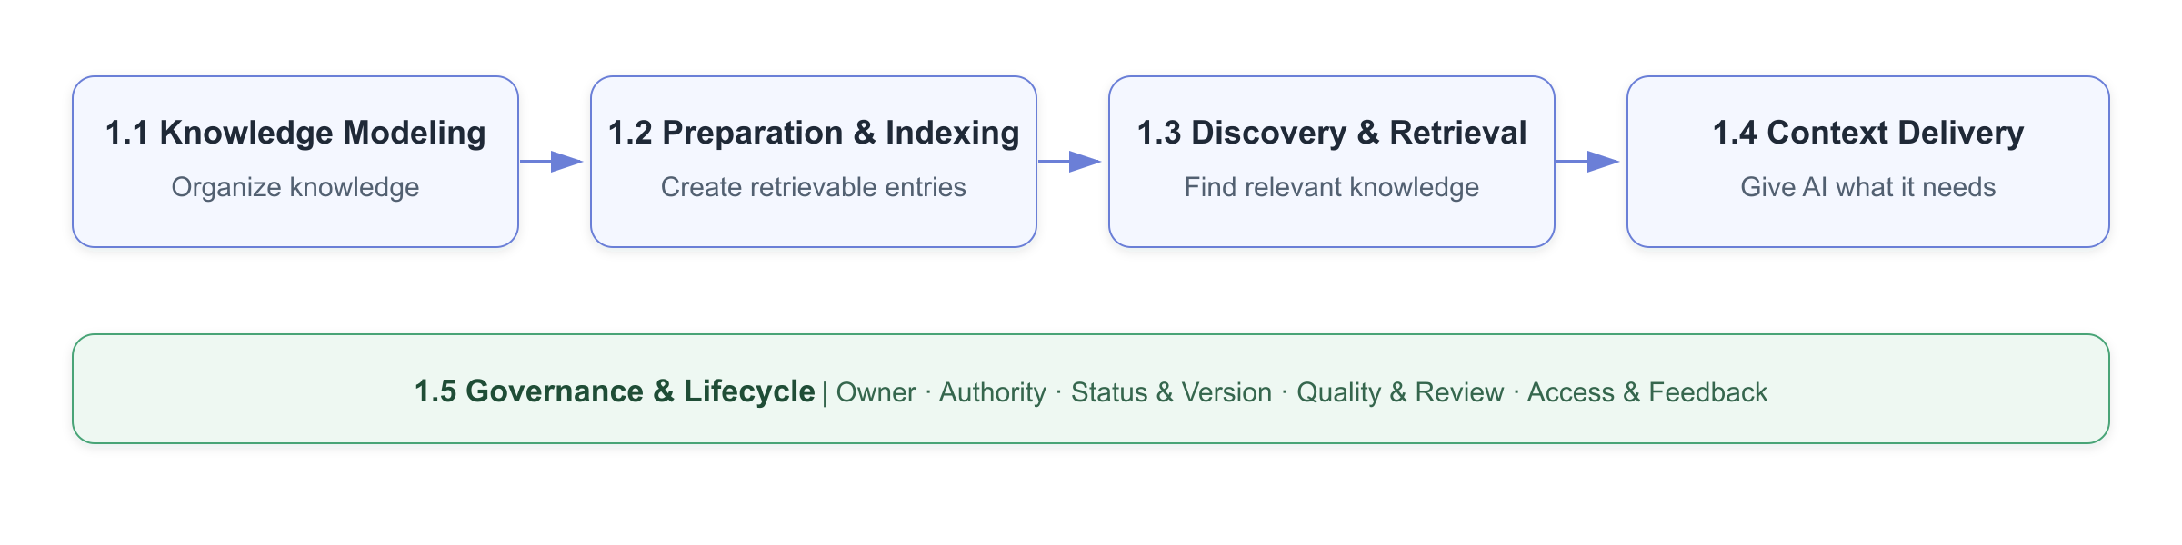
The first four modules form the path from knowledge sources to agent context. Governance spans knowledge creation, indexing, retrieval, and use. These are capability boundaries—not necessarily five separate systems.

Module（模块） | What is it? | Problem addressed | Out of scope | Architectural role | Representative sources
Knowledge Modeling（知识建模） | Defines how documents, metrics, tables, fields, events, SQL, and relationships are represented. | Mixed long documents, duplicated shared knowledge, and inconsistent concepts. | Does not decide how a query searches. | Start of the main path. | Google: Business Glossary · DataHub: Context Layer
Knowledge Preparation & Indexing（知识准备与索引） | Keeps knowledge current, defines retrievable units, and maintains indexes. | Source content cannot be queried consistently or continuously. | Does not interpret the user’s question or choose final evidence. | Offline or near-real-time preparation stage. | Anthropic: Contextual Retrieval · Microsoft GraphRAG: Indexing
Discovery & Retrieval（发现与检索） | Finds candidate knowledge from directories or indexes when a query arrives. | The correct document, section, or cross-document evidence cannot be found. | Does not decide whether every candidate enters the prompt. | Online query stage. | Microsoft: Hybrid Search · Microsoft: Agentic Retrieval
Context Delivery（上下文交付） | Selects evidence, expands dependencies, flags conflicts, and packages citations before passing context to the model. | The right document is found, but the wrong section is read; context is overloaded or untraceable. | Does not maintain source correctness. | Between retrieval and agent reasoning. | Anthropic: Agent Skills · DataHub: Context Layer
Governance & Lifecycle（治理与生命周期） | Manages ownership, authority, status, versions, quality, permissions, and change impact. | Stale documents, conflicting definitions, missing owners, and unauthorized access. | Does not replace content development or retrieval algorithms. | Cross-cutting across all modules. | GitHub: CODEOWNERS · Google: Knowledge Catalog

The report proceeds in three layers: Section 1 reviews industry approaches within the five capability modules; Section 2 explains the product and platform forms that carry these capabilities; Section 3 makes company-specific choices.

1. Industry Approaches Across the Five Capabilities（五项能力的行业方法）

1.1 Knowledge Modeling: How Knowledge Is Represented（知识建模：知识以什么形式存在）
Knowledge modeling defines the boundaries, structure, and relationships of knowledge units. It answers how metrics, tables, tracking events, SQL, and business context should be organized—not how search or prompt assembly works.
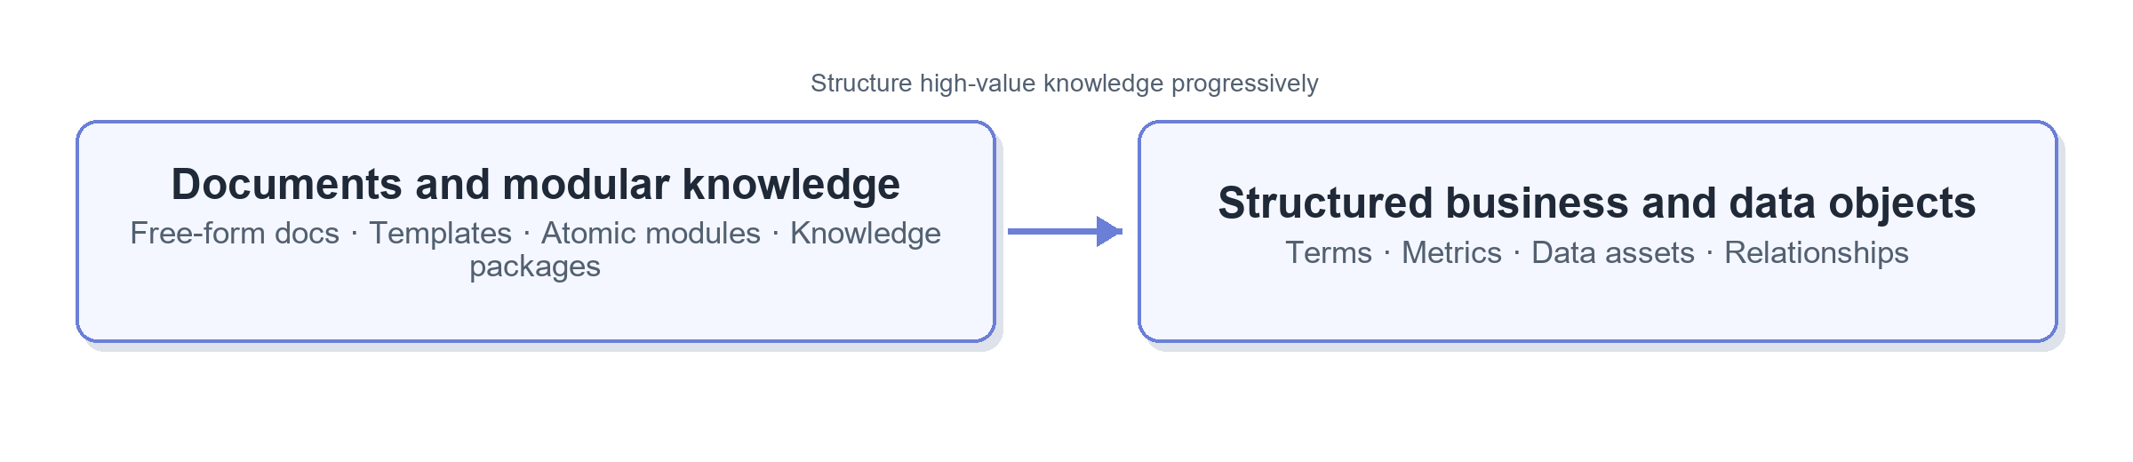
The two forms can coexist: documents hold long-tail context and explanation, while structured objects hold high-value knowledge that requires stable identification, linkage, or execution.

1.1.1 Documents and Modular Knowledge（文档与模块化知识）
Approach / capability（方案 / 能力） | What is it? | Problem addressed | Strengths | Trade-offs / limits | Best fit / adoption conditions | Representative sources
Free-form long document（自由大文档） | One business area mixes context, definitions, tables, and SQL in a single document. | Captures knowledge quickly. | Flexible authoring and minimal migration cost. | Duplicated content, difficult partial updates, and easy for AI to get lost. | Baseline for current-state or low-frequency knowledge. | Traditional Wiki and full-text search practice.
Templated document（模板化文档） | Standardizes summaries, contents, fixed sections, and metadata by knowledge type. | Inconsistent structure makes the right content hard to locate. | Lightweight change; easier validation and heading-level reading. | Shared knowledge may still be copied across documents. | Document-first teams without a structured platform. | Google: Business Glossary
Modular knowledge / knowledge package（模块化知识 / 知识包） | Splits metrics, tables, events, and SQL into reusable units. A parent file keeps only purpose, entry points, and dependencies. | Shared knowledge is duplicated and topic documents become too long. | Single-point maintenance, composability, and on-demand loading. | More files; requires stable IDs, directories, and dependency rules. | The same knowledge is reused across documents or workflows. | Anthropic: Agent Skills

1.1.2 Structured Business and Data Objects（结构化业务与数据对象）
Approach / capability（方案 / 能力） | What is it? | Problem addressed | Strengths | Trade-offs / limits | Best fit / adoption conditions | Representative sources
Business glossary（业务术语表） | Gives each term a unique ID, definition, synonyms, related terms, and owner. | Teams use different names or meanings for the same concept. | Creates one business language and maps aliases to one concept. | Requires ongoing ownership by domain experts. | Core metrics, dimensions, and business concepts. | Google: Business Glossary
Metric / semantic model（指标 / 语义模型） | Expresses formulas, dimensions, filters, and valid relationships as machine-executable definitions. | Metric logic exists only in prose or example SQL. | One metric can be reused by BI, SQL, and agents. | Higher modeling cost and limited long-tail coverage. | Stable, high-frequency, high-value metrics. | dbt: Semantic Layer
Data asset catalog（数据资产目录） | Treats tables, fields, dashboards, and queries as assets linked to owners, status, usage, and lineage. | Finding tables, choosing fields, and judging authoritative sources are difficult. | Technical context becomes searchable, filterable, and traceable. | Requires source integration and continuous synchronization. | Many assets distributed across systems. | DataHub: Context Layer
Knowledge graph / context graph（知识图谱 / Context Graph） | Explicitly models relationships among terms, metrics, tables, fields, documents, and people. | Multi-hop dependencies, impact analysis, and cross-document relationships are hard to express. | Direct relationship queries and impact analysis. | High modeling and update cost; incorrect edges amplify errors. | Stable relationship queries have clear value. | Google: Knowledge Catalog · Microsoft GraphRAG

1.2 Knowledge Preparation & Indexing: Creating Retrievable Objects（知识准备与索引：如何持续形成可检索对象）
This module addresses three pre-query questions: when knowledge is refreshed, what unit can be located, and what indexes are maintained. A connector is an implementation mechanism for scheduled or event-driven synchronization; it is not an alternative category to a native file.
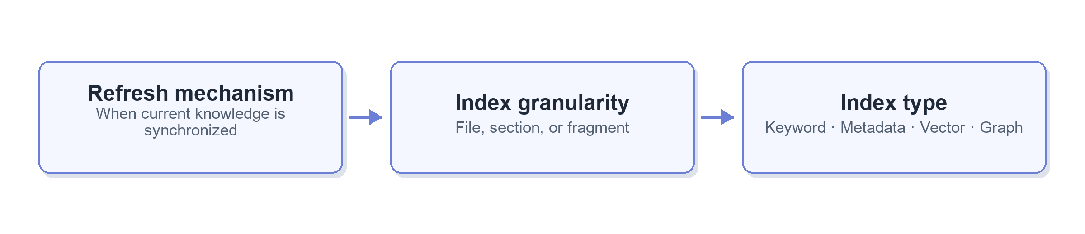

1.2.1 Refresh Mechanisms（更新机制）
Approach / capability（方案 / 能力） | What is it? | Problem addressed | Strengths | Trade-offs / limits | Best fit / adoption conditions | Representative sources
Read directly from source（源端直接读取） | Copies nothing; reads the current Wiki, Git, or source-system version at query time. | Always use the latest source text. | No synchronization lag and one source of truth. | Slow across sources; unavailable when the source system is down. | Few directly accessible sources. | Native Git / Wiki practice.
Scheduled scan and incremental refresh（定时扫描与增量更新） | Periodically checks hashes, timestamps, or change logs and updates only changed objects. | A local directory or index is needed while synchronization cost must stay controlled. | Simple and stable for file-based knowledge bases. | Minutes or hours of lag. | Markdown Wikis, code, and SQL repositories. | DataHub: Ingestion
Event-driven refresh（事件驱动更新） | Uses webhooks, messages, or change logs to update indexes after source changes. | Time-sensitive knowledge cannot wait for scheduled scans. | Timely and avoids full scans. | Requires source events and replay for failures. | Many frequently changing sources with strict freshness needs. | DataHub: Ingestion

1.2.2 Index Granularity（索引粒度）
Index granularity is not the same as RAG chunking. Even without vector retrieval, headings and knowledge objects can form logical units for precise grep/read access. Fixed-token and contextual chunks mainly serve vector RAG.
Approach / capability（方案 / 能力） | What is it? | Problem addressed | Strengths | Trade-offs / limits | Best fit / adoption conditions | Representative sources
File-level index（文件级索引） | Treats an entire document as one retrievable object. | Finds relevant files quickly. | Simplest approach; source text is unchanged. | The correct section may remain hard to find. | Short documents or an initial stage. | Git / Wiki full-text search practice.
Heading / object-level index（标题 / 对象级索引） | Creates stable anchors for Markdown headings, metrics, tables, fields, or code blocks. | Precise navigation within long documents. | No vector database; preserves semantics and stable citations. | Requires clear structure and object IDs. | The current Markdown knowledge base; recommended. | Google: Knowledge Catalog Metadata
Fixed-token chunking（固定 Token 切块） | Produces fragments using token counts and overlap windows. | Embedding models cannot index an entire long document well. | General-purpose and easy to automate. | Can split sections, tables, and business conditions. | Unstructured text entering vector RAG. | Anthropic: Contextual Retrieval
Contextual chunking（上下文化切块） | Adds document, topic, time, and object context to every RAG fragment. | A fragment loses meaning outside its source document. | Makes each fragment more independently retrievable. | Adds offline model cost and can generate incorrect context. | Vector or hybrid retrieval already exists and wrong-section recall is common. | Anthropic: Contextual Retrieval

Complex PDFs, Word documents, and spreadsheets also need structure-aware parsing for headings and tables. Because the current knowledge sources are mainly Markdown, this is not a near-term priority. RAGFlow is a representative open-source implementation.

1.3 Discovery & Retrieval: Finding Relevant Evidence（发现与检索：如何找到相关证据）
Retrieval produces candidate knowledge after a user request arrives. Industry methods have two separate dimensions: how candidates are recalled and ranked, and how multiple retrievals are organized for complex questions. They can be combined but should not be treated as one taxonomy.
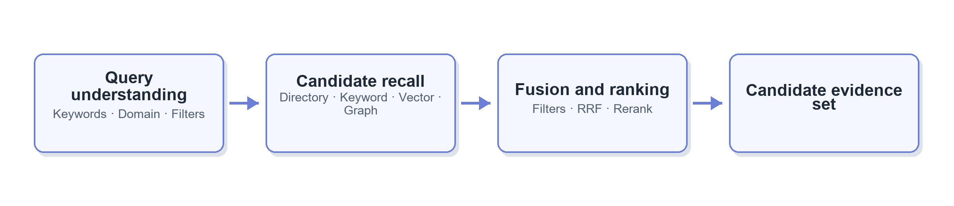

1.3.1 Candidate Recall and Ranking（候选召回与排序）
Approach / capability（方案 / 能力） | What is it? | Problem addressed | Strengths | Trade-offs / limits | Best fit / adoption conditions | Representative sources
Directory / navigation retrieval（目录 / 导航检索） | Narrows the search by domain, knowledge type, and object ID. | Many knowledge items with clear domain and type boundaries. | Explainable, low-cost, and suited to progressive reading. | Poor taxonomy or classification causes misses. | Stable domains and metadata-ready documents. | Google: Data Domains
Keyword / BM25（关键词 / BM25） | Matches table names, fields, metric abbreviations, code, and text terms. | Locating technical terms and exact names. | Fast, transparent, and strong on exact matching. | Misses synonyms and natural-language paraphrases. | Data assets, SQL, events, and metric retrieval. | Microsoft: Hybrid Search
Metadata filtering（元数据过滤） | Restricts candidates by domain, type, status, owner, time, and access. | Irrelevant, stale, or unauthorized content appears in results. | Explainable and compatible with any retrieval method. | Depends on complete, reliable metadata. | Foundational enterprise retrieval capability. | Google: Knowledge Catalog Search
Vector retrieval（向量检索） | Uses embeddings to find semantically similar fragments or objects. | Users do not know official terms or use paraphrases. | Strong natural-language recall. | May return semantically similar but definitionally different content. | Keyword-search failure samples are common. | Microsoft: Hybrid Search
Hybrid retrieval + reranking（混合检索 + 重排） | Runs keyword and vector retrieval together, merges candidates, then reranks them. | Exact-match and semantic retrieval have different blind spots. | Usually more robust than either alone. | Adds indexes, model calls, latency, and evaluation cost. | Stable indexes and a retrieval evaluation set exist. | Microsoft: Hybrid Search · Anthropic: Contextual Retrieval

1.3.2 Retrieval for Complex Questions（复杂问题的检索组织）
Approach / capability（方案 / 能力） | What is it? | Problem addressed | Strengths | Trade-offs / limits | Best fit / adoption conditions | Representative sources
Hierarchical / recursive retrieval（分层 / 递归检索） | Finds a domain, parent document, or summary first, then enters child modules and sections. | One search across all content creates too much noise. | Naturally fits business directories and modular knowledge. | An incorrect upper-level route can hide lower-level evidence. | Hundreds of modules with a clear hierarchy. | LlamaIndex: Retrievers
GraphRAG（图检索增强生成） | Extracts entities, relationships, and community summaries, then performs local, global, or multi-hop retrieval. | Questions depend on cross-document relationships or overall themes. | Strong for relational and global questions. | High indexing cost; graph errors are difficult to govern. | Ordinary retrieval repeatedly fails on stable multi-hop questions. | Microsoft GraphRAG: Query
Agentic Retrieval（智能体式检索） | A model decomposes a complex question into parallel subqueries, reranks results, and merges evidence. | One query cannot cover multiple conditions or sources. | Covers complex questions while retaining activity records and citations. | More latency, cost, and behavioral variance; some capabilities remain in preview. | Complex questions are common and basic retrieval is already stable. | Microsoft: Agentic Retrieval

1.4 Context Delivery: Supplying Knowledge to AI（上下文交付：如何提供给 AI 使用）
Context delivery begins after retrieval. It decides what the model actually sees in the current turn, including dependencies, conflicts, and provenance. This is the final layer that addresses “the correct document was found, but the correct content was not read.”
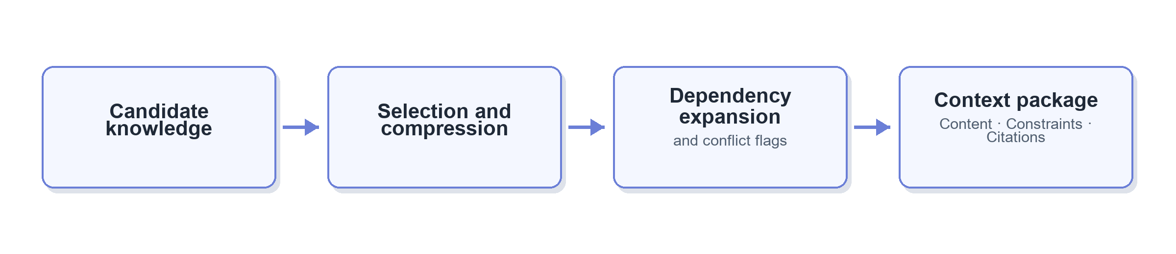

1.4.1 Content Loading and Context Control（内容加载与上下文控制）
Approach / capability（方案 / 能力） | What is it? | Problem addressed | Strengths | Trade-offs / limits | Best fit / adoption conditions | Representative sources
Full-document loading（全文加载） | Places the full matched document into context. | Lowest-effort knowledge injection. | Simple; less likely to miss details in short documents. | Long documents dilute key facts and consume tokens. | Small volumes and short documents. | Traditional long-context practice.
Top-K fragment loading（Top-K 片段加载） | Loads only the highest-ranked fragments. | Full documents are too long. | Saves context and fits classic RAG. | Fragments may omit assumptions or conflict with one another. | Documents are reliably chunked and indexed. | Anthropic: Contextual Retrieval
Progressive reading（渐进式读取） | Shows a directory and summary first, then reads the main guide and opens referenced sections or scripts only when needed. | Too much irrelevant content enters context at once. | Keeps context compact while preserving drill-down. | Requires extra reads; poor entry descriptions cause misses. | Many modules or long modules. | Anthropic: Agent Skills
Context compression / summarization（上下文压缩 / 摘要） | Extracts query-relevant points from candidate evidence while retaining source references. | Candidate evidence exceeds the context budget. | Controls token use and focuses the task. | Compression can remove important conditions. | Many results and original evidence remains accessible. | Microsoft: Agentic Retrieval

1.5 Governance & Lifecycle: Keeping Knowledge Trustworthy（治理与生命周期：如何保持可信）
Governance does not produce answers. It determines which knowledge is trustworthy, who maintains it, when it expires, and who may see it. It spans the first four modules.
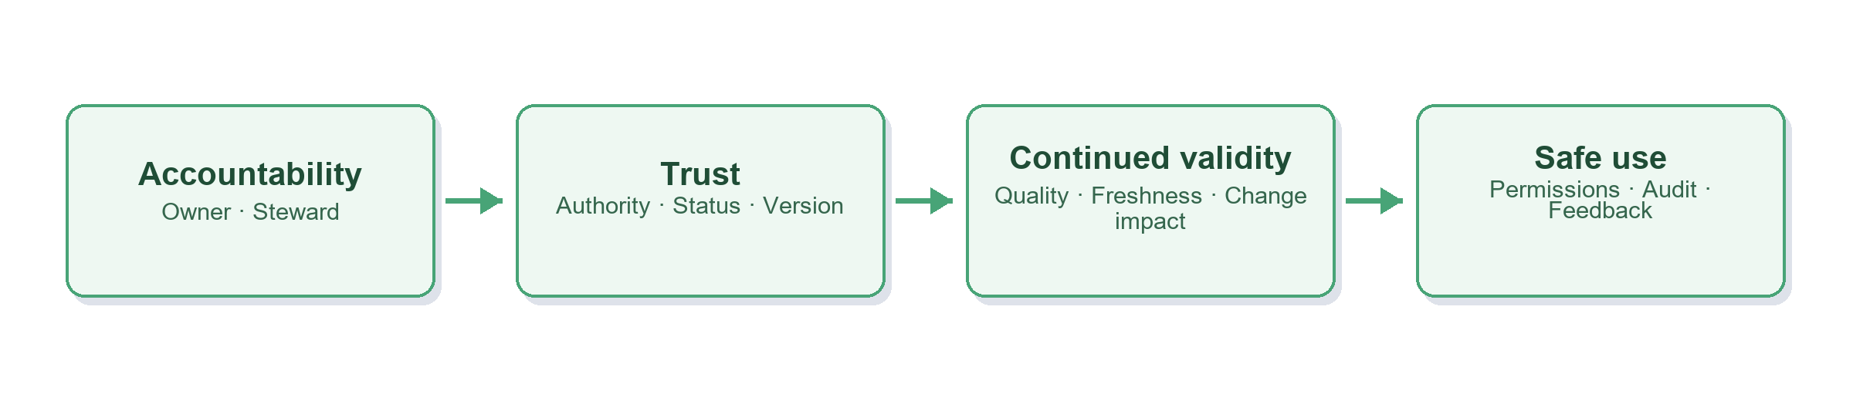

1.5.1 Ownership, Authority, and Lifecycle（责任、权威与生命周期）
Approach / capability（方案 / 能力） | What is it? | Problem addressed | Strengths | Trade-offs / limits | Best fit / adoption conditions | Representative sources
Owner / steward（责任人 / 数据管家） | Assigns an accountable person for a domain, knowledge module, or data asset. | No one owns the content or resolves conflicts. | Clear accountability for review and escalation. | Ownership must change when people move roles. | All core knowledge used in production Q&A. | Google: Business Glossary · DataHub: Ownership
Authority and lifecycle labels（权威与生命周期标记） | Records canonical / reference / example, draft / active / deprecated, version, update time, and supersedes. | Examples, stale documents, and formal definitions compete equally. | Enables ranking, traceability, and exclusion of replaced content. | Labels require approval and maintenance. | Metrics, table guides, tracking events, and SQL examples. | DataHub: Context Layer
CODEOWNERS / review gate（CODEOWNERS / 评审门禁） | Requires designated reviewers for changes to specific files or directories. | Authoritative content changes without confirmation. | Fits Git workflows and provides a clear audit trail. | Mandatory review for everything slows routine contributions. | Core metrics, shared tables, and event definitions. | GitHub: CODEOWNERS

1.5.2 Quality, Change, and Access（质量、变更与权限）
Approach / capability（方案 / 能力） | What is it? | Problem addressed | Strengths | Trade-offs / limits | Best fit / adoption conditions | Representative sources
Freshness and completeness checks（新鲜度与完整性检查） | Checks timestamps, required metadata, broken links, missing owners, and dependency closure. | Documents silently expire or remain structurally incomplete. | Automatically exposes governance debt. | A recent update does not prove correctness. | Structured metadata is in place. | Google: Knowledge Catalog
Dependency impact and change notification（依赖影响与变更通知） | Identifies and notifies dependent workflows and modules when shared definitions or tables change. | Downstream assets keep using old logic after a shared update. | Reduces silent failure. | Dependencies must remain maintained. | Shared metrics, tables, and dimensions are widely reused. | DataHub: Subscriptions
Permission-aware indexing and retrieval（权限感知索引与检索） | Synchronizes ACLs during indexing and query, returning only authorized content. | The model sees sensitive content before attempting to hide it. | Reduces leakage at the retrieval source. | ACL synchronization and cache invalidation are complex. | Knowledge includes sensitive business or personal information. | Microsoft: Security Trimming
Usage feedback and governance loop（使用反馈与治理闭环） | Records misses, wrong citations, conflicts, user corrections, and common questions to drive content updates. | Maintenance relies on periodic cleanup rather than real usage. | Uses production tasks to prioritize governance. | Requires structured feedback and assignment. | The agent is in continuous use. | DataHub: Build a Data Agent

2. Technology Forms and Representative Platforms（技术形态与代表平台）
Capability modules define what the system needs. Technology forms define which product or engineering combination carries those capabilities. One platform often spans several modules, so platform names should not become new knowledge-base responsibility modules.
Technology form（技术形态） | What is it? | Main capabilities covered | Strengths | Trade-offs / limits | Best fit / adoption conditions | Representative sources
File / Wiki knowledge base（文件 / Wiki 知识库） | Uses Markdown, Wiki, and Git as knowledge sources with directories, full-text search, and file reading. | Modeling, basic indexing, and basic retrieval. | Simple, transparent, low-cost, and version-controlled. | Metadata, relationships, permissions, and cross-source synchronization need custom work. | Knowledge is document-first and scale remains manageable. | GitHub / Wiki / Claude Code practice.
RAG engine（RAG 引擎） | Provides parsing, chunking, embeddings, retrieval, reranking, and citations. | Preparation and indexing, retrieval, and context delivery. | Rapid setup for general document Q&A. | Does not automatically resolve business-definition conflicts or governance. | Multi-format documents and semantic retrieval are important. | RAGFlow: popular open-source project
Enterprise search / Agentic Retrieval（企业搜索 / Agentic Retrieval） | Unifies keyword, vector, filtering, semantic ranking, and multi-query retrieval. | Indexing, retrieval, and evidence delivery. | Mature enterprise search, access control, and scaling. | Higher platform dependence, cost, and tuning complexity. | Multiple applications share one retrieval service. | Microsoft: Azure AI Search
Data catalog / context platform（数据目录 / Context Platform） | Combines technical metadata, business semantics, lineage, quality, usage, and contextual documents. | Modeling, governance, retrieval, and agent access. | Strong fit for data Q&A and can use authority and usage signals. | Significant integration and organizational governance effort. | Many data assets are distributed across systems. | Google: Knowledge Catalog · DataHub: Context Layer
GraphRAG / knowledge-graph retrieval（GraphRAG / 知识图检索） | Builds entity-relationship graphs from text or structured assets and queries them locally, globally, or across hops. | Relationship modeling, graph indexing, and complex retrieval. | Strong for cross-document relationships and global themes. | High indexing and governance cost; not the default next step after ordinary RAG. | Evaluation proves multi-hop relationships are a core bottleneck. | Microsoft GraphRAG
Semantic layer（Semantic Layer） | Defines executable metrics, dimensions, entities, and relationships for BI and agents. | Structured modeling and trusted query context. | Highest determinism for frequently used metrics. | Limited long-tail coverage and ongoing modeling cost. | Core metrics are stable and reused frequently. | dbt: Semantic Layer

3. Recommended Direction for the Company（适配当前公司的方案建议）

3.1 Overall Choice（总体选择）
The current foundation is several hundred Markdown Wiki documents, Claude Code grep/glob/read, an event-tracking platform, and table-building code in GitHub. The main problem is not complete retrieval failure. It is long documents, incorrect section selection, duplicated shared knowledge, and insufficient authority signals.
The near-term direction should be:
A modular Markdown knowledge base + three-level navigation + structured metadata + heading-level reading + minimum viable governance. Introduce vector retrieval, GraphRAG, and a context platform only when production failure samples justify them.
A context platform unifies knowledge, metadata, governance, and retrieval; it is not a new knowledge form. Building one now is unnecessary. Revisit it when multi-source integration and governance across Wiki, code, the warehouse, and BI become the dominant bottleneck.
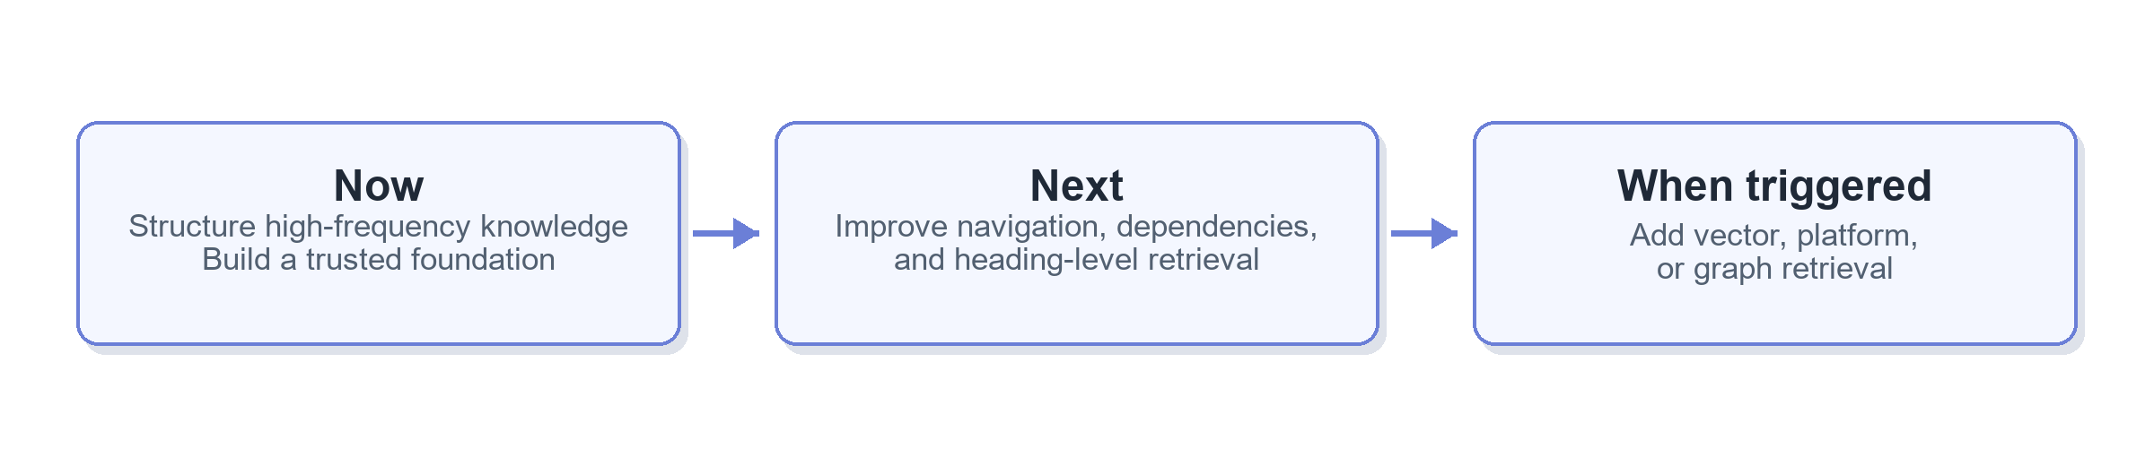
“When triggered” means adding the corresponding technology only after real tasks repeatedly show weak keyword recall, missing cross-system context, or stable multi-hop relationship failures.

3.2 Module-by-Module Selection Matrix（分模块选型矩阵）
Priority levels: P0 = foundation to build now; P1 = add after P0 stabilizes; P2 = add only when production failure samples justify it.
Module（模块） | Submodule（子模块） | Recommended choice | Implementation | Why it fits now | Main benefits | Trade-offs / risks | Priority / timing | Representative sources
1.1 Knowledge Modeling（知识建模） | Document template and metadata（文档模板与元数据） | Use one template and minimum metadata for every AI knowledge document. | Record stable ID, type, domain, summary, content map, sections, dependencies, owner, status, authority, update time, and source. | The AI must first know what a document contains, whether it is usable, and what else must be read. | Shared foundation for navigation, filtering, progressive reading, and governance. | Historical documents need initial remediation. | P0｜Now | Google: Business Glossary
1.1 Knowledge Modeling（知识建模） | Modular reuse（模块化复用） | Separate shared knowledge; other documents declare dependencies. | Extract shared metrics, tables, fields, events, concepts, and SQL templates into stable modules; reference them through depends_on. | Revenue definitions, device models, and similar knowledge are reused across scenarios. | Single-point maintenance with fewer duplicates and version conflicts. | Over-fragmentation increases navigation cost. | P0｜Now | Anthropic: Agent Skills
1.1 Knowledge Modeling（知识建模） | Structured objects（结构化对象） | Structure core terms, metrics, and data assets first. | Give high-frequency objects unique IDs, definitions, synonyms, and relationships; retain Markdown for long-tail context. | Balances determinism with implementation cost. | Maps aliases to one concept and stabilizes core definitions. | Requires domain-expert review. | P1｜After P0 stabilizes | Google: Business Glossary
1.2 Preparation & Indexing（知识准备与索引） | Refresh mechanism（更新机制） | Read from source + scheduled change scans. | Keep Wiki / Git as sources of truth, refresh the manifest automatically, and store only links to the event platform and table-building code. | Sources are few and file-based; a connector platform is unnecessary now. | One source of truth and low-cost directory synchronization. | Scan lag remains; more sources may require connectors later. | P1｜After the base structure | DataHub: Ingestion
1.2 Preparation & Indexing（知识准备与索引） | Index granularity（索引粒度） | Use heading / object-level indexes, not fixed-token chunks. | Assign stable anchors to Markdown headings, knowledge objects, and code blocks so grep/read can locate exact sections. | The current failure is often “right document, wrong content.” | No RAG dependency; complete semantics and stable citations. | Requires document restructuring. | P0｜Now | Google: Knowledge Catalog Metadata
1.2 Preparation & Indexing（知识准备与索引） | Index type（索引类型） | Start with keywords + metadata; defer vector and graph indexes. | Keep grep and add filters such as domain, type, status, and authority. Test advanced indexes only on failure samples. | Tables, fields, metrics, and SQL rely heavily on exact terms. | Explainable, low-cost, and preserves room to evolve. | Synonyms may still be missed. | P0｜Basic index; P2｜Vector / graph | Microsoft: Hybrid Search
1.3 Discovery & Retrieval（发现与检索） | Basic retrieval（基础检索） | Three-level directory + metadata filters + keyword retrieval. | Use business domain, knowledge type, and knowledge module as three levels; narrow scope before searching headings and body text. | Several hundred documents are well suited to hierarchical navigation. | Lower noise and an explainable retrieval path. | Poor directory or metadata maintenance causes misses. | P0｜Now | Google: Data Domains
1.3 Discovery & Retrieval（发现与检索） | Advanced retrieval（高级检索） | Introduce hybrid retrieval from failure samples; defer GraphRAG and Agentic Retrieval. | Run controlled comparisons only for keyword misses, complex multi-condition questions, or stable multi-hop problems. | Avoids amplifying noisy content before document quality improves. | Makes the incremental value of new technology measurable. | Requires evaluation samples, infrastructure, and more latency. | P2｜When triggered | Microsoft: Agentic Retrieval · Microsoft GraphRAG
1.4 Context Delivery（上下文交付） | Progressive loading（渐进式加载） | Directory → metadata / summary → section → dependencies. | Show the directory by default. After a module is selected, read the main guide, then open exact sections, SQL, code, and dependencies as needed. | Directly addresses context overload and wrong-section reading. | Reduces tokens and noise while preserving autonomous exploration. | Directory descriptions and section anchors must be accurate. | P0｜Now | Anthropic: Agent Skills
1.4 Context Delivery（上下文交付） | Dependencies and evidence（依赖与证据） | Explicit dependencies + source citations + stop-on-conflict rule. | Return source, heading, version, and authority; expand depends_on only when needed; list unresolved conflicts and request confirmation. | Prevents shared-knowledge copying and model-led blending of conflicting definitions. | Single-point updates, traceability, and reviewability. | Dependency expansion needs cycle and budget controls. | P0｜Now | DataHub: Context Layer
1.5 Governance & Lifecycle（治理与生命周期） | Authority and freshness（权威与时效） | Owner + status + authority + version + updated_at + supersedes. | Cover core metrics, datasets, events, and workflows first. Keep old documents but mark them reference or deprecated. | These signals are required for the AI to choose the right document. | Separates formal, reference, example, and historical knowledge. | Requires explicit ownership and historical cleanup. | P0｜Now | GitHub: CODEOWNERS
1.5 Governance & Lifecycle（治理与生命周期） | Sources of truth and conflict rules（来源与冲突规则） | Define the source of truth by knowledge type; escalate conflicts to the owner. | Use the tracking platform for event definitions, Git code for table computation, and canonical documents for metrics. Do not merge two conflicting active canonical sources. | Timestamps alone cannot determine business authority. | Clear decision rules reduce confidently wrong selections. | Requires agreement across source systems. | P0｜Now | DataHub: Context Layer
1.5 Governance & Lifecycle（治理与生命周期） | Freshness and impact（新鲜度与影响） | Required-field checks + review_by + dependency change notifications. | Detect missing owners, overdue reviews, broken links, and downstream dependencies of changed modules. | Turns ad hoc cleanup into a manageable process. | Reduces silent knowledge decay. | Recent updates still do not prove correctness. | P1｜After P0 stabilizes | DataHub: Subscriptions
1.5 Governance & Lifecycle（治理与生命周期） | Access and data boundary（权限与数据边界） | Inherit source permissions; never store live business data in the knowledge base. | Retrieve Wiki / Git knowledge under source ACLs. Query live values from the database under the user’s permissions. | Matches the current system boundary. | Prevents indexes from bypassing access controls or copying sensitive data. | Multi-source ACL synchronization needs additional design. | P0｜Guardrail before launch | Microsoft: Security Trimming
1.5 Governance & Lifecycle（治理与生命周期） | Usage feedback（使用反馈） | Record not found, wrong document, wrong section, conflict, stale, and missing dependency. | Turn agent failures into governance tasks and assign them to the relevant owner. | Future improvement should follow real problems. | Shows whether content, navigation, governance, or retrieval needs work. | Requires structured records and closed-loop ownership. | P1｜Build with the pilot | DataHub: Build a Data Agent

3.3 Examples: Taxonomy, Directory, Metadata, and Dependencies（示例：知识分类、目录、元数据与依赖）

3.3.1 Knowledge Types（知识类型）
Start with six knowledge object types:
Type（类型） | Main content | Typical examples
concept（业务概念） | Business context, terms, and object relationships. | Push types; device-model concepts.
metric（指标） | Definitions, formulas, scope, and limitations. | Revenue definition; active-user definition.
event（埋点） | Tracking-event definition, design context, and usage limits. | Push click event.
dataset（数据集） | Tables, fields, granularity, lineage, and use cases. | Revenue base table; event base table.
sql（SQL） | Reusable query fragments or complete examples. | Revenue by device model SQL.
workflow（工作流） | AI task steps, dependencies, checks, and deliverables. | Revenue-by-device workflow; may become a Skill when mature.

3.3.2 Three-level Directory（三级目录）
Generate the directory from metadata rather than maintaining a second manual list:
Knowledge Catalog
├── revenue # Level 1: business domain
│ ├── metric # Level 2: knowledge type
│ │ └── metric.revenue # Level 3: knowledge module
│ ├── concept
│ │ └── concept.device_model
│ ├── dataset
│ │ └── dataset.revenue_detail
│ └── workflow
│ └── workflow.revenue_by_device
├── push
└── delivery

3.3.3 Metadata and Content Map（元数据与内容地图）
Metadata states what the object is, what the document contains, what it depends on, and whether it is trustworthy:
id: workflow.revenue_by_device
type: workflow
domain: revenue
title: Revenue by device model
summary: Instructions, checks, and delivery requirements for splitting revenue by device model
contains: [scope, steps, checks, output]
sections:
scope: "#Scope"
steps: "#Execution steps"
checks: "#Result checks"
keywords: [revenue breakdown, device model]
owner: revenue-analytics
status: active
authority: canonical
version: 1.3
updated_at: 2026-10-01
review_by: 2027-01-01
source: wiki-url
depends_on:
- metric.revenue
- concept.device_model
- dataset.revenue_detail
- sql.device_mapping
supersedes: []

3.3.4 Dependencies and Progressive Reading（依赖与渐进读取）
Global directory
→ Revenue domain directory
→ Metadata and section map for workflow.revenue_by_device
→ The required "Execution steps" section
→ Read metric.revenue / concept.device_model / dataset.revenue_detail on demand
→ Attach source, version, and cited sections to the output

3.3.5 Sources of Truth and Conflict Rules（来源与冲突规则）
Knowledge content（知识内容） | Preferred source of truth
Tracking-event technical definition（埋点技术定义） | Event-tracking platform.
Tracking-event design context（埋点设计背景） | Corresponding requirement or design document.
Table computation and lineage（表的实际计算与血缘） | Table-building code in GitHub.
Table business meaning and limits（表的业务含义与限制） | Canonical dataset document.
Metric definition（指标口径） | Canonical metric document.
Live business values（实时业务数值） | Database; never stored in the knowledge base.

Selection order: active canonical > active reference > example. An explicit supersedes relationship takes precedence over timestamps. If two active + canonical sources conflict, the AI should list the sources and differences, stop synthesizing, and request confirmation from the owner or user.

3.3.6 Minimum Feedback Record（最小反馈记录）
During the pilot, record only six failure types: not_found, wrong_document, wrong_section, conflict, stale, and missing_dependency. They map directly to content, navigation, section structure, governance, or dependency design and can guide the next iteration.

4. References（参考文献）

4.1 Anthropic（Anthropic 公司）
- [A1] Modular capabilities and progressive loading: Agent Skills
- [A2] Contextual chunking and hybrid retrieval: Contextual Retrieval

4.2 Google Cloud and dbt（Google Cloud 与 dbt）
- [G1] Business terms, synonyms, and relationships: Business Glossary
- [G2] Enterprise data context platform: Knowledge Catalog
- [G3] Metadata discovery and indexing: Metadata Overview
- [G4] Domain organization: Data Domains
- [G5] Keyword, semantic, and structured search: Knowledge Catalog Search
- [G6] Data products: Data Products
- [G7] Executable metric semantics: dbt Semantic Layer

4.3 Microsoft（微软）
- [M1] Keyword and vector hybrid retrieval: Hybrid Search
- [M2] Multi-query retrieval and evidence merging: Agentic Retrieval
- [M3] Permission-aware retrieval: Security Trimming
- [M4] Graph indexing: GraphRAG Indexing
- [M5] Graph retrieval: GraphRAG Query

4.4 DataHub, GitHub, and Open-source Projects（DataHub、GitHub 与开源项目）
- [D1] Business and technical context layer: DataHub Context Layer
- [D2] Context loop for data agents: Build a Data Agent
- [D3] Metadata ingestion: DataHub Ingestion
- [D4] Change subscriptions: DataHub Subscriptions
- [D5] File ownership and review: GitHub CODEOWNERS
- [O1] Document parsing and RAG engine: RAGFlow
- [O2] Hierarchical and recursive retrieval: LlamaIndex Retrievers
Note: Industry capabilities are based on the linked official documentation and open-source projects. Section 3 is our assessment for the company’s current context, not an official recommendation from those vendors. The knowledge base stores business context, metric definitions, data-asset descriptions, and query methods—not live business data. Live values remain in the database and are queried under user permissions.

