AI Research Report II: Enterprise Data Q&A Agent Architecture（AI 调研报告（二）：企业数据问答 AI 架构全景）
The company’s data Q&A setup connects Claude Code / Devin directly to the enterprise Wiki for data retrieval, charts, and business Q&A. Planning, conversation management, and basic tool calls are primarily platform-provided. The company should focus on knowledge, task constraints, trusted delivery, and the evaluation loop. The modules below are labeled as P0 (high priority), P1 (lower priority), built-in capability, or industry reference.
P0 (high priority) P1 (lower priority) (built-in capability) (industry reference) Gray content is built into tools such as Claude Code / Devin, or included only as an industry reference.

0. Report Structure（报告框架与章节关系）

Architecture at a Glance: 3 Online Modules + 3 Cross-cutting Modules + 1 Offline Improvement Loop（行业架构分析框架：3 个在线模块 + 3 个横向支撑模块 + 1 个离线闭环）
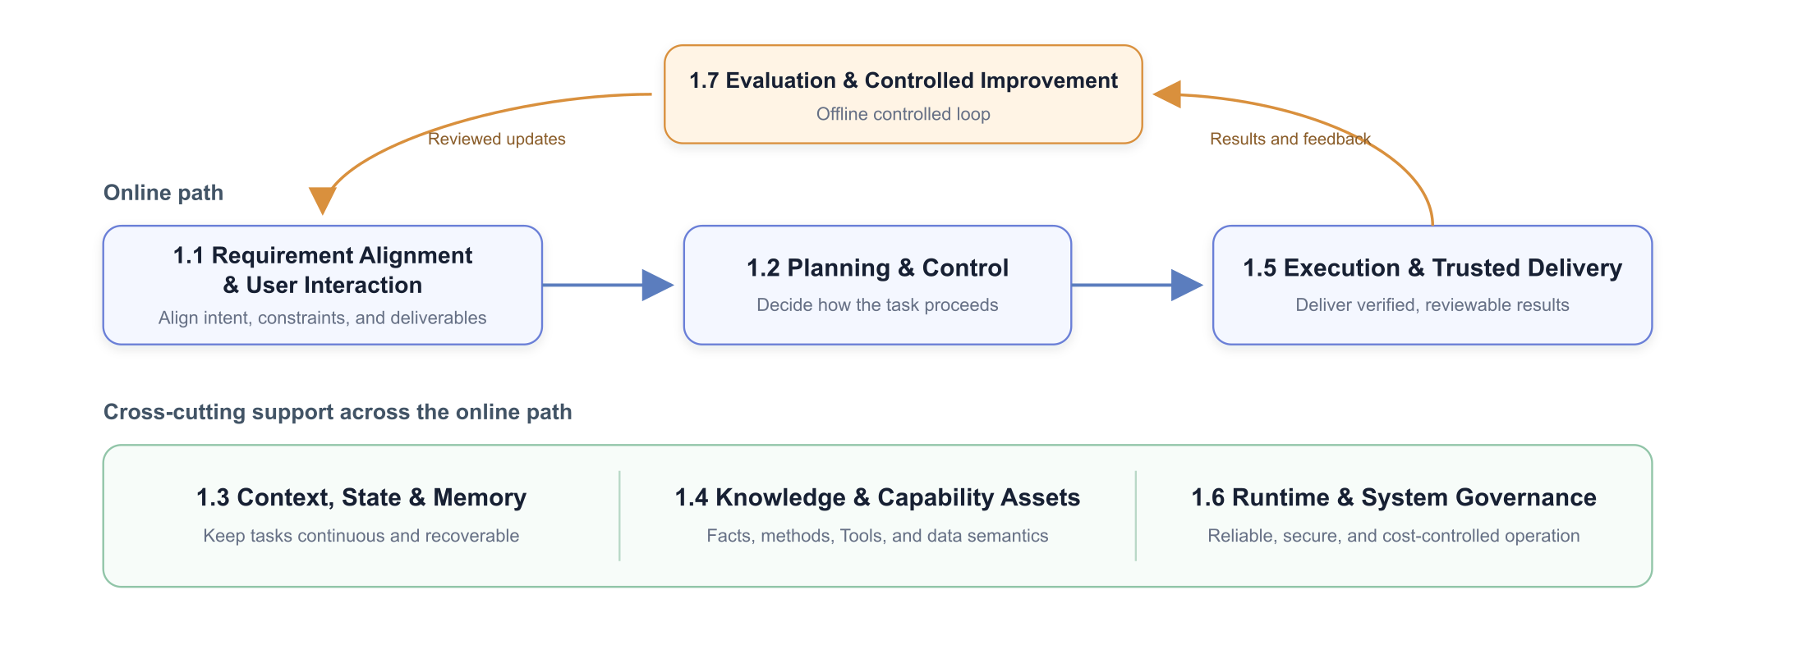
The online path turns a user request into a verifiable result. Three cross-cutting modules provide context, knowledge, tools, runtime reliability, and governance throughout the task. The offline loop improves the other six modules using production evidence. These are capability boundaries—not necessarily seven services or seven sequential steps.

1. Industry Approaches Across the Seven Capabilities（七项能力的行业方法）
An enterprise data Q&A agent needs all seven capabilities, but each can evolve independently. Clear state, asset, and interface boundaries are more important than forcing every capability into a separate service.

1.1 Requirement Alignment & User Interaction（需求对齐与用户交互）
This module aligns the agent and the user. It does not own planning, SQL execution, or result validation. It covers requirement confirmation before execution and the minimum status, approval, and correction interactions needed during and after execution.
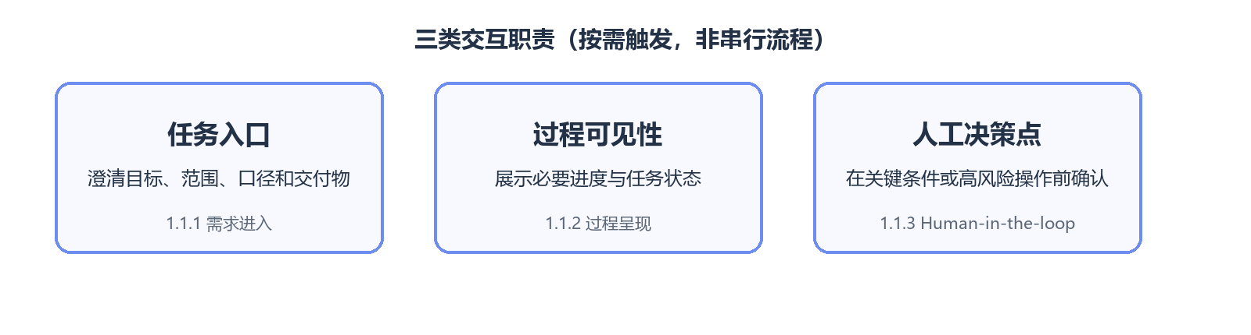

1.1.1 Request Intake: Forming a Task Contract（需求进入：如何形成任务契约）
Approach / capability（方案 / 能力） | What is it? | Problem addressed | Strengths | Trade-offs / limits | Best fit / adoption conditions | Representative sources
Free-form chat（自由聊天） | The model infers constraints from an ongoing conversation. | Lowest-friction Q&A. | Natural and fast to start. | Critical conditions stay implicit and may be lost. | Low-risk exploration. | OpenAI: Session Memory
Proactive clarification（主动澄清） | The agent asks for missing time ranges, metrics, dimensions, scope, or deliverables. | Missing conditions that change the answer. | Prevents work based on unsafe assumptions. | Too many questions degrade experience. | Metric-sensitive tasks; ask only when the answer would change. | Microsoft: Map agent flows
Slot filling（Slot Filling / 参数收集） | Maps a request to predefined fields and fills gaps. | Stable input structure for repeated tasks. | Easy to validate and connect to workflows. | Poor fit for open-ended analysis. | High-volume standardized requests. | Microsoft: Map agent flows
Structured task contract（结构化任务契约） | Stores goal, metric, time, scope, constraints, and output as a JSON/state object. | Later steps interpret the task differently. | Gives every step one shared definition. | Needs update and confirmation rules. | Multi-step analysis; recommended. | Microsoft: Map agent flows
Form-based confirmation（表单化确认） | A UI shows parsed parameters for user review and editing. | The model silently invents key conditions. | Verifiable and auditable. | Adds UI development. | Important metrics or high-risk queries. | Microsoft: Human-in-the-loop

1.1.2 Progress Presentation: What the User Sees（过程呈现：用户能看到什么）（Click to expand）
Approach / capability（方案 / 能力） | What is it? | Problem addressed | Strengths | Trade-offs / limits | Best fit / adoption conditions | Representative sources
Final answer only（仅最终答案） | Returns one response when the task ends. | Lowest-cost delivery. | Simple. | Long tasks are opaque. | Simple tasks completed in seconds. | Microsoft: Map agent flows
Token streaming（逐字流式输出） | Streams generated text. | Perceived first-token delay. | Immediate interaction. | Does not express structured task state; total duration is unchanged. | Standard conversational answers. | OpenAI: Agents API Architecture
Step / event streaming（步骤与事件流） | Shows high-level retrieval, tool, SQL, and validation events—not hidden reasoning. | Users cannot tell whether a task is progressing. | Transparent and observable. | Event granularity and redaction require design. | Multi-step analysis; show only meaningful states. | AG-UI
Generative UI / AG-UI（生成式界面与交互协议） | The agent emits tables, charts, forms, approvals, and artifact events for dynamic rendering. | Text alone cannot support an analysis workspace. | Interactive and approval-ready. | More complex UI protocol and permissions. | Productized analytics workbenches. | AG-UI

1.1.3 Human-in-the-loop: Where People Intervene（Human-in-the-loop：人在哪些节点介入）
Approach / capability（方案 / 能力） | What is it? | Problem addressed | Strengths | Trade-offs / limits | Best fit / adoption conditions | Representative sources
Clarification gate（澄清门） | Pauses when a critical condition is missing. | The agent cannot infer safely. | Stops bad inputs from propagating. | Adds an interaction round. | Task intake. | Microsoft: Human-in-the-loop
Plan approval gate（计划审批门） | Shows the plan, expected scope, or cost before execution. | High-risk plans proceed without review. | Corrects direction before cost is incurred. | Too much approval slows work. | Large scans and complex tasks. | Microsoft: Magentic plan review
Action approval gate（动作审批门） | Requires approval only for writes, sensitive data, or over-budget actions. | High-risk tool calls. | Targets human effort precisely. | Requires accurate risk classification. | Exports, write operations, and sensitive fields. | Microsoft: Human-in-the-loop
Result review / correction（结果审核与纠错） | Users review tables, charts, and conclusions; corrections feed the task and offline evaluation. | Results need business judgment. | Improves both current and future performance. | Feedback must be structured. | Formal analytical delivery. | OpenAI: Agent Improvement Loop
Human takeover（人工接管） | Transfers the task with full state and evidence when automation cannot proceed safely. | Long-tail cases exceed safe automation. | Graceful fallback without losing context. | Needs ownership and an operating queue. | Low confidence, conflicting definitions, or access issues. | Microsoft: Human-in-the-loop

1.2 Task Planning & Control（任务规划与控制）
This module decides task direction, execution order, completion criteria, and replanning. Industry practice has moved beyond pure ReAct toward explicit plans, structured ledgers, rolling planning, stall detection, and human review. Process persistence and failure recovery belong to the runtime layer in Section 1.6.
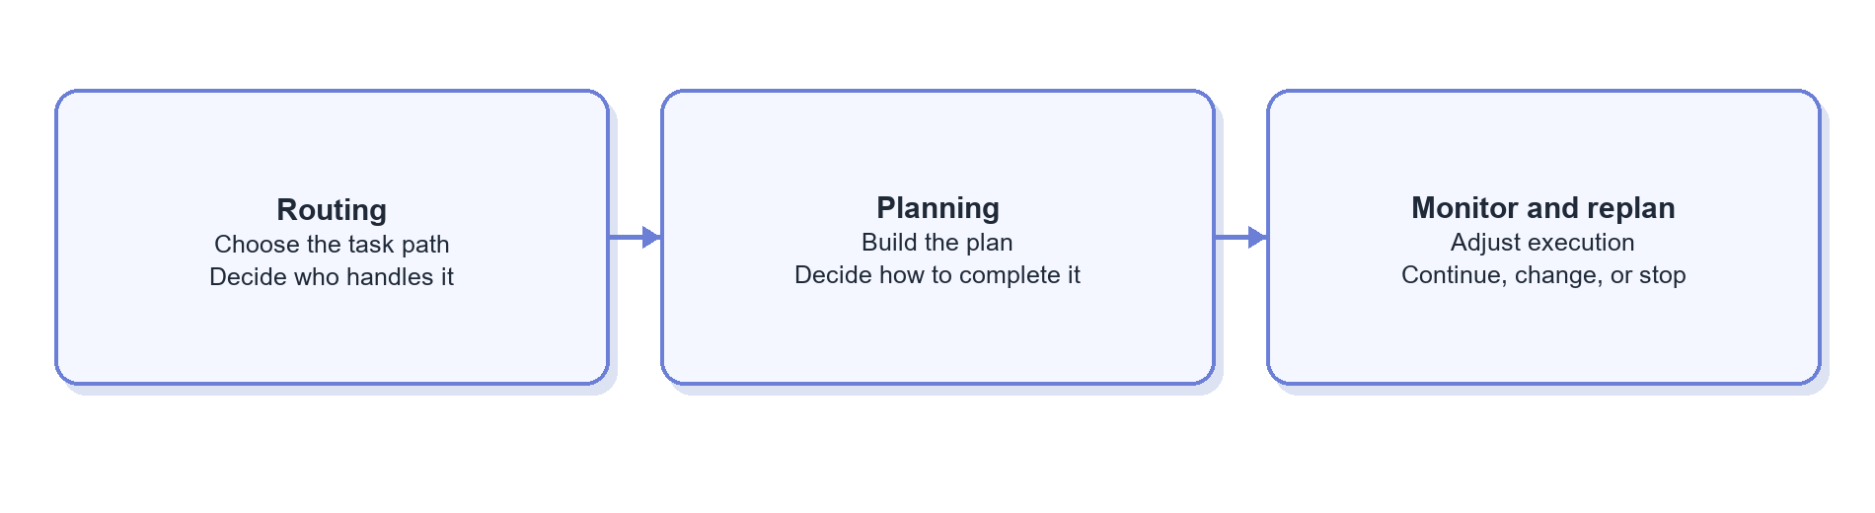

1.2.1 Routing: Choose the Task Path, Not the Exact Skill（Routing：判断任务去向，而不是发现具体 Skill）
Routing identifies task type, handling path, and risk. It has two independent dimensions: decision mechanism and routing depth. Skill/Tool matching belongs to the capability registry in Section 1.4; content loading belongs to context assembly in Section 1.3.
Routing decision mechanisms
Approach / capability（方案 / 能力） | What is it? | Problem addressed | Strengths | Trade-offs / limits | Best fit / adoption conditions | Representative sources
Explicit entry point（显式入口路由） | The user selects “knowledge Q&A,” “data query,” “chart,” etc. | Model-only classification is unstable. | Accurate and model-free. | Adds user effort; categories must stay broad. | Few, clearly bounded task types. | Anthropic: Routing
Rule-based routing（规则路由） | Uses commands, keywords, data types, or risk levels. | Common explicit requests need fast handling. | Fast, cheap, explainable. | Weak on natural-language long tails. | First layer for high-confidence cases. | Anthropic: Routing
Model classification（模型分类路由） | A small or primary model emits task type, risk, and confidence. | Ambiguous language exceeds rules. | Strong semantic coverage. | Adds a call; errors cascade. | Once task categories are reasonably stable. | Anthropic: Routing
Hybrid routing（混合路由） | Rules handle clear cases; a model handles the rest; low confidence falls back to a general agent. | No single method covers accuracy, cost, and long tails. | Combines deterministic and semantic decisions. | Needs priority, confidence, and conflict rules. | Mix of common requests and open-ended language. | Anthropic: Routing

Routing structures
Approach / capability（方案 / 能力） | What is it? | Problem addressed | Strengths | Trade-offs / limits | Best fit / adoption conditions | Representative sources
Flat routing（单层 / 扁平路由） | Classifies once among a small set such as knowledge, data analysis, or other. | Few categories do not need hierarchy. | Simple, fast, easy to evaluate. | Boundaries blur as categories grow. | Small, stable route set. | Anthropic: Routing
Hierarchical routing（分层路由） | Narrows scope in stages—for example task family, then business domain or risk. | One classifier faces too many labels. | Each decision is simpler and separately testable. | Adds latency and error propagation. | Introduce only when domains grow; the final route should still identify a candidate scope, not preload every Skill. | Microsoft: Agentic RAG

Routing output should stay compact: task_type, domain, risk, and candidate capability scope. A registry then finds candidate Skills/Tools, and context assembly loads only what is needed. Routing should not hard-code every execution step.

1.2.2 Planning: How Plans Are Created and Represented（Planning：计划如何生成和表示）
Planning options combine three dimensions: when to plan (upfront or rolling), how to represent the plan (text, structured list, DAG/state graph), and who executes it (the same agent, an executor, or workers).
Approach / capability（方案 / 能力） | What is it? | Problem addressed | Strengths | Trade-offs / limits | Best fit / adoption conditions | Representative sources
Implicit planning / ReAct（隐式规划 / ReAct） | The model chooses the next action after each observation without emitting a full plan. | Short, open-ended tasks. | Flexible and low-overhead. | Goals, dependencies, and completion criteria are easy to lose. | Simple Q&A and short data requests. | Google ADK: PlanReActPlanner
Natural-language checklist（自然语言 Checklist） | Creates a short to-do list and marks progress. | The model forgets remaining work. | Lightweight and readable. | Dependencies and state are hard to validate. | Few-step tasks prone to omission. | Anthropic: Structured note-taking
Structured task plan（结构化任务计划） | Uses JSON/Schema for goals, steps, dependencies, inputs, outputs, state, and completion criteria. | Plans cannot be persisted or validated. | Testable, observable, and updateable. | Overly rigid schemas constrain the model. | Multi-SQL or multi-artifact tasks. | Microsoft: Magentic task ledger
Plan-and-execute（先规划后执行） | A planner creates the plan; an executor follows it. | Complex goals drift during execution. | Separates global intent from local actions. | Initial plans may use incomplete information and add a model call. | Complex analysis with relatively stable dependencies. | Google ADK: Planner
Rolling-horizon / adaptive planning（滚动式与自适应规划） | Plans only near-term steps and revises after new evidence. | Early information is incomplete. | Adapts to data and execution errors. | Needs loop protection. | Exploratory analysis; useful later-stage enhancement. | Microsoft: Adaptive planning
Task-ledger planning（任务账本规划） | Tracks goals, facts, subtasks, progress, stalls, and the next actor. | Long tasks cannot tell whether progress is real. | Supports stall detection, replanning, and audit. | Heavy for simple tasks. | Long or complex tasks. | Microsoft: Magentic orchestration
DAG / graph planning（有向图规划） | Represents tasks as dependency graphs and runs independent nodes in parallel. | Complex dependencies and parallel opportunities. | Makes dependencies explicit. | Graph generation and runtime are more complex. | Stable complex pipelines. | LangGraph
Hierarchical planning（分层规划） | Decomposes goals into subgoals for specialized workers or subagents. | One planning context becomes too large. | Supports focus, specialization, and parallelism. | Handoffs and aggregation are costly. | Only after a clear multi-agent need. | Anthropic: Orchestrator-workers
Human-reviewed planning（人工审核规划） | Presents plans before expensive or sensitive execution. | High-risk plans run unchecked. | Makes risk visible before action. | Adds approval latency. | Large scans, sensitive data, or formal reports. | Microsoft: Magentic plan review

These options combine naturally: short tasks use implicit planning or a checklist; tasks spanning many tables, queries, or deliverables can adopt a structured plan or ledger; uncertain environments favor rolling planning over a fixed upfront plan.

1.2.3 Execution Monitoring, Completion, and Replanning（执行监控、完成判断与 Replan）
Approach / capability（方案 / 能力） | What is it? | Problem addressed | Strengths | Trade-offs / limits | Best fit / adoption conditions | Representative sources
Fixed stop conditions（固定停止条件） | Ends by completed steps, tool calls, time, or token limits. | Infinite loops and runaway cost. | Simple and deterministic. | Tight limits may stop valid work. | Required for every production agent. | Microsoft: Agent design patterns
Result-driven replanning（结果驱动 Replan） | SQL errors, empty results, or incomplete coverage trigger a plan update. | The plan conflicts with real data. | Uses environmental feedback directly. | Needs structured errors and result checks. | Primary replanning mode for data Q&A. | Google: Data Science Agents
Stall / loop detection（停滞与循环检测） | Detects repeated tools, no progress, or repeated errors and resets, reroutes, or stops. | The agent loops on a bad path. | Controls cost and improves explainability. | “No progress” can misclassify legitimate exploration. | Long tasks and agentic SQL. | Microsoft: Magentic progress ledger
Evaluator–optimizer（评估器—优化器） | Rules or a reviewer agent checks whether results meet the goal and requests revisions. | Execution completes but quality is insufficient. | Separates generation from completion judgment. | Evaluators can also be wrong and add cost. | SQL and reports with explicit checks. | Anthropic: Evaluator-optimizer
Human escalation / clarification（人工升级 / Clarification） | Requests a user decision when confidence is low or definitions conflict. | The agent should not guess critical business conditions. | Stops automated error propagation. | Interrupts the experience. | Metric conflicts, access issues, or critical ambiguity. | Microsoft: Human-in-the-loop

1.3 Context, State & Memory（上下文、状态与记忆）
上下文管理决定模型在每一轮能够看到哪些信息；Memory 用于保存允许跨会话复用的信息；Knowledge 保存组织级权威事实；Skill 保存版本化的方法资产。不同对象的生命周期、可信等级和更新责任不同，需要分别治理。
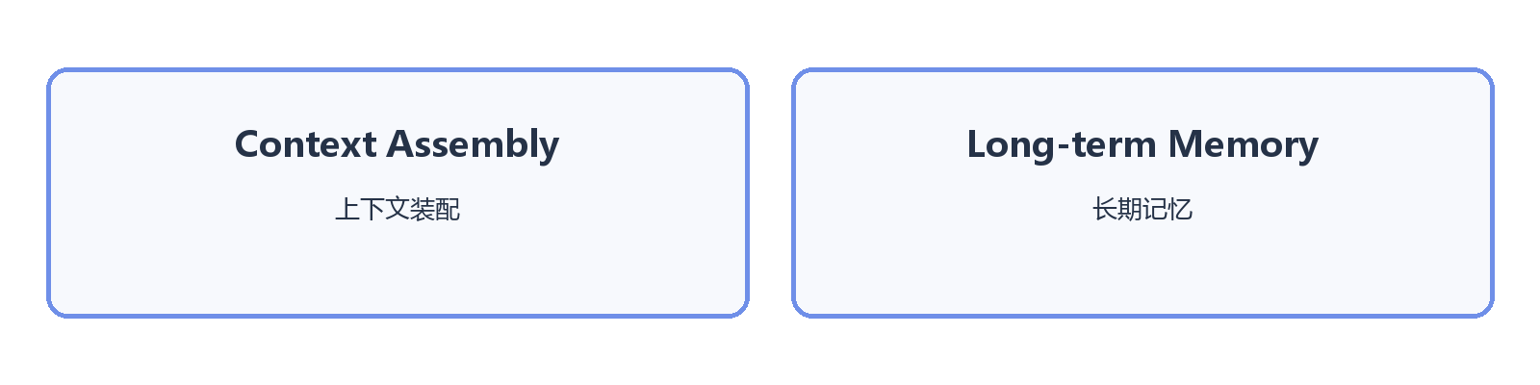

1.3.1 Context Assembly: What the Model Sees Each Turn（Context Assembly：每一轮让模型看到什么）
Context controls are composable. Progressive loading defines when content enters the prompt: first an index or summary, then the matched body, and finally references, schemas, scripts, or raw artifacts only when needed.
Approach / capability（方案 / 能力） | What is it? | Problem addressed | Strengths | Trade-offs / limits | Best fit / adoption conditions | Representative sources
Full context（全量上下文） | Places as much chat, documentation, and tool output as possible in the prompt. | Fear of missing information. | Simple with high recall. | Expensive and highly distracting. | Only very short tasks. | Anthropic: Context Engineering
Sliding window（滑动窗口） | Keeps only the most recent turns. | Unbounded history growth. | Fast and cheap. | Drops early critical constraints. | General chat, not reliable task state. | Anthropic: Context Engineering
Summarization / compaction（摘要 / Compaction） | Compresses earlier history before continuing. | Long tasks exceed context limits. | Preserves continuity at lower token cost. | Irreversibly loses detail. | Medium or long tasks; pair with structured state. | Anthropic: Compaction
Tool-result clearing（工具结果清理） | Keeps conclusions or references while removing older raw outputs. | Tool results crowd the context. | Low-risk token savings. | Details must be re-read later. | Large SQL results, schemas, or logs. | Anthropic: Tool result clearing
On-demand / progressive loading（按需 / 渐进式上下文加载） | Starts with names, summaries, and IDs; loads bodies and deeper resources only when selected. | Too many Knowledge, Skill, and Tool definitions are preloaded. | Keeps context focused while retaining traceability. | Adds retrieval steps; weak descriptions reduce recall. | Large or lengthy capability catalogs. | Anthropic: Just-in-time context · Anthropic: Skill progressive disclosure
Structured Context Builder（结构化 Context Builder） | Assembles fixed sections from state, route, permission, and token budget each turn. | Context selection is entirely improvised by the model. | Observable, testable, and prioritized. | Requires assembly logic and budgets. | Productization stage. | Microsoft Agent Framework: Context providers
Subagent context isolation（子 Agent 上下文隔离） | Gives a subtask a separate context and returns only a compressed result. | Search or analysis noise pollutes the main task. | Isolates noise and enables parallelism. | Summaries lose information and calls cost more. | Independent, noisy, or permission-isolated subtasks. | Anthropic: Sub-agent context

Routing and the capability registry only define a candidate scope. Context Assembly decides what actually enters the prompt. The same Skill may be represented by a summary, a full SKILL.md, or a specific reference—these are loading depths, not different routes.

1.3.2 Long-term Memory: What Should Persist Across Tasks（跨任务应该记住什么）（Click to expand）
方案 / 能力 | 这是什么？ | 解决什么问题？ | 优势 | 代价或局限 | 适用场景 / 采用条件 | 代表来源 / 实践
（内置能力） Profile / Semantic Memory | 保存用户偏好、稳定环境信息和当前有效事实。 | 每次重新说明习惯和环境。 | 高信号、注入成本低。 | 会过期，涉及隐私和作用域。 | 有明确跨会话偏好时。 | Microsoft：Semantic memory
（内置能力） Episodic Memory | 保存“某次任务发生了什么、结果如何”的历史事件。 | 无法利用以前任务的经历。 | 支持跨任务追溯和案例复用。 | 历史案例可能已过期或条件不同。 | 有足够任务历史后，按需检索。 | AWS：Agent memory definitions
（内置能力） Procedural Memory | 保存从经验中学到、但尚未正式沉淀的方法。 | 重复摸索相似任务。 | 支持经验积累和自优化。 | 与 Skill 容易重叠，自动生成风险高。 | 仅作为候选经验；审核后转为 Skill。 | Microsoft：Procedural memory
（内置能力） Session Search | 对历史会话建立关键词/语义索引，需要时检索原始记录。 | 单一摘要不足以覆盖历史细节。 | 保留原始证据，可追溯。 | 检索可能召回错误或敏感内容。 | 事故复盘和重复分析。 | Hermes Agent：Session and memory
（行业参考） 自动 Memory Extraction | 每轮结束由模型抽取值得长期保存的信息。 | 人工记录记忆成本高。 | 自动积累。 | 极易保存错误、琐碎或敏感信息。 | 只在有严格写入规则和审阅时。 | OpenAI Agents SDK：Memory
P1（低优） 审批式写入与遗忘 | 记忆先进入候选区，经人审/规则后写入，并支持 TTL、删除和作用域。 | 自动记忆污染和隐私风险。 | 可治理、可纠错。 | 增加运营和审批成本。 | 企业长期记忆的推荐方式。 | Microsoft：Memory governance

Authoritative business definitions and table metadata belong in Knowledge, not personal or agent Memory. Stable operating methods belong in reviewed Skills. Memory should retain only cross-task information that is allowed to expire or be deleted.

1.4 Knowledge & Capability Assets（知识与能力资产）
知识与能力资产模块将企业事实、任务方法、确定性动作和跨系统互联分别管理。Knowledge 解释事实，Skill 描述任务方法，Tool 执行动作，协议负责这些资产在不同运行环境中的互联。
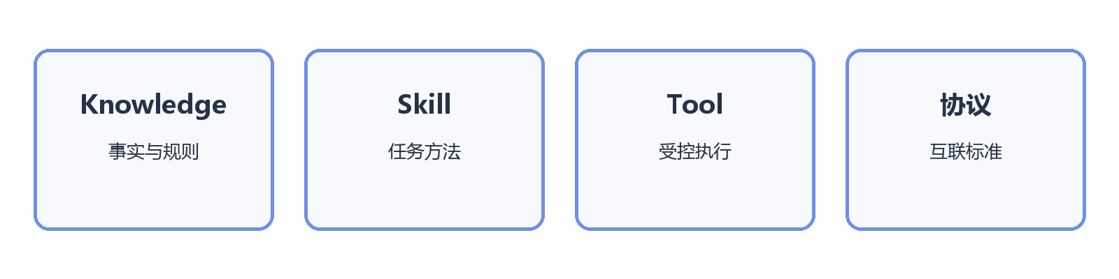

1.4.1 Knowledge: Organizing Enterprise Facts（Knowledge：企业事实如何组织）
Approach / capability（方案 / 能力） | What is it? | Problem addressed | Strengths | Trade-offs / limits | Best fit / adoption conditions | Representative sources
Profile / semantic memory（用户画像与语义记忆） | Stores user preferences, stable environment information, and currently valid facts. | Repeatedly restating preferences. | High-signal and cheap to inject. | Can expire; raises privacy and scope questions. | Clear cross-session preferences. | Microsoft: Semantic memory
Episodic memory（情景记忆） | Stores what happened in a past task and its outcome. | Past experience cannot be reused. | Supports history and case retrieval. | Old cases may no longer apply. | Retrieve on demand after enough history exists. | AWS: Agent memory definitions
Procedural memory（程序性记忆） | Stores experience-derived methods not yet promoted to formal Skills. | Similar tasks are repeatedly rediscovered. | Enables learning from experience. | Overlaps Skills; automatic generation is risky. | Keep as candidates; publish as Skills after review. | Microsoft: Procedural memory
Session search（历史会话检索） | Indexes prior sessions for keyword or semantic retrieval. | A single summary misses historical detail. | Preserves original evidence. | May retrieve irrelevant or sensitive content. | Incident review and repeated analysis. | Hermes Agent: Session and memory
Automatic memory extraction（自动 Memory Extraction） | A model selects information to retain after each task. | Manual memory capture is expensive. | Accumulates automatically. | Easily stores errors, trivia, or sensitive data. | Only with strict write policy and review. | OpenAI Agents SDK: Memory
Reviewed writes and forgetting（审批式写入与遗忘） | Candidate memories are reviewed or rule-checked and support TTL, scope, and deletion. | Memory pollution and privacy risk. | Governable and correctable. | Adds operating overhead. | Recommended enterprise pattern. | Microsoft: Memory governance

1.4.2 Skill: A Better Organization Model（Skill：更好的组织方式是什么）
A mature Skill system combines one clear task entry point, declared dependencies, layered content, a searchable registry, executable resources, versioning, and evaluation. These are complementary design dimensions. Renaming a long document as a Skill does not improve selection or execution.
方案 / 能力 | 这是什么？ | 解决什么问题？ | 优势 | 代价或局限 | 适用场景 / 采用条件 | 代表来源 / 实践
（行业参考） 单体大 Skill | 一个 Skill 包含某方向全部背景、口径、步骤和 SQL。 | 快速把长手册迁入 Skill。 | 易创建。 | 与原长文问题相同，加载后仍会迷失。 | 仅作为迁移过渡。 | Anthropic：Skill progressive disclosure
（行业参考） 单一职责 Skill | 每个 Skill 对应一个明确任务和交付物，如“按设备型号拆收入”。 | Skill 边界模糊、互相重叠。 | 易选择、易评测、易复用。 | Skill 数量会增加。 | 推荐的基本粒度。 | Anthropic：Agent Skills
P1（低优） 组合 / Orchestrator Skill | 一个入口 Skill 只描述高层流程，并调用多个子 Skill 或 Knowledge。 | 复杂任务需要复用多个能力。 | 避免重复，支持组合。 | 编排边界设计不当会隐藏复杂度。 | 一个业务任务包含多个稳定子能力时。 | Anthropic：Skill composition
P1（低优） 依赖声明式 Skill | 在元数据中声明 required/optional Knowledge、Tool、权限和前置条件。 | Agent 不知道还需读取哪些内容。 | 依赖显式，可预检和按需加载。 | 需要统一 ID、Registry 和依赖解析。 | Skill 需要复用公共知识或受控 Tool 时。 | Anthropic：Skills and bundled resources
P1（低优） 分层 Skill Package | 将名称和摘要、SKILL.md 主体、references/scripts 分层存放，为选择性读取提供结构基础。 | Skill 太多、单个 Skill 太长。 | 入口简洁，细节仍可追溯。 | 只完成分层封装；还需要 Context Assembly 才能实现渐进加载。 | 推荐作为标准目录结构。 | Anthropic：Progressive disclosure
P1（低优） 命名空间 / Registry | 为 Skill 维护稳定 ID、领域、任务类型、描述、标签、owner 和权限；系统可按路由范围、过滤条件或语义相似度返回候选 Skill。 | 几十或上百个 Skill 难以管理和匹配。 | 支持检索、权限、归属和治理。 | 元数据质量差会造成漏召回或误召回。 | Skill 数量增长后；它是能力目录与检索机制，不是任务路由。 | Hermes Agent：Skills · OpenAI：Tool Search
P1（低优） 可执行 Skill | Skill 附带校验脚本、模板或确定性代码，Agent 按说明调用。 | 仅靠文字步骤仍容易漏检查。 | 将稳定部分代码化，结果一致。 | 脚本需要测试、安全和版本管理。 | SQL 校验、图表模板、结果检查。 | Anthropic：Agent Skills
P1（低优） 版本化 / 权限化 Skill | Skill 有 version、owner、review date、allowed tools、权限和 Eval。 | 改动不可追溯、过期无人负责。 | 可审核、灰度、回滚。 | 增加治理成本。 | 生产 Skill 必须逐步具备。 | OpenAI：Agent Improvement Loop
（行业参考） 自动生成 / 自改进 Skill | Agent 从经验中生成或修改 Skill 候选。 | 成功经验无法自动沉淀。 | 改进速度快。 | 会固化错误；直接上线风险高。 | 仅作为候选，经 Eval 和人工审核发布。 | Hermes Agent：Skills

The relationship is simple: routing narrows task scope; the registry finds candidate Skills within that scope; Context Assembly progressively loads the selected Skill package. Skill discovery is not a routing type, and progressive loading is not a Skill type.
Example layered Skill package:
skills/
revenue/
device_breakdown/
SKILL.md # Scope, goal, suggested process, completion criteria
manifest.yaml # ID, version, owner, triggers, dependencies, permissions, output
references/
exceptions.md # Loaded only for exception cases
sql_patterns.md # Loaded only when SQL examples are needed
scripts/
validate_result.sql # Deterministic validation
evals/
cases.yaml # Representative success and failure cases

At minimum, manifest.yaml should include id, summary, when_to_use, when_not_to_use, required_knowledge, optional_knowledge, allowed_tools, required_inputs, outputs, completion_checks, version, owner, and last_reviewed.

1.4.3 Tool: Organizing Executable Actions（Tool：动作能力如何组织）
方案 / 能力 | 这是什么？ | 解决什么问题？ | 优势 | 代价或局限 | 适用场景 / 采用条件 | 代表来源 / 实践
（内置能力） 粗粒度业务 Tool | 一个 Tool 完成完整业务动作。 | Tool Call 轮次过多。 | 调用少、流程稳定。 | 黑盒、复用差、权限面大。 | 稳定且低风险的封装流程。 | OpenAI：Tools
（内置能力） 细粒度原子 Tool | 将查 Schema、校验 SQL、执行、作图分别暴露。 | 需要组合、审计和最小权限。 | 边界清楚、易复用和观测。 | Tool 多时选择困难、调用变多。 | 数据问答核心动作；推荐。 | Google：Data Science Agents
（内置能力） 强类型 Tool Schema | 用必填项、枚举、类型和约束定义输入输出。 | 参数幻觉和下游解析失败。 | 可校验、可生成 UI、可审计。 | Schema 过细会降低灵活性。 | 所有生产 Tool。 | OpenAI：Function calling
（内置能力） Tool Group / Capability Bundle | 路由后只暴露当前领域的 Tool 集。 | 全部 Tool 常驻导致误选。 | 降低选择空间和 Token。 | 分组错误会隐藏所需能力。 | Tool 数增长后。 | Microsoft：Agentic RAG
（内置能力） Tool Search / 延迟加载 | 先检索 Tool 目录，再加载完整 Schema。 | 大规模工具定义挤占上下文。 | 支持大规模能力目录。 | 发现阶段本身需要评测。 | 数十个以上 Tool。 | OpenAI：Tool Search
（内置能力） Policy-wrapped Tool | 在真实 Tool 外包权限、参数检查、预算、审计和确认。 | 模型直接接触高风险操作。 | 安全与业务逻辑解耦。 | 增加网关开发和时延。 | 数据库、外部写操作。 | Microsoft：Agentic RAG Security

1.4.4 协议：模块之间如何互联
Protocols define communication interfaces; they do not redefine business responsibilities. For example, AG-UI transports events, while Section 1.1 decides which events users should see.
方案 / 能力 | 这是什么？ | 解决什么问题？ | 优势 | 代价或局限 | 适用场景 / 采用条件 | 代表来源 / 实践
（内置能力） Function Calling | 模型按 JSON Schema 调用应用内函数。 | LLM 与确定性代码交互。 | 简单、直接、可校验。 | 与具体应用耦合。 | 单一应用内部调用 Tool。 | OpenAI：Tools
（内置能力） MCP | 统一发现和调用 Tools、Resources、Prompts 的开放协议。 | 多客户端重复接入内部系统。 | 解耦、复用、生态广。 | 不替代权限和业务语义。 | 连接器需要跨 Agent 复用时。 | MCP Architecture
（行业参考） A2A / Agent Protocol | 支持相对独立 Agent 跨服务协作。 | Agent-to-Agent 通信缺少统一接口。 | 跨团队、跨系统协作。 | 黑盒更大，身份与审计更复杂。 | 专业 Agent 独立部署后。 | A2A Protocol
（行业参考） AG-UI | 用事件协议连接 Agent Runtime 与前端。 | 流式状态、审批和生成式 UI 难统一。 | 前后端解耦、交互丰富。 | 需要事件和权限规范。 | 建设分析工作台时。 | AG-UI

1.5 Execution & Trusted Delivery（执行与可信交付）
This module turns task-control decisions into data operations and reviewable business artifacts. Industry practice has moved from “can it generate SQL?” to “can it execute within policy and resource limits, validate the result, and preserve evidence?”
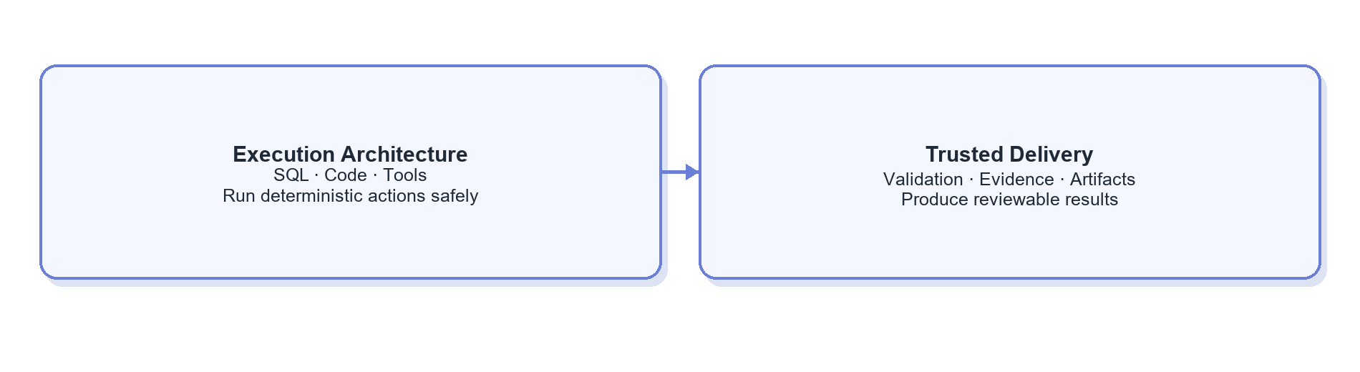

1.5.1 Execution Architecture（执行架构）
方案 / 能力 | 这是什么？ | 解决什么问题？ | 优势 | 代价或局限 | 适用场景 / 采用条件 | 代表来源 / 实践
（行业参考） 直接 Text-to-SQL | 问题加 Schema，一次生成 SQL。 | 最简单的自然语言取数。 | 快、系统简单。 | 多表、复杂口径和歧义场景不稳定。 | 小 Schema、低风险探索。 | Google：Data Science Agents
（行业参考） 检索增强 Text-to-SQL | 先找口径、表字段和历史 SQL，再生成查询。 | Schema 太大、业务语义缺失。 | 减少干扰，可复用验证案例。 | 旧知识或旧 SQL 会传播错误。 | 知识资产逐步整理后。 | Vanna
（行业参考） 语义层驱动查询 | 从治理过的指标、维度和 Join 生成语义查询或受限 SQL。 | 指标口径不一致。 | 高频指标更稳定、可治理。 | 前期建模成本高，长尾仍需原生 SQL。 | 核心指标成熟后。 | Google Dataplex
（行业参考） Agentic SQL | Agent 查询目录/Schema、生成、试跑、读取错误并有限修复。 | 复杂探索式需求。 | 能覆盖多步和长尾问题。 | 更慢、更贵，必须限制轮次和权限。 | 查询路径难预定义且允许有限试错时。 | Google：Data Science Agents
（行业参考） 受控查询执行器 | 在执行 SQL 前后用代码检查只读、语句类型、分区、扫描量、超时、行数和结果位置。 | 模型生成的 SQL 可能越权、消耗过大或产生不可控结果。 | 安全规则确定、可审计，不依赖模型记忆。 | 需要适配数据库方言和内部资源策略。 | 任何连接生产或准生产数据库的 Agent。 | Microsoft：Agentic RAG Security
（行业参考） Code Interpreter / Sandbox | 在隔离环境运行 Python、SQL 和可视化代码。 | 复杂计算与探索式作图。 | 灵活、适合数据分析。 | 需要资源、网络和数据外泄控制。 | 受控的数据分析环境。 | Google ADK：Code Execution

1.5.2 Trusted Results & Artifact Delivery（结果可信与产物交付）
方案 / 能力 | 这是什么？ | 解决什么问题？ | 优势 | 代价或局限 | 适用场景 / 采用条件 | 代表来源 / 实践
P0（高优） 结果校验 / Reconciliation | 检查空结果、量级、时间覆盖、分组合计、异常值和关键约束。 | SQL 成功但业务结果错误。 | 用确定性规则提升可信度。 | 需要为关键指标定义检查规则。 | 所有正式数据交付。 | Google Cortex：Data Product Skills
P0（高优） 来源与证据链 | 记录所用口径、表字段、SQL、运行时间、数据版本和结果引用。 | 结论无法解释或复现。 | 可追溯、可审计。 | 需要统一证据 Schema。 | 所有企业数据问答。 | OpenAI：Trace Grading
P1（低优） Artifact-centric Delivery | 将表、图、报告、SQL 和证据保存为有 ID/版本的产物。 | 聊天消息不可复用、不可下载。 | 支持复核、复用和长期留存。 | 需要管理存储、权限和生命周期。 | 图表、报告和正式分析交付。 | OpenAI：Agent Improvement Loop

Interactive tables, charts, and approvals belong to Section 1.1; synchronous/asynchronous task lifecycle belongs to Section 1.6.1. This module owns the trustworthiness, reviewability, and reusability of delivered content.

1.6 Runtime & System Governance（运行与系统治理）
Agent 运行时与治理底座保障任务在生产环境中稳定、安全、经济地运行，但不参与业务目标和任务步骤的判断。该模块包含三个并列子域：运行生命周期、模型访问与性能、安全策略。
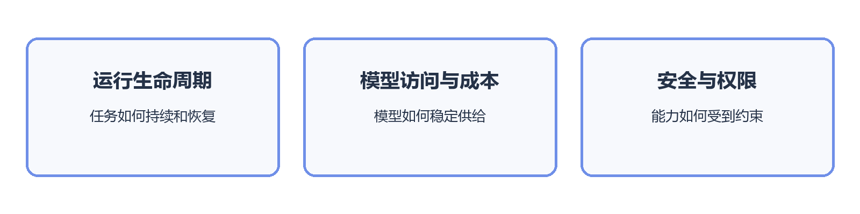

1.6.1 Runtime Lifecycle and Persistence（运行生命周期与持久化）（Click to expand）
方案 / 能力 | 这是什么？ | 解决什么问题？ | 优势 | 代价或局限 | 适用场景 / 采用条件 | 代表来源 / 实践
（内置能力） 临时进程内运行 | 会话状态只存在当前进程或当前聊天中，任务结束即释放。 | 简单短任务需要最低运行成本。 | 实现最简单、时延低。 | 进程中断后难恢复，不适合等待和长任务。 | 秒级、无需审批或异步等待的任务。 | Google ADK：Sessions
（内置能力） 持久化 Session / Run State | 将会话、任务状态和执行记录保存到外部存储。 | 多轮任务、重启或跨设备后状态丢失。 | 可恢复、可审计，也便于多人协作。 | 需要状态 Schema、并发和过期治理。 | 任务跨多轮或需要历史追溯时。 | Google ADK：Sessions, State and Memory
（行业参考） Checkpoint / Durable Execution | 在关键步骤保存检查点，恢复时从确定位置继续，并避免重复副作用。 | 长任务、审批暂停和故障重试会重复执行或丢进度。 | 支持暂停恢复和可靠重放。 | 需要幂等设计、序列化和版本迁移。 | 分钟级任务、异步等待或人工审批。 | LangGraph：Durable Execution
（内置能力） 异步队列与调度 | 将长任务放入队列，由 Worker 执行并通过任务 ID、事件或通知返回结果。 | 大查询和定时任务阻塞在线请求。 | 削峰、并发控制、可调度。 | 引入队列、Worker、重试和任务生命周期管理。 | 任务耗时差异大或需要定时运行时。 | Temporal

1.6.2 Model Access, Performance, and Cost（模型访问、性能与成本）（Click to expand）
方案 / 能力 | 这是什么？ | 解决什么问题？ | 优势 | 代价或局限 | 适用场景 / 采用条件 | 代表来源 / 实践
（内置能力） 直接模型接入 | 应用直接调用单一模型供应商 API。 | 早期快速验证 Agent 能力。 | 链路短、调试简单。 | 多模型切换、配额和成本治理分散。 | 模型数量少、调用规模较小时。 | OpenAI：Agents
（内置能力） 模型网关 | 统一模型 API、鉴权、配额、回退、成本和审计。 | 多模型接入与运营规则散落在各应用。 | 集中治理并降低供应商耦合。 | 网关会成为关键基础设施和潜在单点。 | 多模型、多团队或规模化调用后。 | LiteLLM
（内置能力） 模型路由 / Cascade | 根据任务难度、风险或失败信号选择模型，并在必要时升级。 | 所有步骤都使用强模型造成成本和时延浪费。 | 降低平均成本和响应时间。 | 错误降级会损失准确率，需要持续评测。 | 任务分布、质量阈值和回退规则已经可测时。 | Microsoft：Agent Host
（内置能力） Prompt / Context Cache | 缓存稳定的系统提示、Tool 定义和公共前缀。 | 重复输入增加成本和首字时延。 | 对行为影响较小，性能收益直接。 | 收益依赖重复率和稳定前缀。 | 公共上下文较长且重复调用较多时。 | Anthropic：Prompt Caching
P1（低优） 预算与并发控制 | 为单任务设置 Token、Tool 次数、时长、扫描量和并发上限。 | 自主循环导致成本或资源使用不可控。 | 上限明确，可按用户和任务分级。 | 限制过紧会提前终止有效分析。 | 所有进入生产的自主 Agent。 | Microsoft：Agent design patterns

1.6.3 Security, Permissions & Isolation（安全、权限与隔离）
Approach / capability（方案 / 能力） | What is it? | Problem addressed | Strengths | Trade-offs / limits | Best fit / adoption conditions | Representative sources
Ephemeral in-process run（临时进程内运行） | State exists only in the current process or chat. | Lowest-cost execution for short tasks. | Simple and low-latency. | Hard to recover after interruption. | Tasks completed in seconds without waits or approval. | Google ADK: Sessions
Persistent session / run state（持久化 Session / Run State） | Stores sessions, task state, and execution records externally. | State is lost across turns, restarts, or devices. | Recoverable and auditable. | Needs schemas, concurrency, and expiry rules. | Multi-turn tasks or historical review. | Google ADK: Sessions, State and Memory
Checkpoint / durable execution（检查点与持久化执行） | Saves checkpoints and resumes without repeating side effects. | Long tasks, approvals, and retries duplicate work or lose progress. | Reliable pause, resume, and replay. | Needs idempotency, serialization, and migration. | Long, asynchronous, or approval-based tasks. | LangGraph: Durable Execution
Asynchronous queue and scheduling（异步队列与调度） | Runs long tasks on workers and returns results through IDs, events, or notifications. | Large queries and scheduled work block online requests. | Controls concurrency and supports scheduling. | Adds queues, workers, retries, and lifecycle management. | Highly variable or scheduled task duration. | Temporal

1.7 Evaluation & Controlled Improvement（评测与受控改进）
This module converts production traces, user feedback, and evaluations into verified system changes. RSI—Recursive Self-Improvement—uses system outcomes to propose changes. In enterprise settings, RSI should be controlled: candidates pass evaluation, human or code review, staged release, and rollback gates before production.
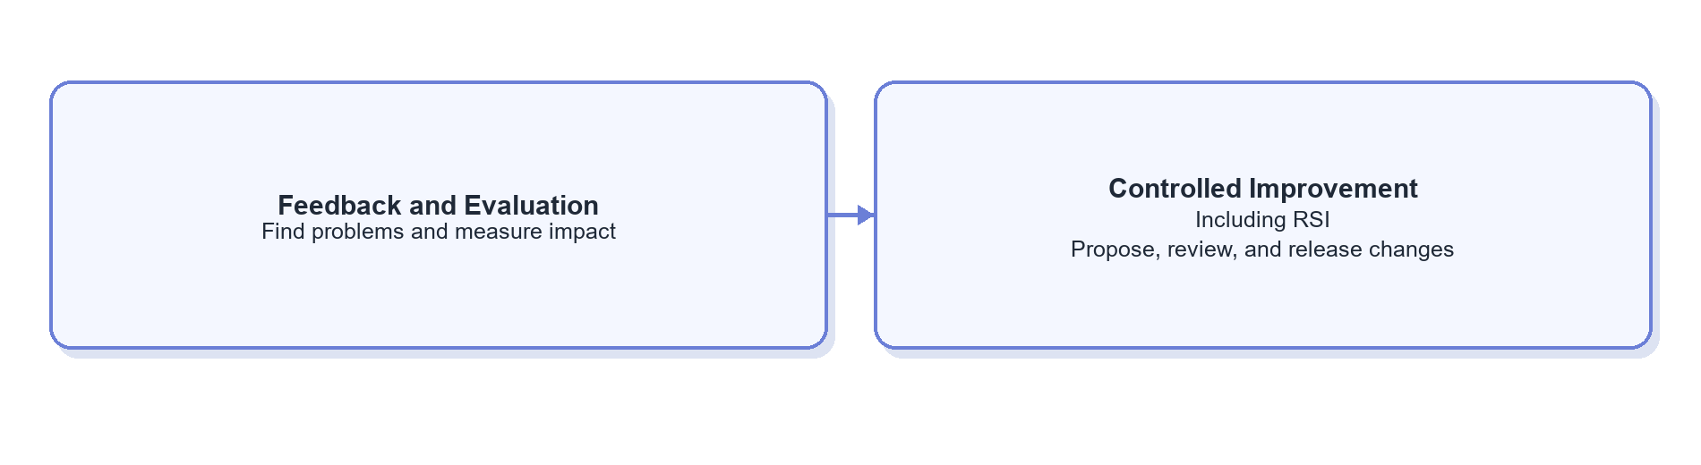
Evaluation here is an offline release gate. Result validation in Section 1.5.2 is an online check within one task. They may share rules, but differ in timing and ownership.

1.7.1 Feedback & Evaluation Signals（反馈与评测信号）
Approach / capability（方案 / 能力） | What is it? | Problem addressed | Strengths | Trade-offs / limits | Best fit / adoption conditions | Representative sources
Direct model access（直接模型接入） | The application calls one provider directly. | Fast early validation. | Short path and simple debugging. | Multi-model switching, quotas, and cost are fragmented. | Few models and modest scale. | OpenAI: Agents
Model gateway（模型网关） | Centralizes APIs, auth, quotas, fallback, cost, and audit. | Model operations are duplicated across apps. | Central governance and less provider coupling. | Becomes critical infrastructure and a potential bottleneck. | Multiple models, teams, or significant scale. | LiteLLM
Model routing / cascade（模型路由 / Cascade） | Selects models by difficulty, risk, or failure signal and escalates when needed. | Strong models are overused. | Reduces average cost and latency. | Bad downgrades reduce quality; requires evaluation. | Task distribution and quality thresholds are measurable. | Microsoft: Agent Host
Prompt / context cache（提示词与上下文缓存） | Caches stable system prompts, Tool definitions, and shared prefixes. | Repeated input raises cost and first-token latency. | Direct savings with limited behavioral change. | Depends on repetition and stable prefixes. | Long shared context with frequent reuse. | Anthropic: Prompt Caching
Budget and concurrency controls（预算与并发控制） | Caps tokens, tool calls, duration, scan size, and concurrency per task. | Autonomous loops consume uncontrolled resources. | Clear limits by user and task. | Tight limits can stop valid work. | Every production autonomous agent. | Microsoft: Agent design patterns

1.7.2 From Feedback to Controlled Release（从反馈到受控发布）
方案 / 能力 | 这是什么？ | 解决什么问题？ | 优势 | 代价或局限 | 适用场景 / 采用条件 | 代表来源 / 实践
P0（高优） 人工迭代 | 人根据失败案例修改 Prompt、Knowledge、Skill 或 Tool。 | 需要高判断力的改进。 | 可控、适合早期。 | 速度慢，知识依赖个人。 | 样本少或变更风险高的早期系统。 | OpenAI：Agent Improvement Loop
P1（低优） 自动诊断与候选建议 | 模型分析 Trace、反馈和 Eval，给出失败归因及改动建议。 | 人工难以阅读大量运行记录。 | 提高发现问题和设计改动的效率。 | 诊断可能错误，不能直接上线。 | Trace 和 Eval 有一定规模后。 | OpenAI：Agent Improvement Loop
P1（低优） Shadow / Canary Release | 新版本先影子运行或只服务少量流量，再比较质量、成本和时延。 | 离线 Eval 无法覆盖真实分布。 | 控制上线风险。 | 需要流量分配和版本观测。 | 系统进入多人使用后。 | OpenAI：Model optimization
P1（低优） Rollback / Version Gate | 每次发布绑定 Prompt、Skill、Tool、模型和数据版本，失败可回滚。 | 改进导致线上退化。 | 可审计、可恢复。 | 需要统一版本和发布体系。 | 所有生产变更。 | OpenAI：Agent Improvement Loop
（行业参考） 受控 RSI | 从失败 Trace、反馈和 Eval 中生成候选 Skill、Prompt、Tool 或代码改动。 | 反馈停留在评论，无法进入工程循环。 | 加速发现和实施改进。 | 候选本身可能错误，必须有发布门禁。 | Eval 和版本体系成熟后。 | OpenAI：Agent Improvement Loop · Hermes Agent
（行业参考） 在线直接自修改 | Agent 修改生产资产后立即生效。 | 追求完全自动适应。 | 理论迭代速度快。 | 不可控、难审计、可能放大错误。 | 不作为企业生产默认方案。 | Hermes Skills and Memory

2. Two Dimensions of End-to-End Architecture Choices（端到端架构的两类选择维度）（Click to expand）
End-to-end design is shaped by two independent choices: whether the execution path is predefined or decided dynamically, and whether one agent or several agents share the work. The seven capability modules define what the system needs; this section defines how those capabilities are assembled.
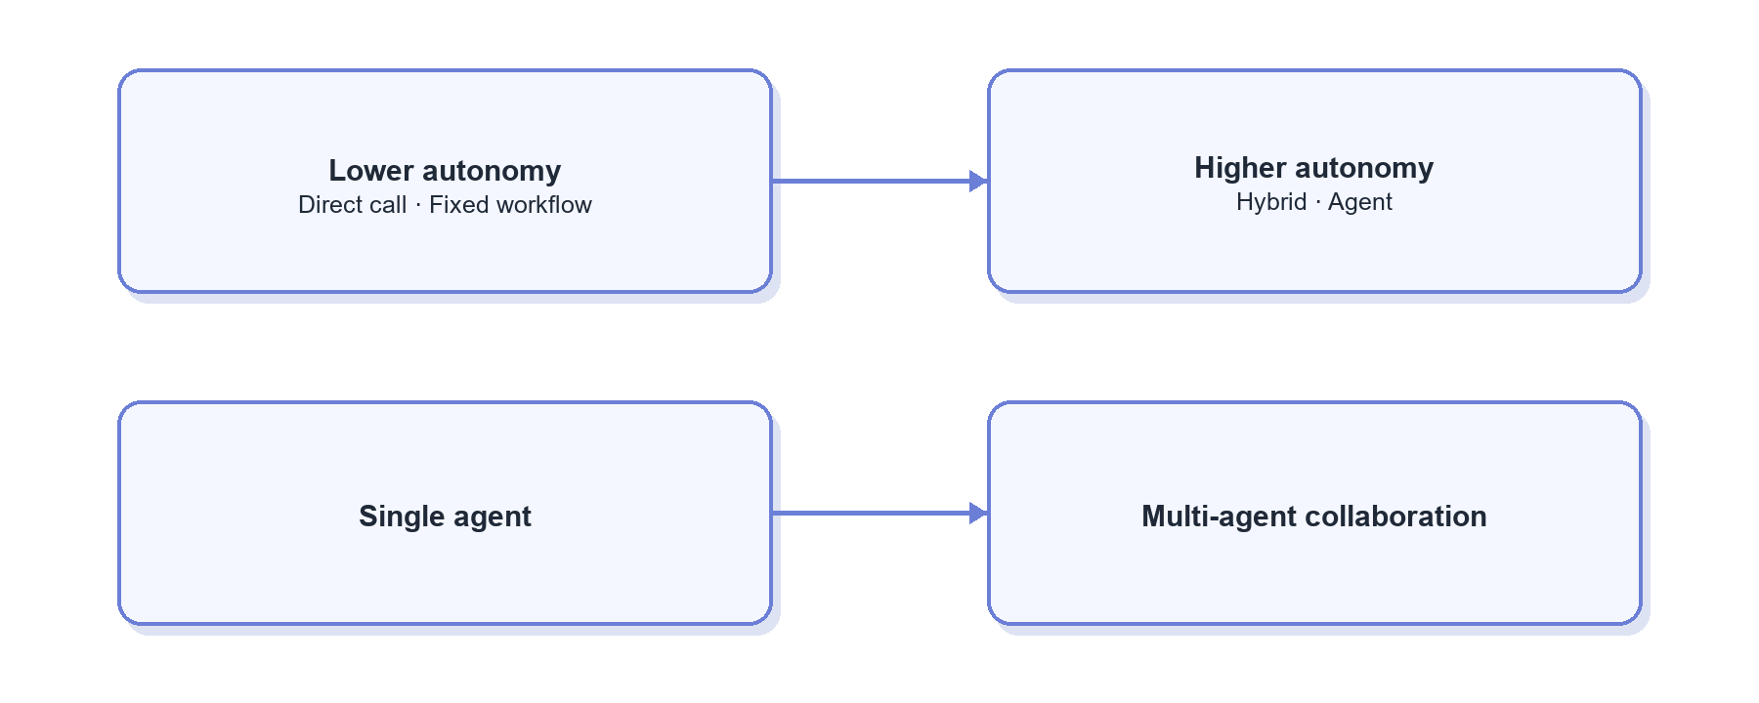

2.1 Degree of Autonomy（自主程度）
More autonomy improves long-tail coverage but raises cost, latency, and behavioral variance. More determinism improves testing and auditability but reduces adaptability.
方案 / 能力 | 这是什么？ | 解决什么问题？ | 优势 | 代价或局限 | 适用场景 / 采用条件 | 代表来源 / 实践
（行业参考） 直接模型调用 | 一次 Prompt 或结构化输出直接返回。 | 简单抽取、改写和解释。 | 最快、最便宜。 | 不查企业事实，也不能执行动作。 | 上下文完整的单步任务。 | OpenAI：Agents
（行业参考） 固定 Workflow / RAG | 路径由代码预先规定。 | 稳定且重复的任务。 | 行为、成本和时延可预测。 | 对长尾和歧义任务不灵活。 | 单一知识问答或稳定流程。 | Microsoft：Standard and Agentic RAG
（行业参考） 有限自主混合架构 | 外层固定边界，阶段内允许 Agent 自主决策。 | 同时需要可靠边界和探索能力。 | 生产中最实用的折中。 | 需要明确代码与模型职责。 | 数据取数和分析。 | Anthropic：Building Effective Agents
（行业参考） 高自主 Agent | Agent 动态决定计划、工具和终止路径。 | 路径无法预定义的复杂任务。 | 长尾覆盖能力强。 | 成本、时延和行为波动最大。 | 高价值探索任务。 | Anthropic：Agents

2.2 Agent Organization（Agent 组织方式）
Agent organization determines how context, permissions, and responsibility are divided. A single agent fits most tasks with one decision owner. Multi-agent designs are justified only when context isolation, permission separation, specialization, or parallelism creates measurable value.
Approach / capability（方案 / 能力） | What is it? | Problem addressed | Strengths | Trade-offs / limits | Best fit / adoption conditions | Representative sources
User feedback（用户反馈） | Captures ratings, written corrections, and expert comments. | Real user dissatisfaction. | Easy and business-relevant. | Sparse and subjective. | Collect from launch. | OpenAI: Evaluating Agents with Langfuse
Human trace review（人工 Trace Review） | Experts inspect knowledge, plan, SQL, result, and answer. | The final answer looks right while the process is risky. | Locates root causes. | Labor-intensive. | Sampling and incident review. | OpenAI: Trace Grading
Deterministic checks（确定性检查） | Code validates SQL syntax, data coverage, constraints, and artifact completeness. | Subjective scoring misses hard failures. | Stable, cheap, explainable. | Covers only formalizable rules. | Build from day one. | Google Cortex: Data Product Skills
Regression evaluation（回归评测） | Freezes representative tasks, expected behavior, and grading rules and reruns them after changes. | A local improvement breaks prior capability. | Repeatable, comparable, release-ready. | Cases need maintenance. | Before and after Prompt, Skill, or Tool changes. | OpenAI: Agent Evals
LLM-as-a-Judge（大模型评审） | Uses a model and rubric to grade answers or full traces. | Human review does not scale. | Scales trend detection. | Biased; should not approve high-risk releases alone. | Combine with rules and human sampling. | OpenAI: Agent Evals

3. Agent Technology Stack and Representative Approaches（Agent 技术栈与代表方案）（Click to expand）
The technology stack is the engineering vehicle for the seven capabilities, not an eighth business capability. Products often span SDKs, workflows, runtimes, UI, and multi-agent features, so they should be compared by primary role and actual capability coverage.
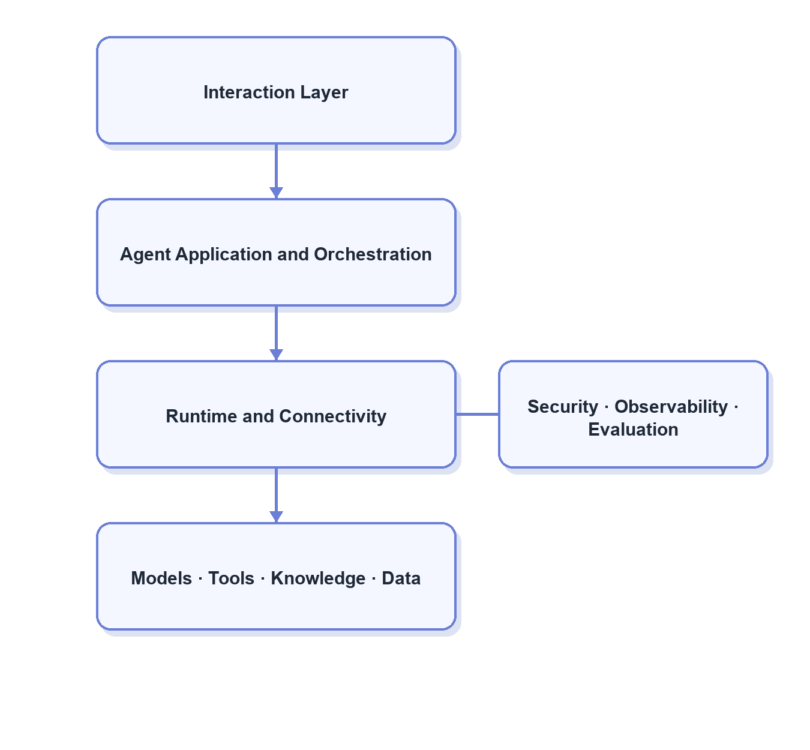

3.1 Technology Categories（技术栈类别）
方案 / 能力 | 这是什么？ | 解决什么问题？ | 优势 | 代价或局限 | 适用场景 / 采用条件 | 代表来源 / 实践
（行业参考） Agent SDK | 用代码定义 Agent、Tool、Guardrail 和输出。 | 快速构建定制 Agent。 | 灵活、易嵌入现有服务。 | 状态和治理通常需另建。 | 需要高度定制并嵌入现有应用时。 | OpenAI Agents SDK · Google ADK · PydanticAI
（行业参考） Workflow / Durable Runtime | 表达步骤、状态、分支、暂停、恢复和重试。 | 长任务和可靠执行。 | 可审计、可恢复。 | 容易过度流程化。 | 存在长任务、审批等待或故障恢复需求时。 | LangGraph · Microsoft Agent Framework · Temporal
（行业参考） Agent Harness | 将 Agent loop、会话、工具、记忆、Skill 和入口打包。 | 持续运行的通用 Agent。 | 开箱能力完整。 | 通用设计未必适合企业数据治理。 | 希望快速获得完整自主 Agent 工作环境时。 | Hermes Agent · OpenHands
（行业参考） Multi-agent Framework | 提供角色、消息、委派、群聊和 Supervisor。 | 多 Agent 专业化与协作。 | 分工表达直观。 | 成本、交接、调试复杂。 | 上下文、权限或并行隔离收益明确时。 | AutoGen · CrewAI
（行业参考） Web / Generative UI SDK | 将模型、Tool Call 和流式结果接入 Web UI。 | Agent 前端和交互式产物。 | 流式和 UI 体验好。 | 不负责后端 Durable Runtime。 | 建设独立分析工作台或交互式产物时。 | Vercel AI SDK · AG-UI
（行业参考） 低代码 Agent 平台 | 可视化配置模型、RAG、Workflow、Tool 和渠道。 | 快速验证和业务人员参与。 | 上线快。 | 深度定制、版本和复杂调试受限。 | 快速原型、标准流程和连接器集成。 | Dify · Flowise · Langflow
（行业参考） 国内工程框架 | 面向 Java、Go、Python 和国内模型生态的 Agent 框架。 | 匹配本地技术栈。 | 组件与国内生态结合紧密。 | 成熟度和治理能力需分别验证。 | 国内模型、部署环境或既有语言栈约束明显时。 | Spring AI Alibaba · Eino · Qwen-Agent · Youtu-Agent
（行业参考） 云托管 Agent 平台 | 云厂商托管模型、Session、Tool、部署和观测。 | 降低基础设施建设。 | 集成和运维负担较低。 | 平台绑定和成本需评估。 | 企业数据与基础设施已集中在对应云平台时。 | Vertex AI Agent Engine · Azure AI Foundry · Bedrock Agents
（行业参考） 协议层 | 定义 Tool、资源、Agent 和 UI 的跨系统通信方式。 | 不同客户端重复集成。 | 解耦、互通、可复用。 | 不负责业务逻辑和权限本身。 | 同一能力需要被多个客户端或服务复用时。 | MCP · A2A · AG-UI
（行业参考） 模型网关与可观测 | 统一模型路由、成本、回退、Trace、Prompt 和 Eval。 | 多模型运营和故障定位。 | 可独立于主框架建设。 | 需要接入和数据治理。 | 多模型、多应用或调用规模明显增长后。 | LiteLLM · Langfuse · Phoenix

3.2 Positioning of Representative Frameworks（代表框架的主要定位）
方案 / 能力 | 这是什么？ | 解决什么问题？ | 优势 | 代价或局限 | 主要覆盖的能力模块 | 代表来源 / 实践
（内置能力） Claude Code / Claude Agent SDK | Claude Code 是面向文件和终端任务的 Agent Harness；Agent SDK 用于将类似循环与工具能力嵌入应用。 | 快速获得自主 Agent loop、文件操作和 Tool 执行环境。 | 通用任务自主性强，适合代码与文件型工作。 | 企业数据语义、权限、专用 Task State 和发布治理仍需补充。 | 任务控制、上下文、执行、基础 Runtime。 | Claude Agent SDK
（行业参考） LangGraph | 以状态图或函数式 API 构建有状态 Agent，强调 Persistence、Checkpoint、HITL 和 Durable Execution。 | 长任务、暂停恢复、显式状态和故障容错。 | 状态与恢复能力强，可局部或渐进采用。 | 过早图化会增加设计负担，业务资产仍需自建。 | 任务控制、Task State、Runtime、HITL。 | LangGraph：Durable Execution
（行业参考） Hermes Agent | 一体化持续运行 Agent Harness，整合 Tool、Skill、持久记忆、会话检索、Gateway、Cron 和学习闭环。 | 通用 Agent 的跨会话运行、渠道接入和能力积累。 | 开箱能力广，对 Skill、Memory 和持续学习有参考价值。 | 面向通用 Agent；企业场景中的自动写入和自改进需要额外门禁。 | Runtime、Skill、Memory、Tool、持续改进。 | Hermes Agent · Hermes Skills
（行业参考） OpenAI Agents SDK | 轻量代码 SDK，提供 Agent、Tool、Handoff、Guardrail、Session 和 Trace。 | 在应用内构建可观测的定制 Agent。 | 抽象简洁，Tool、Handoff 和评测链路较完整。 | Durable Runtime 和企业数据治理需要组合建设。 | 任务控制、Tool、多 Agent、Trace。 | OpenAI Agents SDK
（行业参考） Google ADK / Agent Engine | Agent SDK 加 Session、Memory、Planner、Tool 和云端托管运行时。 | 在 Google Cloud 生态构建、部署和运营 Agent。 | Session、数据分析和 GCP 集成较完整。 | 对 GCP 生态依赖更强。 | Planning、Memory、Tool、Runtime、云部署。 | Google ADK
（行业参考） Microsoft Agent Framework | 面向 Agent 与 Workflow 的企业框架，覆盖编排、HITL、状态和连接器。 | 将 Agent 自主性与企业流程、审批结合。 | Workflow、HITL 和企业集成边界清楚。 | 组件较多，选型和演进成本需要评估。 | 交互审批、任务控制、Runtime、多 Agent。 | Microsoft Agent Framework
（行业参考） Temporal | 通用 Durable Execution 平台，并非专门的 LLM Agent 框架。 | 超长任务、可靠重试、定时调度和跨故障恢复。 | 工作流可靠性和可恢复性成熟。 | Agent、Prompt、Tool 和业务状态抽象需要自行建设。 | Runtime 生命周期和可靠执行。 | Temporal
（行业参考） AutoGen / CrewAI | 以角色、消息、协作流程和 Supervisor 等抽象构建多 Agent 系统。 | 专业 Agent 分工、委派和协商。 | 多 Agent 表达直观，适合验证协作模式。 | 交接损耗、成本和调试复杂度高。 | 多 Agent 组织方式。 | AutoGen · CrewAI
（行业参考） Dify / Flowise / Langflow | 通过可视化界面配置模型、RAG、Workflow、Tool 和应用入口。 | 快速搭建原型并让非纯研发角色参与配置。 | 验证快、连接器丰富。 | 深度定制、复杂状态和版本治理可能受平台限制。 | 低代码应用、Workflow、RAG 和 Tool 集成。 | Dify · FlowiseAI · Langflow
（行业参考） Spring AI Alibaba / Eino / Qwen-Agent / Youtu-Agent | 面向 Java、Go、Python 和国内模型生态的工程框架。 | 与国内技术栈、模型和部署环境集成。 | 本地生态适配更直接，语言选择丰富。 | 各项目的状态、治理和生产成熟度需要分别验证。 | SDK、Workflow、Tool 与国内模型接入。 | Spring AI Alibaba · Eino · Qwen-Agent · Youtu-Agent

3.3 Framework Selection Principles（框架选型原则）
- Identify whether the real gap is business knowledge, Task State, Tool safety, or runtime reliability; a framework cannot replace business governance.
- Change runtime only when the current harness cannot meet persistence, recovery, asynchronous execution, multiple entry points, or unified operations needs.
- Multi-agent is not the natural upgrade path from single-agent. Adopt it only for proven context, permission, specialization, or parallelism benefits.
- “Broadest feature set” is not “best fit.” Compare task success, development complexity, operating cost, observability, and migration cost together.

4. Recommendations for the Current Company Context（适配当前公司的方案建议）

4.1 Overall Selection（总体选择）
This chapter focuses on P0 work for the current stage: while reusing Claude Code / Devin platform capabilities, prioritize requirement constraints and task state, progressive knowledge loading, result validation, and evaluation iteration. These address missed conditions, long-task drift, inaccurate knowledge loading, and hard-to-verify results.
The figure below shows only near-term P0 items; “None at this stage” means the module has no high-priority implementation item now.
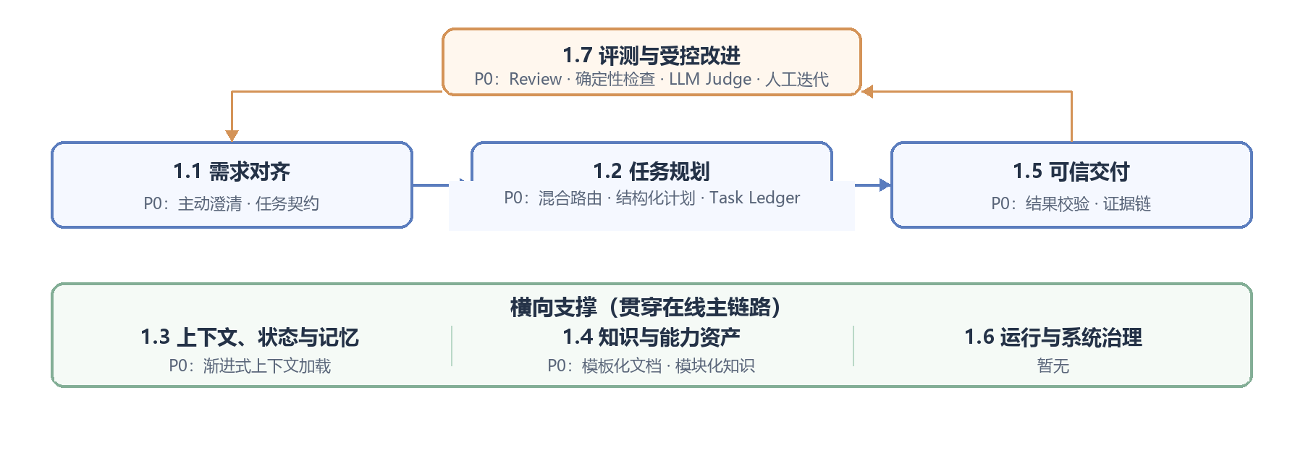

4.2 P0 Module Selection Matrix（分模块选型矩阵）
Module（模块） | Capability（能力） | Implementation（具体做法） | Example（示例） | Primary benefit（主要收益） | Representative sources（代表来源）
1.1 | Proactive clarification + structured task contract（主动澄清 + 结构化任务契约） | After clarification, persist the metric definition, time window, scope, grain, deliverable, and validation criteria. Do not query when critical fields are missing. | For “revenue by device model”, confirm GMV vs. net revenue, time, device grain, chart, and “sum of segments = total revenue”; reference this contract throughout. | Turns one confirmation into a task-wide constraint, reducing unsafe assumptions, rework, and incorrect SQL. | Microsoft：Map agent flows
1.2 | Hybrid routing + structured planning + Task Ledger（混合路由 + 结构化计划 + Task Ledger） | Use light rules for first-pass routing and hand low-confidence cases to the agent. Generate a checklist and continually log the goal, confirmed conditions, knowledge read, SQL, results, pending work, and completion state. | Classify as “data retrieval + chart”; the Ledger records the agreed revenue definition, required revenue/device knowledge, executed SQL, pending reconciliation, and trend chart. | Combines stable routing with long-tail flexibility and prevents drift, omission, and repeated work. | Anthropic：Routing  Anthropic：Context Engineering · Google ADK：State
1.3 | Progressive context loading（渐进式上下文加载） | Read the domain directory, metadata, and summary first; then load only necessary body sections, referenced modules, or SQL examples. | Locate the “Revenue — Device Model” directory first; load only revenue definition, revenue tables, device definition, and update rules, not unrelated Push knowledge. | Reduces irrelevant context and improves retrieval accuracy, latency, and cost control. | Anthropic：Just-in-time context · Anthropic：Skill progressive disclosure
1.4 | Template documents + modular knowledge（模板化文档 + 模块化知识） | Maintain metrics, tables, fields, definitions, and update methods as separate modules governed with stable IDs, owners, and dependencies. | Maintain revenue definition, revenue base tables, device-model logic, and refresh method separately; the “revenue by device model” playbook only references them. | Update once and reuse everywhere; reduces long-document conflicts and enables traceability. | Google Dataplex：Glossary · Anthropic：Context Engineering
1.5 | Result validation + evidence trail（结果校验 + 证据链） | Validate definitions, coverage, magnitude, and reconciliation deterministically; deliver SQL, tables/charts, knowledge citations, and run information. | Check whether device-model revenue sums to same-definition total revenue before delivering the trend chart, rerunnable SQL, and definition source. | Upgrades “SQL ran successfully” into a reviewable, reproducible business result. | Google Cortex：Data Product Skills · OpenAI：Trace Grading
1.7 | Human Review + deterministic checks + LLM Judge + manual iteration（人工 Review + 确定性检查 + LLM Judge + 人工迭代） | Rules block hard errors; LLM Judge scores against rubrics at scale; experts sample and calibrate. Owners update Knowledge/Skill based on failure cases, then re-evaluate before release. | For a device-model mapping error: reconciliation detects the mismatch, the Judge checks definition and citations, experts confirm root cause, and the owner updates the knowledge module before rerunning evaluation. | Creates a measurable, accountable, and controlled improvement loop. | OpenAI：Agent Evals · OpenAI：Trace Grading  OpenAI：Agent Improvement Loop · Hermes Agent

5. References（参考文献）
5. References（参考文献）

All sources below are cited in the report. Vendor documentation, standards bodies, and official project repositories are prioritized. Open-source repositories illustrate engineering practice; stars alone do not establish suitability, quality, or long-term support.
- 5.1 Anthropic（Anthropic 公司）
- [A1] Agent design patterns: Building Effective Agents
- [A2] Agent context engineering: Effective Context Engineering for AI Agents
- [A3] Agent Skill engineering: Equipping Agents for the Real World with Agent Skills
- [A4] Claude agent development: Claude Agent SDK
- [A5] Claude Skill usage: Claude Agent Skills

[A6] Prompt caching and cost: Prompt Caching
- 5.2 OpenAI（OpenAI 公司）
- [O1] Agent capability overview: Agents Guide
- [O2] Agents API architecture: Agents API Architecture
- [O3] Agent orchestration: Agent Orchestration
- [O4] Tools and function calling: Tools and Function Calling
- [O5] Agent observability: Agent Observability
- [O6] Agent evaluation: Agent Evals
- [O7] Trace grading: Trace Grading
- [O8] Model optimization: Model Optimization
- [O9] Agent improvement loop: Agent Improvement Loop
- [O10] Langfuse evaluation example: Evaluating Agents with Langfuse
- [O11] Session memory: Session Memory
- [O12] OpenAI Agents SDK: OpenAI Agents SDK for Python

[O13] Agent workspace memory: OpenAI Agents SDK Memory
- 5.3 Google Cloud, dbt, and Data Semantics（Google Cloud、dbt 与数据语义）
- [G1] Data-science agent architecture: Google Cloud: Agentic AI for Data Science
- [G2] Agentic data platform: Google Cloud: Agentic Data Cloud
- [G3] Data-product Skills: Google Cortex Framework: Data Product Skills
- [G4] Business terms and synonyms: Google Dataplex: Business Glossary
- [G5] Looker Join modeling: Google Looker: Working with Joins
- [G6] Join cardinality: Google Looker: Join Relationship
- [G7] Google agent development kit: Google ADK
- [G8] Sessions, State, and Memory: Google ADK: Sessions, State and Memory
- [G9] Controlled code execution: Google ADK: Code Execution
- [G10] Agent planning: Google ADK: Planner Documentation
- [G11] Managed agent runtime: Vertex AI Agent Engine
- [G12] Data semantic models: dbt: Semantic Models
- [G13] Metric query engine: dbt: MetricFlow

[G14] Semantic-layer joins: dbt: Join Logic
- 5.4 Microsoft（微软）
- [M1] Agent flow mapping: Map Agent Flows
- [M2] Agent Host responsibilities: Agent Host Platform
- [M3] Agent Framework overview: Agent Framework Overview
- [M4] Agent Framework documentation: Agent Framework
- [M5] Human-in-the-loop: Human-in-the-loop Workflows
- [M6] Magentic orchestration: Magentic Orchestration
- [M7] Agent design patterns: AI Agent Design Patterns
- [M8] Standard and agentic RAG: Standard and Agentic RAG
- [M9] Task progress ledger: Magentic Progress Ledger
- [M10] Multi-agent memory: Multi-agent Reference Architecture: Memory
- [M11] Multi-agent framework: Microsoft AutoGen
- [M12] GraphRAG: Microsoft GraphRAG

[M13] Enterprise AI platform: Azure AI Foundry
- 5.5 Open Protocols and Runtime Infrastructure（开放协议与运行基础设施）
- [P1] Tool and resource protocol: Model Context Protocol Architecture
- [P2] Agent-to-agent protocol: A2A Protocol
- [P3] Agent-to-UI protocol: AG-UI Protocol
- [P4] Stateful graph agent framework: LangGraph
- [P5] Durable agent execution: LangGraph Durable Execution
- [P6] Durable execution platform: Temporal
- [P7] Multi-model gateway: LiteLLM
- [P8] LLM observability and evaluation: Langfuse
- [P9] LLM tracing and evaluation: Arize Phoenix

[P10] AI application front-end SDK: Vercel AI SDK
- 5.6 Agent Frameworks, Harnesses, and Low-code Platforms（Agent 框架、Harness 与低代码平台）
- [F1] General agent harness: Hermes Agent
- [F2] Hermes Skill system: Hermes Agent Skills
- [F3] Software-development agent platform: OpenHands
- [F4] Multi-agent collaboration: CrewAI
- [F5] Typed Python agent framework: PydanticAI
- [F6] Low-code agent platform: Dify
- [F7] Visual agent orchestration: Flowise
- [F8] Visual agent workflows: Langflow
- [F9] Java agent framework: Spring AI Alibaba
- [F10] Go agent framework: Eino
- [F11] Qwen agent framework: Qwen-Agent
- [F12] Tencent modular agent framework: Tencent Youtu-Agent

[F13] Text-to-SQL agent: Vanna
- 5.7 Other Cloud Platforms（其他云平台资料）
- [C1] AWS managed agents: Amazon Bedrock Agents

