- Create Dataset

Select ‘Data set’ as following Fig.1-1.

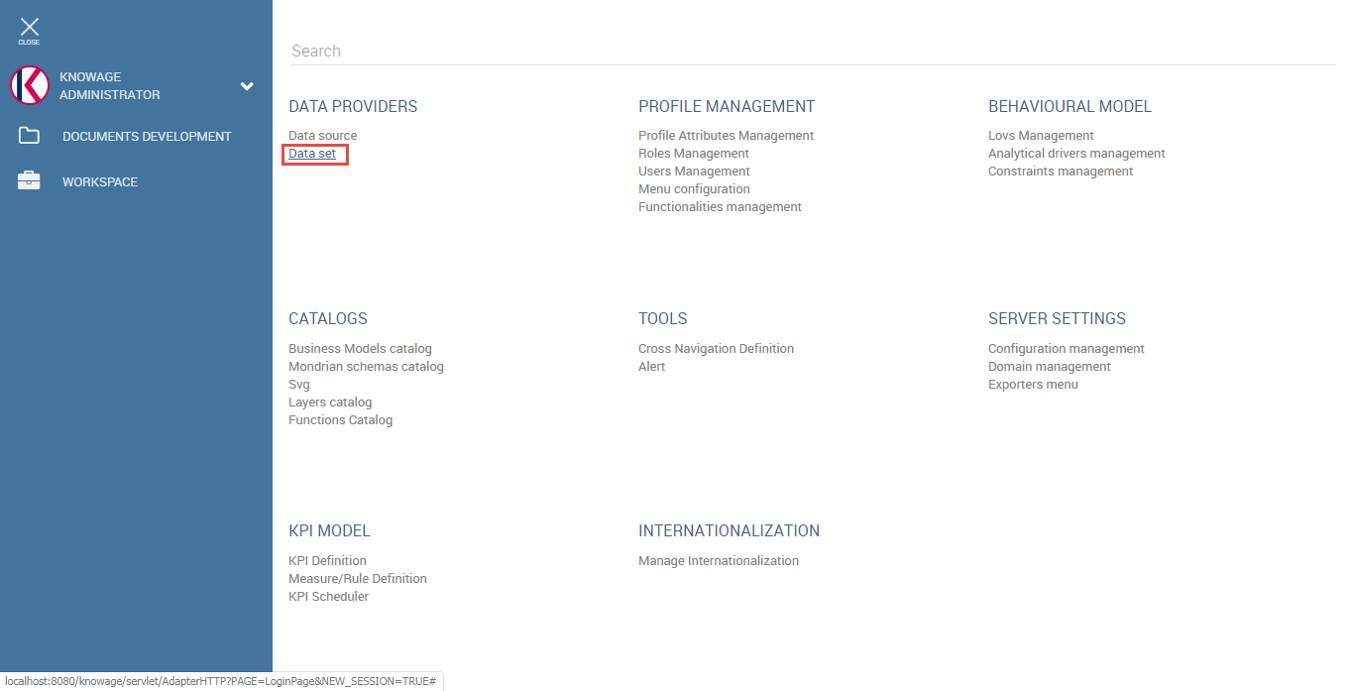

Fig.1-1 Select dataset

Create dataset as following Fig.1-2.

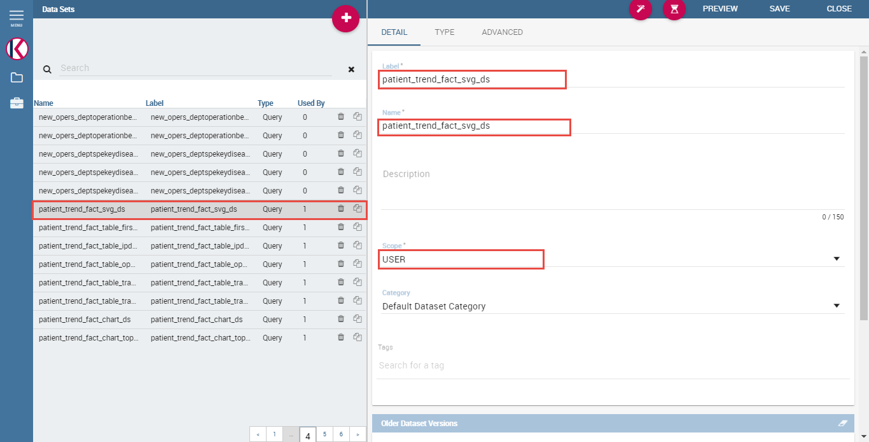

Fig.1-2 Create dataset

Select dataset type as ‘Query’ and data source and input query as following Fig.1-3.

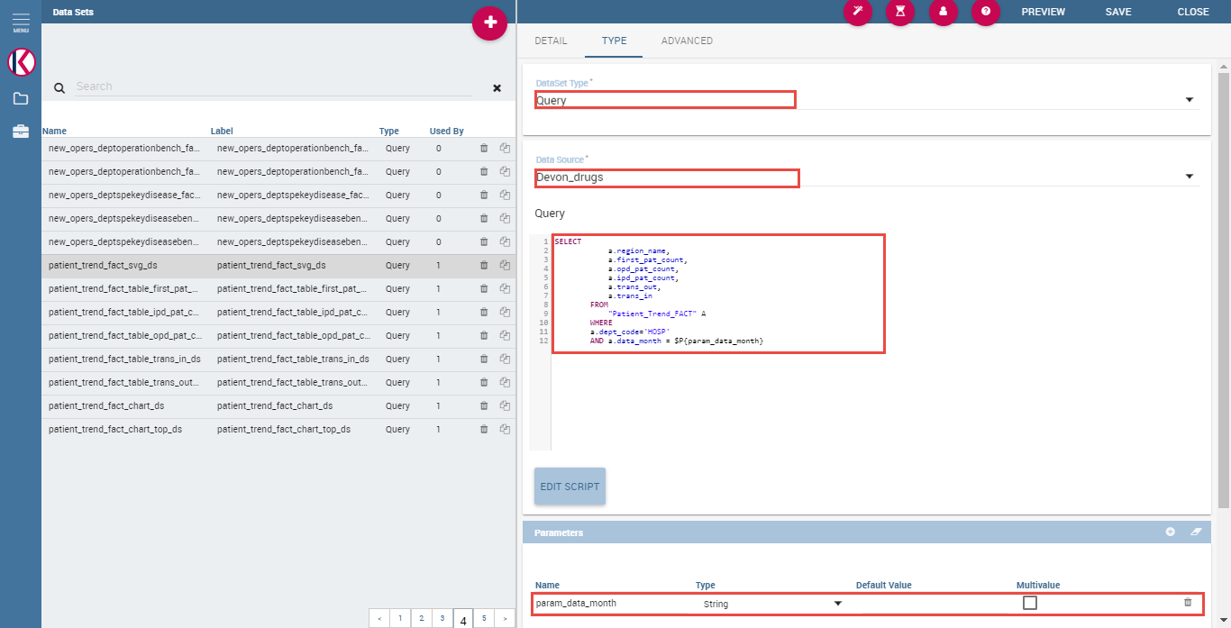

Fig.1-3 Customize dataset

Add parameters as above Fig.1-3.

Create dataset for 5 indicators(首诊病人数, 门诊病人数, 住院病人数, 转出病人数, 转入病人数) same way as above too.

Create dataset for charts too.

- Analytical drivers management for input parameters of document

Press ‘Analytical drivers management’ as following Fig.1-4.

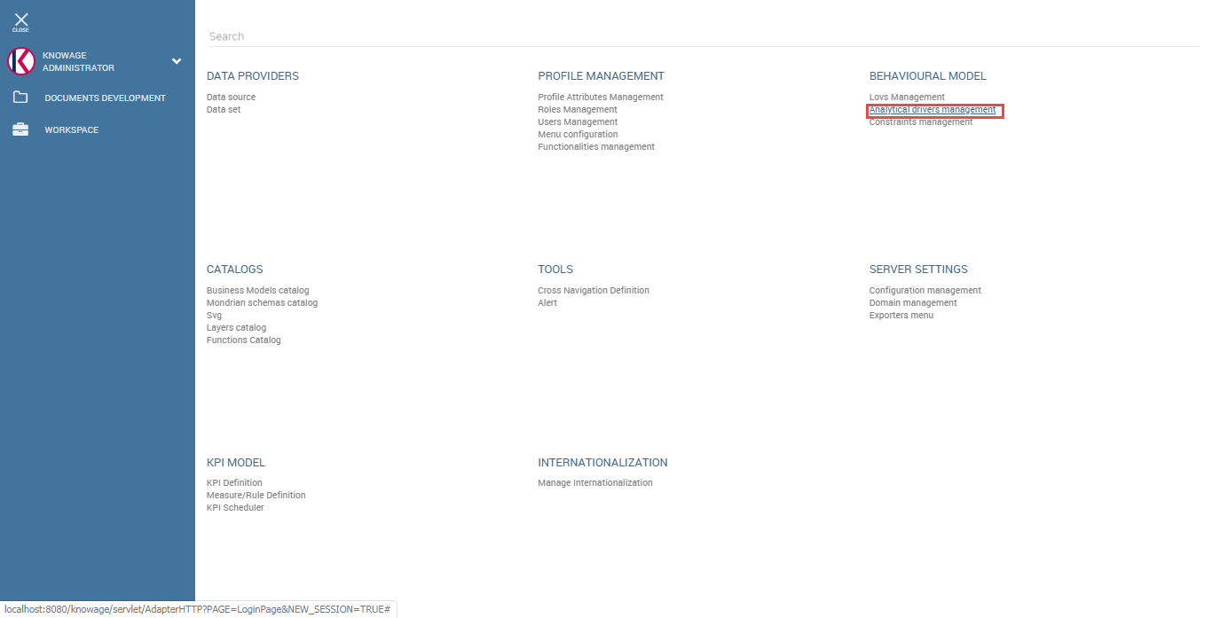

Fig.1-4 Analytical drivers management

Create 3 analytical drivers for document as following.

Add analytical driver for ‘From_Month’ parameter of document.

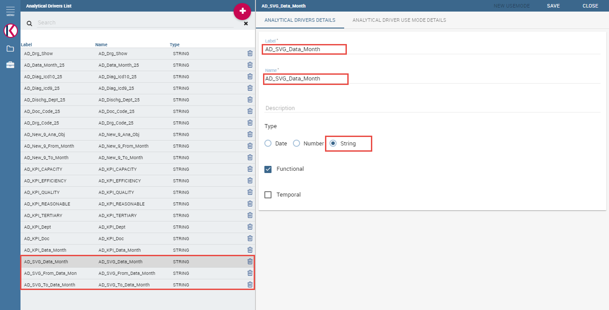

Fig.1-5 Create analytical driver

Save it then ‘ANALYTICAL DRIVER USE MODE DETAILS’ will be activated.

Press it and press ‘NEW USEMODE’ button on the right top of the screen.

Add use mode as following Fig.1-6.

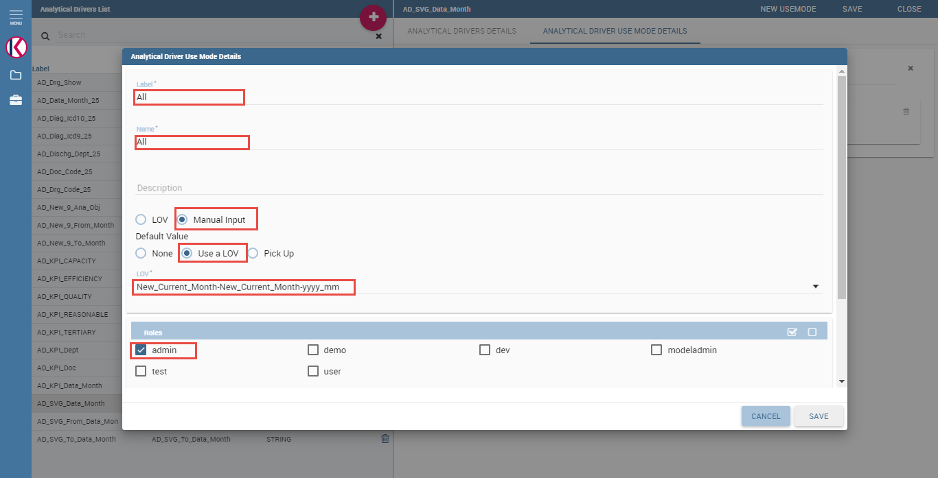

Fig.1-6 Add analytical driver use mode

- SVG Upload for SVG Viewer with China map

Select ‘SVG’ on the menu as following Fig.1-7.

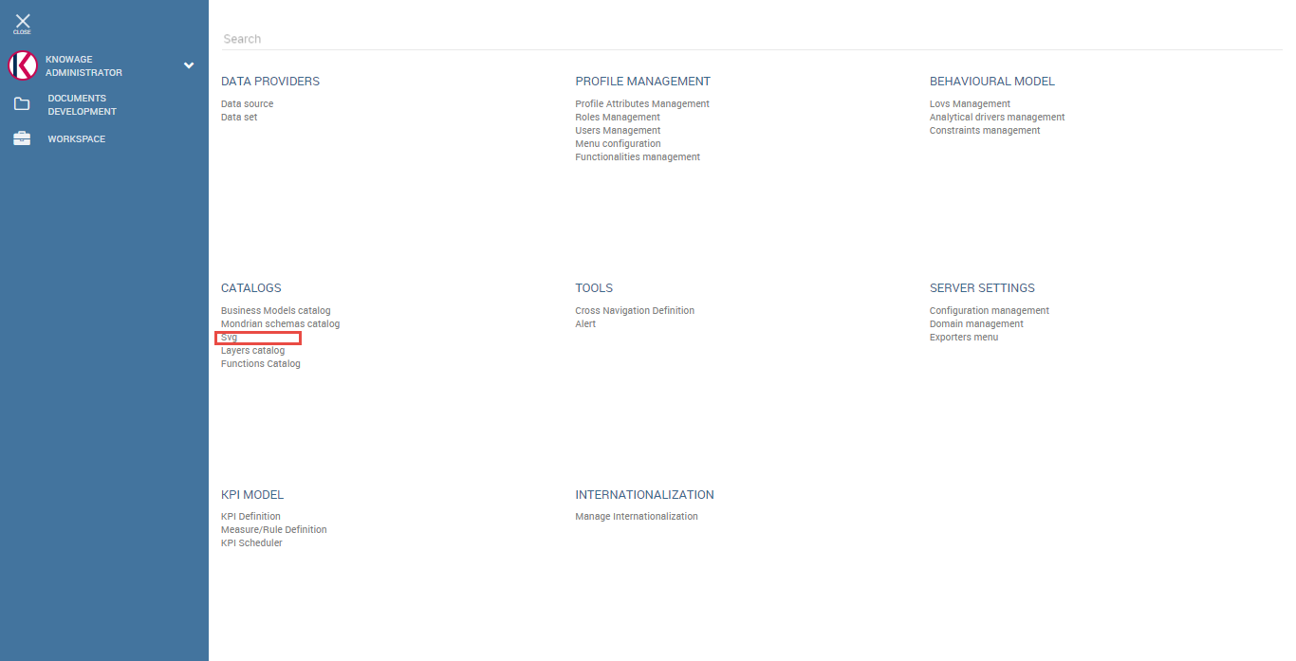

Fig.1-7 Select SVG on the menu

Click ‘Insert’ button on the top-right corner.

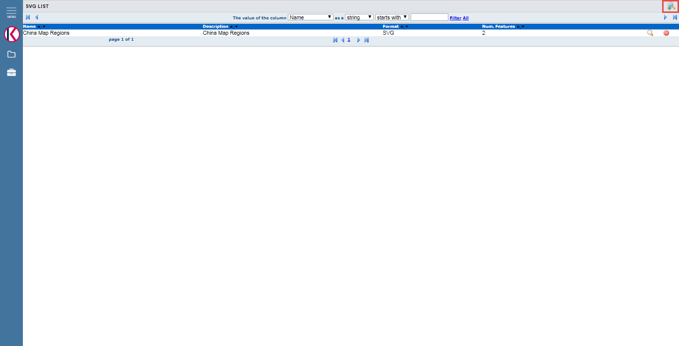

Fig.1-8 Insert SVG

Upload SVG with detailed informations as following Fig.1-9.

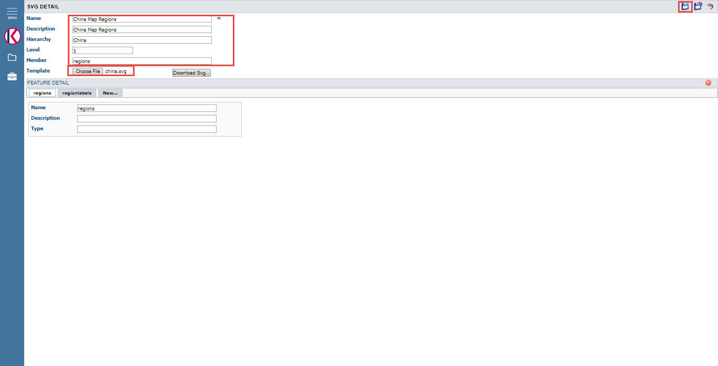

Fig.1-9 SVG upload

Name is mandatory.

Hierarchy will be used in template.xml for the SVG Viewer document.

Level starts from 1.

Member will be used in template.xml for the SVG Viewer document.

When click ‘Save’ button on the top-right corner, the features(<g> tag in the svg) will be added automatically.

Click ‘Save and Return’ button on the top-right corner.

- SVG Viewer Engine document

Add normal cockpit document as following Fig.1-10.

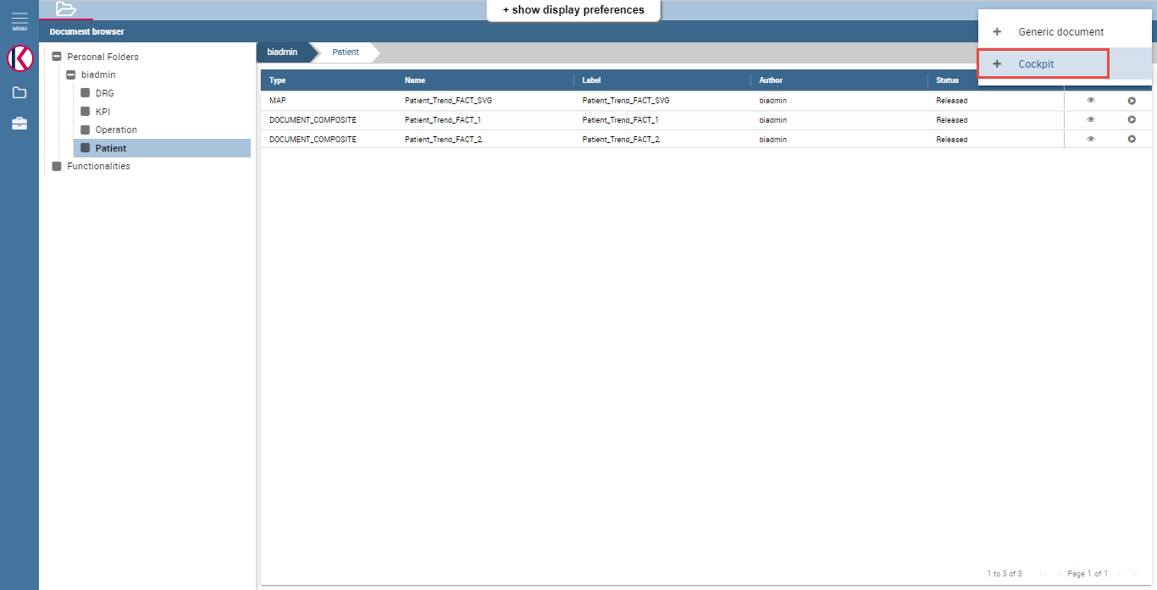

Fig.1-10 Add normal cockpit document

Save cockpit document with proper name and label as following Fig.1-11.

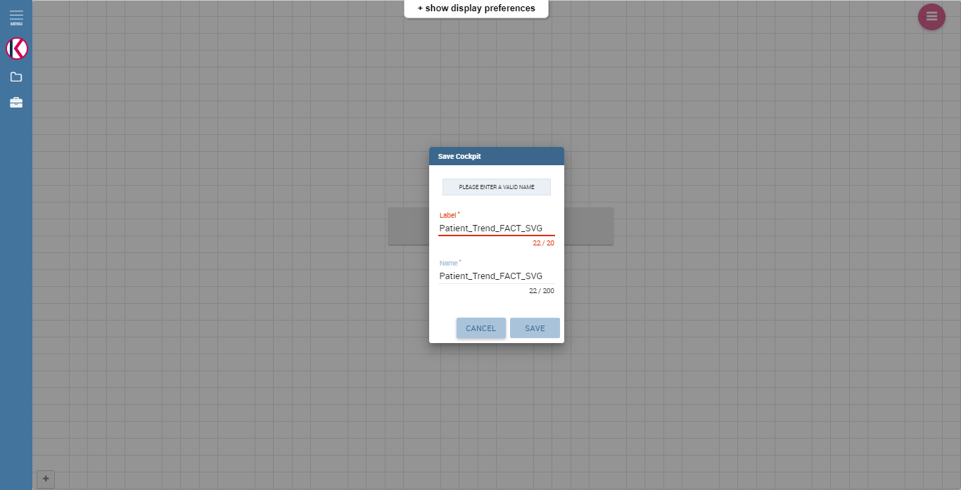

Fig.1-11 Save cockpit document

Click ‘Edit’ button to edit normal cockpit document as following Fig.1-12.

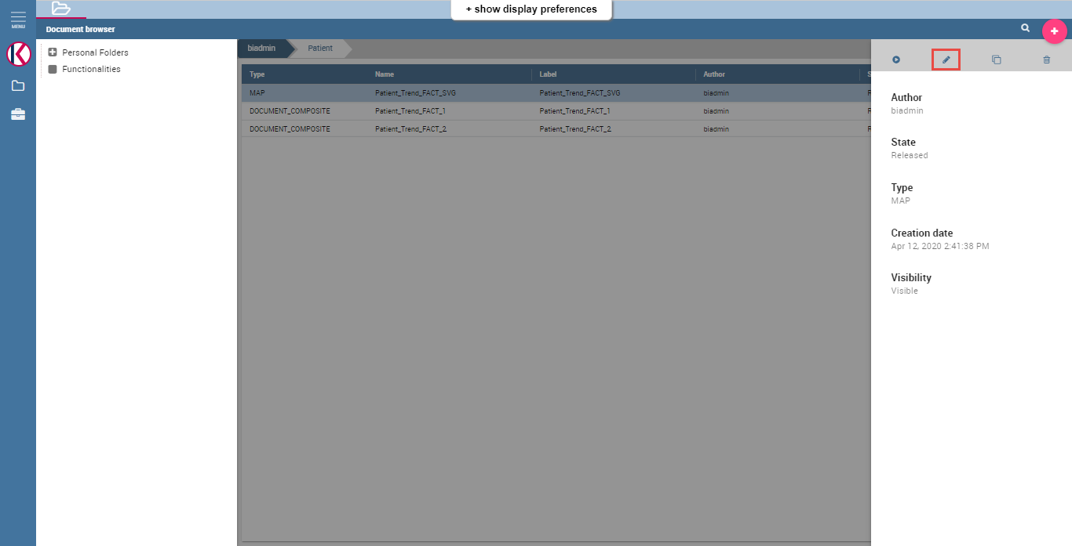

Fig.1-12 Edit cockpit document

Change document type and engine with ‘Location Intelligence’ and ‘SVG Viewer Engine’ to make the document SVG Viewer document as following Fig.1-13.

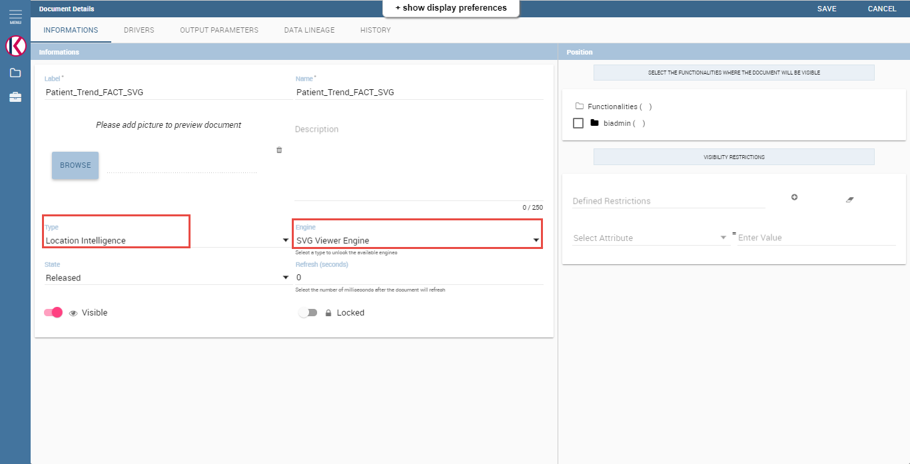

Fig.1-13 Change Type and Engine

Upload template.xml in ‘HISTORY’ tab and save it as following Fig.1-14.

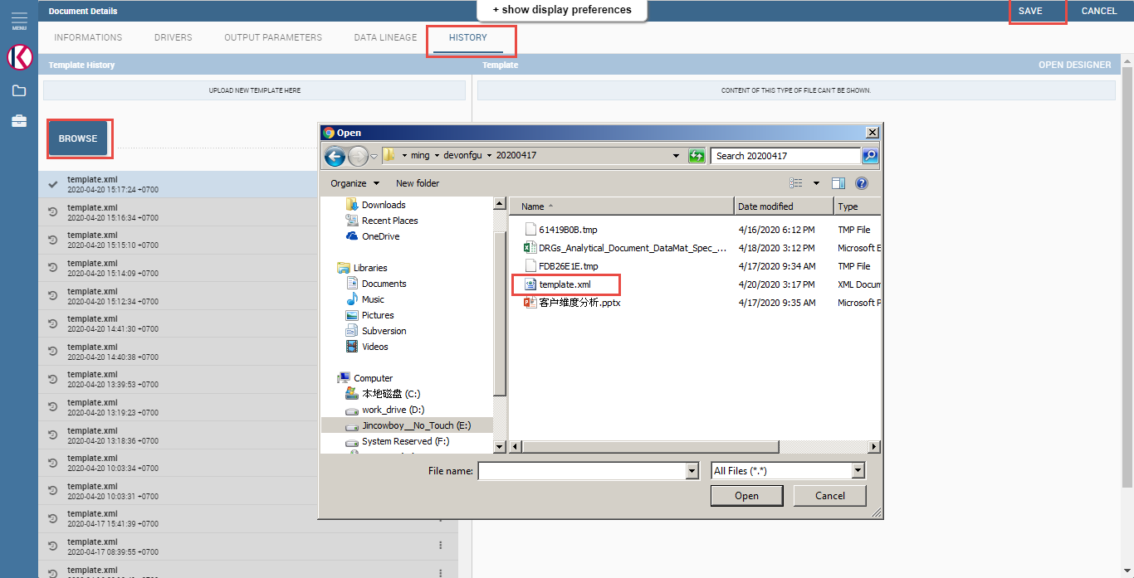

Fig.1-14 Upload template.xml

Add input parameters in ‘DRIVERS’ tag as following Fig.1-15.

Url name should be same as the name of the dataset parameter.

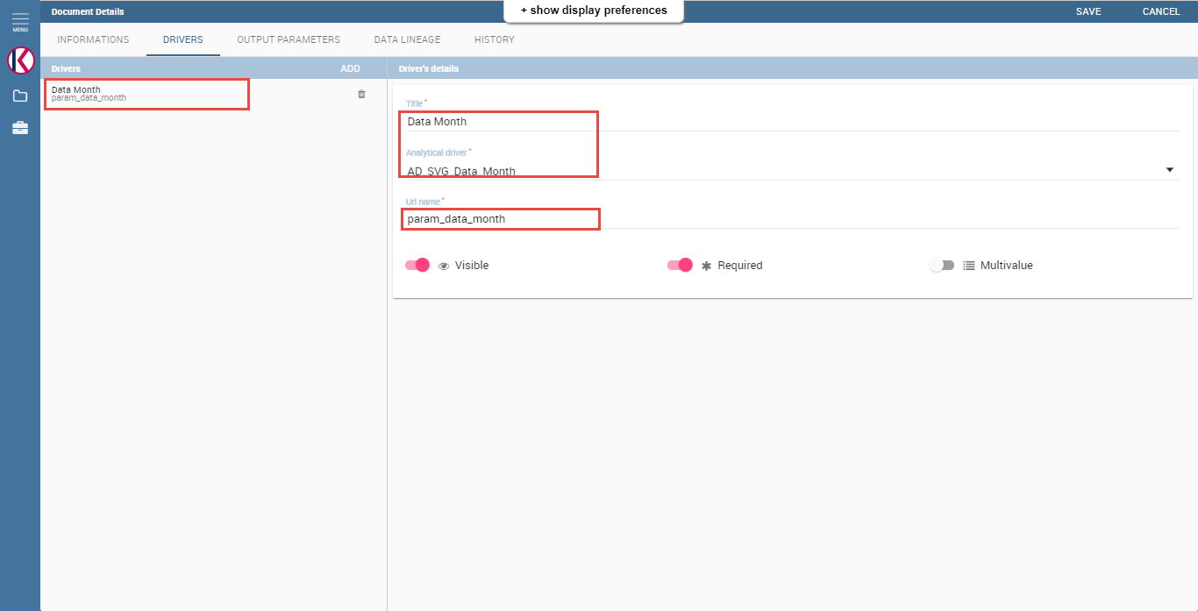

Fig.1-15 Input parameters for SVG Viewer document

- Cockpit document with svg viewer map

Add normal cockpit document and save it as Fig.1-11.

Add input parameters for ‘Data Month’, ‘From Month’ and ‘To Month’ as Fig.1-15.

Add normal cockpit document and click ‘Data Configuration’ button as following Fig.1-16.

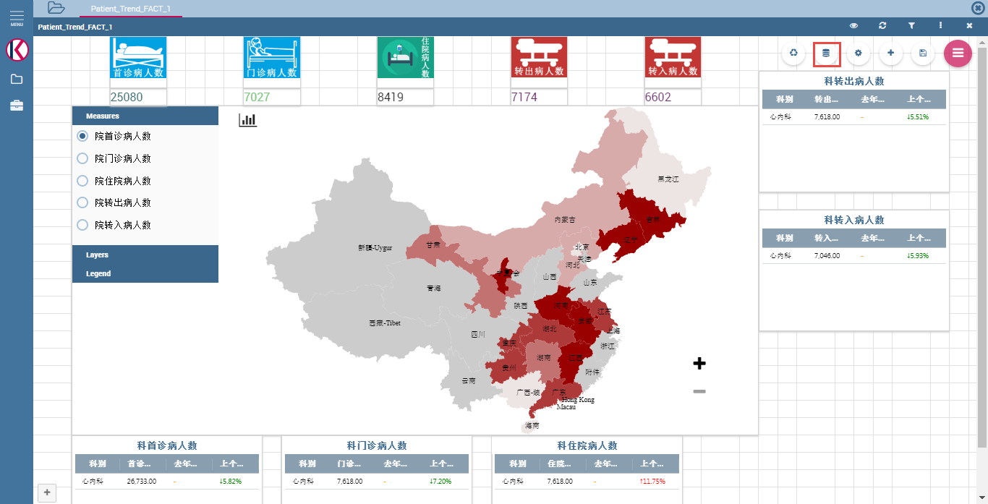

Fig.1-16 Cockpit document with map viewer

Add datasets and document and link document input parameters to dataset’s input parameter and svg viewer document’s parameter as following Fig.1-17.

Save them.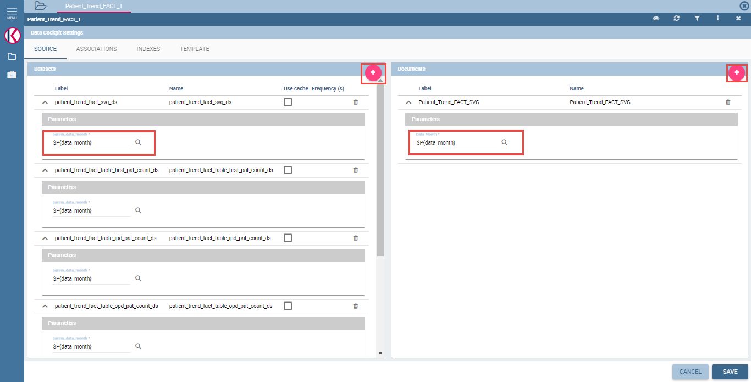

Fig.1-17 Add datasets and documents

Add document widget using ‘Add Widget’ button as following Fig.1-18.

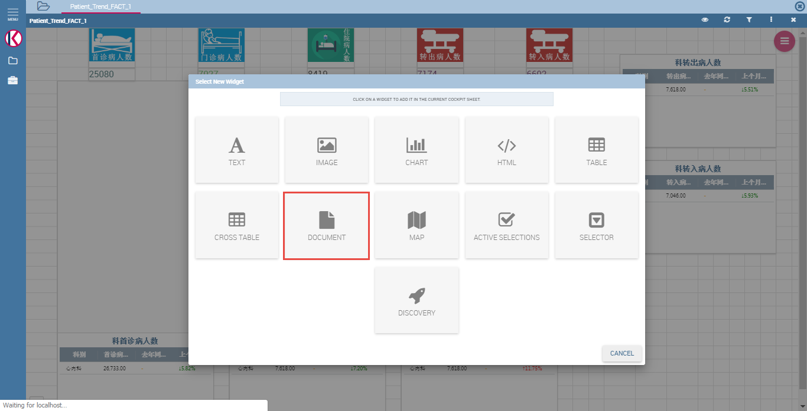

Fig.1-18 Add document widget

Select svg viewer document and save it.

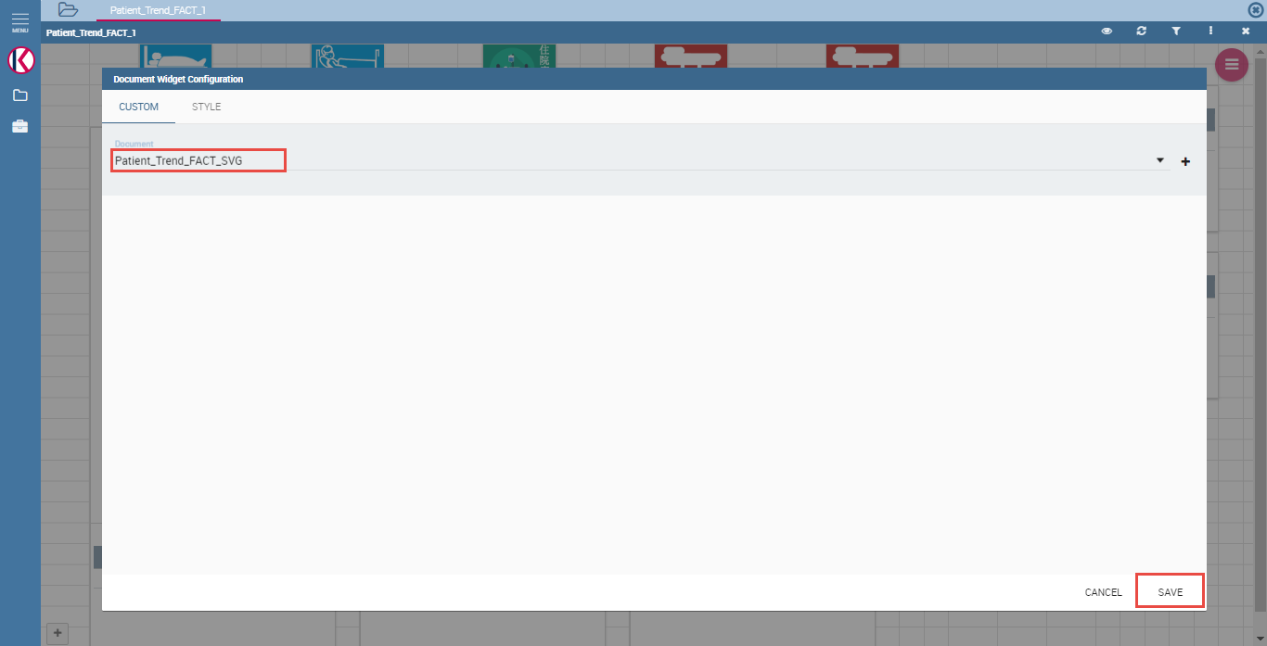

Fig.1-19 Select svg viewer document

Save cockpit document