**Computer Vision HW2 Report**

Student ID: R012323007

Name: 廖明祐

**Part 1. (10%)**

**• Plot confusion matrix of two settings. (i.e. Bag of sift and tiny image) (5%)**

**Ans:**

Bag of sift:

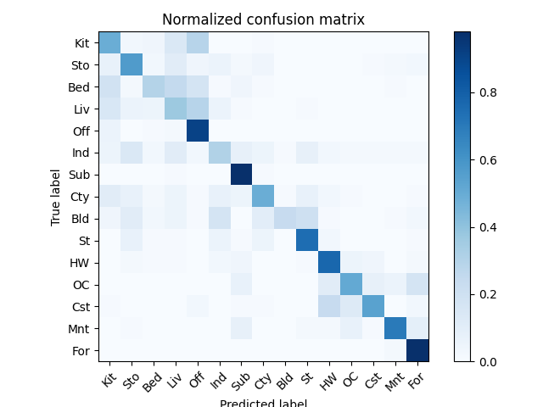

Tiny image:

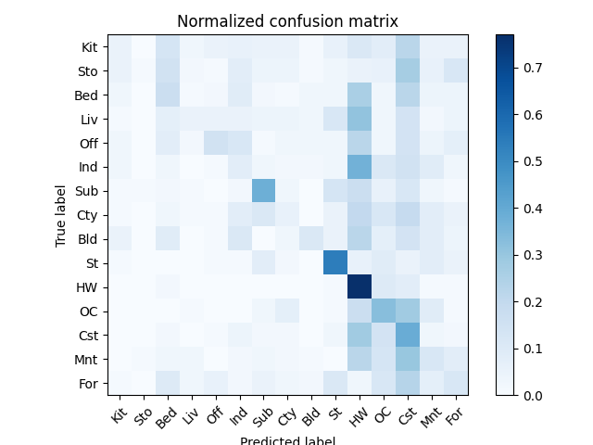

**• Compare the results/accuracy of both settings and explain the result. (5%)Ans:**

1.Feature: tiny_image, Classifier: nearest_neighbor, Accuracy = 0.222

2. Feature: bag_of_sift, Classifier: nearest_neighbor, Accuracy = 0.594

從confusion matrix來看，使用Bag of sift方式的大部分的種類都能正確分類，因此對角線顏色很深。使用tiny image則是將很多圖片歸類為St、HW、OC、Cst三類，所以造成Accuracy很低。

**Part 2. (25%)**

**• Report accuracy of both models on the validation set. (2%)**

**Ans:**

Using resnet18, accuracy is 0.888 on validation set.

Using mynet, accuracy is 0.6262 on validation set.

**• Print the network architecture & number of parameters of both models. What is the main difference between ResNet and other CNN architectures? (5%)**

**Ans:**

ResNet:

ResNet18(

(resnet): ResNet(

(conv1): Conv2d(3, 64, kernel_size=(5, 5), stride=(1, 1), padding=(2, 2))

(bn1): BatchNorm2d(64, eps=1e-05, momentum=0.1, affine=True, track_running_stats=True)

(relu): ReLU(inplace=True)

(maxpool): Identity()

(layer1): Sequential(

(0): BasicBlock(

(conv1): Conv2d(64, 64, kernel_size=(3, 3), stride=(1, 1), padding=(1, 1), bias=False)

(bn1): BatchNorm2d(64, eps=1e-05, momentum=0.1, affine=True, track_running_stats=True)

(relu): ReLU(inplace=True)

(conv2): Conv2d(64, 64, kernel_size=(3, 3), stride=(1, 1), padding=(1, 1), bias=False)

(bn2): BatchNorm2d(64, eps=1e-05, momentum=0.1, affine=True, track_running_stats=True)

)

(1): BasicBlock(

(conv1): Conv2d(64, 64, kernel_size=(3, 3), stride=(1, 1), padding=(1, 1), bias=False)

(bn1): BatchNorm2d(64, eps=1e-05, momentum=0.1, affine=True, track_running_stats=True)

(relu): ReLU(inplace=True)

(conv2): Conv2d(64, 64, kernel_size=(3, 3), stride=(1, 1), padding=(1, 1), bias=False)

(bn2): BatchNorm2d(64, eps=1e-05, momentum=0.1, affine=True, track_running_stats=True)

)

)

(layer2): Sequential(

(0): BasicBlock(

(conv1): Conv2d(64, 128, kernel_size=(3, 3), stride=(2, 2), padding=(1, 1), bias=False)

(bn1): BatchNorm2d(128, eps=1e-05, momentum=0.1, affine=True, track_running_stats=True)

(relu): ReLU(inplace=True)

(conv2): Conv2d(128, 128, kernel_size=(3, 3), stride=(1, 1), padding=(1, 1), bias=False)

(bn2): BatchNorm2d(128, eps=1e-05, momentum=0.1, affine=True, track_running_stats=True)

(downsample): Sequential(

(0): Conv2d(64, 128, kernel_size=(1, 1), stride=(2, 2), bias=False)

(1): BatchNorm2d(128, eps=1e-05, momentum=0.1, affine=True, track_running_stats=True)

)

)

(1): BasicBlock(

(conv1): Conv2d(128, 128, kernel_size=(3, 3), stride=(1, 1), padding=(1, 1), bias=False)

(bn1): BatchNorm2d(128, eps=1e-05, momentum=0.1, affine=True, track_running_stats=True)

(relu): ReLU(inplace=True)

(conv2): Conv2d(128, 128, kernel_size=(3, 3), stride=(1, 1), padding=(1, 1), bias=False)

(bn2): BatchNorm2d(128, eps=1e-05, momentum=0.1, affine=True, track_running_stats=True)

)

)

(layer3): Sequential(

(0): BasicBlock(

(conv1): Conv2d(128, 256, kernel_size=(3, 3), stride=(2, 2), padding=(1, 1), bias=False)

(bn1): BatchNorm2d(256, eps=1e-05, momentum=0.1, affine=True, track_running_stats=True)

(relu): ReLU(inplace=True)

(conv2): Conv2d(256, 256, kernel_size=(3, 3), stride=(1, 1), padding=(1, 1), bias=False)

(bn2): BatchNorm2d(256, eps=1e-05, momentum=0.1, affine=True, track_running_stats=True)

(downsample): Sequential(

(0): Conv2d(128, 256, kernel_size=(1, 1), stride=(2, 2), bias=False)

(1): BatchNorm2d(256, eps=1e-05, momentum=0.1, affine=True, track_running_stats=True)

)

)

(1): BasicBlock(

(conv1): Conv2d(256, 256, kernel_size=(3, 3), stride=(1, 1), padding=(1, 1), bias=False)

(bn1): BatchNorm2d(256, eps=1e-05, momentum=0.1, affine=True, track_running_stats=True)

(relu): ReLU(inplace=True)

(conv2): Conv2d(256, 256, kernel_size=(3, 3), stride=(1, 1), padding=(1, 1), bias=False)

(bn2): BatchNorm2d(256, eps=1e-05, momentum=0.1, affine=True, track_running_stats=True)

)

)

(layer4): Sequential(

(0): BasicBlock(

(conv1): Conv2d(256, 512, kernel_size=(3, 3), stride=(2, 2), padding=(1, 1), bias=False)

(bn1): BatchNorm2d(512, eps=1e-05, momentum=0.1, affine=True, track_running_stats=True)

(relu): ReLU(inplace=True)

(conv2): Conv2d(512, 512, kernel_size=(3, 3), stride=(1, 1), padding=(1, 1), bias=False)

(bn2): BatchNorm2d(512, eps=1e-05, momentum=0.1, affine=True, track_running_stats=True)

(downsample): Sequential(

(0): Conv2d(256, 512, kernel_size=(1, 1), stride=(2, 2), bias=False)

(1): BatchNorm2d(512, eps=1e-05, momentum=0.1, affine=True, track_running_stats=True)

)

)

(1): BasicBlock(

(conv1): Conv2d(512, 512, kernel_size=(3, 3), stride=(1, 1), padding=(1, 1), bias=False)

(bn1): BatchNorm2d(512, eps=1e-05, momentum=0.1, affine=True, track_running_stats=True)

(relu): ReLU(inplace=True)

(conv2): Conv2d(512, 512, kernel_size=(3, 3), stride=(1, 1), padding=(1, 1), bias=False)

(bn2): BatchNorm2d(512, eps=1e-05, momentum=0.1, affine=True, track_running_stats=True)

)

)

(avgpool): AdaptiveAvgPool2d(output_size=(1, 1))

(fc): Linear(in_features=512, out_features=10, bias=True)

)

)

MyNet:

MyNet(

(conv1): Sequential(

(0): Conv2d(3, 6, kernel_size=(5, 5), stride=(1, 1))

(1): ReLU()

(2): MaxPool2d(kernel_size=2, stride=2, padding=0, dilation=1, ceil_mode=False)

)

(conv2): Sequential(

(0): Conv2d(6, 16, kernel_size=(5, 5), stride=(1, 1))

(1): ReLU()

(2): MaxPool2d(kernel_size=2, stride=2, padding=0, dilation=1, ceil_mode=False)

)

(fc1): Sequential(

(0): Linear(in_features=400, out_features=120, bias=True)

(1): ReLU()

)

(fc2): Sequential(

(0): Linear(in_features=120, out_features=84, bias=True)

(1): ReLU()

)

(fc3): Linear(in_features=84, out_features=10, bias=True)

)

Resnet和一般CNN模型的差別在於，再Resnet的模型中，他有直通網路，直通網路的好處在於，他和卷基層相加時，模型只需要學習 residual，就可以解決CNN會遇到的梯度問題。即使Resnet有很多層，讓模型變得很重，但因為直通網路的加成，就讓Resnet可以訓練得不錯。

**• Plot four learning curves (loss & accuracy) of the training process (train/validation) for both models. Total 8 plots. (8%)**

**Ans:**

Resnet:

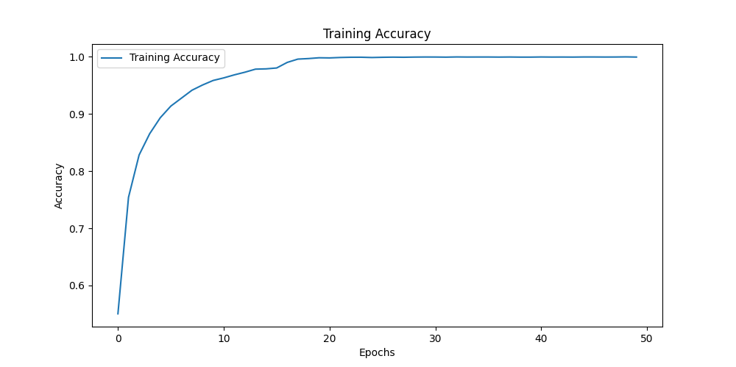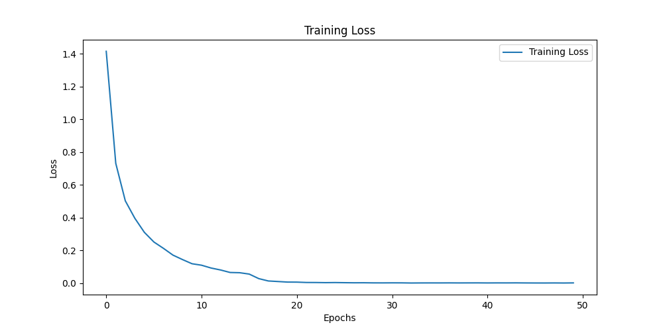

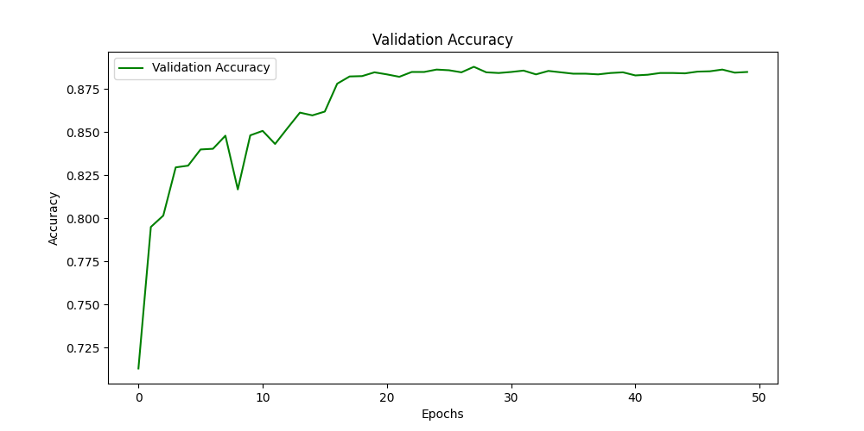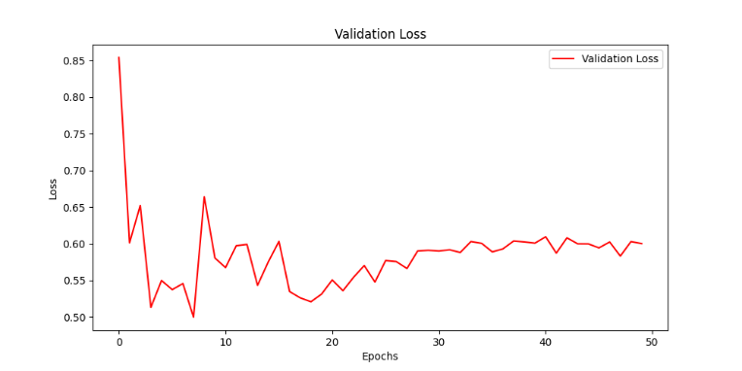

Mynet:

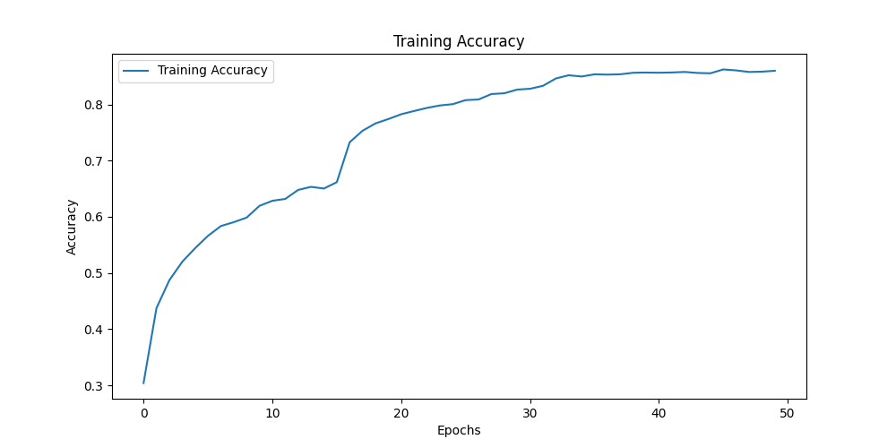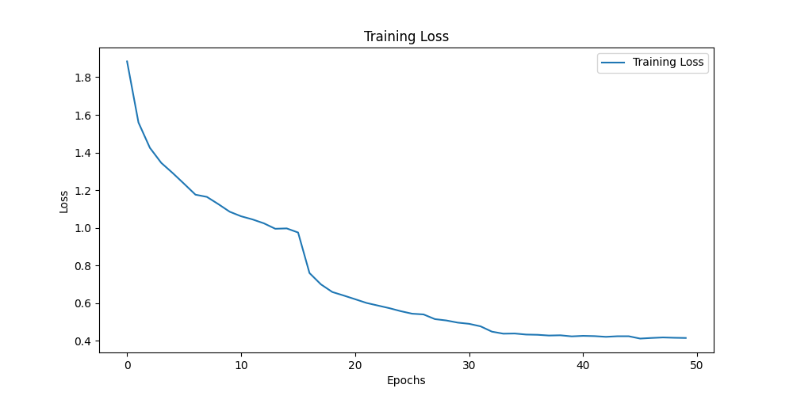

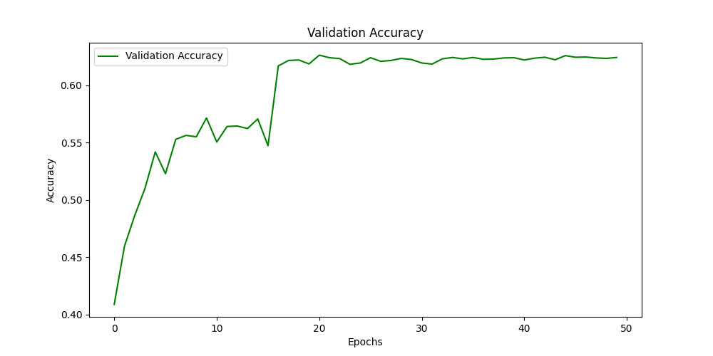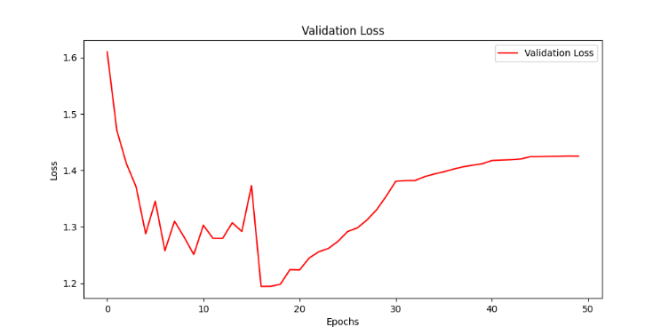

**• Briefly describe what method do you apply on your best model? (e.g. data augmentation, model architecture, loss function, etc) (10%)**

**Ans:**

以下是我增加Accuracy的方法:

1. 我在data augmentation 上採用transforms.RandomHorizontalFlip 的方式來實作，發現這樣的方式可以降低over fitting的問題。

2. Model的話，我採用題目給的Hint實作，將 resnet18第一個捲基層的kernel size改成 3*3 並把maxpool層換成 Identity。