**Homework 1 Statement**

**Test Accuracy:** **97.97%**

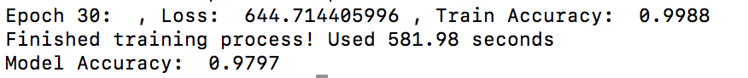

**Implementation**

In this assignment, I constructed my neural network with **one hidden layer** which has **100 hidden units**. The activation function of the hidden layer is **sigmoid function**. The output layer applies **softmax function** as its activation function. The learning rate is set to be constantly **0.01**. The optimization algorithm is **stochastic gradient descent**. I trained my model for **30 epochs**.

**How to Run**

Just run the .py file in terminal as follow.



**Step 1.** Initialize the model. (Feed the learning rate and number of hidden units)



**Step 2.** Train the model. (Feed the number of training epochs)



**Step 3.** Evaluate the model. (Calculate the Test Accuracy)

