For your information, the graphs may look like as the following:

Graph 1: Scatter and Line plots

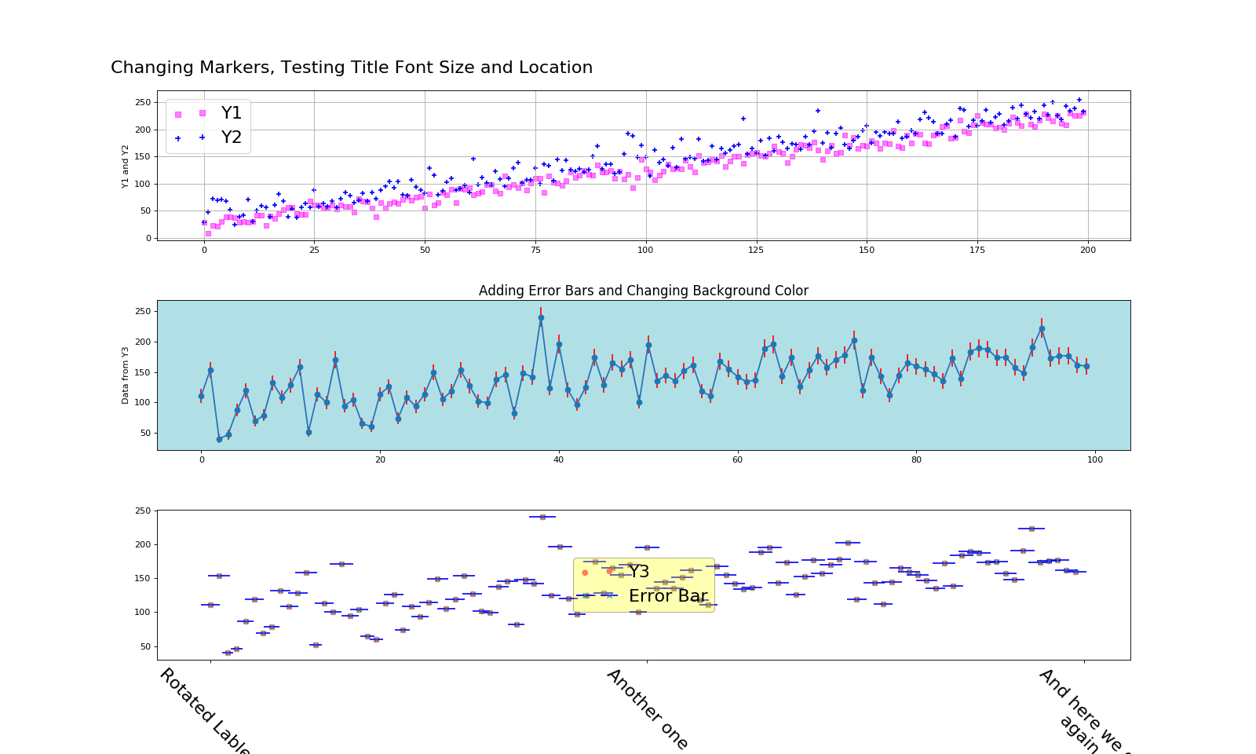

Graph 2: Annotations

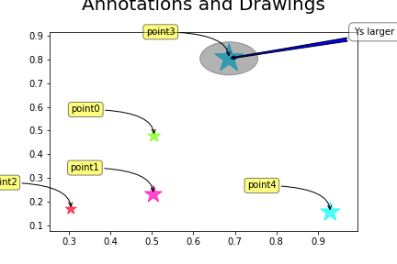

Graph 3: Box plots:

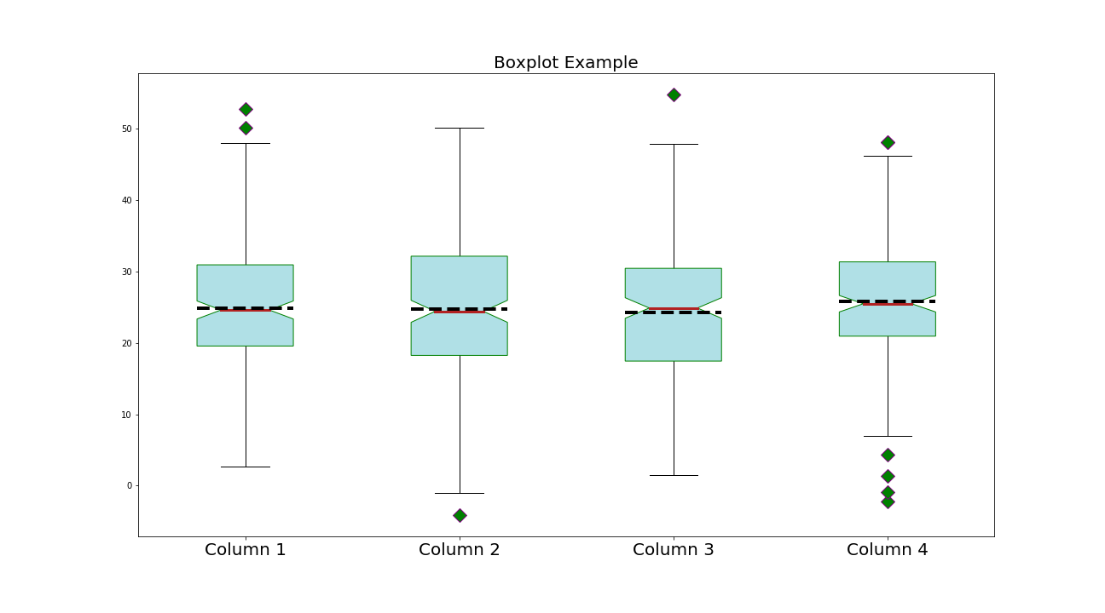

Graph 4: Histograms

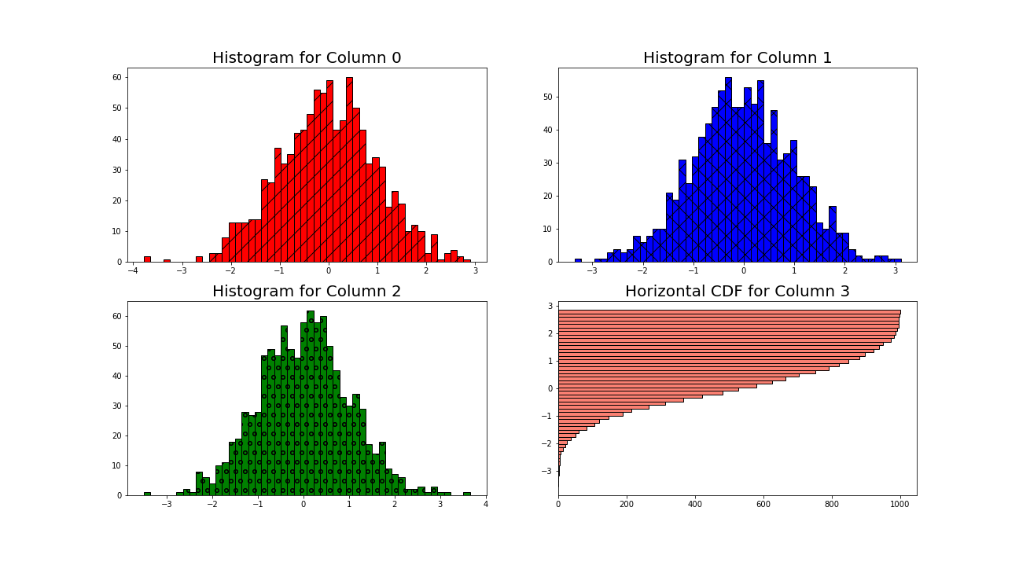

Graph 5: Stacked Histogram

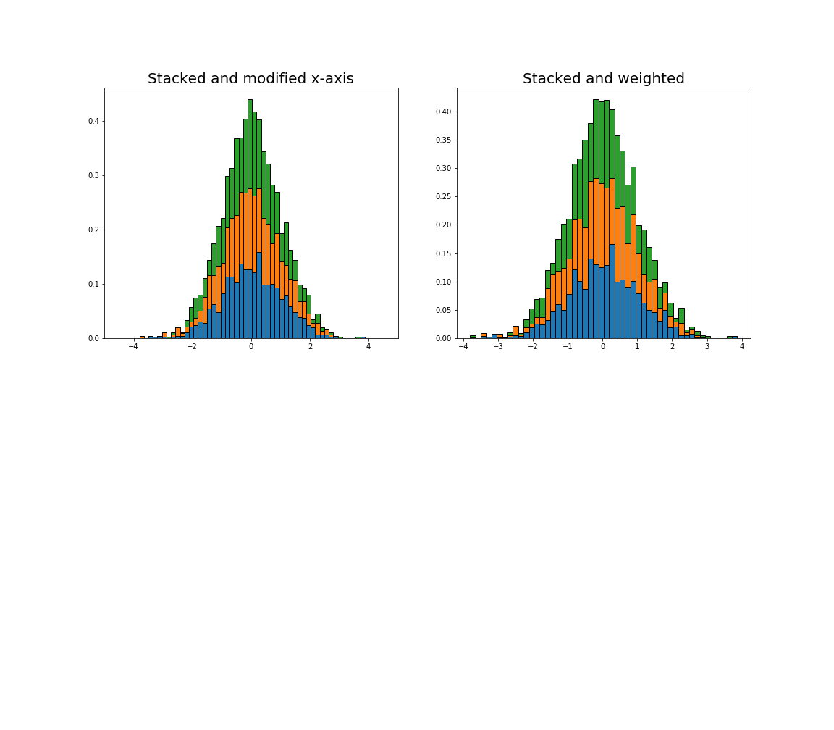

Graph 6: Bar plots:

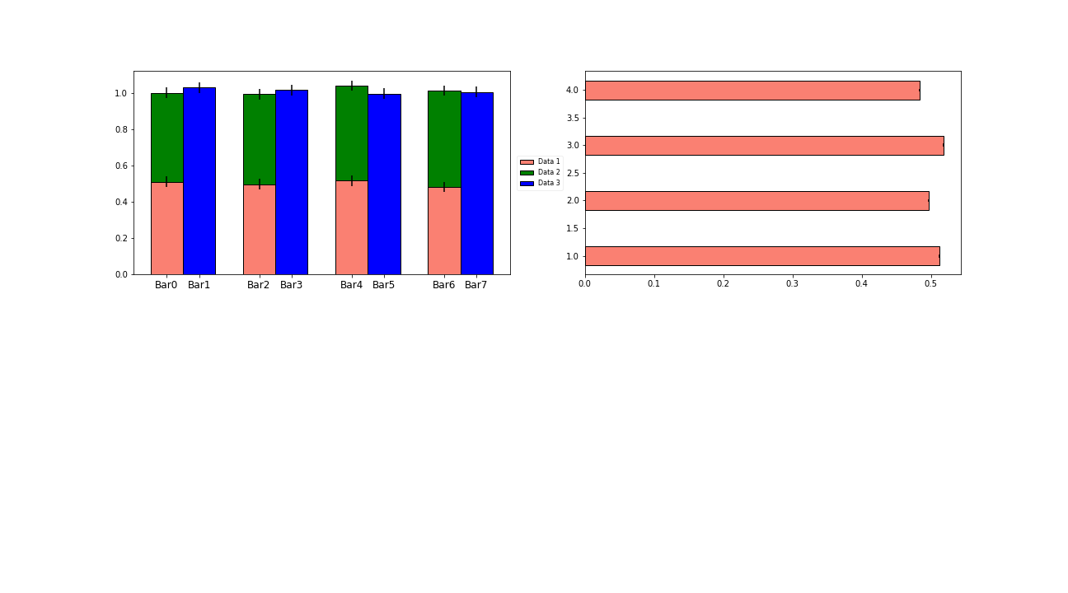

Graph 7: Pie plots:

