Design and Implementation of Portal using Enterprise Architecture CASE Tools

Module Title: Enterprise Architecture

Module Code: CN6111

Tutor: Dr. Aloysius Edoh PhD

Students:

Ning Bei 1441757

Mingzhao Xie 1441910

Mingzhou Hu 1441739

# Abstract

Enterprise Architecture is a very important and useful notion in the IT world, it captures the essentials of the business, IT and its evolution. It provides the blueprint for systematically defining an organization’s current of future environment, coupled with a process for development and maintenance. In this report, our group provides the design and implement an EA model based on the EA principles. our case study is focusing on the new Web-based registration system of State University, which performs several functions to allow students to register online. We developed business process model for the enterprise using Bonita software package. In the BPMN model, we clearly identified all the processes in this the case study and modelled them using the appropriate and standard business process notations. Also, we developed a class diagram for the case study and converted it into ERD based on the correct UML to ERD principles. Then, the Enterprise Architecture model, which comprises of three layers (the business process layer, information system and Technical infrastructure layer) was drawn based on the previous analysis. We also implemented a prototype Web based Client Server System software, which performs and executes the main business processes, for State University. We evaluated the design and implementation of the prototype software based using the top down and bottom up techniques. At the end of the report the conclusion and conclusion have been provided.

Keywords: Enterprise Architecture, Business Process Model and Notation, Enterprise Architecture, BonitaSoft, GenMyModel, yEd, ArchiMate, Visual Studio

Table of Contents

Abstract 2

1 Introduction 4

1.1 Overview 4

1.2 Case study 4

1.3 Software 4

2 Modelling and Implementation 6

2.1 Business Process Model 6

2.2. Class Diagram 6

2.3 Data Entity Model 6

2.4 Enterprise Architecture Model 7

3 Implementation of Portal CSS Prototype Software 8

4 Individual Evaluations: 11

4.1 Evaluation by Ning Bei 11

4.2 Evaluation by Mingzhao Xie 11

4.3 Evaluation by Mingzhou Hu 11

5 Individual Conclusions: 12

4.1 Conclusion by Ning Bei 12

4.2 Conclusion by Mingzhao Xie 12

4.3 Conclusion by Mingzhou Hu 12

6 Recommendation 13

7 Individual Reference 13

6.1 Reference – Ning Bei 13

6.2 Reference – Mingzhao Xie 13

6.3 Reference – Mingzhou Hu 13

8 Reference 14

9 Appendix 15

9.1 Meeting Record 15

9.2 Gantt Chart 15

# 1 Introduction

## 1.1 Overview

Enterprise Architecture is a Management tool and blueprint for the organization, which reflects the integration and standardization requirements of the company’s operating model. It is the entire principles, methods, and models used in the design and development of the enterprise’s organizational structure, business processes, information system and IT Infrastructure. State University’s new Web-based registration system will provide a platform to 35,000 students. In this report, we will help the State University to design and model their new registration system. Our group analysed the case study then designed and modelled an Enterprise Architecture system for the organization.

## 1.2 Case study

State University is building a Web-based registration system runs 24/7(24 hours a day, 7 days a week). It has 35,000 students who must register and 90% of them register during the first week of each semester. Each registration is approximately 400 kb. This online system allows the prospective students to browse courses and collect information. To register on a course, a student must fill in personal details form first, and after the admission officer’s verification, he or she can then fill in application form which contains selected course and is checked by the admission lecturer for the qualification. After this procedure is completed the student is sent an authenticated username and password to complete the registration process.

## 1.3 Software

1.3.1 Bonita

Bonita is an open-source business process management and workflow suite. It can be used for creating high-tech workflows and business process model. In our project, it was used for modelling business processes.

1.3.1 GenMyModel

GenMyModel is an UML editor with powerful features for creating UML class diagrams online. We used this tool for drawing Class Diagram

1.3.2 yEd

The yEd software is a powerful application that can be used to quickly and effectively generate high-quality diagrams. In our report yEd helped us a lot when we generate the entity data model.

1.3.2 archimate

Archimate is an open and independent enterprise architecture modelling language to support the description, analysis and visualization of architecture within and across business domain in a straightforward way. We used archimiate to create the Enterprise Architecture model for the State University.

1.3.3 Visual Studio

Microsoft Visual Studio is an IDE from Microsoft, which is used to develop web sites. In our project, we implemented the prototype of Client Server System via Visual Studio.

# 2 Modelling and Implementation

## 2.1 Business Process Model

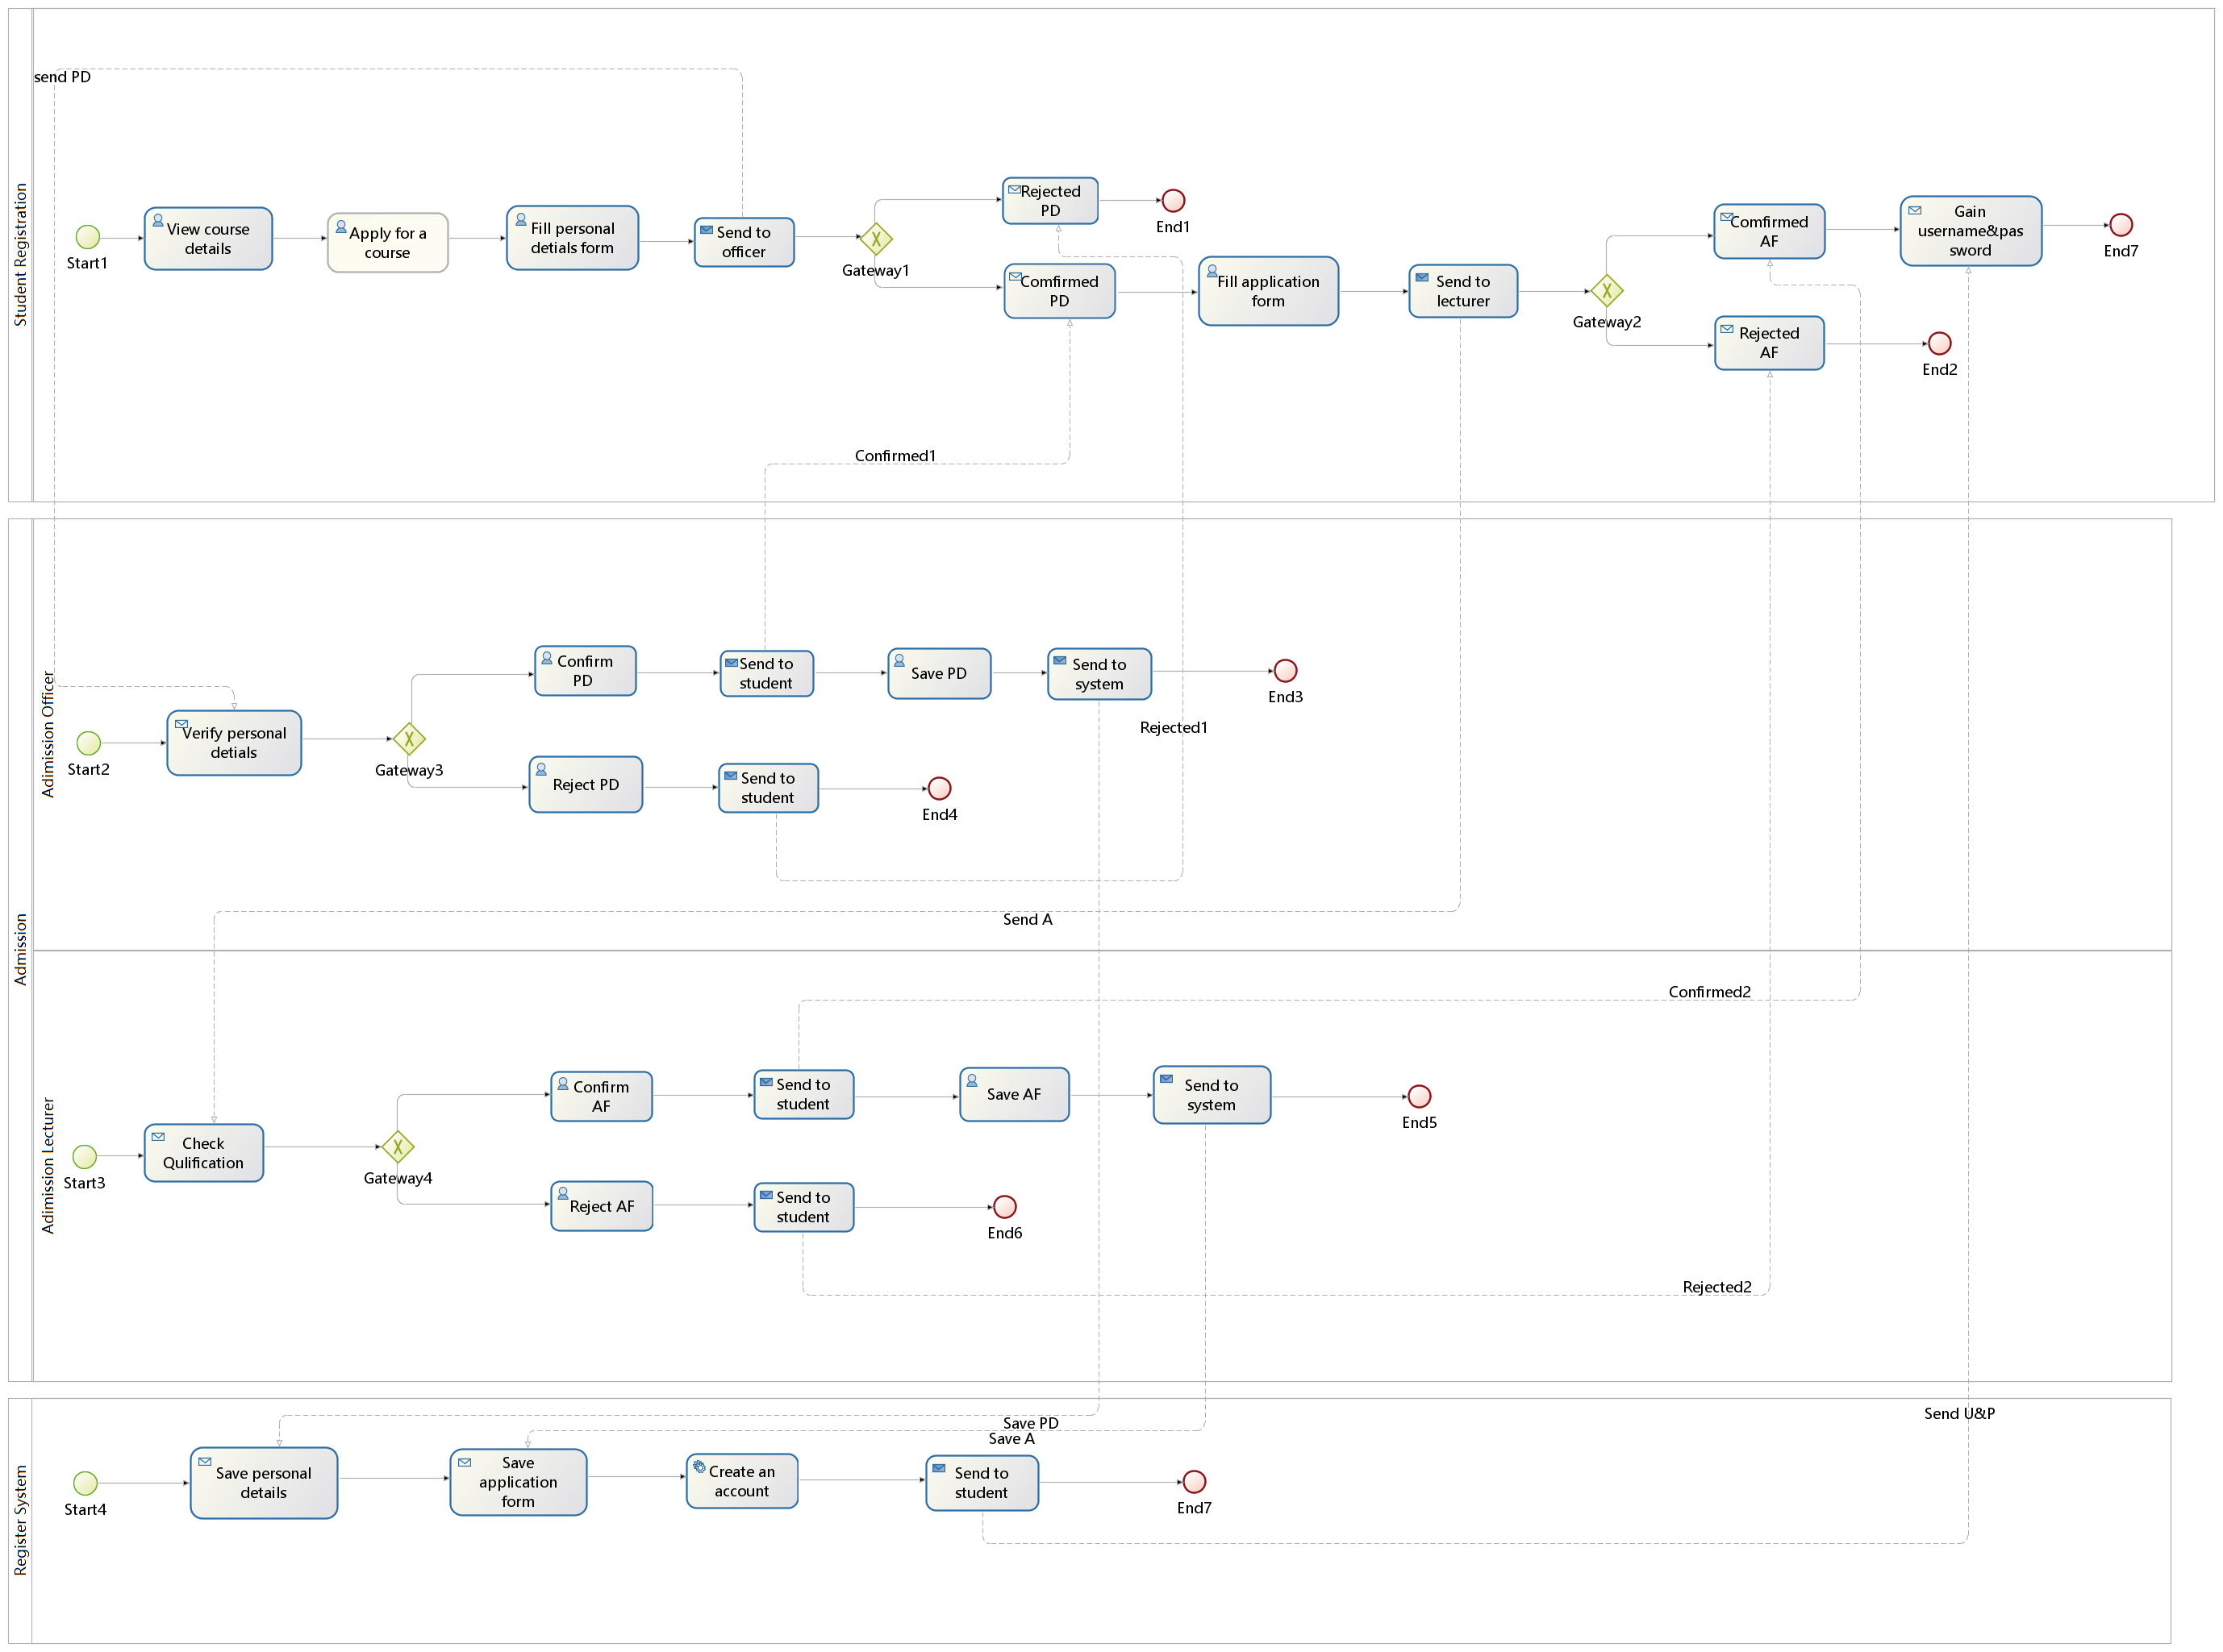

Figure 2.1 Business Process Model

The diagram above shows the business processes of our case study, which includes four participates: students, admission officer, admission lecturer and registration system. Firstly, students are required to fill personal details form and application form for applying a course. And then the personal details form and application form should be sent to and verified by admission officer and lecturer respectively, at the same time, they will send messages to students to tell decisions. Lastly, when the two forms are saved to system, it will allocate username and password to students.

## 2.2. Class Diagram

## WechatIMG154.jpeg

Figure 2.2 Class Diagram

The diagram above shows the attributes and methods of classes and relationship between classes in the use case.

## 2.3 Data Entity Model

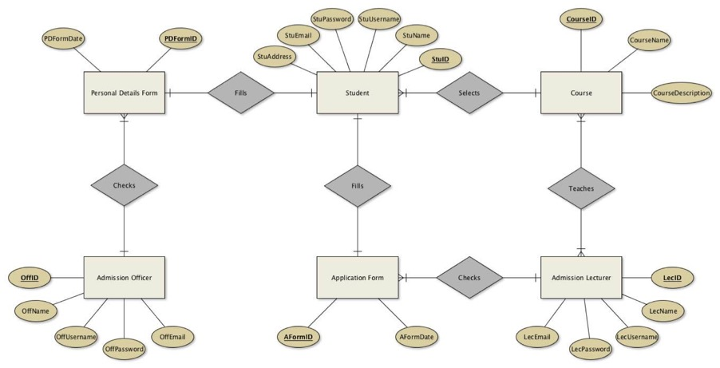

Figure 2.3 Data Entity Model

The diagram above shows the attributes of entities and relationship between entities in the use case. One student can only select one course, so one student only can fill one personal details form and application form. Similarly, one personal details form and one application form can only be filled by one student. And one personal details form can only be checked by one officer, but one officer can check one or more personal details forms. The relationship between application form and lecturer is as same as that between personal details form and officer. One course can be selected by one or more students and can be taught by one or more lectures, and one lecturer can also teach one or more courses.

## 2.4 Enterprise Architecture Model

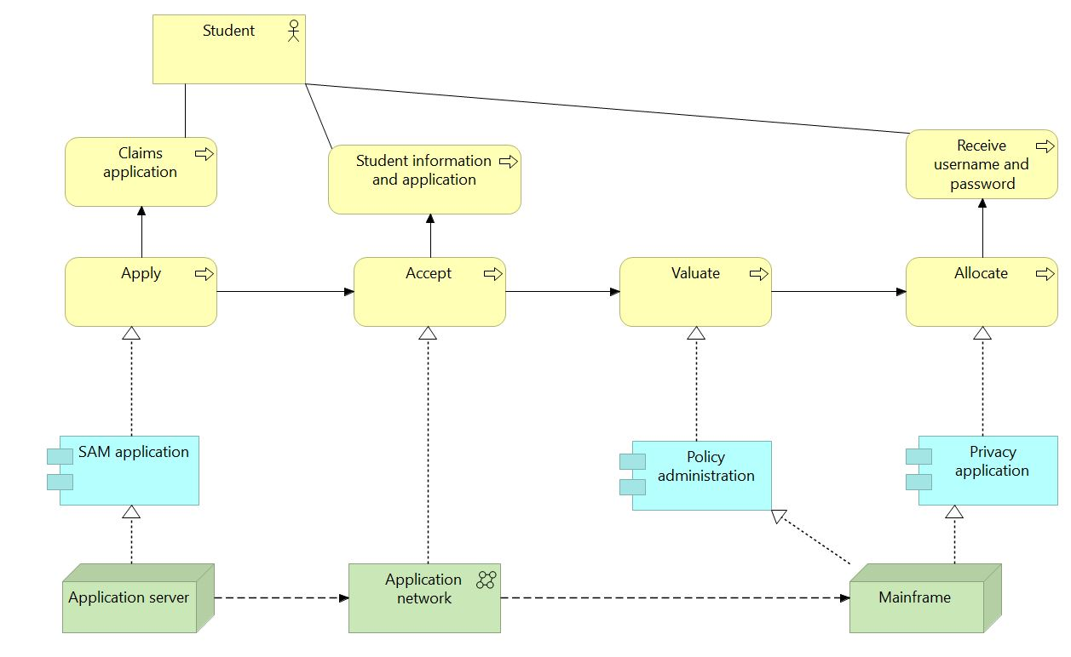

Figure 2.4 Enterprise Architecture Model

The diagram above shows the enterprise architecture model which includes three layers ---business layer, application layer and technology layer.

# 3 Implementation of Portal CSS Prototype Software



Figure 3.1 Main Page

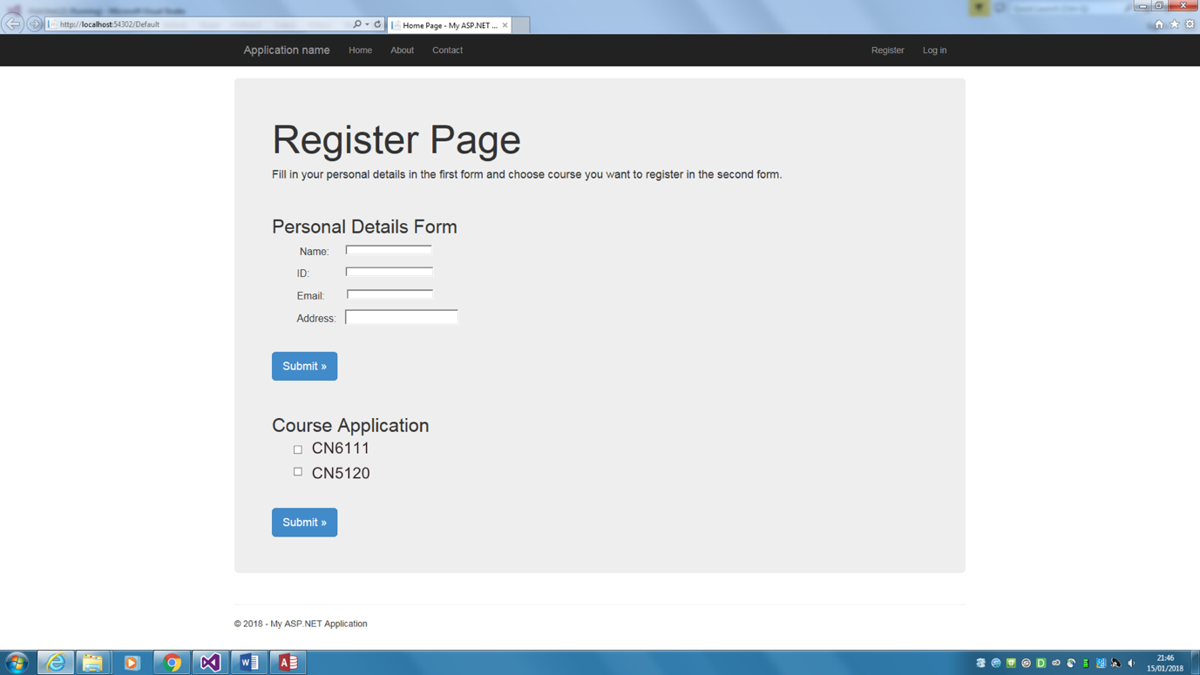

Figure 3.2 Register page

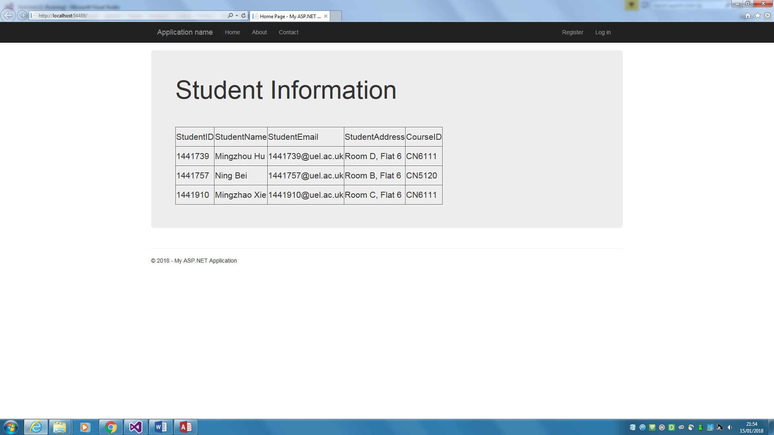

Figure 3.3 Student Information

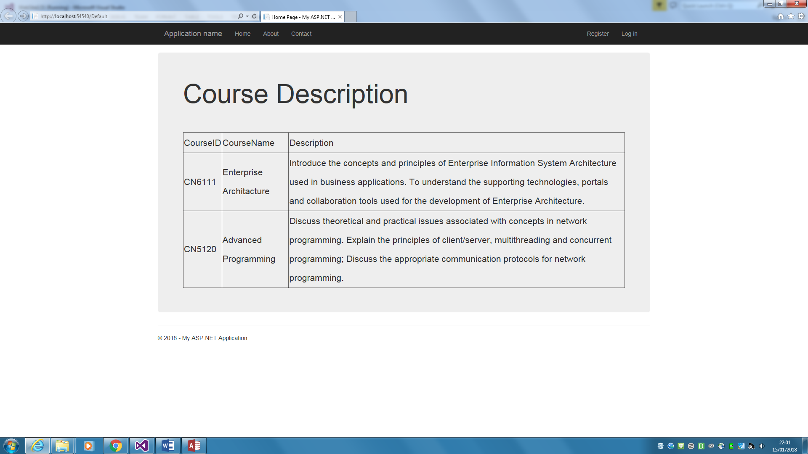

Figure 3.4 Course Description

The screenshots above show the implementation of the use case. Students can register course and view course details in the website. When they enter the register page, they can fill in the personal details form and application form. And after they click submit button, their information will be written to database.

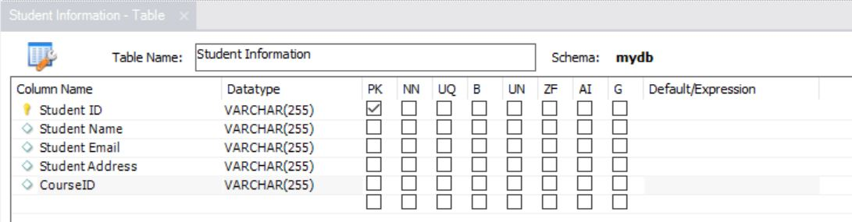

Figure 3.5 Student Information database

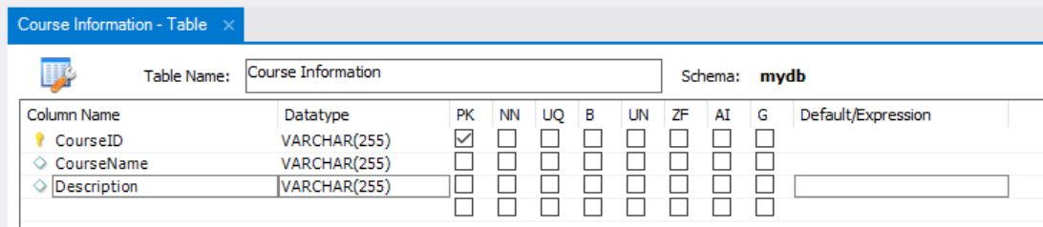

Figure 3.6 Course Description database

# 4 Individual Evaluations:

## 4.1 Evaluation by Ning Bei

The website is running 24 hours a day, 7 days a week, every semester there are 35,000 students need to register and 90% of them register in the first week. This means the system should handle 31,500 student’s registrations at first week and at least 4,500 students every day during the first week. Therefore, the throughput of the system should maximum be 1.72 Gb/s to allow students to register. However, in real life students do not register at the same time in a day, so the throughput will not be this high. In Register Page, students can fill in their personal details and their choice of course. What they enter will be stored in the database for officers and lecturers to check and use.

## 4.2 Evaluation by Mingzhao Xie

According to the case study, the system should allow more than 30,000 student registers at the same period of time. It will be acceptable if the throughput of the system could reach 2.0 Gb/s to fit the amount of the registration. Also, the processing time and response time should be as short as possible. According to the system we modelled in this report, the system we built will be unimpeachable for the State University because the system is just a lightweight class programme running on the university’s website.

## 4.3 Evaluation by Mingzhou Hu

According to the implementation of our system, the system we built is acceptable for the State University. Because the user interface is friendly to the students, which means they will find the appropriate functions directly and clearly. The system met the requirement of the State University registration system because the throughput will be enough to support the large amount of registration in a short time. Also, the connection of database ensures the reliability of the system.

# 5 Individual Conclusions:

## 4.1 Conclusion by Ning Bei

In this report, we chose the State University as our case study. Before we started, we updated the existing case study to match their business process. We analysed the requirement of the organisation, then designed and modelled the Enterprise Architecture. During this period, we learned large numbers of EA tools like Bonitasoft, yEd, GenMyModel. When finished this report, I clearly understood the relation between Enterprise Portal and mobile application. When design and implement the system, we met some problems but finally we solved them with the help of Dr Aloysisus Edoh and teamwork.

EA and BPMN, which combine a set of activities within an organization with a structure describing their logical order and dependence, is the key to integrating an enterprise successfully. Hence, it is essential to identify all the processes in the case study and model them using the appropriate business process notations. In our report, we listed all the steps of modelling. By completing this report, we fully understand the concepts and principles of Enterprise Architecture and how importance it is.

In the future work, we as IT students, should design and model the target task using Enterprise Architecture principles before we start implementation like what we did at in this coursework.

## 4.2 Conclusion by Mingzhao Xie

This report is about the designing and implementation of the State University’s new registration system. A lot of research had been done and large amount of data had been collected before we started. At the beginning, we updated the case study to meet their actual requirement. After analysed the case study, we designed and created Business Process Model, class diagram, data entity model, enterprise architecture model based on the aim and objectives of State University by team work. During that period, we understand how to solve the problems with the help of the supporting tools. At the end of the report, we evaluated the system individually and gave our own conclusion and reference. By completing this teamwork report, we developed the skills of analysing different Enterprise Architectures, developing Enterprise Portal with the help of different tools, evaluating the relation between Enterprise Information Portal and mobile applications, simulating web portals using software packages and the report writing skills.

According to the process and evaluation results of our report, we found that the business

case study can be analysed and improved by approaches such as business process modelling and enterprise architecture model. It is very important to analyse and model the information system using EA tools before we develop applications.

## 4.3 Conclusion by Mingzhou Hu

In our report, we analysed, designed, modelled and implemented the updated State University case study based on the principles of Enterprise Architecture. We finished the investigation, design, and modelling parts with the help of enterprise architecture tools like Bonitasoft, yED, GenMyModel. To complete the report by teamwork, every member should have a good understanding of the principles of Enterprise Architecture and the tools used to design, model and implement the case study. Hence, before we started, we had done a lot of research and investigation, which made me have a better understanding of different types of Enterprise Architecture and how to analyse them using supporting software. Then we designed and modelled the enterprise system by team work. We implemented and simulated the test prototype web based on our architecture. Then we discussed the results of the implementation and evaluated them individually in Chapter 4.

According to the whole process, The Enterprise Architecture Frameworks and the Business Information System Modelling make us easier to achieve specific goals. Also, with the help of the principles and the models of Enterprise Information System Architecture, we could integrate all the information and data we collected for the system and applied them when implemented the system What’s more, with the help of the models, we could keep correcting ourselves to make sure we were moving towards the right direction.

# 6 Recommendation

According to our report, we highly recommend that every IT enterprise should consider the requirement of the task, business processes, relationship between the entities of the system, how the data within the system is managed and the hardware and software infrastructures, because they will make the development stage more efficient and accurate.

# 7 Individual Reference

## 6.1 Reference – Ning Bei

1. Aguilar-Saven, R.S., 2004. Business process modelling: Review and framework. *International Journal of production economics*, *90*(2), pp.129-149.
2. Aguilar-Saven, Ruth Sara. "Business process modelling: Review and framework." *International Journal of production economics* 90, no. 2 (2004): 129-149.
3. Whitman, L., Ramachandran, K. and Ketkar, V., 2001, December. A taxonomy of a living model of the enterprise. In *Proceedings of the 33nd conference on Winter simulation* (pp. 848-855). IEEE Computer Society.

## 6.2 Reference – Mingzhao Xie

1. Melão, N. and Pidd, M., 2000. A conceptual framework for understanding business processes and business process modelling. *Information systems journal*, *10*(2), pp.105-129.
2. Ould, M.A. and Ould, M.A., 1995. *Business Processes: Modelling and analysis for re-engineering and improvement* (Vol. 598). Chichester: Wiley.
3. Whitman, L., Ramachandran, K. and Ketkar, V., 2001, December. A taxonomy of a living model of the enterprise. In *Proceedings of the 33nd conference on Winter simulation* (pp. 848-855). IEEE Computer Society.

## 6.3 Reference – Mingzhou Hu

1. Aguilar-Saven, Ruth Sara. "Business process modelling: Review and framework." *International Journal of production economics* 90, no. 2 (2004): 129-149.
2. Fox, M.S. and Gruninger, M., 1998. Enterprise modeling. *AI magazine*, *19*(3), p.109.
3. Frank, U., 1997. Enriching Object-Oriented Methods with Domain Specific Knowledge: Outline of a Method for Enterprise Modelling.

# 8 Reference

1. Marc Lankhorst. Introduction to enterprise architecture. In Enterprise Architecture at Work, The Enterprise Engineering Series. Springer Berlin Heidelberg, 2009.
2. Zachman, J.A., 1997. Enterprise architecture: The issue of the century. *Database Programming and Design*, *10*(3), pp.44-53.
3. Bonitasoft.com. (2018). Bonita : Develop engaging digital user experience. [online] Available at: https://www.bonitasoft.com/bonita-platform [Accessed 6 Jan. 2018].
4. GenMyModel. (2018). Software Modeling in the Cloud. [online] Available at: https://www.genmymodel.com/class-diagram-online [Accessed 6 Jan. 2018].
5. yWorks, t. (2018). yEd Graph Editor. [online] yWorks, the diagramming company. Available at: https://www.yworks.com/products/yed [Accessed 6 Jan. 2018].
6. Fox, M.S. and Gruninger, M., 1998. Enterprise modeling. *AI magazine*, *19*(3), p.109.

# 9 Appendix

## 9.1 Meeting Record

\

|  |  |  |
| --- | --- | --- |
| Date | Attendance | Outcome |
| 05/12/2017 | Mingzhao Xie, Ning Bei, Mingzhou Hu | Identification of the main problem of the use case |
| 12/12/2017 | Mingzhao Xie, Ning Bei, Mingzhou Hu | Collection of information and allocation of tasks |
| 19/12/2017 | Mingzhao Xie, Ning Bei, Mingzhou Hu | Evaluation of the models and implementation |
| 05/01/2018 | Mingzhao Xie, Ning Bei, Mingzhou Hu | Conclusion of the coursework |

Table 9.1 Meeting Record

## 9.2 Gantt Chart

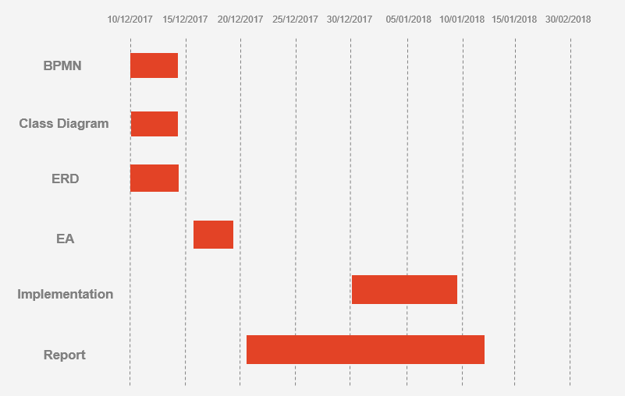

Table 9.2 Gantt Chart