**Optimal Multi-objective Architecture for Reconfigurable Battery System: Optimization Based on Directed Graph and Genetic Algorithm**

Binghui Xua, Cheng Qiana[1], Yi Rena, Bo Suna, Zili Wanga

a School of Reliability and Systems Engineering, Beihang University, Beijing, 100191,China

Abstract

The reconfigurable battery system (RBS) has recently become popular as a flexible and efficient battery system that allows for dynamic changes in the modes of connection of its battery cells. Several RBS architectures have been developed at varying levels of complexity to customize the system output, enhance its fault tolerance, and make full use of its capacity. However, owing to the absence of quantitative evaluation methods, these architectures are usually manually designed, and rely heavily on the experience of designers. Therefore, they are unlikely to guarantee Pareto optimality in case of multiple objectives. In this study, the authors propose a method to assess and optimize RBS architectures based on the directed graph and genetic algorithm (GA). We first develop a directed graph-based model to accurately describe the RBS architecture and then propose a quantitative scoring technique to evaluate the architecture based on five quantitative indicators. Finally, we develop a GA-based optimization method to assess prevalent RBS architectures, and compare the outcome with optimized RBS architectures in three scenarios. The results show that the proposed method of optimization can provide solutions for RBS architectures that are as good as or better than currently used methods according to the given requirements.

**Keywords**: Reconfigurable battery system, architecture, optimization, directed graph, genetic algorithm.

1. Introduction

With the ongoing promotion of low-carbon and environmentally friendly technologies in the last few decades, an increasing amount of clean and renewable energy, such as solar and wind energy, has been used in place of traditional sources of energy. However, the output of these renewable sources of energy is highly influenced by the weather, and generally fluctuates. There is thus growing demand for energy storage systems that can reduce the volatility in the output of renewable energy to ensure the stability of the grid and improve the reliability of the power supply [1–3]. Given their merits of a high energy density and fast response, battery energy storage systems (BESS) have attracted considerable attention in recent years [4, 5]. Multiple batteries need to be connected in series or parallel in a BESS to meet the demands for power, voltage, and current in various applications. However, due to variations in the manufacturing process and the local environment, inconsistency between batteries in the BESS is inevitable [6,7]. Such inconsistency can reduce the available capacity of a typical BESS with a fixed configuration and reduce its lifetime [8]. Many studies have considered equalization management to maintain a balance of voltage or the state-of-charge between the batteries [9,10]. However, a BESS with a fixed configuration still suffers from the cask effect, whereby the weakest battery determines the available capacity and lifetime of the system. Furthermore, a faulty battery cannot be isolated in a BESS with a fixed configuration such that this poses a significant threat to its functionality, and even to its safety.

A reconfigurable battery system (RBS) that can dynamically change the connections between batteries according to demand has been developed to solve the above problems that afflict a BESS with a fixed configuration. By reconfiguring the battery connections, the RBS can manage each cell's energy flow and maximize its available capacity. Furthermore, the dynamic reconfiguration of battery connections helps isolate faulty batteries and customize the system’s output to ensure its functionality and improve its energy efficiency. For these reasons, the RBS exemplifies the next generation of battery systems [11]. In RBS, battery connections are generally reconfigured by changing the states of electronic switches in the system. The architecture of the RBS, which characterizes static connections between batteries and switches in the system, determines the upper bound of its reconfiguration-related functionality and therefore needs to be designed first when building the BESS.

1.1 Related work and gap in research

Fig. 1 shows the most commonly observed RBS architectures designed for different purposes, such as to improve the system’s energy efficiency and maximize its available capacity [11, 12].

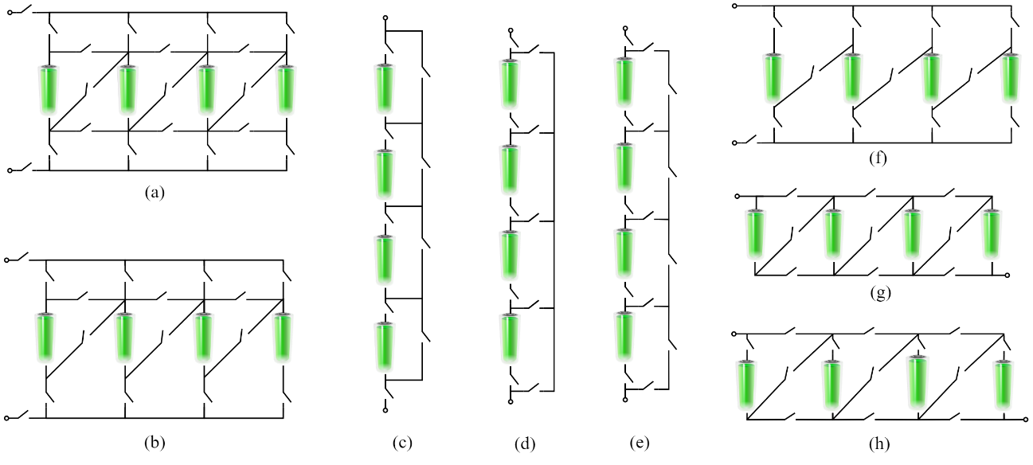

Fig. 1. RBS architectures currently available in recent literature. (a) Type A [13], (b) type B [14], (c) type C [15], (d) type D [16], (e) type E [17], (f) type F [18], (g) type G [19], and (h) type H [20].

To maximize the available capacity of the battery system, Ci et al. designed an RBS with the type A architecture, shown in Fig. 1(a), in 2007 [13]. This kind of RBS can flexibly connect batteries in series, in parallel, or in the hybrid series–parallel mode. It can also bypass and isolate any faulty battery to maintain system operation. A slightly simplified RBS, the architecture of which is shown in Fig. 1(b), was subsequently developed by NASA’s Jet Propulsion Laboratory (JPL). It is designed to provide multiple modes of operation and fault-tolerant capabilities for aerospace applications [14]. Although these two types of RBS architectures provide flexibility for system reconfiguration, they are costly because each battery needs four to five switches on average.

Guided by the goal of simplification, Kim et al. developed the series-connected RBS shown in Fig. 1(c) [15]. Similar RBS architectures were developed by He [16] and Barrie et al. [17], and are shown in Figs. 1(d) and (e), respectively. These three kinds of RBS can disconnect any battery to isolate the faulty one or to provide redundancy, and require significantly fewer switches than the two architectures mentioned above. Accordingly, the cost, complexity, and difficulty of control of these three RBS are lower as well. However, reducing the number of switches weakens the flexibility of reconfiguration of the RBS. For instance, the batteries in these RBS can be connected only in series mode, but not in parallel mode or the mixed series–parallel mode.

To improve the efficiency of energy conversion of the power supply in portable computers, Visairo et al. proposed an RBS with the architecture shown in Fig. 1(f) [18]. It can dynamically change the output voltage according to the external load to reduce the loss of power caused by the voltage regulator and improve the endurance of the battery system in the computer. The RBS architectures shown in Figs. 1(g) and (h) were also developed for efficient battery management by Younghyun et al. [19] and Hahnsang et al. [20], respectively. These three types of architectures strike a better balance between cost and the flexibility of reconfiguration than the systems discussed above. With only three switches per battery, all of the series, parallel, and mixed series–parallel modes of batteries can be implemented in the RBS through reconfiguration.

Although a variety of RBS architectures with different levels of complexity have been designed for different purposes, some issues still need to be resolved in the evaluation and design of RBS architectures:

1. Systematic methods for the quantitative evaluation of RBS architectures are unavailable, which makes it difficult to objectively and effectively compare different architectures. Although the methods for their qualitative analysis have been summarized in the literature [11, 12], they cannot be used to accurately evaluate RBS architectures in case of multiple objectives.
2. Methods of optimizing the RBS architecture remain elusive. Most RBS architectures have been designed based on the experience of experts with only a single objective. However, these optimized architectures cannot satisfy Pareto optimality under multiple objectives because they conflict with one another. For instance, the flexibility of reconfiguration of the RBS requires numerous switches to construct a complex architecture, which in turn raises the cost of the system.

1.2 Main contributions of this study

To solve the two problems mentioned in Section 1.1, we propose a method of optimization for RBS architecture based on the directed graph and the genetic algorithm (GA) in this study. The main contributions of this paper are as follows:

1. A directed graph-based model is developed to accurately describe the architecture of the RBS in which the batteries, switches, and their connections are represented by using vertices and directed edges.
2. A quantitative method to assess the architecture of the RBS is proposed for the first time in the literature, to the best of our knowledge. Specifically, we define a quantitative score for the RBS architecture based on five quantitative indicators extracted from the variety of functions expected of the RBS. We also provide the corresponding algorithms to calculate these indicators.
3. A GA-based method is developed to optimize the architecture of the RBS under multiple objectives according to the practical requirements of the battery system. This eliminates the dependence of the design of the architecture of the RBS on expert knowledge.

1.3 Organization

The remainder of this paper is organized as follows: Section 2 provides details of the directed graph-based method for modeling the RBS architecture, and Section 3 presents the method to quantitatively evaluate the RBS architecture based on five indicators. Section 4 describes the process of multi-objective optimization of the RBS architecture by using the GA-based algorithm, Section 5 compares and discusses the results of optimization of RBS architectures in light of the requirements of different applications, and Section 6 summarizes the conclusions of this study.

2. Directed graph-based model of the RBS architecture

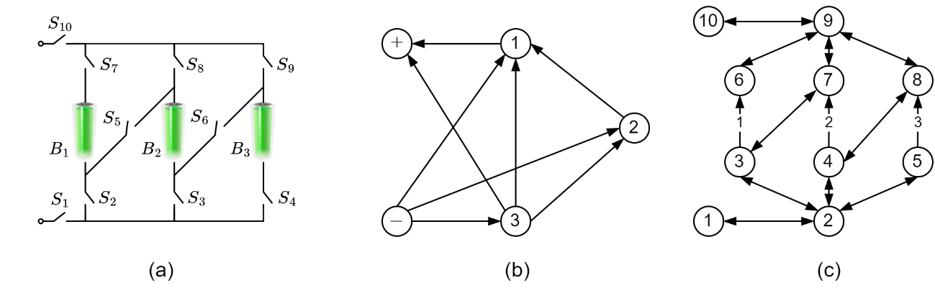

Fig. 2. A typical RBS architecture and its graph-based models. (a) RBS architecture. (b) Connectivity model. (c) Architecture model.

The graph model was initially used by He et al. to represent the connectivity of batteries in the RBS and improve the energy efficiency of large-scale battery systems [21]. In their model, the vertices of the graph represent the batteries and its edges represent the connectivity between them. An example of connectivity model of RBS is shown in Figs. 2(a) and (b). In Fig. 2(b), the vertices 1, 2,and3of the model represent the batteries , ,and , respectively, in the RBS. Additional vertices –and+ are used to represent the anode and cathode of the RBS, respectively, and the directed edges between the neighboring nodes represent the possible flows of current between the batteries. However, the main drawback of this model is that it cannot represent a unique correspondence with each RBS architecture. Although the edges can reflect the connectivity between batteries, they cannot specify how this connectivity is physically realized. In other words, it does not discern whether the wires or the switches help achieve connectivity between batteries. This leads to a significant problem whereby RBS with different structures are represented by the same graph model.

To resolve the above issues, we develop a directed graph-based model to uniquely characterize the architecture of the RBS. Given an RBS with a specific architecture, we construct the corresponding model *G* = (*V, E*) as follows:

1. The vertex set *V* = {*v*1*,v*2*,……,vn*} represents the nodes connecting batteries and/or switches, where *v*1and *vn* represent the anode and cathode of the RBS, respectively.
2. The set of directed edges *E* represents all the batteries and switches in the RBS. A battery is represented by a directed edge *eij* = (*vi,vj*), where the vertices *vi* and *vj* are the anode and the cathode of the battery, respectively. A switch is represented by two antithetical directed edges to cover the possible directions of the flow of current. To further distinguish between batteries and switches in the graph, edges that represent batteries are marked with numbers.

The above directed-graph based model can accurately and uniquely describe the architecture of the RBS. As an example, the directed graph-based model of the RBS architecture shown in Fig. 2(a) is plotted in Fig. 2(c), in which the edges (*v*3*,v*6)*,* (*v*4*,v*7), and (*v*5*,v*8) with labels 1, 2, and 3 represent the batteries *B*0*, B*1*,* and *B*2,respectively, the vertices (*v*1*,v*10) represent the anode and cathode of the system, respectively, and the other directed edges represent switches. By using this directed graph-based model of the architecture, any possible mode of batteries in the RBS can be specified by a combination of simple, valid paths in the graph from the anode vertex to the cathode vertex.

3. Quantitative evaluation of the RBS architecture

An RBS architecture that can dynamically reconfigure the connections between batteries is expected to be able to isolate faulty batteries, control the sequential discharge of batteries to maximize battery capacity, control the sequential charging of batteries to equalize the battery status, and actively regulate the system output. We extract five indicators to evaluate the extent of implementation of the RBS architecture with respect to these functions. Their detailed definitions and explanations are provided below.

3.1 *F*conn

To evaluate the capability of sequential charging and discharging batteries of the RBS so that it can make full use of its capacity or equalize the status of the batteries, the indicator *Fconn* is defined as the ratio of batteries in the RBS that can be connected alone through reconfiguration. Specifically, a battery is considered to be connected alone if and only if it is connected while all the other batteries are disconnected. Consider the three-battery RBS shown in Fig. 2(a) as example. When the switches , and are closed and the other switches are open, as shown in Fig. 3(a), the battery is considered to be individually connected. Likewise, we can deduce that the batteries and can be individually connected in this RBS as well. In this case, the value of the indicator *Fconn* of this RBS is one.

3.2 *F*disc

To evaluate the capability of the RBS to isolate a faulty battery, the indicator *Fdisc* is defined as the ratio of batteries in the RBS that can be disconnected alone through reconfiguration. A battery is considered to be disconnected alone if and only if it is disconnected from the circuit while all the other batteries are still connected. For the three-battery RBS shown in Fig. 2(a), when the switches , and are losed and the other switches are open, as shown in Fig. 3(b), the battery is individually disconnected. Likewise, each of the three batteries in this RBS can be disconnected by itself through reconfiguration, in which case the value of indicator *Fdisc* of this RBS is one.

3.3 *F*cur

To evaluate the capability of the RBS to regulate the output current of the system, the indicator *Fcur* is defined as the ratio of the maximum allowable current of the RBS to its theoretical maximum current under a parallel connection. When all batteries in a RBS is connected in parallel, the maximum allowable current of the RBS equals to its theoretical maximum current under a parallel connection. Taking the three-battery RBS shown in Fig. 2(a) as example, Fig. 3(c) shows that all three batteries are connected in parallel when the switches , and are closed while the other switches are open. Assuming that the maximum current allowed by each battery is 1A, therefore, both its maximum allowable current and theoretical maximum current are 3 A, and the value of the indicator *Fcur* is one.

3.4 *F*vol

To evaluate the capability of the RBS to regulate the output voltage of the system, the indicator *Fvol* is defined as the ratio of the number of voltage levels of the RBS to the maximum number of voltage levels, assuming that the terminal voltage of each battery is constant. We can then infer that the maximum number of voltage levels of an n-battery RBS is n when one to n batteries can be connected in series. Taking the three-battery RBS shown in Fig. 2(a) as an example, it is clear from Figs. 3(a), (b), and (d) that this RBS has three voltage levels. Thus, the value of its indicator *Fvol* is one.

3.5 *F*cost

To evaluate the cost of the RBS architecture, the indicator *Fcost* is defined as the ratio of the number of switches in the RBS to the maximum number of switches in currently available RBS architectures. In this study, we assume that the cost of the RBS is determined only by the number of switches. The three-battery RBS shown in Fig. 3(a) has 10 switches, and the maximum number of switches in currently available three-battery RBS is 14 (i.e., RBS with the type A structure). Thus, the value of the indicator *Fcost* of this RBS is 0.714. Moreover, according to its definition, *Fcost* reflects the complexity of the system’s structure.



Fig. 3. Modes of connection of batteries in a three-battery RBS. (a) Battery is connected alone, (b) battery is disconnected alone, (c) all three batteries are connected in parallel, and (d) all three batteries are connected in series.

According to the above definitions, these above-mentioned indicators are calculated by analyzing simple and valid paths from the anode vertex to cathode vertex in the direct graph-based model of the RBS. Detailed algorithms are developed to this end, as shown in Appendix 1. Then, the RBS architecture is comprehensively evaluated by a weighted sum of these five indicators as shown in Eq. (1):

where *F* is the comprehensive score of an RBS architecture, and *wconn, wdisc, wcur, wvol,* and *wcost* are the personalized weights of the corresponding indicators that can be customized depending on the scenario at hand. In general, a higher value of *F* yields a better RBS architecture.

4. GA-based optimization of the RBS architecture

The GA is an adaptive meta-heuristic approach to the problem of optimization inspired by Darwin's theory of evolution [22]. Due to its merits of a high efficiency and the capacity for global search, the GA and its variants have been widely used to find optimal solutions to complex problems in various fields, especially those involving discrete design variables [23]. In this study, we utilize the GA to optimize the RBS architecture by using the process shown in Fig. 4. Because the number of switches per battery in currently available RBS architectures generally ranges from two to five, the number of switches per battery in the process of optimization is limited to five. Overall, in the process of GA-based optimization, the population of chromosomes representing solutions of RBS architecture is first initialized. Then, the crossover, mutation, and selection operations are iteratively performed 10,000 times on the population to obtain the optimized RBS architecture. Given that the directed graph-based model represented by the new generation of chromosomes may not be a connected graph, its largest connected sub-graph is used to represent the architecture model of the RBS.

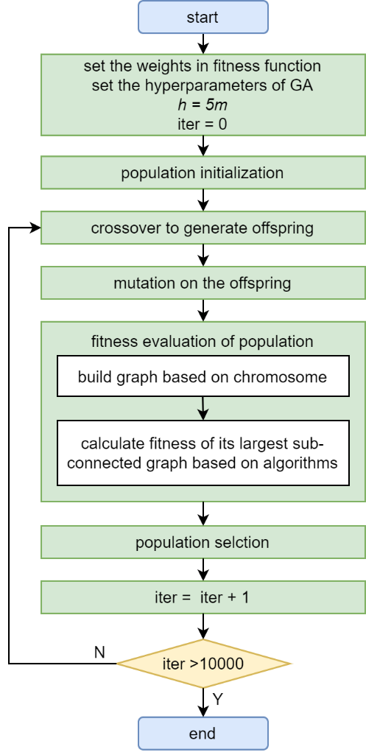

Fig. 4. Flowchart of the GA-based optimization of an RBS containing *m* batteries.

4.1 Chromosome representation and population initialization

The solution to the problem needs to be canonically encoded in the GA by using strings, matrices, or other formal structures. Each representation of a solution is called a chromosome. To represent the directed graph-based model of the RBS architecture, the incidence matrix of the directed graph, denoted by *M*, is considered as the chromosome. Each column of the chromosome *M* represents an edge of the directed graph and each row represents a vertex. The element *Mij* is set to -1 if a directed edge leaves from the vertex *vi*, 1 if it enters the vertex *vi*, and 0 otherwise. Fig. 5 shows the chromosomal representation of an RBS architecture consisting of *m* batteries and *h* switches. Because each switch and each battery are modeled by a pair of antithetical directed edges and one directed edge, respectively, the total number of edges in the model of the RBS architecture is *m+2h*. Thus, as illustrated in Fig. 5, there are *m+2h* columns in *M*, and the batteries and switches are arranged from left to right in numerical order. This is to say that the first *m* columns in *M* represent the directed edges of the battery p = 1, 2, …*m*, while every pair of the remaining columns represents the two antithetical directed edges of the switch q=1, 2, …*h*. Moreover, given that the connected graph composed of *m*+2*h* edges has at most *m*+2*h*+1 vertices, there are *m*+2*h*+1 rows in *M*.

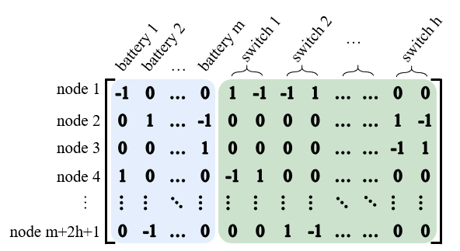

Fig. 5. Chromosomal representation of the architecture of an RBS containing *m* batteries and *h* switches.

By using the above chromosomal coding scheme, 150 chromosomes are initialized based on currently available structures to form the population while improving the efficiency of optimization.

4.2 Crossover and mutation

The crossover and mutation operations are the primary means to generate increasingly better solutions in the GA. Fig. 6 illustrates the crossover and mutation operations over chromosomes designed in the previous sub-section. In the crossover operation, every two chromosomes in the population are chosen to cross over with a probability *pc*. Then, the edges of a battery or switch in the parent chromosome 1 are randomly selected and swapped with those in the corresponding position in parent chromosome 2 to generate two new child chromosomes, as shown in Fig. 6(a). Following this, the offspring generated by the crossover operation is processed with the mutation operation, in which every chromosome has a probability *pm* of mutating. Then, the edges of a battery or switch are randomly selected and its vertices are updated by random sampling, as shown in Fig. 6(b). Finally, the offspring generated by the mutation operation is added to the population.

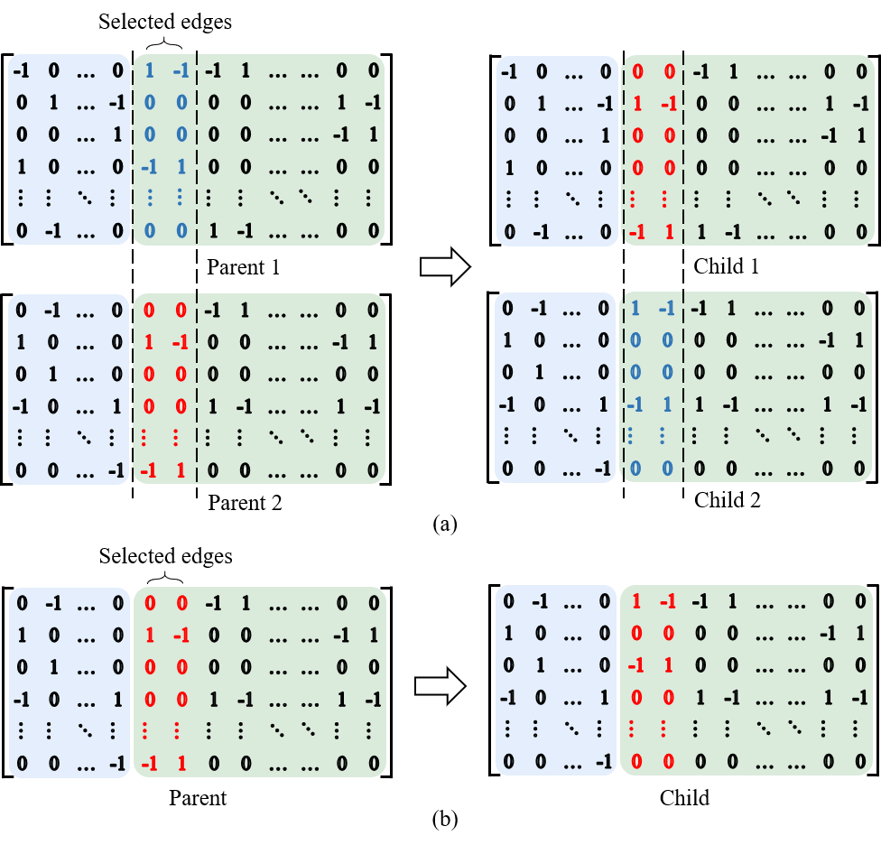

Fig. 6. Crossover and mutation operations. (a) Crossover. (b) Mutation.

4.3 Fitness function and selection

A fitness function is used to evaluate the goodness of the solutions represented by the chromosomes and guide the direction of population evolution. In this study, Eq. (1) is used as the fitness function to assess all chromosomes in the initial population as well as their offsprings. In addition, an elitist selection strategy is used to improve the efficiency of the evolution. That is, only the 150 chromosomes with the minimal fitness in each iteration are selected from the initial population and its offsprings to participate in the next iteration.

5. Results and discussion

5.1 Evaluation of currently available RBS architectures

We use the five indicators of quantitative evaluation proposed in Section 3 to assess the currently available RBS architectures shown in Fig. 1. All batches of indicators of these RBS architectures are calculated and compared in terms of battery size in Fig. 7. It is clear that the values of both *Fvol* and *Fdisc* of all currently available RBS architectures have reached their upper bounds (i.e., one), indicating that these RBS architectures have sufficient capability to regulate the output voltage and can disconnect any single battery through reconfiguration. In addition, the values of *Fconn* of all RBS architectures except for those of type D also reach one, indicating that every individual battery can be separately connected through reconfiguration in these RBS architectures. On the contrary, only the two batteries close to the system's anode and cathode can be separately connected in the RBS architecture of type D. Therefore, the *Fconn* of RBS of type D decreases with the increase in the size of the battery. In addition, because the batteries of RBS architectures of types C–E can be connected only in series, the maximum allowable currents of these RBS architectures are equal to the maximum current allowed by a single battery. Thus, the values of *F*curof these three types of RBS architectures decrease with the increase in battery size. Finally, the RBS architecture of type A has the highest value of *F*cost while that of type C has the lowest value.

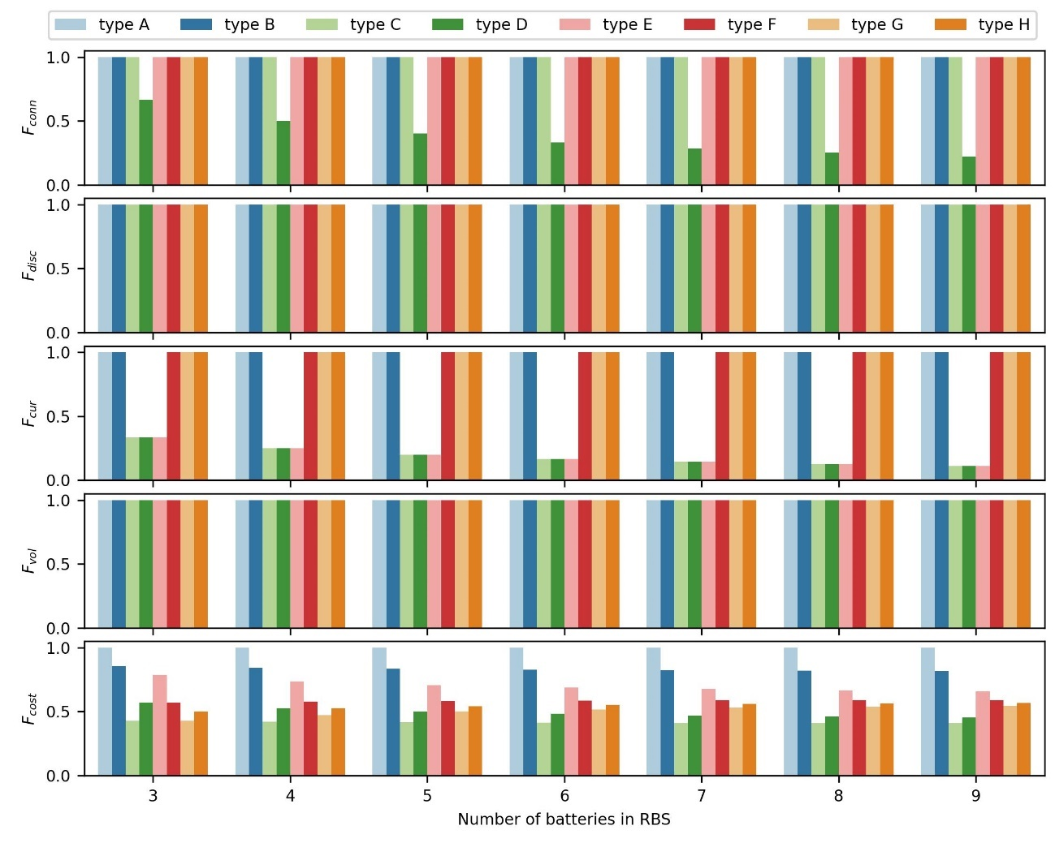

Fig. 7. The values of currently available RBS architectures shown in Fig. 1 with batteries of different sizes in terms of the five proposed indicators.

The comprehensive scores of the currently available RBS architectures shown in Fig. 1 can then be calculated with different battery sizes by using Eq. (1). To consider the influence of the weights of the indicators on the fitness of these architectures, three weights groups (*W*1, *W*2, *W*3) are defined in Table 2, and correspond to the requirements of different battery systems. For example, the five proposed indicators all have the same importance in such battery systems as lithium-ion battery-based energy storage power stations. Thus, the weights of all five indicators in *W*1 are set to 0.2. For an RBS that needs to adjust the output voltage to extend its endurance, such as the power supply of a computer, *F*vol is more important than *F*cur. Thus, the weight *wcur* is set to zero in *W*2 while the other weights are set to 0.25. In addition, the weight *wvol* is set to zero in *W*3 to approximate the needs of an RBS that focuses on charging or discharging with a high current, such as a fast-charging battery system in electric vehicles.

Fig. 8(a) shows the fitness values of currently available RBS architectures under *W*1. The RBS architecture of type G has the highest comprehensive score regardless of the number of batteries. As the number of batteries increases, the comprehensive scores of the RBS architectures of types F and H approach that of type G. Conversely, the RBS architecture of type D has the lowest comprehensive score because its values of *Fcur* and *Fconn* are the minimum of all architectures. Fig. 8(b) presents comprehensive scores of all RBS architectures under *W*2. In contrast to the results shown in Fig. 8(a), the optimal RBS architecture changes from type G to type C because the latter has the lowest *Fcost*, and the highest values of *Fconn, Fdics,* and *Fvol*. Fig. 8(c) shows that the RBS architecture of type G has the best fitness once again under *W*3 and that of type C is still the worst regardless of battery size. In general, the performance of currently available RBS architectures varies with the weights of the indicators. The proposed method of evaluation makes it possible to objectively quantify different RBS architectures, and can be used to choose the appropriate one according to the scenario in question.

Table 2 Three schemes of weight groups

| **Scheme** | ***wconn*** | ***wdisc*** | ***wcur*** | ***wvol*** | ***wcost*** |
| --- | --- | --- | --- | --- | --- |
| *W*1 | 0.2 | 0.2 | 0.2 | 0.2 | 0.2 |
| *W*2 | 0.25 | 0.25 | 0 | 0.25 | 0.25 |
| *W*3 | 0.25 | 0.25 | 0.25 | 0 | 0.25 |

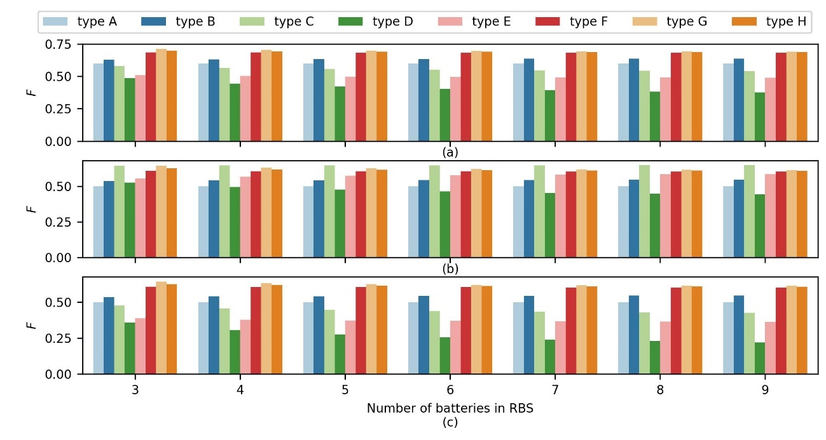

Fig. 8. Fitness values of currently available RBS architectures shown in Fig. 1 with batteries of different sizes. (a) Fitness under W1, (b) under W2, (c) and under W3.

5.2 Optimizing the RBS architecture: A case study

A sensitivity analysis of the probabilistic parameters *pc* and *pm* of the GA was conducted to choose appropriate values for them before further optimizing the RBS architecture. In the sensitivity analysis, an RBS architecture containing three batteries was considered as the object of optimization, and the weight group *W*1 was used to evaluate the fitness of the chromosomes. The fitness values of different RBS architectures optimized by the GA by using different pairs of (*pc, pm*) were generated and are shown in Fig. 9(a). The best fitness value was -0.71 when six pairs of (*pc, pm*), indicated by dark-green color in Fig. 9(a), were used in the GA. Fig. 9(b) illustrates curves of the evolution of fitness of the best chromosome during GA-based optimization under the three pairs of (*pc, pm*). Its fitness first reached its maximum value when *pc, and pm* were 0.75 and 0.2, respectively. Thus, we used these values of *pc* and *pm* to further optimize the RBS architecture based on the GA.

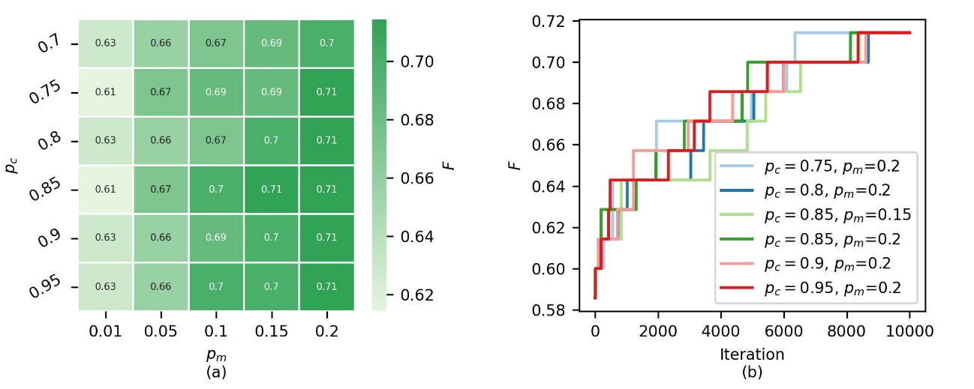

Fig. 9. The fitness values of the RBS architectures optimized by the GA under different parameters. (a) Fitness of the final results. (b) Evolution of fitness.

Fig. 10 shows a comparison of the fitness values between the optimized RBS architecture and the best RBS architectures that are currently available (types A to H shown in Fig. 1). In case weight groups *W*1 and *W*2 were used, the fitness values of the optimized architectures were equal to that of the best currently available RBS architecture. When weight group *W*3 was used, the fitness of the optimized RBS architecture was even better than that of the best currently available RBS architectures. Figs. 11(a) to (c) present the optimized RBS architectures obtained by using weight groups *W*1 to *W*3, respectively. It is clear that the optimized RBS architectures under *W*1 and *W*2 were the same as the currently available architectures of type G and type C, respectively. The optimized RBS architecture under *W*3 was superior to all currently available RBS architectures. With only three switches (relatively low cost), it could separately connect/disconnect every battery, and its maximum current reached the maximum value when all switches were closed.

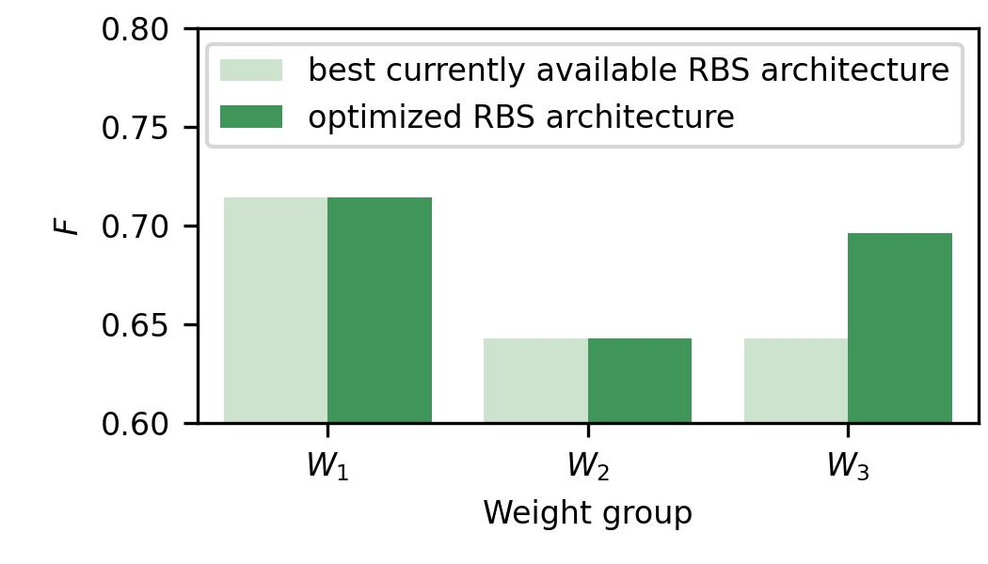

Fig. 10. Fitness values of the optimal RBS architectures with different weight groups.

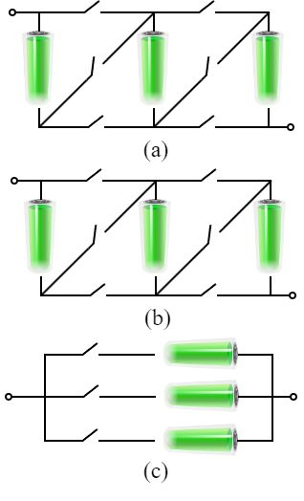

Fig. 11. Optimized three-battery RBS architectures under different weight groups. (a) W1. (b) W2. (c) W3.

6. Concluding remarks

In this study, we first proposed a directed graph-based model to describe the architecture of the RBS, and then developed five indicators to quantitatively evaluate it from the perspective of the extent of implementation of the target reconfiguration functions. Furthermore, we developed a GA-based method to optimize the RBS architecture by maximizing its comprehensive score based on the five indicators. The results of assessment of currently available RBS architectures under three scenarios showed that the best-performing architecture varied with the weights of the five indicators. In addition, the results of optimization of a three-battery RBS architecture showed that the proposed GA-based method of optimization can deliver solutions that are as good as or even better than those provided by the best currently available RBS architectures in three different application scenarios. In conclusion, the work here provides the means to objectively compare RBS architectures and inform their optimal design, which is essential for building the BESS.

Acknowledgements

This research was supported by the National Natural Science Foundation of China (Grant No. 52075028).

References

1. L. M. S. de Siqueira, W. Peng, Control strategy to smooth wind power output using battery energy storage system: A review, J. Energy Storage 35 (2021) 102252.
2. R. Karandeh, T. Lawanson, V. Cecchi, A two-stage algorithm for optimal scheduling of battery energy storage systems for peak-shaving, in 2019 IEEE North American Power Symposium (NAPS), 1–6.
3. P. D. Lund, J. Lindgren, J. Mikkola, J. Salpakari, Review of energy system flexibility measures to enable high levels of variable renewable electricity, Renewable Sustainable Energy Rev. 45 (2015) 785–807.
4. Y. Yang, S. Bremner, C. Menictas, M. Kay, Battery energy storage system size determination in renewable energy systems: A review, Renewable Sustainable Energy Rev. 91 (2018) 109–125.
5. J. Cho, S. Jeong, Y. Kim, Commercial and research battery technologies for electrical energy storage applications, Prog. Energy Combust. Sci. 48 (2015) 84–101.
6. T. Baumhöfer, M. Brühl, S. Rothgang, D. U. Sauer, Production caused variation in capacity aging trend and correlation to initial cell performance, J. Power Sources 247 (2014) 332–338.
7. N. Yang, X. Zhang, B. Shang, G. Li, Unbalanced discharging and aging due to temperature differences among the cells in a lithium-ion battery pack with parallel combination, J. Power Sources 306 (2016) 733–741.
8. F. Feng, X. Hu, L. Hu, F. Hu, Y. Li, L. Zhang, Propagation mechanisms and diagnosis of parameter inconsistency within liion battery packs, Renewable Sustainable Energy Rev. 112 (2019) 102–113.
9. M. H. Lipu, M. Hannan, T. F. Karim, A. Hussain, M. H. M. Saad, A. Ayob, M. S. Miah, T. I. Mahlia, Intelligent algorithms and control strategies for battery management system in electric vehicles: Progress, challenges and future outlook, J. Cleaner Prod. 292 (2021) 126044.
10. F. Feng, X. Hu, J. Liu, X. Lin, B. Liu, A review of equalization strategies for series battery packs: Variables, objectives, and algorithms, Renewable Sustainable Energy Rev. 116 (2019) 109464.
11. W. Han, T. Wik, A. Kersten, G. Dong, C. Zou, Next generation battery management systems: Dynamic reconfiguration, IEEE Ind. Electron. Mag. 14(4) (2020) 20–31.
12. S. Muhammad, M. U. Rafique, S. Li, Z. Shao, Q. Wang, X. Liu, Reconfigurable battery systems: A survey on architecture and research challenges, ACM Trans. Des. Autom. of Electron. Syst. (TODAES) 24(2) (2019) 1–27.
13. S. Ci, J. Zhang, H. Sharif, M. Alahmad, A novel design of adaptive reconfigurable multicell battery for power-aware embedded networked sensing systems, in IEEE GLOBECOM 2007–IEEE Global Telecommunications Conference, 2007, 1043–1047.
14. M. Alahmad, H. Hess, M. Mojarradi, W. West, J. Whitacre, Battery switch array system with application for JPL's rechargeable micro-scale batteries, J. Power Sources 177(2) (2018) 566–578.
15. T. Kim, W. Qiao, L. Qu, A series-connected selfreconfigurable multicell battery capable of safe and effective charging/discharging and balancing operations, in 2012 Twenty-Seventh Annual IEEE Applied Power Electronics Conference and Exposition (APEC), 2012, 2259–2264.
16. L. He, L. Kong, S. Lin, S. Ying, Y. Gu, T. He, C. Liu, Reconfiguration-assisted charging in large-scale lithium-ion battery systems, in 2014 ACM/IEEE International Conference on Cyber-Physical Systems (ICCPS) 2014, 60–71.
17. B. Lawson, A software configurable battery, in 26th International Battery, Hybrid Fuel Cell Electric Vehicles Symposium, 2012, 252– 263.
18. H. Visairo, P. Kumar, A reconfigurable battery pack for improving power conversion efficiency in portable devices, in 2008 7th IEEE International Caribbean Conference on Devices, Circuits and Systems, 2008, 1–6.
19. Y. Kim, S. Park, Y. Wang, Q. Xie, N. Chang, M. Poncino, M. Pedram, Balanced reconfiguration of storage banks in a hybrid electrical energy storage system, in 2011 IEEE/ACM International Conference on Computer-Aided Design (ICCAD), 2011, 624–631.
20. H. Kim, K. G. Shin, Dependable, efficient, scalable architecture for management of large-scale batteries, in Proceedings of the 1st ACM/IEEE International Conference on Cyber-Physical Systems, 2010, 178–187.
21. L. He, L. Gu, L. Kong, Y. Gu, C. Liu, T. He, Exploring adaptive reconfiguration to optimize energy efficiency in largescale battery systems, in 2013 IEEE 34th Real-Time Systems Symposium, 2013, 118–127.
22. J. H. Holland, Genetic algorithms, Sci. Am. 267(1) (1992) 66–73.
23. C. M. Chan, H. Bai, D. He, Blade shape optimization of the savonius wind turbine using a genetic algorithm, Appl. Energy 213 (2018) 148–157.

Appendix 1：Algorithms to calculate the five indicators of an RBS architecture

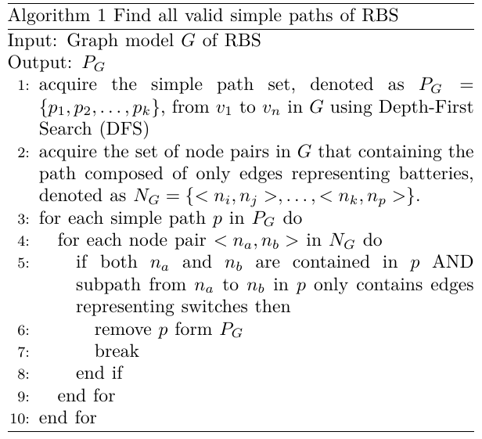

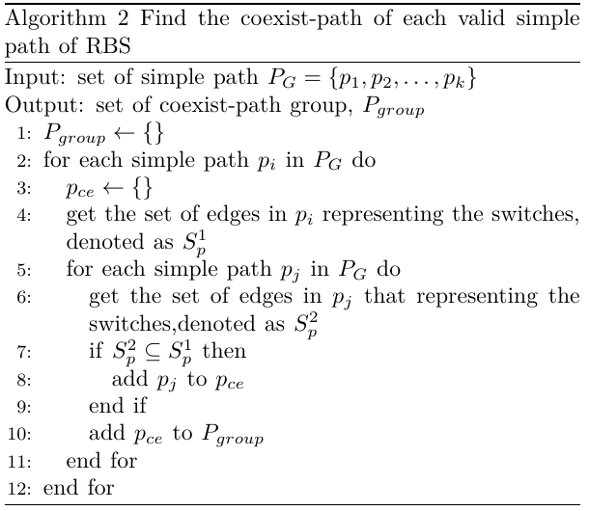

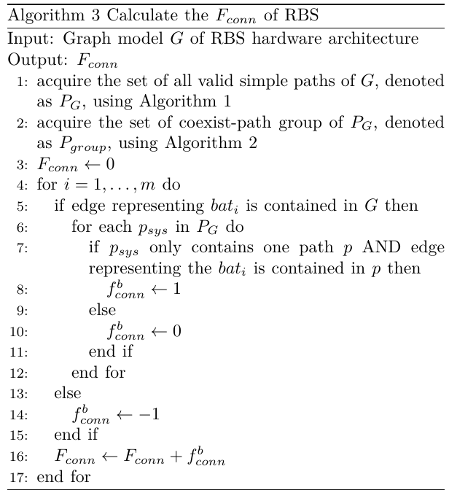

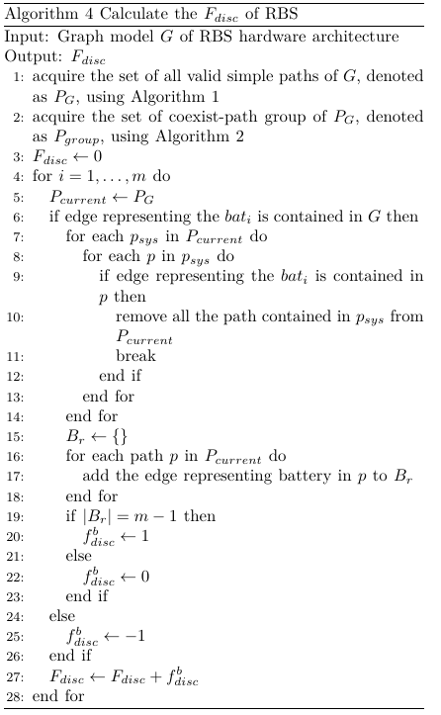

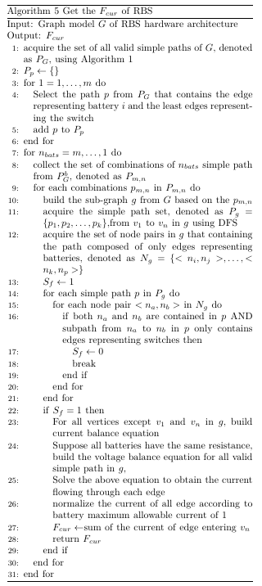

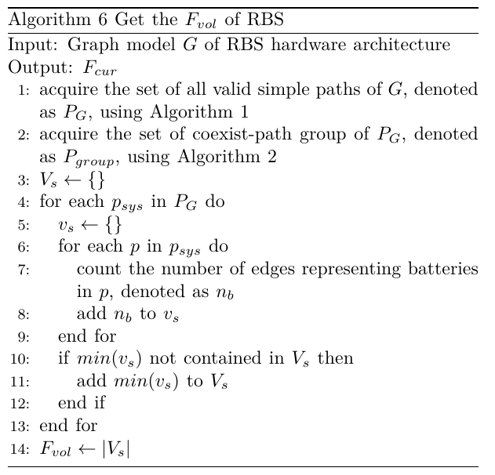

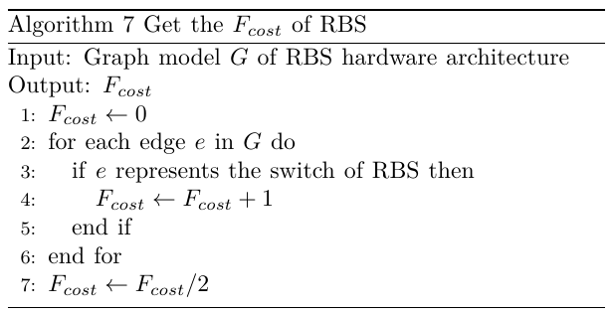

1. Corresponding author.

   E-mail address: [cqian@buaa.edu.cn](mailto:cqian@buaa.edu.cn) (C. Qian).