Title ((no stars))

Author(s), and Corresponding Author(s)*

((Optional Dedication))

((Abstract text. 12 point, double-spaced. Maximum length 200 words. Written in the present tense.))

Keywords: ((3–7 keywords, not capitalized, plural, separated by commas, no full stop))

# 1. Introduction

# 2. First-Order Heading

## 2.1. Second-Order Heading

### 2.1.1. Third-Order Heading

((Main Text Paragraphs. 12 Point, double-spaced. Please make the first reference to a display item bold **(Figure 1)**. Do not abbreviate Figure, Equation, etc.; display items are always singular, i.e., Figure 1 and 2. Equations are always singular, i.e., Equation 1 and 2, and should be inserted using the Equation Editor, not as graphics, in the main text. Display items and captions should be inserted in-line within the main text))

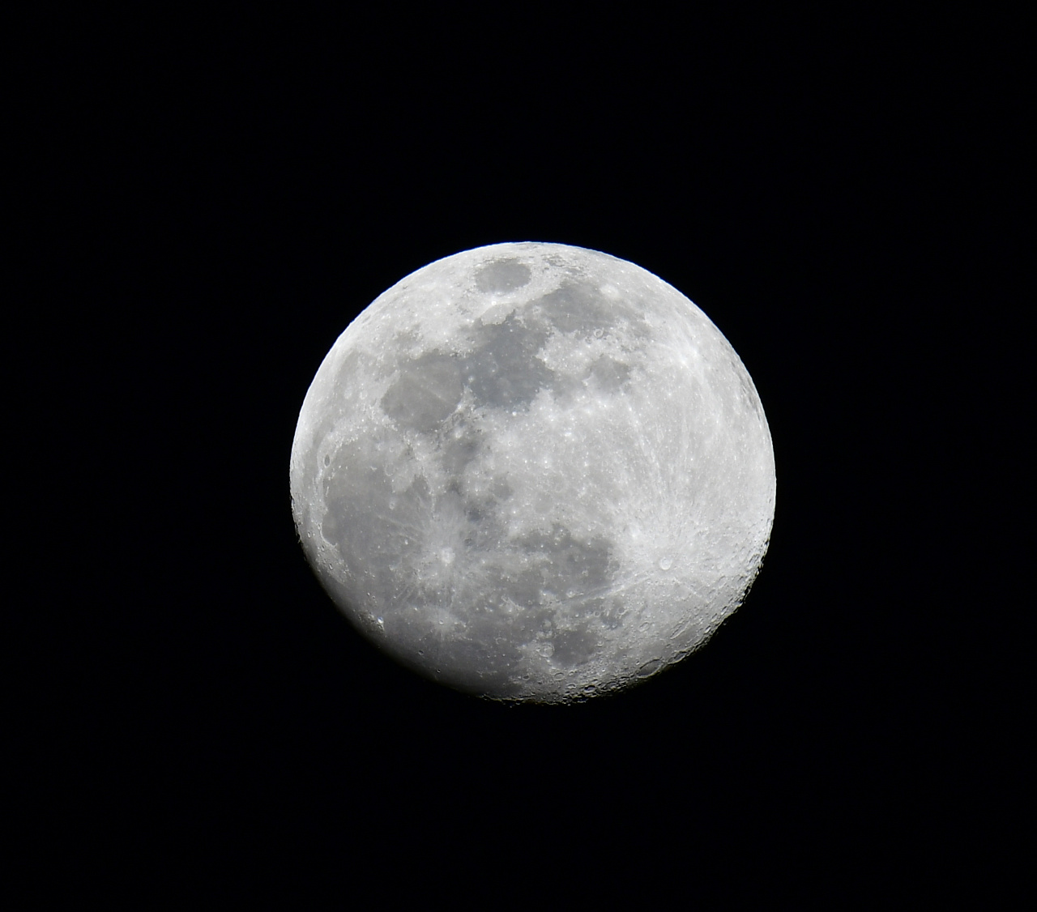

Figure 1 ((Figure Caption. Note: Please do not combine figure and caption in a textbox or frame.))

Reproduced with permission.[Ref.] Copyright Year, Publisher. ((Permission statement required for all figures reproduced or adapted from previously published articles/sources; delete if not applicable))

Table 1((Table Caption. Note: Please do not combine table and caption in a textbox or frame and do not submit tables as graphics, please use Word’s “insert table” function.))

|  |  |  |  |  |
| --- | --- | --- | --- | --- |
| Head 1 [units]a) | Head 2 | Head 3 | Head 4 | Head 5 [units] |
| Column 1 | Column 2 | Column 3b) | Column 4 | Column 5 |
| Column 1 | Column 2 | Column 3 | Column 4 | Column 5 |

((Equation)) (1)

((References should be superscripted and appear after punctuation.[1,2] If you have used reference management software such as EndNote to prepare your manuscript, please convert the fields to plain text by selecting all text with [ctrl]+[A], then [ctrl]+[shift]+[F9]).[3–5] Please do not use footnotes in the text, additional information can be added to the Reference list. Please define all acronyms except IR, UV, NMR, and DNA or similar (for a complete list of acronyms not requiring definition, please see the list available on the journal homepage in our “Author Guidelines” section.))

# ((Number)). Conclusion

# ((Number)). Experimental Section/Methods ((delete section if not applicable))

*Experimental Subheading*: Experimental Details. 12 point, double-spaced. References are superscripted and appear after the punctuation.[6]

Physical data should be quoted with decimal points and negative exponents (e.g., 25.8JK−1mol−1), and arranged as follows where possible: mp/bp 20 °C; [α]D20 = −13.5 (*c* = 0.2, acetone) (please also give units for [α] and *c*, usually deg cm3 g−1 dm−1 and g cm−3, respectively); 1H NMR (400 MHz, DMSO-*d*6, δ): 7.15 (s, 2H, Ar H), 1.3 (q, *J* = 8 Hz, 2H; CH2), 0.9 (t, *J* = 8 Hz, 3H; CH3); 13C NMR (100 MHz, CDCl3, δ): 175.4 (C=O), 156.5 (C4); IR (KBr): *ν* = 2972 (w), 2907 (w), ..., 1026 (s; *ν*as(SiOSi)), 971 (*ν*s), ..., 666 (w; *ν*s(SiOSi)), ..., 439 (m), 401 cm−1 (m); UV–vis (*n*-hexane): *λ*max (*ε*) = 320 (5000), 270 nm (12000); EIMS *m*/*z* (%): 108 (20) [M+], 107 (60) [M+ − H], 91 (100) [C7H7+]; HRMS (ESI) *m*/*z*: [M + H]+ calcd for C21H38N4O6S, 475.2591; found, 475.2593. Anal. calcd for C45H28N4O7: C 62.47, H 3.41, N 6.78; found: C 62.27, H 3.46, N 6.80.

[CCDC ###### contains the supplementary crystallographic data for this paper. These data can be obtained free of charge from The Cambridge Crystallographic Data Centre via www.ccdc.cam.ac.uk/data_request/cif.] ((delete if not applicable))

# Supporting Information((delete if not applicable))

Supporting Information is available from the Wiley Online Library or from the author.

# Acknowledgements

((Acknowledgements, general annotations, funding. Other references to the title/authors can also appear here, such as “Author 1 and Author 2 contributed equally to this work.”))

Received: ((will be filled in by the editorial staff))  
Revised: ((will be filled in by the editorial staff))  
Published online: ((will be filled in by the editorial staff))

# References

[1] ((Journal articles)) a) A. B. Author 1, C. D. Author 2, *Adv. Mater.* **2020**, *18*, 2001086; b) A. Author 1, B. Author 2, *Adv. Funct. Mater.* **2019**, *16*, 1900965.

[2] ((Work accepted)) A. B. Author 1, C. D. Author 2, *Macromol. Rapid Commun.*, DOI: 10.1002/marc.#########.

[3] ((Books)) H. R. Allcock, *Introduction to Materials Chemistry*, Wiley, Hoboken, NJ, USA **2008**.

[4] ((Edited books or proceedings volumes)) J. W. Grate, G. C. Frye, in *Sensors Update*, Vol. 2 (Eds: H. Baltes, W. Göpel, J. Hesse), Wiley-VCH, Weinheim, Germany **1996**, Ch. 2.

[5] ((Presentation at a conference, proceeding not published)) Author, presented at Abbrev. Conf. Title, Location of Conference, Date of Conference ((Month, **Year**)).

[6] ((Thesis)) Author, *Degree Thesis*, University (location if not obvious), Month, **Year**.

[7] ((Patents)) a) A. B. Author 1, C. D. Author 2 (Company), *Country Patent Number*, **Year**; b) W. Lehmann, H. Rinke (Bayer AG) *Ger. 838217*, **1952**.

[8] ((Website)) Author, Short description or title, URL, accessed: Month, **Year**.

[9] ((Preprints)) A. B. Author 1, C. D. Author 2, *(Preprint) Preprint server name*, preprint identifier/DOI, version, submitted: Month, **Year**.

[10] …((Please include all authors, and do not use “et al.”))