An Example Test Document

Author A

Author B

Author C

Author D

# 1 Introduction

This document is a test example designed to help check various LaTeX formatting techniques, including tables, figures, and formulas. In the following sections, we will demonstrate these features.

# 2 Chapter1

This is a chapter with some text. You can check the references number here, like Fig. 1.1 or Fig. 1.

## 2.1 Tables

There is a simple table in this section (Tab. 2.1).

Table : An example table with parameters.

|  |
| --- |
| image |

Tab. 2.2 shows a more complex table.

Table : Example Global Economic Indicators

|  |
| --- |
| image |

## 2.2 Figures and their References

### 2.2.1 Example Figure

Below is an example figure (Fig. 2.1) showing a diagram that might represent a process or a conceptual flow.

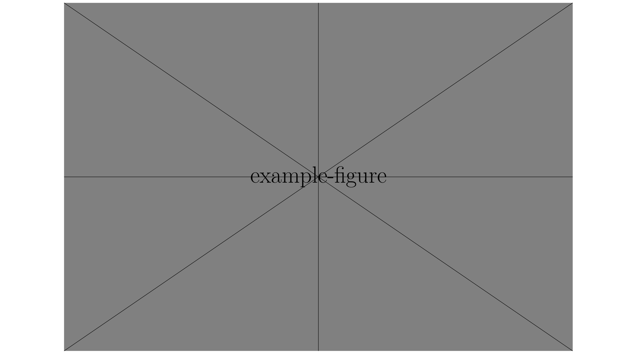

Figure : An example figure showing a conceptual diagram.

### 2.2.2 Subfigures

Below is an example of subfigures (Fig. 2.2), which contains 4 subfigures (Fig. 2.2(a), Fig. 2.2(b), Fig. 2.2(c), and Fig. 2.2(d)).

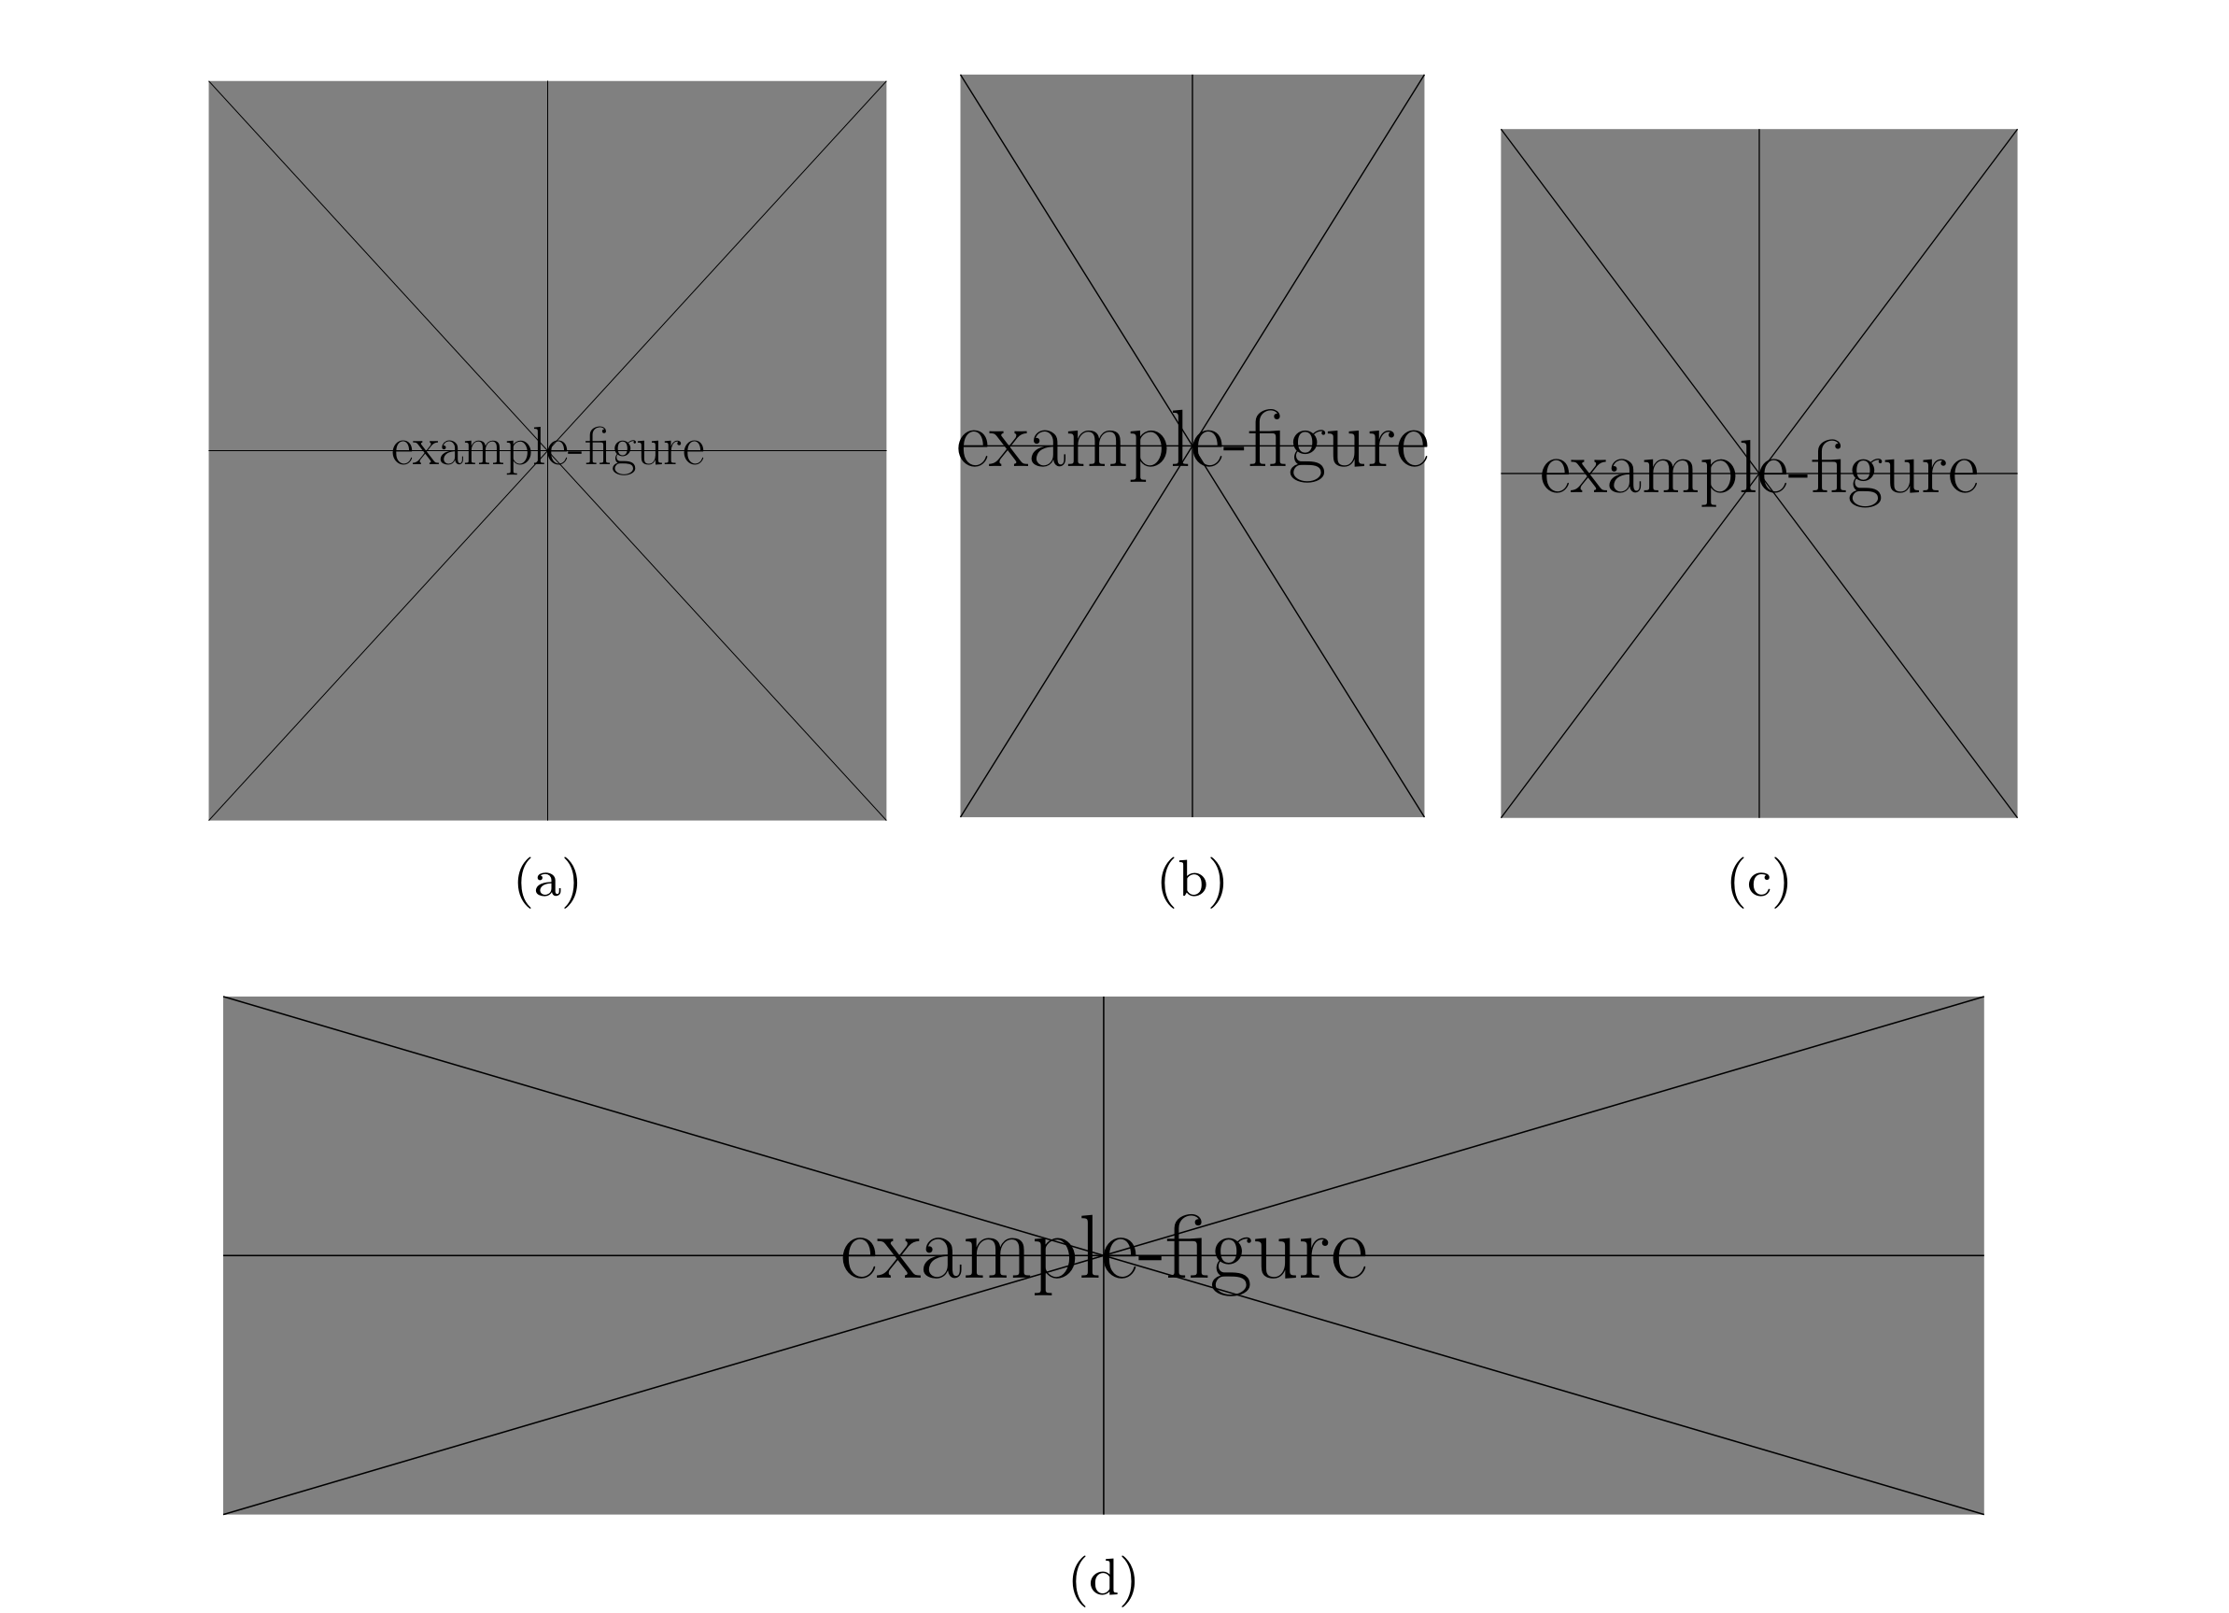

Figure : Example subfigures (a) Subfigure 1, (b) Subfigure 2, (c) Subfigure 3, and (d) Subfigure 4.

## 2.3 Formulas and Equations

This section includes an example of how to format equations. The incidence matrix is given by Eq. [eq:incidence]:

|  |  |
| --- | --- |
| $$\begin{matrix}a_{kl}=\left\{\begin{matrix}1, & \text{edge }l\text{ leaves node }k, \\ −1, & \text{edge }l\text{ enters node }k, \\ 0, & \text{otherwise},\end{matrix}\right.\end{matrix}$$ | $$\left(1\right)$$ |

where $a_{kl}$ is the element of the incidence matrix, $k$ is the node index, and $l$ is the edge index.

## 2.4 References

This section includes an example of how to cite references(personA 2018).

# Reference

personA, personB. 2018. “Title of the Article.” *Journal of Journal* 91 (August): 109–25. <https://doi.org/doi>.