(the spacing is set to 1.5)

no more than 250 words for the abstract

* a description of the research question/knowledge gap – what we know and what we don’t know
* how your research has attempted to fill this gap
* a brief description of the methods
* brief results
* key conclusions that put the research into a larger context
* MDS : MultiDimensional Scaling
* UMAP : Uniform Manifold Approximation and Projection for Dimension Reduction
* TME: Tumor MicroEnvironment

Thank you for following this tutorial!

I hope you’ll find it useful to write a very professional dissertation.

# 1 Introduction

* introduce the reader to the subject area and clarify the knowledge gap that the dissertation research will fill.
* set the context for the dissertation by reviewing the relevant literature.
* include relevant references to general (theoretical papers and reviews) and specific (specific to the particular question addressed) literature, to justify the research that has been undertaken and define the questions being addressed.
* state the primary research questions and hypotheses in the final paragraph.
* follow an ‘inverted triangle’ format, progressing from general scientific ideas and why they matter to the specific research questions addressed in the dissertation project.

(Khatami, 2014)

*The introduction should not be just a ‘Literature Review.’*

# 2 Objective and experimental principle

# 3 Methods

Write your methods here. In this tutorial you can use this already made file\to add examples of figures and tables and explore knitr and kableExtra functionalities!

# 4 Results

Some more guidelines from the School of Geosciences.

This section should summarize the findings of the research referring to all figures, tables and statistical results (some of which may be placed in appendices).

* include the primary results, ordered logically - it is often useful to follow the same order as presented in the methods.
* alternatively, you may find that ordering the results from the most important to the least important works better for your project.
* data should only be presented in the main text once, either in tables or figures; if presented in figures, data can be tabulated in appendices and referred to at the appropriate point in the main text.

**Often, it is recommended that you write the results section first, so that you can write the methods that are appropriate to describe the results presented. Then you can write the discussion next, then the introduction which includes the relevant literature for the scientific story that you are telling and finally the conclusions and abstract – this approach is called writing backwards.**

## 4.1 Creation of inflammatory groups

Inflammatory groups characterizing the intensity of inflammatory status in tumors were created by choosing the lowest and highest mean of Z-score of the hallmark inflammatory response signature from MSigDB, containing 200 genes. ICAM4 was notably not present in the dataset in TARGET-OS cohort. The groups were cut off evenly using the *ntile* function in *dplyr* R package.

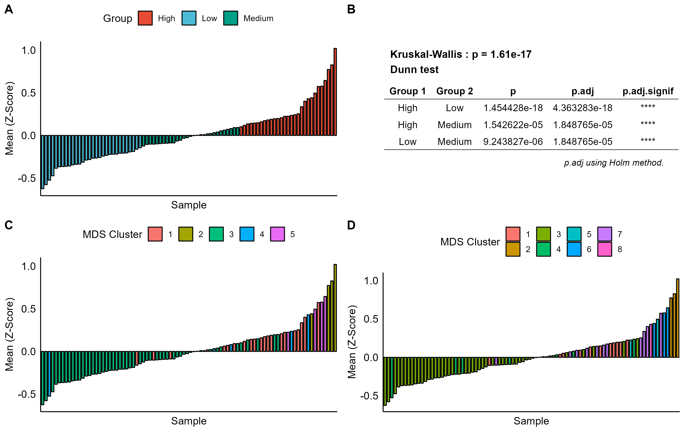

Histogram

Those manually defined groups correspond fairly well to functional groups, defined by k-means clustering based on MDS visualization **(Figure @ref(fig:inflammatory-group))**.

# 5 Discussion

the purpose of the discussion is to summarise your major findings and place them in the context of the current state of knowledge in the literature. When you discuss your own work and that of others, back up your statements with evidence and citations.

* The first part of the discussion should contain a summary of your major findings (usually 2 – 4 points) and a brief summary of the implications of your findings. Ideally, it should make reference to whether you found support for your hypotheses or answered your questions that were placed at the end of the introduction.
* The following paragraphs will then usually describe each of these findings in greater detail, making reference to previous studies.
* Often the discussion will include one or a few paragraphs describing the limitations of your study and the potential for future research.
* Subheadings within the discussion can be useful for orienting the reader to the major themes that are addressed.

# 6 Bibliography

Khatami, M. (2014). Chronic Inflammation: Synergistic Interactions of Recruiting Macrophages (TAMs) and Eosinophils (Eos) with Host Mast Cells (MCs) and Tumorigenesis in CALTs. M-CSF, Suitable Biomarker for Cancer Diagnosis! Cancers *6*, 297–322.

# 7 Appendix: code

All analysis was done using R software. Code is available at <https://github.com/Minh-AnhHuynh/Osteosarcoma-Project>

English Summary