Final Report

Share a Book Android App

(BOOKA)

Group 6

Minh Bui - 300345000

Thi Ngoc Tram Dang - 300302010

Dung Nguyen - 300345575

April 2rd, 2022

Number of screens of the app

Splash screen Log In screen

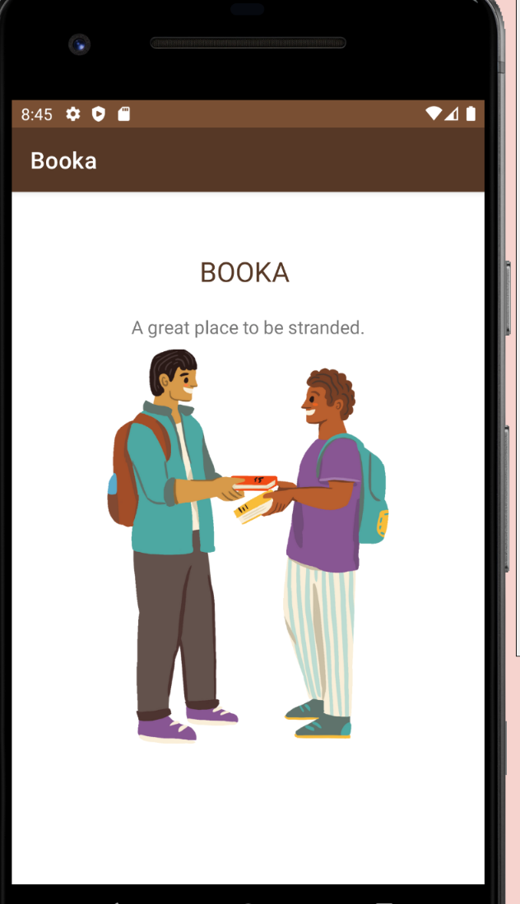 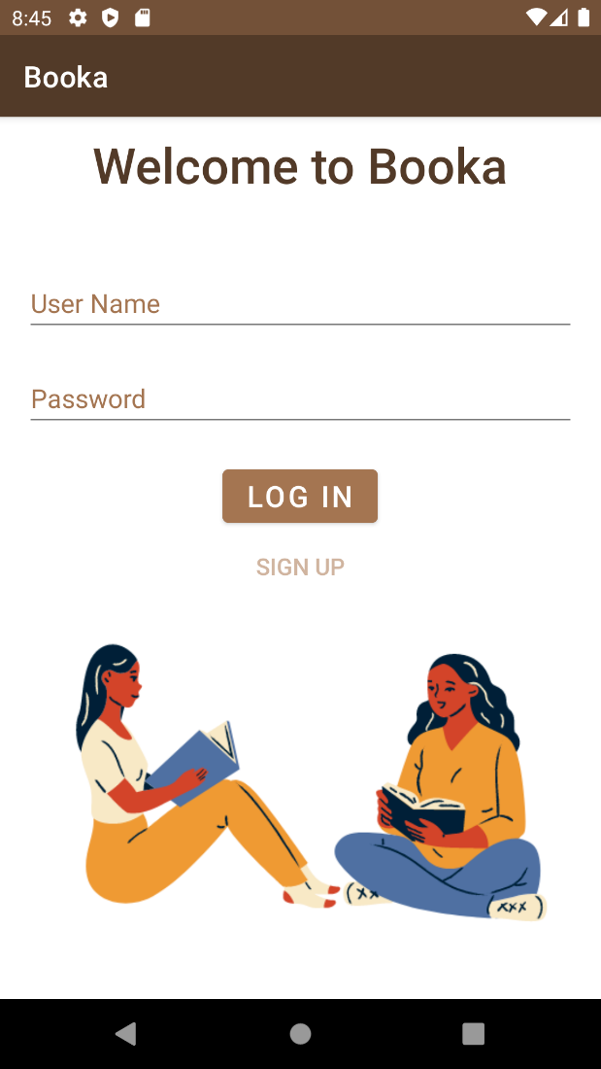

Sign Up screen Main Page

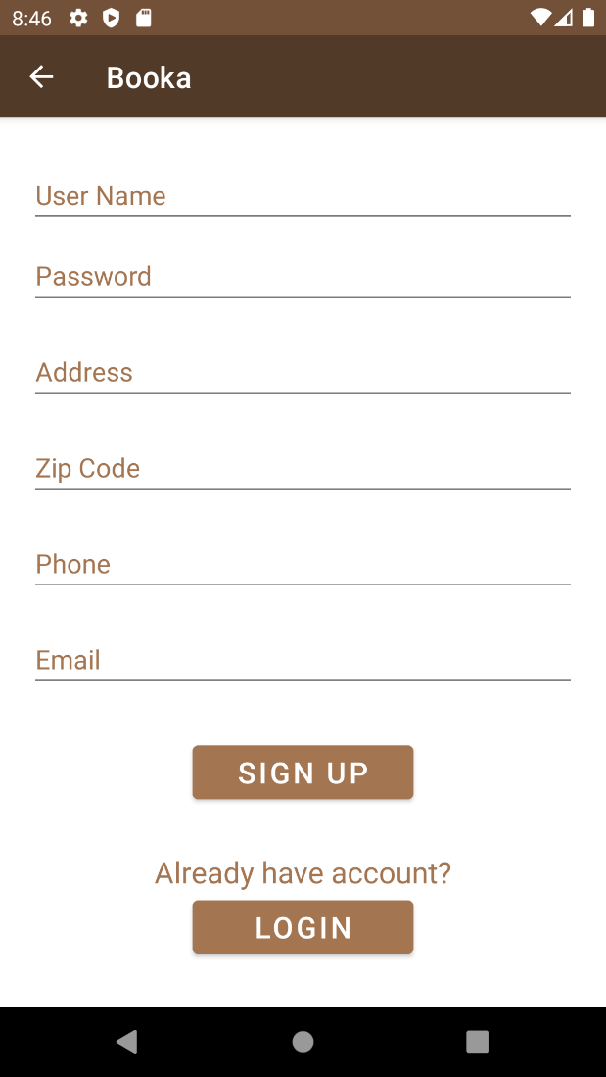 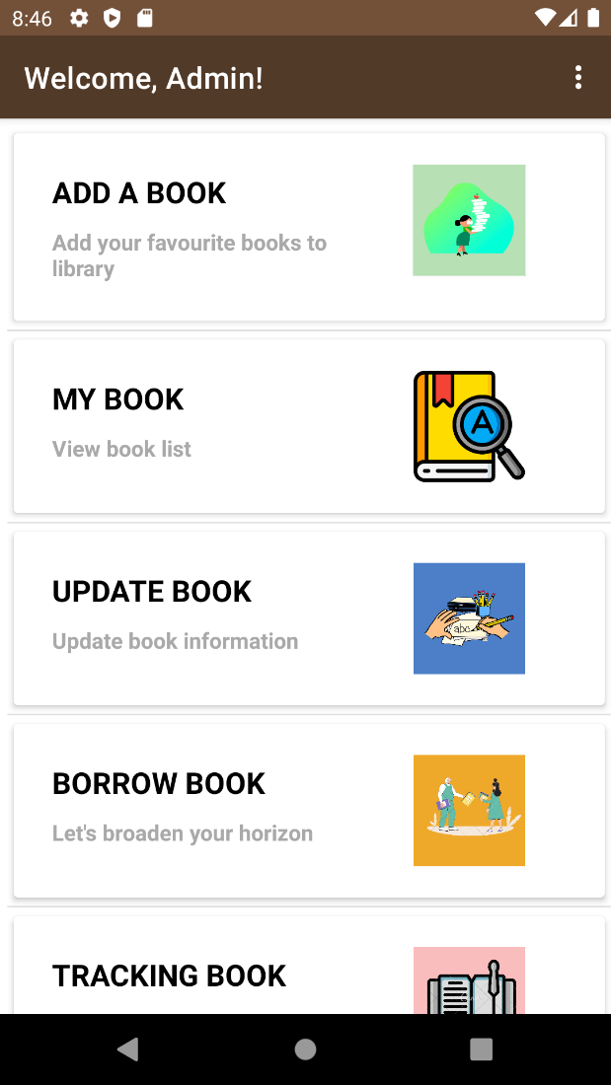

Side bar screen User Info Screen

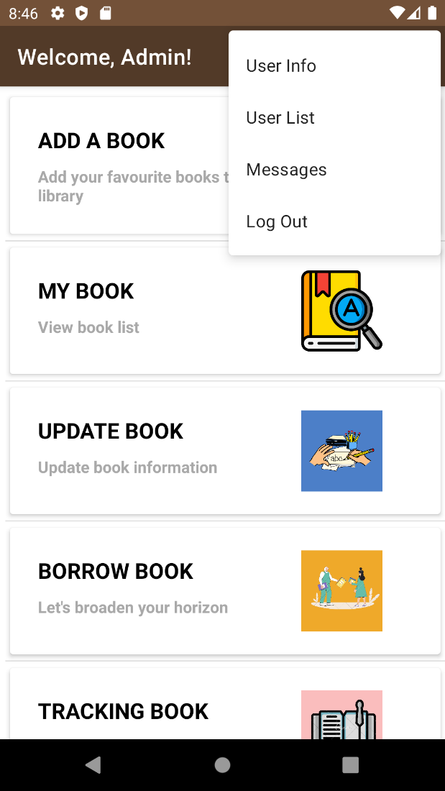 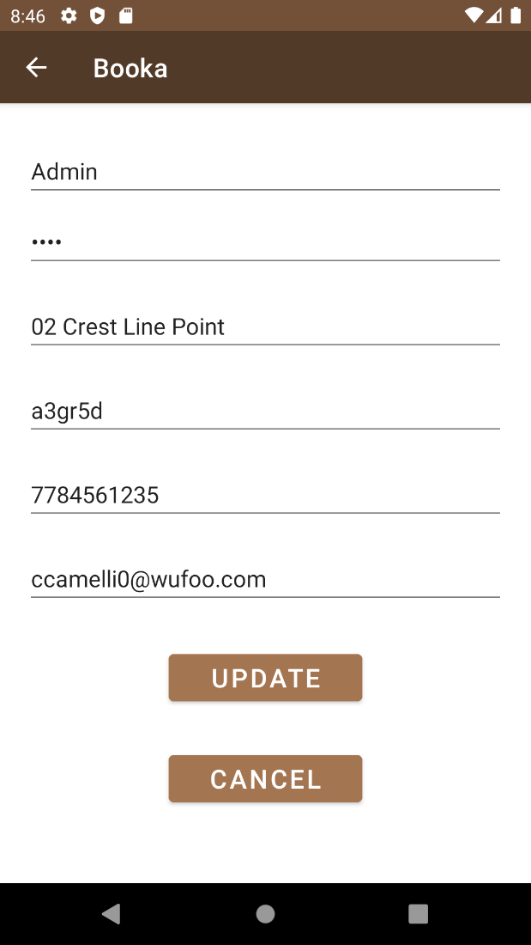

User List Screen (admin mode only) Message List screen

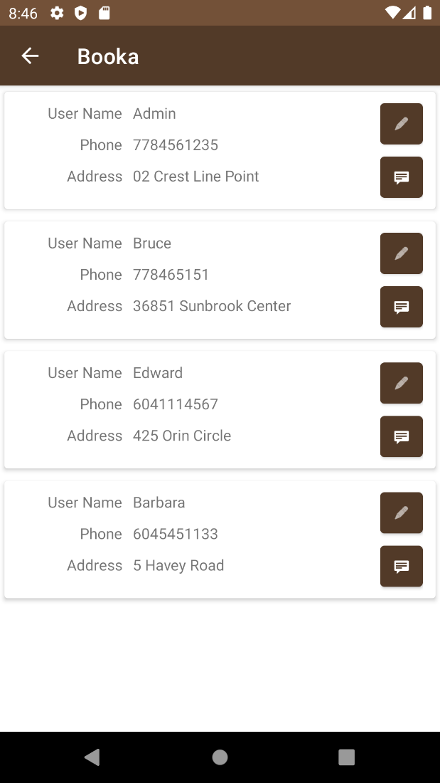 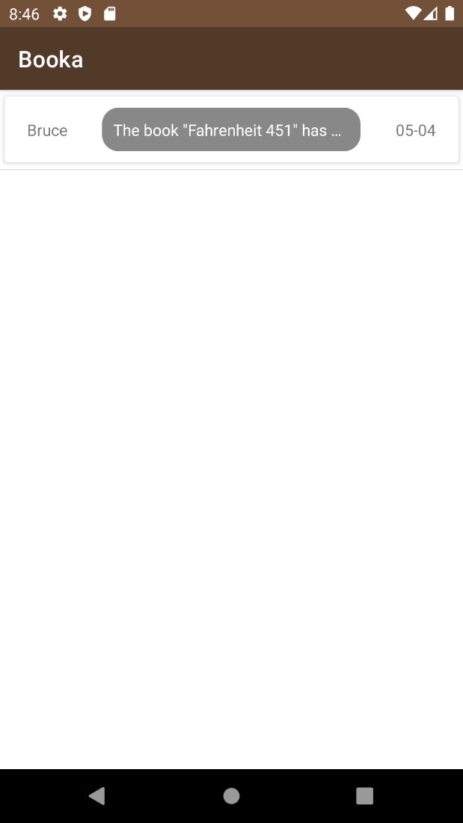

Message screen Add book screen

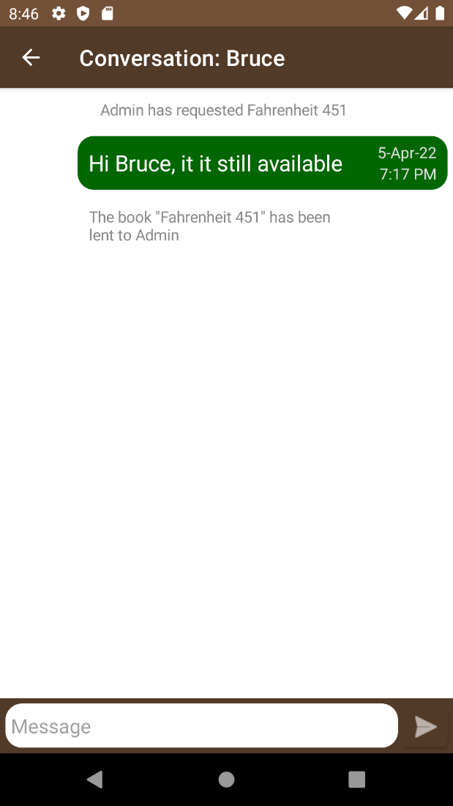 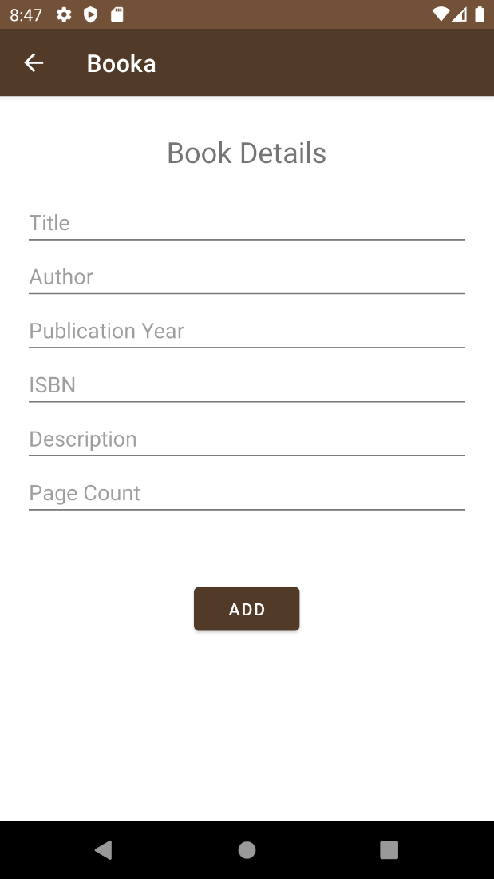

View user's books screen Book List to Update screen

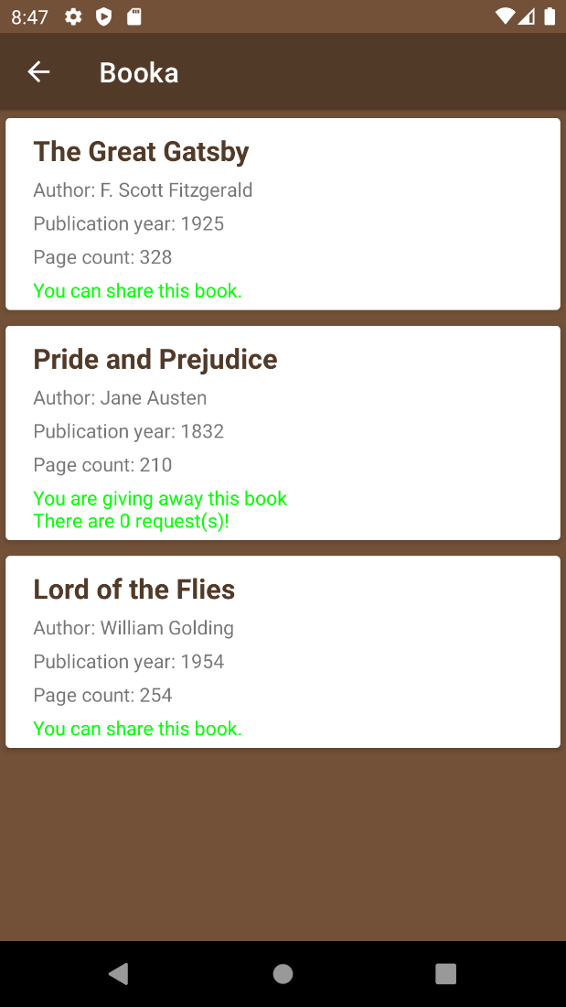 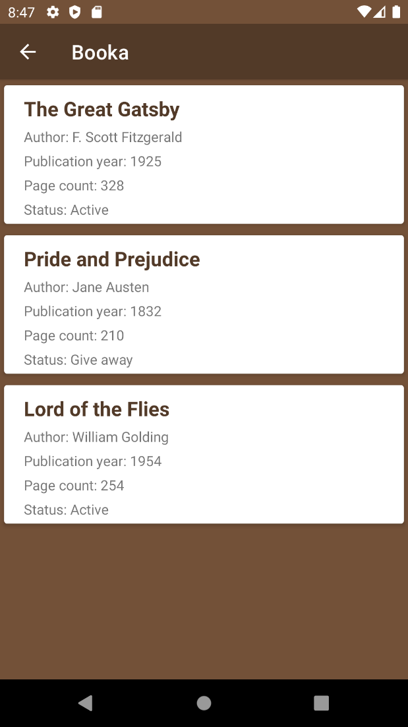

Update book screen Borrow book screen

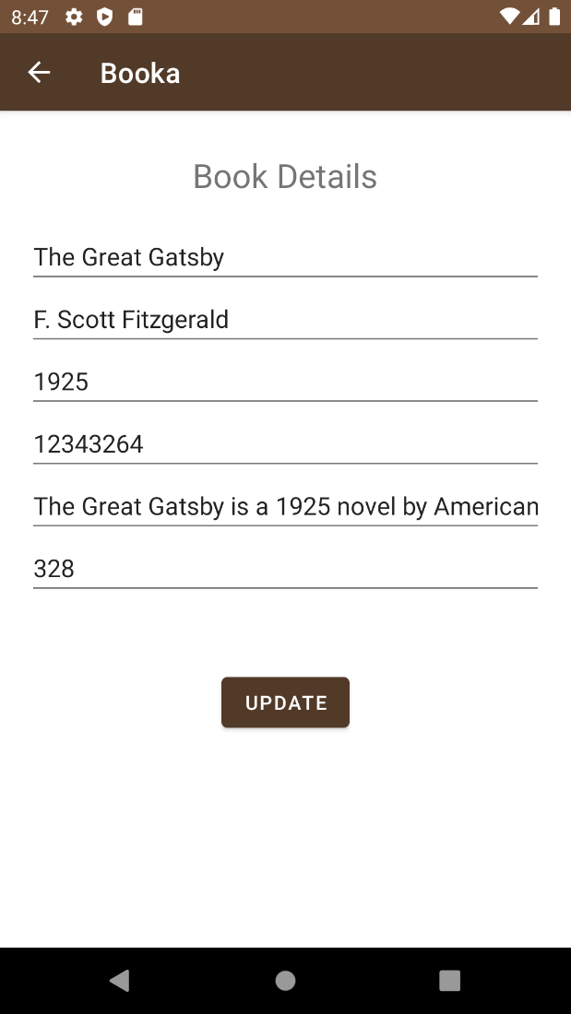 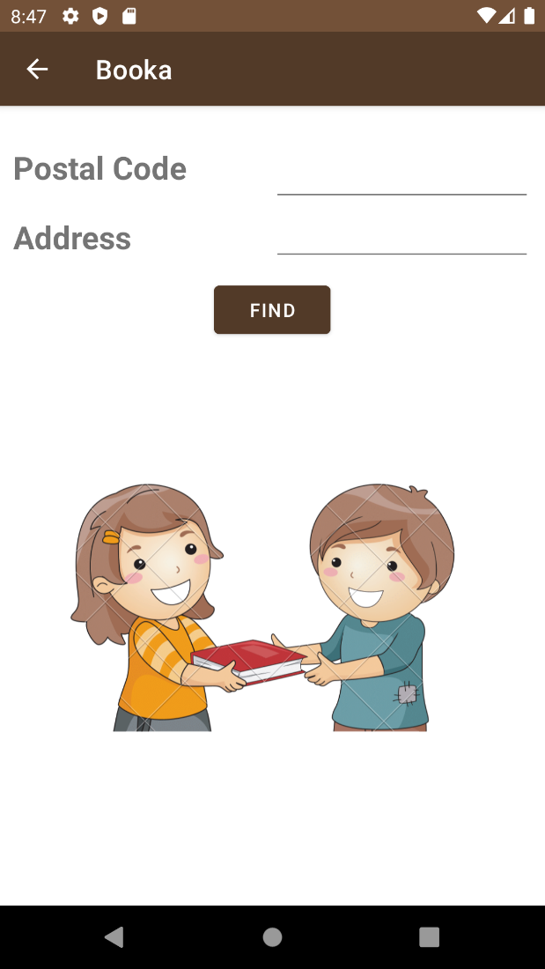

Book list to request borrow screen Pop up contact information screen

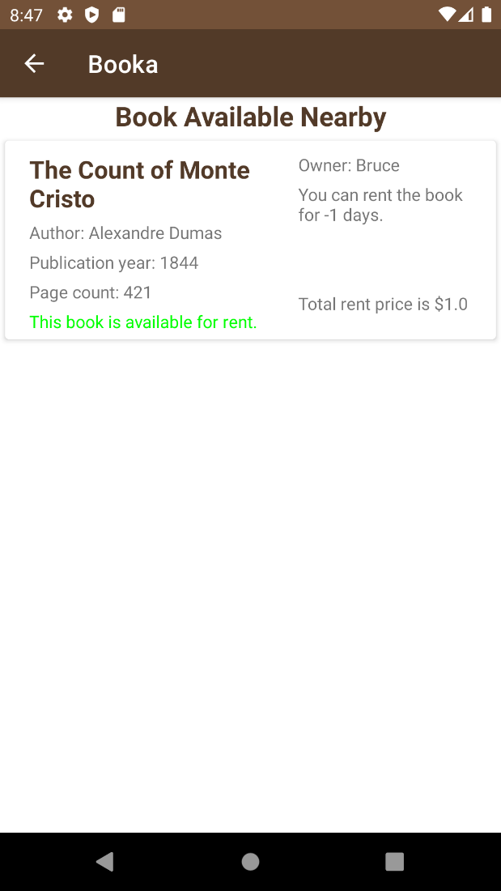 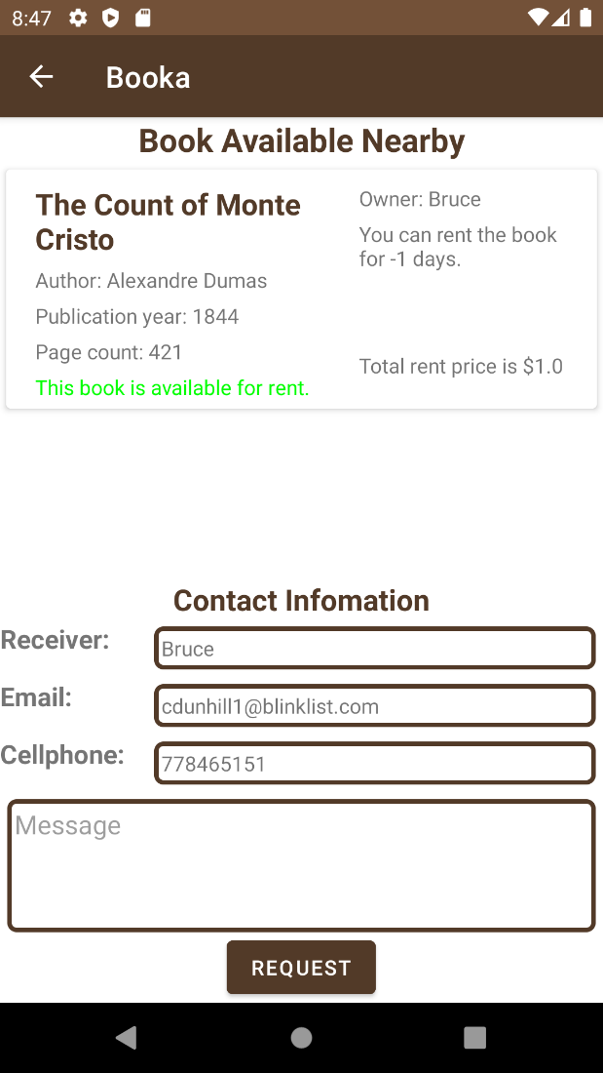

Tracking book screen Share book screen

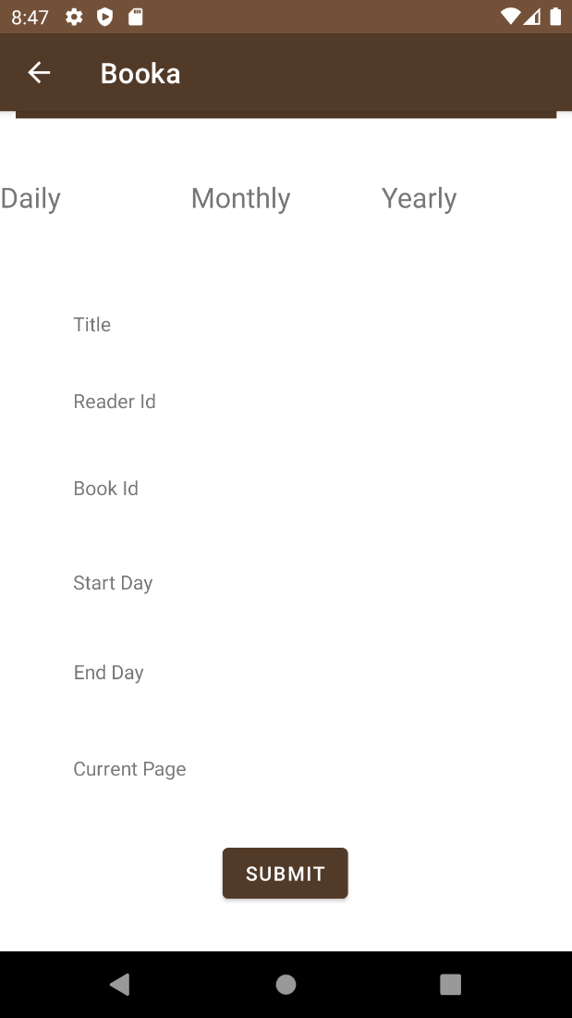 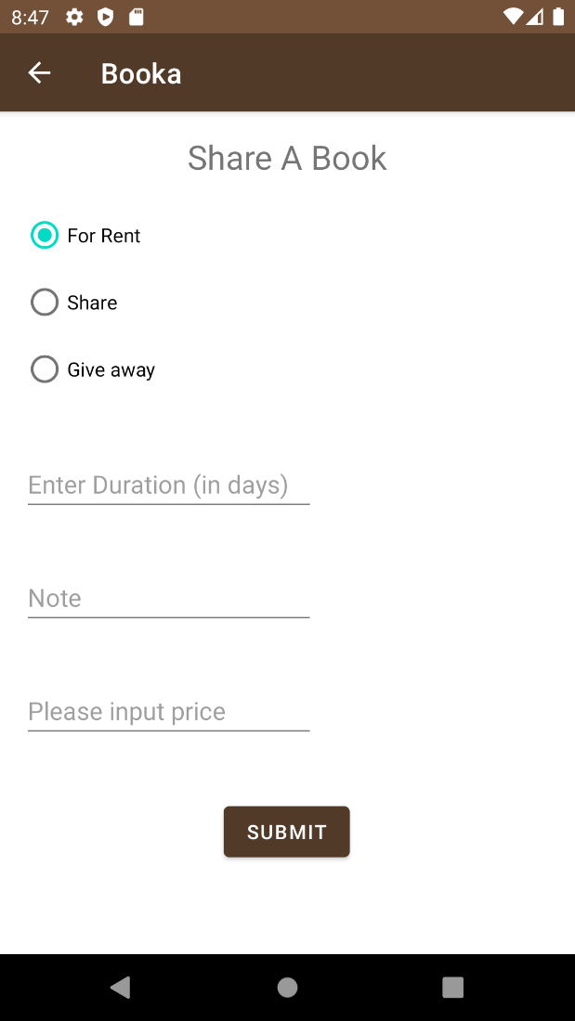

Requested book screen

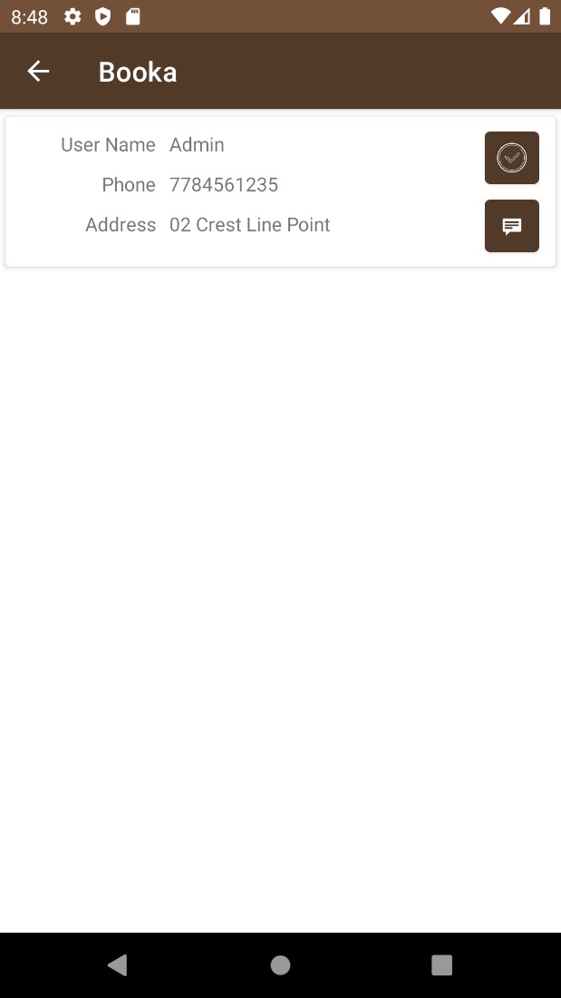

The main features   
<Required functions>

* Register (ask for name, password, zip code, phone, email, address, login (username and password required). Once login, displays 5 options: add a book, view my book, update a book, borrow a book, and reading tracker.
* Update user account
* If “borrow” selected:
  + ask for address, postal code and open list of books available nearby after click find button.
  + Book is selected: display owner’s contact information and request to pick up where user can leave message – will be response by owner. Users can log out once the request is finalized.
  + If user rents a book-> display total amount.
* If “reading tracker” selected: asked for entries of the books the user read during the week.
* If “my book” selected: display list of books belongs to that user. Clicking on a specific book will open another activity to ask for availability of the book (for rent, share, give away)
* If “update book” selected: click on specific book need to update will open another activity with information of the book that can change by click update button.
* If “tracking book” selected: display continuing books
* If “add a book” selected:
  + Add: book details (title, author, publication year, isbn, Description, Page count) will be required

<Additional functions>

* Log out.
* View user list (administrators only – who can edit user information and send messages to them)
* View messages

The names of Java class and activities of your app

Class

Dataaccess: DataOpenHelper

Entities: Book, message, read history, request, user

Adpater: UserAdapter, BookAdapter, MessageAdapter

App.java

Activities:

* MainAcitvity, SplashActivity
* AddActivity
* ViewBookActivity, ShareBookActivity
* BorrowActivity, BorrowRequestActivity
* Update activity, UpdateBookViewActivity
* MessageActivity, ViewMessageActivity
* UserAvtivity, SignInActivity, SignUpActivity
* TrackingActivity

Any features/tools/third party S/W that are not covered in class but have applied in the project along with the reference

Implement android action bar back button

Implement side menu

Using GitHub to keep track of team members’ workload

Database details including the database name, table names and design

Entity Diagram

Uses case diagrams

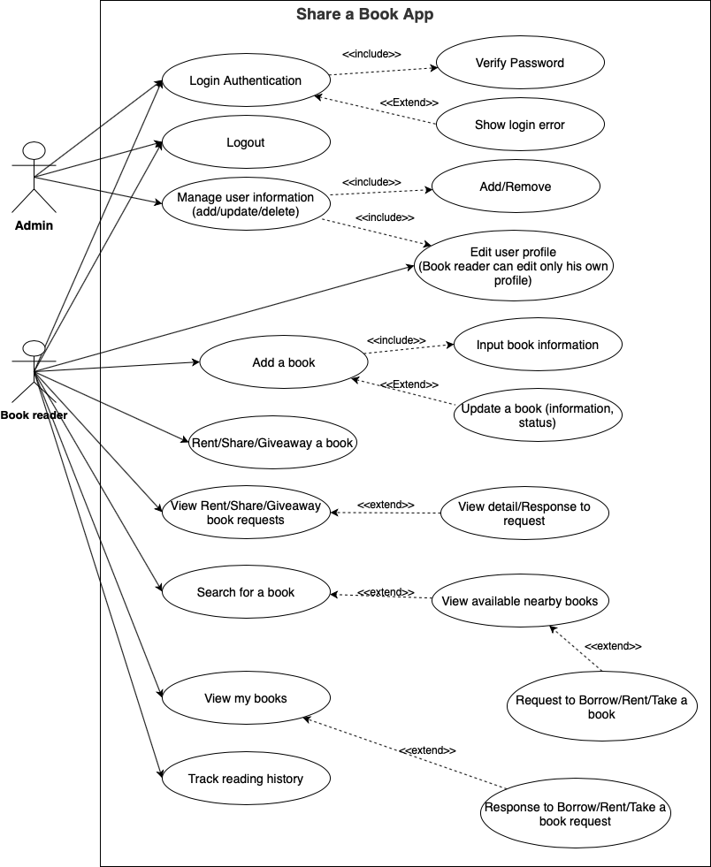

Sequence Diagram

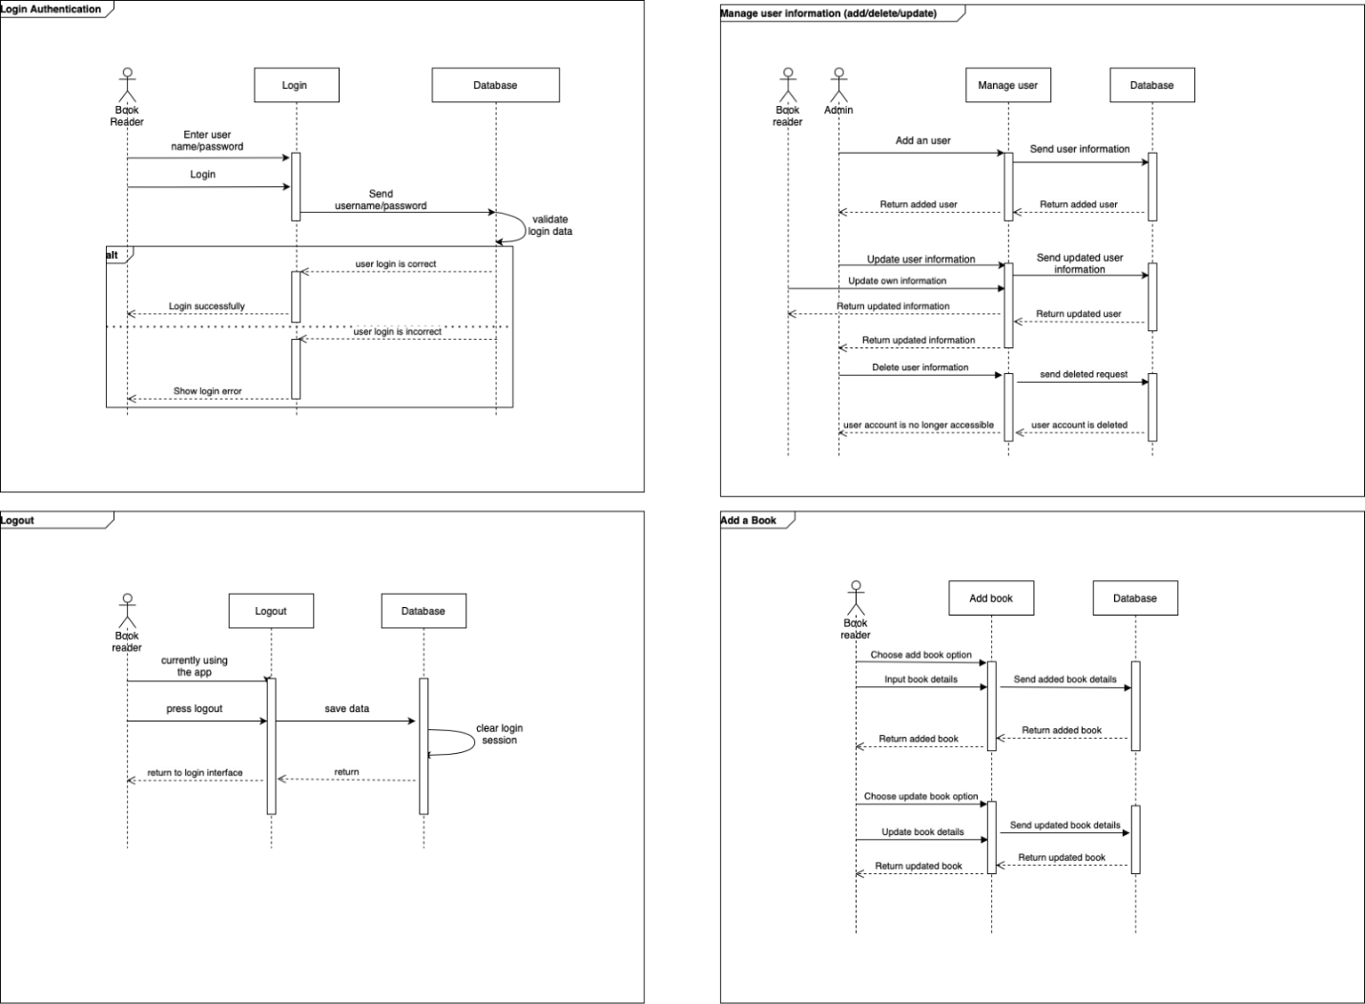

Project log

Full project detail at: https://github.com/Minh-BuiQuang/CSIS3175TermProject

|  |  |  |
| --- | --- | --- |
| Minh Bui | Tue Apr 5 22:18:47 2022 -0700 | Fix incorrect message displayed for shared book |
| Minh Bui | Tue Apr 5 20:46:13 2022 -0700 | Format code for Activity classes |
| Minh Bui | Tue Apr 5 20:40:15 2022 -0700 | Clean up Entity classes |
| Minh Bui | Tue Apr 5 20:38:24 2022 -0700 | Clean up DatabaseHelper |
| Minh Bui | Tue Apr 5 20:23:24 2022 -0700 | Show user name on main activity action bar |
| Minh Bui | Tue Apr 5 20:18:37 2022 -0700 | Update book item display texts |
| Minh Bui | Tue Apr 5 19:24:41 2022 -0700 | Add returning book logic |
| taccumei | Tue Apr 5 19:21:49 2022 -0700 | Add to Customize layout to show total rent price |
| Minh Bui | Tue Apr 5 17:26:35 2022 -0700 | Add Accept Book Request feature |
| taccumei | Tue Apr 5 13:42:45 2022 -0700 | Redesign UI for Customize book list |
| Minh Bui | Tue Apr 5 12:27:11 2022 -0700 | adjust book item layout |
| taccumei | Tue Apr 5 12:10:40 2022 -0700 | Fix user object to display contact information |
| Minh Bui | Tue Apr 5 00:28:54 2022 -0700 | Remove redundant code related to share button |
| Minh Bui | Tue Apr 5 00:27:43 2022 -0700 | Remove Share button and replace with OnItemClick event handler |
| Minh Bui | Mon Apr 4 23:52:06 2022 -0700 | Add database query for book request; Goto chat activity if user clicked on an already requested book |
| Minh Bui | Mon Apr 4 21:41:01 2022 -0700 | Go to message activity after user send a book request |
| Minh Bui | Mon Apr 4 20:23:32 2022 -0700 | Filter shared book in Borrow Activity |
| Minh Bui | Mon Apr 4 19:49:07 2022 -0700 | Fix conversation show incorrect target user |
| Minh Bui | Mon Apr 4 19:34:46 2022 -0700 | Filter conversation and add only the latest message |
| Minh Bui | Mon Apr 4 19:18:15 2022 -0700 | Update UI for viewing user's messages |
| Minh Bui | Mon Apr 4 01:33:15 2022 -0700 | Add view user message list feature |
| taccumei | Sun Apr 3 23:22:30 2022 -0700 | Merge branch 'main' of https://github.com/Minh-BuiQuang/CSIS3175TermProject |
| taccumei | Sun Apr 3 23:22:28 2022 -0700 | Change contactLayout to Invisible |
| Dzung Nguyen | Sun Apr 3 18:21:07 2022 -0700 | handle validation for sharebook activity |
| taccumei | Sun Apr 3 17:55:13 2022 -0700 | Modify message request for borrow book |
| Dzung Nguyen | Sun Apr 3 16:52:33 2022 -0700 | Implement share book activity (completed) |
| taccumei | Sun Apr 3 01:12:50 2022 -0700 | insert message request by click Request button to Table_Message |
| taccumei | Sun Apr 3 00:14:56 2022 -0700 | Update book in AddActivity |
| taccumei | Sat Apr 2 12:02:38 2022 -0700 | Implement back button on all activities |
| taccumei | Sat Apr 2 11:27:17 2022 -0700 | Modify BorrowRequestAct UI(change to textview add 2 more information) |
| taccumei | Sat Apr 2 10:24:20 2022 -0700 | Merge branch 'main' of https://github.com/Minh-BuiQuang/CSIS3175TermProject |
| taccumei | Sat Apr 2 10:24:17 2022 -0700 | update in progress |
| Minh Bui | Sat Apr 2 00:43:33 2022 -0700 | Update app theme to brown |
| Minh Bui | Fri Apr 1 22:57:53 2022 -0700 | Implement adding new message feature |
| Minh Bui | Fri Apr 1 20:45:23 2022 -0700 | Use ArrayList for database access objects |
| Minh Bui | Fri Apr 1 20:21:09 2022 -0700 | Add MessageAdapter/Update database creation scripts |
| Minh Bui | Fri Apr 1 18:33:37 2022 -0700 | Add Start conversation logic and layout for message |
| Minh Bui | Fri Apr 1 17:01:46 2022 -0700 | Add navigation to MessageActivity in UserActivity |
| taccumei | Thu Mar 31 22:13:43 2022 -0700 | Add getBookByOwnerId method for ViewBookActivity |
| taccumei | Thu Mar 31 01:14:58 2022 -0700 | Implement onItemClickListener method for BorrowRequest display sender and receiver name |
| Dzung Nguyen | Wed Mar 30 23:07:01 2022 -0700 | implement share a book activity (in progress) |
| Minh Bui | Wed Mar 30 13:27:20 2022 -0700 | Set book adapter mode to borrow for BorrowRequestActivity |
| Minh Bui | Wed Mar 30 13:25:38 2022 -0700 | Fix null pointer to recyclerView |
| taccumei | Wed Mar 30 12:26:36 2022 -0700 | Change to Recycler view for borrow request activity |
| Minh Bui | Wed Mar 30 00:33:30 2022 -0700 | Apply recycler view for book list |
| Minh Bui | Tue Mar 29 15:33:23 2022 -0700 | Add mockup data for books |
| taccumei | Tue Mar 29 14:29:41 2022 -0700 | ViewMyBookList not working (display all books instead of books by user) |
| taccumei | Mon Mar 28 10:13:05 2022 -0700 | Add Borrow and BorrowRequest parse book data to list view items |
| Minh Bui | Sat Mar 26 00:53:07 2022 -0700 | Add user list view and update feature that is only available to admin accounts |
| Minh Bui | Fri Mar 25 19:03:26 2022 -0700 | Update SignUp and Edit User Info logic with the new DatabaseHelper |
| Minh Bui | Fri Mar 25 17:36:06 2022 -0700 | Update SignIn logic to use new DatabaseHelper |
| Minh Bui | Wed Mar 23 19:34:29 2022 -0700 | Enable foreign keys |
| taccumei | Wed Mar 23 19:12:48 2022 -0700 | Merge branch 'main' of https://github.com/Minh-BuiQuang/CSIS3175TermProject |
| taccumei | Wed Mar 23 19:11:03 2022 -0700 | Update tables by adding Foreign Key |
| Dzung Nguyen | Wed Mar 23 19:01:02 2022 -0700 | Create view my book in main menu |
| taccumei | Wed Mar 23 18:24:10 2022 -0700 | Add Request table and 4 columns to Book table |
| taccumei | Wed Mar 23 16:23:39 2022 -0700 | Modify update account xml file |
| taccumei | Wed Mar 23 15:02:47 2022 -0700 | Add SignInActivity logic add CheckUser method to databaseOpenHelper delete unused MainMenu and SideMenu |
| taccumei | Wed Mar 23 13:06:43 2022 -0700 | Modify DatabaseOpenHelper Activity and SignUpActivity |
| Minh Bui | Wed Mar 16 00:33:00 2022 -0700 | Add menu option to Main Activity menu bar and logic for UserInfo and LogOut logic |
| Minh Bui | Tue Mar 15 23:07:34 2022 -0700 | Added create a new book logic with title and page count check |
| Minh Bui | Tue Mar 15 21:41:44 2022 -0700 | Add Sign Up logic with database insert |
| Minh Bui | Tue Mar 15 21:15:24 2022 -0700 | Remove recovery password button fix sign up activity name spelling. |
| Minh Bui | Tue Mar 15 20:33:45 2022 -0700 | Add sign in logic to check for existing user in database |
| Dzung Nguyen | Tue Mar 15 02:30:22 2022 -0700 | Implement list view for main screen |
| Minh Bui | Fri Mar 11 21:28:30 2022 -0800 | Add database manipulation methods for books and users |
| taccumei | Fri Mar 11 21:12:18 2022 -0800 | Modify all UI files from constraint layout to linear layout |
| Minh Bui | Fri Mar 11 17:33:00 2022 -0800 | Add Book Message ReadHistory tables |
| Minh Bui | Fri Mar 11 15:59:33 2022 -0800 | Implement code-first database approach with ormlite framework. Add User data population logic |
| Minh Bui | Fri Mar 4 23:46:18 2022 -0800 | Add Database helper logic |
| Minh Bui | Fri Mar 4 23:45:57 2022 -0800 | Update package name for build config |
| Minh Bui | Fri Mar 4 21:58:27 2022 -0800 | Remove unused library |
| Minh Bui | Fri Mar 4 21:55:59 2022 -0800 | Rename root project name |
| Minh Bui | Tue Mar 1 16:59:14 2022 -0800 | Rename project package |
| Minh Bui | Thu Feb 24 09:01:24 2022 -0800 | Remove unused import |
| Minh Bui | Thu Feb 24 08:52:38 2022 -0800 | Change launching activity to SplashActivity. SplashActivity will start MainActivity with delay |
| Minh Bui | Thu Feb 24 08:45:40 2022 -0800 | Remove remnant file nav_graph.xml |
| Minh Bui | Thu Feb 24 08:45:00 2022 -0800 | Add version control config |
| Minh Bui | Thu Feb 24 08:44:48 2022 -0800 | Rename welcome_img resource reference |
| Minh Bui | Wed Feb 23 15:54:37 2022 -0800 | add gitignore in root folder remove ignored files |
| taccumei | Sun Feb 13 20:45:08 2022 -0800 | Project Proposal final final |
| taccumei | Sun Feb 13 17:36:32 2022 -0800 | project proposal final |
| taccumei | Sun Feb 13 00:51:15 2022 -0800 | ProjectProposal final |
| Dzung Nguyen | Sat Feb 12 06:26:21 2022 -0800 | Create BookShareSequenceDiagram.drawio |
| taccumei | Fri Feb 11 23:51:50 2022 -0800 | UpdatedLayout Feb11 |
| taccumei | Fri Feb 11 22:01:03 2022 -0800 | Project Proposal draft1 |
| Minh Bui | Fri Feb 11 19:11:53 2022 -0800 | Update Sequence diagram part 2 |
| Minh Bui | Fri Feb 11 19:00:17 2022 -0800 | Add back in a deleted use case |
| Minh Bui | Fri Feb 11 18:45:51 2022 -0800 | Add rent/share/giveaway book sequence diagram |
| Minh Bui | Fri Feb 11 18:27:29 2022 -0800 | Update rent/borrow/take a book usecase |
| Minh Bui | Thu Feb 10 13:29:48 2022 -0800 | Minor change to use case diagram |
| Minh Bui | Thu Feb 10 13:27:50 2022 -0800 | Update usecase diagram |
| James Nguyen | Wed Feb 9 23:44:19 2022 -0800 | Update README.md |
| James Nguyen | Wed Feb 9 23:43:56 2022 -0800 | Add files via upload |
| taccumei | Wed Feb 9 10:27:27 2022 -0800 | Add team member info |
| taccumei | Wed Feb 9 09:54:16 2022 -0800 | BookaLayout |
| Minh Bui | Tue Feb 8 19:54:04 2022 -0800 | Add Entity Diagram |
| Minh Bui | Tue Feb 8 18:15:35 2022 -0800 | Update team member info |
| Minh Bui | Tue Feb 8 18:11:20 2022 -0800 | Initial Commit |