**Project Proposal**

**Share a Book Android App**

**(BOOKA)**

**Group 6**

Minh Bui - 300345000

Thi Ngoc Tram Dang - 300302010

Dung Nguyen - 300345575

February 2rd, 2022

Review the existing apps

|  |  |  |
| --- | --- | --- |
| **OverDrive app** | **Goodreads** | **Kindle** |
|  |  |  |
| Pros: Classic interface, loved by thousands of users due to its allowance for using library cards to borrow e-books and audiobooks from that library. Advantages of this app are free of charge and titles user borrowed are being returned automatically so that no pay late fees occur.  Cons: No reviews available or genre to search for specific book. | Pros: a world’s largest site for readers and book recommendation.  Better user interface with a fair review aggregation and better recommendation system. The library has a map with events (for bibliophiles) grouped by location to check events nearby.  Cons: used only for reviews, cannot read, borrow or rent out books on this app. | Pros: huge collection of free books, access to thousands of free books  Cons: must log into Amazon before using app, not all books are free.  devoid of touching physical books. |

Title and brief description

Title: BOOKA

This shares a book application named Booka- facilitates book readers to interact with other bookworms, share their real thoughts (compliments or criticism) about the books, give away their books and rent out books at the minimum rate.

Project Scope

The goal of this project is to develop an android app for book readers in which users can not only share their favorite books and interact with other readers but also rent or borrow the physical one from the book owner through the app. The application will be built gradually by 3 members during the term. Each member will be assigned appropriate tasks regarding the features of the app and modify or give feedback if needed from other team members.

Main features

**<Required functions>**

* Register (ask for name, address, book genre interested), login (username and password required), update account and log out.
* Once login, display 3 options: add/update a book, borrow a book, reading tracker.
* If “borrow” selected:
  + ask for address, postal code and open list of books available nearby after click find button.
  + Book is selected: display owner’s contact information and request to pick up where user can leave message – will be response by owner. Users can log out once the request is finalized.
  + If user rents a book-> display total amount.
* If “reading tracker” selected: asked for entries of the books the user read during the week.
* If “add/update” selected:
  + Add: book details (title, author, publisher and publication year) will be required. Once added, the app gives options such as making the book available to **share,** to **give away**, or to **rent out.**
  + Update: show book details and options for updating with
  + status (borrowed, taken, rented).

**<Additional functions>**

* //Provide an online reading option to read books or magazines.
* Generate a report to show the reading history of a user not only weekly but also monthly.
* view or edit account information, request history. Add log-out option.

Layout of the application and explaination

|  |  |
| --- | --- |
| Splash screen | Login page |
|  |  |

When users open the app, the welcome splash screen will show up in 3 seconds and go straight to login page in which prompt user to enter username and password to login. If they do not have an account, click sign up button will help them create an account.

|  |  |
| --- | --- |
| Sign up | Main menu |
|  |  |

The sign-up layout allows users to type their desired account name, password, and book interested genre. After finishing filling all the requirements, click sign up button will lead them to the main page. Four main functions will appear on this main page: add, borrow, update, and tracking book.

|  |  |
| --- | --- |
| Add book | Borrow book |
|  |  |

By clicking the add function, users will have to enter book details and choose an add button to save the data. The borrow function asks to enter address and postal code to find book available nearby to borrow.

|  |  |
| --- | --- |
| Borrow request | Update book |
|  |  |

Once the find button is clicked, the other layout will show up and display all the books available on the left side. Contact information about the owner will appear on the right side after the user chooses the book. The update layout asks users to modify the book information and it will be updated after new data is submitted.

|  |  |
| --- | --- |
| Track book | Side menu |
|  |  |

Tracking book layout appears after choosing tracking function. It will ask the user to make entries of the books the user reads during the week. Side menu layout represents the update information, tracking history report and logout. For administrator accounts, the side menu will have two more functions which are to create and delete user accounts.

|  |  |
| --- | --- |
| History Report | Update account |
|  |  |

Clicking update account function from the side bar, username and password are required to update. The history will generate a report to show the reading history of a user.

Entity Diagram

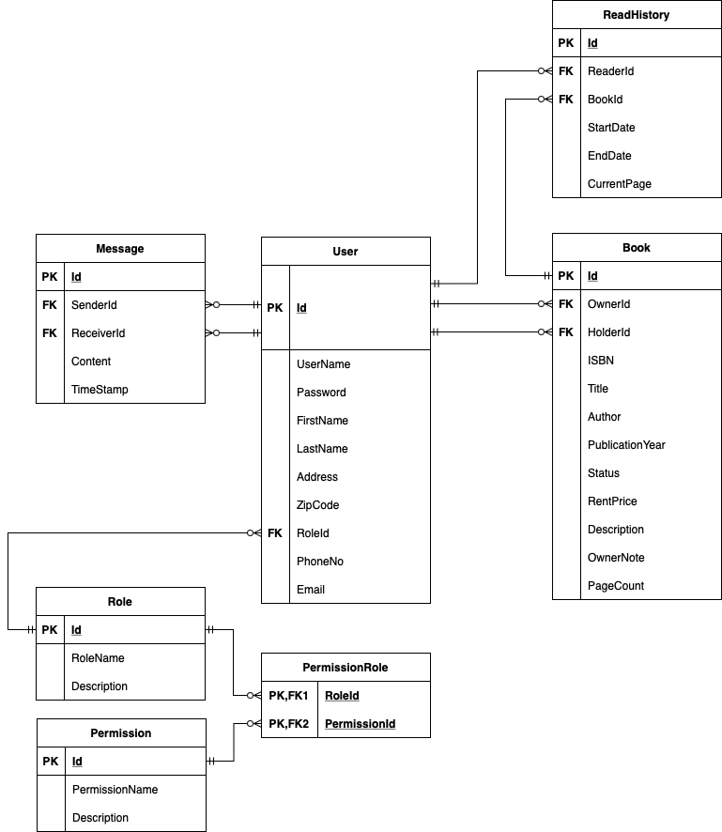

Sequence diagram

Uses case diagram

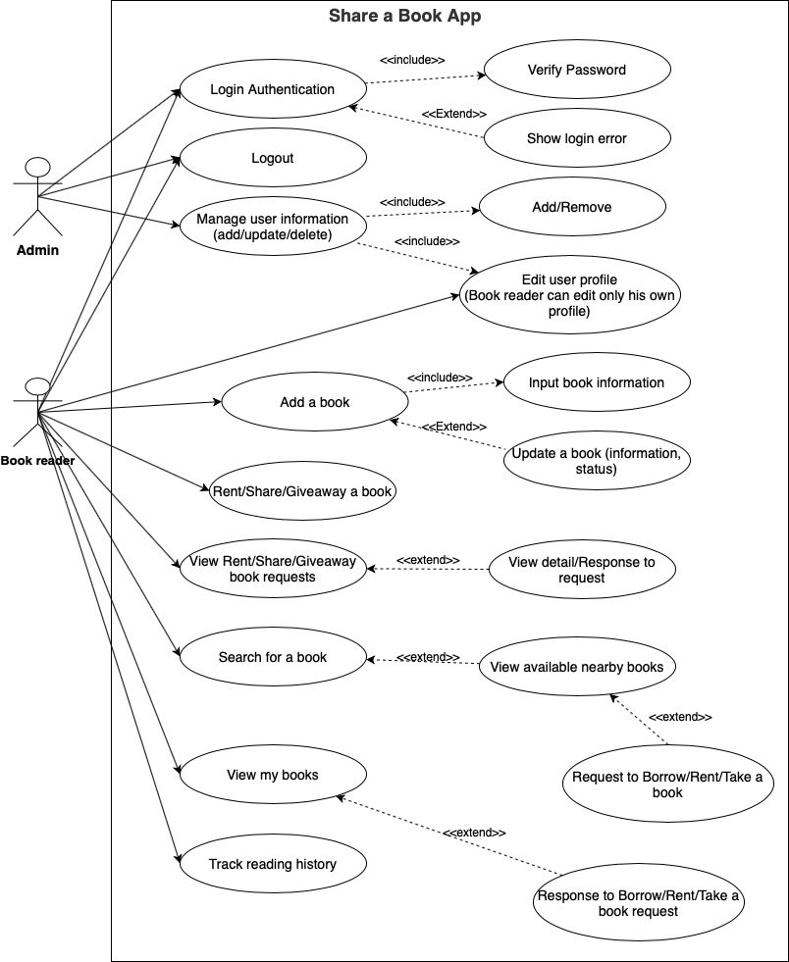

General Task, project team roles for the project proposal

Minh Bui - Team leader: responsible for uploading documents related to the project. Creating entity diagram and generate sequences and uses case diagram.

Tram Dang: creating layout of the project that meets the requirements. Writing proposal, proof-reading, and polishing.

Dung Nguyen: Generate uses case and sequence diagrams.

Features, third party

GitHub

References

Kinde app: https://www.amazon.com/gp/browse.html%3Fnode=16571048011&ref=kcp_fd_hz