Student Name: Minh Bui

Student ID: 300345000

GROCERECIPE User manual

# Introduction

GROCERECIPE is a mobile app that allows the user to search for recipes and create a grocery list from ingredients of recipes of their choice. The app name is a combination of “Grocery” and “Recipe”. The app used a public API for recipe search and allowed the user to save their favorite recipes. The main features of the app are:

* Search for recipes with a keyword and options such as calories, diets, cuisine type.
* View information and save recipes to their favorite.
* View full cooking instructions on an external website.
* Save the search preferences for later use.
* Create a grocery list for the recipes of their choice.

# Search Recipe

After starting the app, the user is presented with a search bar that they can use to enter the search keyword.

Tapping the search button on the right side will return results that match the keyword. User can tap on the recipe to view the ingredients and health information.  
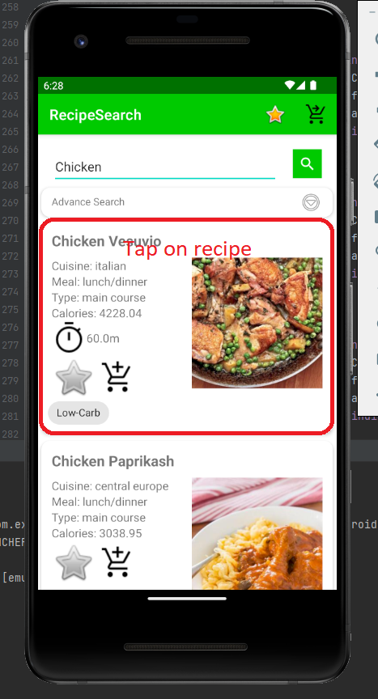

In the detail view, the user can see more information about the recipe. They can tap on Diets and Allergy Information tabs to expand them.

Tapping the View Instruction will redirect the user to an external website with instructions for the recipe.  
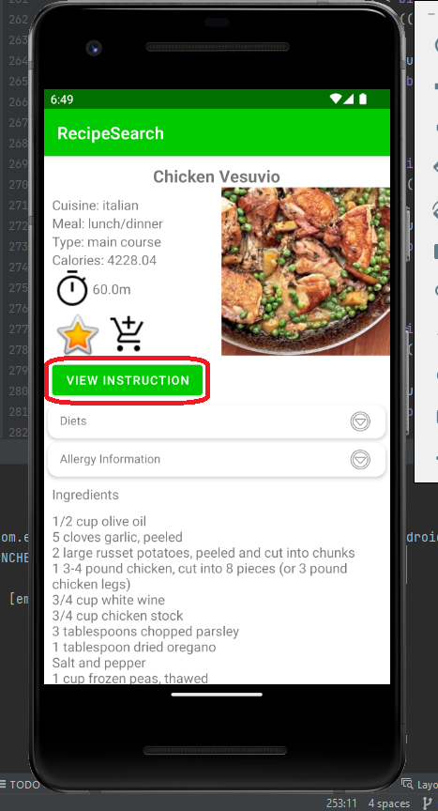

# Save to Favorite

Users can touch the Star icon to save the recipe to their favorite. The icon is available in both the search view and the detail view. Tapping them again will remove the recipe from favorite.

Saved recipes can be view by tapping the star icon on the right side of the header bar.  
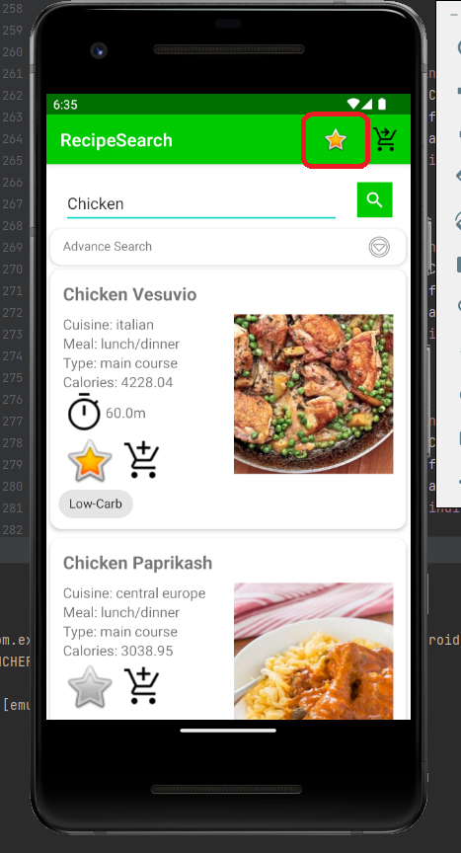

# Advance search and save search preferences

Users can expand the Advance Search tab for more options on their results. Here they are allowed to select their calories, diets, allergies, cuisine type, meal type and dish type

To save the search references for later use, the user can tap the save icon and enter a name for this search references.  
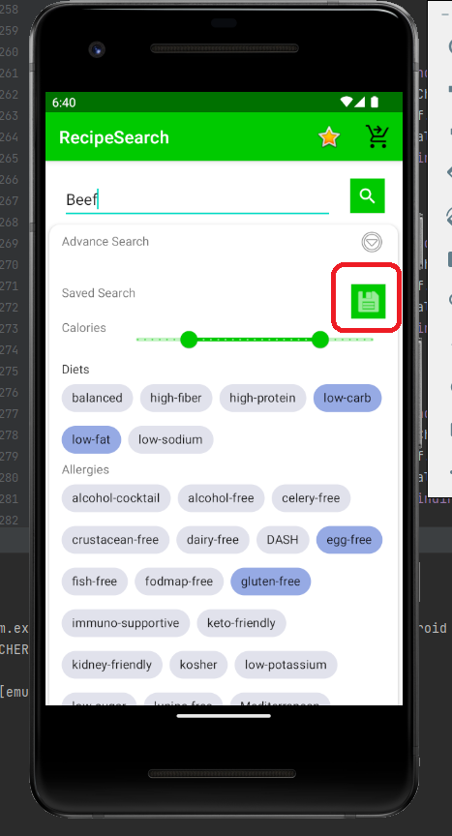

The search references will show up. Tapping on them will load the references. Tapping the cross icon will delete the search references.

# Grocery List

To create a grocery list for ingredients from the recipe, user can tap the cart icon in either the recipe list view or detail view.  
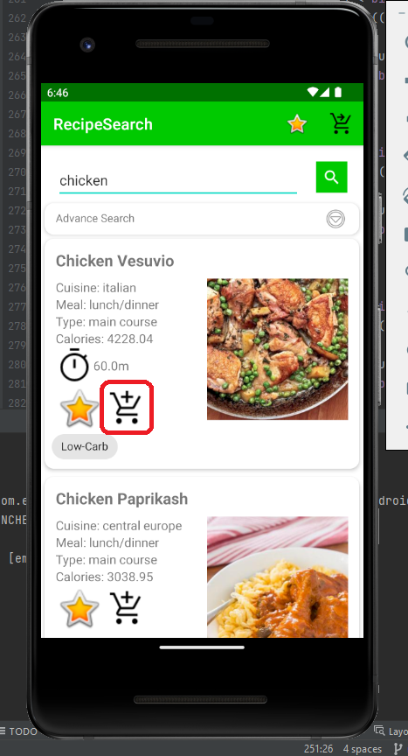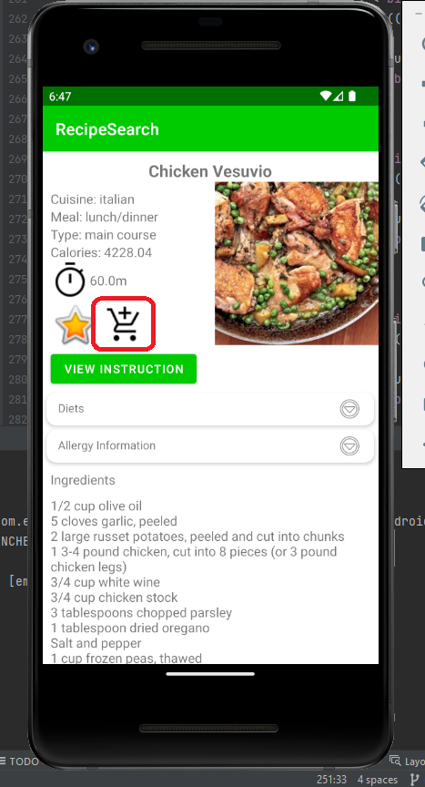

To view their grocery list, users can tap the cart icon on the main screen. In the grocery list view, users will see all the ingredients of all the recipes they chose. Tapping the check icon will clear the recipe from their list.  
