## **INSTALLATION INSTRUCTIONS**

MS SQL Server

1. Follow the link provided to get started installing MS SQL Server 2022 and select the developer edition: <https://www.microsoft.com/en-ca/sql-server/sql-server-downloads>
2. Use the ‘Basic’ installation option.
3. At the bottom of the confirmation screen, you must click the install SSMS button.
4. The first time you open MS SQL Server you will see a screen showing your server information. Make sure to select ‘Trust Server Certificate’ before continuing.
5. To have remote access that will allow MS Access or other applications to connect to our databases, we need to create a username that does not rely on windows authentication.

5.1 Open the properties window of your server. Select the ‘Security’ page and select SQL Server and Windows Authentication mode.

5.2 Select the ‘Connections’ page and choose ‘Allow remote connections to this server’. Click OK

1. Right click on your server and restart the server after your changes have been made
2. In your side bar select Security > Logins and right click for new login
3. Create a username and password and make sure to select ‘SQL Server authentication’. Choose which database to be the default for this user. (Assignment_01 in this case)

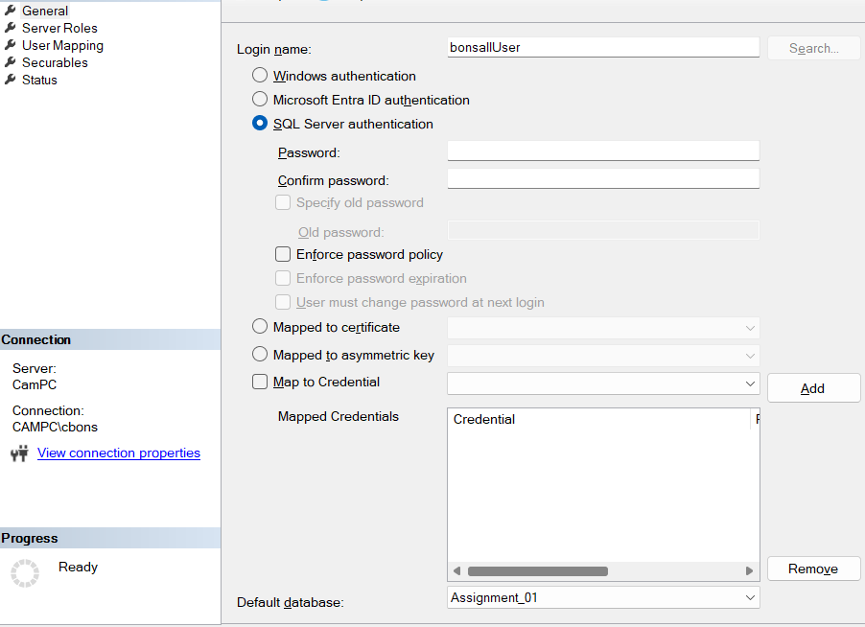

## **BACKUP AND RESTORE INSTRUCTIONS**

Backup

1. Left click to select the Assignment_01 database under databases.
2. Right-click Assignment_01 and scroll down to tasks.
3. Under tasks, select backup.

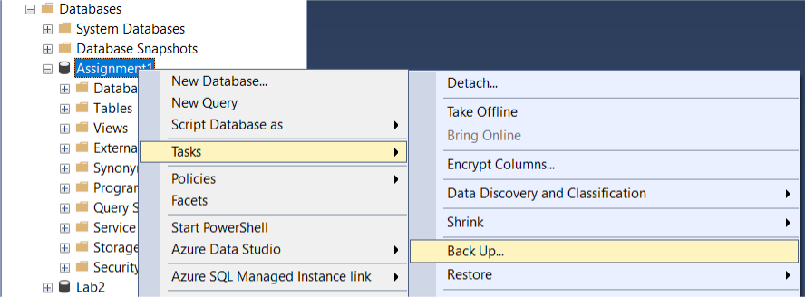

1. In the backup window choose where you want the backup file to be saved and click OK. Your backup has been created.

## Restore Instructions

1. As your main Microsoft user, right-click databases and select restore database
2. Select Device then click the ‘...’ button to browse. The select backup devices screen will appear then click the add button. Now browse to your backup file wherever it was saved. Click OK.
3. Give the destination the name you want for your restored database. If you have a warning message about ‘Tail-log backups…” go to the Options page and unselect that option.
4. Click Ok.

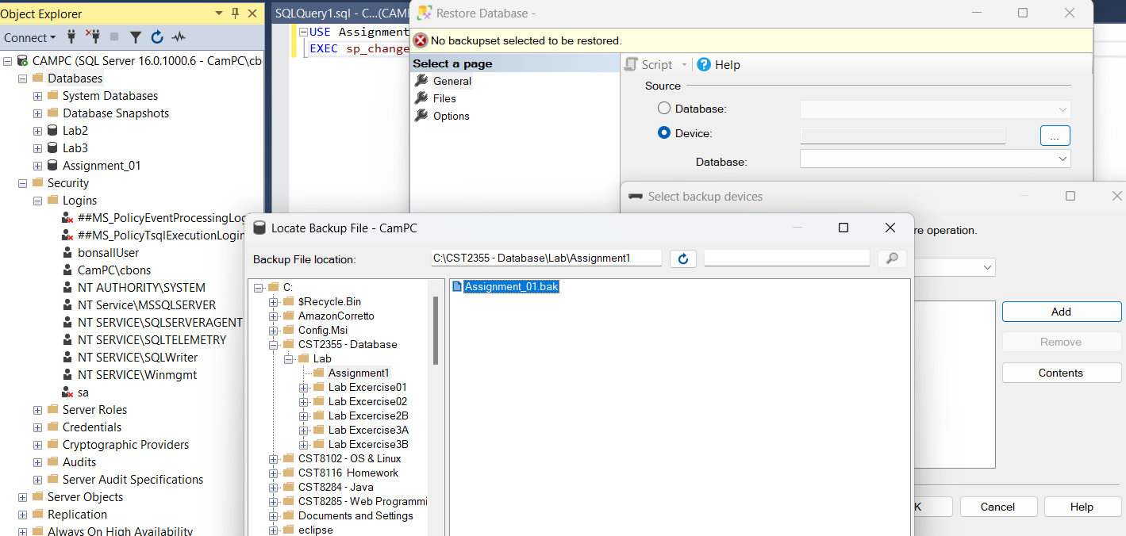

1. Once you restored your database you will need to change ownership. Run the following query. (use your own login name, in my case ‘onsallUser’).

Use Assignment_01;

EXEC sp_changedbowner ‘bonsallUser’, ‘true1’;

1. Now in your side menu under security > logins open the properties of your username and make the default database your new database you just restored.