| **Team Number** | 07 | **Section** | 05 |
| --- | --- | --- | --- |
| **Team Members** | 1. Minh Le 2. Seyed Morsali 3. Quang Tang 4. Van Chuong Pham | | |
| **Software Name** | Password Manager | | |

## Problem Statement

Computers and the Internet are being used extensively and the security of users' privacy has become a big issue. One of the oldest ways to provide security is using passwords. Choosing and storing passwords are hard tasks for the majority of the users and cause millions of breaches. Since the number of websites that we use every day is increasing, this causes most users to choose simple memorable passwords, store them improperly, or reuse them for many websites/applications that increase the risk of being cracked. The existing password managers are not reliable because there is always the risk of leaking our information to the developers of the software!

## Functional Requirements

The password manager should have the following minimum features:

1. The application shall be multiuser.
2. The user shall log in/signup/reset the password when running the application.
3. The user's login password (aka master password) shall be reset by one

security question that is set during signup.

1. The application shall store the username, password, website/application name, specified email, creation date, expiration date
2. The application shall generate a password based on the given criteria:

* Minimum/maximum lengths of the generated password can be set to any non-zero positive integer
* The option of including special characters (!"#$%&'()*+,-./:;<=>?@[\]^_`{|}~)
* The option of including capital letters. In this case, the user needs to specify how many capital letters are required.

1. The passwords shall be encrypted before storing and decrypted before retrieving. For security purposes, the code of encryption/decryption will be provided by the client (the professor).
2. The password shall be copied in the clipboard by a button.
3. The application shall warn the user about the expired passwords right after successful login to the system.
4. The user shall search based on the website/application name or username.
5. The user shall modify the information of the application.

* When the user updates the duration of the password, the current expiration day will not change. New duration will apply for the next time when the user updates their old password.

## References

N/A

## Use Cases

1. **Login menu:**

| **Use Case Name** | | Login | |
| --- | --- | --- | --- |
| Goal | | | |
| This use case describes how a user login into the system. | | | |
| Participating Actors | | | |
| User, System. | | | |
| Glossary | | | |
| N/A | | | |
| Primary Flow of Events | | | |
| Trigger | | | |
| User runs the application and gets in login menu | | | |
| **Steps** | **Action** | | **System Response** |
| 1 | Run the application | |  |
| 2 |  | | Show the login menu |
| 3 | Enter username and passwords then press “Login” | |  |
| 4 |  | | Verify username and password |
| 5 |  | | checks if any record has an expired password |
| 6 |  | | Search for expired passwords and warn the user about it. |
| Alternate Flow of Events | | | |
| **Alternate Trigger** | | | |
| The user enters the wrong password or username | | | |
| **Steps** | **Action** | | **System Response** |
| 1 | Enter the wrong username or password | |  |
| 2 |  | | Show the message in red “ Wrong user name or password. Please try again” |
| Alternate Flow of Events | | | |
| **Alternate Trigger** | | | |
| The user clicks on the signup button | | | |
| **Steps** | **Action** | | **System Response** |
| 1 | Click on sign up button | |  |
| 2 |  | | Redirects the user to the Signup menu |

| **Use Case Name** | | Sign Up Button | |
| --- | --- | --- | --- |
| Goal | | | |
| This use case describes how a user signs up new account | | | |
| Participating Actors | | | |
| User, System. | | | |
| Glossary | | | |
| N/A | | | |
| Primary Flow of Events | | | |
| Trigger | | | |
| - User runs the application  - User clicks on the "Sign up" button | | | |
| **Steps** | **Action** | | **System Response** |
| 1 | Run the application | |  |
| 2 |  | | Show the login menu |
| 3 | Click on the “Sign Up” button | |  |
| 4 |  | | Show the “Sign Up” menu |
| 5 | Enter username, passwords, re-enter password, security question, and answer | |  |
| 6 | Click “Submit” button | |  |
| 7 |  | | Verifies username, passwords, re-enter password, security question, and answer |
| 8 |  | | Show the message” Creating a new account is successfully done!” |
| 9 |  | | Show the “Main menu” |
| Alternate Flow of Events | | | |
| **Alternate Trigger 1** | | | |
| The user enters an invalid username or password | | | |
| **Steps** | **Action** | | **System Response** |
| 1 | Enter the invalid username or password | |  |
| 2 |  | | Show the message in red “ your user name or password is invalid. Please try again” |
| **Alternate Trigger 2** | | | |
| The user enters an existing User Name | | | |
| **Steps** | **Action** | | **System Response** |
| 1 | Enter a username that is already taken | |  |
| 2 |  | | Show the message in red “ User name already exists. Please try again”. |
| **Alternate Trigger 3** | | | |
| The user clicks the “Cancel” button | | | |
| **Steps** | **Action** | | **System Response** |
| 1 | Click “Cancel” button | |  |
| 2 |  | | Show the “login” menu |

| **Use Case Name** | | Reset Master Password | |
| --- | --- | --- | --- |
| Goal | | | |
| This use case describes how a user reset a master password | | | |
| Participating Actors | | | |
| User, system | | | |
| Glossary | | | |
| N/A | | | |
| Primary Flow of Events | | | |
| Trigger | | | |
| - User runs the application and gets into the login menu  -User clicks on the "Forgot Password" button | | | |
| **Steps** | **Action** | | **System Response** |
| 1 |  | | Show reset master password username menu and ask username |
| 2 | Enter username | |  |
| 3 | Press submit | |  |
| 4 |  | | Show the menu with security question |
| 5 | Enter the answer for security question | |  |
| 6 |  | | Show the menu to set new password |
| 7 | Enter a new password and re-enter password | |  |
| 8 | Click Submit | |  |
| 9 |  | | Show the message “ Success change password” |
| 10 | Click “Ok” button | |  |
| 11 |  | | Return to log in menu |
| Alternate Flow of Events | | | |
| **Alternate Trigger** | | | |
| The user enters the wrong answer for security question | | | |
| **Steps** | **Action** | | **System Response** |
| 1 | Enter the wrong answer for security question | |  |
| 2 |  | | Show the message in red “ Wrong answer. Please try again” |
| Alternate Flow of Events | | | |
| **Alternate Trigger** | | | |
| The user clicks the “Submit” button before filling in a new password or invalid new password | | | |
| **Steps** | **Action** | | **System Response** |
| 1 | Click on the “Submit” button | |  |
| 2 |  | | Show the red message “Invalid new password. Please try again.” |
| Alternate Flow of Events | | | |
| **Alternate Trigger** | | | |
| User enters a non-existing user name | | | |
| **Steps** | **Action** | | **System Response** |
| 1 | Enter the non-existing username in the “Password resetting username” menu, and click submit | |  |
| 2 |  | | Show the alert message “User name does not exist!” |

1. **Setting menu**

| **Use Case Name** | | Change current user’s master password | |
| --- | --- | --- | --- |
| Goal | | | |
| Change current user’s master password | | | |
| Participating Actors | | | |
| User, System. | | | |
| Glossary | | | |
| N/A | | | |
| Primary Flow of Events | | | |
| Trigger | | | |
| -User logins into the System  -User clicks on the "Setting" button | | | |
| **Steps** | **Action** | | **System Response** |
| 1 |  | | Show the Setting menu |
| 2 | Click on the “Change” button next to the “Master Password” line | |  |
| 3 |  | | Show the Change Master Password menu |
| 4 | Enter Old, New, Re Enter Password and clicks on “Submit” button | |  |
| 5 |  | | Verifies new password, re-enter password, and change to a new password |
| 6 |  | | Show the message “Show the message” |
| Alternate Flow of Events | | | |
| **Alternate Trigger** | | | |
| User clicks on “Main” button in Setting menu | | | |
| **Steps** | **Action** | | **System Response** |
| 1 | Click on “Main” button | |  |
| 2 |  | | Show Main menu |
| Alternate Flow of Events | | | |
| **Alternate Trigger** | | | |
| User clicks on “Cancel” button in Change Master Password menu | | | |
| **Steps** | **Action** | | **System Response** |
| 1 | Click on “Cancel” button | |  |
| 2 |  | | Show Setting menu |
| Alternate Flow of Events | | | |
| **Alternate Trigger** | | | |
| User enters a new password and reenter password don’t match | | | |
| **Steps** | **Action** | | **System Response** |
| 1 | New password and reenter password don’t match | |  |
| 2 |  | | Show message “passwords do not match, please try again” |
| 3 |  | | Show Change Master Password menu |

| **Use Case Name** | | Change current user’s Master Security Question | |
| --- | --- | --- | --- |
| Goal | | | |
| Change current user’s Master Security Question | | | |
| Participating Actors | | | |
| User, System. | | | |
| Glossary | | | |
| N/A | | | |
| Primary Flow of Events | | | |
| Trigger | | | |
| -User logins into the System  -User clicks on the "Setting" button in “Main menu”  - User clicks the “Change” button next to the “Question” line | | | |
| **Steps** | **Action** | | **System Response** |
| 1 |  | | Show the Change “Master Security Answer” menu |
| 2 | Enter new question clicks on “Submit” button | |  |
| 3 |  | | Show the message “Successfully update security question” |
| 4 | Click “Ok” button | |  |
| 5 |  | | Show the Main menu |
| Alternate Flow of Events | | | |
| **Alternate Trigger** | | | |
| User clicks on “Main” button in Setting menu | | | |
| **Steps** | **Action** | | **System Response** |
| 1 | Click on “Main” button | |  |
| 2 |  | | Show Main menu |
| Alternate Flow of Events | | | |
| **Alternate Trigger** | | | |
| User clicks on “Cancel” button in Change Master Security Question menu | | | |
| **Steps** | **Action** | | **System Response** |
| 1 | Click on “Cancel” button | |  |
| 2 |  | | Show Setting menu |

| **Use Case Name** | | Change current user’s Master Security Answer | |
| --- | --- | --- | --- |
| Goal | | | |
| Change current user’s Master Security Answer | | | |
| Participating Actors | | | |
| User, System. | | | |
| Glossary | | | |
| N/A | | | |
| Primary Flow of Events | | | |
| Trigger | | | |
| -User logins into the System  -User clicks on the "Setting" button in “Main menu”  - User clicks the “Change” button next to the “Answer” line | | | |
| **Steps** | **Action** | | **System Response** |
| 1 |  | | Show the Change “Master Security Question” menu |
| 2 | Enter new Answer | |  |
| 3 |  | | Show the message “Successfully update security answer!” |
| 4 | Click “Ok” button | |  |
| 5 |  | | Show the Main menu |
| Alternate Flow of Events | | | |
| **Alternate Trigger** | | | |
| User clicks on “Main” button in Setting menu | | | |
| **Steps** | **Action** | | **System Response** |
| 1 | Click on “Main” button | |  |
| 2 |  | | Show Main menu |
| Alternate Flow of Events | | | |
| **Alternate Trigger** | | | |
| User clicks on “Cancel” button in Change Master Answer menu | | | |
| **Steps** | **Action** | | **System Response** |
| 1 | Click on “Cancel” button | |  |
| 2 |  | | Show Setting menu |

## Main menu:

| **Use Case Name** | | Add new Account | |
| --- | --- | --- | --- |
| Goal | | | |
| User add new account | | | |
| Participating Actors | | | |
| User, System. | | | |
| Glossary | | | |
| N/A | | | |
| Primary Flow of Events | | | |
| Trigger | | | |
| -User logins into the system and get into the “Main menu” | | | |
| **Steps** | **Action** | | **System Response** |
| 1 | Click on the “Add” Button | |  |
| 2 |  | | Show the Add Application menu |
| 3 | Enter Application Name, User Name, Password, and Email, password duration | |  |
| 4 | Click on “Submit” button | |  |
| 5 |  | | Verifies if an account already exists |
| 6 |  | | Show the message “ Adding a new record is successfully done!” |
| 7 | Users click on the “Ok” button. | |  |
| 8 |  | | Show the “Main menu” |
| Alternate Flow of Events | | | |
| **Alternate Trigger** | | | |
| User click cancel button | | | |
| **Steps** | **Action** | | **System Response** |
| 1 | Click cancel button | |  |
| 2 |  | | Return to “ Main menu” |

## 

| **Use Case Name** | | Log out current User | |
| --- | --- | --- | --- |
| Goal | | | |
| User log out current user account | | | |
| Participating Actors | | | |
| User, System. | | | |
| Glossary | | | |
| N/A | | | |
| Primary Flow of Events | | | |
| Trigger | | | |
| -User logins into the system and get into the “Main menu” / Search Menu | | | |
| **Steps** | **Action** | | **System Response** |
| 1 | Click on the “Log out” Button | |  |
| 2 |  | | Asking for confirmation |
| 3 | Users click on the “Ok” button. | |  |
| 4 |  | | Show the “Log In” page |
| Alternate Flow of Events | | | |
| **Alternate Trigger** | | | |
| User click cancel button when asking for confirmation | | | |
| **Steps** | **Action** | | **System Response** |
| 1 | Click cancel button when asking for confirmation | |  |
| 2 |  | | Stay in the same page. |

## Account Information menu

| **Use Case Name** | | User update Account information | |
| --- | --- | --- | --- |
| Goal | | | |
| User update an account from account list | | | |
| Participating Actors | | | |
| User, System. | | | |
| Glossary | | | |
| N/A | | | |
| Primary Flow of Events | | | |
| Trigger | | | |
| * User logins into the System * User selected and account on Main Scene / Expired Scene/ Search Result then click edit | | | |
| **Steps** | **Action** | | **System Response** |
| 1 |  | | Show user the account information menu |
| 2 | Enter new information | |  |
| 3 | Click Submit | |  |
| 4 |  | | Verify new information |
| 5 |  | | Show Message “Successful update new information!” |
| 6 | Click the “Ok” button | |  |
| 7 |  | | Return the user to the previous scene |
| Alternate Flow of Events | | | |
| **Alternate Trigger** | | | |
| User change application information, and that new Application and username information already exists in the database | | | |
| **Steps** | **Action** | | **System Response** |
| 1 |  | | Show message “Application and username pair already exists!” |
| 2 | Click “Ok” button | |  |
| 3 |  | | Return user to editing information scene |
| Alternate Flow of Events | | | |
| **Alternate Trigger** | | | |
| User click cancel button | | | |
| **Steps** | **Action** | | **System Response** |
| 1 | Click cancel button | |  |
| 2 |  | | Return to previous scene |

| **Use Case Name** | | Delete Application record | |
| --- | --- | --- | --- |
| Goal | | | |
| User can delete the application account they already created after click Edit button after click an | | | |
| Participating Actors | | | |
| User, system | | | |
| Glossary | | | |
| N/A | | | |
| Primary Flow of Events | | | |
| Trigger | | | |
| * User login * User Click “Edit” button next to an application in “Main menu” and get into “Application information menu” | | | |
| **Steps** | **Action** | | **System Response** |
| 1 | Click to delete button | |  |
| 2 |  | | Asking for confirmation |
| 3 | Click “Ok” | |  |
| 4 |  | | Show the message” Deleting the record is successfully done!” |
| 5 | Click “ok” | |  |
| 6 |  | | Return to previous scene |
| Alternate Flow of Events | | | |
| **Alternate Trigger** | | | |
| * Click cancel on “delete confirmation menu” | | | |
| **Steps** | **Action** | | **System Response** |
| 1 | Click on Delete Button | |  |
| 2 |  | | Asking for confirmation |
| 3 | Click cancel | |  |
| 4 |  | | Return to Account information scene |

## Search menu

| **Use Case Name** | | Searching for a password of an application | |
| --- | --- | --- | --- |
| Goal | | | |
| User can search for a list of application passwords | | | |
| Participating Actors | | | |
| User, System. | | | |
| Glossary | | | |
| N/A | | | |
| Primary Flow of Events | | | |
| Trigger | | | |
| User logins into the System and get to “Main menu” | | | |
| **Steps** | **Action** | | **System Response** |
| 1 | click the search button | |  |
| 2 |  | | Show the “Search menu" |
| 3 | Fill in at least one category application or user name | |  |
| 4 | Click submit | |  |
| 5 |  | | Show the list of application that match one of the categories. |
| Alternate Flow of Events | | | |
| **Alternate Trigger** | | | |
| User click cancel button in searching page | | | |
| **Steps** | **Action** | | **System Response** |
| 1 | user click cancel | |  |
| 2 |  | | Return to the “Main menu” |

## Copy Button in the Main menu/ Search result menu / Expired menu:

| **Use Case Name** | | Copy button | |
| --- | --- | --- | --- |
| Goal | | | |
| User can use this button to copy the password of application | | | |
| Participating Actors | | | |
| User, system | | | |
| Glossary | | | |
| N/A | | | |
| Primary Flow of Events | | | |
| Trigger | | | |
| * User Click copy button next to an application in Search Result menu/ Main menu | | | |
| **Steps** | **Action** | | **System Response** |
| 1 | Enter the main menu/ search result menu | |  |
| 2 | Click copy button next to one application | |  |
| 3 |  | | Copy the password to clipboard |
| Alternate Flow of Events | | | |
| **Alternate Trigger** | | | |
| N/A | | | |
| **Steps** | **Action** | | **System Response** |
| 1 | N/A | | N/A |

## Password Generation menu

| **Use Case Name** | | Password generation button | |
| --- | --- | --- | --- |
| Goal | | | |
| User can generate new password during the process of adding a new application or editing application information | | | |
| Participating Actors | | | |
| User, system | | | |
| Glossary | | | |
| N/A | | | |
| Primary Flow of Events | | | |
| Trigger | | | |
| * User login * User click on “Add” button in “Main menu” * User click password generation button in “Adding Application menu” | | | |
| **Steps** | **Action** | | **System Response** |
| 1 | Fill in the number of the digits box, the number of the special letterbox, the number of the upper case letterbox and the number of lowercase box. | |  |
| 2 | Click generate button | |  |
| 3 |  | | Generate password based on user setting constraint |
| 4 | click Use button | |  |
| 5 |  | | Return to previous scene |
| 6 |  | | Fill out a password with generated password |
| 7 |  | | Copy the generated password to clipboard |
| Alternate Flow of Events | | | |
| **Alternate Trigger** | | | |
| user clicks cancel | | | |
| **Steps** | **Action** | | **System Response** |
| 1 | Click cancel button | |  |
| 2 |  | | return to the previous page. |

## 

## Mockup

1. **Login menu:**

## 

1. **Sign Up menu**

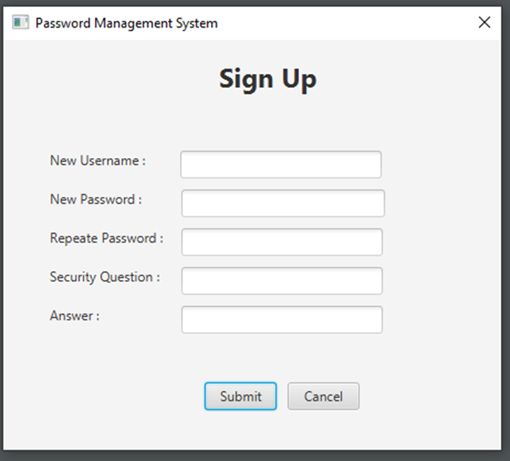

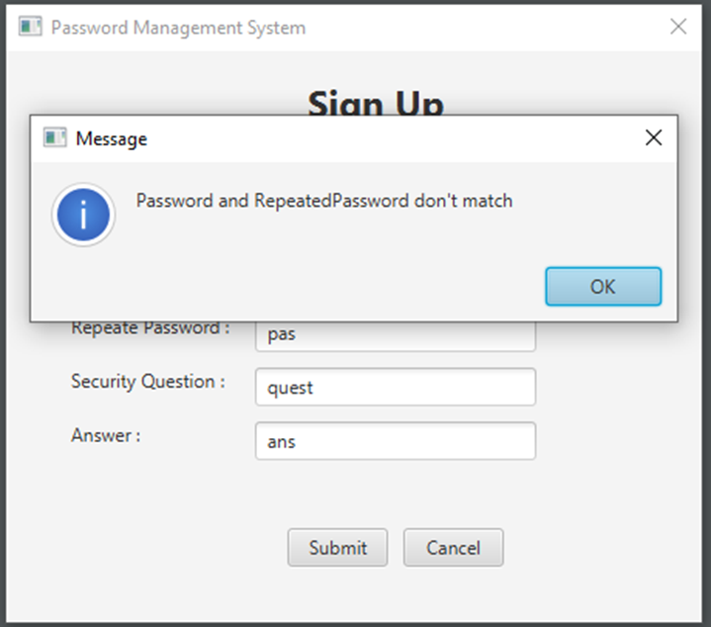

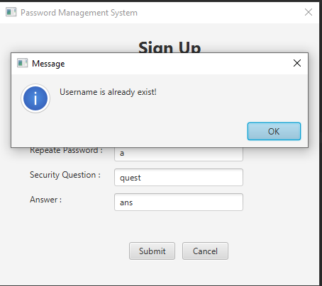

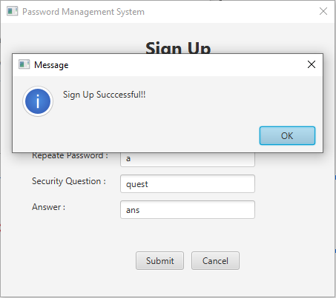

1. **Reset Master Password**

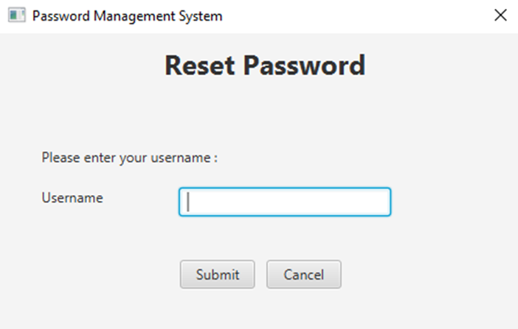

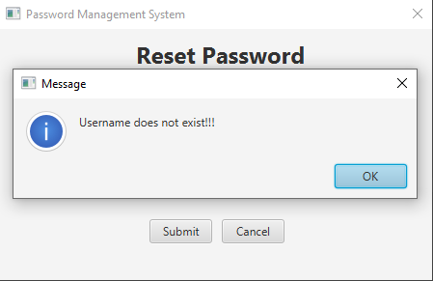

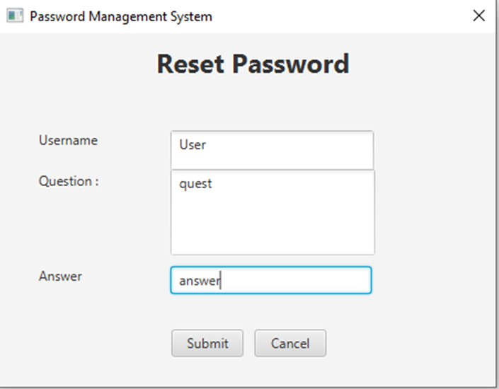

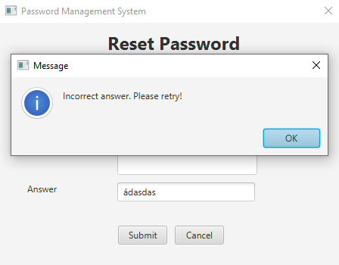

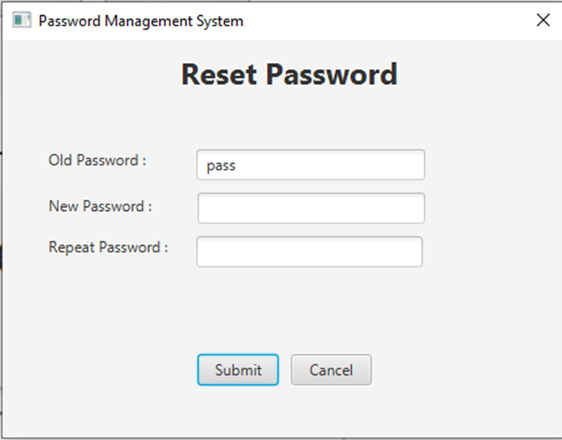

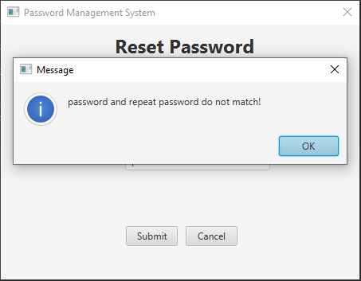

**C. Main menu:**

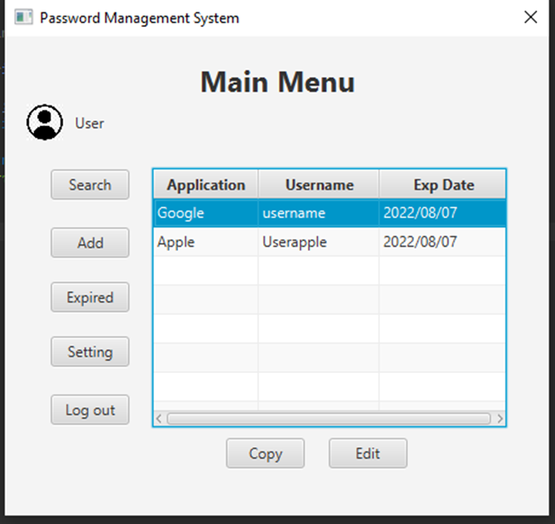

1. **Expired Password menu**

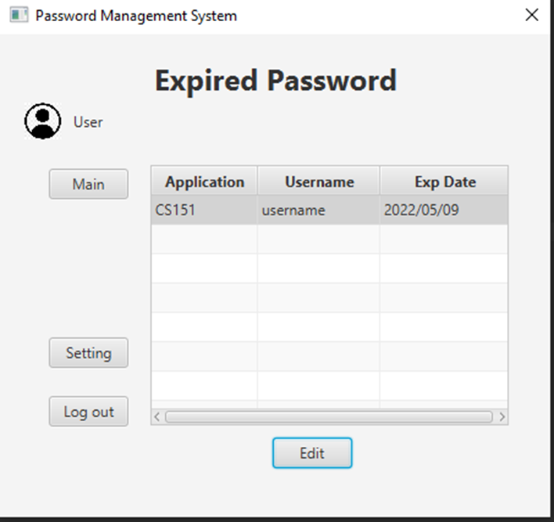

1. **Search menu:**

`

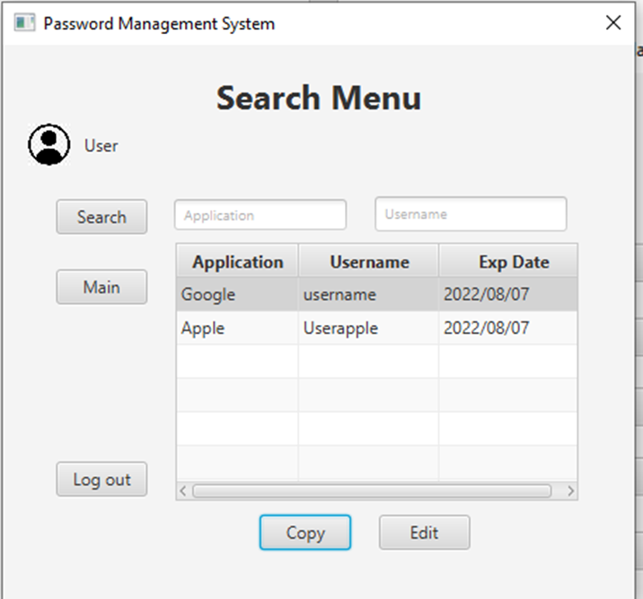

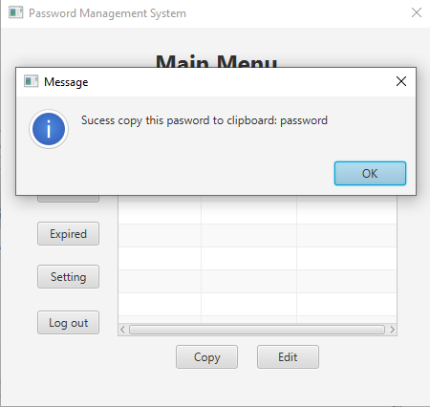

1. **Application Editing menu:**

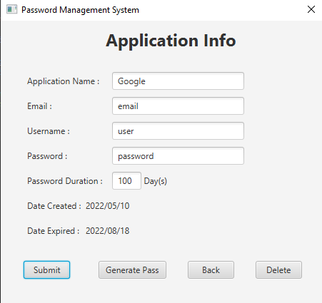

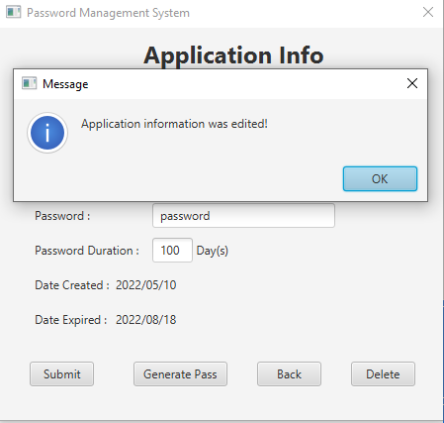

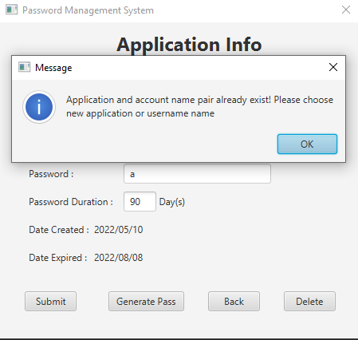

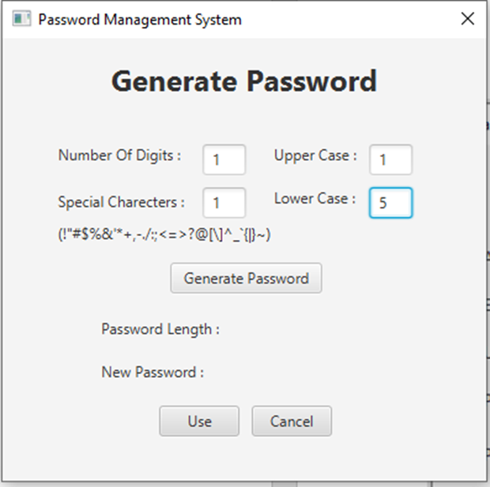

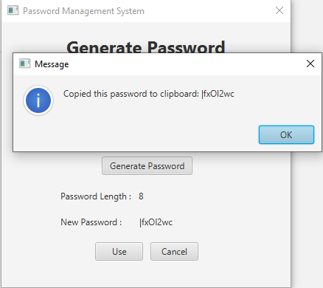

1. **Add Application menu**

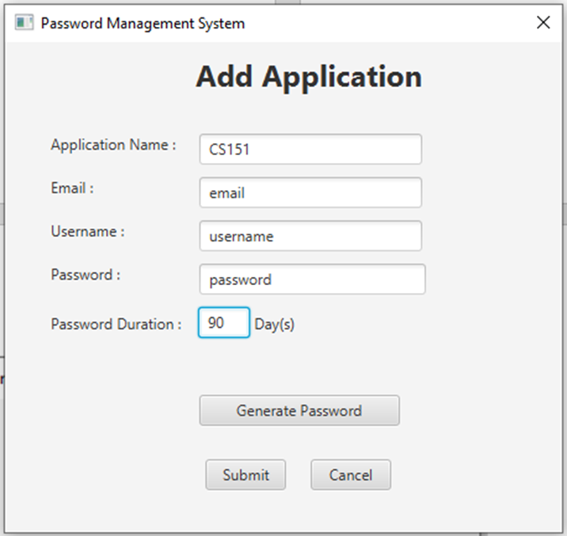

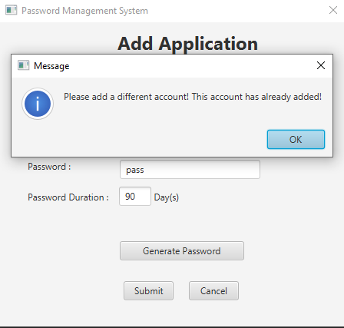

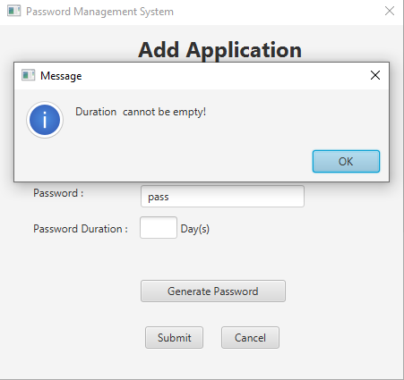

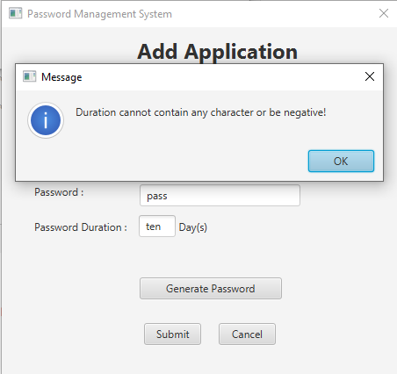

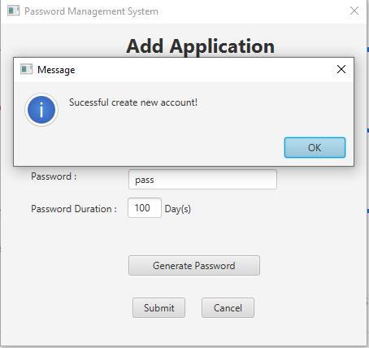

1. **Setting menu:**

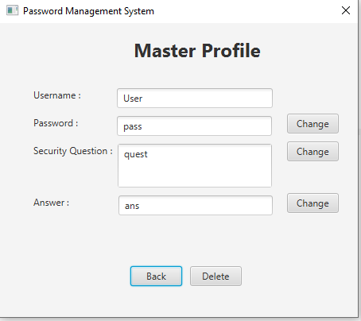

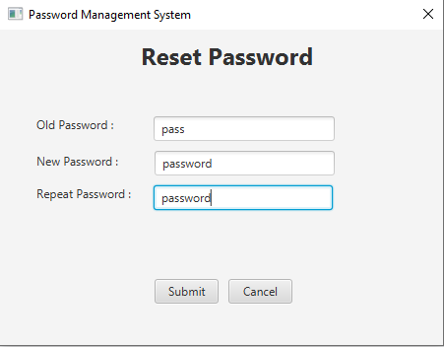

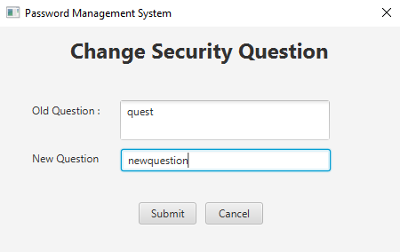

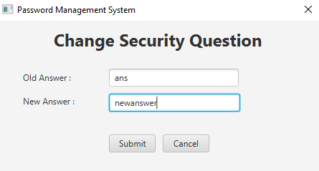

## Glossary

N/A