| **Team Number** | 07 | **Section** | 05 |
| --- | --- | --- | --- |
| **Team Members** | 1. Minh Le 2. Van Chuong Pham 3. Seyed Morsali 4. Quang Tang | | |
| **Software Name** | Password Manager | | |

# Introduction

## Objective

This document demonstrates the recognizable classes, attributes, and methods that will appear in the implementation process up to this moment. Also, this document shows how classes and objects interact with each other when the user uses the application. This document is important for the developer to follow during the coding process.

## References

UML Class diagram, sequence, and state diagram tool: Violet

<https://sourceforge.net/projects/violet/>

Mockup tool: Adobe Xd

<https://www.adobe.com/products/xd.html>

## Acronyms, and Abbreviations

N/A

# Software Overview

## Problem Statement

Computers and the Internet are being used extensively and the security of users' privacy has become a big issue. One of the oldest ways to provide security is using passwords. Choosing and storing passwords are hard tasks for the majority of the users and cause millions of breaches. Since the number of websites that we use every day is increasing, this causes most users to choose simple memorable passwords, store them improperly, or reuse them for many websites/applications that increase the risk of being cracked. The existing password managers are not reliable because there is always the risk of leaking our information to the developers of the software!

## Scope

**Target user:** Everyone who has an online account and wants to increase their password security.

# Detailed Design

## UML Class Diagrams (for all classes/interfaces)

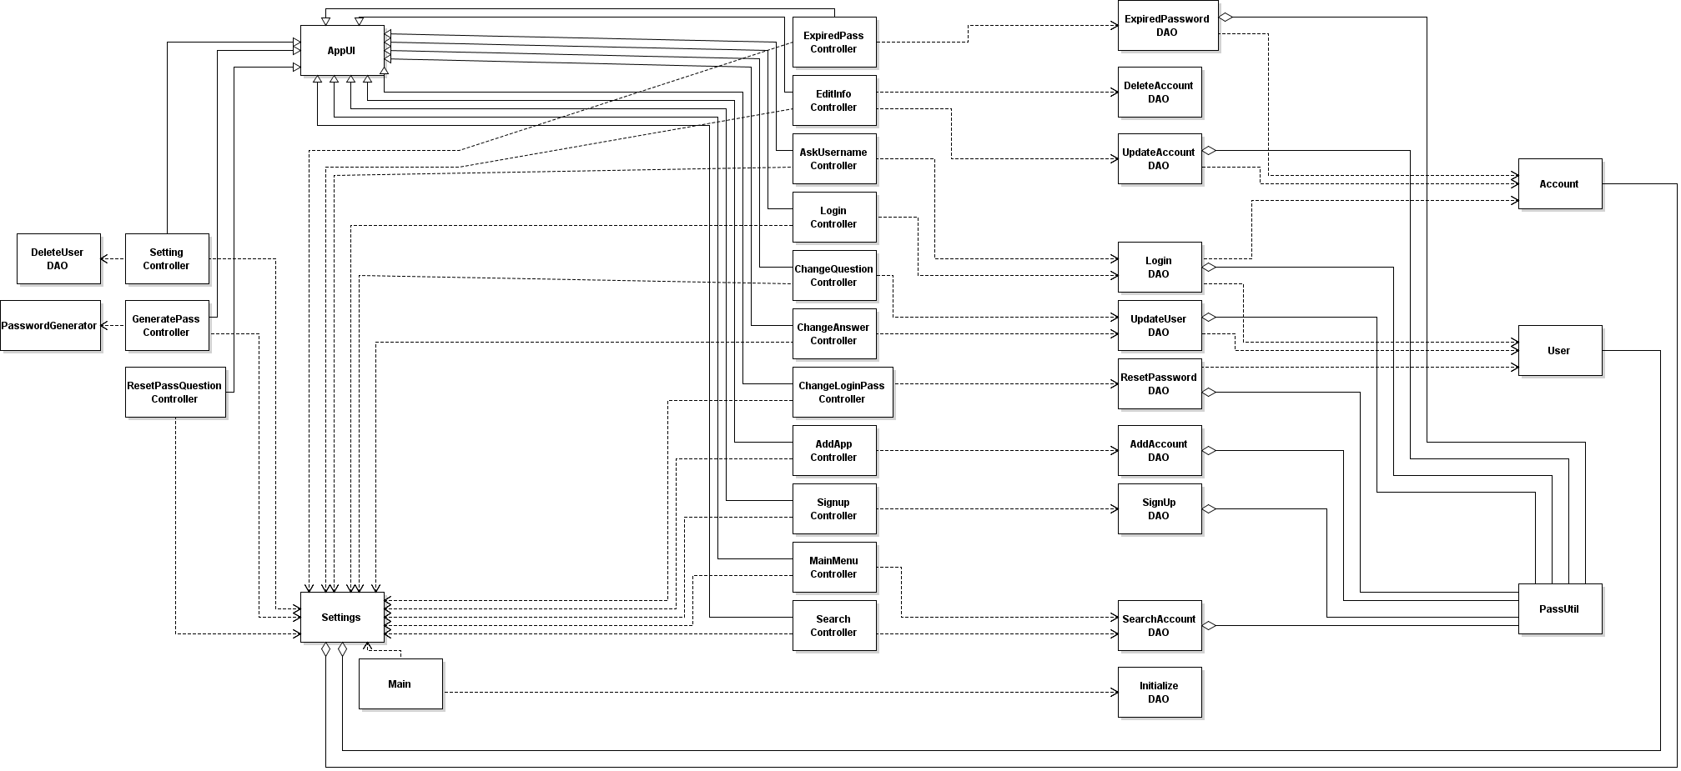

## UML Sequence and/or State Diagrams (at least two)

1. Sequence Diagram for adding new account

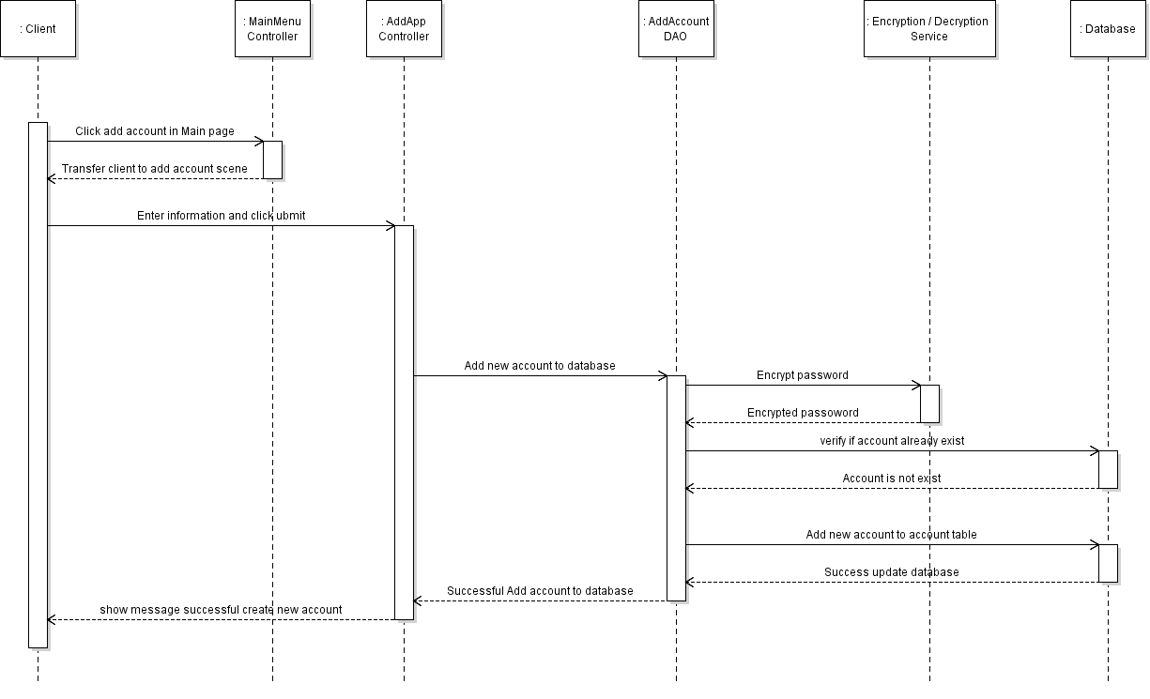

1. Sequence diagram for Sign up

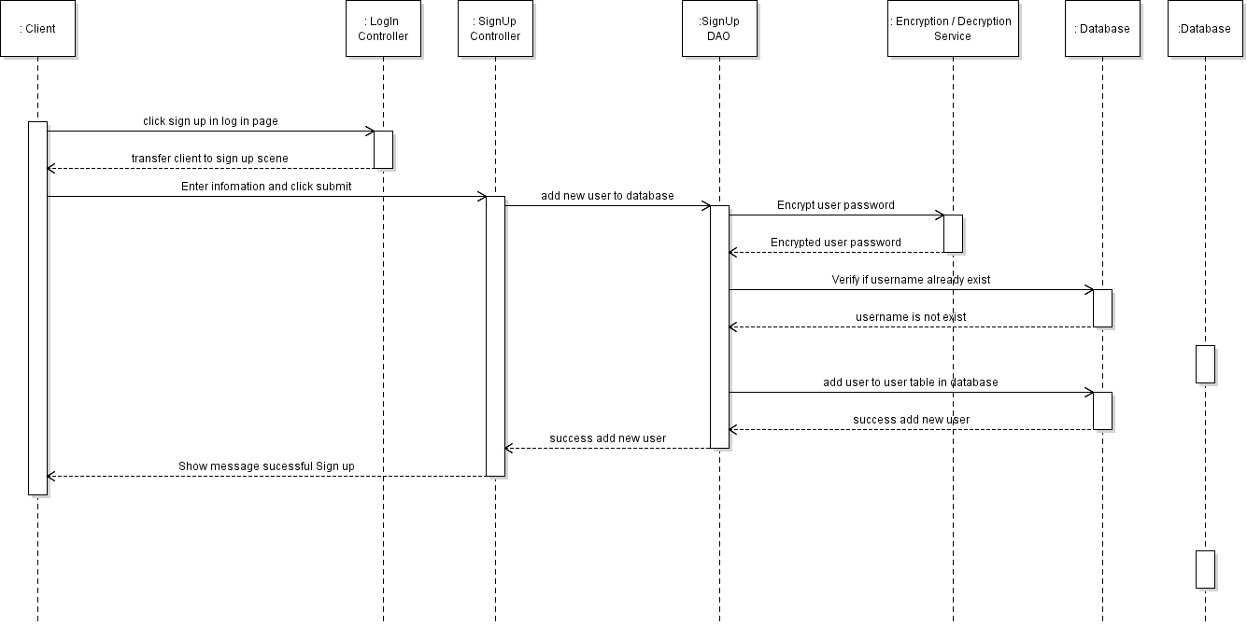

1. Sequence diagram for search accounts

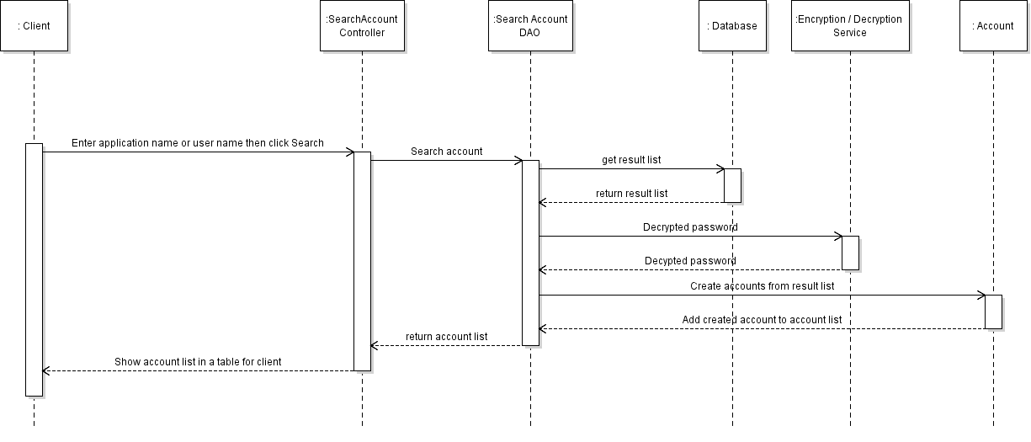

1. Sequence diagram for reset user password

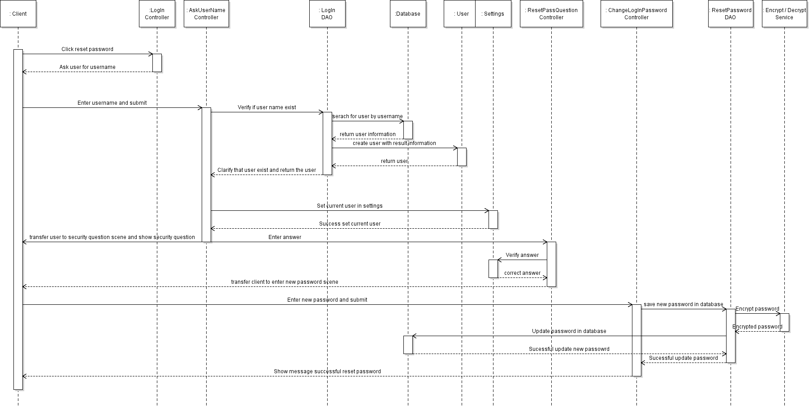

1. Sequence diagram for edit account information

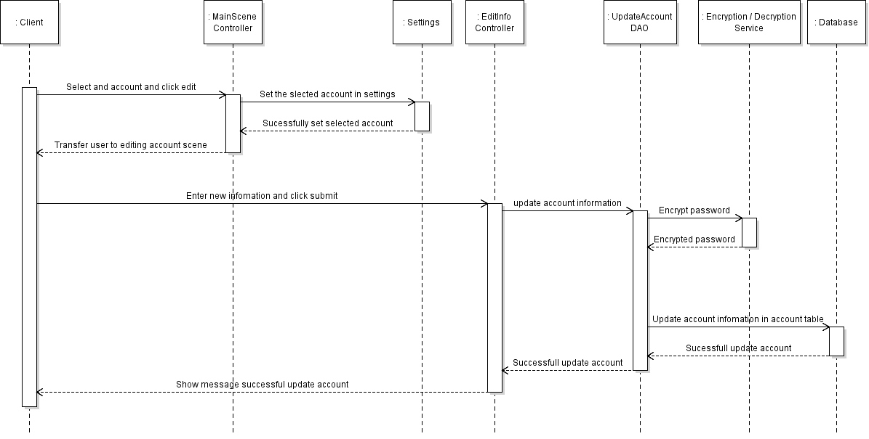

## Mockups

1. **Login menu:**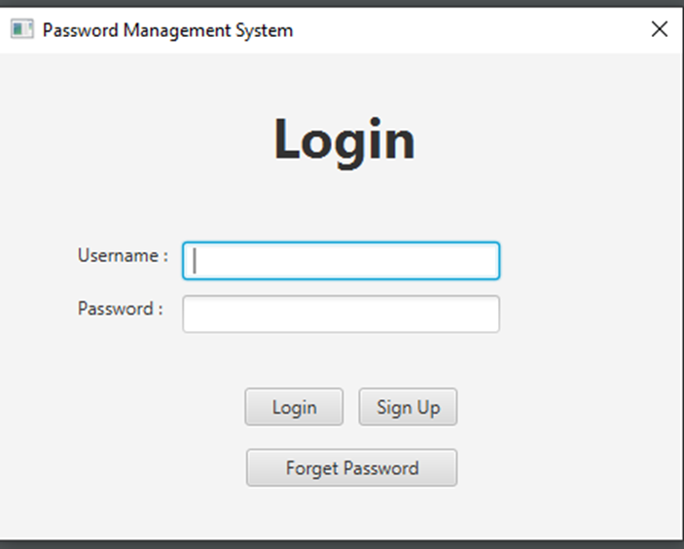

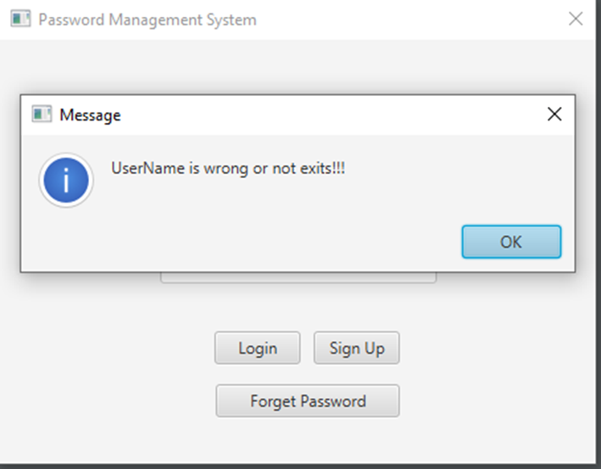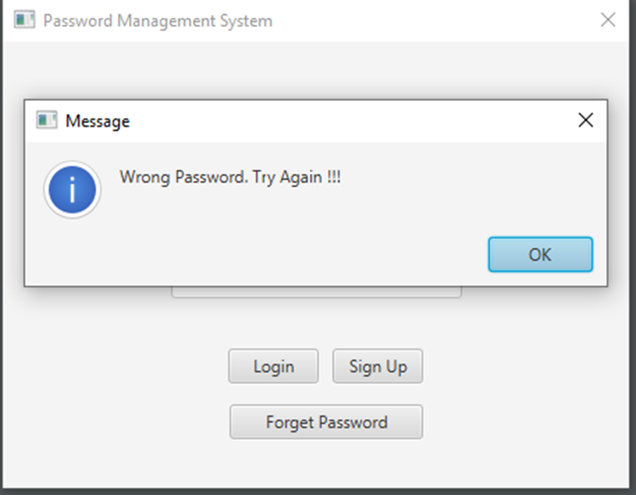

1. **Sign Up menu**

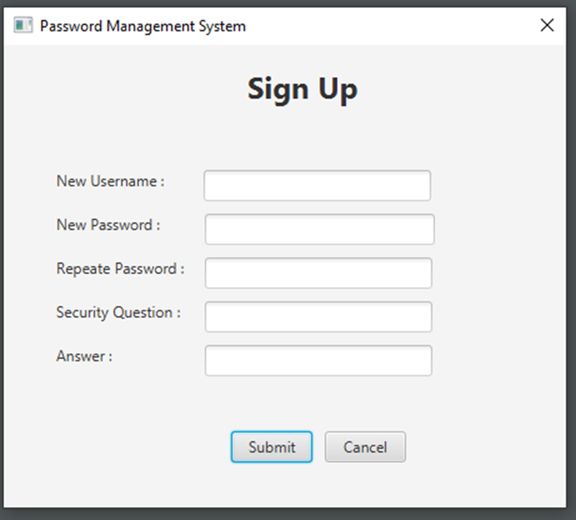

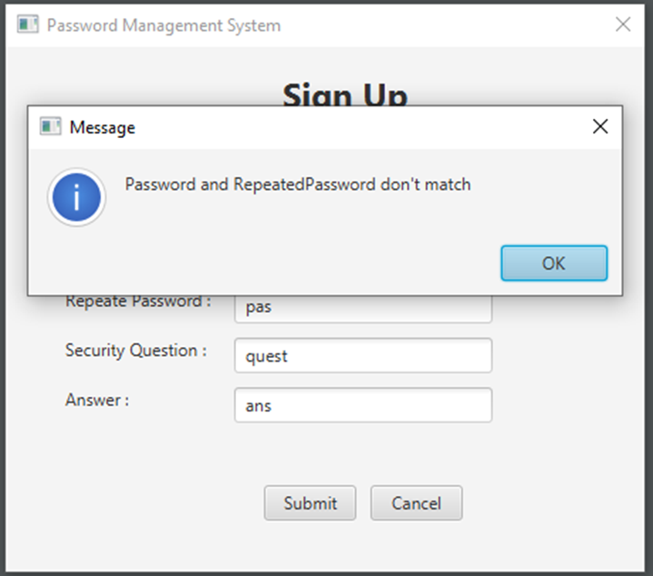

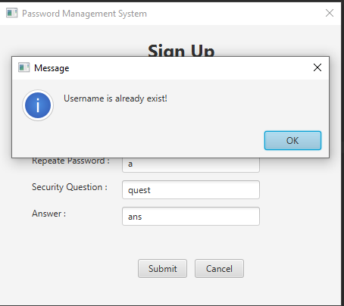

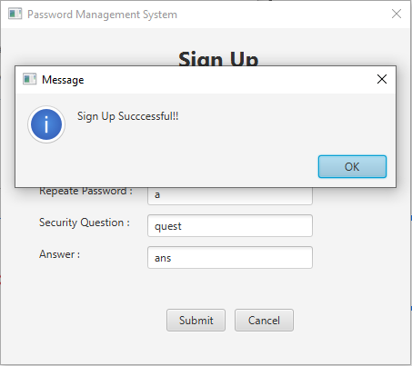

1. **Reset Master Password**

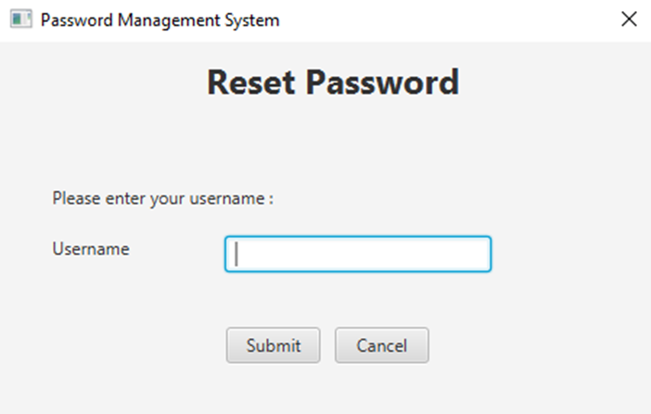

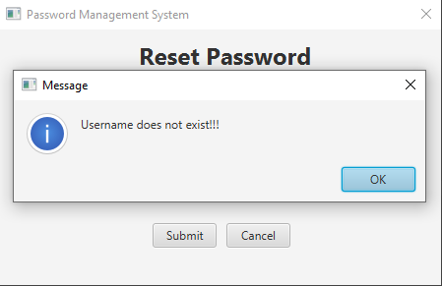

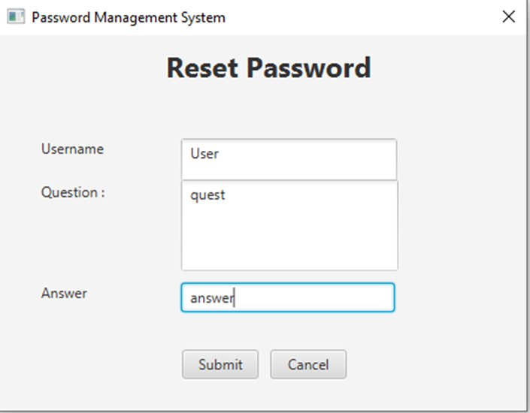

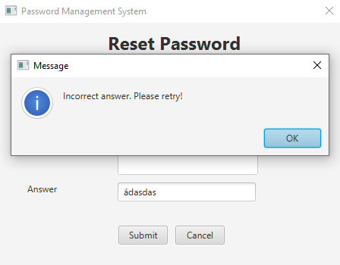

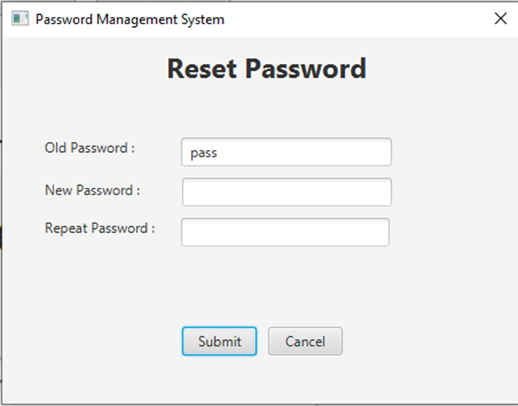

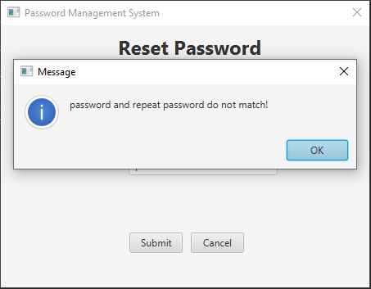

1. **Main menu:**

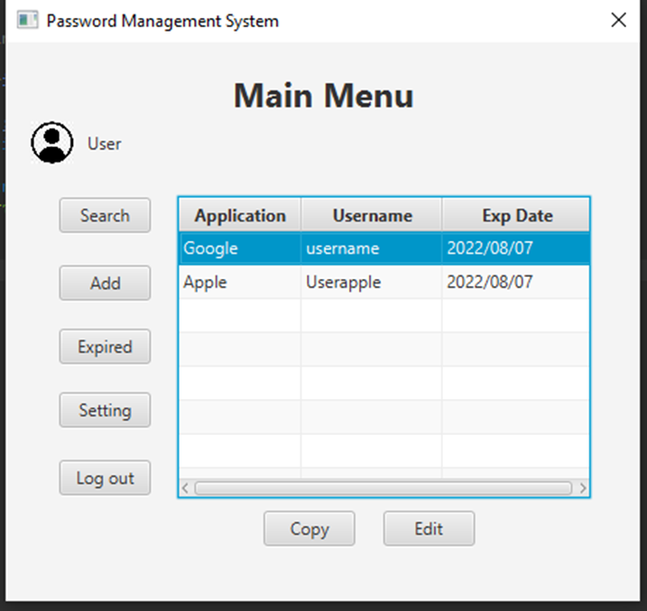

1. **Expired Password menu**

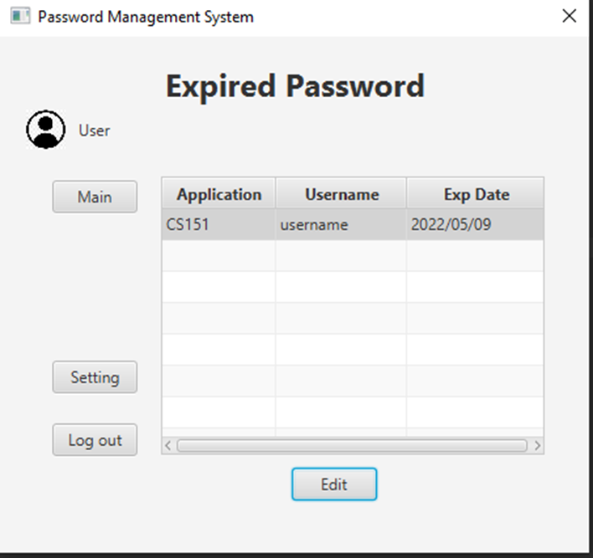

1. **Search menu:**

`

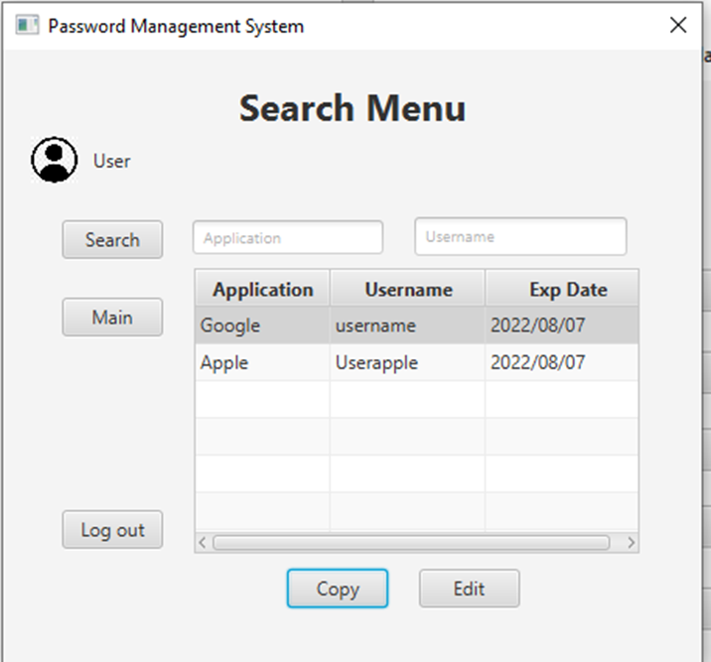

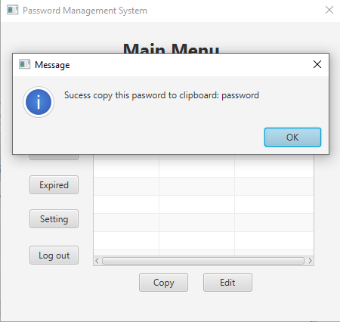

1. **Application Editing menu:**

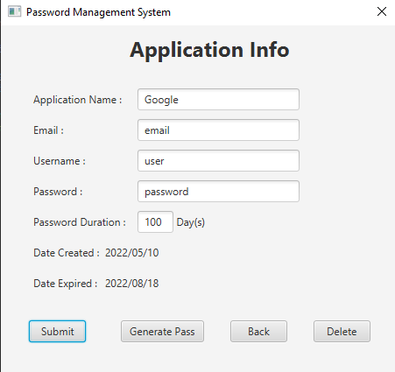

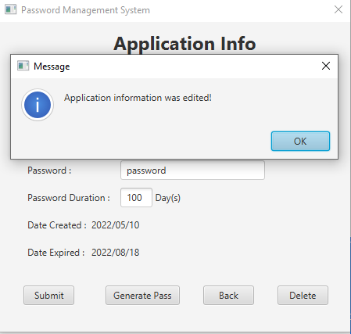

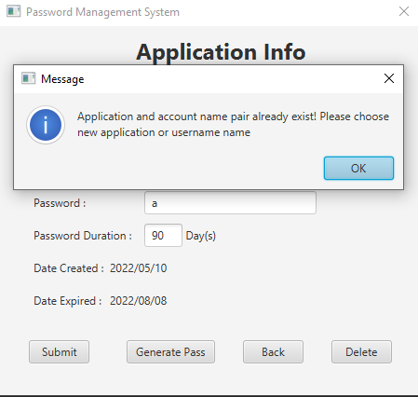

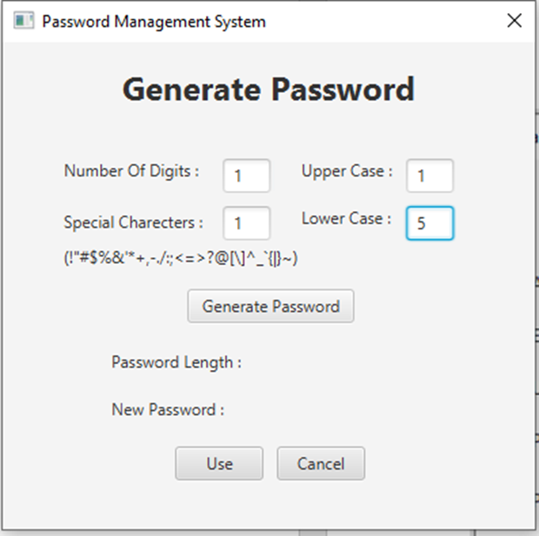

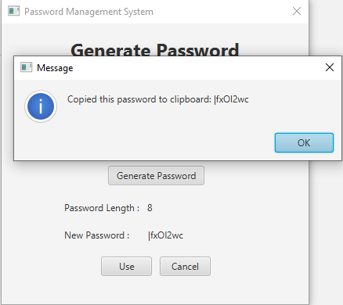

1. **Add Application menu**

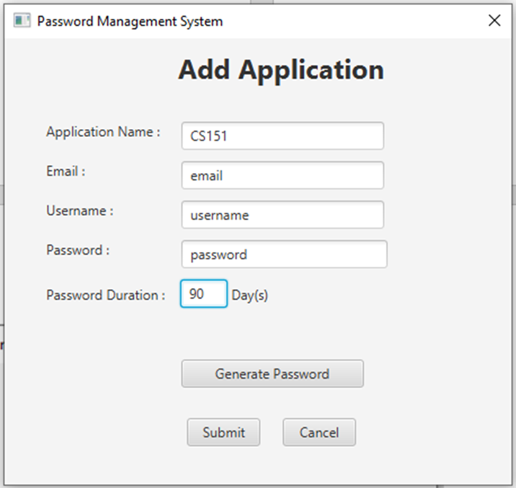

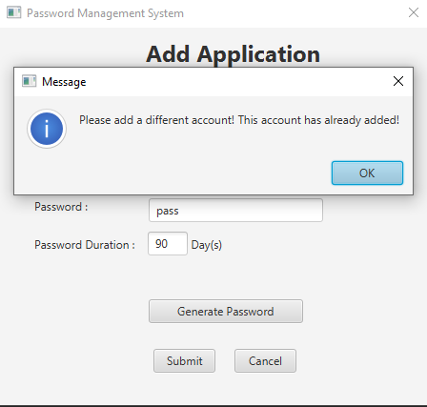

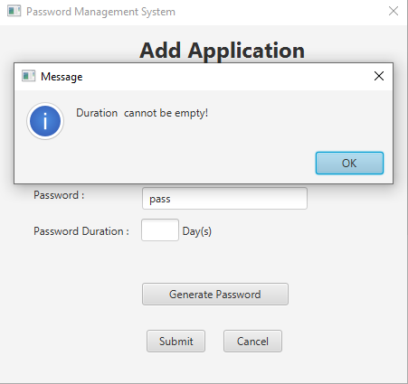

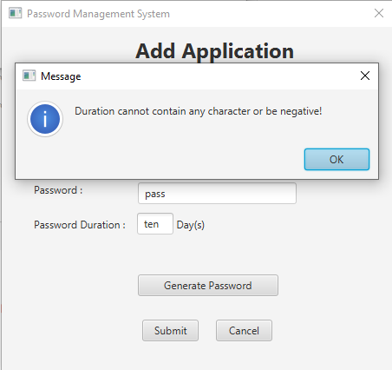

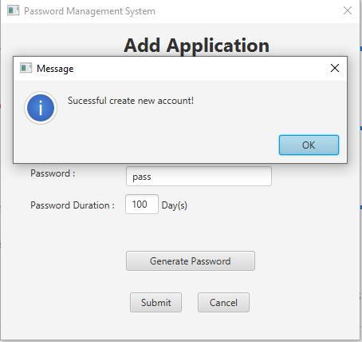

1. **Setting menu:**

