1. **Business context and articulation of problems (5%)**

In recent years, there has been significant research interest in modelling and predicting the volatility of financial time series. This is due to the recognition of volatility as a crucial concept in various economic and financial applications (Lestari et al., 2016). Volatility refers to the “conditional variation of the underlying stock return”, as defined by Lestari et al. (2016).  
The primary objective of this paper is to analyse the effectiveness of volatility modelling by employing several methods to forecast the conditional variance for the returns of Genex Power Limited (GPL) under different assumptions on the distribution of errors. This analysis utilised the daily closing price of GPL from July 31, 2015, to May 31, 2024. It employed the Generalised Autoregressive Conditional Heteroscedastic (GARCH), Integrated Generalised Autoregressive Conditional Heteroscedastic (IGARCH), and GJR-GARCH models, with a student's t error distribution. This research primarily focuses on evaluating the predictive accuracy of volatility models across various error distributions. Ultimately, select the optimal model for forecasting the conditional variance by conducting a thorough comparison of the Root Mean Square Error (RMSE) and Mean Absolute Deviation (MAD).

1. **Data processing and EDA (20%)**

The dataset consists of daily trading data for GNX.AX over a span of 9 years. The data provides a robust timeline for assessing long-term trends and cyclicality in the stock's behavior. The dataset is complete with no missing values, ensuring that there are no gaps in the data that could potentially skew analysis or model training.

GPL daily stock return series is, therefore, calculated using the following log transformation:

or

Where is the logarithmic return on GPL indices for time t, is the closing price at time t, and is the corresponding price in the period at time t-1(Ahmed et al., 2021).

|  |  |  |  |  |  |  |  |
| --- | --- | --- | --- | --- | --- | --- | --- |
| Sample size | Min | Max | Mean | SD | Skewness | Kurtosis | Jarque-Bera |
| 2236 | -49.2474 | 53.3303 | 0.0244 | 4.3609 | 0.7084 | 29.3887 | 65064.7912 |

*Table 1: Descriptive Statistics*

From this table, the skewness is 0.7084. They are not zero which means all of the rates of returns are not symmetric. The kurtosis of the return is 29.3887, greater than 3 which implies that the return series is fat-tailed and does not follow a normal distribution. Furthermore, the Jarque-Bera Test tells us the higher value represents the non-normality of the rate of returns.

The top plot of GPL Prices shows a general downward trend in the first half, followed by a recovery and stabilization towards the end, indicative of a potential mean-reverting series. The bottom plot of GPL Returns highlights extreme volatility at specific points, with returns spikes exceeding 25 and -25, suggesting significant market reactions or events influencing these price changes.

The next table helps us to check whether the rate of returns has the ARCH effect or not, the null hypothesis is the rate of returns doesn’t have ARCH effect, while the alternative hypothesis is opposite (Forsberg and Bollerslev, 2002).

|  |  |  |  |  |
| --- | --- | --- | --- | --- |
| Lag/Max lag | Box Ljung test (returns) | | Engle ARCH statistic | |
| Test statistic | p-value | Test statistic | p-value |
| 5 | 20.090165 | 0.001202 | 17.794795 | 0.003215 |
| 10 | 52.016997 | 1.132877e-07 | 44.021834 | 0.000003 |

*Table 2: Test Result*

Based on the assumption of 5% significance level, all of the p-values are smaller than 0.05, which means the rates of returns have ARCH effect.

The ACF plot for GPL returns squared shows a significant autocorrelation at lag 0 and near lag 10, which then quickly diminishes and remains near zero for subsequent lags, indicating strong but brief volatility clustering. This pattern suggests that while the returns exhibit significant volatility, it does not persist over extended periods, aligning with the characteristics of financial time series where volatility shocks are often short-lived.

The QQ plot of GPL Returns illustrates significant deviation from the theoretical normal distribution, especially in the tails, indicating fat tails and potential outliers. This is consistent with the histogram of GPL Returns, which shows a leptokurtic distribution with a sharp peak and heavy tails, typical of financial return data that exhibit higher probabilities of extreme returns than a normal distribution would predict. Both plots underscore the non-normality of the returns, suggesting that using student-t is appropriate to incorporate heavy-tailed distributions.

1. **Model building (50%)**
   1. **Train-test split: ?**

I will split the model using common split 80/20, where 20% (447 data points) of the dataset will be given to the test set, while the rest will be used for train.

**3.2 Benchmark Model – AR(1)-GARCH(1,1)-t**

Using the AIC and SIC criteria suggests that a GARCH(1,1) model is appropriate. In this report, we justify using the GARCH(1,1) model as a benchmark due to its simplicity, widespread acceptance, and robustness, making it ideal for consistent and interpretable volatility analysis across diverse financial scenarios. The GARCH(1,1) model is highly valued for its ability to effectively model 'volatility clustering,' a common feature in financial time series where periods of high volatility follow one another. This model predicts future volatility by leveraging past conditional variances and squared returns, demonstrating its robust applicability to financial data.

The Jarque-Bera p-value result of 0.0 indicates that the data is significantly non-Gaussian. Therefore, we will focus on the student-t distribution for the GARCH model and other latter proposed models.

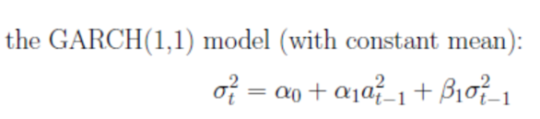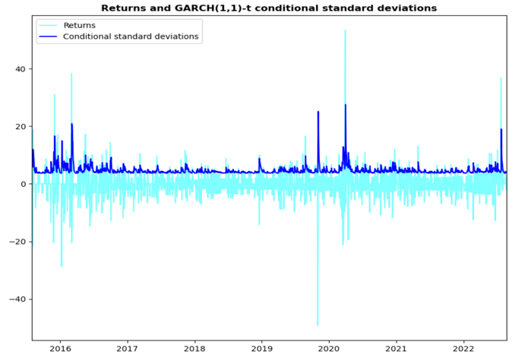

The top graph displays the transformed standardized residuals over time. The residuals fluctuate within a range of approximately -4 to 4, with no evident patterns of clustering at different times, which suggests that the model is relatively effective in capturing the major volatilities within the series.

For all depicted lags, ACF plot shows almost zero but slightly positive autocorrelations. The GARCH model has worked well, however volatility clustering may still be present. Stronger ARCH impacts are indicated by higher values of these variables. This model appears to perform well given its closeness to zero. However, even these modest numbers must be properly monitored, especially in delicate analyses or risk management scenarios.

The QQ plot of the GARCH(1,1)-t transformed standardized residuals shows a good fit to the theoretical normal distribution, particularly across the central quantiles, although slight deviations in the tails indicate heavier tails than the normal distribution.

|  |  |  |  |  |  |
| --- | --- | --- | --- | --- | --- |
|  | Max Lag | Test statistic | p-value | Hypothesis | Decision |
| Ljung-Box (Squared residuals) | 7 | 0.572634 | 0.989222 | No significant autocorrelation | Do not reject H0 (no ARCH effect) |
| 12 | 1.964898 | 0.996602 | No significant autocorrelation | Do not reject H0 (no ARCH effect) |
| Engle ARCH statistic | 5 | 0.426718 | 0.994562 | No significant ARCH effects | Do not reject H0 (no ARCH effect) |
| 10 | 1.512030 | 0.998897 | No significant ARCH effects | Do not reject H0 (no ARCH effect) |
| Jarque-Bera | - | 56797.791803 | 0.0 | Residuals are not normally distributed (extreme skewness and kurtosis) | Reject H0 (non-normality) |

For the squared transformed residuals, Jarque-Bera test found p-value of 0.0 and high test statistic, indicating that the residuals are not normally distributed. Therefore, GARCH(1,1) volatility equation can still be improved

Furthermore, the limitation to the standard GARCH process is that it still fails to capture the leverage effect due to its symmetric distribution. These findings suggest that while the GARCH(1,1) handles some aspects effectively, it may need adjustments to fully account for volatility dynamics.

* 1. **GJR-GARCH(1,1)-t model:**

While GARCH can model volatility clustering and leptokurtosis, but it fail to capture the asymmetric relationship between asset returns and volatility changes which is needed when handling financial time-series data(). Several nonlinear extensions to the GARCH have therefore been proposed to address this problem. Glosten, Jagananthan and Runkle (1993) developed the GARCH model which allows the conditional variance has a different response to past negative and positive innovations (Ugurlu et al., 2014).

The left plot highlights how the model accurately captures extreme volatility, as shown by conditional standard deviation spikes after big return variations. The GJR-GARCH model accurately models greater volatility, especially after negative returns, to represent financial data asymmetries. This is called the leverage effect.

|  |  |  |  |  |  |
| --- | --- | --- | --- | --- | --- |
|  | Max Lag | Test statistic | p-value | Hypothesis | Decision |
| Ljung-Box (Squared residuals) | 9 | 5.605224 | 0.346546 | No significant autocorrelation | Do not reject H0 |
| 14 | 9.876386 | 0.451405 | No significant autocorrelation | Do not reject H0 |
| Jarque-Bera | - | 0.2669 | 0.8751 | Residuals are normally distributed | Do not reject H0 |

*Compare with GARCH(1,1)-t*

Similar volatility patterns captured by both models. While both models are effective in tracking the conditional volatility of the data, the GJR-GARCH(1,1)-t might be slightly more sensitive to capturing large volatility spikes, possibly due to its ability to model asymmetry in the volatility response to negative shocks ().

*Adding NIC*

News impact curves (Engle and Ng, 1993) are often used to assess the level of volatility asymmetry in GJR-type models. The NIC (News Impact Curve) for the GJR-t model depicted in these plots illustrates the asymmetric response of volatility to past shocks: the curve is steeper for negative shocks compared to positive ones

The output indicates that following a positive shock of size 5, the predicted conditional standard deviation is 25.3007, while a negative shock of the same magnitude leads to a conditional standard deviation of 22.0573. The value 1.147 indicates that conditional volatility following a negative shock of size 5 is 1.147 times, or 14.7%, higher than the volatility following a positive shock of size 5

However, in some financial series, the shocks may exhibit extremely high persistence. This means that once volatility increases, it tends to stay high for a long period. We will therefore introduce IGARCH models, which allows for capture the unending impact of shocks, a feature that might be missed by models that allow volatility to revert to a long-term mean.

* 1. **IGARCH(1, 1) model:**

The Risk Metrics model, as illustrated in the plot, effectively tracks general market volatility trends but seems to display a more subdued response to spikes in returns compared to the GJR-GARCH or GARCH model. This suggests that while the Risk Metrics model captures overall volatility patterns, it might underreact to extreme market movements and may not fully account for the asymmetric volatility responses typically seen in financial markets.

|  |  |  |  |  |  |
| --- | --- | --- | --- | --- | --- |
|  | Max Lag | Test statistic | p-value | Hypothesis | Decision |
| Ljung-Box (Squared residuals) | 6 | 0.528823 | 0.991030 | No significant autocorrelation | Do not reject H0 |
| 11 | 0.866012 | 0.999911 | No significant autocorrelation | Do not reject H0 |
| Engle ARCH statistic | 5 | 0.375187 | 0.995986 | No significant ARCH effects | Do not reject H0 |
| 10 | 0.862079 | 0.999913 | No significant ARCH effects | Do not reject H0 |
| Jarque-Bera | - | 50055.649308 | 0.000000 | Residuals are not normally distributed | Reject H0 |

**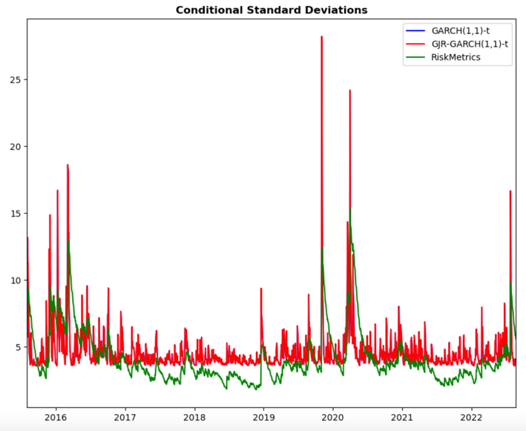***Compare with the previous models*

Risk Metrics has lower conditional standard deviations than GARCH(1,1)-t and GJR-GARCH(1,1)-t. This suggests that the Risk Metrics model smooths volatility and may not respond as quickly to major market volatility rises as the other two models. When markets are volatile, the Risk Metrics model's projections are typically lower, suggesting it may underestimate risk.

The presence of heavy tails suggests that the IGARCH model may not fully capture extreme values or outliers in the data, indicating potential leptokurtosis.

1. **Volatility forecasting**
   1. **In-sample performance**

- GARCH(1,1)-t and GJR-GARCH models: For circumstances needing sensitivity to sudden market fluctuations, both models capture sharp volatility changes well. For negative shocks, the GJR-GARCH(1,1)-t model is slightly more sensitive.

- IGARCH(1,1): provides smoother, more stable volatility forecast is better for long-term volatility patterns but might underestimate short-term spikes.

- Combination model: This balanced approach uses the qualities of each model. Its consistent forecast reduces model extremes, making it valuable for risk management.

* 1. **Introduce proxies: To assess each model volatility forecast accuracy**

We do not have the true volatilities for any real data set since volatility is an unobserved process. It is thus difficult to assess the accuracy of volatility forecasts, in general. Volatility proxies are often used in place of the true series to assess forecast accuracy Molnar (2012, 2016). These are alternative estimates of volatility, and often use other information, such as intra-day price movements, or information available at the forecasted time that could not be used when the forecast was made. volatility proxies 1-4 as follows.

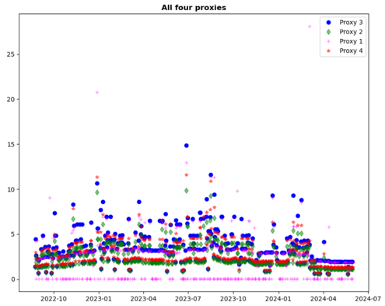**The models again provide a stable and conservative forecast, but might not fully account for all instances of high volatility, as seen by the numerous outliers.

For all proxies (1, 2, 3, and 4), the GJR-GARCH(1,1)-t model consistently shows the lowest MSE and MAD values, indicating it has the best fit and predictive performance.

* 1. 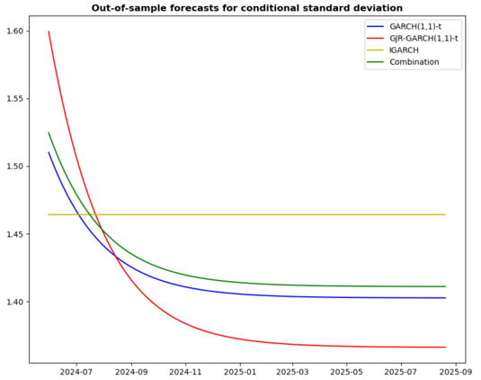**Out of Sample Forecasting**

Generate from 1 up to 447-step-ahead forecasts of volatility, for the final 447 daily returns

The general pattern suggests a decline in volatility, indicating an anticipation of a more stable market.

The GARCH(1,1)-t and GJR-GARCH(1,1)-t models are effective in predicting times of volatility, but the IGARCH model is more suitable for periods of stability.

The combination model is a well-balanced approach that might be valuable for risk management as it delivers a more cautious prediction of future volatility.

1. **Conclusions and recommendations (15%)**

**REFERENCES**

Ahmed, M. T., Naher, N. (2021). Modelling & Forecasting Volatility of Daily Stock Returns Using GARCH Models: Evidence from Dhaka Stock Exchange. *Economics and Business Quarterly Reviews*, *4*(2775–9237). https://doi.org/10.31014/aior.1992.04.03.371

Forsberg, L. and Bollerslev, T., 2002, Bridging the gap between the distribution of realized (ECU) volatility and ARCH modeling (of the EURO): the GARCH-NIG model. Journal of Applied Econometrics, 17: 535–548.

Lestari, K. E., Pasaribu, U. S., & Indratno, S. (2016, December). *Modelling Stock Return Volatility using ARCH and GARCH Models*. The 2nd International Conference on Acturial Science and Statistics (ICASS) 2016.

Molnar, P. (2016). High-low range in garch models of stock return volatility. Applied Economics, 48(51), 4977{4991.

Singh, S., Parmar, K. S., & Kaur, J. (2023). Forecasting volatility in the stock market data using GARCH, EGARCH, and GJR models. In *Elsevier eBooks* (pp. 207–220). https://doi.org/10.1016/b978-0-12-821285-1.00024-5

Ugurlu, E., Thalassinos, E., & Muratoglu, Y. (2014). Modeling Volatility in the Stock Markets using GARCH Models: European Emerging Economies and Turkey. *International Journal of Economics & Business Administration*, *II*(Issue 3), 72–87. https://doi.org/10.35808/ijeba/49