**Class Management App (QM-E)**

**Project Proposal (COMP1682)**

Name: Ho Quang Minh (minhhqgch190485)

Instructor: Doan Trung Tung

November, 2022

Table of Contents

1 Introduction / Overview 3

2 Aim 4

3 Objective 4

3.1 Join the class 4

3.1.1 Activities 4

3.1.2 Deliverables 4

3.2 Post assignments 4

3.2.1 Activities 4

3.2.2 Deliverables 4

3.3 Scoring for students 4

3.3.1 Activities 4

3.3.2 Deliverables 4

4 Legal, Social, Ethical and Professional 5

4.1 Legal 5

4.2 Social 5

4.3 Ethical 5

4.4 Professional 5

5 Plan 6

5.1 WBS 6

5.2 Gantt Chart 7

6 Initial References 7

# Introduction / Overview

Because of its convenience, most people nowadays prefer to work online. The same is true for teachers and students, especially in a university setting where teachers must manage a large number of students and classes. This project was created by the author with the goal of developing a classroom and student management system for teachers. The main function is that teachers can easily assign assignments to students and grade students. This is a writing system modeled after the existing Google Classroom system.

Effective classroom management is undoubtedly one of the most important tasks teachers must carry out in any educational environment. This may be the case, particularly for recently credentialed teachers. When teachers talk about the most challenging situations they faced during their first few years of teaching, classroom management is commonly brought up. Classroom management is the process of keeping an eye on a group of students' interactions, behaviors, educational situations, and lessons. Preventive classroom management strategies reduce discipline problems. According to the principle of preventive management, intelligent planning, interesting lessons, and excellent instruction can help to solve many problems in the classroom (Stewart, 2008).

Being organized and being strict or arbitrarily enforcing rules are not the only components of effective classroom management. Establishing a structured learning environment in which some behaviors are encouraged and others are not is necessary if you want your classroom to function as smoothly as a well-oiled learning machine recommended. Classroom management systems keep logs, allowing you to see what materials have been used. This can help you keep track of needed materials and identify what's missing, reducing waste and promoting the use of materials in their original state. This will also ensure that students have received all of the materials they require for both study and work. Teachers can use the system to assess and monitor student behavior, ensuring that all students complete their homework. Teachers can mark who completed which tasks as students complete them, allowing teachers to see what students have completed and ensure that they are following the correct procedure. While there may be an unthinkable day in grading, classroom management software is certainly interested in getting there as soon as possible. Teachers can grade without using paper and without having to worry about printing, distributing, or even losing students' work by centralizing assignments in one place.

In this project, the author used the language NodeJS to write code for the system. Even while JavaScript has generally only been used to write client-side code in the browser, Node.js allows developers to utilize it to construct server-side code. It's easier to construct web servers when both sides are in the same environment, which is why Node.js' popularity as a useful tool for writing server code has surged.

JavaScript consistently ranks first among programming languages in terms of benefits. When you use Node.js for backend development, you instantly have access to all the benefits of full-stack JS development, such as blazingly fast speed and performance, the capacity to reuse and share code, and a wide variety of free tools. Code reuse is enabled by encapsulating the front end and back end in modules. Your development team is therefore agile, and development costs and time are reduced. You receive your product quicker as a result, and you can easily make future improvements (Fedyk, 2020).

Its notoriously unstable API is one of Node.js's shortcomings. As a result of its frequent changes and lack of backward compatibility, software engineering requires more time and effort. Node.js is an open source platform with a substantial selection of libraries and modules available to developers, despite numerous gaps in the documentation (Fedyk, 2020).

# Aim

The author's goal is to develop a system that will allow teachers to manage their classrooms. Users can create multiple classes and add more students to their classes, after which teachers can post assignments from that class, students can receive assignments and submit assignments, and administrators can manage which students have submitted assignments and grade them. Scores will be emailed to students rather than handed over in person by the teacher. Teachers, in particular, can send links to students so that they can join the class on their own.

# Objective

## Join the class

### Activities

During the teacher creating a new class, the system will generate an id link so that students can join that class.

### Deliverables

The teacher can copy the self-created link when creating a class and send it to the student in any format, such as Facebook, Mail, or simply show the student's class link id, and students can join the teacher's class from there.

## Post assignments

### Activities

After creating a class, the teacher can post the exercises in that class with a word file. The author will use the Multer library for teachers to upload the exercise file for each class.

### Deliverables

Students can go to that section and download the file once the teacher posts the assignment. Students can submit their assignments directly from this section.

## Scoring for students

### Activities

The author will create a page that lists students who have submitted assignments, and teachers will be able to download or view the submitted file online.

### Deliverables

Teachers can grade each student right in the margins of the student's previously submitted assignment view. After grading, the score will be saved in the list of assignments that students have previously submitted.

# Legal, Social, Ethical and Professional

## Legal

Regarding the legality of classroom management software, it is completely reasonable because the functions of the software do not harm any individual or organization when using this system. This system also does not steal user information because no user information is required to use it.

## Social

To address the issue of interaction between teachers and students in this system, the author will include a comment function in each exercise item that the teacher posts, so that students and members can comment when they have questions about something related to that exercise. However, because each opinion is public, the author has not considered a private interaction between a teacher and any one student.

## Ethical

This author's classroom management software serves only the primary purpose of education and contains no illegal or unethical functions. The author's software is inspired by the existing system Google Classroom, but it is not plagiarized; all the author does is simulate the main functions of the required classroom management system. The author has no intention of doing business or competing with the existing system, in part because this is only the author's graduation project.

## Professional

This author's system can meet the needs of managing a class by allowing teachers to easily assign tasks to multiple students at the same time without wasting time. In terms of security, each user account will have a unique id and will be able to log in using the password of the previously created user.

# Plan

## WBS

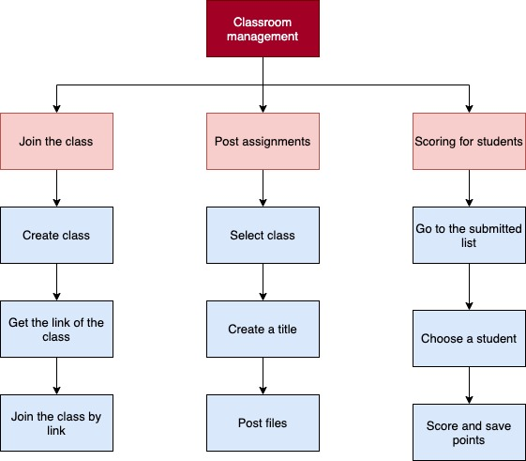

## Gantt Chart

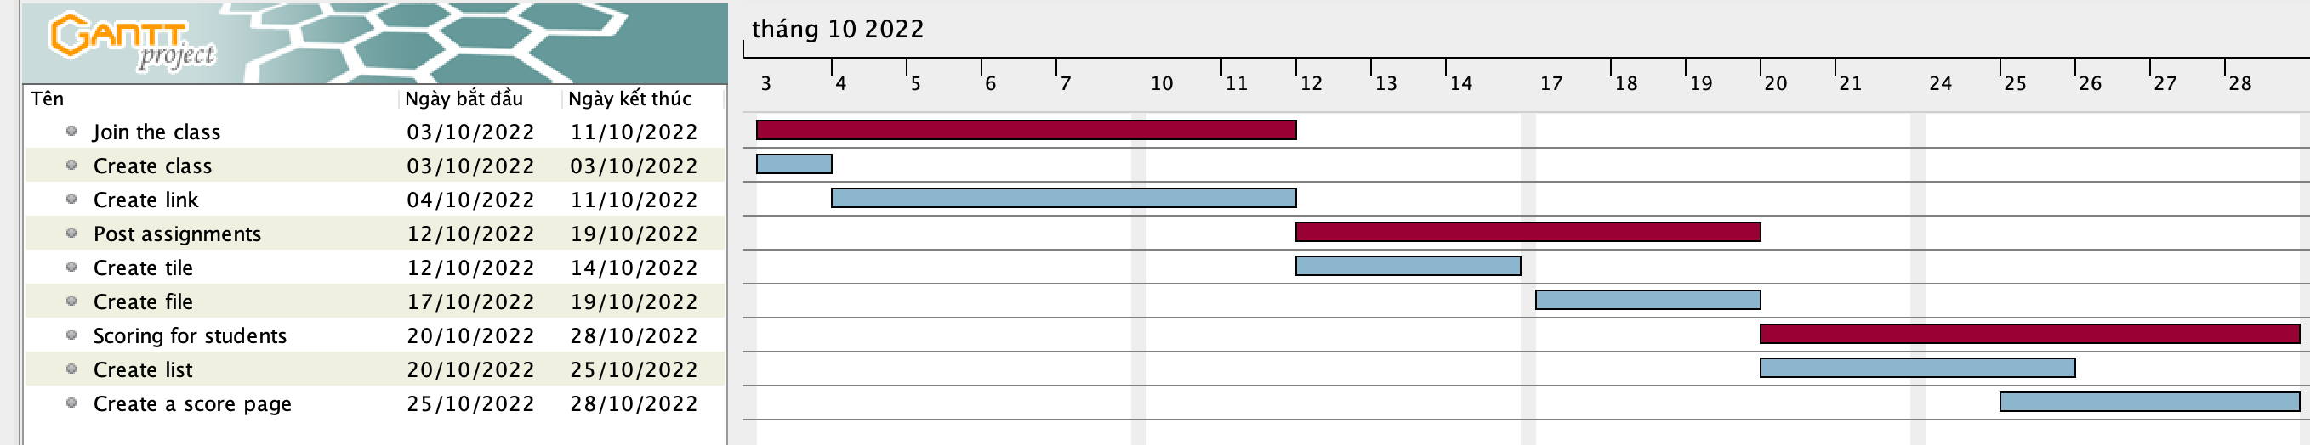

# Initial References

Fedyk, Y. (2020) *Pros & Cons of using node.js - why to use node.js?*, *Inverita*. Available at: https://inveritasoft.com/article-pros-&-cons-of-using-node-js-why-to-use-node-js (Accessed: November 25, 2022).

Stewart, D. (2008). Classroom management in the online environment. *Journal of online learning and teaching*, *4*(3), 371-374.