**Class Management App (QM-E)**

**Project (COMP1682)**

Name: Ho Quang Minh (minhhqgch190485)

Instructor: Doan Trung Tung

November, 2022

Table of Contents

1 Abstract 3

2 Introduction 3

3 Literature Review 3

3.1 Review of Domain 3

3.2 Review of Technologies 4

3.3 Review of Methodologies 5

3.4 Choosing solutions 6

4 Requirements analysis 6

4.1 Google classroom 6

4.2 Classkick 7

4.3 Conclusion 7

5 Software design 7

5.1 Architecture (optional) 7

5.2 GUI (optional) 7

5.3 DB (optional) 7

5.4 UML (optional) 7

6 Software implementation 7

6.1 Development environment 7

6.2 Important technical problems & solutions 7

6.3 Test (optional) 7

6.4 Results 7

7 Evaluation and conclusion 7

7.1 Evaluation of results 7

7.2 Conclusion 8

8 Appendix 8

9 Reference 8

# Abstract

In this report, the author will carry out the author's graduation project. Overview of this project, the author will first introduce the project that the author will implement, then the method by which the author will carry out the project, and finally the project results that the author has worked on to completion.

# Introduction

Most people today prefer working online due to its convenience. The same is true for instructors and pupils, particularly in a university setting where instructors have to oversee numerous classes and pupils. A classroom and student management system for teachers is what motivated the author to start this project. The primary purpose is to make it simple for teachers to set homework for students and grade their performance. The existing Google Classroom system served as the inspiration for this writing program.

# Literature Review

## Review of Domain

The techniques and tactics a teacher employs to establish a learning environment that is conducive to student success are referred to as classroom management. While there are various pedagogical techniques used in classroom management, the key is making sure that students feel as though they are in a setting that supports their success. Respect is a key component of effective classroom management. Mutual respect between the learner and the teacher must be established prior to any instruction taking place. The norms that students must adhere to in order to succeed must be understood by them. There will be some trial and error involved with any classroom management strategy. It takes time to determine what works best for the students, and this allows the classroom to transform into a secure space. The most crucial aspect of classroom management is giving your students the chance to comprehend how your rules contribute to their receiving the best education possible (Cini, 2020).

One of the most significant duties educators must perform in any classroom setting is probably effective classroom management. For newly certified teachers in particular, this may be true. Classroom management is frequently brought up when teachers discuss the toughest issues they had to deal with in their first few years of teaching. Monitoring interactions, actions, instructional contexts, and lessons for a group of students is what is referred to as classroom management. Discipline issues are decreased as a result of preventive classroom management techniques. According to the theory of preventive management, a lot of issues in the classroom can be resolved with thoughtful planning, engaging lessons, and effective instruction. When implementing classroom management in the setting of an online community college, there will be unique challenges to overcome if management is poor. With regard to student diversity and online instruction, particular emphasis will be placed on the unique challenges faced by online community college faculty (Stewart, 2008).

In a virtual classroom, which is an online setting for teaching and learning, participants can present course materials, engage in group projects and collaboration, and communicate with other participants. together. The primary distinction between a virtual classroom and a traditional one is that the former occurs in a synchronous, real-time setting. Virtual classrooms allow professors and students to communicate face-to-face while taking an online course, even when some of the material may be pre-recorded and asynchronous. Students' ability to master new subjects and abilities will undoubtedly be greatly facilitated by virtual classrooms. The ability to learn new skills and broaden one's knowledge is facilitated by online learning for working professionals, people with demanding home life, or people with little financial resources. Offering online courses offered through virtual classrooms can be a smart method for colleges and universities seeking to expand their brand awareness and draw in more students to reach more students who are not in their local area (Barron, 2020).

Take the Google Classroom app, for instance. A web application called Google Classroom allows teachers to keep track of all the resources they frequently share with and collect from students in the classroom. This Google Workspace for Education Fundamentals application, which is free and open-source, uses that company's education and productivity tools to offer a safe environment for teaching, teamwork, and communication. To upload their own files, students can use their personal Google accounts. Whether it takes place in the classroom or remotely with students accessing from home, Google Classroom makes it simple to share a range of content with students and enable them interact with teachers. On Google Classroom's home page, teachers can post notices and messages. These can be brief welcomes, inspirational quotes, reminders for assignments, updates on grades, or whatever else you need to say because they are freeform and unstructured. A complete tool for classwork is Google Classroom. To upload files that students will need to complete assignments, set assessment criteria and due dates, and communicate any other information you need to, utilize Google Docs. When an assignment is finished, students can publish it to Google Classroom by receiving notification. Quizzes can be made by teachers and posted online. Google provides a great deal of versatility; tests can be any size and level of difficulty, including those with multiple-choice and short-answer questions. You can make resources available to your students by using Google Classroom as a Google Drive-compatible user interface (Johnson, 2021).

Effective classroom management involves more than just being well-organized and being stern with or arbitrarily enforcing regulations. If you want your classroom to run as smoothly as a well-oiled learning machine, you must create a controlled learning atmosphere where some behaviors are encouraged and others are not. Systems for managing classrooms keep logs that let you see what resources have been used. By avoiding waste and encouraging the use of materials in their natural state, this can help you keep track of the things you need and detect what's missing. Additionally, doing so will guarantee that kids have all of the supplies they need for both their schoolwork and employment. As student complete activities, teachers can mark who completed certain tasks, enabling them to see what pupils have finished and confirm that they are following the proper method. While there might be a day when grading is beyond comprehension, classroom management software is undoubtedly eager to avoid that day. By consolidating all of the assignments in one location, teachers can grade without using paper and without worrying about printing, distributing, or even losing the students' work.

## Review of Technologies

### Back End

#### PHP

The shorthand for PHP stands for Personal Home originally. Now, though, it stands for Hypertext Preprocessor and is recursive. A big number of web developers use PHP, a highly well-liked programming language, to create all kinds of dynamic websites and web applications. It is one of the well-known languages used for web development because of its adaptability and simplicity.

**Advantages of PHP:**

PHP is platform-neutral. It may be used with any operating system, including Mac, Windows, and Linux, so you don't need to have a particular one to do so. Open source software exists for PHP. Anyone who wants to expand on the original code can do so by using it. For beginners, PHP is not difficult to learn. If you are already familiar with programming, you can choose it. PHP makes it simple to connect to both relational and non-relational databases. So it can instantly connect to any database, including MySQL, Postgress, MongoDB, etc. A very helpful online community exists for PHP. When using the features, you can find instructions in the official documentation, and if something goes wrong, you can quickly fix it (Johnson, 2021).

**Disadvantages of PHP:**

Because PHP is open source and anyone can access the source code, it is not secure. Additionally, if a problem is detected in the source code, anyone can utilize it to find the weak spot. One of the primary drawbacks of the PHP programming language is this. For complex content-based web applications, PHP is unsuitable and cumbersome. This is because the programming language is not very modular, making it challenging to manage large applications created using the PHP programming language. PHP is thought by developers to have subpar error handling techniques when compared to other programming languages. This is due to PHP having fewer debugging capabilities than other programming languages, making it easier to find faults and warnings. One of PHP's biggest drawbacks is this (Johnson, 2021).

#### Node JS

Based on the V8 JavaScript engine in Chrome, Node.js is an open source runtime environment that was created in JavaScript and C/C++. In order to execute apps on Linux, Windows, and OS X, it is utilized for server-side activities, bringing JavaScript programming to the backend.

**Advantages of Node JS:**

In terms of advantages, JavaScript has consistently risen to the top of the list of programming languages. When you use Node.js for backend development, you automatically gain access to all the advantages of full-stack JS development, including incredible speed and performance, the ability to reuse and share code, and a wide range of free tools. Encapsulating front and back end code in modules allows for reuse. Because of this, your development team is agile, and development takes less time and money. As a result, you get your product faster and can easily improve it over time. One benefit of Node.js is that it allows developers to create robust, high-performance apps that deliver results right away. The multitasking capabilities of Node.js are the cause of this. Because of its single-threaded architecture and event-driven design, Node.js performs better than competitors and can process multiple requests at once without clogging RAM (Fedyk, 2020).

**Disadvantages of Node JS:**

One drawback of Node.js is its infamously unstable API. Software engineers have to spend more time and effort on it because it changes frequently and those changes are not backward compatible. Despite many gaps in the documentation, Node.js is an open source technology with a large number of libraries and modules available to developers. In order to avoid falling into this trap, it is crucial to collaborate with developers who have sufficient experience with this technology. Code maintenance in Node.js is challenging due to the asynchronous approach. This technology is heavily reliant on callbacks, and when there are too many mixed callbacks, it is referred to as "callback hell." The code in this situation is challenging to maintain. Node.js is single-threaded and event-driven, which has many benefits for development but is also a significant drawback when performing computationally intensive tasks on the CPU (Fedyk, 2020).

### Front End

#### Single Page Application

A single page application is one where only a small portion of the information needs to be updated at a time and when the most of the information is static. With each click, SPA sends only the data you actually need, which your browser then displays. With each click you make, the server re-renders the entire page and delivers it to your browser, making this distinct from a typical page load.

**Advantages of SPA:**

After the first page loads in a single page application, the server stops sending you additional HTML; instead, you download the entire document at once. The user interface is displayed by your browser when the server delivers you a shell page (UI). SPA lessens the overall load on your server because it doesn't have to expend as much time and resources rendering pages. SPA enables developers to create user interfaces more quickly in addition to faster execution speeds. This is because the back-end services and the front-end display are separated by the SPAs' decoupled architecture. In order to provide a compelling user experience, the SPA framework is perfect for testing out these services. vibrant, exciting, and even leading (BasuMallick, 2022).

**Disadvantages of SPA:**

Because the JS volume is so much larger with SPA, the first load takes longer. Due to the requirement to read and interpret JavaScript data, a mobile browser can also drastically slow down the loading of applications, especially when the smartphone's processor isn't as powerful. The precision and value of website traffic metrics are impacted by SPA. And last, when visiting a website, internet users frequently click the "back" button. Rolling back on a single page app removes them entirely from the app or website, which is obviously frustrating and could even be fatal for the user (BasuMallick, 2022).

#### Template Engine (Handlebars)

Users can create HTML templates with little to no code thanks to the template engine. Additionally, it can create the final HTML by injecting data into an HTML template on the client side.

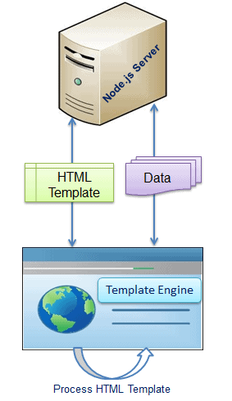

Figure 1. Template Engine (TutorialsTeacher, 2022)

The JSON/XML data, the HTML template, and the template engine library are all loaded from the server by the client-side browser as seen above. The final HTML is produced by the template engine utilizing the client's browser's data and template.

**Advantages of template engine:**

The Node JS template engine boosts developer productivity, which is a positive. More readable and maintainable. Accelerated performance. Enhance client-side processing. For several pages, a single template is used. Samples are accessible via CDN (Content Delivery Network).

**Disadvantages of template engine:**

On the downside, without a built-in template, there will be many changes and iterations before the user is satisfied with the end result when writing the code. Custom interface design takes a long time, and when time is limited, the interface may not perform as expected.

## Review of Methodologies

### Waterfall Method

The waterfall technique is the simplest and most often used version of the systems development lifecycle (SDLC) for software engineering and information technology. It follows a linear, step-by-step process. Typically, a graph is used to plan it out, with each task's start and end dates indicated. The phrase "waterfall" is used to describe a process that incorporates each phase of the process that depends on the preceding step, creating a single-direction process flow by building on prior foundations. For projects with a set scope, timeframe, and money, waterfalls work best (Balasubramani, 2021).

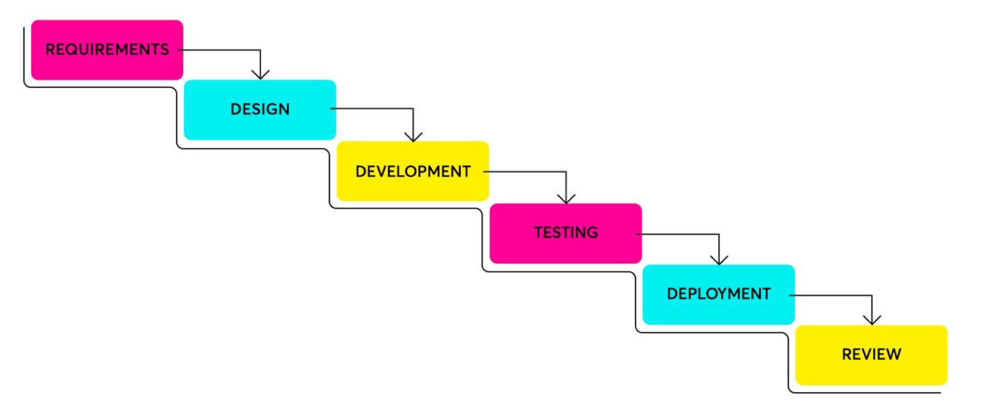

Figure 2. Waterfall method (Lyabik, 2022)

**Advantages of waterfall method:**

The Waterfall technique is best suited for straightforward, unchanging projects due to its strict, linear structure. Since it always proceeds in the same order for every project, it also makes the process pretty simple to manage and record. Every stage of every phase contains specified objectives and deliverables, as well as a review procedure, making it very simple to administer and maintain. Development teams need little to no introduction before beginning a project in the interest of simplicity (Balasubramani, 2021).

**Disadvantages of waterfall method:**

The Waterfall method's inability to adapt to change is by far the most prominent issue it has. Since each stage informs the next, it is nearly impossible to skip a step or jump between them when problems arise at any stage; instead, you must start over from scratch (Balasubramani, 2021).

### Agile Method

Agile software development is built on an incremental, iterative method, in stark contrast to the Waterfall method. Agile adopts a more open-minded and flexible approach that allows for changes and iterations as necessary. It's possible for requirements to alter at nearly any point during a project, thus extensive planning is not necessary before it starts. Agile promotes ongoing user feedback so that it may adjust to the consumers' shifting needs. The cross-functional units that make up development teams operate in iterations over time, with the creation of a usable product as the end aim of each iteration (Balasubramani, 2021).

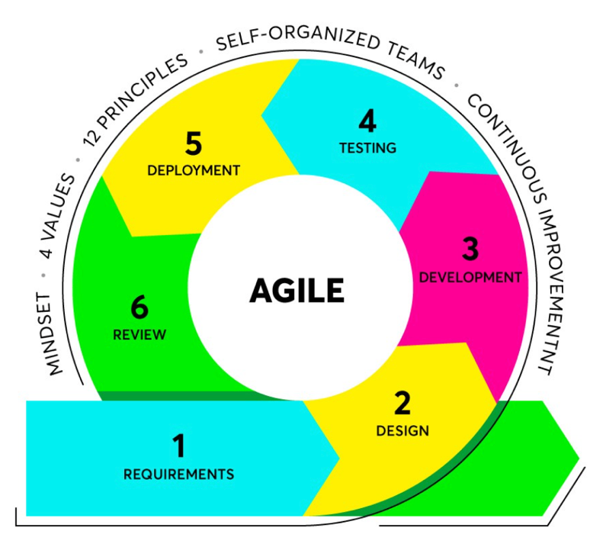

Figure 3. Agile method (Lyabik, 2022)

**Advantages of agile method:**

The most obvious feature of Agile is that it wholeheartedly values flexibility, speed, and most importantly, continuous improvement. Because pre-project planning is so loose, teams are not bound by a rigid system based on predefined constraints and are therefore free to adjust and change as necessary. Any stage of the process benefits from this flexibility because it fosters creativity and freedom. Backlogs can be adjusted and re-prioritized by development teams, allowing for rapid implementation of significant changes (Balasubramani, 2021).

**Disadvantages of agile method:**

Planning a project before beginning any actual work is less time-consuming than using the Waterfall technique, which may cause difficulties in locating the ultimate result. Some see this as a professional, while others see it as a con. Those who like set deadlines and schedules instinctively view Agile is flexibility as a scam. Naturally, delivery delays and scheduling problems can result from an Agile project's tendency to veer and bounce from one concept to the next. In essence, it complicates the project manager's job. It also means that the final product might not exactly match the initial objective (Balasubramani, 2021).

### Scrum Method

It is thought that Scrum, a branch of Agile, is the most widely used framework for putting Agile into practice. Scrum is merely one of several frameworks, methodologies, practices, and technologies connected to agile. To manage the development of complex software and products, this methodology, which is based on iterative software development, is utilized. By using sprints (timed iterations), which increase efficiency, the development team is able to release software on a regular basis. At the conclusion of each sprint, the team and stakeholders set new plans and actions that will improve the team's productivity (Balasubramani, 2021).

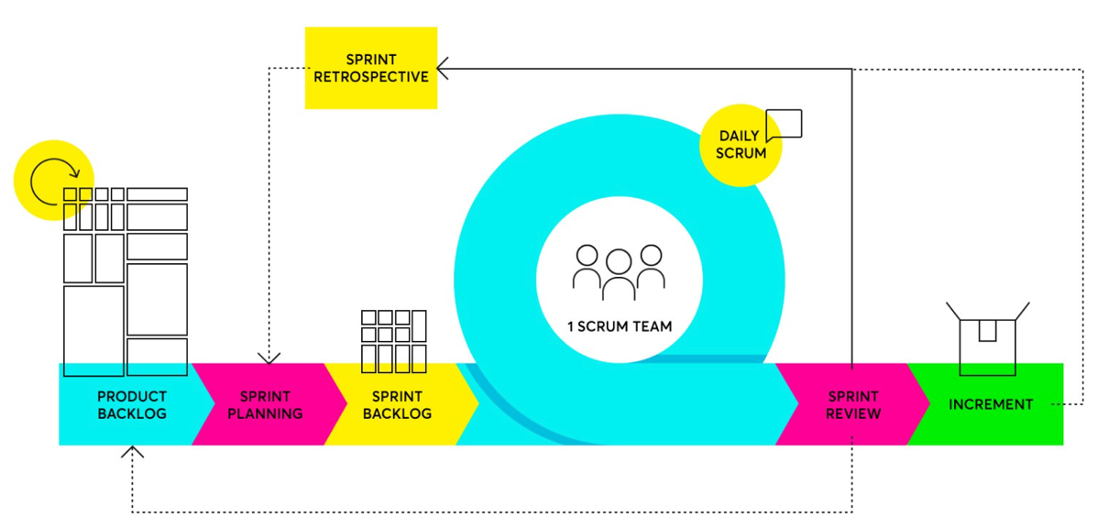

Figure 4. Scrum method (Lyabik, 2022)

**Advantages of scrum method:**

With a unique framework outlining the guidelines, roles and responsibilities, facts, and artifacts, Scrum adds an additional layer of structure to Agile. It enables ongoing improvement because of that. Daily team meetings are used to discuss the current state of the project and make plans for the next working day. This contributes to overall project transparency and aids in the early identification of problems that need to be fixed. It fosters a level of cohesion that enables mastery to develop when everyone is on the same page (Balasubramani, 2021).

**Disadvantages of scrum method:**

Given that Scrum is a subtype of Agile, a lack of project deadlines may result in ongoing additions of work, thus delaying completion. Additionally, the entire team's dedication to the project is crucial, as it is with any team that depends on divisional cohesion. The entire squad will fall apart if one member does. Thus, commitment and focus on both the part of the individual and the team are crucial (Balasubramani, 2021).

## Choosing solutions

### Technology

#### Back End

|  |  |  |
| --- | --- | --- |
|  | **Node JS** | **PHP** |
| **Coding** | Because the entire development environment is written in JavaScript, there is no need to learn other languages' syntax while coding. | PHP is even simpler because functions may be completed with less lines of code. However, be well-versed in the operation of operators and generators in LAMP. |
| **Performance** | Async nature characterizes Node.js. It makes use of the V8 JavaScript engine, which accelerates startup time and execution speed. | PHP is an older technology. Therefore, it has a different concept to handle requests, which is slower. |
| **Functionality** | Programming language Node.js unifies some of the most crucial components into a solitary, cohesive bundle without functional fragmentation. It enables you to build a full backend model. | PHP is a pure language. Therefore, its scope of development is limited. |
| **Frameworks** | Excellent libraries and frameworks are available for Node JS. Fast-paced framework development is typical of the JavaScript ecosystem. Express is a well-known Node framework that can do anything but doesn't have any built-in tutorials. It is a adaptable framework without any pre-installed default functionality. | It's not surprising that there are so many ready-made systems and frameworks you can use to create apps quickly and easily given that PHP has been one of the most widely used programming languages available for more than two decades. |
| **Modules** | Compared to PHP projects, Node JS projects are less reliable. As the community is still growing, the quality control system has not yet been implemented. | For many years, PHP has had the edge in this area. PHP has a larger library of modules. |
| **Request Handling** | The system does not have to wait for one process to finish before moving on to the next because many requests are processed asynchronously. RAM and CPU time are not being squandered here. | PHP can only process one request at once. As a result, more CPU and RAM resources are needed. |
| **Database** | With NoSQL databases like CouchDB and MongoDB, Node.js functions flawlessly and is fine. | The most popular database for building PHP websites is MySQL. |

(Vuollet, 2020)

The author chose to utilize Node JS to create the back end for his application after comparing the options in the table above. Because the Node JS programming language requires little understanding, it is simple to grasp code. Because Node JS employs the V8 JavaScript engine, which improves execution speed and has a quick startup time, the performance is quick. A bonus feature that gives Node JS an edge is powerful NPM. More project kinds, frameworks, and modules are available with Node JS. An author needs Node JS to create scalable web applications that routinely draw data from relational or conventional databases. It can carry out more processes with fewer resources in terms of request handling.

#### Front End

To complete the system on the front end, the author will use Template Engine (Handlebars). The first reason is that the code I write is easier to read and maintain. Because there are fewer instructions, the system will run faster. It also increases the processing power on the client side. Because the author's time is limited when it comes to coding, this front end is used for some pages, and a single template is used without much tweaking.

### Methodology

The Waterfall approach is the one that the author uses. The timing of the project can be determined early on because the project scope is generally static. The system is changed as little as possible, which reduces the need for repairs and reduces the need for design changes, thanks to early completion of the whole design. Within a set amount of time, the author's schedule can be efficiently organized. Due to the reasonable level of detail in the documentation, having a detailed design and documentation will make the project less difficult to complete on schedule.

# Requirements analysis

## Google classroom

With Google Classroom, teachers may set up an online learning environment where they can keep track of all the resources their students require. Google Docs, Sheets, and other Drive apps allow users to edit documents that are stored on Google Drive. However, the teacher/student interface that Google created for how teachers and students think and work sets Google Classroom apart from the standard Google Drive experience. Teachers may give their students homework. Teachers can submit the content that students will need to read or complete when they create assignments. A new assignment is announced through email to the students. After finishing their work, students "submit" it so that you can grade it. Through the Class interface, students can contact one another, comment on assignments and announcements, and send messages to the class as a whole (Cains, 2016).

**Advantages of Google classroom:**

The document sharing, data collection, communication channels, and closed environment of Google Classroom are major advantages. It's simple to start a class because there are clear tutorials available to help you every step of the way. Sharing is even simpler when you've added students; all you have to do is share the material to the entire group. I've always valued the ability to establish a reusable work archive for Google apps, which includes lesson plans, assignments, contact information, grades, and more. Throughout an assignment, comments are possible at any time. Students may ask questions in response to tasks posted by teachers. Those who choose not to speak in front of the class can still seek assistance online. Teachers can offer guidance as students work by making comments on their progress (Scragg, 2018).

**Disadvantages of Google classroom:**

It is difficult or impossible to share items with the larger school community, community, or parents — even if you wanted to — due to the closed and private environment, which has drawbacks. Google Classroom does not have a formal gradebook, even though student grades are scored. Supervisors can export Google Sheets into generic database files that work with other gradebook applications, but that requires a separate and laborious step (Scragg, 2018).

## Classkick

Direct worksheet uploads and assignment of activities are both possible for teachers. They may already have access to this resource or they may create new ones directly within the Classkick app. Students will be given a Classkick code to log in. Teachers may grade assignments instantly on the app, which is another wonderful feature. Teachers may also provide comments or stickers as forms of feedback. By entering the name and code that the teacher has provided, students log into their accounts. They will be able to either type the answer or draw it using the drawing tool and mouse (Hull, 2022).

**Advantages of Classkick:**

One benefit of the Classkick app is that it gives teachers real-time access to every student assignment. Students are able to assist one another and form bonds. The app works quickly in terms of response time. Learning can also make use of text, audio, video, and images. The application encourages users to use less paper because it takes advantage of electronic devices (Mackey, 2020).

**Disadvantages of Classkick:**

The Classkick app offers a ton of extra expensive capabilities, like the ability to export grades and assignments and integrate a teacher's classroom from Google Classroom, so there is one drawback. In the free edition, each teacher is only allowed to assign a maximum of 20 exercises ((Mackey, 2020).

## Conclusion

There have been a number of similar applications in the past, but the author only included the basic functions that a classroom management application should have. The author has identified the main features of the application that the author does based on previous similar applications. The first function is that students can join the teacher's class by entering the code provided by the teacher. The second feature allows teachers to create assignments and post exercise files for students to download and complete. The third function is that teachers can view and grade students' assignments after they have been submitted.

# Software design

## Architecture

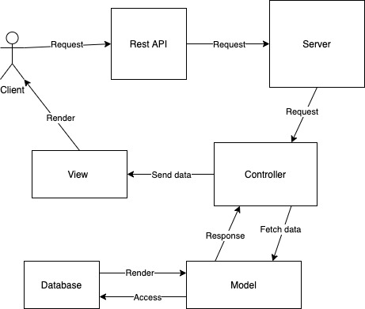

Figure 5. Architecture Diagram

The first is that in the view, the user sends a request to the server via a http client for a rest api, and the request is sent to the route at the server that matches the api that the user has submitted, and the request is then put into the controller corresponding to that route, and the controller sends data to the model to find the database. The database will then find information and send data back to the model, after which the model will send the results to the view to meet the user's needs, after which the view will send back to the user a render, and finally the view on the user's side will display html based on the data from the response.

## GUI

The wireframe of the Teacher and Student list management page is shown below. Users with the Admin role can see all of the Teacher and Student lists, and they can also add, edit, and delete users with the Student or Teacher role. Furthermore, admin can search for any user by first name and see detailed information immediately after pressing "ENTER."

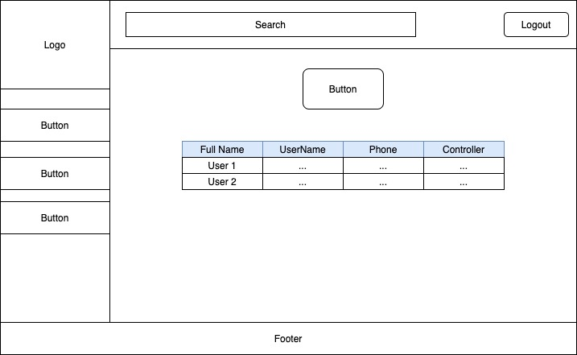

Figure 6. Wireframe Manage Users (role Admin)

The following page manages the Teacher role's assignment items. When a teacher enters a class, he or she can post the work in that class for all students to see.

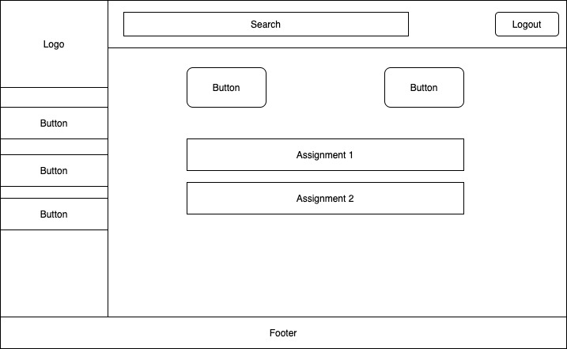

Figure 7. Wireframe Manage Assignments (role Teacher)

The teacher can view the student's submitted work on this page. You can grade the Student on a 100-point scale and comment on the Student's submitted work after viewing.

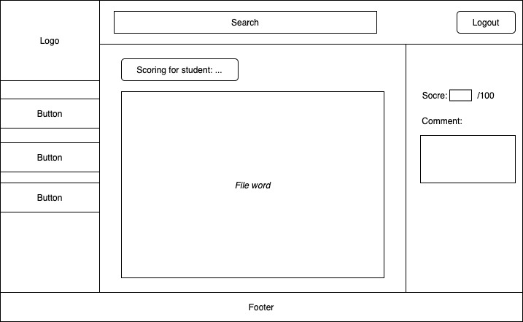

Figure 8. Wireframe scoring for Students (role Teacher)

This is the Student's page. Students can do the exercise by downloading the assignment file link. Students can submit their submissions and see their scores on this page once the Teacher has graded them, as well as the Teacher's comments. Additionally, students can comment on this exercise, and teachers can view and comment on this page.

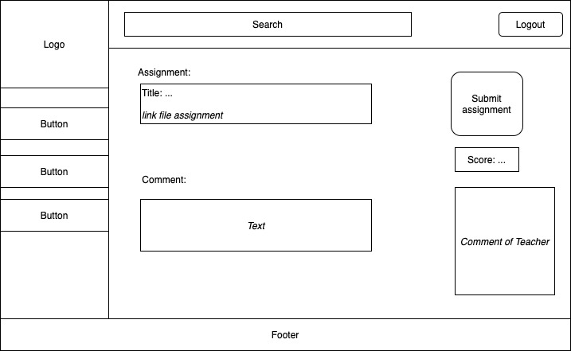

Figure 9. Wireframe View Assignment (role Student)

## DB

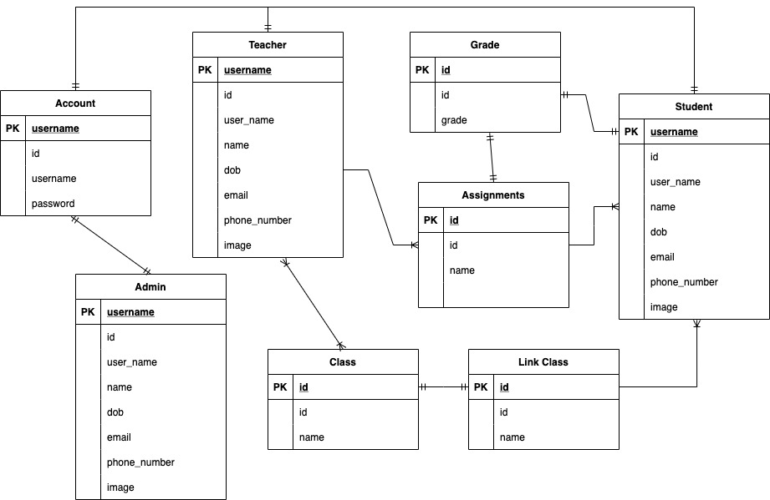

Figure 10. Database

Each user has only one Account when data is used as the Account.

Teacher - Class: A Teacher can enter multiple Classes, and a Class can also place multiple Teachers.

Class - Link: Each class has only one link for students to join.

Link - Student: This is a single link that will be shared with many students.

Teacher - Assignment: In a class, a teacher can assign multiple assignments.

Assignment - Student: An Assignment can be distributed to a large number of students.

Student - Grade: The Student will receive the number of points associated with each Assignment.

## UML

### Use case diagram

In terms of user and class management, the Admin role will have access to functions such as adding, editing, and deleting Student, Teacher, and Class lists. Additionally, the Admin role has the ability to assign Classes to Teachers and Students. The Teacher role also allows the Teacher to create his own classes and post assignments from those classes. The Teacher can grade the assignment for the Student after the Student submits it. The Student role allows the Student to join any class by entering the link to that class. The list of people in the class is visible to both the teacher and the student. Furthermore, all users have the ability to view and edit their own information.

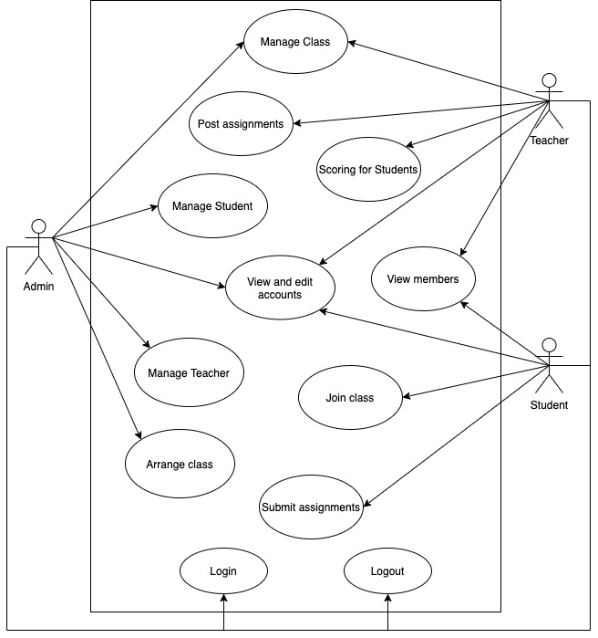

Figure 11. Use Case Diagram

### Activity diagram

The process of creating the Admin role class is depicted in the image below. After creating the class, the administrator can assign Teachers and Students to it.

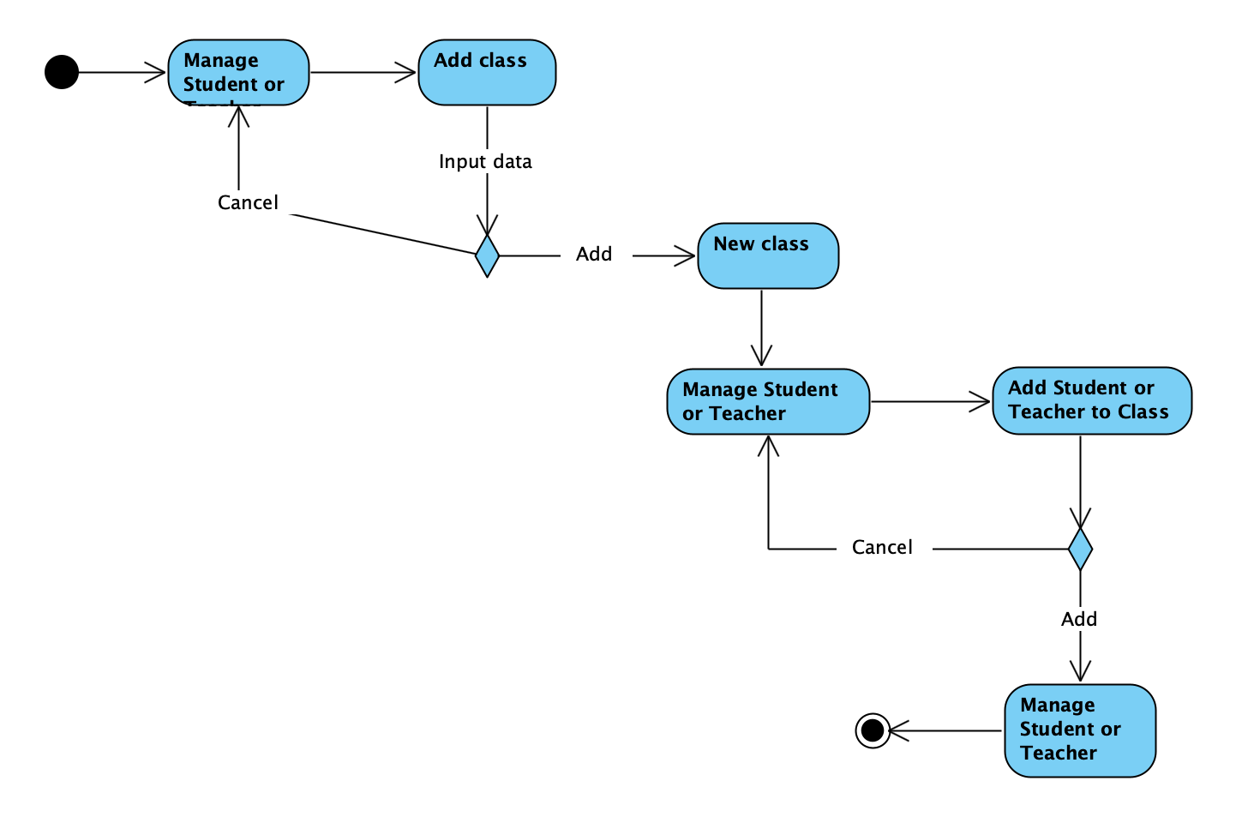

Figure 12. Activity Diagram manage Class (role Admin)

The procedure for posting and grading Teacher's assignment is outlined below. The Student can view and download the assignment to do after the Teacher posts it. The Student will then submit the assignment, and when the Teacher receives it, the Teacher will grade and comment on the Student's submitted work. After scoring and commenting, the results will be sent to the student.

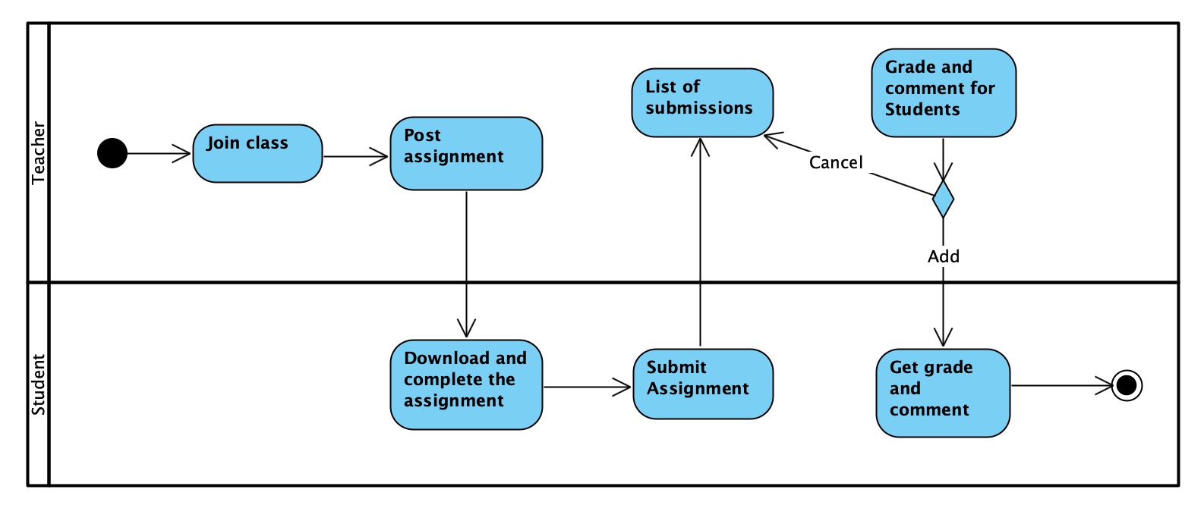

Figure 13. Activity Diagram work with assignment

# Software implementation

## Development environment

Installing Visual Studio Code is the first step in the author's coding process. A quick source code editor is at the heart of Visual Studio Code, making it ideal for regular use. With hundreds of language support and features like syntax highlighting, bracket matching, auto-indent, check boxes, snippets, and more, VS Code helps you be productive right away. You can easily browse your code thanks to intuitive keyboard shortcuts, simple modification, and community-contributed shortcut mapping. The same underlying technologies that power Visual Studio also power VS Code, which offers comprehensive integrated support for Node.js development with JavaScript and TypeScript. Excellent web development tools are also included in VS Code, including those for JSX/React, HTML, CSS, SCSS, Less, and JSON.

Using a vast ecosystem of extensions, Microsoft's open-source, cross-platform editor functions more like a full-fledged IDE. VS Code was used for 18,637,503 hours of programming in 2020, compared to only 3,087,864 hours for Chrome, the editor that came in second (Ramel, 2021).

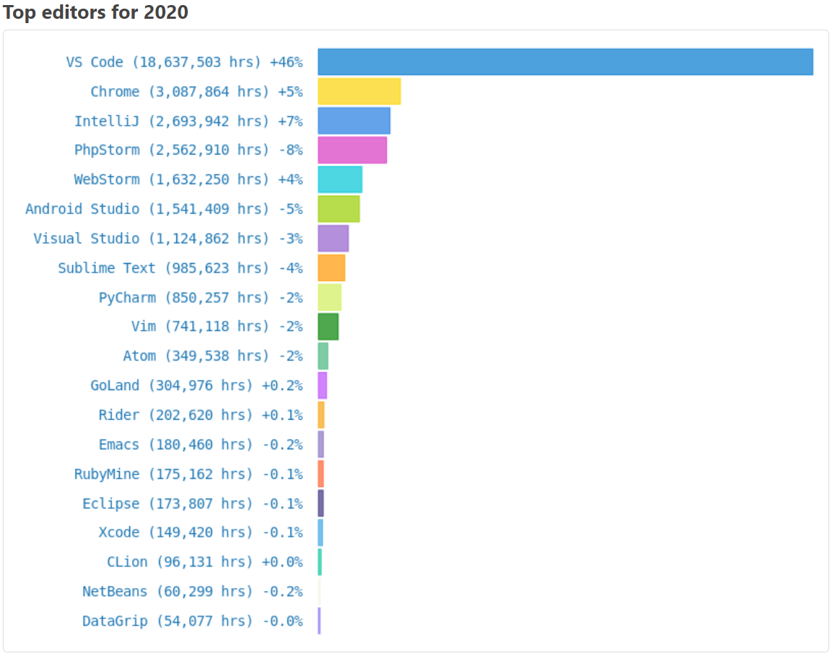

Figure 14. Top Editors for 2020 (Ramel, 2021)

The author will install npm, which stands for Node Package Manager. It is a library and registry for JavaScript software packages. It also has command line tools to help you install different packages and manage their dependencies. The author will then install express, which is a node js web application framework with numerous features for developing web and mobile applications. It is employed in the development of single-page, multi-page, and hybrid web applications. It is a Node js layer that helps manage servers and routes.

Next, Express is installed by the author. The most well-liked Node.js web framework is Express.js. It is said to as the de facto standard server framework for Node.js and is made for creating online applications and APIs. It might be tough and time-consuming to create the backend from scratch for an application in Node.js. Building all the boilerplate code, such as port configuration and routing handlers, takes away time from writing business logic for an application, which is what truly important. Web frameworks like Express.js allow developers to focus on other crucial activities while saving time. A web server waits for HTTP requests from the client in conventional web applications. When an HTTP request is received, the server chooses the appropriate routing handler and transfers further responsibility for that request to that handler. Typically, developing a route handler from scratch in Node can be a little challenging. Thankfully, Express offers ways to select the function to call for each each HTTP verb (GET, POST, PUT, etc.) and URL pattern (Route). In the code below, an example of an Express route is displayed. Here, Express is declaring that all GET requests made to the "/" route will be handled by a function that responds to the client using the Login page:

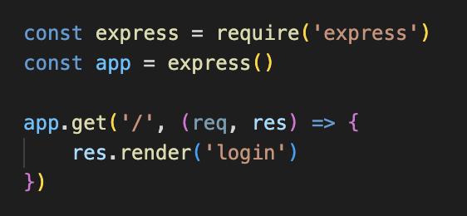

Figure 15. Code using Express

The author then installs hbs in order to create the front end. Handlebars js is a templating engine similar to the ejs module in node.js, but more powerful and easier to use. It ensures minimal templating and is a logic-free engine that separates view and code. It can be used with express as an hbs module, which is available via npm. HandleBars can be used to render web pages to the client from data on the server side. Finally, the author installed MongoDB in order to save data to the database. MongoDB is a document-based database that is open source, cross-platform, and distributed. It is designed to make application development and extensibility easier. MongoDB stores data in the form of JSON-based documents that are not schema-enforced. It enables the author to store hierarchical data in a document, making data storage and retrieval easier.

For the system's data management, the author installs MongoDB last. An open source, NoSQL database management system written in C++, MongoDB is cross-platform and available for free. In MongoDB, records are stored as text data, a data structure made up of value pairs and fields akin to JSON objects.

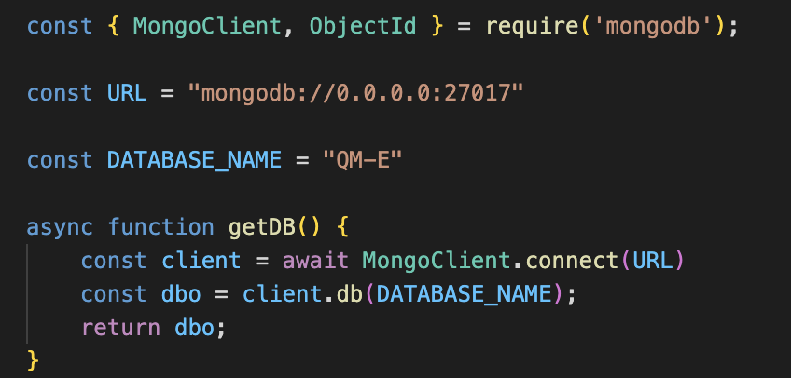

Figure 16. Database creation and connection process

The author further installs nodemon. A well-liked tool for creating Node.js-based applications is Nodemon. Every time it notices changes in the files present in the working directory for the author's project, it merely restarts the node application.

**Project directory structure:**

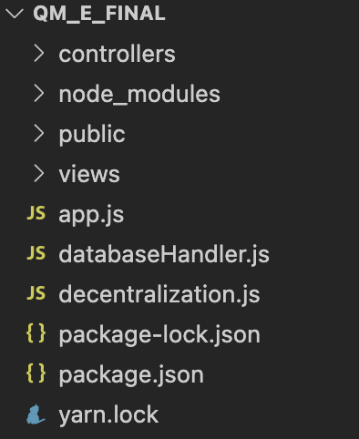

Figure 17. Project directory structure

Controllers - This component manages the business-related tasks prompted by the pages and serves as a liaison between the user and the program. In order to expose user actions and anticipated results, intermediate-level endpoints are scripted using controllers.

Public - This is where the software's CSS is stored. The user's images and the user's word links posted. From this section the author can access here to get information from the required items.

Views - This is the part of the page that uses html to display the user interface.

DatabaseHandler.js - This is the item used to connect and work with the database.

Package.json - This is where the project's heart is. It specifies the functional aspects of the project that npm utilizes to install dependencies and run scripts, as well as critical project metadata that must be recorded before publishing to NPM.

## Important technical problems & solutions

The author's first challenge was organizing the students and teachers into a class. Adding people one by one and then rerunning the application will take a long time. So the author used a check box to accomplish this. Also, if else is used to add class names to Student's data. First, the author declares the id in order to obtain the id of the selected Student in order to add the Class to that Student. The next step is to access the data of all classes in order to filter all classes. The author then creates a new array, and if the data in the Student is empty, it can be added, and if it is different, it can add the data from the Class to the Student. Finally, use the checkbox so that when checked, it will add the Class to the Student, and if the check is removed, the data of the Class will be deleted from the Student.

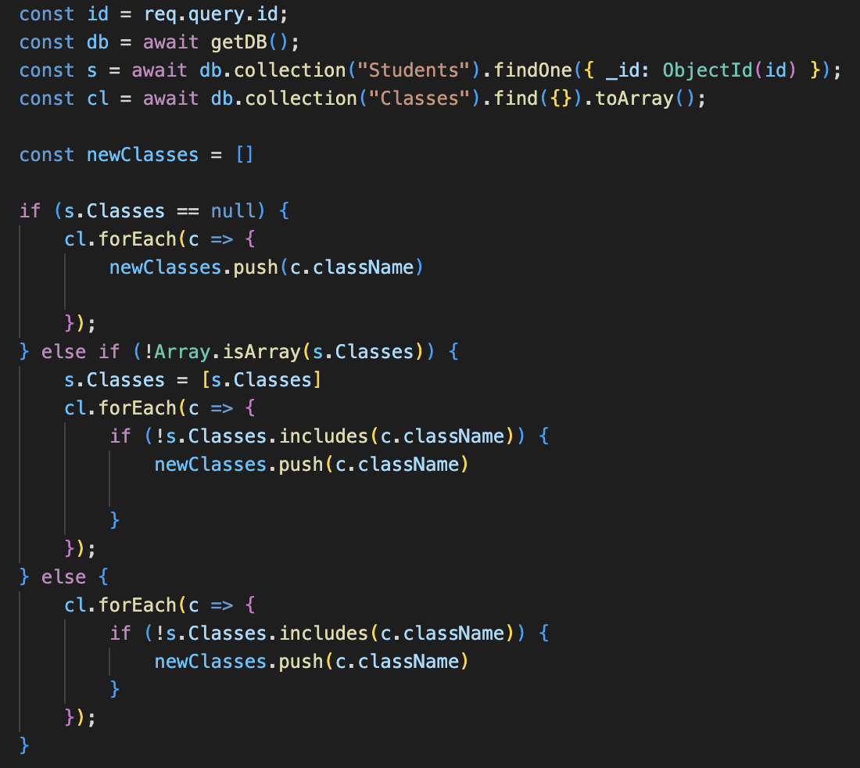

Figure 18. Code create an array containing Student's Class

After uploading the file, the author faces the next challenge of figuring out how to download it so that when the teacher posts the exercise, the students can download it and complete it. The author's solution is to install the adm-zip package, which allows users to download the file as a zip file. The adm-zip package is an npm package for compressing zip data and allowing you to extract zip files to disk or a memory buffer.

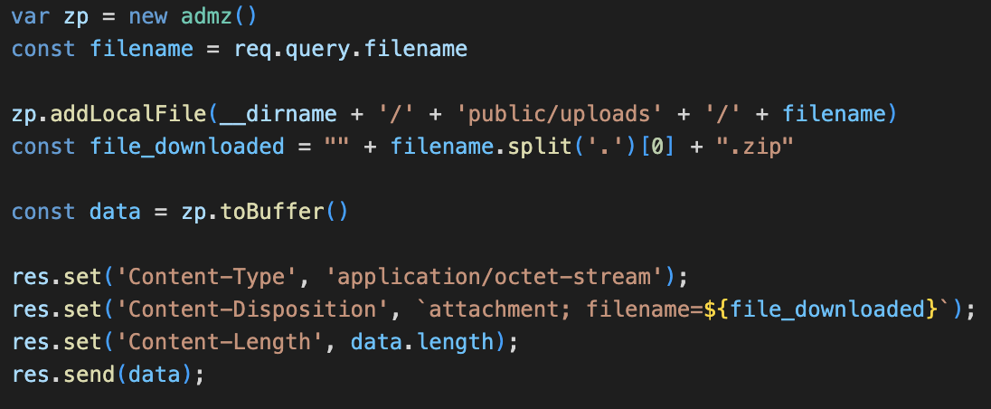

Figure 19. Code download file zip

## Test

|  |  |  |  |  |  |  |
| --- | --- | --- | --- | --- | --- | --- |
| ID | Case | Type | Input | Expected Result | Actual Result | Status |
| 1 | Login | Normal | Enter the correct username and password | User can login to the homepage with the role corresponding to the account | As expected | Pass |
| 2 | Login | Validation | Enter wrong username or password | The system will not be able to log in | As expected | Pass |
| 3 | Logout | Normal | Click the "Logout" button | The system will log out to the Login page | As expected | Pass |
| 4 | Create User | Normal | Enter information of User | The system will return the management page corresponding to the newly added data | As expected | Pass |
| 5 | Create User | Validation | Enter wrong information: import image file as docx | The system will report an error and notice that only png or jpg files can be used | As expected | Pass |
| 6 | Edit User | Normal | Enter the information you want to edit | The system will return the information page with the corrected information | As expected | Pass |
| 7 | Delete function | Normal | Click on any "Delete" button on any list management page | The system will delete that data | As expected | Pass |
| 8 | Class placement for Teacher and Student | Normal | Tick the classes that the user wants to put Student or Teacher in | If Student or Teacher is marked with Classes, when logging in with the Student or Teacher role, they will see a list of their classes. | As expected | Pass |
| 9 | Scoring for Student | Normal | Teacher enters score and comments for Student's submitted assignment | In the Student role, Teacher's grades and comments will be displayed | As expected | Pass |
| 10 | Scoring for Student | Validation | Teacher entered too many points on a scale of 100 or less than 0 | The system reported an error of entering the wrong number of points within the allowed range | As expected | Pass |
| 11 | Download file zip | Normal | User clicks on assignment link | The system will download the zip file of that link to the server | As expected | Pass |
| 12 | Student join class | Normal | Student enters Class name | Student will be joined to the corresponding Class named Class | As expected | Pass |
| 13 | Student join class | Validation | Student entered wrong Class name | The system will display an error saying "there is no such class" | The system does not report an error | Fail |

## Results

First, when logging in to any role, the system will display the home page of that role. Here is the admin homepage:



Figure 20. Homepage of admin

When entering the Manage Student page, the system will display a list of Students:

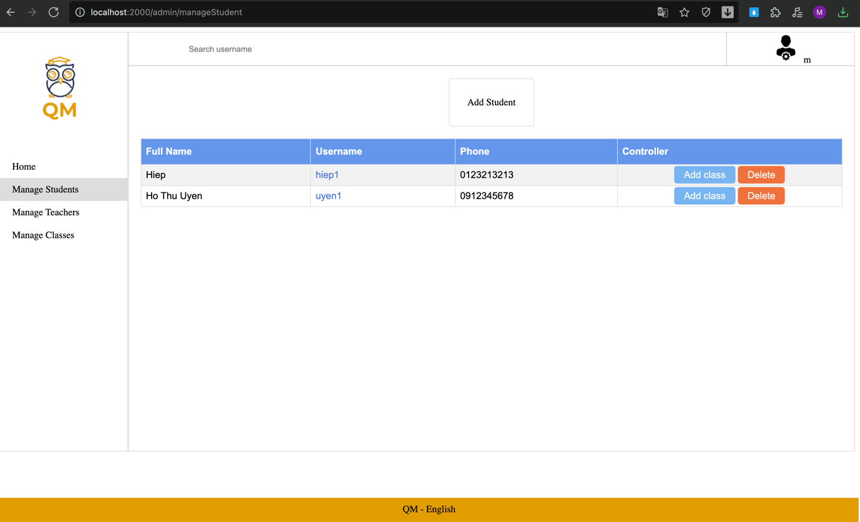

Figure 21. Screenshot Manage Student

When clicking on any Username, the system will display detailed information of that Student:



Figure 22. Screenshot Detail User

When clicking "Add Student", the system will display the information entry page of the Student you want to add:

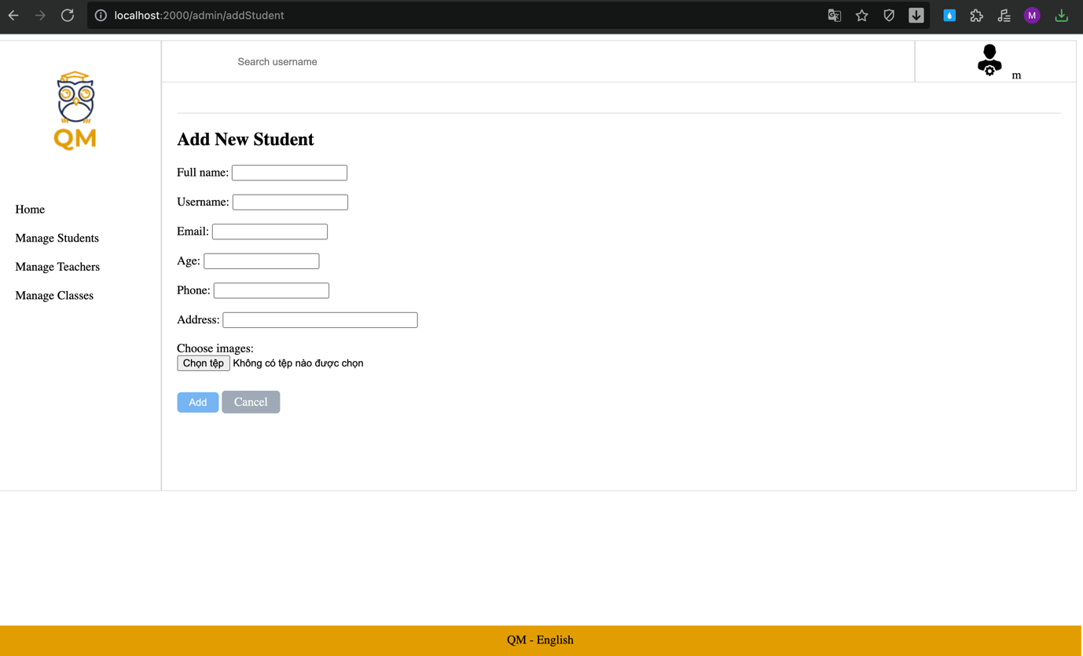

Figure 23. Screenshot Add Student

When the admin wants to put the Teacher into a certain class, when clicking "Add Class" in Manage Teacher, the system will display a page to check the Classes that the Admin wants the Teacher to enter that class:

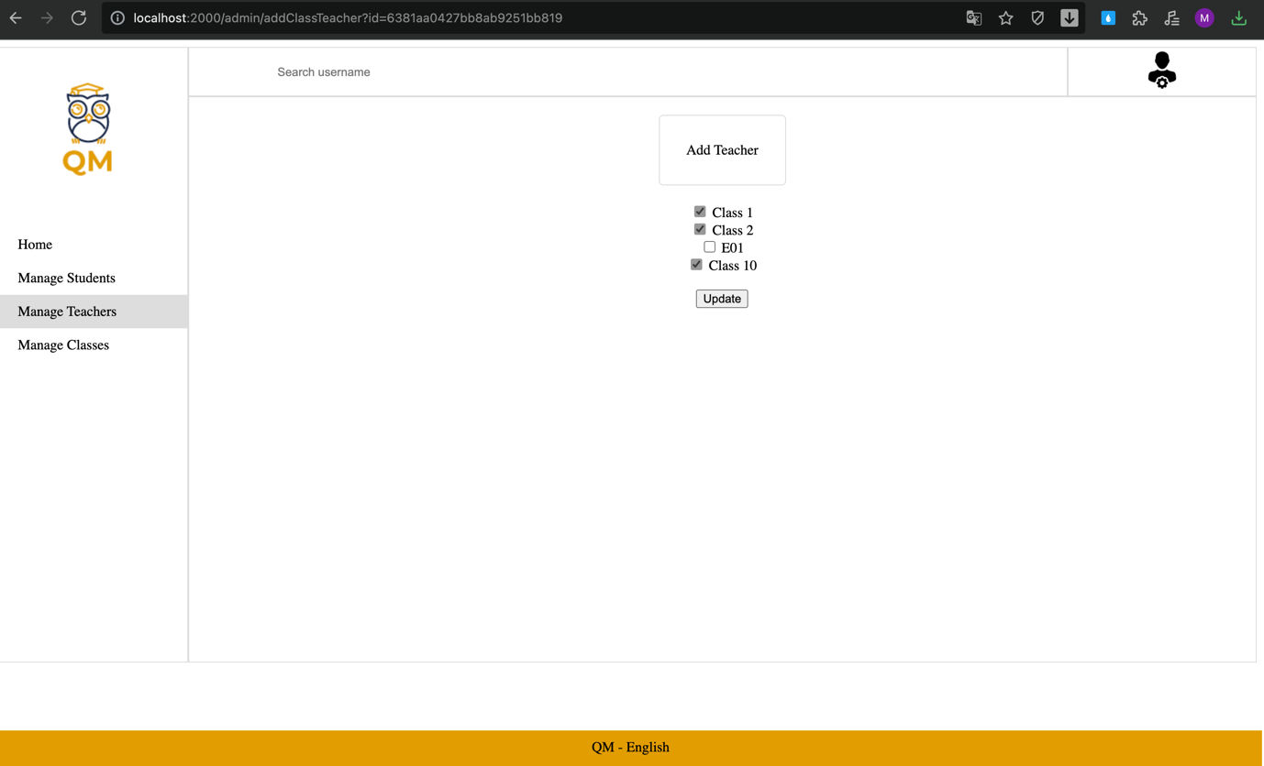

Figure 24. Screenshot Add Teacher to Classes

When you go to the Teacher role page and go to the "Classes" section after adding the Teacher to the Class, the system will display the Classes that the Teacher has added corresponding to the marks that the Admin has previously marked:

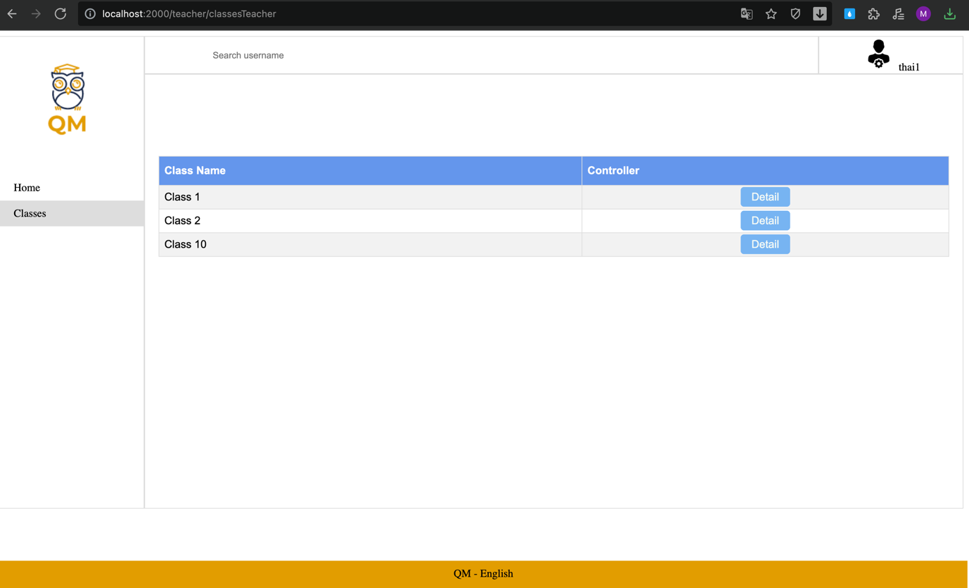

Figure 25. Screenshot list classes of teacher

When Teacher clicks "Detail" button, the system will display the page of that Class and Teacher can post assignment to that Class:

For Student, when you want to join a Class, in addition to Admin can add, Student can also enter the name of the Class you want to join to join that Class:

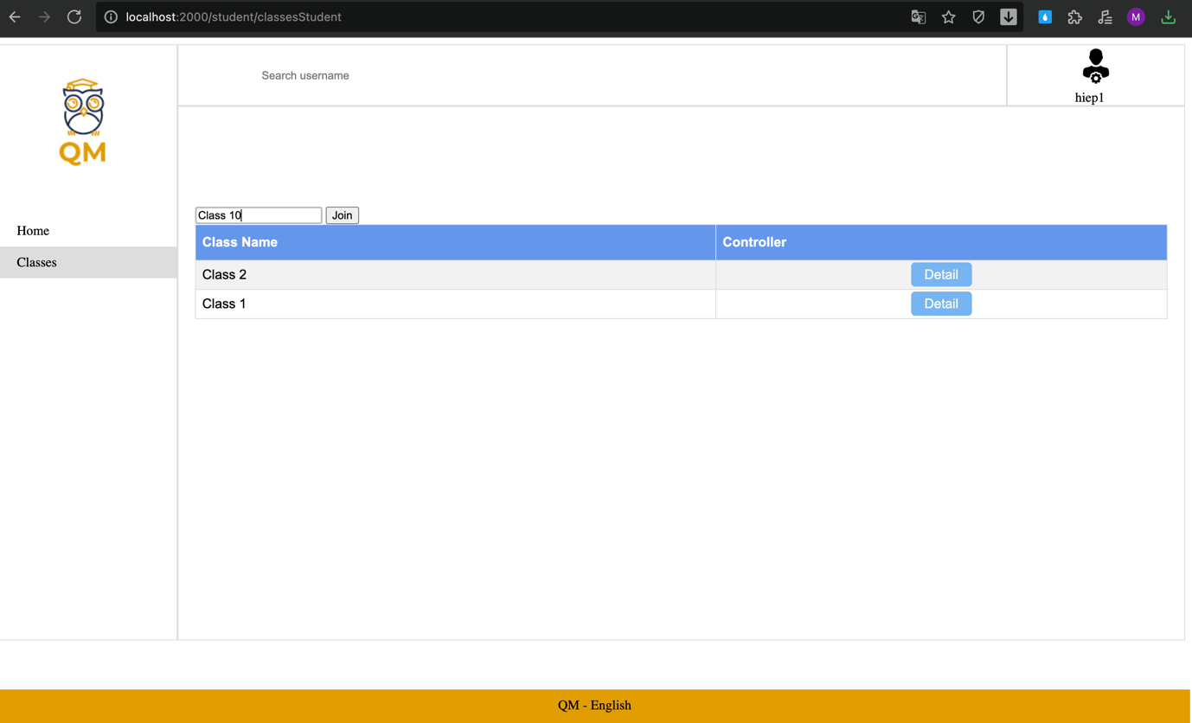

Figure 26. Screenshot student join class with class name

After entering the class name and clicking the "join" button, the system will display the Class that the Student has just joined:

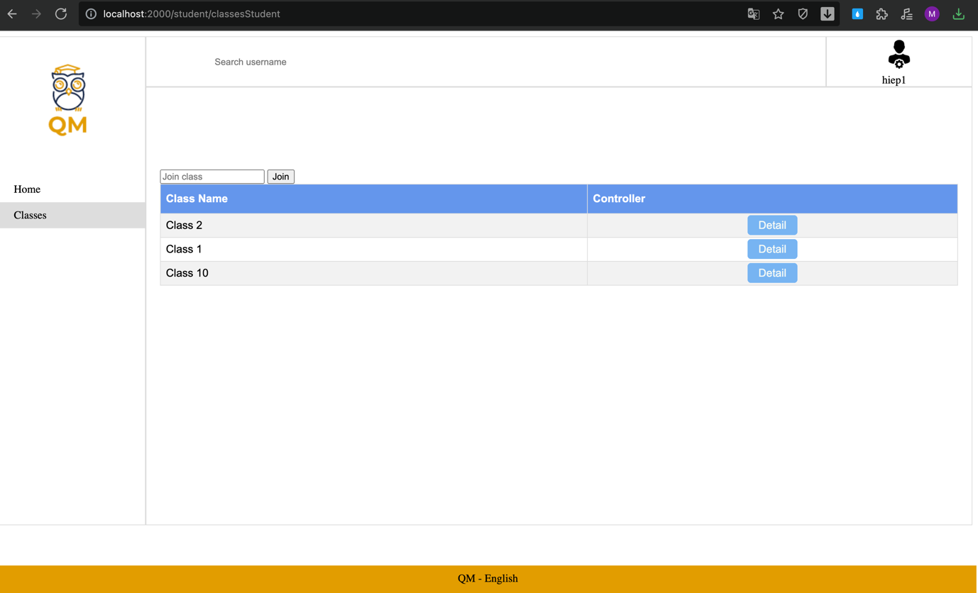

# Evaluation and conclusion

## Evaluation of results

**Advantages**

The first advantage of this author's application is that the system's performance is quite fast, with all operations and functions responding quickly after the user creates a specific function. Second, the interface is simple to use and not overly colorful or eye-catching. Finally, this application is simple to use; users can use it without any instructions for the first time.

**Disadvantages**

Because this is the first time the author creates an application that the author thinks and learns and then designs, the application's interface is still too simple. The functions for a classroom management software are few. In addition, there are some author functions that are not completely completed, so there are some logical errors.

## Conclusion

**Lessons learnt**

The author has learned the most important lesson about the distribution of working time. Because the author postponed the project work until the new implementation date, the project did not finish on time.

**Problems / difficulties**

The author also had many problems with coding, the author took a lot of time to create an application with the required functions. Although it took a long time, the results obtained were still not as expected by the author.

**Future improvements**

In the future, the author will practice a lot about coding, learn more English so that he can read many useful documents in English to improve his level of coding.

**Conclusion**

The author gained a lot of experience when implementing a project to create software that requires important things such as planning, design, and so on through the implementation of this graduation project, so that after graduation, Fake will no longer be surprised when going to work.

# Appendix

* Final plan
* Screenshots (optional)

# Reference

Cini, S. (2020) *Seven key elements for effective classroom management*, *Synonym*. Available at: https://classroom.synonym.com/seven-elements-effective-classroom-management-6562940.html (Accessed: November 27, 2022).

Johnson, D. (2021) *What is google classroom?*, *Lifewire*. Lifewire. Available at: https://www.lifewire.com/what-is-google-classroom-4845937 (Accessed: November 27, 2022).

Stewart, D. (2008). Classroom management in the online environment. *Journal of online learning and teaching*, *4*(3), 371-374.

Fedyk, Y. (2020) *Pros & Cons of using node.js - why to use node.js?*, *Inverita*. Available at: https://inveritasoft.com/article-pros-&-cons-of-using-node-js-why-to-use-node-js (Accessed: November 25, 2022).

Cains, J. (2016) *What is google classroom?*, *dummies*. Available at: https://www.dummies.com/article/technology/software/google-products/what-is-google-classroom-144820/ (Accessed: November 25, 2022).

Hull, R. (2022) *Classkick: A review from a first grade teacher*, *Teaching Firsties*. Available at: https://teachingfirsties.com/classkick-a-review-from-a-first-grade-teacher/ (Accessed: November 25, 2022).

Barron, S. (2020) *What is a virtual classroom?*, *Owl Labs Blog*. Available at: https://resources.owllabs.com/blog/virtual-classroom (Accessed: November 27, 2022).

Johnson, D. (2021) *What is google classroom?*, *Lifewire*. Lifewire. Available at: https://www.lifewire.com/what-is-google-classroom-4845937 (Accessed: November 27, 2022).

Vuollet, P. (2020) *Comparison: Node.js vs. php*, *Stackify*. Available at: https://stackify.com/node-js-vs-php/ (Accessed: November 27, 2022).

BasuMallick, C. (2022) *What is a single-page application? architecture, benefits, and challenges*, *Pros and Cons of Single-Page Applications*. Available at: https://www.spiceworks.com/tech/devops/articles/what-is-single-page-application/ (Accessed: November 27, 2022).

*Template engines for Node.js* (2022) *TutorialsTeacher*. Available at: https://www.tutorialsteacher.com/nodejs/template-engines-for-nodejs (Accessed: November 27, 2022).

Lyabik, T. (2022) *Waterfall vs agile vs Scrum: What's the difference?*, *WeAreBrain Blog*. Available at: https://wearebrain.com/blog/software-development/waterfall-vs-agile-vs-scrum/ (Accessed: November 27, 2022).

Balasubramani, V. (2021) *Agile vs Scrum vs waterfall: Choose the Right Software Development Approach*, *MUO*. Available at: https://www.makeuseof.com/agile-vs-scrum-vs-waterfall/ (Accessed: November 27, 2022).

Scragg, S. (2018) *Pros and cons of google classroom*, *A union of professionals*. Available at: https://www.uft.org/news/teaching/linking-learning/pros-and-cons-google-classroom (Accessed: November 28, 2022).

Mackey, S. (2020) *Pros and cons*, *The Secret Life Of a High School Teacher*. Available at: https://shelbymackey.wordpress.com/tag/pros-and-cons/ (Accessed: November 28, 2022).

Ramel, D. (2021) *Time Tracker says vs Code is no. 1 editor for DEVS, some working 15+ hours per day*, *Visual Studio Magazine*. Available at: https://visualstudiomagazine.com/articles/2021/01/13/wakatime-vs-code.aspx (Accessed: November 29, 2022).