Subject: Data Structure and Algorithms

Code: CSD201

Assignment1 Report

Title: Domitory_Management

Group number: 04

Members:

1. Trần Đức Anh - HE190049

2. Nguyễn Bảo Nam - HE19091

3. Ngô Đức Anh - HE190128

4. Đặng Đức Minh - HE190158

5. Ngô Minh Nhật - HE190217

**Tasks status**

|  |  |  |  |
| --- | --- | --- | --- |
| **Name/ Number** | **Content** | **Member** | **Status** |
| **1. RoomList** |  |  |  |
| 1.1. | Load data from file | Đặng Đức Minh | Done |
| 1.2. | Input and Add to the end | Đặng Đức Minh | Done |
| 1.3. | Display Data | Ngô Minh Nhật | Done |
| 1.4. | Save room list to file | Đặng Đức Minh | Done |
| 1.5. | Search by rcode | Nguyễn Bảo Nam | Done |
| 1.6. | Delete by rcode | Nguyễn Bảo Nam | Done |
| 1.7. | Sort by rcode | Nguyễn Bảo Nam | Done |
| 1.8 | Input & Add to beginning | Nguyên Bảo Nam | Done |
| 1.9 | Add before position k | Ngô Minh Nhật | Done |
| 1.10 | Delete position k | Ngô Minh Nhật | Done |
| 1.11 | Search by name | Ngô Minh Nhật | Done |
| 1.12 | Search booked by rcode | Đặng Đức Minh | Done |
| **2. StudentList** |  |  |  |
| 2.1. | Load data from file | Đặng Đức Minh | Done |
| 2.2. | Input and Add to the end | Trần Đức Anh | Done |
| 2.3. | Display data | Trần Đức Anh | Done |
| 2.4. | Save student list to file | Đặng Đức Minh | Done |
| 2.5. | Search by scode | Ngô Minh Nhật | Done |
| 2.6. | Delete by scode | Trần Đức Anh | Done |
| 2.7. | Search by name | Trần Đức Anh | Done |
| 2.8 | Search lending books by scode | Trần Đức Anh | Done |
| **3. BookingList** |  |  | Done |
| 3.1. | Load data from file | Ngô Đức Anh | Done |
| 3.2. | Book the room | Ngô Đức Anh | Done |
| 3.3. | Display data | Ngô Đức Anh | Done |
| 3.4. | Save booking list to file | Ngô Đức Anh | Done |
| 3.5. | Sort by rcode + scode | Ngô Đức Anh | Done |
| 3.6. | Leave the room by rcode + scode | Ngô Đức Anh | Done |

**Tasks results (Screen short):**

**1. RoomList**

**1.1. Load data from file**

**Input: data in file**

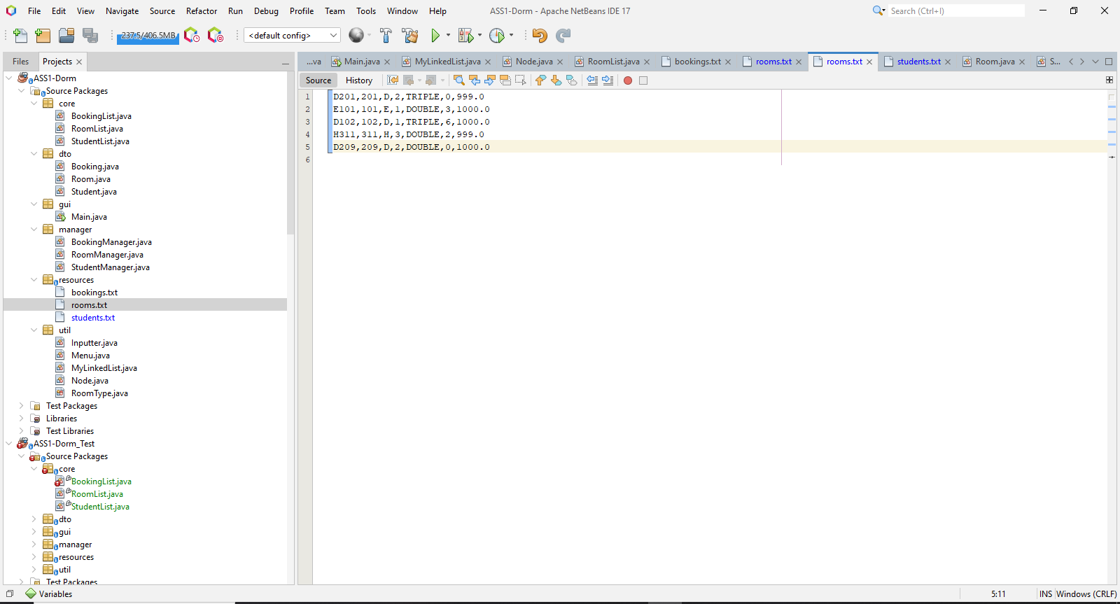

**Output: screen after loading data**

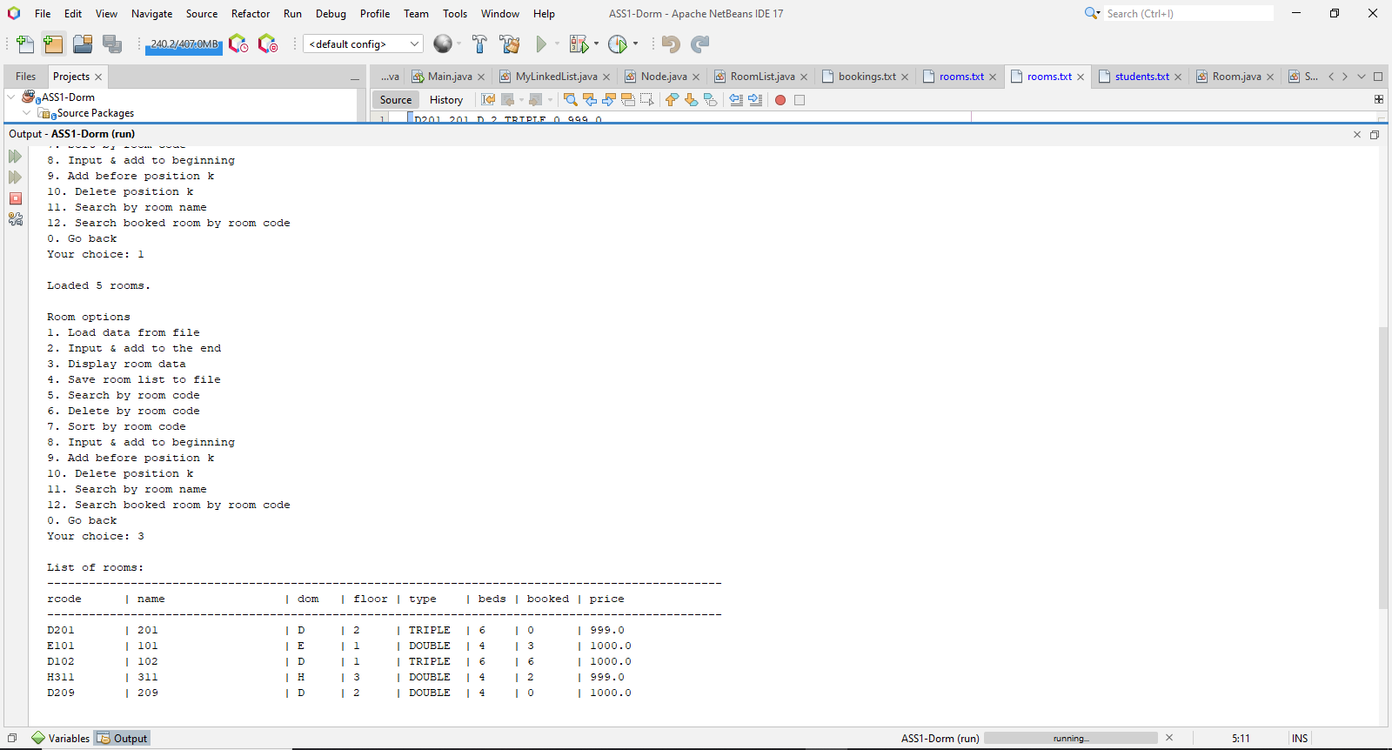

**1.2. Input and Add to the end**

**Input: screen enter data**

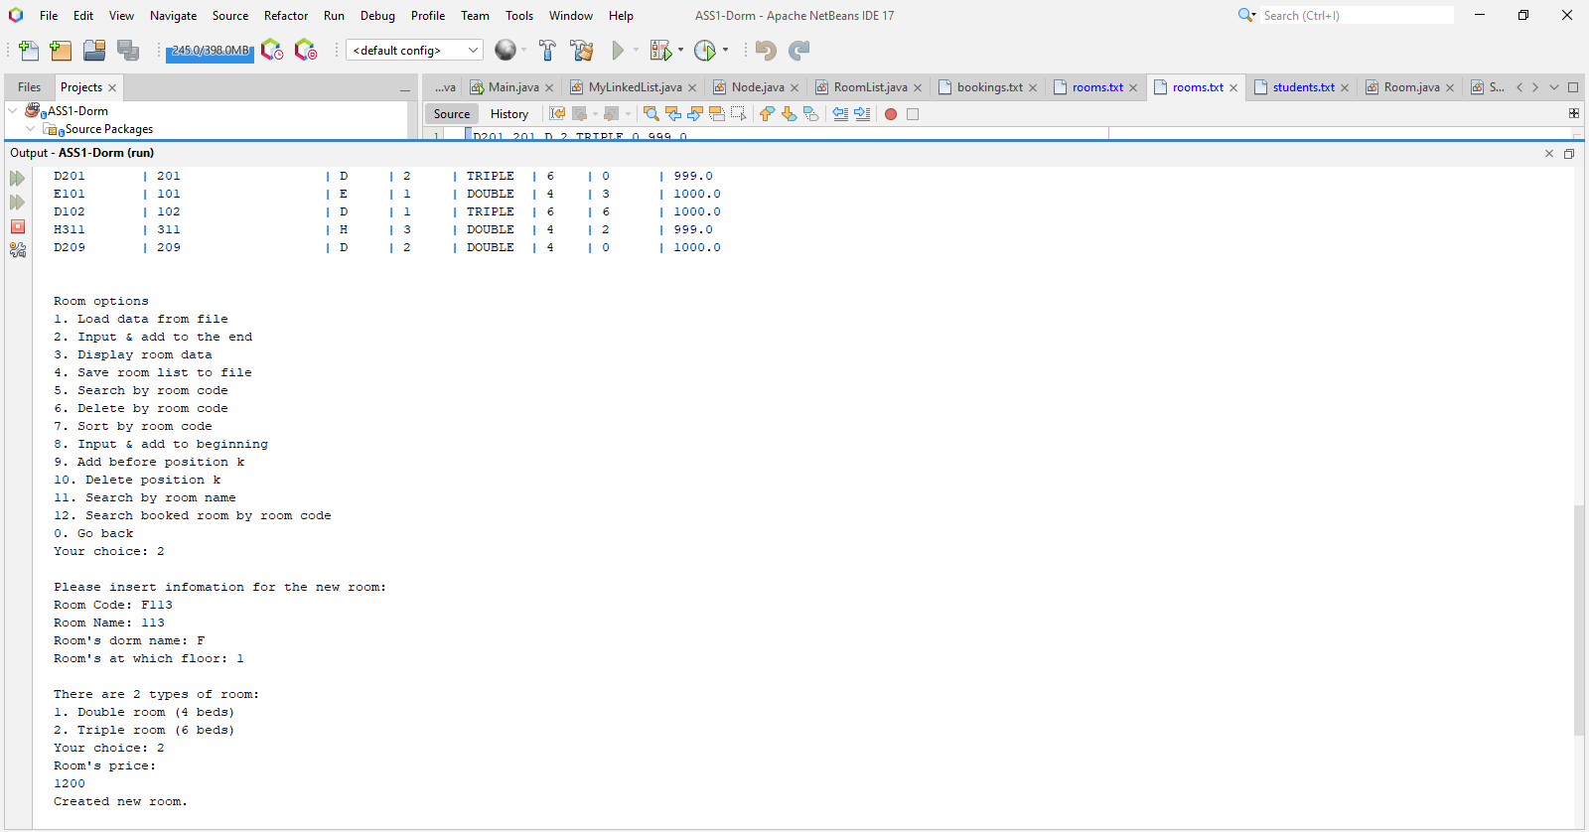

**Output: screen after entering data**

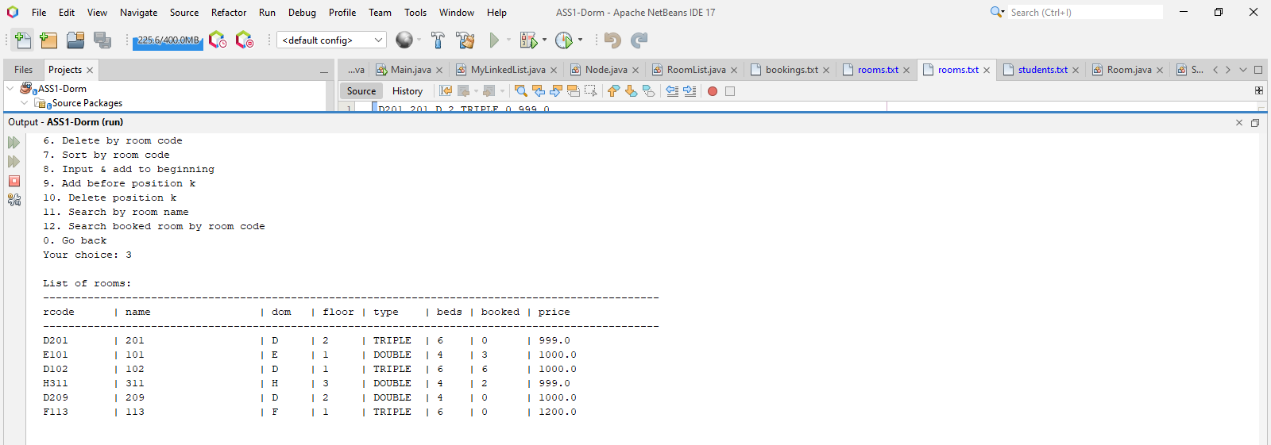

1.4. Save room list to file

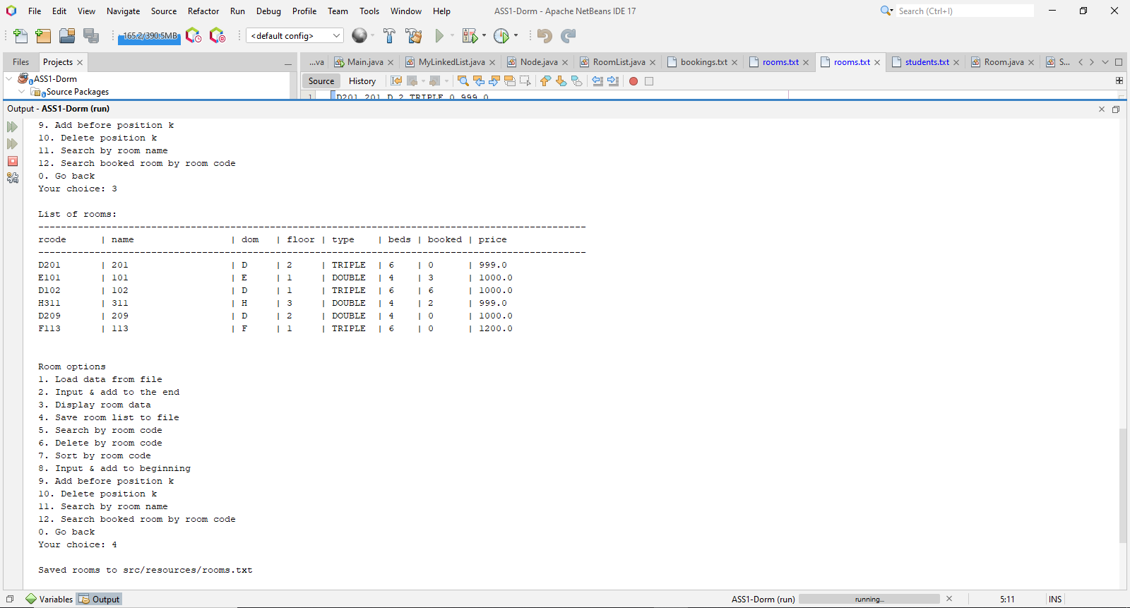

1.5. Search by room code

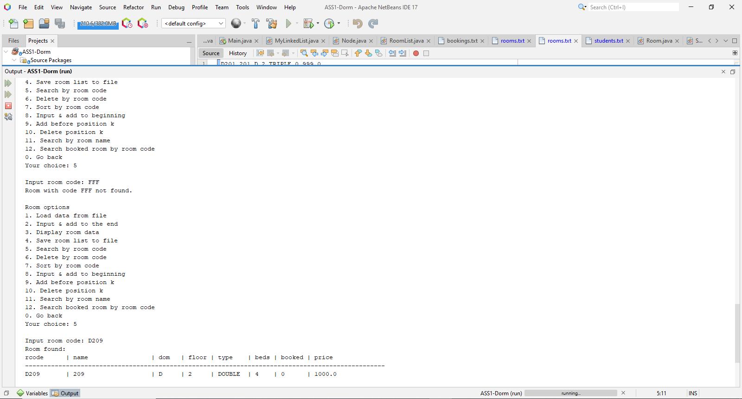

1.6. Delete by room code

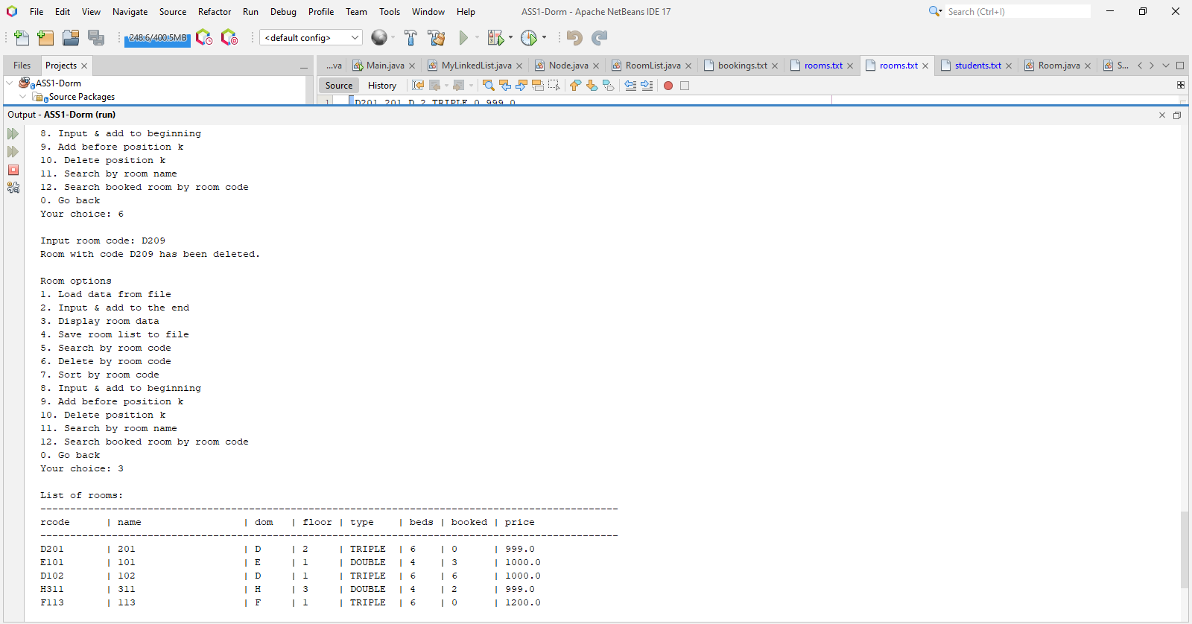

1.7. Sort by room code

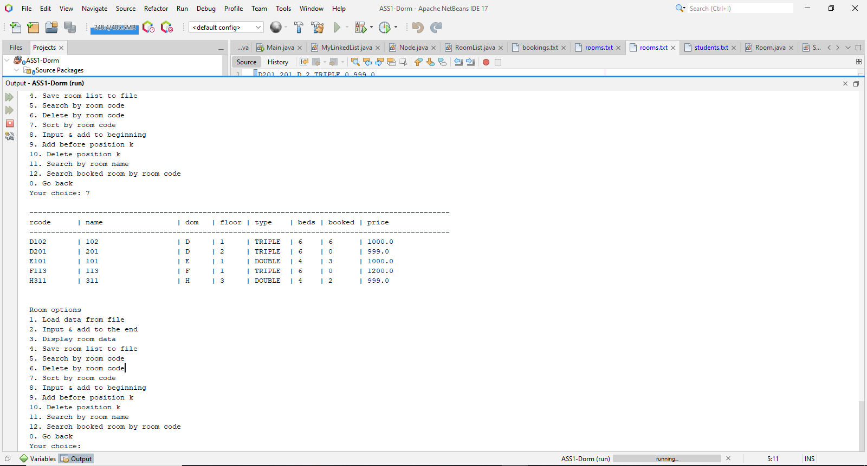

1.8. Input & add to beginning

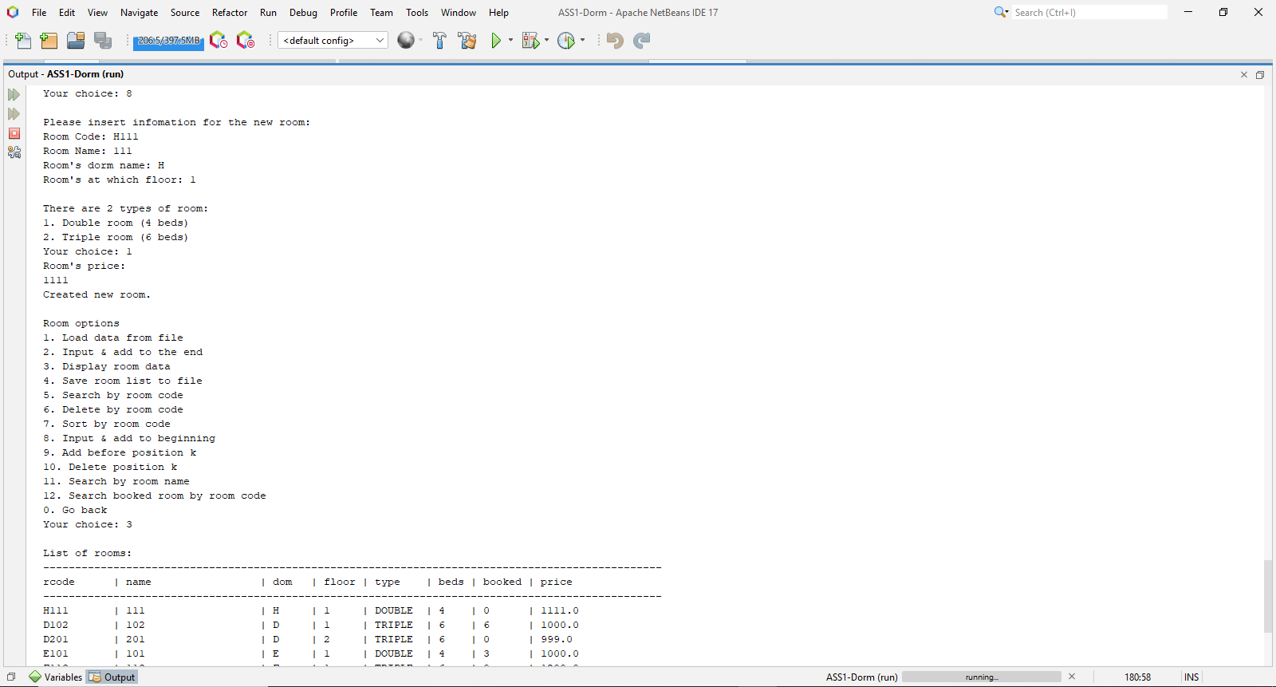

1.9. Add before position k

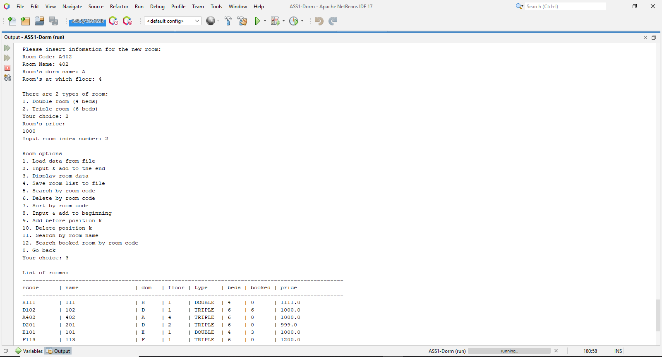

1.10. Delete position k

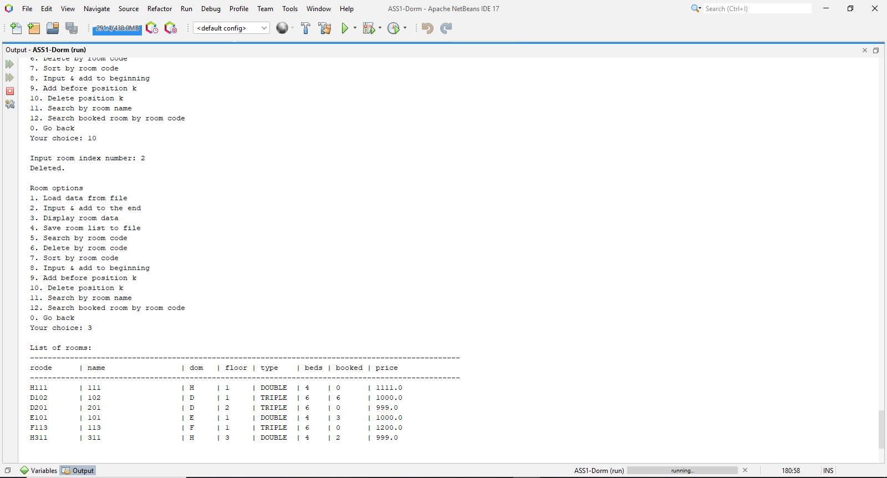

1.11. Search by room name

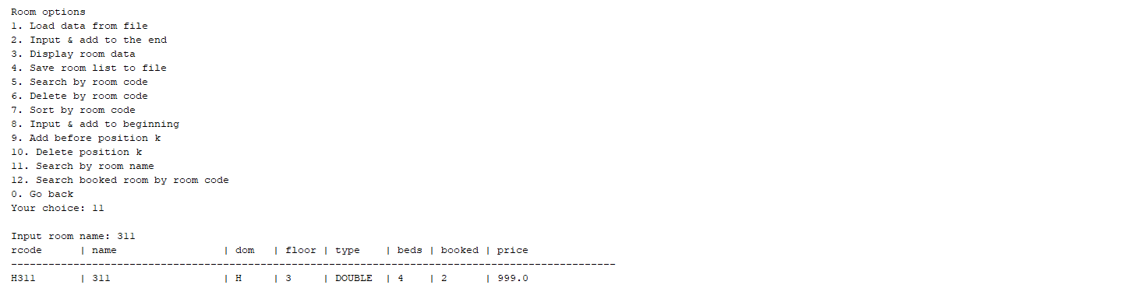

**2. StudentList**

2.1. Load from file

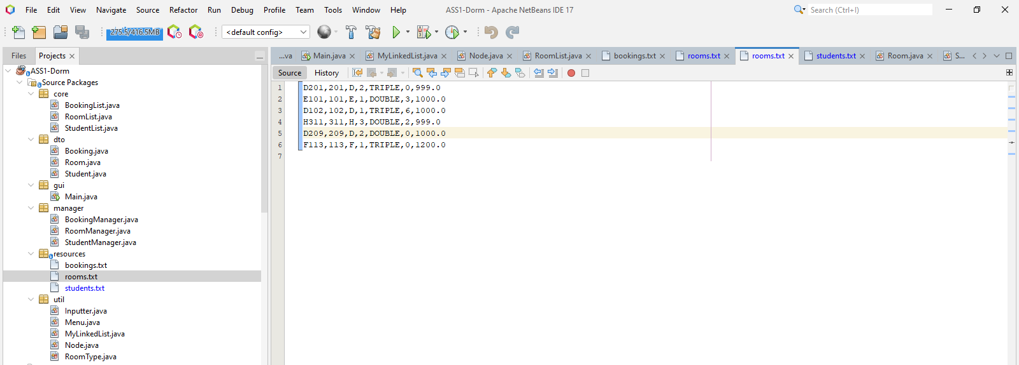

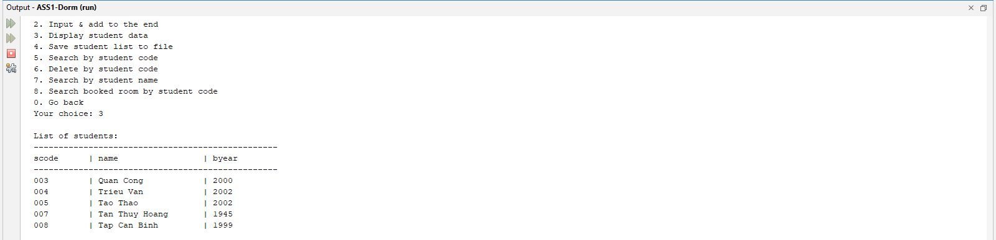

2.2. Input and add to end

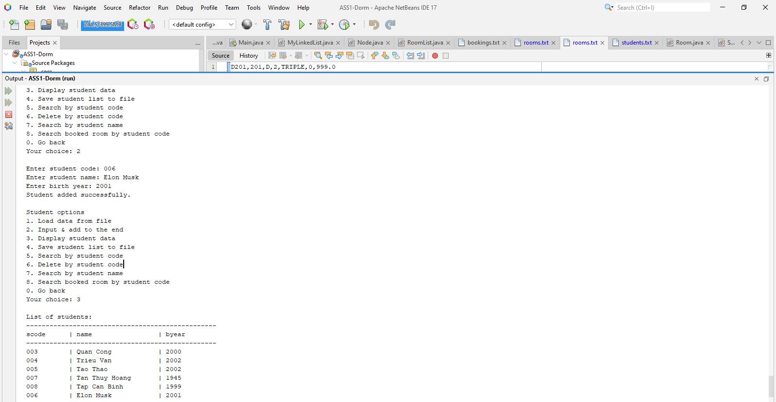

2.3. Display

2.4. Save to file

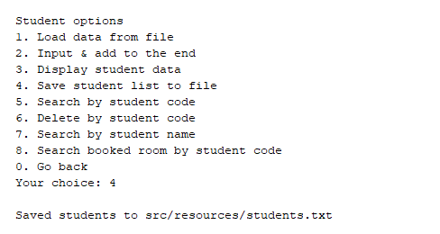

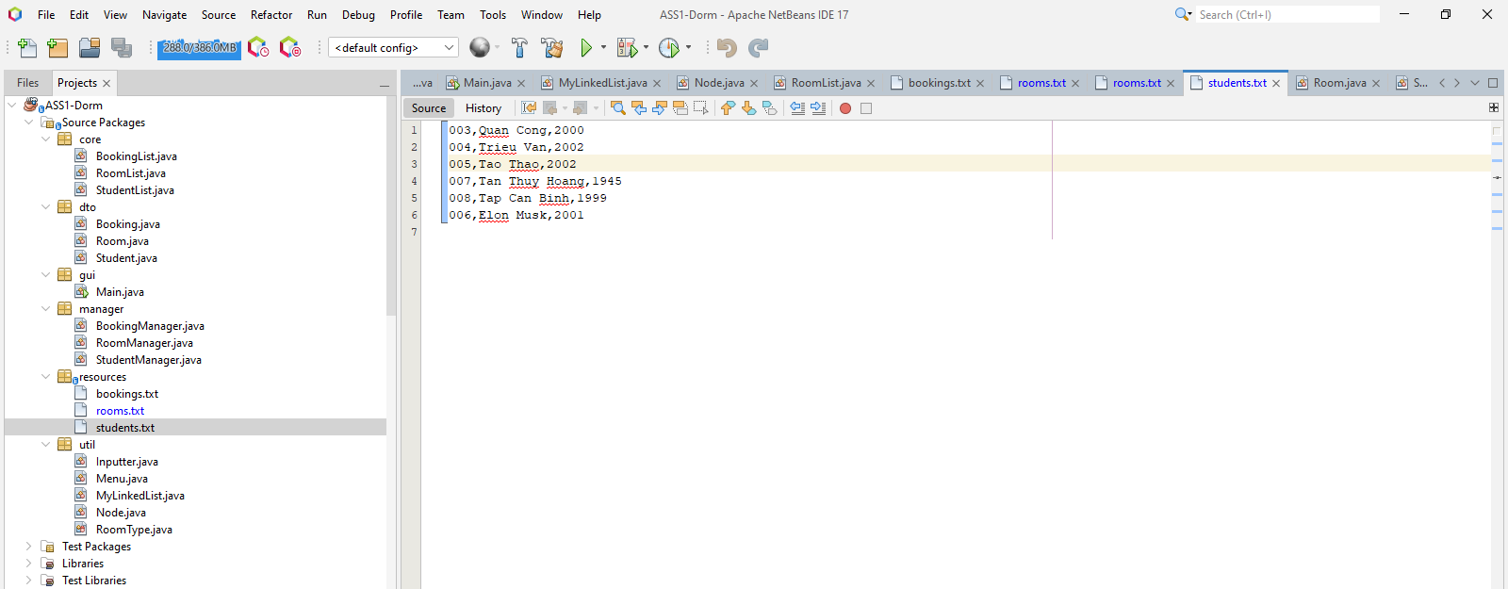

2.5. Search by student code

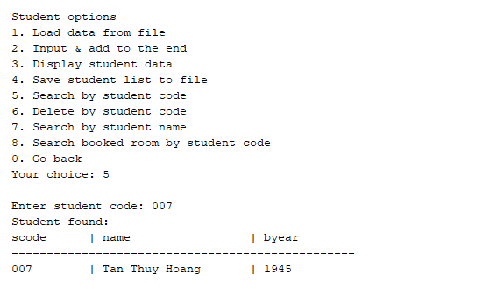

2.6. Delete by student code

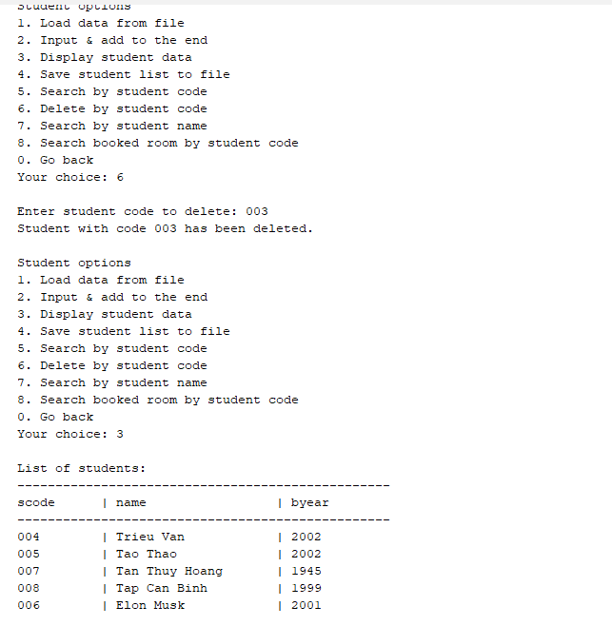

2.7. Search by student name

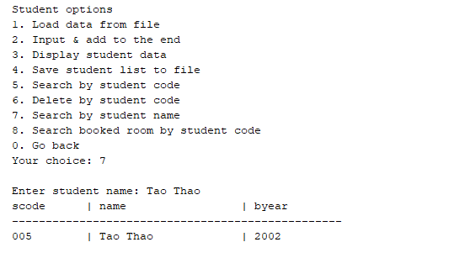

2.8. Search booked room by student code

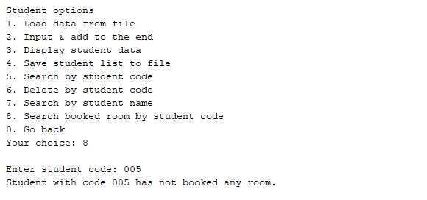

**3. BookingList**

3.1. Load data from file

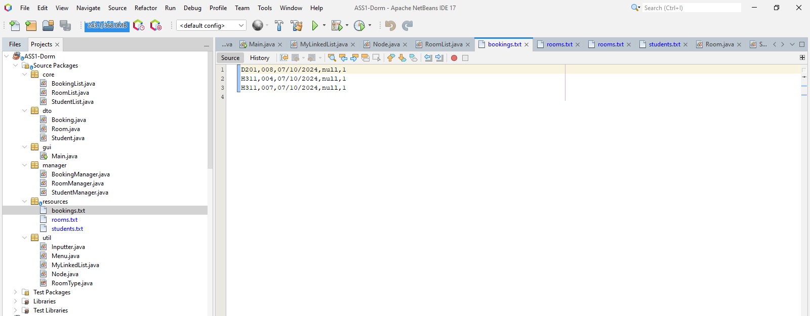

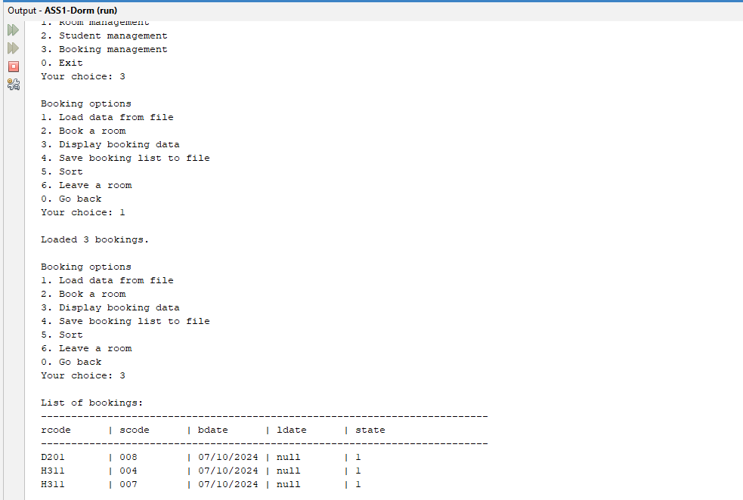

3.2. Book a room

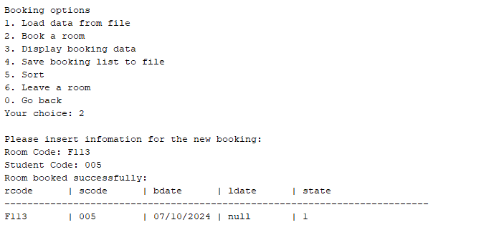

3.3. Display booking data

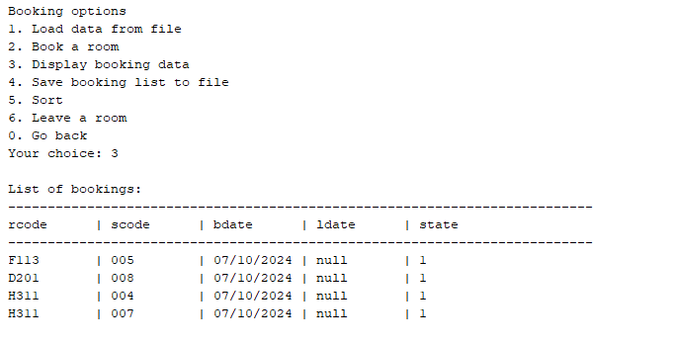

3.4. Save booking list to file

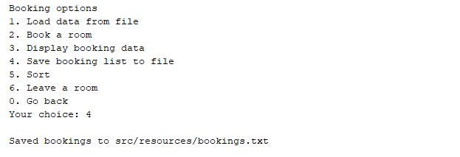

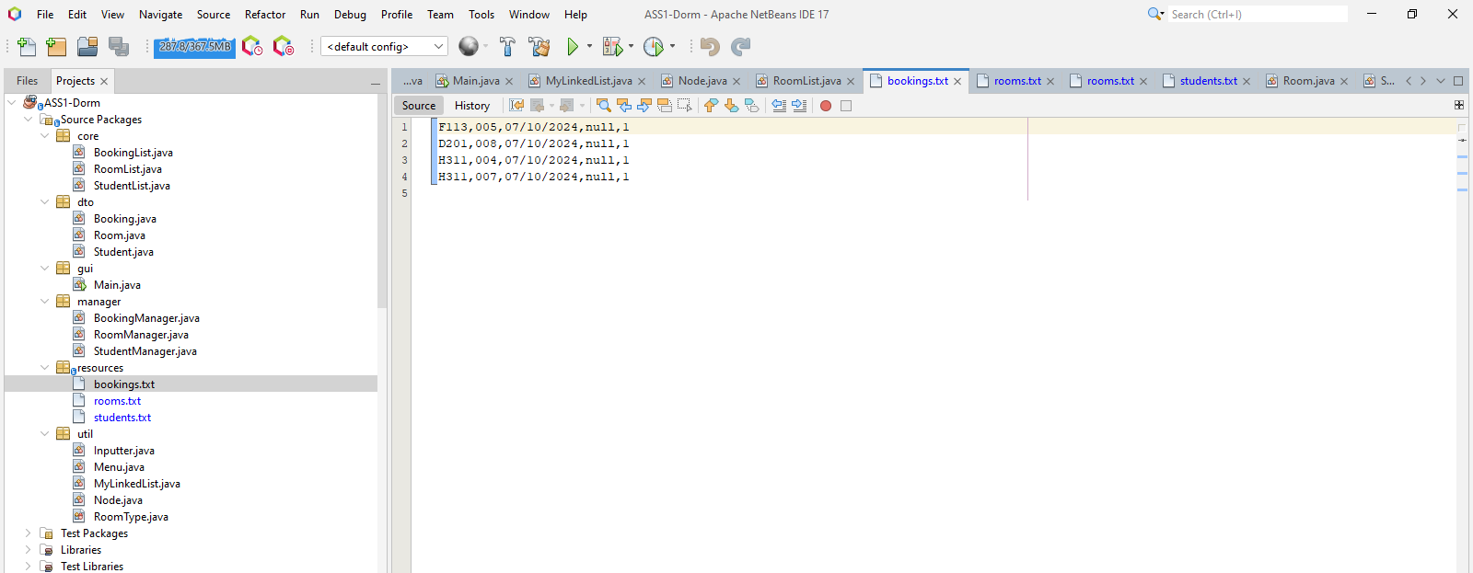

3.5. Sort ( descending of rcode first, then in the descending of the scode)

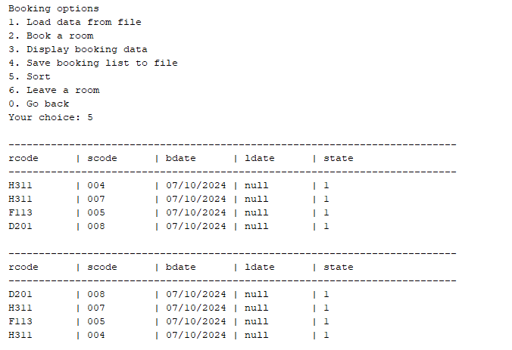

3.6. Leave room

