Subject: Data Structure and Algorithms
Code: CSD201
Assignment2 Report
Title: Domitory Management System
Group number: 04
Members:
- Ngô Đức Anh – HE190128
- Trần Đức Anh – HE190049
- Nguyễn Bảo Nam – HE190091
- Đặng Đức Minh – HE190158
- Ngô Minh Nhật – HE190217
Tasks status
Name/  Number | Content | Member | Status
1. BookList
1.1. | Load data from file | Ngo Duc Anh | Done
1.2. | Input & add to the tree | Ngo Duc Anh | Done
1.3. | Display data by in-order traversal | Ngo Duc Anh | Done
1.4. | Save room tree to file by post-order traversal | Ngo Duc Anh | Done
1.5. | Search by rcode | Ngo Duc Anh | Done
1.6. | Delete by bcode by copying | Nguyễn Bảo Nam | Done
1.7. | Delete by bcode by merging | Nguyễn Bảo Nam | Done
1.8 | Simply balancing | Nguyễn Bảo Nam | Done
1.9 | Display data by breadth-first traversal | Ngô Minh Nhật | Done
1.10 | Count the number of rooms | Ngô Minh Nhật | Done
1.11 | Search by name | Ngô Minh Nhật | Done
1.12 | Search booked by rcode | Nguyễn Bảo Nam | Done
2. ReaderList
2.1. | Load data from file | Đặng Đức Minh | Done
2.2. | Input & add to the tree | Đặng Đức Minh | Done
2.3. | Display data by pre-order traversal | Đặng Đức Minh | Done
2.4. | Save student tree to file by in-order traversal | Đặng Đức Minh | Done
2.5. | Search by scode | Trần Đức Anh | Done
2.6. | Delete by scode by copying | Trần Đức Anh | Done
2.7. | Search by name | Trần Đức Anh | Done
2.8 | Search booking room by scode | Trần Đức Anh | Done
3. LendingList
3.1. | Load data from file | Ngô Minh Nhật | Done
3.2. | Book the room | Nguyễn Bảo Nam | Done
3.3. | Display data | Đặng Đức Minh | Done
3.4. | Save booking list to file | Ngô Đức Anh | Done
3.5. | Sort by rcode + scode | Đặng Đức Minh | Done
3.6. | Leave the room by rcode + scode | Trần Đức Anh | Done

Tasks results (Screen short):
1. Booking list
1.1. Load data from file
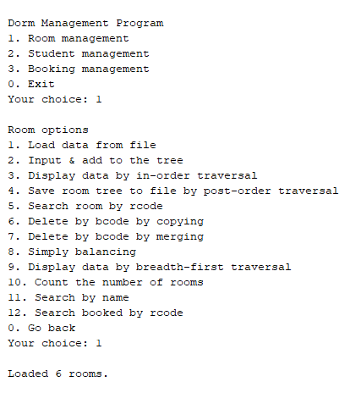
1.2. Input and Add to the end

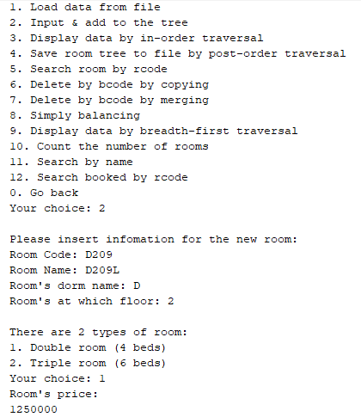
1.3
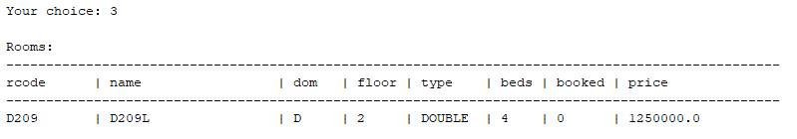

1.4
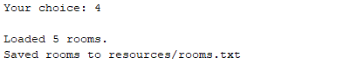

1.5
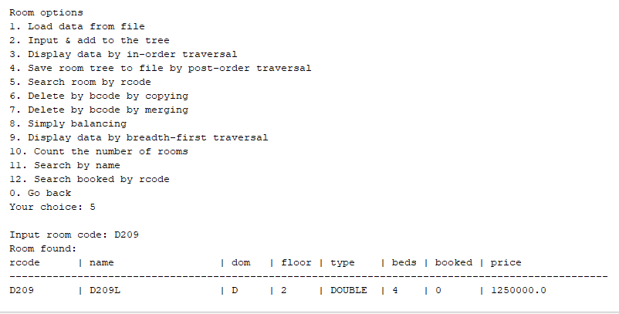

1.6
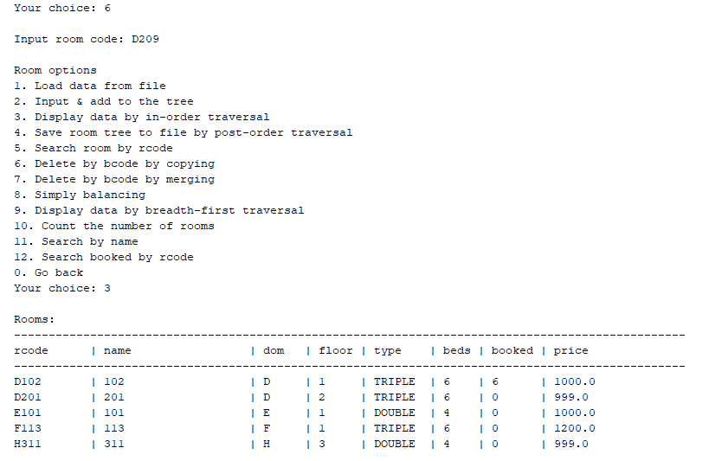

1.7
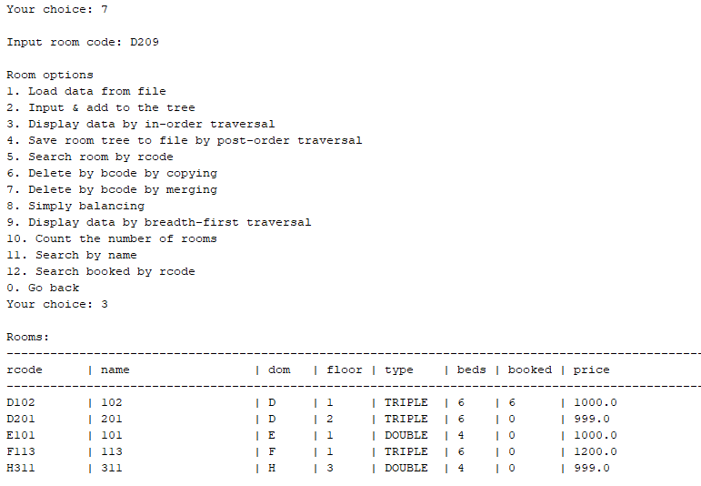
1.8
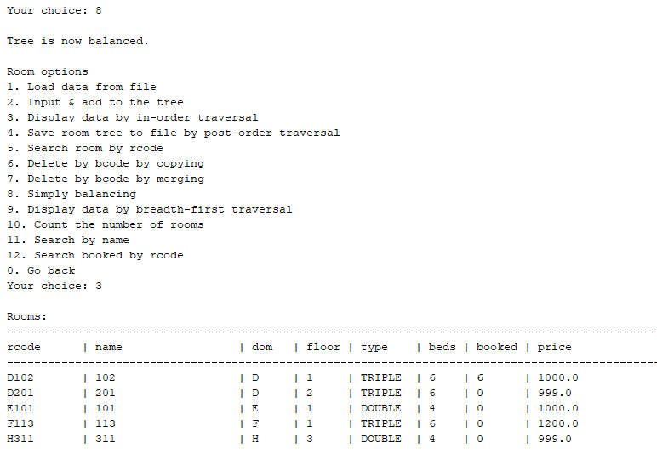
1.9
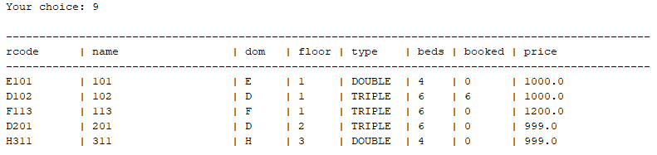
1.10

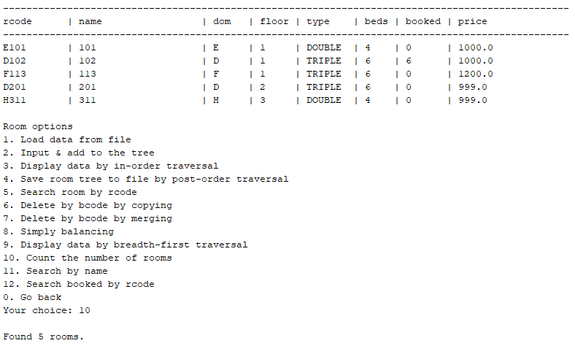
1.11
1.12

2.1
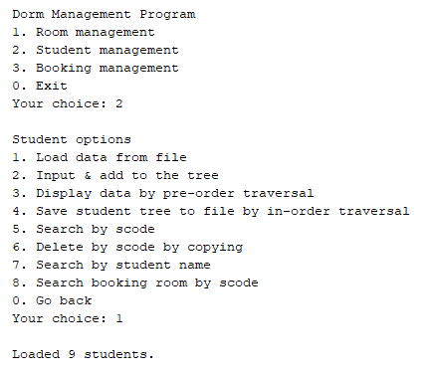
2.2
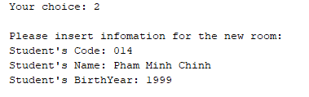
2.3
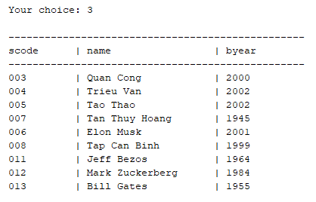
2.4
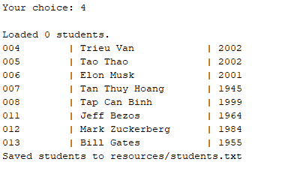
2.5
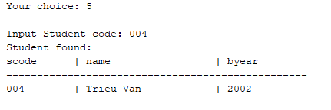
2.6
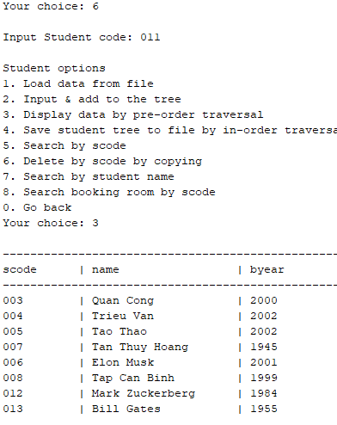
2.7
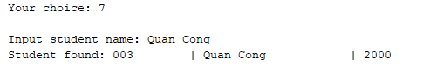
2.8

