HOMEWORK 3: VIDEO COMPRESSION
Motion Estimation & Compensation

Introduction
Motion estimation is a critical component in video compression algorithms like H.264 and HEVC. By predicting motion between frames in a video, we can reduce redundancy and compress video more efficiently. In this homework, we implemented two block-matching motion estimation algorithms:
- Full Search Block Matching Algorithm
- Three-Step Search (TSS)
Both algorithms were tested on two grayscale frames, and the quality of the motion compensation was evaluated using Peak Signal-to-Noise Ratio (PSNR). Additionally, we compared the computational efficiency of the algorithms by measuring their runtime.

Problem Setup
The input for this homework was two consecutive grayscale frames (Frame 1 – one.png and Frame 2 – two.png) from a video (I think). The task was to:
- Perform motion estimation between the two frames using block-based techniques.
- Use two different methods for motion estimation: Full Search and Three-Step Search.
- Evaluate the quality of the predicted frame by calculating the PSNR between the predicted frame and the actual frame.
- Measure the runtime of both algorithms and compare their efficiency.
- Change the search range in [+-8, +-16, +-32] to see the result.
The input data are two images which can be the first and the second frame from a video:
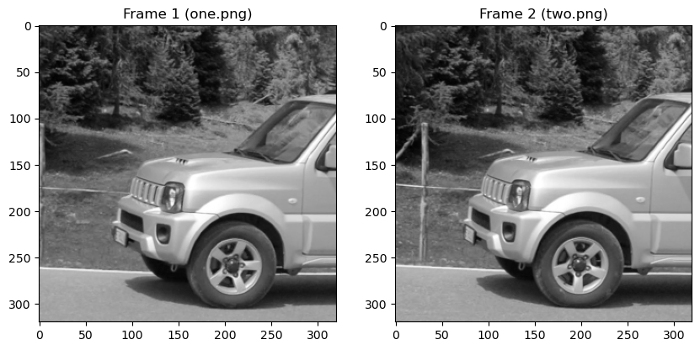
Figure 1: Input frame one and frame two

Motion Estimation Algorithms
- Full Search Block Matching
The Full Search Block Matching Algorithm is the most straightforward approach to motion estimation. For each block in the current frame, it searches within a defined search window in the reference frame (the previous frame) to find the block that minimizes the Sum of Absolute Differences (SAD).
The key steps are:
  - Block Division: Both frames are divided into 8x8 blocks (Can be customized).
  - SAD Calculation: For each block in Frame 2, the algorithm searches within a [-8, +8] pixel search range in Frame 1, calculating the SAD for each candidate block.
  - Motion Vector Selection: The motion vector that minimizes the SAD is selected for each block.
  - Motion Compensation: The motion vectors are used to generate a predicted frame.
Advantages: It finds the global minimum for motion vectors, leading to high PSNR.
Disadvantages: It is computationally expensive due to its exhaustive search of all possible displacements within the search window.
- Three-step search (TSS):
The Three-Step Search is a more efficient alternative to full search. Instead of searching exhaustively, TSS begins with a large step size and progressively reduces the step size to refine the search.
The key steps are:
- Step 1: Start with a large step size (e.g., 4 pixels) and search the center and its eight neighboring points.
- Step 2: Select the point with the minimum SAD and reduce the step size by half.
- Step 3: Repeat the search process in the smaller neighborhood until the step size becomes 1 pixel.
- Motion Compensation: Use the final motion vectors to generate the predicted frame.
Advantages: It is computationally efficient and faster than full search.
Disadvantages: It may not always find the global optimum, leading to slightly lower PSNR.

Experiments
- Predicted frames
The predicted frames generated by both algorithms were compared with the actual current frame (Frame 2). Below are the images of the predicted frame and residuals for each algorithm.
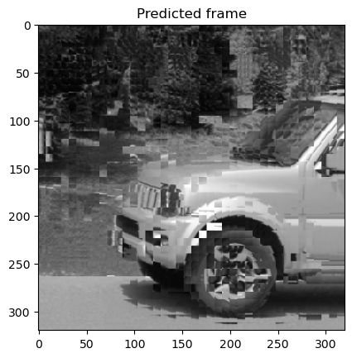
Figure 2: Full search predicted frame
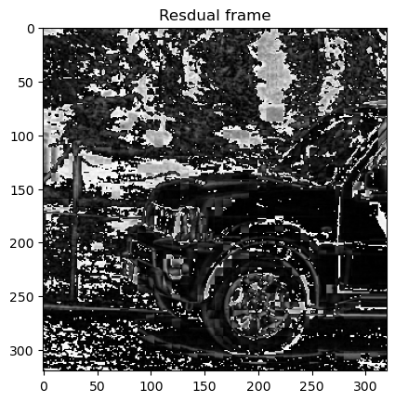
Figure 3: Full search residual frame
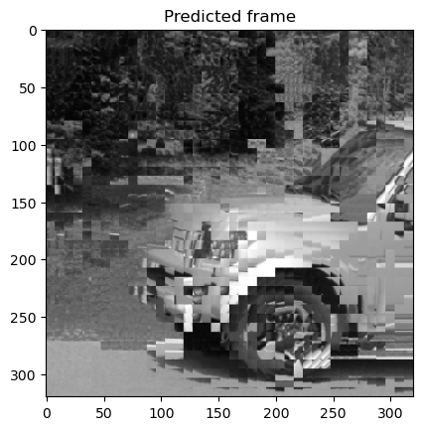
Figure 4: Three step search predicted frame
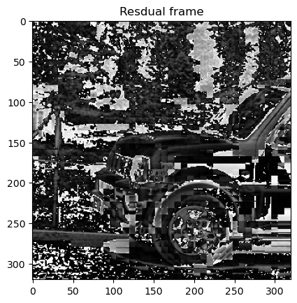
Figure 5: Three step search predicted frame
- PSNR Comparison
PSNR was calculated between the predicted frames and the actual current frame (Frame 2). Higher PSNR indicates better accuracy of the predicted frame.
Table 1: PSNR Comparison
Algorithm | PSNR (dB)
Full search | 29.22299893141674
Three-Step search (TSS) | 28.59888524959291

Table 2 : Summarizing the PSNR thresholds for frame quality qualification
PSNR Range (dB) | Quality Level | Description
< 20 dB | Low | Significant distortion, poor visual quality. Not suitable for most applications.
20 db <= PSNR < 30 dB | Medium | Noticeable artifacts or degradation, but possibly usable in some cases.
30 dB <= PSNR < 40 dB | Good | Good visual quality, minimal visible artifacts. Acceptable for general use.
>= 40 dB | Excellent | Nearly indistinguishable from the original, ideal for high-end applications.

The Full Search algorithm yielded a slightly higher PSNR, indicating that its exhaustive search approach found motion vectors that better matched the blocks in the current frame. However, the Three-Step Search still provided a reasonably high PSNR with far fewer calculations.
- Runtime Comparison
The runtime for both algorithms was measured to compare their computational efficiency. The results are shown in the table below.
Table 3: PSNR Comparison between Full Search and TSS
Algorithm | Runtime (s)
Full search | 4.749370574951172
Three-Step search (TSS) | 0.332169771194458

The Three-Step Search was significantly faster, as expected, due to its reduced search space. This shows that TSS offers a good balance between computational efficiency and accuracy.
Table 4: Check runtime and psnr with different search ranges
Search range | Runtime (s) | PNSR (dB)
[+-8] | 4.8347179889678955 | 29.222998931416736
[+-16] | 4.844379663467407 | 29.222998931416736
[+-32] | 5.06472635269165 | 29.222998931416736

The PSNR remains constant at 29.22 dB across all search ranges, indicating that increasing the search range does not improve the prediction accuracy in this case. This suggest the optimal motion vectors are found within the smallest search range.
In terms of runtime, there is a slight increase as the search range expands, with 4.83 seconds for [+-8], 4.84 seconds for [+-16], and 5.06 seconds for [+-32]. This reflects the expected trend that larger search ranges lead to increased computational cost, though the change in runtime is relatively small.
Overall, the [+-8] search range offers the best balance between speed and accuracy in this context.

Conclusion
In this homework, we successfully implemented and compared two motion estimation algorithms: Full Search and Three-Step Search. The results highlight the trade-off between computational efficiency and accuracy:
- Full Search offers higher accuracy (PSNR) but is slower.
- Three-Step Search is faster and still produces reasonably good results.
In practical video compression systems, the choice between these algorithms depends on the specific requirements of the application. For example, real-time video encoding systems may favor Three-Step Search due to its speed, while offline compression tasks might benefit from Full Search’s accuracy.

