Course: Video Compression
Student Name: Le Minh Bang
Student ID: 313540015 – EECS IGP

Homework 2:
1D and 2D DCT/IDCT with PSNR Evaluation

Introduction
This project demonstrates the process of converting a digital image from the time domain to the frequency domain using Discrete Cosine Transform (DCT) and subsequently reconstructing the image using Inverse Discrete Cosine Transform (IDCT). The quality of the reconstructed image is evaluated using Peak Signal-to-Noise Ratio (PSNR) to measure the effectiveness of the transformation.
The main objectives of this project are:
- To apply 1D DCT/IDCT and 2D DCT/IDCT on a grayscale image (lena.png).
- To compare the runtime of the two approaches.
- To compare the PSNR values of the reconstructed images.
Methodology
1D DCT/IDCT
The 1D DCT is applied row-wise followed by column-wise on the input grayscale image. This results in a set of DCT coefficients that represent the image in the frequency domain. The 1D IDCT is then applied to reconstruct the image by reversing the transformation.
Steps for 1D DCT/IDCT:
- Apply 1D DCT to each row of the grayscale image.
- Apply 1D DCT to each column of the result.
- Save the DCT coefficients.
- Apply 1D IDCT on the coefficients to reconstruct the original image.
- Calculate the PSNR by comparing the original and reconstructed images.
2D DCT/IDCT
The 2D DCT is applied directly to the entire image block, converting the image into the frequency domain. The 2D IDCT reconstructs the image from these DCT coefficients.
Steps for 2D DCT/IDCT:
- Apply 2D DCT to the entire image.
- Save the DCT coefficients.
- Apply 2D IDCT to the coefficients to reconstruct the image.
- Calculate the PSNR by comparing the original and reconstructed images.
PSNR Calculation
The Peak Signal-to-Noise Ratio (PSNR) is calculated to measure the quality of the reconstructed image compared to the original. The formula used for PSNR is:
Where:
- MAX is the maximum possible pixel value of the image (255 for an 8-bit grayscale image).
- MSE is the Mean Squared Error between the original and reconstructed image.
Implementation
The code is structured into three blocks:
- BLOCK 1: This block handles the setup and grayscale conversion of the image. It must be executed every time the script is run.
- BLOCK 2: This block performs the 1D DCT/IDCT transformations and saves the results.
- BLOCK 3: This block performs the 2D DCT/IDCT transformations and saves the results.
Note: To run BLOCK 2 (1D DCT/IDCT), uncomment BLOCK 2 and comment out BLOCK 3. Similarly, to run BLOCK 3 (2D DCT/IDCT), comment out BLOCK 2 and uncomment BLOCK 3.
Results
1D DCT/IDCT Results
- Coefficient Values: The 1D DCT coefficients are saved in results/1D_DCT_COE.npy.
- Reconstructed Image: The reconstructed image is saved in results/1D_IDCT.npy.
- PSNR Value: The PSNR for the 1D DCT/IDCT process is saved in results/1D_DCT_PSNR.txt.
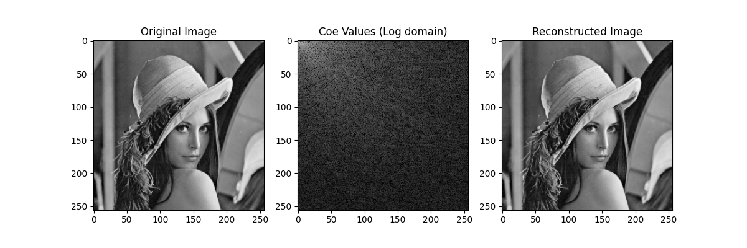
Figure 1: The two 1D-DCT / IDCT Result
2D DCT/IDCT Results
- Coefficient Values: The 2D DCT coefficients are saved in results/2D_DCT_COE.npy.
- Reconstructed Image: The reconstructed image is saved in results/2D_IDCT.npy.
- PSNR Value: The PSNR for the 2D DCT/IDCT process is saved in results/2D_DCT_PSNR.txt.
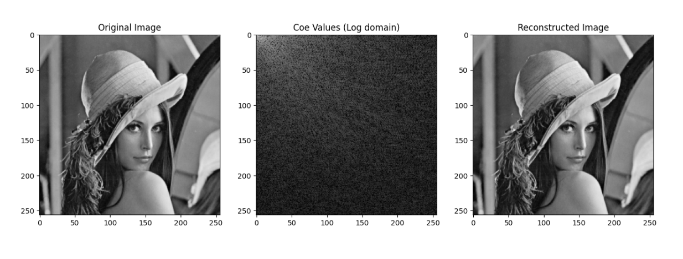
Figure 2: The 2D-DCT/IDCT result
Performance Comparison: 2D-DCT vs Two 1D-DCT
The processing times for both two 1D-DCT and 2D-DCT transformations were recorded using Python’s time.process_time() function, which measures CPU time in seconds. The following table summarizes the results:
Transformation | Process Time (seconds) | PSNR (dB)
1D-DCT | 29.21875 | -
1D-IDCT | 31.03125 | 52.8976
2D-DCT | 7363.8125 | -
2D-IDCT | 8022.09375 | 52.8998
Comparison and Discussion
- Runtime Comparison:
  - Two 1D-DCT is much faster than 2D-DCT:
    - 1D-DCT: ~29.22 seconds.
    - 2D-DCT: ~7363.81 seconds (~2 hours).
  - Similarly, the 1D-IDCT is completed in ~31.03 seconds, whereas 2D-IDCT took ~8022.09 seconds.
- Efficiency:
  - The two 1D-DCT method is computationally more efficient. It breaks the DCT computation into two smaller steps (row-wise and column-wise), reducing overall complexity.
  - The 2D-DCT, on the other hand, applies the transformation directly on the entire 2D image block, resulting in higher computational cost.
- PSNR Comparison:
  - The PSNR values for both methods are almost identical:
    - 1D-IDCT PSNR: 52.8976 dB
    - 2D-IDCT PSNR: 52.8998 dB
  - This indicates that both methods result in nearly the same image quality, despite the significant difference in processing times.
Conclusion
In this project, I implemented both 1D and 2D DCT/IDCT transformations and compared their runtimes and PSNR values. The two 1D-DCT method was significantly faster, making it more efficient than 2D-DCT while delivering nearly identical image quality. A potential improvement for this project is to divide the image into smaller blocks, such as 8x8 pixels, and apply DCT/IDCT block by block. This approach is commonly used in real-world compression algorithms like JPEG and MPEG to reduce computational complexity and efficiently handle spatial redundancies. My code is structured to support this enhancement, allowing for block-based DCT processing, which would further optimize performance and align with industry standards. By implementing this block-based approach, the code would become more efficient and practical for real-world applications in image and video compression.

