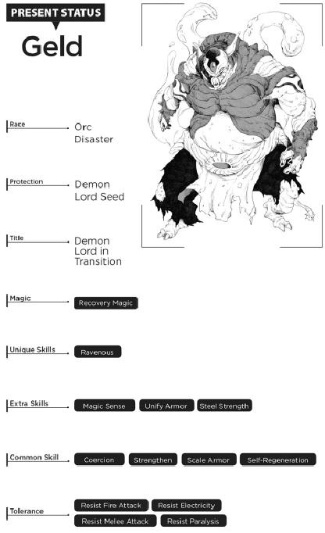

FINAL CHAPTER

A RELAXING SPOT

I was resting in my room.

Over three months had passed since I returned. All kinds of things had happened since, but I was taking a moment to reflect on all the chaos of a time gone by.

After I left Abil behind, I decided to exercise my Shadow Motion skills and head home first. It turned out to be pretty useful, whisking me back far more quickly than expected.

I was quickly mobbed by townspeople awaiting good news, so I made sure to tell them everyone was safe, going into further detail with those who were interested.

Once they learned the town would have a few new members soon, people immediately set to work. Their anxieties were gone as they got down to business setting up beds for the upcoming move in. Nobody voiced any complaints as they prepared the town.

It wasn’t long before Benimaru and his kindred returned. They were soon joined by the goblin riders who guided the high orcs across the forest for me. Like the rest, they too settled back to their posts, back to the old routine.

The town was coming together at breakneck speed.

The high orcs, who had reached town in less than a month’s time, had learned their jobs in a flash, guided by the dwarves and the better-trained goblins. “Train ’em well enough,” Kaijin told me, “and they could form a corps of engineers as strong as what the dwarves have!”

With all this new labor, we were able to tackle jobs that had been shunted to the wayside before. The town experienced a construction boom, fueled by a steady stream of resources entering and leaving the area. We had dismantled the tents we no longer needed, sending them off to the orc settlements. The goblin riders must’ve done their jobs well—each of the orc tribes took root in their new lands, crafting the fundamentals needed for life. The journeys they took between our town and their homelands kept them in contact with us, as they helped ferry the needed materials back and forth.

We were in the midst of a true trade system—one where each settlement sent their specialty products to us, and we replied in kind. It wasn’t much evolved from the barter systems of ancient times, but the orcs were actually thinking and taking action for themselves, which I loved seeing. They were in no shape for large-scale agriculture yet, but I was sure it would happen before long.

Speaking of that, while we didn’t have many types to work with yet, we had managed to grow some pretty hardy potatoes, capable of growing even in harsh environments. They were fairly nutritious, and as long as you weren’t too picky, they could be the staple of anyone’s diet. We spread these plants around, teaching the high orcs how to cultivate them. And who knew? Maybe they’d be able to sustain themselves in two years or so.

Geld was a huge help in moving those tents and plants around. The Stomach that his Gourmet unique skill provided was perfectly suited for small-scale resource transfers. The “forwarding” service he offered quickly became a vital part of the transit network we were building between the high-orc settlements.

His Stomach had a lot of restrictions associated with it, but it was still almost like cheating at life. And Geld himself was helping transport larger objects that his Stomach couldn’t, er, stomach. Whatever we could take apart and fit in there, following his instructions and suggestions, we did. That did the job perfectly for things like tents and bulkier materials.

The starwolves did their part, too. They roamed the lands, making the most of their Shadow Motion, and even inspired Geld to train himself to withstand the skill’s rigors. It didn’t take him long, with the kind of dedication he showed to all his work, and while he couldn’t trigger Shadow Motion himself, he could hop on a starwolf and have them take care of the jump for him.

After that, things went fast. A delivery run to the mountain areas that took several months on foot could now be finished in a round trip of twenty-four hours. It helped all the settlements stay closer in contact with us than ever—a kind of express mail, maybe. I was even able to write some content on wooden boards and send them to each orc colony, like a sort of neighborhood circular. Nobody else was exactly literate yet, so I didn’t want to rely on that too much for now. We’d need to work on that, too. Thought Communication only worked at so much of a distance.

Still, we now had solid links between all the settlements. Life was starting to become more stable. And time passed.

Along the way, a group of goblins had arrived, bringing their vassals along. I might as well name these guys, too , I thought. I was the one who told them all not to look down on other races, after all, and I had to live up to that. If I merely let them live there without taking that extra step, I risked creating a class-based society.

These guys had kind of a greenish tone to their skin, so I decided to go with Green-[insert number here]. All that naming, though… Yeesh. Maybe Gelmud’s Death March was doing its work on me after all, delayed-action style. Scary guy.

The gang would later come to be known as the Green Numbers. Together with the Yellow Numbers, they would form the twin walls of our alliance’s main defense force, but that was still well in the future.

Once I was completely burned out from number assigning yet again, we finally had enough homes in town for all the monsters to live in. The goblins would have to live in groups within dormitory-style buildings, but it still beat the tents.

We had set up a water and sewer system pretty early on, but we had nowhere near the resources required to bring water to everyone’s houses. Instead, we had well pumps throughout the town, which made the whole place seem a lot more culturally advanced than before.

Having real flush toilets was incredible, too. You still had to fetch water from a well and fill up the toilet tank yourself, but we were a town of overpowered, muscle-bound monsters, so it was no big deal. After all, I didn’t want this town stinking of excrement here and there—that was one “must” I refused to give up.

Plus, some of ’em didn’t even generate any crap to flush anyway. Me, for example.

We still had a lot of things on the back burner, but I supposed we had time. We had a town to build, and it was never gonna happen overnight.

So despite all the nuttiness, things were coming together. Right here, in this land, there lived over ten thousand monsters, gathered here because they believed in what I was doing, all working together to make it a better place.

They saw this as a place of peace. Our place of peace. A true town of monsters. And it was finally here.



