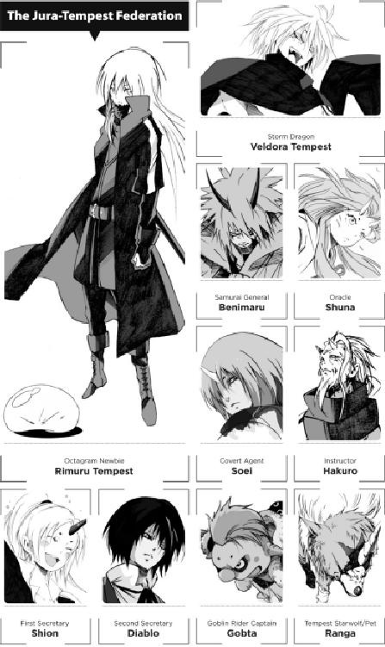



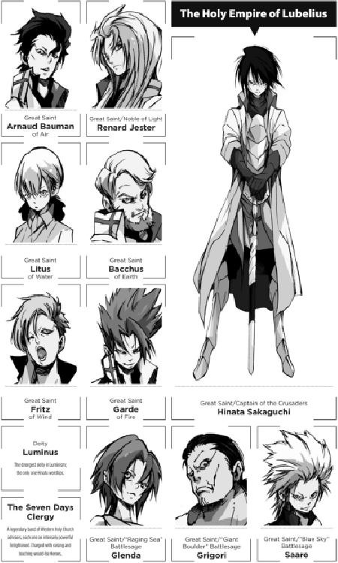

PROLOGUE

THE MAGIC-BORN MEMORIAL

Clayman was dead. And when Laplace delivered the news to the group assembled before him, the reaction was stunned silence.

“You lie! There is no way that could happen!”

This was Footman frantically shouting now, but no one could find it in themselves to see things his way. Laplace was always so aloof, easygoing, never one to express any of his true emotions. But his face said it all. This was not the joker all of them knew—he was literally hanging his head in shame before them. It was all they needed to see to know that Clayman was really and truly dead.

“…Last night, the night of that Walpurgis Council, I lost my connection with Clayman,” Kazalim ponderously stated as Teare sobbed nearby. “My connection with someone I viewed as my own child. It could only mean one thing for him—death. I hardly wanted to admit it to myself. Even now, Laplace, after what you told us, I am filled with a stubborn refusal to admit it…”

“This was my mistake,” a boy with black hair regretfully lamented. “I thought the demon lords were kid stuff. I needed to be more careful. Gather more intelligence and then take action.”

There were ten demon lords in all, looking down upon the world from atop their lofty peaks. But even in such heady territory, each of them bore different strengths and weaknesses. Clayman’s apparently successful application of Demon Dominate on the mind of the demon lord Milim caused him to forget that vital fact—and even worse, led him to believe he could rule over all his fellow lords. It was much too rash of him.

“If you’re gonna put it that way,” replied Laplace, lightening the mood with a joking tone, “I’m the one who suggested it to the guy. I never thought for a moment it’d turn out like this, no, not that it matters now. Plus, you have to admit it—Clayman was too stupid for his own good this time. I told him not to let his guard down, but he got carried away with it, and it blew up on him. All there is to it.”

“Laplace!” snarled Footman. “You can’t speak of him like that!”

“I’m only tellin’ the truth. He was weak, he got carried away, and now he’s dead.”

“Laplace!!”

Letting his anger overcome him, Footman took a swing at Laplace. His fist dug into the cheek of its target; Laplace didn’t bother to dodge it. But that was all. Laplace remained where he stood, his eyes swiveling toward his attacker.

“Oh, what, you wanna go, Footman? Well, be my guest!”

He let slip an easygoing smile as he taunted Footman, all but daring him to focus his anger upon him. Kazalim saw right through it.

“Stop it, you two!” she roared, halting them both. “This is a sad occasion for each of us.”

“She’s right,” the boy added. “Why are you playing the bad guy all by yourself here, Laplace? That’s not like you. If anyone should play that role, it oughtta be me for hiring all of you.”

“Ah…” Now Footman realized it. Laplace was goading him on purpose. “My apologies, Laplace.”

“…Nah, it’s fine. But you know, pal—and you too, President—you sure are mean, ain’tcha? I am trying to be the bad guy here, so how ’bout not letting the cat out of the bag?”

He rubbed his cheek as he continued to complain. And something about the sight was so comical that it really did lighten the mood—if only a little.

Back in control of their emotions, the magic-born discussed what to do next. Wailing about the misfortune of it all, Kazalim reasoned, would do nothing to realize Clayman’s goals. Their talks grew sterner, more serious.

“…I couldn’t tell you what happened in there, but as the demon lord Valentine put it, Clayman definitely died during the Council. He didn’t mention who did it, though…”

“Too bad I couldn’t have beaten it outta him…”

“No, Laplace. I am glad to see you still breathing, at least.”

“Ahh, I was just lucky. It happened to be the new moon, and bein’ a vampire, Valentine was at the low end of his strength. We were in a holy place to boot. Lotsa holiness fillin’ up the atmosphere. That’s the only reason my attacks worked at all.”

Nobody doubted Laplace’s words. Laplace only managed to defeat Valentine, whose strength was on a par with the Kazalim of the past, thanks to several overlapping factors working out in his favor. Plus, Laplace was second only to Kazalim in brute force. His role as vice president of the Moderate Jesters was no empty title—he had the strength to back it up. That was why everyone in the room so readily accepted Laplace’s astonishing victory—and thus, the talks continued, with nobody noticing the lie lurking between his words.

“This is quite the conundrum, however…”

“You could say that,” Kazalim muttered. “We lost the base of operations we granted Clayman, his forces, his treasure…everything. A staggering loss.”

The boy nodded his agreement.

“Wh-what do you mean?” Teare asked. “Whether the demon lords killed Clayman or not, we still have his headquarters, don’t we?”

“I know that Clayman’s forces were routed,” added Footman, “but we still have every chance to regroup and attack once again, no? We still have Adalmann, that crazed Saint, patrolling the lands. A wight king like him is just as strong as any of us—and the curse you’ve laid upon him is as active as ever, isn’t it, President?”

Kazalim exchanged glances with the boy before slowly, painfully, opening his mouth. “The complex I granted Clayman fell yesterday, in the course of a single evening. That slime, of all people, sent a small assault force to capture it.”

“Huhhh?” Laplace reacted.

“No!” Teare shouted.

“You’re kidding me!” protested Footman. “So the magic-born I saw on that battlefield wasn’t even the full force at that Rimuru’s disposal— Ah, wait a minute.” He looked up for a moment. “Hold on, hold on, I remember that crystal…”

“Right.” The boy nodded. “The images Laplace took— You saw the ogre mages in there, didn’t you? I think it’s safe to say that each of them alone is a Special A-grade threat in the battlefield.”

Footman fell silent, mouth agape.

“…Really?” Teare whispered. Nobody answered.

“Regardless,” reported Kazalim, “that slime Rimuru was at the battle. I suppose he sprang that fight upon us as a ruse so he could capture Clayman’s quarters himself. For a slime of his caliber, it’s not impossible to imagine him breaking through our defensive lines.”

Now the rest of the room was beginning to realize just how ominous the situation was.

“Which is why,” the boy said, “I think we need to reconsider our objective.”

With the majority of their military forces gone, he reasoned, any strategic moves needed to be avoided for now. Clayman’s death alone was a serious psychological blow to everybody who knew him. But fortunately, they had not lost everything. They still had resources left untapped in order to spread out the risk, as well as the group they had implanted deep inside the Western Nations. Plus, the political influence they wielded behind the scenes with those two groups was still as strong as ever. Perhaps they lacked physical might, but they had intelligence-gathering experts deployed across the land, laying out feelers to gauge every nation’s direction.

To the boy, who had started with nothing and come this far, it was still possible to stage a comeback. And that was why…

“…For the time being, we need to lay low. It’s a shame about Clayman, but we don’t have enough power to try to exact revenge upon the demon lords. If we want to reach our ultimate goal of conquering the world, I think we need to be patient for now.”

His audience nodded their agreement.

“True enough. We’ve made major strides over the past ten years. Perhaps it planted the seeds of arrogance inside all of us.”

“Yep. Hence why Clayman got it in his head to pull all that nonsense…”

“Right. I hate to say it, but doing anything rash right now is likely to make things even worse.”

“I hesitate to accept it myself, but I concede it is our best option for now…”

The boy giggled a little as the magic-born all offered their agreement. “Ha-ha-ha! Oh, cut me a break, Footman,” he chuckled, patting him on the shoulder. “I’ve still got all of you—the best cards in my hand. I can’t afford to lose you guys over some reckless shot in the dark, too.”

This was something he truly meant and also the main reason behind his decision. He needed to be sure everyone was on the same page as him, or else he feared at least one would let their anger get the best of them. Footman knew that perfectly well—and he knew he had to accept it.

“I know, pal. Better to bottle it up inside for now, so we can let it fully erupt later.”

He did understand that. Losing his cool and picking a fight with a cadre of demon lords would simply spell the end of his life. He had to accept the boy’s reasoning.

The boy, appreciating this, looked at the magic-born assembled before him. “But hey, it’s no fun to be the punching bag all the time, right? Maybe we won’t do anything, but we can say a lot of things. That slime took Clayman for everything he had, and I think I know how to get back at him a bit.”

He gave an ominous little grin.

“How do you mean?” Kazalim asked.

“There is something unusual about that slime,” the boy replied, grinning with glee. “In just a few years, he has built up a new, and massive, force. It’s hard for me to believe, and in any normal situation, we’d never want to defy him. So let’s wait and see a little, huh? And to do that, I’ve got something I want to deploy.”

“Oh, great.” Laplace shrugged. “Another little scheme of yours? At least it beats you ordering me to pull off some other insane trick, as you usually do. Hopefully I can stay in the audience for this one, thanks.”

For now, the magic-born were withdrawing from the public eye, descending into a sort of primordial darkness—sharpening their fangs for the fated day of revenge, whenever it may come.