

Afterword

The sixteenth volume of my work has finally been released.

It’s been a long time coming.

In the early days, the pace was one book every five months, but now it has extended to six months. Even so, I’ve been able to continue regularly, thanks to all of you who have been supporting me.

Really, the days go by quickly.

I will try my best to keep this pace, two books a year, in the future.

Here is a little explanation of the contents of this book.

It contains spoilers.

In this volume, I’ve finally implemented the forbidden quantification of combat power.

I wanted to do it earlier, but I-San, the editor in charge, was adamantly against it. I could understand I-san’s point of view, so I tried to keep it out until now…But I thought it was unreasonable to use Clayman-san as a guideline.

Alas, Clayman-san did his best. He was used along with Gelmud-san and Karion-san to explain the power levels of the story.

Even though he has left, his name appeared quite a few times.

But by now, that scale has reached its limit.

Even if I say, “a hundred Claymans,” it doesn’t convey the difference at all.

Good work! And so, the number of Clayman’s appearances will be drastically reduced.

The existence value, which has been adopted this time, also appears as an EP in the web version.

It is called “EXISTENCE POINT” in the story, but it is actually energy points. So, please be aware that it is not directly related to combat power, but it can be helpful.

Now then, I’d like to talk a little about my future plans.

Since this volume ends only with the end of the Empire chapter, I’m going to write a short story, not from Rimuru’s point of view, before I start the final chapter in the next volume. There are a lot of stories I want to write, but I’m thinking of including a few stories that are related to the main story.

Depending on the page space and my mood, I may write some casual stories. As usual, I’ll just write what I feel like!

The numbering system will continue with volume 17.

Volume 18 will begin the final arc, so please look forward to it.

I have a plan for the Tenma War—Exposition Arc, Clash Arc, and Conclusion Arc, but this may change depending on my mood. It’s only for reference, but please understand that I’m just thinking in that direction!

Once the story is finished, I’m thinking of writing an extra story. There are two web versions of this story, and there are other stories I want to write.

So, please continue to support me so that I can continue ‘That Time I Got Reincarnated as a Slime’ until then!

Lastly, I would like to thank all the people who have been involved in this work.

And the biggest thanks of all goes to all of the fans who have supported this work!

I will continue to do my best so that everyone can enjoy this story.



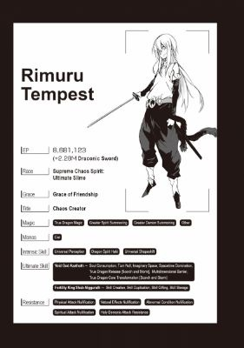



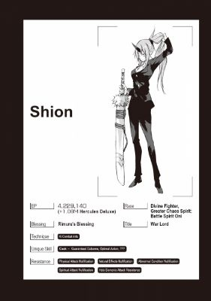

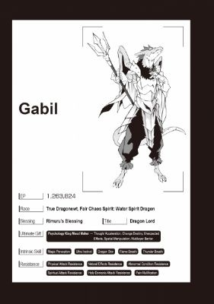

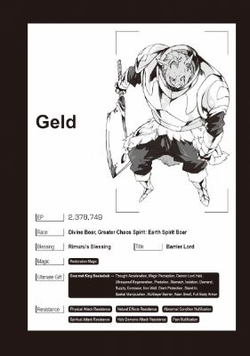

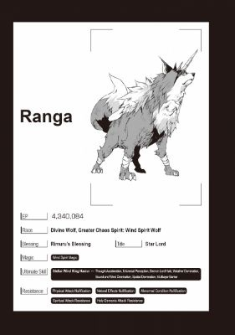

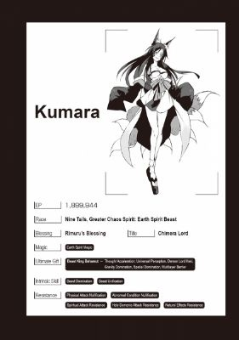

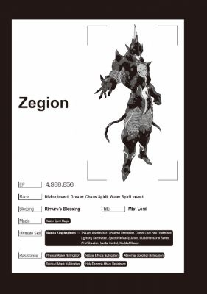





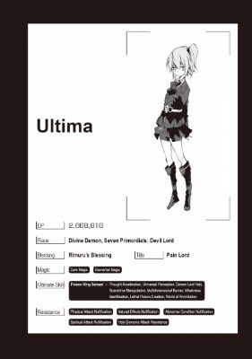

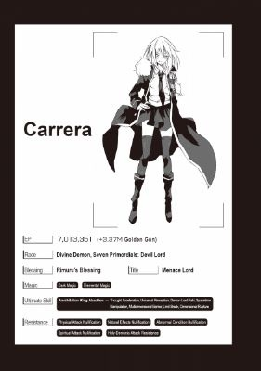

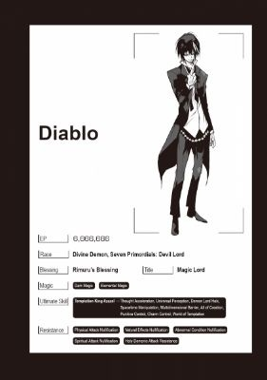

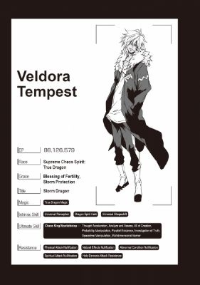

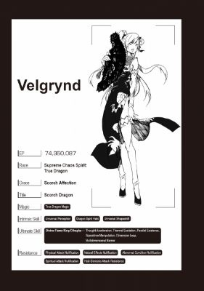

Notes

[←1]

Seraph is singular, seraphim is plural. The word is borrowed from the bible.

[←2]

Previously called Jiu and Bonnie.

[←3]

Was also called “Houga” but I’ll just stick with Kuzurekiba (Crumbling Fang) for now until translators fix it.

[←4]

Also called ‘Reverser’ previously.

[←5]

I’m not positive, but Dino might have briefly used Kansai dialect here.

[←6]

“Genkage-ryu”—I’m just calling it Phantom Flow style for now.

[←7]

I also referred to them as Seven Angels of the Origin or the ‘Originals’ in previous translations. I called them ‘Originals’ instead of ‘Primordials’ so as not to mix them up with the Primordial Demons.

[←8]

The translation was a bit confusing so I could be slightly off, but I’m pretty sure that Rimuru just put ‘re’ in front of all the Japanese numbers in an obvious sequence. It’s supposed to be funny because of the lack of creative effort.

[←9]

For any who were curious, adding Rimuru + Veldora + Velgrynd’s EPs together add up to about 171 million, not including the 2.28 million boost Rimuru gets with his Draconic Sword.

[←10]

Basically, Rimuru is speaking casually in contrast to the serious atmosphere from everyone else.

[←11]

Rimuru’s nickname for Elmesia

[←12]

A traditional multi-course Japanese meal.

[←13]

I think this is some sort of Italian potato donut/dumpling

[←14]

Italian mini food-rolls. Eggplant involtini is fairly common.

[←15]

Rimuru’s nickname for Elmesia. “El-tan” is kind of like saying “El-chan” or “El-cchi.” It’s a very cutesy nickname—not something that one would normally use to refer to the leader of a country.

[←16]

This group will be explained more in future volumes. It is a Japanese acronym, but it doesn’t correlate well in English. The ‘Three Drunk Sages’ are called the ‘Sankensui’ or the ‘Riega’ (no kanji) in Japanese, so the ‘Ri’ from Rimuru, the ‘E’ from Elmesia, and the ‘Ga’ from Gard (Myourmiles) combine to create the ‘Riega’. A funny play on words.

[←17]

i.e. They definitely have ultimate skills

[←18]

In Japanese, “Guy” is pronounced as “Gii’ which is how that name came from people’s dying screams.

[←19]

It’s not really shown in English, but Guy speaks very brash and disrespectfully to Veldanava.

[←20]

The seraphim

[←21]

The name ‘Guy’ sounds like ‘Gii’ in Japanese

[←22]

Velgrynd is the scorch dragon and associates herself with the color Cardinal (red). For example, a lot of her attacks seem to have the word ‘Cardinal’ in them like the Cardinal Acceleration. That’s why she doesn’t want ‘Cardinal’ red to be used by anyone else.

[←23]

 Basically, Guy and Rudra are like the pot calling the kettle black by talking about Velzard and Velgrynd’s ridiculous fights.