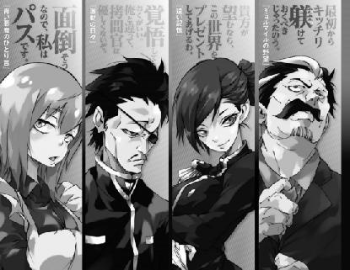

Myourmiles: “I should have taught you your manners much earlier.”

Velgrynd: “If you so desire, I shall give you the entire world.”

Calgurio: “Then you had better prepare yourself. Unlike me, the one in charge of your torture isn’t going to be that nice.”

Rain: “Sounds annoying, so I’ll pass.”



Velgrynd: “Ara, may I ask just what you were trying to achieve by making Masayuki cry like that?”

Testarossa: “Oh no, I assure you that I would not do anything of the sort.”

The two beautiful ladies stare at each other with smiles on their faces.

The forces of their gazes collide, causing a fearsome pressure to fall on the surroundings.

