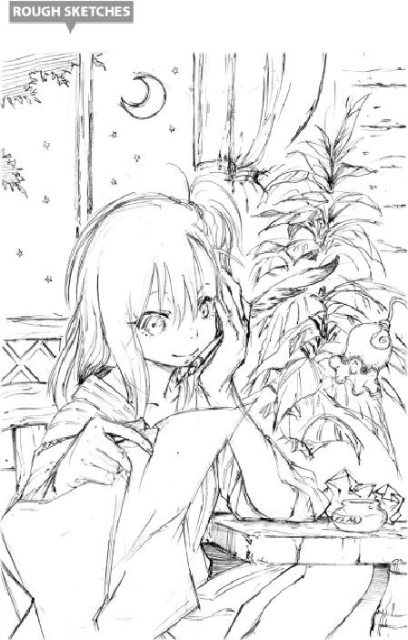

EPILOGUE

IN THE HOLY LAND

Dang, Laplace thought as he ran as fast as his legs could take him, I thought I was gonna die!

Just as they had discussed, he had attempted to break into the holy domain once more, the moment the Walpurgis Council began. He was on his way to the cathedral inside the Holy Temple, headed for the Inner Cloister where he ran into a demon lord last time…only to run into the worst person possible.

She was none other than the epitome of strength and beauty—Hinata Sakaguchi, captain of the Chief Knights of the Holy Imperial Guard and leader of the Church’s paladin forces.

Whoaaa! What the hell? This ain’t how the promise went!

Laplace cursed his absent client. The “promise” was that said client would lure Hinata out of there for him. He could already hear the guy laughing and saying “Oops! Sorry, sorry” to him. The mere thought of it irritated him gravely.

But now was no time for grousing.

“I do so detest insects like you. Burrowing into a holy place such as this…”

The sound of Hinata’s cold voice made him feel like the life was ebbing out of him. Without another moment’s hesitation, Laplace decided to run—and he made it out, alive and well.

His mission was a failure. The Inner Cloister might as well have been on another planet. But none of it was Laplace’s fault.

Whether the demon lord Valentine’s absent or not, if she’s around, it doesn’t bloody matter…

“You expect me to beat that monster?” he whispered to himself as he gave up the job. Still, he thought, I’ve been doin’ nothin’ but run lately, huh?

He wanted to give himself a well-deserved pat on the back for getting away from Hinata at all, but that didn’t mean he liked it much. Given the terrible hand fate had been dealing him lately, it didn’t seem smart to assume he’d make it all the way—

Then he felt a rift appear, on the outskirts of the holy city, erupting into a massive wave of magical energy.

“Whoa… For real…?”

Laplace could barely stand this any longer. That wasn’t just a high-level magic-born—it was something even stronger than that. Plus, Laplace was familiar with its magical wavelength.

“You little worm! Show yourself before me, now!!”

The voice of the demon lord Valentine thundered angrily, like a maelstrom of purging fire.

“Dammit! Now it’s a demon lord?!”

Laplace wanted to wail out loud at the completeness of his sheer bad luck. But now wasn’t the time for that. He attempted to run off once more—

“Hmph! You’re just as lowly as him, I see. Do you just enjoy inching around?”

—then he stopped, sensing something in Valentine’s choice of words.

“What do you mean?”

“Pfft! It does not involve you.” Valentine scornfully laughed. “But very well. Just a moment ago, the demon lord Clayman lost his life. That foolish, sniveling little maggot fled for his life, too, just like you, mewling pathetically the whole time.”

“What?”

“Ha-ha-ha! What, are you angry? What does it matter to you?”

“Shut up! Are you fer real? Clayman’s dead?”

“Haaaaah-ha-ha-ha! So the maggot’s let the cat out of the bag, has he? I thought you two might be connected. By the will of the goddess Luminus!!”

Laplace stood there, dazed, before Valentine’s loud laughter. Clayman’s death was too much for him to believe. Not that he couldn’t believe it, he just didn’t want to. To him, Clayman was a good friend and companion, if restless and nervous.

“What’re you laughin’ about, ya pile of garbage?!”

“Who do you think you’re talking to, you—gnnngh?!”

“Dumbass! I told you not to laugh at my friend!”

Laplace’s fists never stopped swinging. They were literally killer, both of them.

“Gnhh, don’t—don’t you start on me, maggot!!”

His face reddened with anger and humiliation, Valentine glared at Laplace. No matter how much this insect hit him, Ultraspeed Regeneration made it all pointless. Death was the only way to give fools like these a lesson, as he thought it. He didn’t even stop to wipe the blood sprays—sprays that even now turned into a fine, crimson mist that descended around them both:

“Die! Bloodray!!” Valentine cried.

Amid this absolute barrier of gore, a torrent of visceral blood particles hurtled at the speed of a bullet toward—nowhere.

“Uh-uh. You’re a dead man.”

“Wha…?!” Valentine had no idea what happened. He bore overwhelming power, and this little maggot was toying with him. He had tried to kill him with his most powerful of skills, but for some reason, it never went off. Tonight was a new moon, the period when his powers were at their lowest point, but to a demon lord, the difference was trivial.

There could be only one explanation: Laplace was strong. And this turned out to be correct. In Laplace’s hand, there was something throbbing.

“…!!”

“Yep. That’s yer core, there, your heart. Can’t move, can’t speak, am I right? That’s what I do.”

As Laplace gave him the cruel news, Valentine’s body began to unconsciously shiver, little by little. It almost felt like…

…Fear? Am I feeling fear?!

“You were juuuust a little late on the uptake there. But you got it now, yeah? I’m a strong one.”

Valentine’s face turned pale, wincing in desperation. He realized that Laplace really did have his core in his hand. All was lost.

The expression made Laplace whoop in crazed laughter as he crushed it with his fingers. The battle was decided in a single moment.

Laplace didn’t stop smiling for a while after.

…Oooh, Footman’s not gonna like this…

He had massacred all the guards who spotted him.

…Ooh, and Teare’s probably gonna cry, too…

He had attempted to flee straight out of there.

…And that’s exactly why I’m laughing. Laughing at you, Clayman. For being such a perfect idiot.

The Crazed Clown, in his estimation, had experienced exactly the death he deserved. Laplace wasn’t angry; he wasn’t crying; he was just laughing, in commemoration of a friend who would no longer laugh with him.

