BÁO CÁO THỰC HÀNH LAB 03

LẬP TRÌNH HƯỚNG ĐỐI TƯỢNG

Phạm Minh Đạt -20210169

Mục lục

Mục Lục

1.Branch your repository 2

2.Working with method overloading 4

3.Passing parameter 5

4. Use debug run 5

5. Classifier Member and Instance Member 6

6. Open the Cart class 8

7. Implement the Store class 9

8. Re-organize your projects 11

9. String, StringBuilder and StringBuffer 12

Question: Is JAVA a Pass by Value or a Pass by Reference programming language? 13

# Mục Lục ảnh

Pic1. Tạo branch mới abc và checkout vào để làm việc 3

Pic2: push lên branch abc 3

Pic 3: merge branch abc vào master 4

Pic4: đã merge thành công 4

Pic5: ta merge lại nhánh abc vào nhánh master trên máy tính . 4

Pic6: Method addDigitalVideoDisc 5

Pic 7: Method addDigitalVideoDisc(DigitalVideoDisc dvd1,DigitalVideoDisc dvd2) 5

Pic 8: Passing parameter code 6

Pic 9: Passing parameter code 6

Pic 10: Passing parameter code 6

Pic 11: Classifier Member and Instance Member Code 7

Pic 12: Classifier Member and Instance Member Code 7

Pic 13: Classifier Member and Instance Member Code 8

Pic 14: Classifier Member and Instance Member result 8

Pic 14: Method in class Cart to print the list 9

Pic15: Method in class Cart to search Title 9

Pic16: Method in class Cart to search ID 10

Pic17: Code class Store 10

Pic 18: Code class Store 11

Pic 19: Code class Store 11

Pic 20 sort folder code 12

Pic 21 Code ConcatenationInLoops 13

Pic 22 Code Garbagecreator 13

Pic23 NoGarbage code 14

=> In Java, when you pass a variable to a method, you are passing the value of the variable, not the actual variable itself. This is known as "pass-by-value." 14

In the context of method parameters, passing by value means that a copy of the value stored in the variable is passed to the method. Any changes made to the parameter inside the method do not affect the original variable outside the method. 14

# 1.Branch your repository

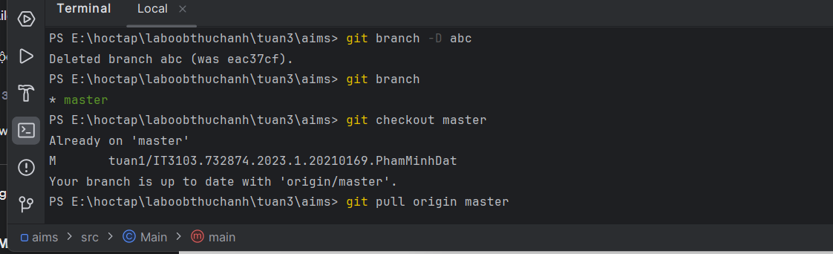

Pic1. Tạo branch mới abc và checkout vào để làm việc

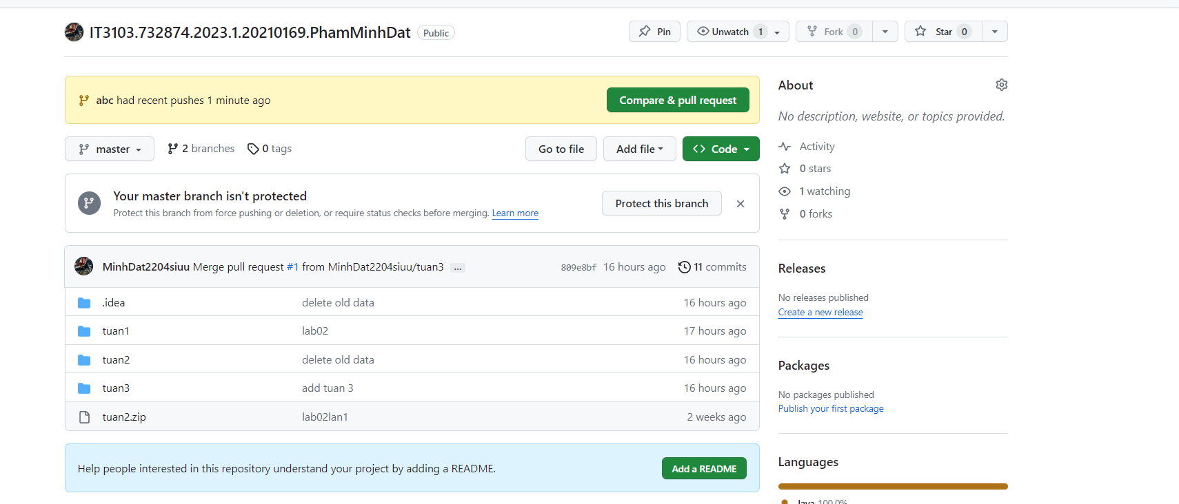

Pic2: push lên branch abc

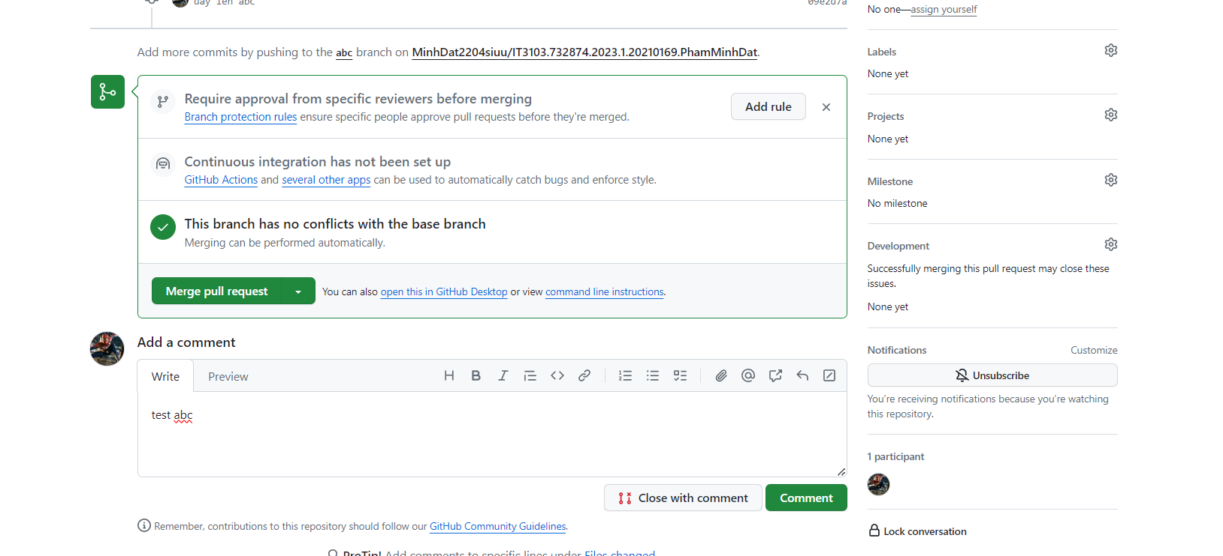

Pic 3: merge branch abc vào master

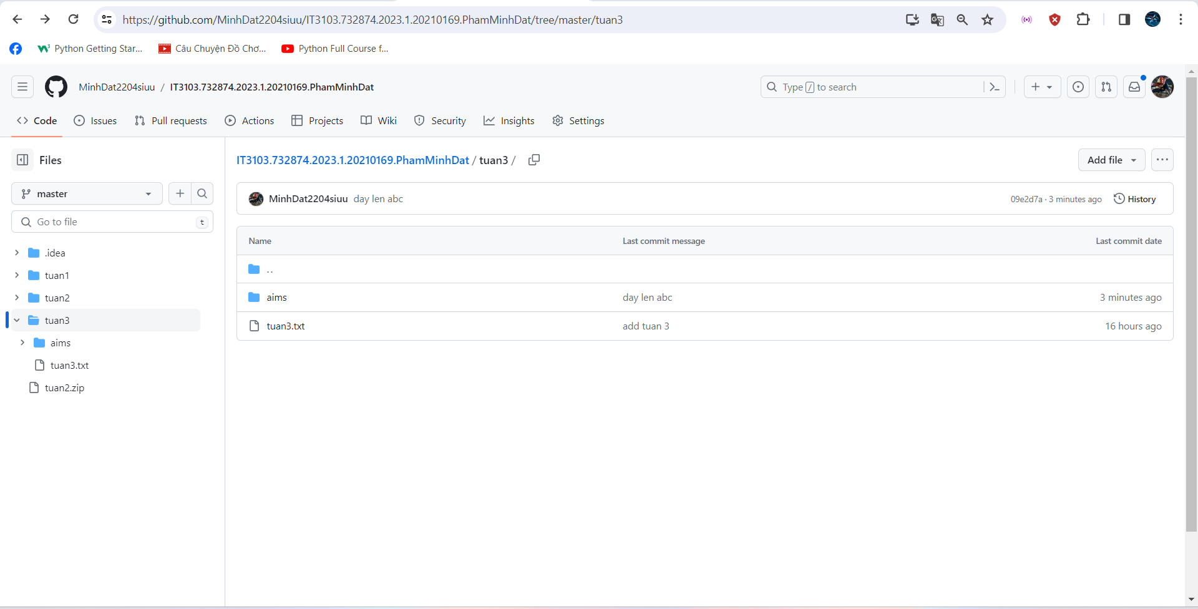

Pic4: đã merge thành công

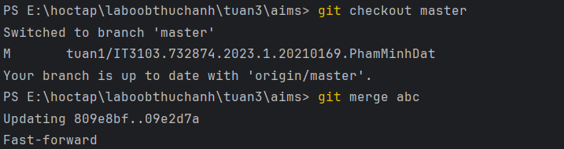

Pic5: ta merge lại nhánh abc vào nhánh master trên máy tính .

# 2.Working with method overloading

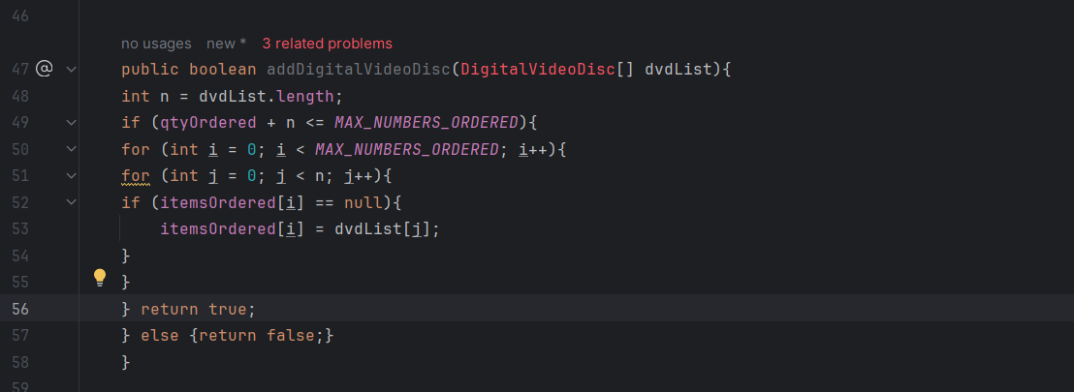

Pic6: Method addDigitalVideoDisc

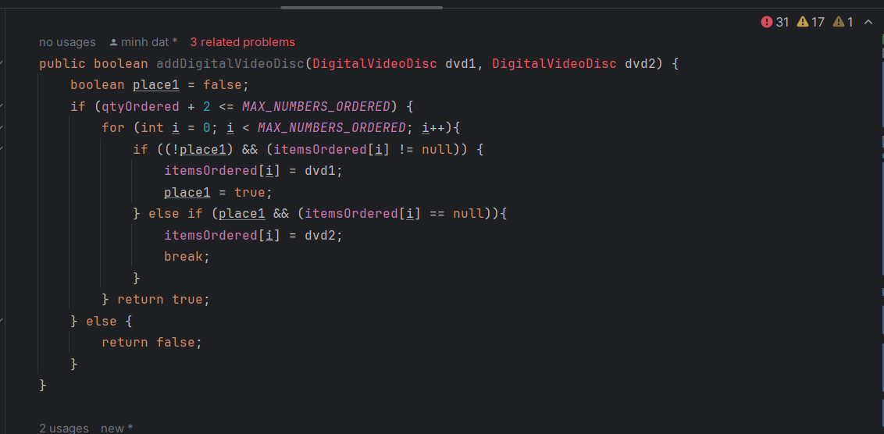

Pic 7: Method addDigitalVideoDisc(DigitalVideoDisc dvd1,DigitalVideoDisc dvd2)

# 3.Passing parameter

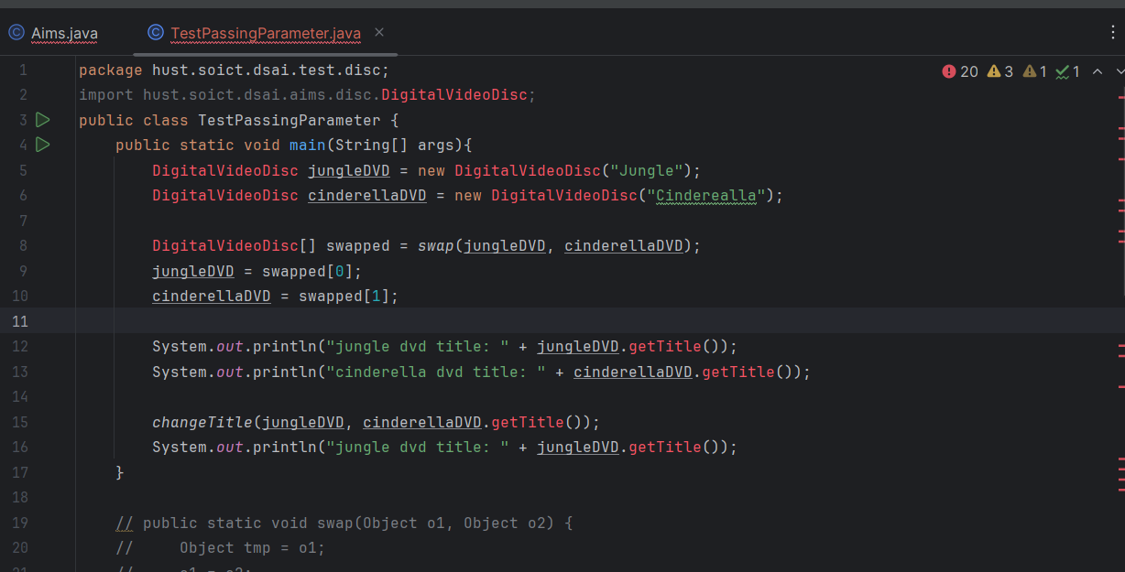

Pic 8: Passing parameter code

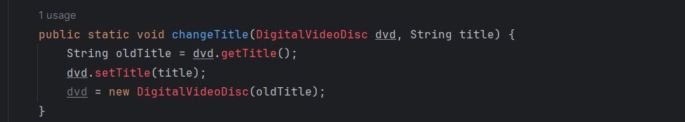

Pic 9: Passing parameter code

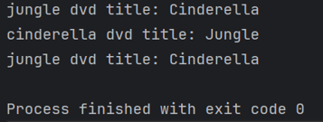

Pic 10: Passing parameter code

# 4. Use debug run

Chạy debug giúp ta hiểu rõ hơn sự thực thi của chương trình, đồng thời ta còn có thể thay đổi giá trị của object một cách thủ công.

# 5. Classifier Member and Instance Member

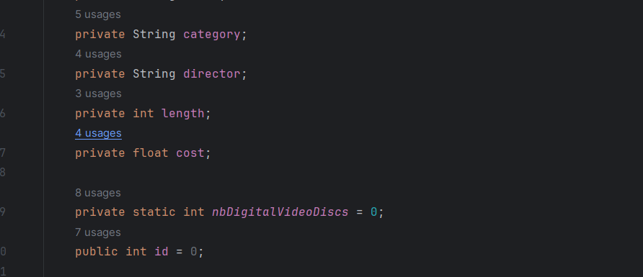

Pic 11: Classifier Member and Instance Member Code

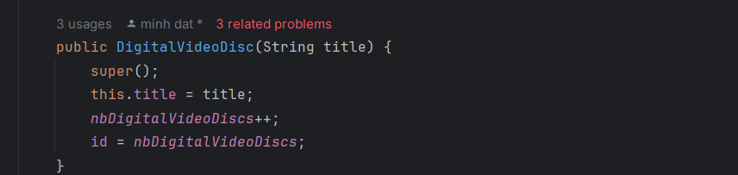

Pic 12: Classifier Member and Instance Member Code

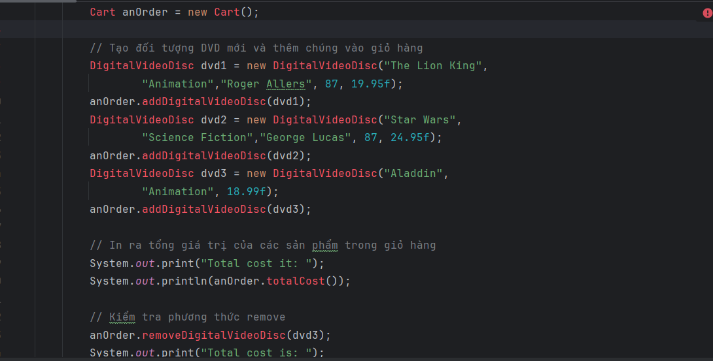

Pic 13: Classifier Member and Instance Member Code

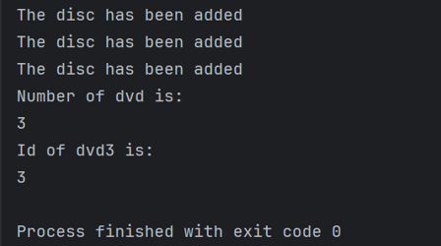

Pic 14: Classifier Member and Instance Member result

# 6. Open the Cart class

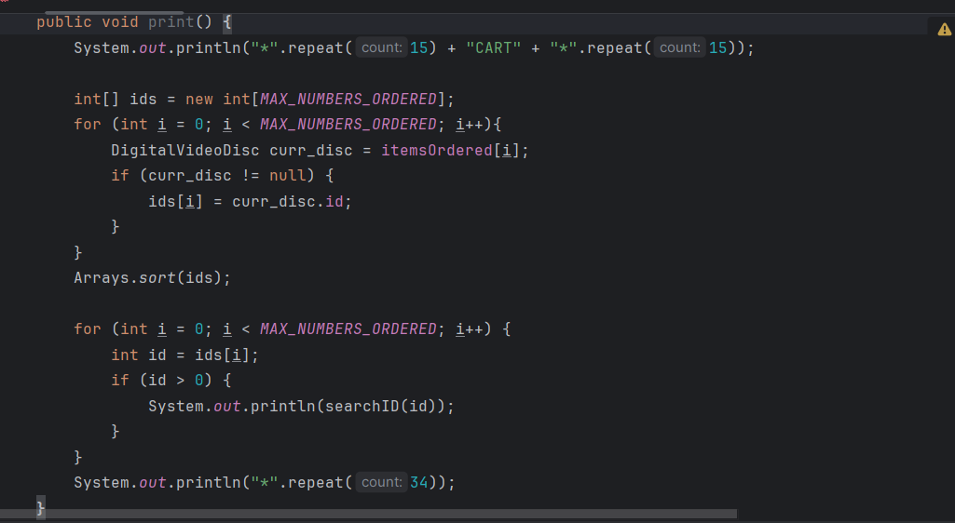

Pic 14: Method in class Cart to print the list

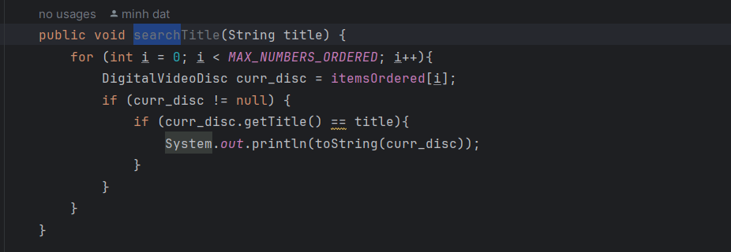

Pic15: Method in class Cart to search Title

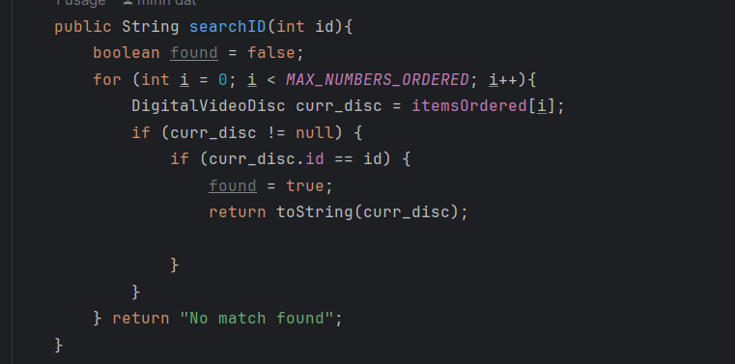

Pic16: Method in class Cart to search ID

# 7. Implement the Store class

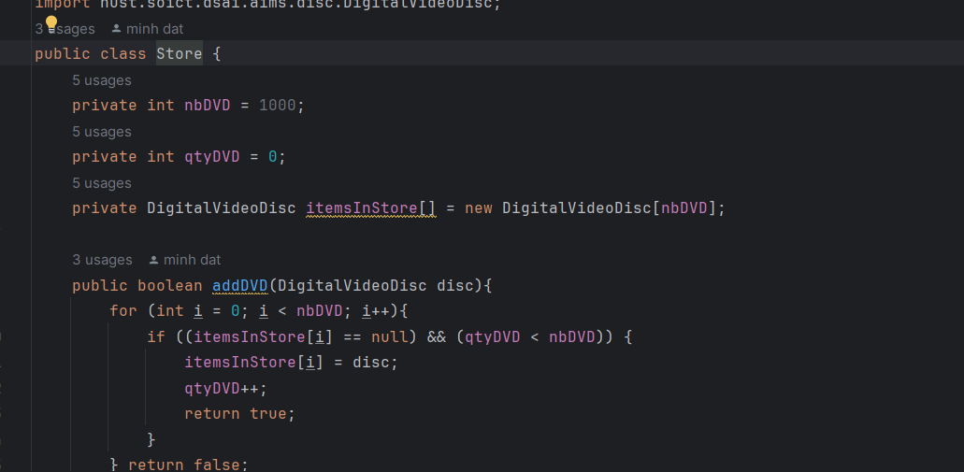

Pic17: Code class Store

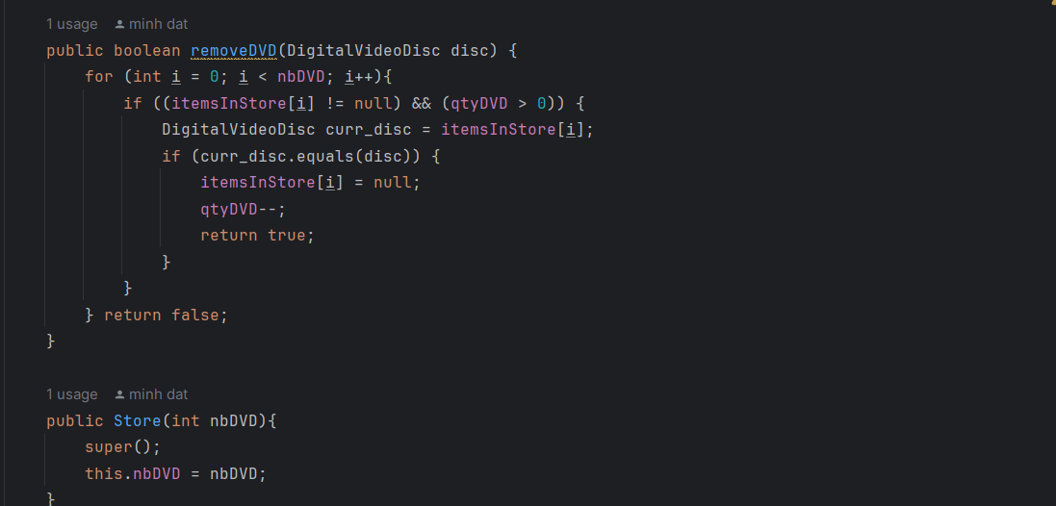

Pic 18: Code class Store

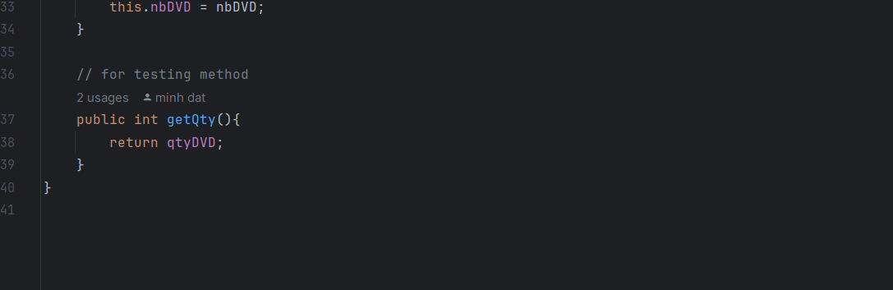

Pic 19: Code class Store

# 8. Re-organize your projects

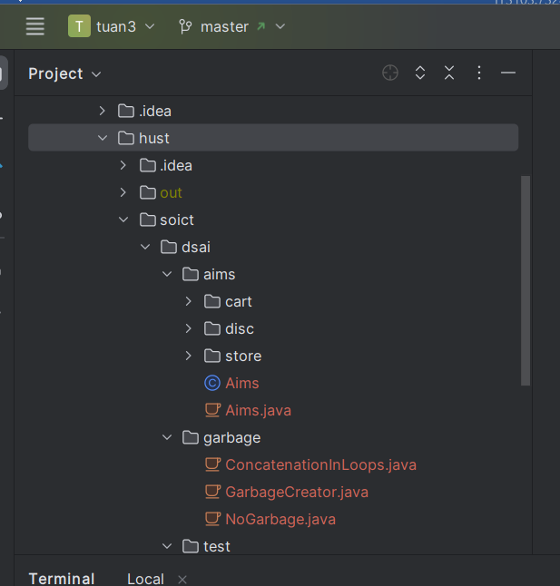

Pic 20 sort folder code

# 9. String, StringBuilder and StringBuffer

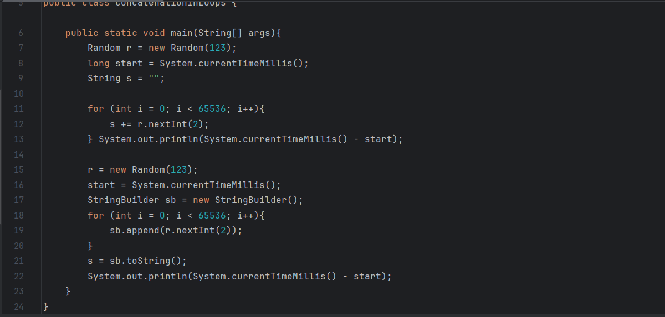

Pic 21 Code ConcatenationInLoops

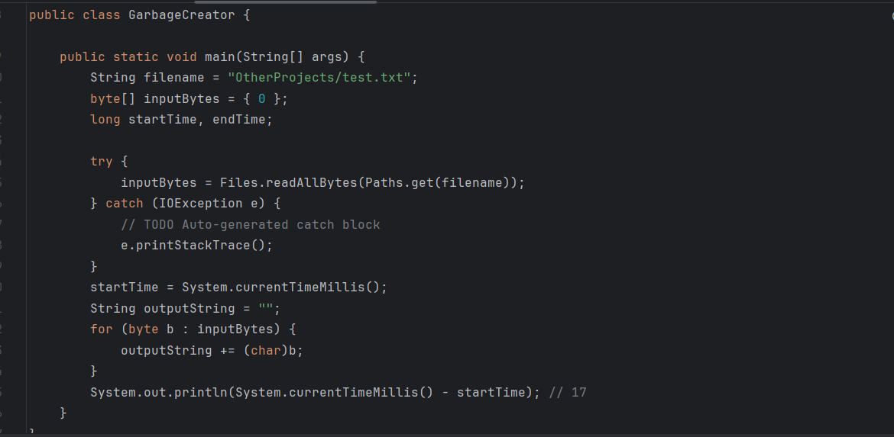

Pic 22 Code Garbagecreator

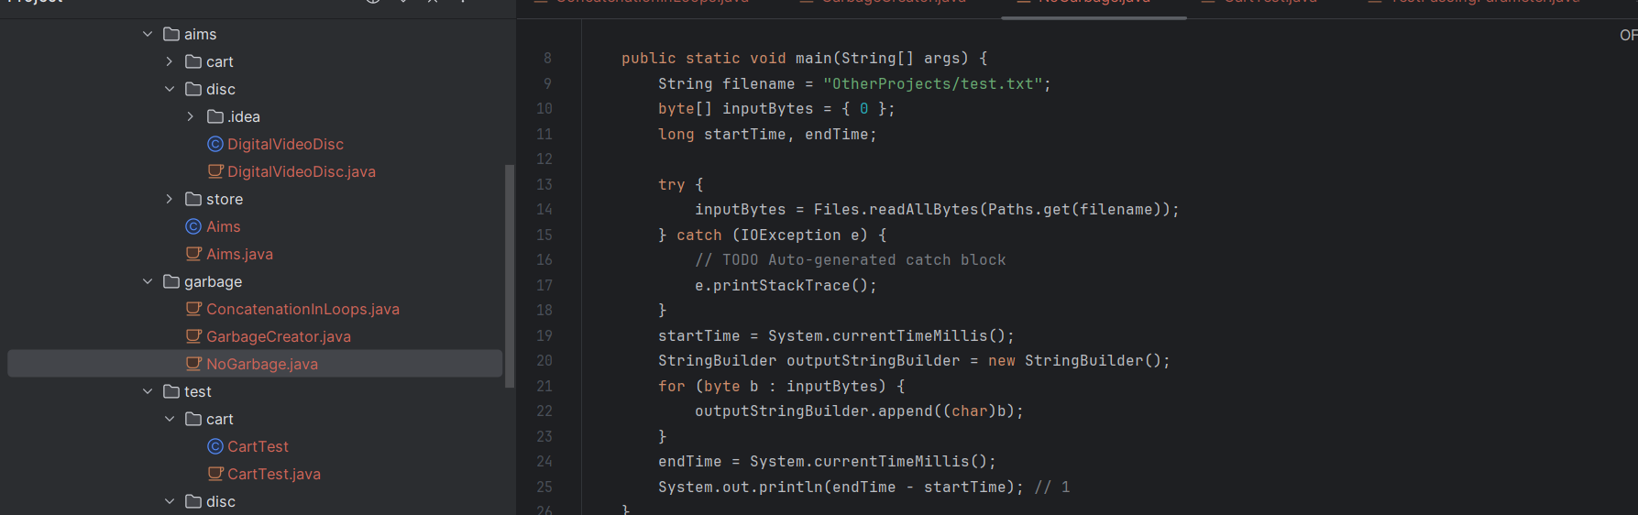

Pic23 NoGarbage code

# Question: Is JAVA a Pass by Value or a Pass by Reference programming language?

=> In Java, when you pass a variable to a method, you are passing the value of the variable, not the actual variable itself. This is known as "pass-by-value."

In the context of method parameters, passing by value means that a copy of the value stored in the variable is passed to the method. Any changes made to the parameter inside the method do not affect the original variable outside the method.