SWT301 – Progress-Test1

1. Project Information
- Course: SWT301
- Student: Ngô Hoàng Minh Đạt
- MSSV: DE190496
- Project: Progress-Test1
- Java: 21
- Build Tool: Maven
- Testing Framework: JUnit 5
- Coverage Tool: JaCoCo

2. How to Run
Open Terminal in the project root directory and run:
- “mvn clean test”
The expected result is:
- Tests run: 97
- Failures: 0
- Errors: 0
- Skipped: 0
The test suite passes successfully.

3. JaCoCo Coverage
JaCoCo report is generated at:
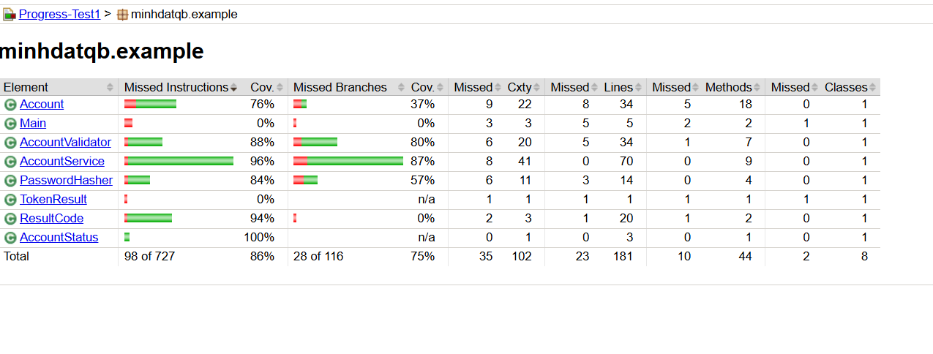
Required coverage:
- Line Coverage >= 80%
- Branch Coverage >= 70%
Result: PASS

4. Mutation Testing
Three mutations were manually introduced and tested.
STT | Lỗi chèn | Test fail | Đã hoàn tác
M1 | >= MAX_FAILED_ATTEMPTS → > MAX_FAILED_ATTEMPTS | AccountServiceTest$Login.login_WrongPassword5thTime_LocksAccount | ✅
M2 | Xóa/tắt if (acc.isLocked()) | AccountServiceTest$Login.login_WhileLocked_RejectsWithoutIncrement | ✅
M3 | {4,19} → {4,20} | AccountValidatorTest.isValidUsername_BoundaryLength | ✅

5. Traceability Matrix
Business Rule | Test
BR-REG-01 - Validate basic registration input | AccountServiceTest$Register
BR-REG-02 - Validate username | AccountValidatorTest.isValidUsername_BoundaryLength
BR-REG-03 - Duplicate username | AccountServiceTest$Register
BR-REG-04 - Validate email | AccountValidatorTest
BR-REG-05 - Duplicate email | AccountServiceTest$Register
BR-REG-06 - Validate password | AccountValidatorTest
BR-REG-07 - Confirm password | AccountServiceTest$Register
BR-REG-08 - Minimum age 18 | AccountServiceTest$Register
BR-REG-09 - Validate phone | AccountServiceTest$Register.register_PhoneVariations
BR-REG-10 - Create account successfully | AccountServiceTest$Register
BR-LOG - Login and failed-attempt handling | AccountServiceTest$Login
BR-ADM-03 - Unlock account | AccountServiceTest

6. Checklist

TODO-8 - Coverage and Mutation Testing
mvn clean test → 0 failures, 0 errors, 0 skipped.
Opened target/site/jacoco/index.html.
AccountValidator Line Coverage >= 80%.
AccountValidator Branch Coverage >= 70%.
AccountService Line Coverage >= 80%.
AccountService Branch Coverage >= 70%.
Mutation M1 detected by test.
Mutation M2 detected by test.
Mutation M3 detected by test.
All mutations were restored.
Final tests pass.
Working tree is clean.

TODO-9 - Submission
README.md contains run guide.
README.md contains test count.
README.md contains coverage results.
README.md contains mutation table.
README.md contains traceability matrix.
Checklist completed.
Create Lab2_<MSSV>_<HoTen>.zip.
Exclude target/.
Exclude .idea/.
Exclude .vscode/.

7. Final Result
The project was tested using Maven and JUnit 5.
Final test result:
- Tests run: 97
- Failures: 0
- Errors: 0
- Skipped: 0
JaCoCo coverage satisfies the required Line and Branch Coverage thresholds.
Three manual mutations were introduced successfully, detected by automated tests, and restored before submission.

