

**Information Technology Institute**

**(ITI)**

**Intake 39**

**Embedded Systems Track**

**Graduation Project**

**Title:-**

- An adaptable digital hearing aid.

**Team members:-**

1) Hanna Nabil Abd El-shahid.

2) Bishoy Medhat Elraheb.

**Under the supervision of:-**

1) Eng.\ Ahmed Al-Ashmawy.

2) Eng.\ Yousef Nofel.

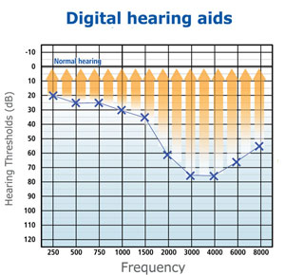**Description:-**

- An adaptable digital hearing aid that allows the

dynamic change of its amplification by the

user. Moreover, it will be less costly than an

analogue prefixed hearing aid that requires

constant changing to adapt with the patient’s

changing state.

- The most basic function of a hearing aid is to

amplify sound. Digital hearing aids do this in a

rather sophisticated way.

- As sound enters the device, it is broken into multiple frequency bands. Each band is

then amplified by the amount necessary to return the wearer's hearing to normal

levels at that band.

- With digital technology, devices can now break sound into as many as 24 different

bands.

- Given that every person has a unique pattern of hearing loss, the sound quality

provided by a modern hearing aid is far better the previous analogue technologies

that were restricted to two bands - base (low frequencies) and treble (high

frequencies).

**Problem Definition:-**

- Hearing impairment is one of the commonest birth defects.

- It is the third leading chronic disability affecting nearly 250 million people in the

world, and 75% of sufferers live in developing countries.

- The impact of hearing impairment on the individual and society is significant.

- Development of hearing loss leads to severe handicap that affects the sufferer’s job,

home and life with subsequent social and economic burden on the society.

- In children the problem is compounded since normal hearing is the primary source

for acquisition of language, speech and cognitive skills.

- In a national household survey conducted to estimate the prevalence of hearing

impairment in Egypt, it was found to be high in those aged 0-4 years (22.4%).

**Our objective is a product with 2 options:-**

- A complete standalone headset that works as a Digital Hearing Aid and controllable

by a mobile app via Bluetooth **with:-**

- **1st option:** the output sound is send to an audio Bluetooth module then wirelessly to

earphones.

- **2nd option:** the output sound is send to an audio codec then send by wire to

earphones.

**Our product advantage:-**

- **Appearance**: Our product appears like mobile’s earphones in shape so it will not be

shame to anyone who have a hearing impairment problem to use our product.

- As we know many of friends have already this problem and they feel shy to wear a

hearing aid because it has a unique shape.

- **Cost**:The range of hearing aids products is from 500£ to 2000£ but our product will

be less than this price.

- **Controllable by mobile app:** you can control our product using mobile app by varying

the gain of specific frequency bands using specific buttons on the mobile app.

**Block diagram:-**

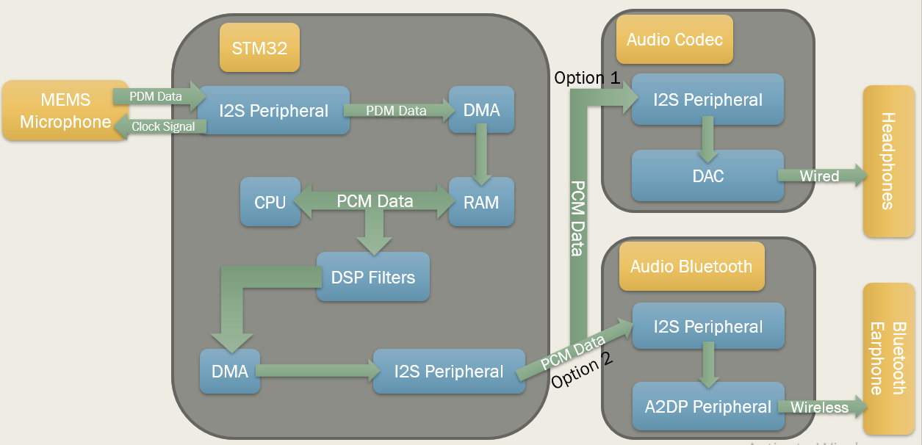

**Mems microphones:-**

- The digital MEMS microphone is a sensor that convert acoustic pressure waves into a

digital signal. The STM32 microcontroller acquires digital data from the

microphone(s) through particular peripherals to be processed and transformed into

data standard for audio. The audio data is then handled by the microcontroller

according to the targeted audio application.

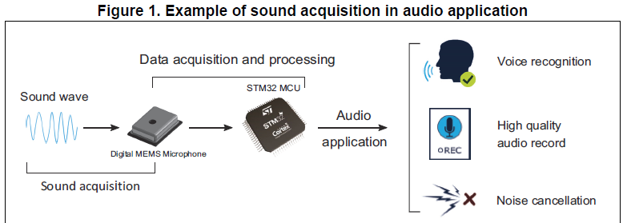

**PDM digital microphone block diagram:-**

- The main parts in a digital microphone are a **MEMS transducer**, an **amplifier** and a

**PDM modulator**.

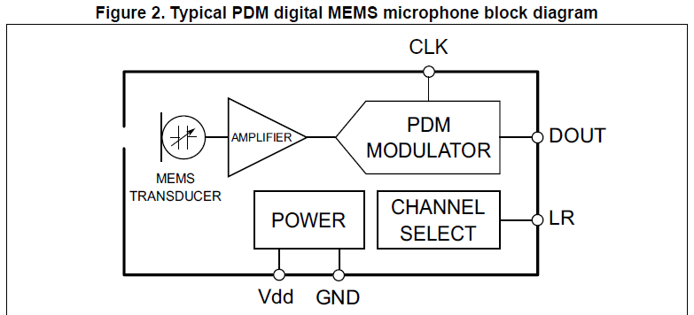

**MEMS TRANSDUCER:-**

- The MEMS TRANSDUCER is a variable capacitance that converts the change into air

pressure caused by sound waves to a voltage.

**AMPLIFIER:-**

- The AMPLIFIER buffers the voltage provided by the MEMS TRASDUCER, and provides

a sufficiently strong signal to the PDM MODULATOR.

**PDM MODULATOR:-**

- PDM MODULATOR converts the buffered analog signal into a serial pulse density

modulated signal. The clock input (CLK) is used to control the PDM modulator. The

clock frequency range for ST digital microphones is from 1 MHz to 3.25 MHz. This

frequency will define the sampling rate at which the amplifier’s analog output signal

is sampled to produce a discrete-time representation (PDM bit stream).

**CHANNEL SELECT:-**

- The microphone’s output is driven to the proper level on a selected clock edge and

then goes into a high impedance state for the other half of the clock cycle. The

CHANNEL SELECT defines the clock edge on which the digital microphone outputs

valid data. The LR pin must be connected to Vdd or GND.

- Table 1 shows how to select the DOUT signal pattern.

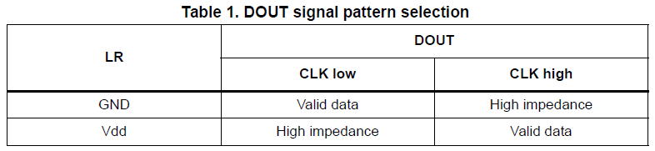

**POWER:-**

- POWER delivers Vdd and GND supplies to the different digital microphone’s

components. The power supply should be properly provided to the microphone since

any ripple can generate noise on the output.

**Pin description:-**

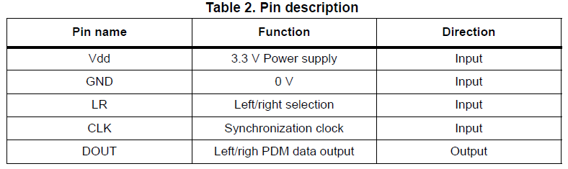

**Basic digital microphones connection:-**

**Mono mode:-**

- In this mode LR pin can be either connected to Vdd or to GND.

- LR pin is connected to Vdd.

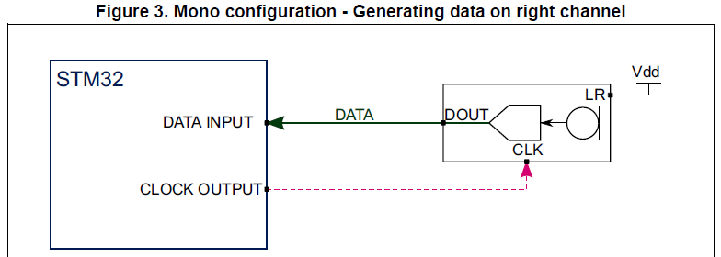

- On the rising edge of the clock, the microphone will generate valid data for half of

the clock period, then goes into a high impedance state for the other half.

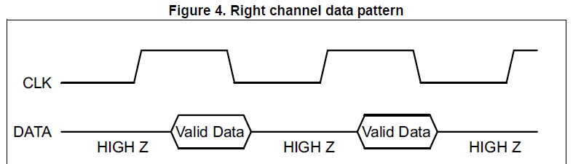

- LR pin is connected to GND.

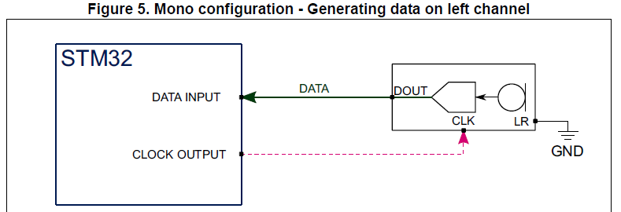

- On the falling edge of the clock, the microphone will generate valid data for half of

the clock period, then goes into a high impedance state for the other half.

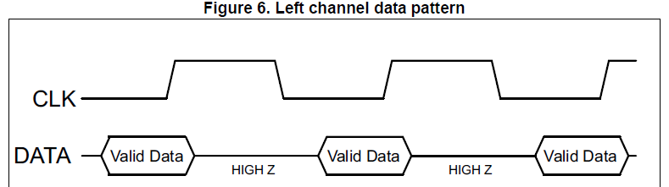

**Stereo configuration:-**

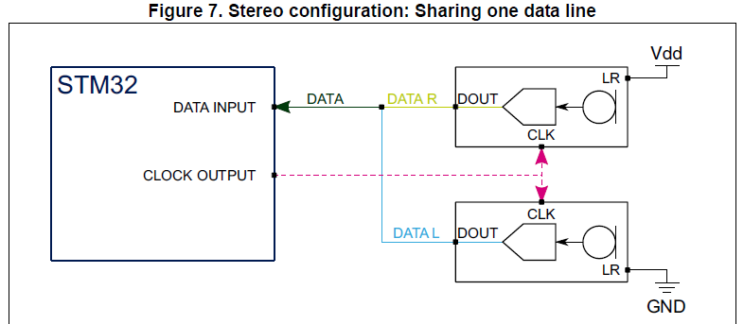

- Two different digital MEMS microphones are connected on the same data line,

configuring the first to generate valid data on the rising edge of the clock by setting

the LR pin to Vdd and the other on the falling edge by setting the LR pin to GND.

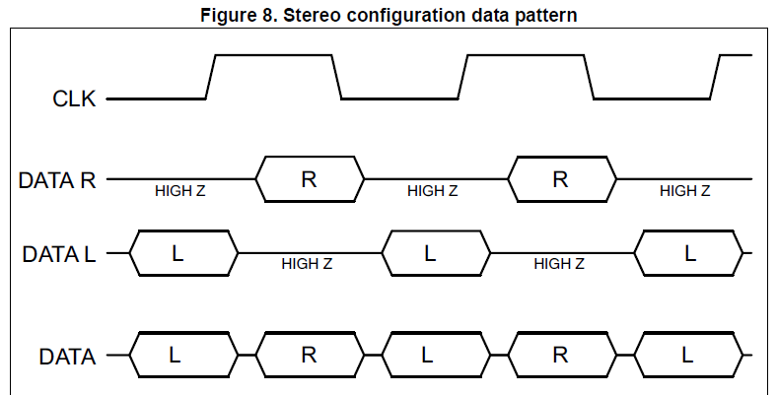

**Pulse density modulation signal (PDM):-**

- PDM is a form of modulation used to represent an analog signal in the digital domain. - It is a high frequency stream of 1-bit digital samples.

- In a PDM signal, the relative density of the pulses corresponds to the analog signal's

amplitude.

- A large cluster of 1s correspond to a high (positive) amplitude value, when a large

cluster of 0s would correspond to a low (negative) amplitude value, and alternating

1s and 0s would correspond to a zero amplitude value.

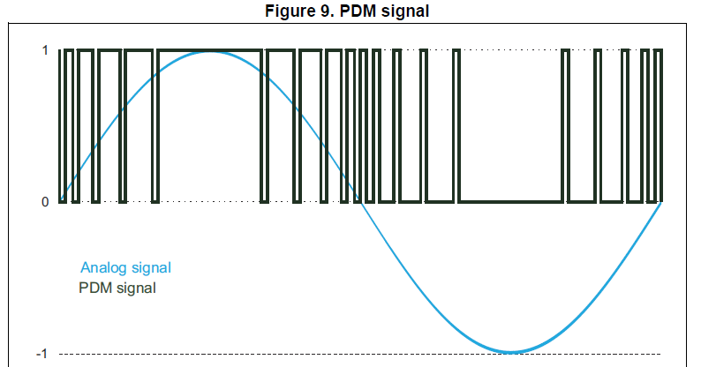

**Pulse code modulation signal (PCM):-**

- In the PCM signal, specific amplitude values are encoded into pulses.

- A PCM stream has two basic properties that determine the stream's fidelity to the

original analog signal:

- The sampling rate.

- The bit depth.

- The sampling rate is the number of samples of a signal that are taken per second to

represent it digitally.

- The bit depth determines the number of bits of information in each sample.

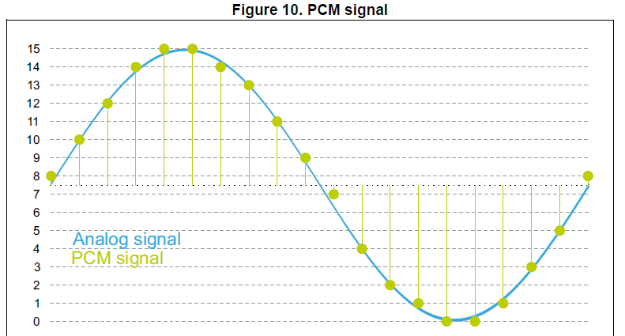

**PDM to PCM conversion:-**

- In order to convert the PDM stream into PCM samples, the PDM stream needs to be

filtered and decimated.

- In the decimation stage, the sampling rate of the PDM signal is reduced to the

targeted audio sampling rate (16 kHz for example).

- By selecting 1 of each M samples, the sample rate is reduced by a factor of M.

Therefore, the PDM data frequency (which is the frequency of the microphone clock)

is M times the target audio sampling frequency needed in an application, where M is

the decimation factor.

**- PDM Frequency = Audio Sampling Frequency * Decimation Factor**

- The decimation factor is generally in the range of 48 to 128.

- The decimation stage is preceded by a low-pass filter to avoid distortion from

aliasing.

**PDM2PCM software library:-**

- The PDM2PCM library converts a PDM bit stream from a MEMS microphone into a

PCM audio stream.

**Algorithm functionality:-**

- The PDM2PCM library has the function to decimate and filter out a Pulse Density

Modulated (PDM) stream from a digital microphone, to convert it to a Pulse Code

Modulated (PCM) signal output stream.

- The PCM output stream is implemented with 16-bit resolution.

- The sampling rate is not specified in the interface but it is agreed in this document

that the PCM sampling rate used is 16 kHz.

- Various decimation factors can be configured, to adapt to various PDM clocks.

- A configurable high-pass filter and a digital volume are also proposed.

**Module configuration:-**

- PDM2PCM library takes as input a PDM signal (768 kHz to 2.048 MHz) stream of 1-bit

digital samples.

- This signal is acquired in blocks of 8 samples by using a synchronous serial port (SPI or

I2S) of the STM32 microcontroller.

**Module interfaces:-**

- Two files are needed to integrate the PDM2PCM library, the pdm2pcm_glo.h header

file and the right library file (according to target and tool chain).

- They contain all definitions and structures to be exported to the software integration

framework.

**APIs:-**

- Five functions have a software interface to the main program:

- PDM_FilterInit.

- PDM_Filter_setConfig.

- PDM_Filter_getConfig.

- PDM_Filter_deInterleave.

- PDM_Filter.

**PDM_FilterInit function:-**

- This procedure initializes the static memory, sets default values and initializes lookup

tables of the PDM2PCM library.

**uint32_t PDM_FilterInit(PDM_Filter_Handler_t *pHandler);**

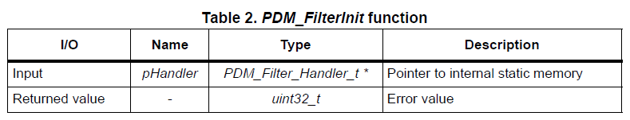

- This routine must be called at least once at initialization time, when the real time

processing has not started yet.

**PDM_Filter_setConfig function:-**

- This procedure sets module dynamic parameters from the main framework to the

module internal memory. It can be called at any time during processing.

**uint32_t PDM_Filter_setConfig(PDM_Filter_Handler_t *pHandler, PDM_Filter_Config_t *pConfig);**

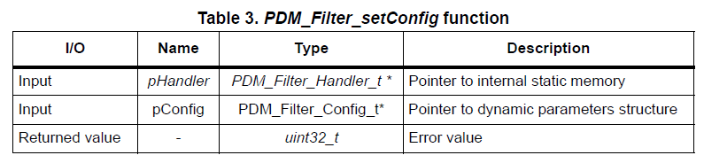

**PDM_Filter_getConfig function:-**

- This procedure gets module dynamic parameters from internal static memory to the

main framework. It can be called at any time during processing.

**uint32_t PDM_Filter_getConfig(PDM_Filter_Handler_t *pHandler, PDM_Filter_Config_t *pConfig);**

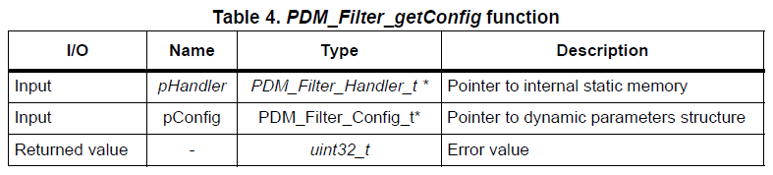

**PDM_Filter function:-**

- This procedure decodes an input PDM stream to an output PCM stream. It has to be

called to process each frame.

**uint32_t PDM_Filter(void *pDataIn, void *pDataOut, PDM_Filter_Handler_t * pHandler);**

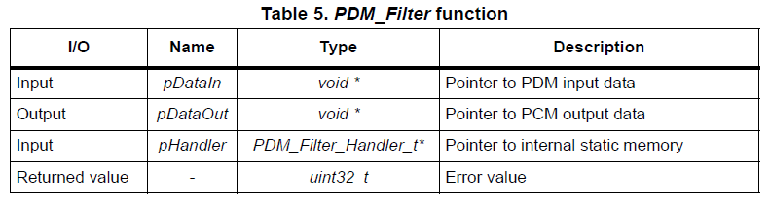

**Static parameters structure:-**

- The PDM2PCM initial parameters are set using the corresponding static parameter

structure before calling the PDM_Filter_setConfig() function.

**typedef struct {**

**uint16_t bit_order;**

**uint16_t endianness;**

**uint32_t high_pass_tap;**

**uint16_t in_ptr_channels;**

**uint16_t out_ptr_channels;**

**uint32_t pInternalMemory[INTERNAL_MEMORY_SIZE];**

**}PDM_Filter_Handler_t;**

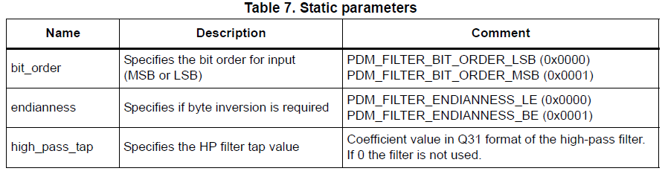

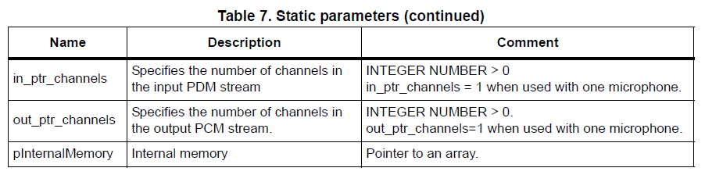

**Dynamic parameters structure:-**

- It is possible to change the PDM2PCM configuration by setting new values in the

dynamic parameter structure before calling the PDM_Filter_setConfig() function.

**typedef struct {**

**uint16_t decimation_factor;**

**uint16_t output_samples_number;**

**int16_t mic_gain;**

**}PDM_Filter_Config_t;**

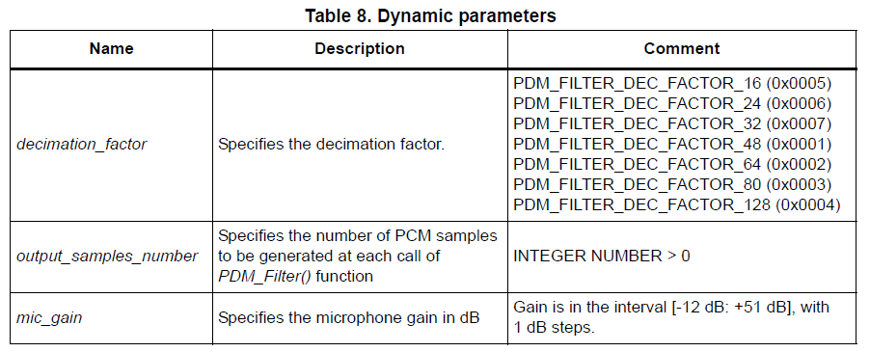

**Processing steps:-**

- A MEMS microphone outputs a PDM stream, which is a high frequency stream of 1-

bit digital samples.

- The library expects a stream made of 8-sample blocks (one byte), which will be

acquired using a synchronous serial port (SPI or I2S) of the STM32 microcontroller.

- The microphone PDM output is synchronous with its input clock, therefore the used

STM32 serial port generates a clock signal for the microphone.

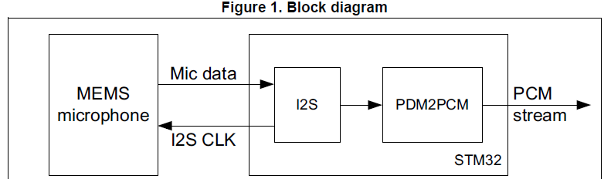

- The PDM data from the microphone are packed in 8-bit blocks, and then filtered and

decimated.

- The frequency of the obtained PCM signal depends on the decimation factor

configured before the library initialization.

- The decimation factors have been defined to get a PCM stream of the desired

sampling frequency, depending on the PDM clock value.

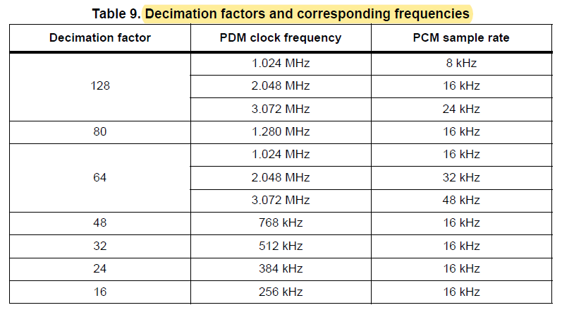

**Library initialization:-**

- Once the memory is allocated, some routines must be called to initialize the

PDM2PCM library static memory:

- PDM_Filter_Init() has to be called each time the processing in the audio is stopped

and started.

- PDM_Filter_setConfig() has to be called at least once before processing start, to set

configurable parameter

- Furthermore, as the PDM2PCM library runs on STM32 devices, CRC HW block must

be enabled and reset.

- The static and dynamic parameters structures must be allocated.

- Their types are defined in pdm2pcm_glo.h header. Example of allocation:

**/*Enables and resets CRC-32 from STM32 HW */**

**__HAL_RCC_CRC_CLK_ENABLE();**

**CRC->CR = CRC_CR_RESET;**

**PDM_Filter_Handler_t PDM1_filter_handler;**

**PDM_Filter_Config_t PDM1_filter_config;**

**/* Initialize PDM Filter structure */**

**PDM1_filter_handler.bit_order = PDM_FILTER_BIT_ORDER_LSB; PDM1_filter_handler.endianness = PDM_FILTER_ENDIANNESS_BE; PDM1_filter_handler.high_pass_tap = 2122358088; PDM1_filter_handler.out_ptr_channels = 1; PDM1_filter_handler.in_ptr_channels = 1;**

**PDM_Filter_Init((PDM_Filter_Handler_t *)(&PDM1_filter_handler));**

**PDM1_filter_config.output_samples_number = 16;**

**PDM1_filter_config.mic_gain = 24;**

**PDM1_filter_config.decimation_factor = PDM_FILTER_DEC_FACTOR_64; PDM_Filter_setConfig((PDM_Filter_Handler_t *)&PDM1_filter_handler, &PDM1_filter_config);**

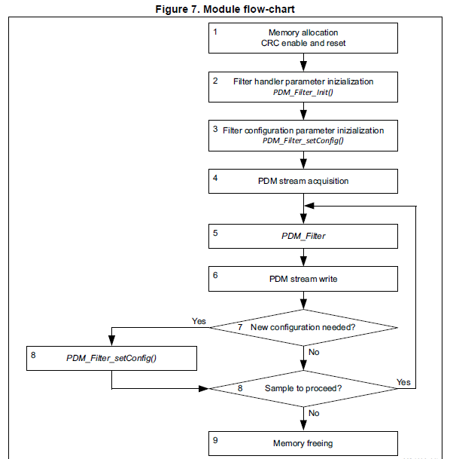

**Connecting PDM digital microphones to STM32 MCUs:-**

- This section describes how to connect digital MEMS microphones to the SPI/ I2S, SAI

and DFSDM peripherals embedded in STM32 microcontrollers in both mono and

stereo configurations.

**Serial peripheral interface/Inter-IC sound (I2S):-**

- The STM32 microcontrollers offer a Serial Peripheral Interface block named SPI.

Some of these SPI blocks also offer the possibility to use the Inter-IC Sound audio

protocol (I2S).

- As we will in the next section, it is possible to connect one or two digital microphones

to a SPI block by either using the SPI or I2S protocol.

- The SPI protocol provides simple communication interface allowing the

microcontrollers to communicate with external devices.

- The I2S protocol is widely used to transfer audio data from a microcontroller/DSP

(Digital Signal Processor) to an audio codec, in order to play melodies or to capture

sound from a microphone.

**Mono configuration:-**

- A single digital microphone is connected to the SPI block. The SPI block can be

configured either in SPI or in I2S mode.

- In both cases, the SPI block is configured in master receiver mode. In this mode, the

periph­eral provides the clock to the digital microphone. The audio samples are

acquired through the serial data pin.

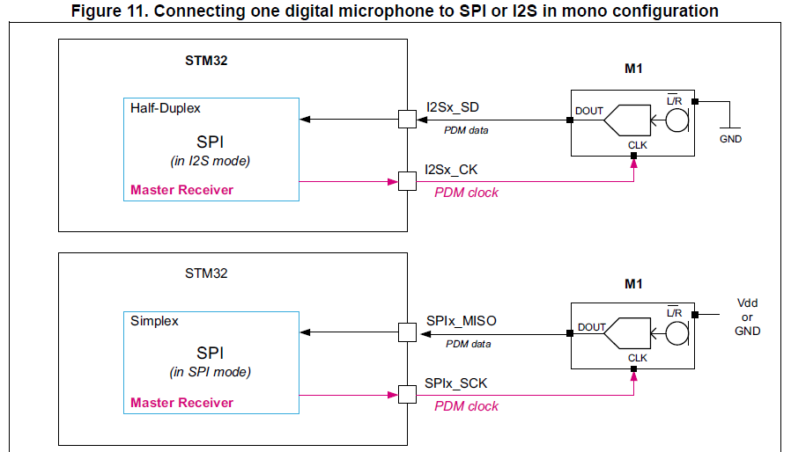

- If the SPI protocol is used, the L/R channel selection (LR) pin of the microphone can

be con­nected either to Vdd or to GND. The SPI clock polarity shall be aligned with the

configura­tion of L/R input.

- If L/R = GND, then the SPI shall sample the incoming data using the rising edge of

SPIx_SCK.

- If L/R = Vdd, then the SPI shall sample the incoming data using the falling edge of

SPIx_SCK.

- If the I2S protocol is used, it is recommended to set the L/R channel selection (LR) pin

of the microphone to GND. By default the I2S protocol will sample the incoming data

using the ris­ing edge of I2Sx_CK. Note that the SPI-V2 block also offers the possibility

to configure the sampling edge for the I2S protocol.

**Data format:-**

- The samples acquired by the SPI block in I2S or SPI mode can be stored into the

memory using either DMA or interrupt signaling.

- The receive data register (SPIx_DR) will provide contiguous bits from the microphone

like shown in the example hereafter for a 16-bit format:

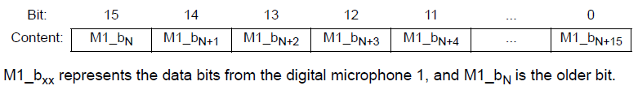

**Stereo configuration:-**

- Two digital microphones can be connected to the SPI block using a timer.

- The SPI block can be configured either in SPI or in I2S mode.

- In both cases, the SPI block is configured in master receiver mode. In this

configuration, the SPI peripheral operates at twice the microphone frequency in

order to read the data pro­vided by both microphones, on the falling edge of its clock.

- This allows the two microphones to share a single data line.

- The SPI block provides the clock to an embedded timer which divides the serial

interface clock (SPIx_SCK or I2Sx_CK) by 2.

- The divided clock is delivered to the digital microphone.

- The audio samples are acquired by the I2S peripheral from the digital microphones

data output pins.

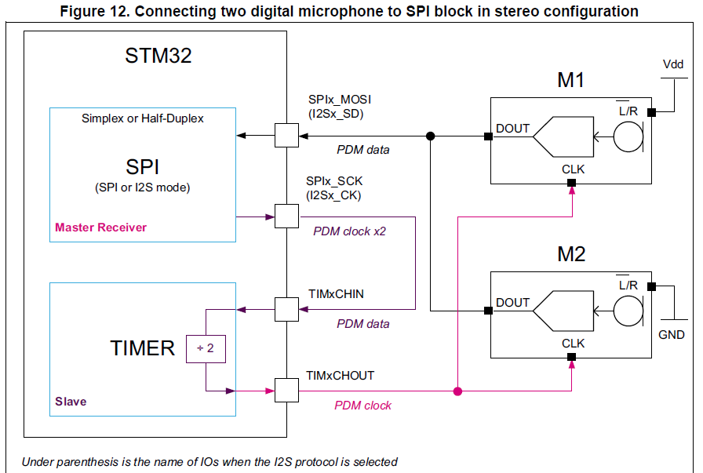

**Using the timer as clock generator**

- When the timer is used to generate the clock for the digital microphones, two points

have to be taken into account:

- The application must insure that the delay introduced by the clock division

performed by the timer still insures a margin in the setup time (TS) of the samples

provided by the microphones.

- For that purpose, the timer shall use a clock as fast as possible.

- The maximum delay (TD) introduced by the timer between the input (TIMxCHIN) and

the output clock (TIMxCHOUT) will be 5 clock cycles of the timer reference clock.

- The timers generally use their APB clock or a multiple of their APB clock as reference.

See Figure 13.

- The application must insure that the peripheral providing the clock to TIMxCHIN

input and the timer used for the division, are working with the same reference clock.

- If this rule is not respected, then from time to time the digital microphone will

receive a clock having a longer or shorter period.

- This jitter may degrade the quality of the analog to digital conversion of the

microphone.

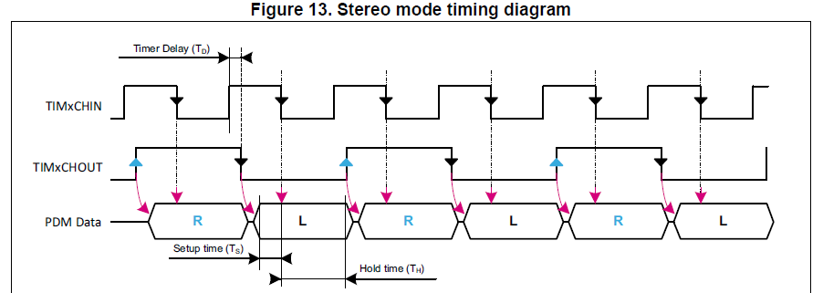

**Data format:-**

- The samples acquired by the SPI block in I2S or SPI mode can be stored into the

memory using either DMA or interrupt signaling.

- In this configuration, the data read from the microphones are interleaved bit per bit.

The data stored into the SPIx_DR register will be interleaved as shown in the example

hereafter for 16-bit format:

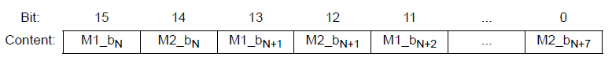

- M1_bxx represents the data bits from the digital microphone 1, and M1_bN is the

older bit.

- M2_bxx represents the data bits from the digital microphone 2, and M2_bN is the

older bit.

**Digital signal processing:-**

- This section presents two ways to convert PDM data into PCM data:

- The first is a software solution which is the PDM audio software decoding library and

the second is hardware solution using the DFSDM peripheral filters.

**PDM audio software decoding Library:-**

**Overview:-**

- PDM audio software decoding Library is an optimized software implementation for

PDM signal decoding and audio signal reconstruction when connecting digital MEMS

microphones with an STM32 microcontroller.

- This library implements several filters for the 1-bit PDM high frequency signal output

from a digital microphone and transforms it into a 16-bit PCM at a proper audio

frequency.

**Digital data flow:-**

- The digital MEMS microphone outputs a PDM signal, which is a high frequency (1 to

3.25 MHz) stream of 1-bit digital samples.

- The PDM data is acquired by a serial interface embedded in the STM32.

- This data is transferred through DMA (thus reducing the software overhead) to a

system RAM buffer to be processed.

- After the conversion, the PCM raw data can be handled depending on the application

implementation (stored as wave/compressed data in a mass storage media,

transferred to an external audio codec DAC...).

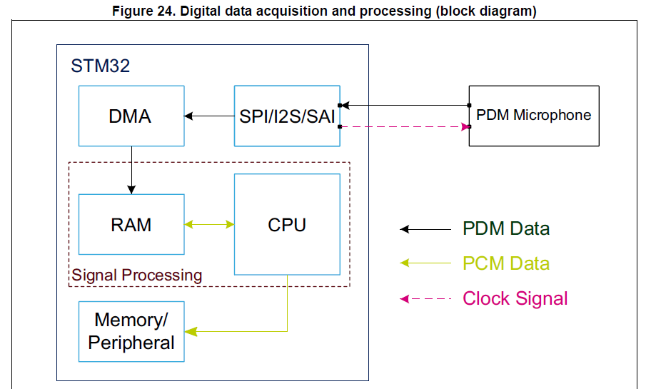

**Digital signal processing:-**

- The PDM audio software decoding Library offers a two steps digital signal processing: - PDM digital filtering and decimation and Digital signal conditioning.

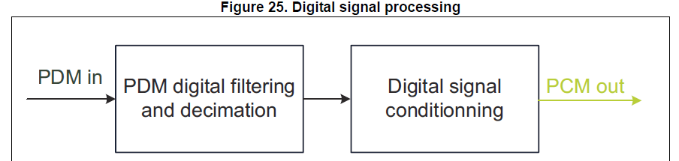

- On the first step, the PDM signal from the microphone is filtered and decimated in

order to obtain a sound signal at the required frequency and resolution.

- On the second step, the digital audio signal resulting from the previous filter pipeline

is fur­ther processed for proper signal conditioning implementing a low pass filter and

a high pass filter.

- Both these filters can be enabled/disabled and configured (cut-off frequencies) by

using the filter initialization function.

**DFSDM filters for digital signal processing:-**

**Digital data flow: acquisition and processing:-**

- The digital MEMS microphone outputs a PDM signal, which is a high frequency (1 to

3.25 MHz) stream of 1-bit digital samples.

- The data is acquired by the DFSDM serial transceiver that provides connection to the

external Sigma-Delta modulator of the digital microphone.

- The digital filters perform CPU-free filtering that averages the 1-bit input data stream

from the SD modulator into a higher resolution and a lower sample rate.

- This data is transferred through DMA (thus reducing the software overhead) to a

system RAM buffer to be further fil­tered.

- After that, the PCM raw data can be handled depending on the application

implemen­tation (stored as wave/compressed data in a mass storage media,

transferred to an external audio codec DAC...).

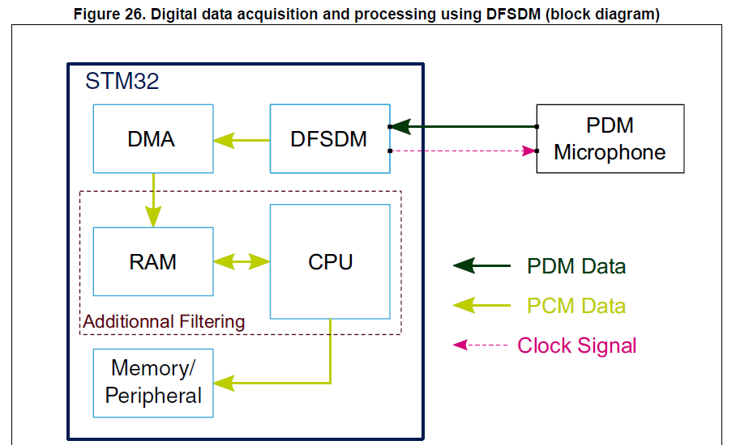

**Audio codec (CS43L22):-**

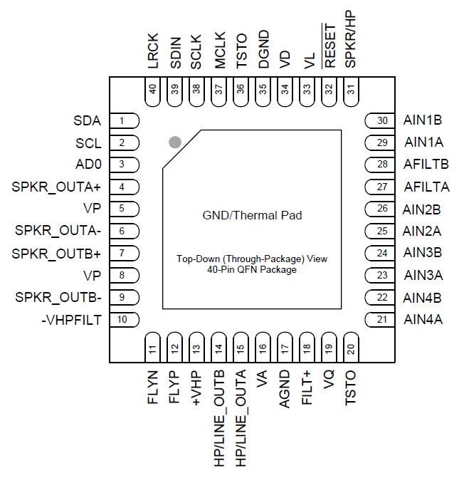

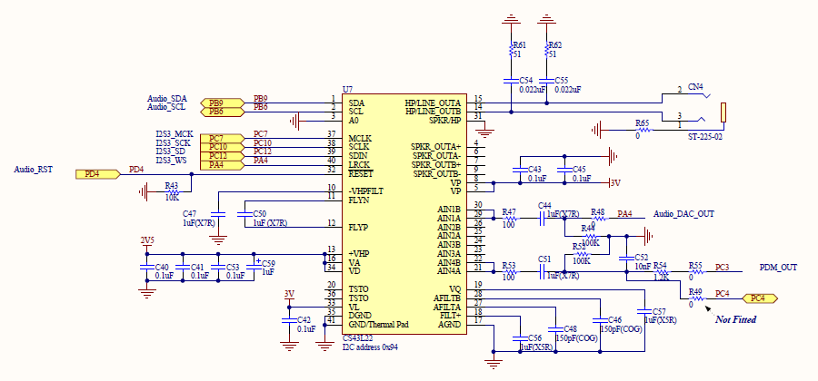

**Basic Architecture:-**

- The CS43L22 is a highly integrated, low power, 24-bit audio DAC comprised of a

Digital Signal Processing Engine, headphone amplifiers, a digital PWM modulator and

two full-bridge power back-ends.

- Other features include battery level monitoring and compensation and temperature

monitoring.

- The DAC is designed using multi-bit delta-sigma techniques and operates at an

oversampling ratio of 128Fs, where Fs is equal to the system sample rate.

- The PWM modulator operates at a fixed frequency of 384 kHz.

- The power MOSFETs are configured for either stereo full-bridge or mono parallel full

bridge output.

- The DAC operates in one of four sample rate speed modes: Quarter, Half, Single and

Double.

- It accepts and is capable of generating serial port clocks (SCLK, LRCK) derived from an

input Master Clock (MCLK).

**Line Inputs:-**

- 4 pairs of stereo analog inputs are provided for applications that require analog pass-

through directly to the HP/Line amplifiers.

- This analog input portion allows selection from and configuration of multiple

combinations of these stereo sources.

**Line & Headphone Outputs:-**

- The analog output portion of the CS43L22 includes a headphone amplifier capable of

driving headphone and line-level loads.

- An on-chip charge pump creates a negative headphone supply allowing a full-scale

output swing centered around ground.

- This eliminates the need for large DC-Blocking capacitors and allows

the amplifier to deliver more power to headphone loads at lower supply voltages.

**Speaker Driver Outputs:-**

- The Class D power amplifiers drive 8 Ω (stereo) and 4 Ω (mono) speakers directly,

without the need for an external filter.

- The power MOSFETS are powered directly from a battery eliminating the efficiency

loss associated with an external regulator.

- Battery level monitoring and compensation maintains a steady output as battery

levels fall.

- A temperature monitor continually measures the die temperature and registers

when predefined thresholds are exceeded.

**Fixed Function DSP Engine:-**

- The fixed-function digital signal processing engine processes the PCM serial input

data.

- Independent volume control, left/right channel swaps, mono mixes, tone control and

limiting functions also comprise the DSP engine.

**Digital Interface Formats:-**

- The serial port operates in standard I²S or DSP Mode digital interface formats with

varying bit depths from 16 to 24. Data is clocked into the DAC on the rising edge of

SCLK.

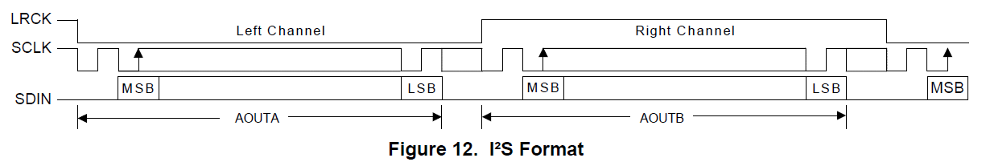

**DSP Mode:-**

- In DSP Mode, the LRCK acts as a frame sync for 2 data-packed words (left and right

channel) input on SDIN.

- The MSB is input on the first SCLK rising edge after the frame sync rising edge.

- The right channel immediately follows the left channel.

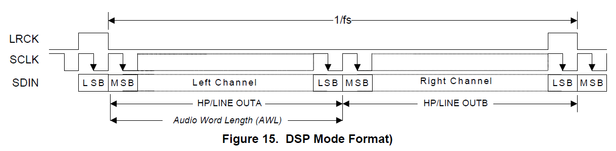

**Initialization:-**

- The CS43L22 enters a Power-Down state upon initial power-up. The interpolation and

decimation filters, delta-sigma and PWM modulators and control port registers are

reset. The internal voltage reference, and switched-capacitor low-pass filters are

powered down.

- The device will remain in the Power-Down state until the RESET pin is brought high.

The control port is accessible once RESET is high and the desired register settings can

be loaded per the interface descriptions.

- Once MCLK is valid, the quiescent voltage, VQ, and the internal voltage reference,

FILT+, will begin powering up to normal operation.

- The charge pump slowly powers up and charges the capacitors. Power is then applied

to the headphone amplifiers and switched-capacitor filters, and the analog/digital

outputs enter a muted state.

- Once LRCK is valid, MCLK occurrences are counted over one LRCK period to

determine the MCLK/LRCK frequency ratio and normal operation begins.

**Recommended Power-Up Sequence:-**

1. Hold RESET low until the power supplies are stable.

2. Bring RESET high.

3. The default state of the “Power Ctl. 1” register (0x02) is 0x01. Load the desired

register settings while keeping the “Power Ctl 1” register set to 0x01.

4. Load the required initialization settings.

5. Apply MCLK at the appropriate frequency. SCLK may be applied or set to master at

any time; LRCK may only be applied or set to master while the PDN bit is set to 1.

6. Set the “Power Ctl 1” register (0x02) to 0x9E.

7. Bring RESET low if the analog or digital supplies drop below the recommended

operating condition to prevent power glitch related issues.

**Recommended Power-Down Sequence:-**

To minimize audible pops when turning off or placing the DAC in standby,

1. Mute the DAC’s and PWM outputs.

2. Disable soft ramp and zero cross volume transitions.

3. Set the “Power Ctl 1” register (0x02) to 0x9F.

4. Wait at least 100 μs.

- The device will be fully powered down after this 100 μs delay.

- Prior to the removal of the master clock (MCLK), this delay of at least 100 μs must be

implemented after step 3 to avoid premature disruption of the DAC’s power down

sequence.

- A disruption in the device’s power down sequence (i.e. removing the MCLK signal

before this 100 μs delay) has consequences on both the headphone and PWM

speaker amplifiers: The charge pump may stop abruptly, causing the headphone

amplifiers to drive the outputs up to the +VHP supply.

- Also, the last state of each ‘+’ and ‘-’ PWM output terminal before the premature

removal of MCLK could randomly be held at either VP or AGND.

- When this event occurs, it is possible for each PWM terminal to output opposing

potentials, creating a DC source into the speaker voice coil.

- The disruption of the device’s power down sequence may also cause clicks and pops

on the output of the DAC’s as the modulator holds the last output level before the

MCLK signal was removed.

5. MCLK may be removed at this time.

6. To achieve the lowest operating quiescent current, bring RESET low. All control port

registers will be reset to their default state.

**Required Initialization Settings:-**

- Various sections in the device must be adjusted by implementing the initialization

settings shown below after power-up sequence step 3. All performance and power

consumption measurements were taken with the following settings:

1. Write 0x99 to register 0x00.

2. Write 0x80 to register 0x47.

3. Write ‘1’b to bit 7 in register 0x32.

4. Write ‘0’b to bit 7 in register 0x32.

5. Write 0x00 to register 0x00.

**CONTROL PORT OPERATION:-**

- The control port operates using an I²C interface with the CS43L22 acting as a slave

device.

**I²C Control:-**

- SDA is a bidirectional data line. Data is clocked into and out of the device by the

clock, SCL.

- The AD0 pin sets the LSB of the chip address; ‘0’ when connected to DGND, ‘1’ when

connected to VL.

- This pin may be driven by a host controller or directly connected to VL or DGND.

- The AD0 pin state is sensed and the LSB of the chip address is set upon the release of

the RESET signal (a low-to-high transition).

- The signal timings for a read and write cycle are shown in Figures.

- A Start condition is defined as a falling transition of SDA while the clock is high.

- A Stop condition is defined as a rising transition of SDA while the clock is high.

- All other transitions of SDA occur while the clock is low.

- The first byte sent to the CS43L22 after a Start condition consists of a 7-bit chip

address field and a R/W bit (high for a read, low for a write).

- The upper 6 bits of the address field are fixed at 100101.

- To communicate with the CS43L22, the chip address field, which is the first byte sent

to the CS43L22, should match 100101 followed by the setting of the AD0 pin.

- The eighth bit of the address is the R/W bit. If the operation is a write, the next byte

is the Memory Address Pointer (MAP), which selects the register to be read or

written. If the operation is a read, the contents of the register pointed to by the MAP

will be output.

- Setting the auto-increment bit in MAP allows successive reads or writes of

consecutive registers. Each byte is separated by an acknowledge bit.

- The ACK bit is output from the CS43L22 after each input byte is read and is input to

the CS43L22 from the microcontroller after each transmitted byte.

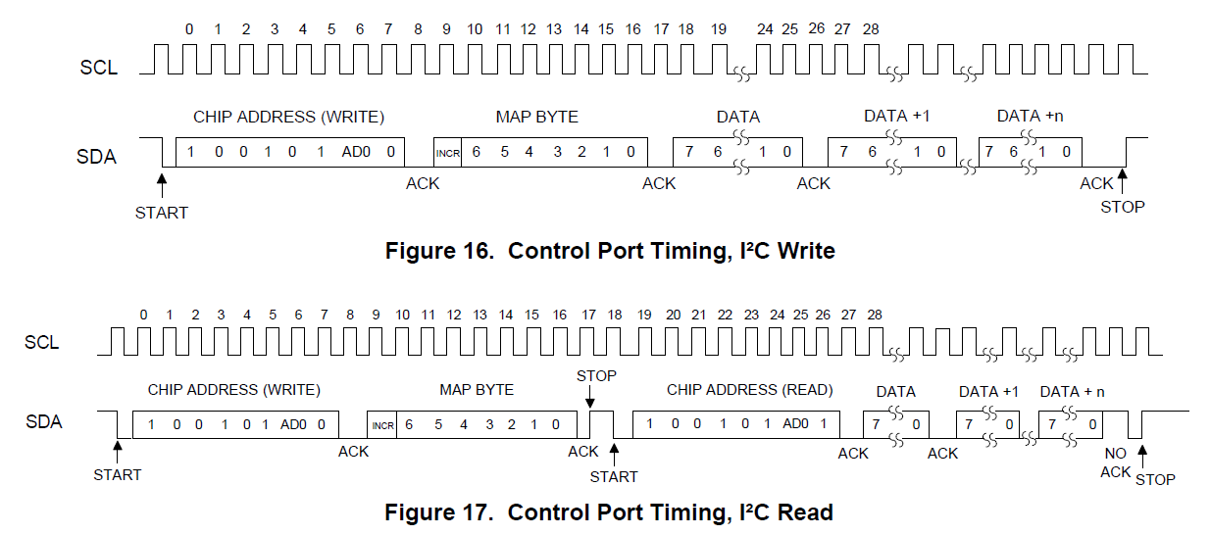

- Since the read operation cannot set the MAP, an aborted write operation is used as a

preamble. As shown in Figure, the write operation is aborted after the acknowledge

for the MAP byte by sending a stop condition.

- The following pseudocode illustrates an aborted write operation followed by a read

operation.

- Send start condition.

- Send 10010100 (chip address & write operation).

- Receive acknowledge bit.

- Send MAP byte, auto-increment off.

- Receive acknowledge bit.

- Send stop condition, aborting write.

- Send start condition.

- Send 10010101 (chip address & read operation).

- Receive acknowledge bit.

- Receive byte, contents of selected register.

- Send acknowledge bit.

- Send stop condition.

- Setting the auto-increment bit in the MAP allows successive reads or writes of

consecutive registers.

- Each byte is separated by an acknowledge bit.

**Memory Address Pointer (MAP):-**

- The MAP byte comes after the address byte and selects the register to be read or

written.

- Refer to the pseudo code above for implementation details.

**Map Increment (INCR):-**

- The device has MAP auto-increment capability enabled by the INCR bit (the MSB) of

the MAP.

- If INCR is set to 0, MAP will stay constant for successive I²C writes or reads.

- If INCR is set to 1, MAP will auto-increment after each byte is read or written,

allowing block reads or writes of successive registers.

**Audio Bluetooth module (WT32I-A-AI6):-**

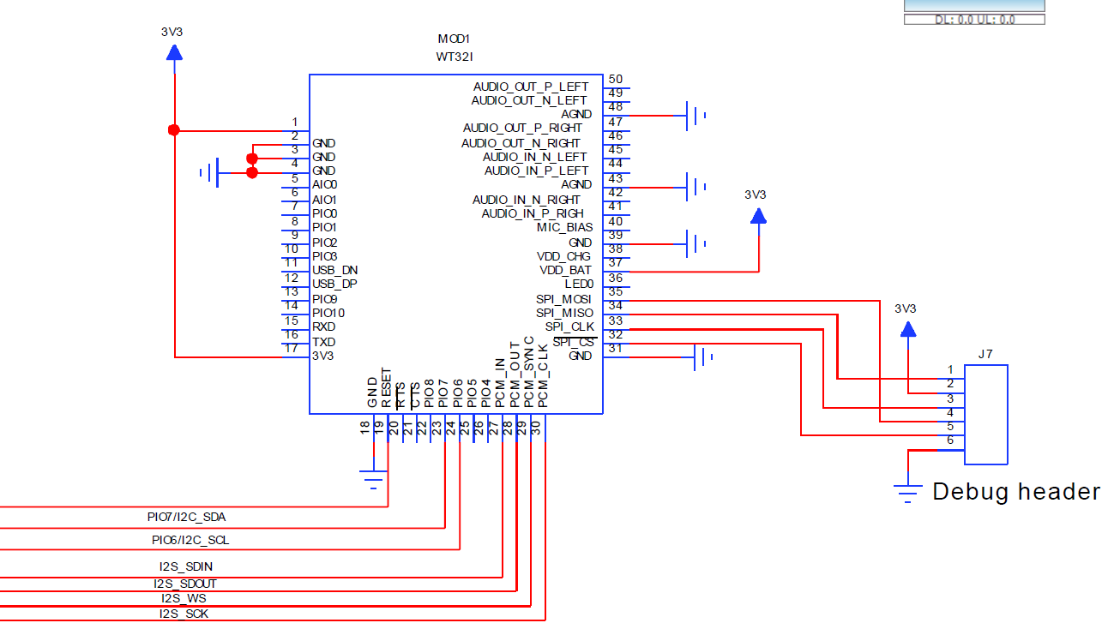

**Description:-**

- WT32i is an audio specific Bluetooth 3.0 module with excellent radio frequency

performance and enhanced audio features, enabling a best in class Bluetooth audio

experience.

- In addition to a certified Bluetooth radio and software stack, WT32i also contains a

DSP, stereo audio codec, and battery charger making it ideal for fixed and portable

audio applications.

- WT32i includes Bluegiga's iWRAP6 Bluetooth stack software which implements A2DP,

AVRCP v.1.5 profiles and supports aptX® and AAC audio codecs for stereo audio

applications.

- For hands-free applications iWRAP6 software also supports HFP v.1.6, HSP, MAP and

PBAP and CVC® echo cancellation software.

- For data communications to Android and iOS applications iWRAP6 also implements

Bluetooth Serial Port Profile (SPP) and Apple iAP profiles.

- WT32i is an ideal solution for developers who want to quickly integrate the latest

Bluetooth audio technologies without the time and costs typically involved with a

Bluetooth audio chipset design.

**Block diagram:-**

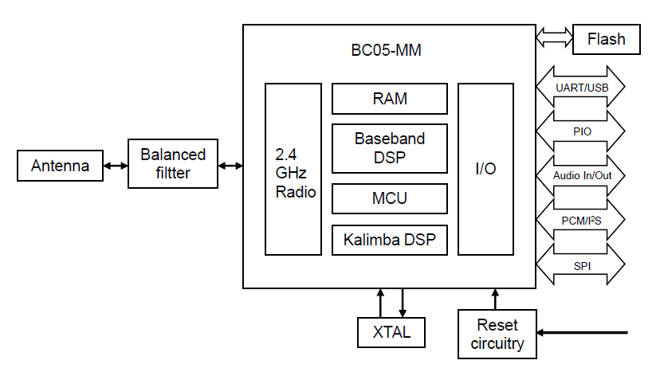

**BC05-MM**

- The BlueCore®5-Multimedia External is a single-chip radio and baseband IC for

Bluetooth 2.4GHz systems.

- It provides a fully compliant Bluetooth v3.0 specification system for data and voice.

BlueCore5-Multimedia External contains the Kalimba DSP coprocessor with double

the MIPS of BlueCore3-Multimedia External, supporting enhanced audio applications.

**XTAL**

- The reference clock of WT32i is generated with 26 MHz crystal.

- All BC05-MM internal digital clocks are generated using a phase locked loop, which is

locked to the frequency of either the 26 MHz crystal or an internally generated

watchdog clock frequency of 1 kHz.

**RESET CIRCUITRY**

- The internal reset circuitry keeps BC05-MM in reset during boot in order for the

supply voltages to stabilize.

- This is to prevent corruption of the flash memory during booting.

**BALANCED FILTER**

- The internal balanced filter provides optimal impedance matching and band pass

filtering in order to achieve lowest possible in-band and out-of-band emissions.

**ANTENNA**

- The antenna is a ceramic chip antenna with high efficiency.

- The antenna is insensitive to surrounding dielectric materials and requires only a

small clearance underneath which makes it compatible with previous WT32I designs

and well suitable for designs with high density.

**FLASH**

- 16 Mbit flash memory is used for storing the Bluetooth protocol stack and Virtual

Machine applications.

- It can also be used as an optional external RAM for memory-intensive applications.

**PCB Designs:-**

**STM32F446RC (Version 1):-**

- First of all we design a PCB that have STM32F446RC with all its 64 pins.

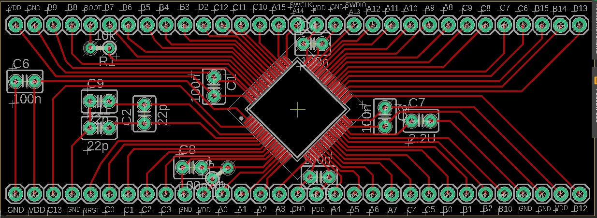

**CS43L22-CNZ with Analog Pins:-**

- After that we design a PCB that have the IC of the audio codec and all its needed

components to work well.

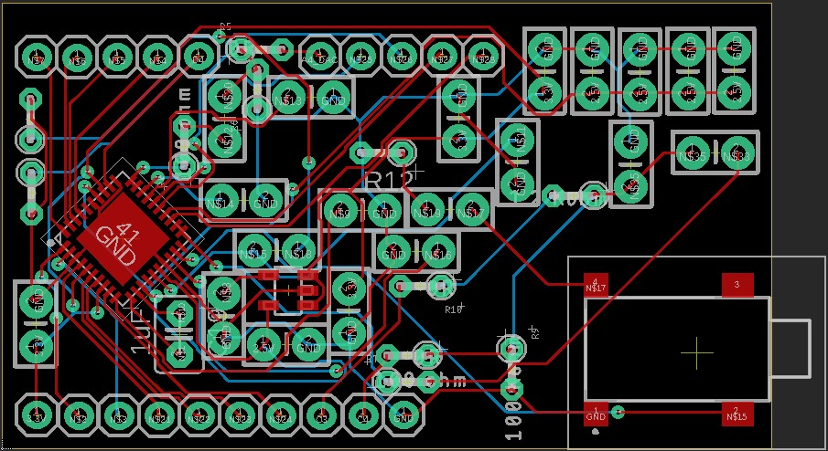

**CS43L22-CNZ without Analog Pins:-**

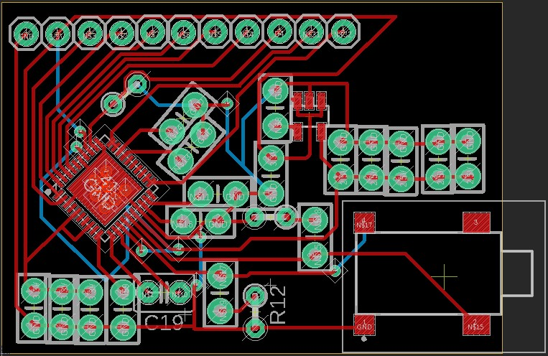

**Audio Bluetooth Module (WT32I-A-AI6):-**

- After that we design a PCB that have the audio Bluetooth module.

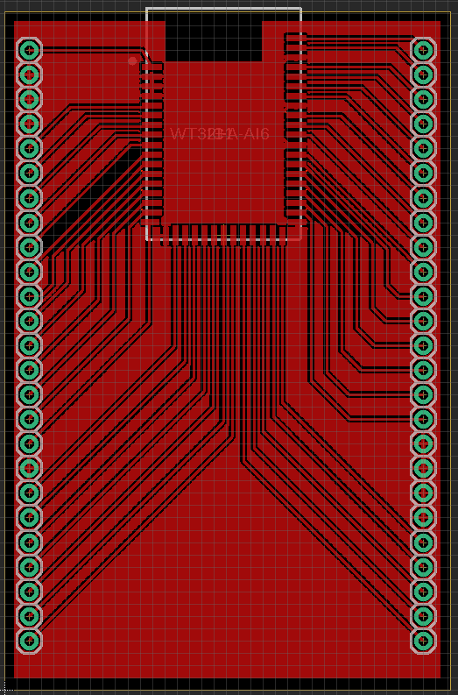

**STM32F446RC (Version 2):-**

- After that we design PCB that have STM32F446RC but with only used pins in our

project to reduce the size of the PCB and of course the size of the project.

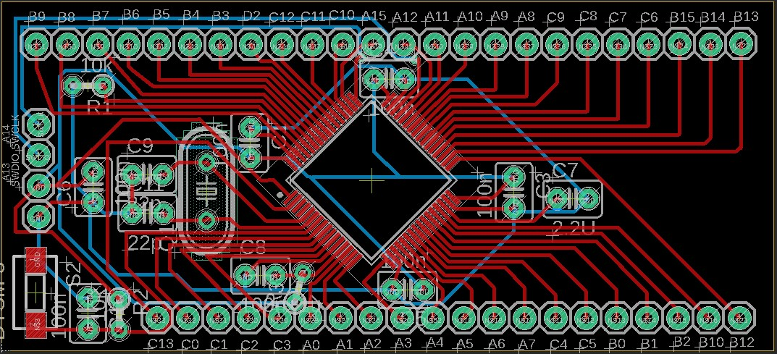

**Our future work:-**

- We chose STM32F413CG instead of STM32F446RC because the new one has DFSDM

peripheral that will help us in our DSP work as we described before.

- And here is the last design of our PCB with all the components (STM32F413CG, audio

codec IC, 2 MEMs microphones and all other needed components).

**STM32F413CG (Version 1) with Audio Codec:-**

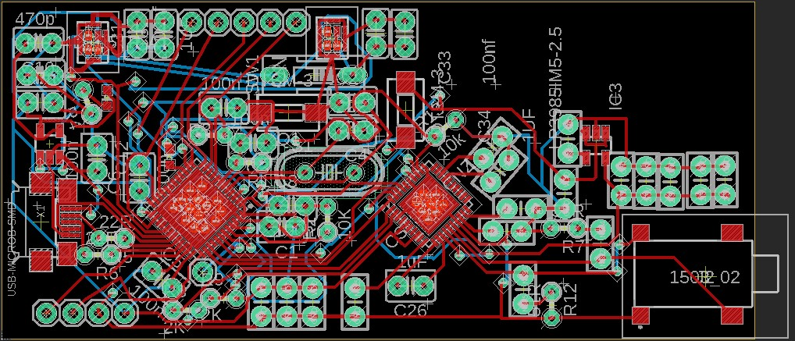

**References used in this project:-**

- AN3126:- Audio and waveform generation using the DAC in STM32 microcontrollers.

- AN3997:- Audio playback and recording using the STM32F4DISCOVERY.

- AN3998:- PDM audio software decoding on STM32 microcontrollers.

- AN4031:- Using the STM32F2, STM32F4 and STM32F7 Series DMA controller.

- AN4566:- Extending the DAC performance of STM32 microcontrollers.

- AN4739:- STM32Cube firmware examples for STM32F4 Series.

- AN5027:- Interfacing PDM digital microphones using STM32 32-bit Arm® Cortex®

MCUs.

- AN5073:- Receiving S/PDIF audio stream with the STM32F4/F7/H7 Series.

- UM2372:- STM32Cube PDM2PCM software library for the STM32F4/F7/H7 Series.

- RM0390:- Reference manual STM32F446xx advanced Arm®-based 32-bit MCUs.

- PM0214:- Programming manual STM32 Cortex®-M4 MCUs and MPUs programming

Manual.

- STM32F446xC/E:- datasheet.

- STM32F446xC/xE:- Errata sheet.

- STM32F446xC/xE:- device limitations.