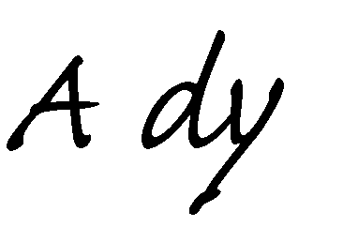

**Problem description:**

Hearing impairment is one of the commonest birth defects. It is the third leading chronic disability affecting nearly 250 million people in the world, and 75% of sufferers live in developing countries.

The impact of hearing impairment on the individual and society is significant. Development of hearing loss leads to severe handicap that affects the sufferer’s job, home and life with subsequent social and economic burden on the society. In children the problem is compounded since normal hearing is the primary source for acquisition of language, speech and cognitive skills.

In a national household survey conducted to estimate the prevalence of hearing impairment in Egypt, it was found to be high in those aged 0-4 years (22.4%).

### Proposed solution and impact:

An adaptable digital hearing aid that allows the dynamic change of its amplification by the user. Moreover, it will be less costly than an analogue prefixed hearing aid that requires constant changing to adapt with the patient’s changing state.

**Main components:** a microphone, a speaker, a microcontroller.

**Main users:** children with hearing impairment in an underprivileged environment.

### Similar products:

1. <https://www.starkey.com/hearing-aids>
2. <https://www.hearingtracker.com/hearing-aids/oticon-opn-bte13-pp-1>
3. <https://eargo.com/products-hearing-aids>

**Our competitive advantage:**

1. We provide a long term device which does not need continuous calibration or doctor visits, because the patient can adjust it anytime anywhere.
2. We offer the product at a much lower price. At 15 USD per piece the price is unmatched given that it does not need to be replaced to adjust for change in patient’s status.
3. We have no competitors within the Egyptian market, which would make us pioneers in this field in Egypt.

**Objectives**

Design and implement financial controls to help ensure success and achieve profitability.

Our objective is 2 products :

Firstly : is mainly a mobile app that helps hearing impaired persons to amplify the frequencies they don’t hear well

Secondly : is a complete standalone headset that works as a Digital Hearing Aid and controllable by a mobile app via Bluetooth

## Business Model:

We propose a hybrid business model that combines two well established models, the low-cost model and the add-ons model as follows:

The low cost model depends on offering the product at lowest value for a large market, and gain profit by driving significant volumes of customers. This will be highly applicable for the Egyptian market.

The add-ons model goal will be to facilitate customized purchases, i.e. each customer can purchase more services according to his needs and financial abilities. This will allow for market expansion to wealthier customers who might be interested in our technology or do not want to import their products from abroad, and have to wait for shipment as well as problems with maintenance … etc.

## Business Canvas:

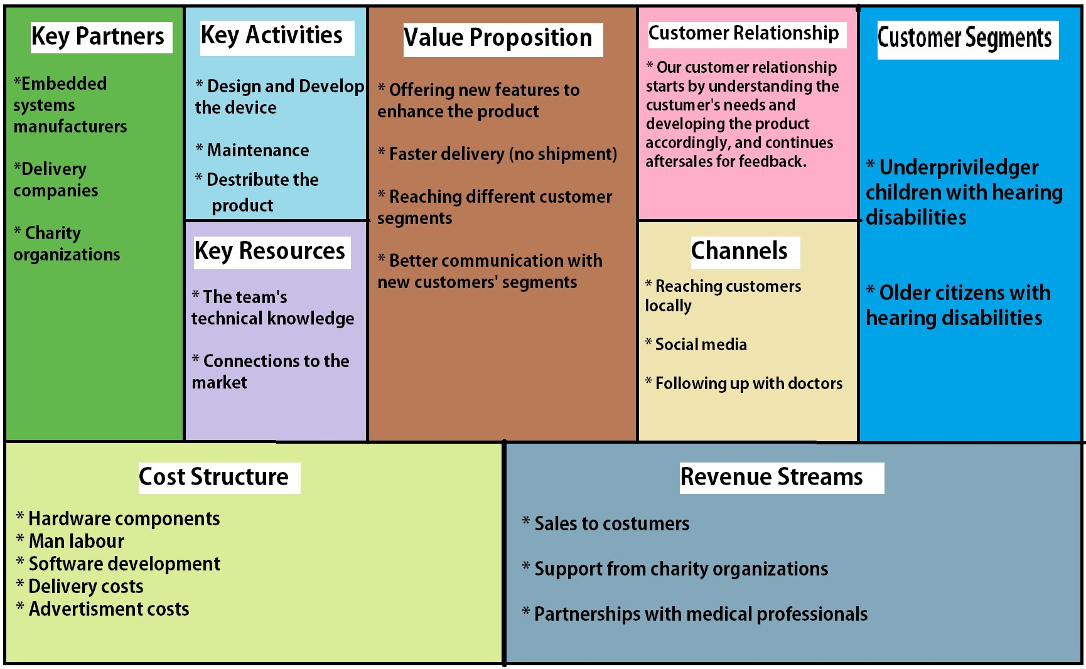

**Marketing plan:**

We plan to reach our target market in two ways:

A – Using social networks, as many people use it these days it can reach anyone either directly or indirectly, i.e. people can recommend us to a customer or vice versa.

B – Via partnerships with charity organizations such as Resala, Misr El-Khair, … etc. Because they already have the manpower to scan many areas to reach potential customers.

## The Team:

Our team consists of two biomedical engineering students, with the roles divided between us as follows:

**Relations and marketing manager:** Amr Ashour

**Embedded systems technical manager:** Hanna Nabil

*Our qualifications:*

All team members attended a 3 months long entrepreneurship course covering all of the basics needed, and we all have the knowledge and ambition to work day and night on our startup.

The team has worked together on multiple projects providing us with the experience needed to handle significant work load and function as a unit.

Our technical members have worked on many related projects and have successfully delivered satisfying results.

# Product:

**Block Diagram:**

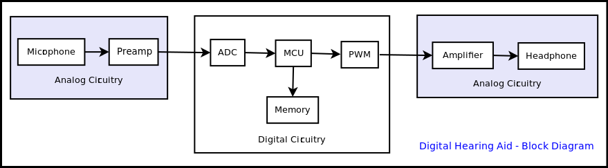

**The main components per piece:**

* A microphone, approximated cost is 2 USD.
* A microprocessor with a suitable ADC and DAC, approximated cost is 6 USD.
* A speaker, approximated cost is 1 USD.

Total product cost is 15 USD per piece after addition of software, labor hours and delivery cost.

**Quality matrix:**

* Acceptable look and comfortable wear.
* Signal to noise ratio.
* Real time processing.

**Pipeline:**

1. **Proof of concept phase (Nov. 2017 to Dec. 2017) :**

After researching the idea and similar products, this phase has been done with satisfying results.

1. **Prototype phase (Dec. 2017 to Feb. 2018) :**

We have a working prototype using a raspberry pi microcontroller with good accuracy.

#### Product manufacturing (July 2018 to Oct. 2018) :

This phase will involve prototype enhancement, and finding a way for mass production.

#### Product distribution (Starting Oct. 2018) :

In this phase we are expecting to have a product ready for the market. And we start delivering to customers.

# Conclusion:

As you can see, we propose to provide a solution to a significant health problem affecting a large demographic of our society. Thus achieving both profit and delivering a value to people’s lives as well as to society over all.

Why us? Because we are qualified engineers working on a product in our field, and we the knowledge and passion to pursue this opportunity from start as far as it takes us.

We will be happy to receive your emails: [hananabilabd@gmail.com](mailto:hananabilabd@gmail.com)