Full name: Võ Minh Hiếu

Email: [minhhieu7101998@gmail.com](mailto:minhhieu7101998@gmail.com)

Link github: <https://github.com/MinhHieu7101998>

REPORT TEST OF DELIVEREE

**Environment**

1. Tools: Selenium WebDriver
2. Programing: Java
3. Browser: Chrome and Firefox

**Requirements**

Complete: 100%

Run file: runTestcaseDeliveree.xml

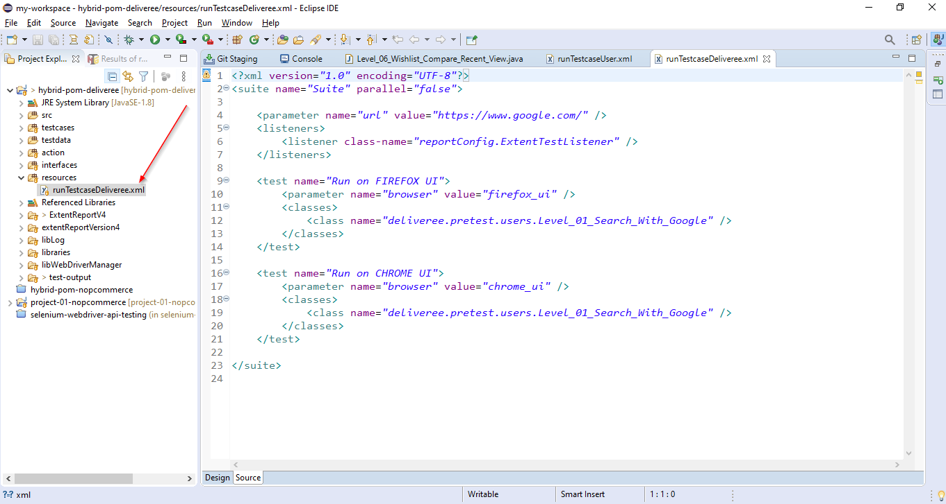

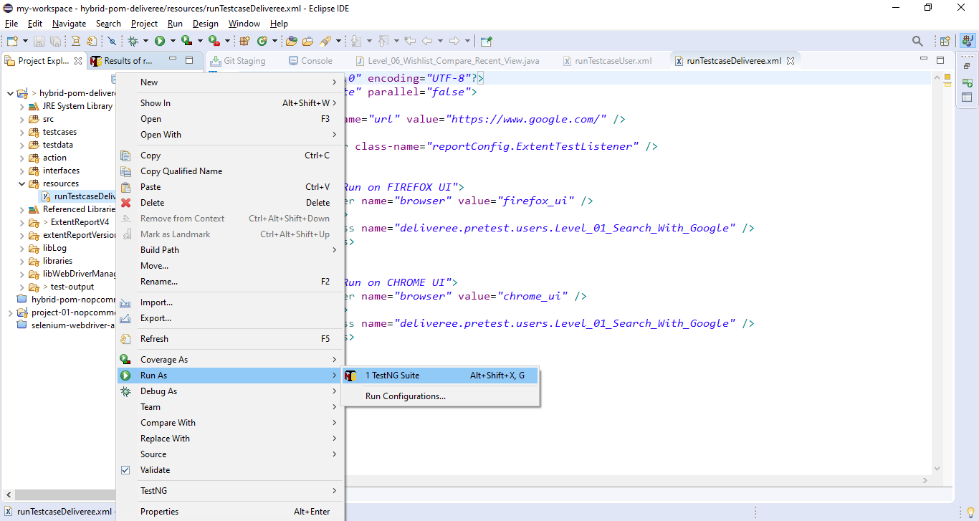

**Result**

